

The International Committee on Taxonomy of Viruses
Taxonomy Proposal Form, 2025

Part 1a: Details of taxonomy proposals

Title: | Create three (3) new species, one in the genus Alphacytorhabdovirus, and the other two in the genus Betacytorhabdovirus, subfamily Betarhabdovirinae (Mononegavirales: Rhabdoviridae)
Code assigned: | 2025.025P.Ac.v3.Rhabdoviridae_Alpha_and_Betacytorhabdovirus_3nsp

Author(s), affiliation and email address(es):
Given name (+middle initial(s)) | Surname | Affiliation | Email address | Corr. author(s)
Nicolas | Bejerman | UFyMA INTA-CONICET, Argentina | bejerman.nicolas@inta.gob.ar | X
Humberto | Debat | UFyMA INTA-CONICET, Argentina | debat.humberto@inta.gob.ar
Ralf G | Dietzgen | QAAFI, UQ, Australia | r.dietzgen@hotmail.com
Juliana | Freitas-A Astúa | EMBRAPA Mandioca e Fruticultura, Brazil | juliana.astua@embrapa.br
Hideki | Kondo | Okayama University, Japan | hkondo@rib.okayama-u.ac.jp
Pedro Luis | Ramos- González | Instituto Biológico de São Paulo, Brazil | plrg1970@gmail.com
Anna E | Whitfield | NC State University, USA | awhitfi@ncsu.edu
Peter J | Walker | School of Chemistry and Molecular Biosciences, The University of Queensland, St Lucia, Australia | peter.walker@uq.edu.au

Part 1b: Taxonomy Proposal Submission
ICTV Subcommittee:
Animal DNA Viruses and Retroviruses |  | Bacterial viruses
Animal minus-strand and dsRNA viruses |  | Fungal and protist viruses
Animal positive-strand RNA viruses |  | Plant viruses | X
Archaeal viruses |  | General

List the ICTV Study Group(s) that have seen or have been involved in creating this proposal:
Rhabdoviridae study group

Optional – complete only if formally voted on by an ICTV Study Group:
Study Group | Number of members
Study Group | Votes in support | Votes against | No vote
Rhabdoviridae | 11 | 0 | 3

Submission date: | 21/05/2025

Part 1c: Feedback from ICTV Executive Committee (EC) meeting
Executive Committee Meeting Decision code: | X
A – Accept
Ac – Accept subject to revision by relevant subcommittee chair. No further vote required | X
U – Accept without revision but with re-evaluation and email vote by the EC
Uc – Accept subject to revision and re-evaluation and email vote by the EC
Ud – Deferred to the next EC meeting, with an invitation to revise based on EC comments
J - Reject
W - Withdrawn

Comments from the Executive Committee:
The EC voted Ac for this proposal (see the table above for explanation), to allow very minor revisions mainly concerning style issues.
It is suggested to remove the header “novel species” since it is confusing because the following paragraphs start with the virus name.

Part 1d: Revised Taxonomy Proposal Submission
Response of proposer:
All proposed changes were accepted, including the removal of the header “novel species”

Revision date: | 19/08/2025

Part 3: TAXONOMIC PROPOSAL

Taxonomic changes proposed:
Establish new taxon | X | Split taxon
Abolish taxon |  | Merge taxon
Move taxon |  | Promote taxon
Rename taxon |  | Demote taxon
Move and rename

Etymology (origin) of proposed taxonomic names:
Taxon name | Etymology of the term
“Alphacytorhabdovirus lonicerae” | The species epithet is derived from Lonicera, the scientific name of the plant host genera from which the sequence of the virus was obtained.
“Betacytorhabdovirus dioscoreae” | The species epithet is derived from Dioscorea, the scientific name of the plant host genera from which the sequence of the virus was obtained.
“Betacytorhabdovirus pyri” | The species epithet is derived from Pyrus, the scientific name of the plant host genera from which the sequence of the virus was obtained.

Permission for use of names derived from a living person:
Taxon name | Full name of person from whom the name is derived | Attached
Abstract of Taxonomy Proposal:
Taxonomic rank(s) affected:
Genera Alphacytorhabdovirus and Betacytorhabdovirus in the family Rhabdoviridae

Description of current taxonomy:
Genera Alphacytorhabdovirus and Betacytorhabdovirus belong to the subfamily Betarhabdovirinae, family Rhabdoviridae and consist of 18 and 19 species, respectively. Viruses classified into species in the genera Alphacytorhabdovirus and Betacytorhabdovirus infect a wide range of plants, and the assignment of viruses to these genera is based on the placement of the viruses on Maximum Likelihood trees inferred from complete L protein sequences

Proposed taxonomic change(s):
Create one new species in the genus Alphacytorhabdovirus, and two new species in the genus Betacytorhabdovirus, subfamily Betarhabdovirinae, family Rhabdoviridae. These species are proposed to be named “Alphacytorhabdovirus lonicerae”, “Betacytorhabdovirus dioscoreae” and “Betacytorhabdovirus pyri”.

Justification:
Three novel rhabdoviruses were identified in honeysuckle [1], Dioscorea rotundata [Silva et al., unpublished (ON924784)] and pear [2]. The characterization of these viruses showed that the honeysuckle-associated virus should be classified into a novel species within the genus Alphacytorhabdovirus [1]; while the Dioscorea rotundata-associated and pear-associated viruses should be assigned to novel species within the genus Betacytorhabdovirus [Silva et al., unpublished (ON924784) and 2, respectively].

Text of Taxonomy proposal:
Taxonomic rank(s) affected:
Genera Alphacytorhabdovirus and Betacytorhabdovirus in the family Rhabdoviridae

Description of current taxonomy:
Genera Alphacytorhabdovirus and Betacytorhabdovirus belong to the subfamily Betarhabdovirinae, family Rhabdoviridae and consist of 18 and 19 species, respectively. Viruses classified into species in the genera Alphacytorhabdovirus and Betacytorhabdovirus infect a wide range of plants, and the assignment of viruses to these genera is based on the placement of the viruses on Maximum Likelihood trees inferred from complete L protein sequences

Proposed taxonomic change(s):
Create one new species in the genus Alphacytorhabdovirus, and two new species in the genus Betacytorhabdovirus, subfamily Betarhabdovirinae, family Rhabdoviridae.

Demarcation criteria:
Viruses assigned to different species within the genera Alphacytorhabdovirus and Betacytorhabdovirus should have several of the following characteristics:
A) nucleotide sequence identity less than 75% for the coding-complete genome sequence
B) amino acid sequence identity less than 86% in proteins encoded by all the cognate open reading frames
C) occupy different ecological niches as evidenced by differences in hosts and/or biological vectors

Justification:
Three novel rhabdoviruses were identified in honeysuckle [1], Dioscorea rotundata [Silva et al., unpublished (ON924784)] and pear [2]. The characterization of these viruses showed that the honeysuckle-associated virus should be classified into a novel species within the genus Alphacytorhabdovirus [1]; while the Dioscorea rotundata-associated and pear-associated viruses should be classified into novel species within the genus Betacytorhabdovirus [Silva et al., unpublished (ON924784) and [2], respectively].

Creation of one new species in the genus Alphacytorhabdovirus

- Honeysuckle -associated cytorhabdovirus 1 (HaCV1) was identified from honeysuckle (Lonicera japonica) samples collected in Henan, China. The complete genome (CG) sequence of HaCV1 consists of 13,930 nucleotides (PQ587056) and contains eight ORFs in the order 3’-N-P´-P- P3-M-G-P6-L-5’ [1] representing the five canonical rhabdovirus structural protein genes as well as the putative cell-to-cell movement protein gene P3 in the conserved location between P and M genes, the overlapping ORF within the P-encoding ORF, which is named P´, and the accessory protein gene P6 between the G and L genes (Figure 1). The CG nucleotide sequence of HaCV1 has the highest identity values with that of Triticum alphacytorhabdovirus 1 (TriACRV1, 71.2%), while the HaCV1 encoded proteins have the highest identity values with those of TriACRV1 (85.3%) [1]. Based on ML trees generated from complete L protein sequences, HaCV1 forms a well-supported clade within alphacytorhabdoviruses with TriACRV1, and Pinellia alphacytorhabdovirus 1 (Figure 2).

HaCV1 meets the demarcation criteria A, B and C. Thus, we propose to classify HaCV1 as member of the new species “Alphacytorhabdovirus lonicerae” subfamily Betarhabdovirinae, family Rhabdoviridae.

Creation of two new species in the genus Betacytorhabdovirus

- Dioscorea rotundata virus 1 (DiRoV1) was identified from white yam (Dioscorea rotundata) samples collected in Nigeria. The coding-complete genome (CCG) sequence of DiRoV1 is 12,751 nucleotides (ON924784) in size and contains seven ORFs in the order 3’-N-P-P3-M-G-P6-L-5’ [Silva et al., unpublished] representing the five canonical rhabdovirus structural protein genes as well as the putative cell-to-cell movement protein gene P3 in the conserved location between P and M genes, and the accessory protein P6 gene between the G and L genes (Figure 1). The CCG nucleotide sequence of DiRoV1 has the highest identity values with that of mango betacytorhabdovirus 1 (ManBCRV1; 50%); while the DiRoV1 encoded proteins have the highest identity values with those of ManBCRV1 (41.74%). Based on ML trees generated from complete L protein sequences, DiRoV1 forms a well-supported clade within betacytorhabdoviruses with ManBCRV1 (Figure 3).
- pear rhabdovirus 1 (PRV1) was identified from pear (Pyrus communis) samples collected in Himachal Pradesh, India. The coding-complete genome (CCG) sequence of PRV1 consists of 15,628 nucleotides (PP512586) and contains seven ORFs in the order 3’-N-P-P3-M-G-P6-L-5’ [2] representing the five canonical rhabdovirus structural protein genes as well as the putative cell-to-cell movement protein gene P3 in the conserved location between P and M genes, and the accessory protein P6 gene between the G and L genes. Interestingly, PRV1 has a shorter G gene, like that one reported for several betacytorhabdoviruses [3] (Figure 1). The CCG nucleotide sequence of PRV1 has the highest identity values with that of Morus betacytorhabdovirus 1 (MorBCRV1; 49.4%); while the PRV1 encoded proteins have the highest identity values with those of MorBCRV1 (41.45%) [2]. Based on ML trees generated from complete L protein sequences, PRV1 forms a well-supported clade with those betacytorhabdoviruses that have the shorter G gene (Figure 3).

DiRoV1 and PRV1 meet the demarcation criteria A, B and C. Thus, we propose to classify DiRoV1 and PRV1 as members of the new species “Betacytorhabdovirus dioscoreae” and “Betacytorhabdovirus pyri”, respectively, subfamily Betarhabdovirinae, family Rhabdoviridae.

References:
[1] Yang J, Liu L, Li J, Chen Z, Peng B, Li Y (2025). Identification and complete genome sequence of Honeysuckle-associated cytorhabdovirus in China. Arch Virol 170:62. PMID: 39976771 DOI: 10.1007/s00705-025-06238-0.
[2] Prajapati M, Gupta N, Thapa P, Diksha D, Sharma S, Baranwal V (2025). Identification and Characterization of a Novel Cytorhabdovirus Associated with Pear (P. communis ‘Bartlett’) Through RNA‑seq. Curr Microbiol 82:39. PMID: 39680169 DOI: 10.1007/s00284-024-04010-2.
[3] Bejerman N, Dietzgen R, Debat H (2023). Novel Tri-Segmented Rhabdoviruses: A Data Mining Expedition Unveils the Cryptic Diversity of Cytorhabdoviruses. Viruses 15:2402, PMID:38140643, doi:10.3390/v15122402.

Accompanying files:
Filename | Description of contents
2025.025P.A.v1.Rhabdoviridae_Alpha_and_Betanucleorhabdovirus_3nsp | Excel sheet

Tables, Figures:
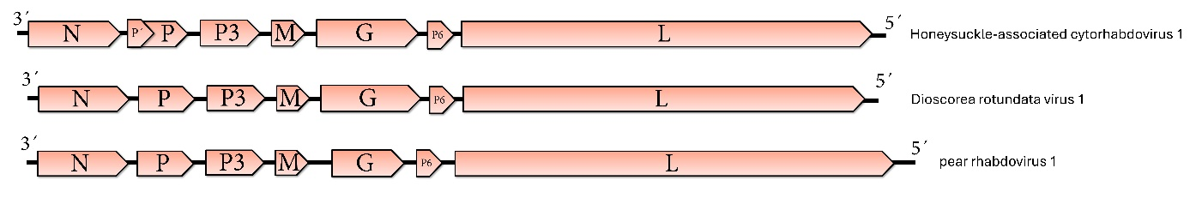

Figure 1. Genome graphs depicting the architecture and gene products of viruses proposed to be included in species within the genera Alphacytorhabdovirus and Betacytorhabdovirus. Abbreviations: N: nucleoprotein; P: P overlapping protein; P: phosphoprotein; P3: putative cell-to-cell movement protein; M: matrix protein; G: glycoprotein; P6: protein 6; L: RNA-dependent RNA polymerase.
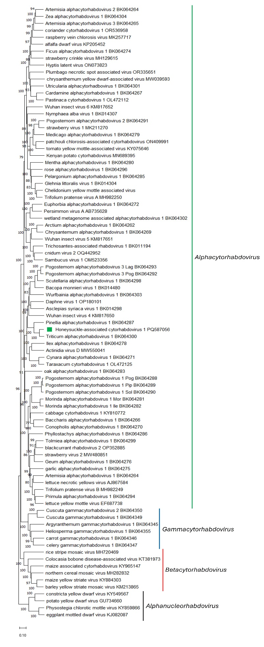
Figure 2. Maximum Likelihood (ML) phylogenetic tree of plant-infecting rhabdovirus L polymerase protein sequences. Amino acid sequences were aligned using MUSCLE. The resulting alignment was used to generate a phylogenetic tree using Mega11 with the best-fit model LG + G + I +F. The virus potentially belonging to the new species are indicated with green square. Numbers at the nodes indicate bootstrap support (1000 replicates).
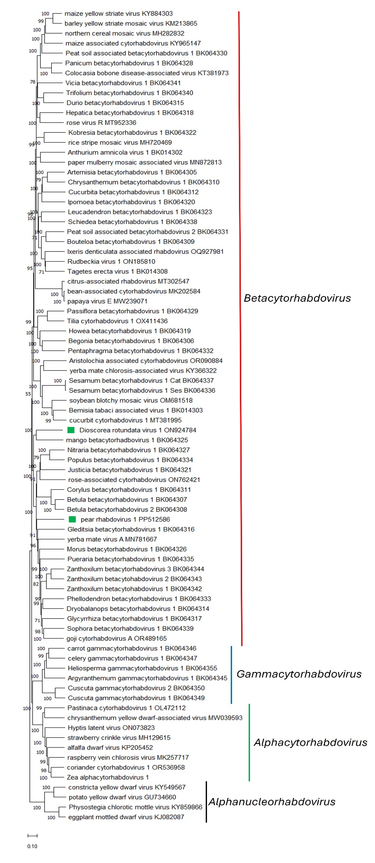
Figure 3 Maximum Likelihood (ML) phylogenetic tree of plant-infecting rhabdovirus L polymerase protein sequences. Amino acid sequences were aligned using MUSCLE. The resulting alignment was used to generate a phylogenetic tree using Mega11 with the best-fit model LG + G + I +F. Two viruses potentially belonging to the new species are indicated with green squares. Numbers at the nodes indicate bootstrap support (1000 replicates).

