

The International Committee on Taxonomy of Viruses
Taxonomy Proposal Form, 2025

Part 1a: Details of taxonomy proposals

Title: | Create one new species in the genus Trirhavirus, subfamily Betarhabdovirinae (Mononegavirales: Rhabdoviridae)
Code assigned: | 2025.023P.Ac.v3.Rhabdoviridae_Trirhavirus_1nsp

Author(s), affiliation and email address(es):
Given name (+middle initial(s)) | Surname | Affiliation | Email address | Corr. author(s)
Nicolas | Bejerman | UFyMA INTA-CONICET, Argentina | bejerman.nicolas@inta.gob.ar | X
Humberto | Debat | UFyMA INTA-CONICET, Argentina | debat.humberto@inta.gob.ar
Ralf G | Dietzgen | QAAFI, UQ, Australia | r.dietzgen@hotmail.com
Juliana | Freitas- Astúa | EMBRAPA Mandioca e Fruticultura, Brazil | juliana.astua@embrapa.br
Hideki | Kondo | Okayama University, Japan | hkondo@rib.okayama-u.ac.jp
Pedro Luis | Ramos- González | Instituto Biológico de São Paulo, Brazil | plrg1970@gmail.com
Anna E | Whitfield | NC State University, USA | awhitfi@ncsu.edu
Peter J | Walker | UQ, Australia | peter.walker@uq.edu.au

Part 1b: Taxonomy Proposal Submission
ICTV Subcommittee:
Animal DNA Viruses and Retroviruses |  | Bacterial viruses
Animal minus-strand and dsRNA viruses |  | Fungal and protist viruses
Animal positive-strand RNA viruses |  | Plant viruses | X
Archaeal viruses |  | General

List the ICTV Study Group(s) that have seen or have been involved in creating this proposal:
Rhabdoviridae study group

Optional – complete only if formally voted on by an ICTV Study Group:
Study Group | Number of members
Study Group | Votes in support | Votes against | No vote
Rhabdoviridae | 11 | 0 | 3

Submission date: | 21/05/2025

Part 1c: Feedback from ICTV Executive Committee (EC) meeting
Executive Committee Meeting Decision code: | X
A – Accept
Ac – Accept subject to revision by relevant subcommittee chair. No further vote required | X
U – Accept without revision but with re-evaluation and email vote by the EC
Uc – Accept subject to revision and re-evaluation and email vote by the EC
Ud – Deferred to the next EC meeting, with an invitation to revise based on EC comments
J - Reject
W - Withdrawn

Comments from the Executive Committee:
The EC voted Ac for this proposal (see the table above for explanation), to allow very minor revisions mainly concerning style issues.
It is suggested to remove the header “novel species” since it is confusing because the following paragraphs start with the virus name.

Part 1d: Revised Taxonomy Proposal Submission
Response of proposer:
All proposed changes were accepted, including the removal of the header “novel species”

Revision date: | 19/08/2025

Part 3: TAXONOMIC PROPOSAL

Taxonomic changes proposed:
Establish new taxon | X | Split taxon
Abolish taxon |  | Merge taxon
Move taxon |  | Promote taxon
Rename taxon |  | Demote taxon
Move and rename

Etymology (origin) of proposed taxonomic names:
Taxon name | Etymology of the term
“Trirhavirus rubi” | The species epithet is derived from Rubus, the scientific name of the plant host genera from which the sequence of the virus was obtained.

Permission for use of names derived from a living person:
Taxon name | Full name of person from whom the name is derived | Attached

Abstract of Taxonomy Proposal:
Taxonomic rank(s) affected:
Genus Trirhavirus, subfamily Betarhabdovirinae, family Rhabdoviridae

Description of current taxonomy:
Five virus species are currently classified in the recently created genus Trirhavirus, whose main feature is the tri-segmented genomic organization of their members. The assignment of viruses to this genus is based on their genome composition, and the placement of the viruses on Maximum Likelihood trees inferred from complete L protein sequences.

Proposed taxonomic change(s):
Create one new species in the genus Trirhavirus, subfamily Betarhabdovirinae, family Rhabdoviridae. This species is proposed to be named “Trirhavirus rubi”.

Justification:
A novel tri-segmented rhabdovirus was identified in Rubus [1]. The characterization of the genome sequence showed that it should be assigned to a novel species within the genus Trirhavirus [1] based on the nucleotide sequence divergence from previously reported trirhaviruses and phylogenetic placement.

Text of Taxonomy proposal:
Taxonomic rank(s) affected:
Genus Trirhavirus, subfamily Betarhabdovirinae, family Rhabdoviridae

Description of current taxonomy:
Five virus species are currently classified in the recently created genus Trirhavirus, whose unique feature is the tri-segmented genomic organization of their members. The assignment of viruses to this genus is based on their genome composition, and the placement of the viruses on Maximum Likelihood trees inferred from complete L protein sequences.

Proposed taxonomic change(s):
Create one new species in the genus Trirhavirus, subfamily Betarhabdovirinae, family Rhabdoviridae.

Demarcation criteria:
We propose that viruses assigned to different species within the genus Trirhavirus, should have several of the following characteristics:
- nucleotide sequence identity lower than 80% for the L ORF
- nucleotide sequence identity lower than 80% in RNA2
- nucleotide sequence identity lower than 80% in RNA 3
- occupy different ecological niches as evidenced by differences in hosts

Justification:
A novel tri-segmented rhabdovirus was identified in Rubus [1]. The characterization of this virus showed that it should be assigned to a novel species within the genus Trirhavirus [1] based on the nucleotide sequence divergence from previously reported trirhaviruses and phylogenetic placement (see below).

- Rubus trirhavirus 1(RTV1) was identified from Rubus samples collected in South Carolina, USA. RTV1 genome is tri-segmented with a coding-complete genome (CCG) RNA1 of 6,557 nucleotides (nt), RNA2 of 4,040 nt and RNA3 of 4,191 nt (PQ317245, PQ317246 and PQ317247, respectively) [1]. RNA1 contains one large open reading frame (ORF) encoding the L polymerase protein while RNA2 and RNA 3 contain four ORFs (Figure 1). The nt and amino acid (aa) sequences of RTV1 L gene have the highest identity values with that of Picris trirhavirus 1 (PiTRV1, 64% and 65%, respectively); while the RTV1 RNA2 and RNA3 have the highest nt identities values with that of PiTRV1 with 57% and 51%, respectively [1]. Based on ML trees generated from complete L protein sequences, RTV1 is placed within a subclade of trirhaviruses with PiTRV1 and Erysimum trirhavirus 1 (Figure 2).

RTV1 meets the demarcation criteria A, B, C and D. Thus, we propose to classify RTV1 as the new species “Trirhavirus rubi” subfamily Betarhabdovirinae, family Rhabdoviridae.
References:
[1] Schnabel E, Diniz Xavier C, Whitfield A, Dubrow Z, Pham G, Cieniewicz E (2025). Exploring the virome of blackberry and wild Rubus spp. in South Carolina. Phytobiomes. doi: https://doi.org/10.1094/PBIOMES-11-24-0106-R.

Accompanying files:
Filename | Description of contents
2025.023P.A.v1.Rhabdoviridae_Trirhavirus_1nsp | Excel sheet

Tables, Figures:
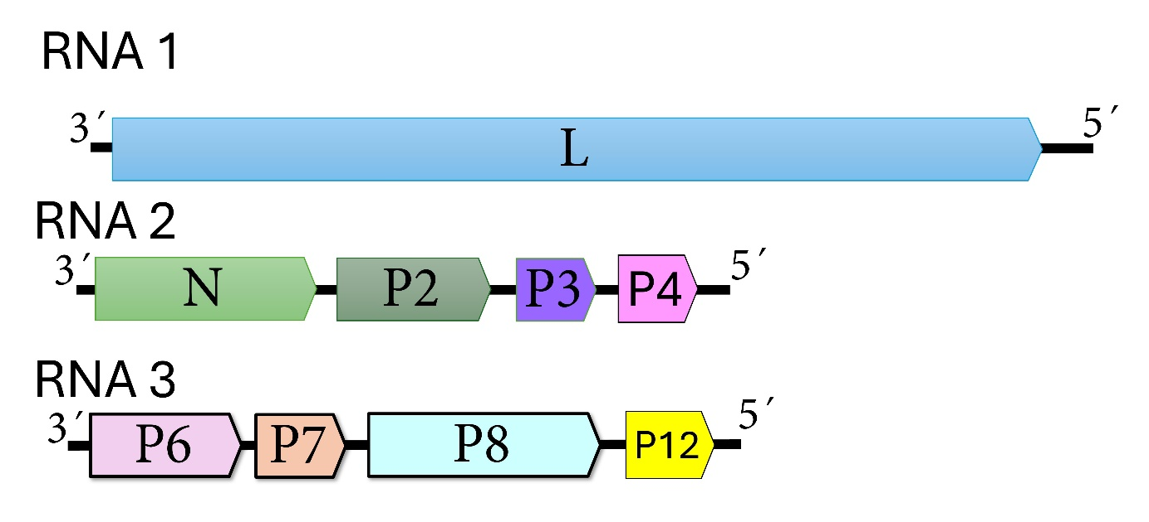Figure 1. Genome graphs depicting the architecture and gene products of the proposed virus (Rubus trirhavirus 1) to be included in the species within the genus Trirhavirus. Abbreviations: N: nucleoprotein; L: RNA-dependent RNA polymerase; P2: protein 2; P3: protein 3; P4: protein 4; P6: protein 6; P7: protein 7; P8: protein 8; P12: protein 12.

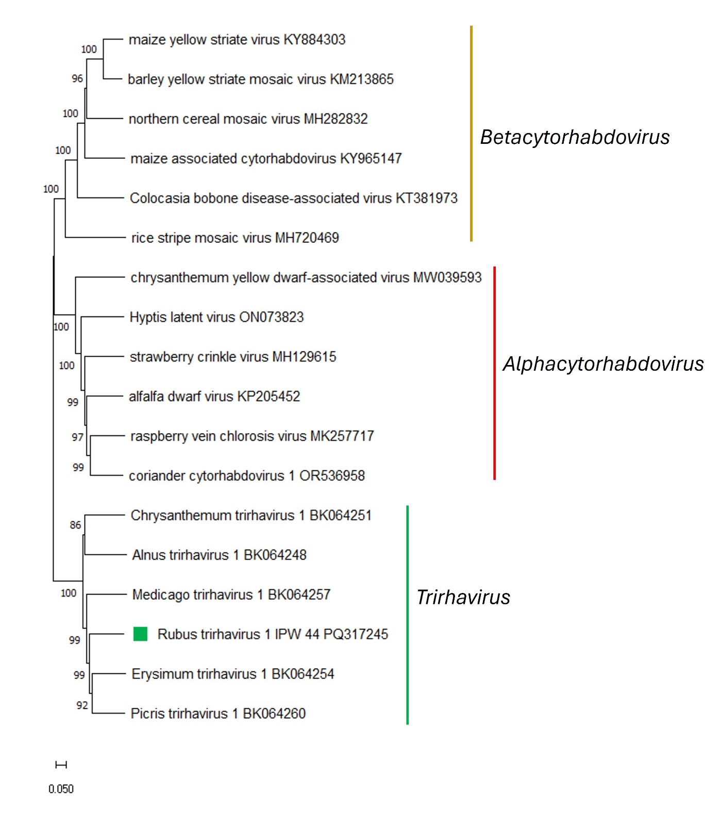

Figure 2. Maximum Likelihood (ML) phylogenetic tree of plant-infecting rhabdovirus L polymerase protein sequences. Amino acid sequences were aligned using MUSCLE. The resulting alignment was used to generate a phylogenetic tree using Mega11 with the best-fit model LG + G + I +F. The virus (Rubus trirhavirus 1), potentially belonging to a new species is indicated with a green square. Numbers at the nodes indicate bootstrap support (1000 replicates).

