

The International Committee on Taxonomy of Viruses
Taxonomy Proposal Form, 2025

Part 1a: Details of taxonomy proposals

Title: | Create ten species in the genus Enamovirus (Sobelivirales:Solemoviridae)
Code assigned: | 2025.020P.Solemoviridae_Enamovirus_10nsp

Author(s), affiliation and email address(es):
Given name (+middle initial(s)) | Surname | Affiliation | Email address | Corr. author(s)
Denis | Fargette | Virus South Data, 16 rue Artaud, Lyon, France | denis.fargette@ird.fr
Fiona | Filardo | Queensland Department of Primary Industries, Brisbane, Australia | fiona.filardo@dpi.qld.gov.au
Mahan | Ghafari | Department of Biology,  University of Oxford, Oxford, UK | mahan.ghafari@ndm.ox.ac.uk
Eugenie | Hebrard | IRD, Institute Agro, Montpellier, France | eugenie.hebrard@ird.fr
Cecilia | Sarmiento | Department of Chemistry and  Biotechnology, TalTech, Tallinn, Estonia | cecilia.sarmiento@taltech.ee
Merike | Sõmera | Department of Chemistry and  Biotechnology, TalTech, Tallinn, Estonia | merike.somera@taltech.ee | X
John | Thomas | The University of Queensland, Brisbane, Australia | j.thomas2@uq.edu.au

Part 1b: Taxonomy Proposal Submission
ICTV Subcommittee:
Animal DNA Viruses and Retroviruses |  | Bacterial viruses
Animal minus-strand and dsRNA viruses |  | Fungal and protist viruses
Animal positive-strand RNA viruses |  | Plant viruses | X
Archaeal viruses |  | General

List the ICTV Study Group(s) that have seen or have been involved in creating this proposal:
Solemoviridae SG

Submission date: | 16/06/2025

Part 1c: Feedback from ICTV Executive Committee (EC) meeting
Executive Committee Meeting Decision code: | X
A – Accept
Ac – Accept subject to revision by relevant subcommittee chair. No further vote required
U – Accept without revision but with re-evaluation and email vote by the EC
Uc – Accept subject to revision and re-evaluation and email vote by the EC | X
Ud – Deferred to the next EC meeting, with an invitation to revise based on EC comments
J - Reject
W - Withdrawn

Comments from the Executive Committee:
The EC voted Uc for this proposal (see the table above for explanation). Before the proposal can be accepted, the following points should be addressed:
- A new tree should be prepared, to be clearer by including enamoviruses only.
- The references should be updated to include the missing citations (highlighted in yellow in the figure legend). Citations should be replaced by numbers in the legend.
- Please remove the yellow box at the end of the document.

Additional comments are reported in the text. Minor revisions mainly concerning style issues have been included.

Part 1d: Revised Taxonomy Proposal Submission
Response of proposer:
A new tree including only the proposed new and previously accepted enamoviruses has been added (Fig. 2). The version of the phylogenetic tree including also known and tentative polerovirus species (Fig. 1) has been retained as well although the figure was edited for clarity. The reasoning behind this decision is that polerovirus/enamovirus combined tree is essential in showing the taxonomic complexities of these closely related genera. This tree indicates why we cannot propose the membership of Enamovirus genus for Brunioides conebush enamovirus and sea-buckthorn enamo-like virus.
The references for MEGA12 and LG model have been added. Yellow ink box has been removed, and the style issues have been addressed.

Revision date: | 28.10.2025

Part 3: TAXONOMIC PROPOSAL

Taxonomic changes proposed:
Establish new taxon | X | Split taxon
Abolish taxon |  | Merge taxon
Move taxon |  | Promote taxon
Rename taxon |  | Demote taxon
Move and rename

Etymology (origin) of proposed taxonomic names:
Taxon name | Etymology of the term
“Enamovirus BUBEV” | Epithet from the virus name acronym
“Enamovirus CAEV” | Epithet from the virus name acronym
“Enamovirus CSEV” | Epithet from the virus name acronym
“Enamovirus CTEV” | Epithet from the virus name acronym
“Enamovirus DEGEV” | Epithet from the virus name acronym
“Enamovirus FTEV” | Epithet from the virus name acronym
“Enamovirus ORAEV” | Epithet from the virus name acronym
“Enamovirus RAEV” | Epithet from the virus name acronym
“Enamovirus WSEV” | Epithet from the virus name acronym
“Enamovirus YPEV” | Epithet from the virus name acronym

Abstract of Taxonomy Proposal:
Taxonomic rank(s) affected:
Genus Enamovirus in the family Solemoviridae

Description of current taxonomy:
Sobelivirales:Solemoviridae:Enamovirus
Currently, the genus Enamovirus consists of 15 species.

Proposed taxonomic change(s):
Create ten new species in the genus Enamovirus

Justification:
High-throughput sequencing (HTS) of raspberry samples collected in 2021 from Czechia and Norway has revealed 14 isolates of a novel Enamovirus candidate, raspberry enamovirus 1 (RaEV1). Carrot enamovirus 1 (CaEV1) was discovered in wild carrot populations in Southwestern France. In addition, the analyses of publicly available plant transcriptome data have enabled the assembly of 16 additional full or partial genome sequences characteristic of enamoviruses: Brunioides conebush enamovirus, Bunge’s buttercup enamovirus, cassava enamovirus, common thyme enamovirus, Coriandrum sativum enamovirus, decurrent goldenrod enamovirus, Fukien tea tree enamovirus, oriental arborvitae enamovirus, rubber tree enamovirus, Rugel’s plantain enamovirus, sea-buckthorn enamo-like virus, showy sunflower enamovirus, silver birch enamovirus, spruce enamovirus, Western salsify enamovirus, and Yunnan pine enamovirus. Eight of these 16 candidates have genome sequences covering all coding regions, while they also cluster with accepted members in the phylogenetic RdRP tree. In total, ten out of 18 candidate species are proposed as the new members of genus Enamovirus, fulfilling the species demarcation criteria and having complete or coding-complete genomes sequences.

Text of Taxonomy proposal:
Taxonomic rank(s) affected:
Genus Enamovirus in the family Solemoviridae
Description of current taxonomy:
Sobelivirales:Solemoviridae:Enamovirus
Currently, the genus Enamovirus consists of 15 species.

Proposed taxonomic change(s):
Create ten new species in the genus Enamovirus

Demarcation criteria:
The following species demarcation criteria for the genus Enamovirus were set in 2023 (accepted in 2024 by the ICTV):
• Differences in breadth and specificity of host range;
• Failure of cross-protection in either one-way or two-way relationships;
• Differences in serological specificity with discriminatory polyclonal or monoclonal antibodies;
• Differences in amino acid sequence identity of RdRPs >10%;
• Differences in nucleotide sequence identity of genomes around or >25%.

Justification:
Enamovirus genomes have five common major open reading frames (ORFs) designated as ORF0, 1, 2, 3, and 5. ORF0 encodes a viral RNA silencing suppressor protein (P0), ORF1 encodes the P1 protein, ORF2 encodes a viral RNA-directed RNA polymerase (RdRP; P2) which is involved in replication, ORF3 encodes the major coat protein (CP; P3), and ORF5 encodes an aphid-transmission factor (P5). The RdRP is synthesized by translational fusion with P1 (P1-P2) via a -1 ribosomal frameshift in ORF1. The P5 is expressed as a readthrough protein with P3 (P3-P5).

High-throughput sequencing (HTS) of raspberry (Rubus idaeus) samples collected in 2021 from Czechia and Norway has revealed 14 isolates of a novel Enamovirus candidate, raspberry enamovirus 1 (RaEV1) [1]. The RNA-Seq data was deposited in the NCBI SRA under BioProjectID PRJNA1028176. The genome sequence of the RaEV1 GR isolate (GenBank Acc. No. OR683427) was confirmed through Sanger sequencing and RACE procedures. The complete genome spans 5824 nucleotides. Five putative open reading frames (ORF0, ORF1, ORF2, ORF3, and ORF5) characteristic of enamoviruses were predicted. The pairwise comparisons of translated polymerase (RdRP) and coat protein (CP) observed the highest identity with the respective proteins encoded by Celmisia lyallii enamovirus RdRP (43%) and red clover enamovirus CP (33%), respectively (Table 1). The recognition of RaEV1 as the member of the new species “Enamovirus RAEV” is consistent with the species demarcation criteria in the genus Enamovirus.

Carrot enamovirus 1 (CaEV1) was identified in wild carrot populations in the Southwest of France in 2019 [2]. A nearly complete genome of CaEV1 was sequenced (OP886449). The genome organization of CaEV1 is typical for the genus, with five predicted ORFs. The sequence is most closely related to a partial sequence of arracacha latent virus E (MF136435; Fig 4) with 57% aa identity and 56% nt identity in the full RdRP and the nearly full-length genome, respectively (Table 1). The recognition of CaEV1 as the member of the new species “Enamovirus CAEV” is consistent with the species demarcation criteria in the genus Enamovirus.

In addition, the analyses of publicly available plant transcriptome data enabled the assembly of 16 additional genome sequences characteristic of Enamovirus species [3, 4]. The putative novel viruses identified in those libraries were tentatively regarded as viruses of the corresponding plant species. Eight of the identified enamoviruses corresponded to complete genomes and grouped with other known enamoviruses, and thus, are proposed as members of new species:

Bunge's buttercup enamovirus (BubEV) genome (BK068694) was assembled from the transcriptome data (DDBJ/EMBL/GenBank entry SRR18512454 PRJNA820952) derived from Ranunculus bungei collected on the Qinghai-Tibet plateau, China [3]. The assembled near-complete genomic sequence spans 5261 nt. The recognition of BubEV as member of the new species “Enamovirus BUBEV” is consistent with the species demarcation criteria in the genus Enamovirus.

Common thyme enamovirus (CtEV) genome (BK068696) was assembled from the transcriptome data (DDBJ/EMBL/GenBank entry SRR6262813; PRJNA417241) derived from the plants grown from the seeds of common thyme (Thymus vulgaris) collected around Saint Martin de Londres, 25 km north of Montpellier, France [3]. The assembled near-complete genomic sequence spans 6099 nt. The recognition of CtEV as member of the species “Enamovirus CTEV” is consistent with the species demarcation criteria in genus Enamovirus.

Coriandrum sativum enamovirus (CsEV) genome was assembled from the transcriptome data (DDBJ/EMBL/GenBank entry GGPN01011425; PRJNA472685) derived from coriander seeds grown in Rajasthan, India [4]. The assembled near-complete 5415-nt CsEV genome (BK063225) contained five ORFs characteristic of enamoviruses, encoding proteins P0, P1, P2, P3 and P5. Phylogenetic relationship of CsEV with other enamoviruses was confirmed based on viral coat protein (P3) amino acid sequence. The recognition of CsEV as member of the new species “Enamovirus CSEV” is consistent with the species demarcation criteria in genus Enamovirus.

Decurrent goldenrod enamovirus (DegEV) genome (BK068695) was assembled from the transcriptome data (DDBJ/EMBL/GenBank entry SRR5943633; PRJNA397809) derived from the plants sown from the seeds of decurrent goldenrod (Solidago canadensis) collected from a suburb of Wuhan city, China [3]. The assembled near-complete genomic sequence spans 5521 nt. The recognition of DegEV as member of the new species “Enamovirus DEGEV” is consistent with the species demarcation criteria in genus Enamovirus.

Fukien tea tree enamovirus (FtEV) genome (BK068686) was assembled from the transcriptome data (DDBJ/EMBL/GenBank entry SRR7076638; PRJNA454043) derived from the root sample of Fukien tea tree (Ehretia microphylla) collected in Nanjing, China [3]. The assembled near-complete genomic sequence spans 5992 nt. The recognition of FtEV as member of the new species “Enamovirus FTEV” is consistent with the species demarcation criteria in genus Enamovirus.

Oriental arborvitae enamovirus (OraEV) genome (BK068685) was assembled from the transcriptome data (DDBJ/EMBL/GenBank entry SRR5892426; PRJNA396655) derived from Chinese arborvitae (Platycladus orientalis) grown in the coniferous plant resource nursery at the Institute of Forestry and Pomology, Beijing, China [3]. The assembled near-complete genomic sequence spans 5768 nt. The recognition of OraEV as member of the new species “Enamovirus ORAEV” is consistent with the species demarcation criteria in genus Enamovirus.

Western salsify enamovirus (WsEV) genome (BK068692) was assembled from the transcriptome data (DDBJ/EMBL/GenBank entry SRR11802599; PRJNA633300) derived from yellow salsify (Tragopogon dubius) plants grown from field-collected seeds obtained at Moscow, Idaho, United States [3]. The assembled near-complete genomic sequence spans 5577 nt. The recognition of WsEV as member of the new species“Enamovirus WSEV” is consistent with the species demarcation criteria in genus Enamovirus.

Yunnan pine enamovirus (YpEV) genome (BK068688) was assembled from the transcriptome data (DDBJ/EMBL/GenBank entry SRR9179537; PRJNA545862) derived from Pinus yunnanensis collected at Kunming, Yunnan, China [3]. The assembled near-complete genomic sequence spans 6221 nt. The recognition of YpEV as member of the new species “Enamovirus YPEV” is consistent with the species demarcation criteria in genus Enamovirus.

Phylogenetic analysis of the putative enamovirus RdRP sequences supports the clustering of the ten mentioned new viruses within the genus Enamovirus (Fig. 1-2).

Related species that remain unclassified according to the current ICTV rules: cassava enamovirus (CasEV; BK068699), rubber tree enamovirus (RtEV; BK068700), Rugel's plantain enamovirus (RpEV; BK068703), showy sunflower enamovirus (SsEV; BK069701), silver birch enamovirus (SbEV; BK068698) and spruce enamovirus (SprEV; BK068704). Their genome sequences are partial, missing part of their 3' ends (CasEV, RtEV, RpEV, SsEV, SbEV, SprEV). Two viruses with genomic sequences covering the coding regions cannot yet be proposed, as Brunoides conebush enamovirus (BrcEV; BK068691) forms a separate and very distant subclade both from enamo- and poleroviruses, and sea buckthorn enamo-like virus (SebEV; BK068687) RdRP clusters within polerovirus RdRPs while it shares the genome organization characteristic of enamoviruses [3].

References:
[1] Koloniuk I, Fránová J, Přibylová J, Sarkisova T, Špak J, Tan JL, Zemek R, Čmejla R, Rejlová M, Valentová L, Sedlák J, Holub J, Skalík J, Blystad DR, Sapkota B, Hamborg Z. Molecular Characterization of a novel enamovirus infecting raspberry. Viruses. 2023 Nov 21;15(12):2281. doi: 10.3390/v15122281.
[2] Schönegger D, Marais A, Babalola BM, Faure C, Lefebvre M, Svanella-Dumas L, Brázdová S, Candresse T. Carrot populations in France and Spain host a complex virome rich in previously uncharacterized viruses. PLoS One. 2023 Aug 16;18(8):e0290108. doi: 0.1371/journal.pone.0290108.
[3] Sidharthan VK, Reddy VP, Krishnan N, Parameswari B. Unveiling the genetic diversity of the genera Enamovirus and Polerovirus through data-driven virus discovery. Arch Virol. 2025 Mar 13;170(4):76. doi: 10.1007/s00705-025-06258-w.
[4] Kavi Sidharthan V, Diksha D, Singh R, Choudhary S, Naika MBN, Baranwal VK. Identification of two putative novel deltapartitiviruses and an enamovirus in coriander transcriptomes. Arch Microbiol. 2023 Sep 27;205(10):342. doi: 10.1007/s00203-023-03681-y.
[5] Le SQ and Gascuel O. An Improved General Amino Acid Replacement Matrix. Mol Biol Evol 2008, 25(7):1307-1320. doi:10.1093/molbev/msn067.
[6] Kumar S, Stecher G, Suleski M, Sanderford M, Sharma S, and Tamura K. Molecular Evolutionary Genetics Analysis Version 12 for adaptive and green computing. Molecular Biology and Evolution 2024, 41:1-9. doi: 10.1093/molbev/msae263.

Accompanying files:
Filename | Description of contents
2025.020P.Uc.v1.Solemoviridae_Enamovirus_10nsp.xlsx | Excel module

Tables, Figures: Table 1; Table 2; Fig. 1 ; Fig.2.

Table 1. Percent identities between the nucleotide sequences of putative new and recognized enamovirus genomes retrieved from NCBI GenBank*. Multiple sequence alignment was performed using the MUSCLE algorithm implemented in Geneious Prime ver. 2025.1.2.
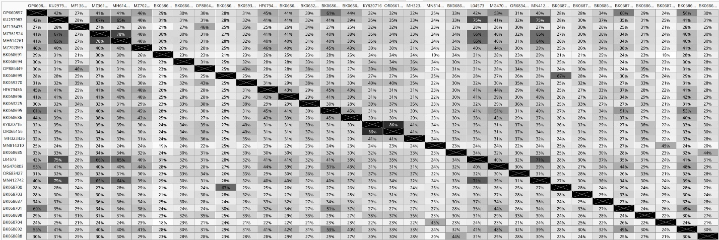
* OP660857 - Ageratum virus 2; KU297983 - Alfalfa enamovirus 1; MF136435 - arracacha latent virus E; MZ361924 - bean enamovirus 1; MH614261 - bird's-foot trefoil enamovirus 1; MZ702869 - black pepper virus E; BK068691 - Brunioides conebush enamovirus; BK068694 – Bunge's buttercup enamovirus; OP886449 – carrot enamovirus 1; BK068699 - cassava enamovirus; BK059370 - Celmisia lyallii enamovirus, HF679486 - Citrus vein enation virus; BK068696 - common thyme enamovirus; BK063225 - Coriandrum sativum enamovirus; BK068695 - decurrent goldenrod enamovirus; BK068686 - Fukien tea tree enamovirus; KY820716 - grapevine enamovirus 1; MH323436 - green Sichuan pepper enamovirus; MN814310 - Kummerowia striata enamovirus; BK068685 - oriental arborvitae enamovirus; L04573 - pea enation mosaic virus 1; MG470803 - pepper enamovirus; OR683427 - raspberry enamovirus 1; MN412742 - red clover enamovirus 1; BK068700 - rubber tree enamovirus; BK068703 - Rugel's plantain enamovirus; BK068687 - sea buckthorn enamo-like virus; BK068701 - showy sunflower enamovirus; BK068698 - silver birch enamovirus; BK068704 - spruce enamovirus; BK068692 - western salsify enamovirus; BK068688 - Yunnan pine enamovirus.

Table 2. Percent identities between amino acid sequences of recognized and putative new enamovirus RdRPs translated from ORF2 of exemplar isolate sequences (indicated in Table 1), starting at the ribosomal frameshift signal. Multiple sequence alignment was performed using the MUSCLE algorithm implemented in Geneious Prime ver. 2025.1.2.
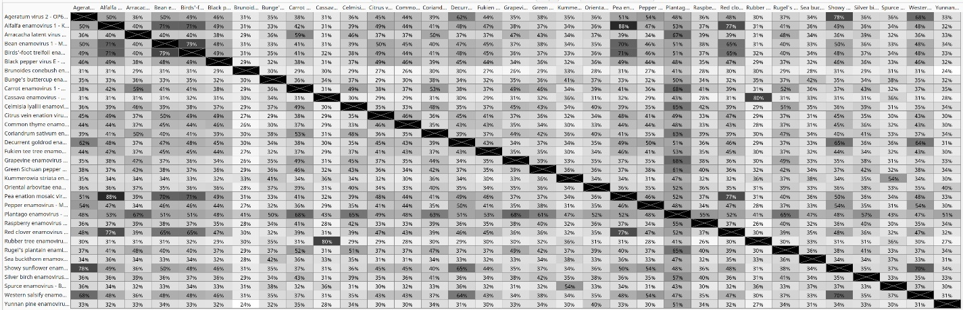

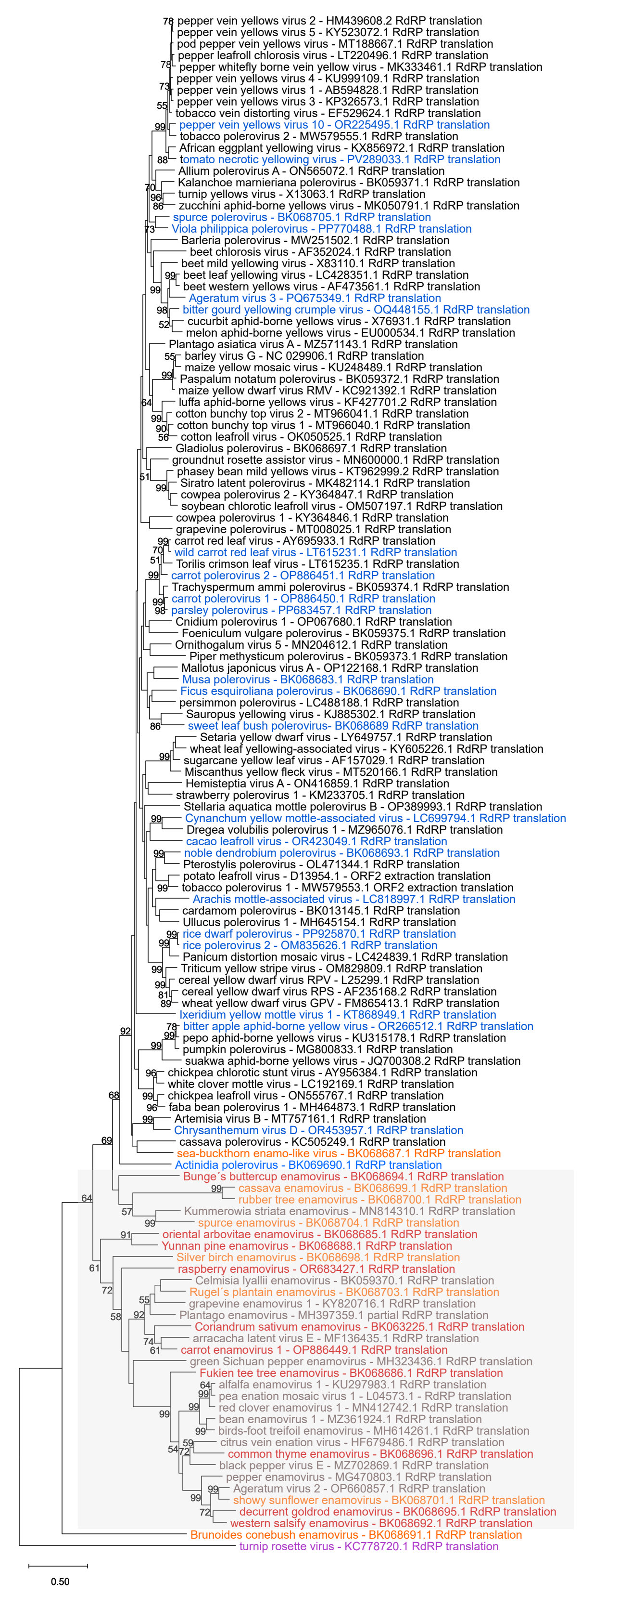

Fig. 1. Phylogenetic analysis of RdRP amino acid sequences of poleroviruses and enamoviruses by the Maximum Likelihood method. RdRP of turnip rosette virus (TRoV, sobemovirus) was used as an outgroup. Putative new polerovirus sequences were marked in blue font, proposed new enamoviruses were marked in red font, and putative related unclassified enamoviruses were marked in orange font. TRoV was marked in violet font. RdRPs grouping within the enamovirus sequences were marked by grey rectangle.
The phylogeny was inferred using the Maximum Likelihood method and Le-Gascuel (LG) model (+Freq) of amino acid substitutions[5]. The tree with the highest log likelihood (-71 207,36) is shown. The percentage of replicate trees in which the associated taxa clustered together, where the number of replicates (127) was determined adaptively, is shown. The initial tree for the heuristic search was selected by choosing the tree with the superior log-likelihood between a Neighbor-Joining (NJ) tree and a Maximum Parsimony (MP) tree. The NJ tree was generated using a matrix of pairwise distances computed using the LG model (+Freq). The MP tree had the shortest length among 10 MP tree searches, each performed with a randomly generated starting tree. The evolutionary rate differences among sites were modeled using a discrete Gamma distribution across 5 categories (+G, parameter = 0,4380), with 6,50% of sites deemed evolutionarily invariant (+I). The analytical procedure encompassed 130 amino acid sequences with 923 positions in the final dataset. Evolutionary analyses were conducted in MEGA12 [6].

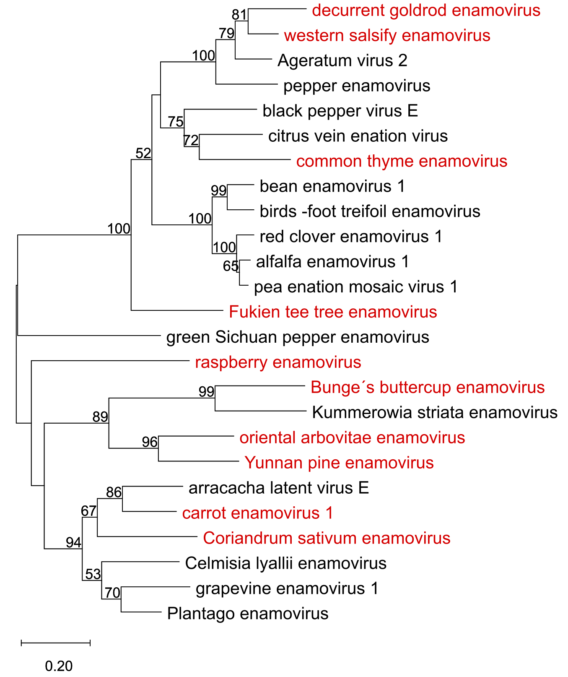

Fig. 2. Evolutionary analysis of RdRP aa sequences of enamoviruses belonging to previously accepted species (black font) and the proposed species of enamoviruses (red font) by the Maximum Likelihood method. The ORF2-encoded enamoviral RdRP sequences were translated by starting from a ribosomal frameshift site using the following genomic sequences: OP660857 - Ageratum virus 2; KU297983 - alfalfa enamovirus 1; MF136435 - arracacha latent virus E; MZ361924 - bean enamovirus 1; MH614261 - bird's-foot trefoil enamovirus 1; MZ702869 - black pepper virus E; BK068694 - Bunge's buttercup enamovirus; OP886449 – carrot enamovirus 1; BK059370 - Celmisia lyallii enamovirus, HF679486 - citrus vein enation virus; BK068696 - common thyme enamovirus; BK063225 - Coriandrum sativum enamovirus; BK068695 - decurrent goldenrod enamovirus; BK068686 - Fukien tea tree enamovirus; KY820716 - grapevine enamovirus 1; MH323436 - green Sichuan pepper enamovirus; MH397359 – Plantago enamovirus; MN814310 - Kummerowia striata enamovirus; BK068685 - oriental arborvitae enamovirus; L04573 - pea enation mosaic virus 1; MG470803 - pepper enamovirus; OR683427 - raspberry enamovirus 1; MN412742 - red clover enamovirus 1; BK068692 - western salsify enamovirus; BK068688 - Yunnan pine enamovirus.
The phylogeny was inferred using the Maximum Likelihood method and LG model (+Freq) [1] of amino acid substitutions and the tree with the highest log likelihood (-19 436,99) is shown. The percentage of replicate trees in which the associated taxa clustered together (500 replicates) is shown above the branches. The initial tree for the heuristic search was selected by choosing the tree with the superior log-likelihood between a Neighbor-Joining (NJ) tree and a Maximum Parsimony (MP) tree. The NJ tree was generated using a matrix of pairwise distances computed using the LG model (+Freq) [5]. The MP tree had the shortest length among 10 MP tree searches, each performed with a randomly generated starting tree. The evolutionary rate differences among sites were modeled using a discrete Gamma distribution across 5 categories (+G, parameter = 0,4379), with 12,22% of sites deemed evolutionarily invariant (+I). The analytical procedure encompassed 25 amino acid sequences with 790 positions in the final dataset. Evolutionary analyses were conducted in MEGA12 [6].

