

The International Committee on Taxonomy of Viruses
Taxonomy Proposal Form, 2025

Part 1a: Details of taxonomy proposals

Title: | Create two (2) new genera and 8 new species in the family Alphasatellitidae
Code assigned: | 2025.013P.Ac.v3.Alphasatellitidae_2ng_8nsp

Author(s), affiliation and email address(es):
Given name (+middle initial(s)) | Surname | Affiliation | Email address | Corr. author(s)
F Murilo | Zerbini | Dep. de Fitopatologia/BIOAGRO, Universidade Federal de Viçosa, Viçosa, Brazil | zerbini@ufv.br | X
José T | Ascencio- Ibáñez | North Carolina State University, Raleigh, USA | jtascenc@ncsu.edu
Cica | Urbino | CIRAD, UMR PHIM, Montpellier, France | cica.urbino@cirad.fr
Jean-Michel | Lett | CIRAD, UMR PVBMT, Saint Pierre de la Réunion, France | lett@cirad.fr
Jesús | Navas-Castillo | Instituto de Hortofruticultura Subtropical y Mediterránea “La Mayora” (IHSM-UMA-CSIC), Málaga, Spain | jnavas@eelm.csic.es
Paola | López-Lambertini | INTA-CIAP-IPAVE, Universidad Nacional de Córdoba, Córdoba, Argentina | plopezlambertini@gmail.com
Darren P | Martin | Institute of Infectious Disease and Molecular Medicine, University of Cape Town, Cape Town, South Africa | darrenpatrickmartin@gmail.com
Simone G | Ribeiro | Embrapa Recursos Genéticos e Biotecnologia, Brasília, Brazil | simone.ribeiro@embrapa.br
Philippe | Roumagnac | CIRAD, UMR PHIM, Montpellier, France | philippe.roumagnac@cirad.fr
Arvind | Varsani | The Biodesign Center for Fundamental and Applied Microbiomics, Center for Evolution and Medicine, School of Life Sciences, Arizona State University, Tempe, USA | Arvind.varsani@asu.edu

Part 1b: Taxonomy Proposal Submission
ICTV Subcommittee:
Animal DNA Viruses and Retroviruses |  | Bacterial viruses
Animal minus-strand and dsRNA viruses |  | Fungal and protist viruses
Animal positive-strand RNA viruses |  | Plant viruses | X
Archaeal viruses |  | General

List the ICTV Study Group(s) that have seen or have been involved in creating this proposal:
Geminiviridae and Tolecusatellitidae

Optional – complete only if formally voted on by an ICTV Study Group:
Study Group | Number of members
Study Group | Votes in support | Votes against | No vote
Geminiviridae and Tolecusatellitidae

Submission date: | 13/06/2025

Part 1c: Feedback from ICTV Executive Committee (EC) meeting
Executive Committee Meeting Decision code: | X
A – Accept
Ac – Accept subject to revision by relevant subcommittee chair. No further vote required | X
U – Accept without revision but with re-evaluation and email vote by the EC
Uc – Accept subject to revision and re-evaluation and email vote by the EC
Ud – Deferred to the next EC meeting, with an invitation to revise based on EC comments
J - Reject
W - Withdrawn

Comments from the Executive Committee:
The EC voted Ac for this proposal (see the table above for explanation), to allow very minor revisions mainly concerning style issues.

Part 1d: Revised Taxonomy Proposal Submission
Response of proposer:
All style-related suggestions were accepted.

Revision date: | 22/08/2025

Part 3: TAXONOMIC PROPOSAL

Taxonomic changes proposed:
Establish new taxon | X | Split taxon
Abolish taxon |  | Merge taxon
Move taxon |  | Promote taxon
Rename taxon |  | Demote taxon
Move and rename

Etymology (origin) of proposed taxonomic names:
Taxon name | Etymology of the term
“Banaphisatellite” | From “banana” and “aphid”, the insect vector
“Banaphisatellite alphamusae” | From the host genus name Musa with prefix
“Banaphisatellite betamusae” | From the host genus name Musa with prefix
“Banaphisatellite gammamusae” | From the host genus name Musa with prefix
“Whedwasatellite” | Contraction of “wheat” and “dwarf”
“Whedwasatellite triticiparvi” | Epithet from the host genus Triticum and the symptom
“Colecusatellite asystasiae” | From the host genus name Asystasiae
“Gosmusatellite asystasiae” | From the host genus name Asystasiae
“Gosmusatellite lactucae” | From the host genus name Lactuca
“Clecrusatellite solanumbrasiliense” | From the host and the geographic origin

Permission for use of names derived from a living person:
Taxon name | Full name of person from whom the name is derived | Attached

Abstract of Taxonomy Proposal:
Taxonomic rank affected:
Family Alphasatellitidae

Description of current taxonomy:
The family Alphasatellitidae is divided into three subfamilies: Geminialphasatellitinae, Nanoalphasatellitinae, and Petromoalphasatellitinae, consisting of 7, 6 and 5 genera, respectively.

Proposed taxonomic changes:
We propose the creation of 2 new genera (1 in subfamily Geminialphasatellitinae and 1 in subfamily Nanoalphasatellitinae) and 8 new species (4 in the 2 new genera, 4 in previously existing genera) to classify new alphasatellites that have been identified and described in the literature over the last two years.

Justification:
The exemplar members of the 3 proposed new species in the proposed new genus “Banaphisatellite” (subfamily Nanoalphasatellitinae) have <67% genome-wide pairwise sequence identity with members of currently established alphasatellite species in this subfamily. The exemplar member of the 1 proposed new species in the proposed new genus “Whedwasatellite” (subfamily Geminialphasatellitinae) has <70% genome-wide pairwise sequence identity with members of currently established alphasatellite species in this subfamily. The exemplar members of the 4 proposed new species in the genera Clecrusatellite, Colecusatellite and Gosmusatellite (subfamily Geminialphasatellitinae) have <88% genome-wide pairwise sequence identity with members of currently established alphasatellite species in this subfamily.

Text of Taxonomy proposal:
Taxonomic rank affected:
Family Alphasatellitidae

Description of current taxonomy:
The family Alphasatellitidae is divided into three subfamilies: Geminialphasatellitinae, Nanoalphasatellitinae and Petromoalphasatellitinae, with 7, 6 and 5 genera, respectively.

Proposed taxonomic changes: We propose the creation of 2 new genera (1 in subfamily Geminialphasatellitinae and 1 in subfamily Nanoalphasatellitinae) and 8 new species (4 in the 2 new genera, 4 in previously existing genera).

Demarcation criteria: Based on genome-wide pairwise sequence identity thresholds. For genera, <70% for members of the subfamily Geminialphasatellitinae, <67% for members of subfamily Nanoalphasatellitinae, and <68% for members of subfamily Petromoalphasatellitinae. For species, <88% for members of the subfamily Geminialphasatellitinae, <80% for members of subfamily Nanoalphasatellitinae, and <81% for members of subfamily Petromoalphasatellitinae [1, 2].

Justification: The 8 alphasatellites summarized in Table 1 can be classified into new species that share <88% and <80% genome-wide pairwise sequence identity with all classified alphasatellites in the subfamilies Geminialphasatellitinae and Nanoalphasatellitinae, respectively (Figure 1). Those classified into new genera share <70% and <67% identity with all classified alphasatellites in the subfamilies Geminialphasatellitinae and Nanoalphasatellitinae, respectively (Figure 1). This is supported by maximum likelihood phylogenetic analysis (Figure 2).

We provide a brief description of each proposed new taxon below:

New genus "Banaphisatellite" (subfamily Nanoalphasatellitinae) [3, 4]
New species "Banaphisatellite alphamusae" [4]
New species "Banaphisatellite betamusae" [4]
New species "Banaphisatellite gammamusae" [4]
- Banana aphids (Pentalonia nigronervosa) were collected in December 2016 on a bunchy top diseased plantain (Musa x paradisiaca genotype AAB) in the Boko village of the Congo-Central province of the Democratic Republic of Congo (DRC) and were placed on healthy seedlings of Cavendish bananas (M. acuminata genotype AAA) for disease transmission under laboratory conditions [3]. All the recipient plants developed characteristic bunchy top symptoms, and PCR analyses with nanovirus DNA-R specific primers confirmed the presence of banana bunchy top virus (BBTV).
- One of the infected plants was used as a source plant for BBTV transmission assays; a single aphid placed on a recipient plant leaf was able to transmit the virus.
- Complete viral genomes were reconstructed de novo from the infected plants and viruliferous aphids using rolling circle amplification (RCA) followed by Illumina sequencing.
- Besides BBTV, 7 of the 11 samples contained contigs representing a 1.1 kb genome of an alphasatellite.
- To validate the Illumina sequencing results, the alphasatellite genome was amplified by PCR, cloned and Sanger-sequenced; moreover, the same alphasatellite was found in a banana leaf sample collected in DRC in 2012.
- The DRC alphasatellite isolates (2012: OK546212; 2016: OK546211) share 98% identity with each other, and have the highest identities (64-68%) with isolates of faba bean necrotic yellows alphasatellite 2 (FBNYA2; AJ005966) of the subfamily Nanoalphasatellitinae; therefore, they are members of a new species in a new genus in this subfamily.
- Authors propose the names banana bunchy top alphasatellite 4 (BBTA4) for the new alphasatellite, "Banaphisatellite" for the new genus, and "Banaphisatellite musae1" for the new species (but see below for the species name).
- In a second study [4], samples from wild and cultivated Musa with bunchy top symptoms were collected in Northern Vietnam (n = 11), Laos (n = 10) and the Yunnan Province of China (n = 5) in 2018-2019.
- Total DNA was extracted and used for RCA amplification followed by Illumina sequencing.
- Twenty-eight complete alphasatellite molecules were identified from 16 samples.
- Sequence comparisons and phylogenetic analysis indicated the presence of four alphasatellites: BBTA2 and BBTA3 (which are members of previously described species in the genus Muscarsatellite of subfamily Petromoalphasatellitinae); BBTA4; and two which are related to BBTA4 but with only 65-71% identity amongst the three (Figure1); thus these two new alphasatellites (named banana bunchy top alphasatellite 5, BBTA5, and banana bunchy top alphasatellite 6, BBTA6) are members of two new species in the proposed new genus “Banaphisatellite” (Figure 2).
- The authors propose the following names for the three new species:
  - "Banaphisatellite alphamusae" (BBTA4)
  - "Banaphisatellite betamusae" (BBTA5)
  - "Banaphisatellite gammamusae" (BBTA6)

New genus "Whedwasatellite" (family Geminialphasatellitinae) [5]
New species "Whedwasatellite triticiparvi" [5]
- Barley and wheat plants were sampled in France in 2022 and subjected to high-throughput sequencing (HTS).
- A single 1217 nt contig was identified from a winter barley sample collected in Essonne (SW of Paris).
- Further analysis produced a 1424 nt circular sequence that is typical for members of the subfamily Geminialphasatellitinae (PP445014).
- Further PCR-based analysis identified the mastrevirus wheat dwarf virus (WDV) in the same sample.
- Genome has a CAGTATT//AC sequence stretch at the origin of replication, Rep ORF, and a second ORF completely embedded, in a different frame, within the Rep ORF.
- Highest nucleotide identity (66.3%) with tomato leaf curl Anand alphasatellite (MH577036) (Figure 1); since the genus demarcation threshold for the subfamily Geminialphasatellitinae is 70% [1, 2], the agent should be classified in a new genus.
- The name "Whedwasatellite" is proposed by the authors for the new genus.
- The name wheat dwarf virus-associated alphasatellite is proposed by the authors; no species name is proposed, so the study group (SG) proposes the species name "Whedwasatellite triticiparvi".

New species "Colecusatellite asystasiae" [6]
New species "Gosmusatellite asystasiae" [6]
- A comprehensive nationwide survey for alternate hosts of cassava mosaic begomoviruses (CMBs) was conducted in 2017 in cassava fields across Côte d’Ivoire.
- Samples (n = 306) were tested with CMB-specific primers, with 51% (156) testing positive.
- Direct sequencing of amplicons identified the begomoviruses African cassava mosaic virus (ACMV) and East African cassava mosaic Cameroon virus (EACMCMV).
- In addition, non-CMBs were detected with the CMB primers in 12 samples: soybean chlorotic blotch virus (SbCBV) in Centrosema pubescens, West African Asystasia virus 1 (WAAV1) and West African Asystasia virus 2 (WAAV2) in Asystasia gangetica.
- Further analysis by RCA confirmed infection of A. gangetica by WAAV1 and WAAV2 and revealed the presence of alphasatellites.
- Nine complete genomes and one partial genome of alphasatellites were sequenced and the sequences were deposited in GenBank (LC724018-22, LC724060-64) under the name Asystasia yellow mosaic alphasatellite.
- Eight sequences (LC724018-20, LC724060-64) are >98% identical to each other and have the highest identity (79%) with tomato leaf curl Cameroon alphasatellite (FN675299) and cotton leaf curl Gezira alphasatellite (EU589450) (Figure 1); therefore, they are members of a new species in the genus Colecusatellite.
- Two sequences (LC724021-22) are 98% identical to each other and have the highest identity (72%) with Vernonia yellow vein Fujian alphasatellite (KC959931) (Figure 1); therefore, they are members of a new species in the genus Gosmusatellite.
- Authors do not propose species names; the SG proposes the names "Colecusatellite asystasiae" for Asystasia yellow mosaic alphasatellite 1 (LC724062) and "Gosmusatellite asystasiae" for Asystasia yellow mosaic alphasatellite 2 (LC724021).

New species "Gosmusatellite lactucae" [7]
- Lettuce plants exhibiting leaf curl and vein enation symptoms (n = 10) were collected in a farm situated in Yuxi city of the Yunnan province, China, in April 2023.
- Total DNA was extracted from each sample and used as a template for PCR with the universal begomovirus primer pair AV494/CoPR; all symptomatic samples were positive, indicating infection by a begomovirus.
- One positive sample was randomly selected for RCA; the RCA products were digested with restriction enzymes and bands with ~2.7 and ~1.3 kbp were cloned and Sanger sequenced.
- One ~2.7 kbp clone corresponded to a begomovirus, displaying >92% identity with pepper leaf curl Yunnan virus (PepLCYnV) according to Sequence Demarcation Tool (SDT) analysis [9].
- Two ~1.3 kbp clones corresponded to alphasatellites; one satellite displayed 95% nt identity with ageratum yellow vein alphasatellite (AYVA); the other alphasatellite, YN-2023-WJ-alpha2, shared the highest nt identities (75.6%) with gossypium mustelinum symptomless alphasatellite (GMusSLA, FJ218494) and Vernonia yellow vein Fujian alphasatellite (VeYVFA, KC959931), thus representing a new species in the genus Gosmusatellite.
- The name pepper leaf curl Yunnan alphasatellite (PepLCYnA) was proposed for the new alphasatellite.
- As a species name was not proposed by the authors, the SG proposes the name "Gosmusatellite lactucae".

New species "Clecrusatellite solanumbrasiliense" [8]
- Total DNA was extracted from 64 symptomatic tomato leaf samples collected in central Brazil from 2003 to 2016 and used as a template for RCA.
- RCA products were combined in a single pool and sequenced in the HiSeq 2500 Illumina platform.
- Among the 13700+ contigs obtained, one corresponded to an alphasatellite-like genome with 1,321 nucleotides and a putative alpha-Rep ORF with 942 nt (deduced aa sequence with 313 amino acids).
- SDT analysis indicated that this alphasatellite shares 69-77% sequence identity with other members of the genus Clecrusatellite (Figure 1), thus corresponding to a new species in this genus.
- The species name "Clecrusatellite solanumbrasiliensis" was proposed by the authors, but the correct genitive form is "solanumbrasiliense".
- The new alphasatellite was found in mixed infections with five different begomoviruses; tomato golden vein virus (TGVV) was the only begomovirus detected in all six positive samples; thus, the SG proposes the name tomato golden vein alphasatellite (TGVA) for the new alphasatellite.
References:
[1] Briddon RW, Martin DP, Roumagnac P, Navas-Castillo J, Fiallo-Olive E, Moriones E, et al. Alphasatellitidae: A new family with two subfamilies for the classification of geminivirus- and nanovirus-associated alphasatellites. Arch Virol. 2018;163:2587-600.
[2] Varsani A, Martin DP, Randles JW, Vetten HJ, Thomas JE, Fiallo-Olive E, et al. Taxonomy update for the family Alphasatellitidae: New subfamily, genera, and species. Arch Virol. 2021;166:3503-11.
[3] Guyot V, Rajeswaran R, Chu HC, Karthikeyan C, Laboureau N, Galzi S, et al. A newly emerging alphasatellite affects banana bunchy top virus replication, transcription, siRNA production and transmission by aphids. PLoS Pathogens. 2022;18:e1010448.
[4] Guyot V, Trieu T-D, Insisiengmay O, Zhang T, Iskra-Caruana M-L, Pooggin MM, et al. A new genus of alphasatellites associated with banana bunchy top virus in Southeast Asia. Virus Evolution. 2023;10:vead076.
[5] Huang A, Svanella-Dumas L, Vitry C, Marais A, Faure C, Candresse T. A new geminialphasatellite associated with wheat dwarf virus identified in winter barley in France. Arch Virol. 2024;169:162.
[6] Yoboué AAN, Kouakou BSM, Pita JS, N’Zué B, Amoakon WJ-L, Kouassi KM, et al. Emergence of begomoviruses and DNA satellites associated with weeds and intercrops: A potential threat to sustainable production of cassava in Côte d’Ivoire. Frontiers in Plant Science. 2025;16:1448189.
[7] Tang Y, Du M, Li Z, Yu L, Lan G, Ding S, Farooq T, He Z, She X. Identification and genome characterization of begomovirus and satellite molecules associated with lettuce (Lactuca sativa L.) leaf curl disease. Plants 2025;14:782.
[8] Reis LNA, Boiteux LS, Fonseca MEN, Pereira-Carvalho RC. Discovery of a novel alphasatellite of the genus Clecrusatellite associated with a wide array of New World tomato-infecting begomoviruses. Arch Virol. 2025;170:108.
[9] Muhire BM, Varsani A, Martin DP. SDT: A virus classification tool based on pairwise sequence alignment and identity calculation. PLOS One 2014;9:e108277.
[10] Katoh K, Standley DM. MAFFT multiple sequence alignment software version 7: Improvements in performance and usability. Mol Biol Evol. 2013;30:772.
[11] Nguyen LT, Schmidt HA, von Haeseler A, Minh BQ. IQ-TREE: A fast and effective stochastic algorithm for estimating maximum likelihood phylogenies. Mol Biol Evol. 2015;32:268.
[12] Kalyaanamoorthy S, Minh BQ, Wong TKF, von Haeseler A, Jermiin LS. ModelFinder: Fast model selection for accurate phylogenetic estimates. Nature Methods. 2017;14:587.
[13] Hoang DT, Chernomor O, von Haeseler A, Minh BQ, Vinh LS. UFBoot2: Improving the ultrafast bootstrap approximation. Mol Biol Evol. 2018;35:518.

Accompanying files:
Filename | Description of contents
2025.013P.A.v1.Alphasatellitidae_2ng_8nsp | spreadsheet
Tables, Figures:

Table 1. Summary of the 2 new genera and 8 new species (indicated in red font) in the family Alphasatellitidae and their members.
Genus | Species name | Accession no. | Alphasatellite name | Isolate name | Country | Host/source | Ref.
“Banaphisatellite” | “Banaphisatellite alphamusae” | OK546212 | banana bunchy top alphasatellite 4 | CD:ALYU21:2012 | DRC* | Musa sp. | [3,4]
 | “Banaphisatellite betamusae” | ON960014 | banana bunchy top alphasatellite 5 | VN:ALYU25:2018 | Vietnam | Musa sp. | [4]
 | “Banaphisatellite gammamusae" | ON960025 | banana bunchy top alphasatellite 6 | VN:ALYU26:2018 | Vietnam | Musa sp. | [4]
“Whedwasatellite” | “Whedwasatellite triticiparvi” | PP445014 | wheat dwarf virus-associated alphasatellite | FR:VC95:2022 | France | barley (Hordeum vulgare) | [5]
Colecusatellite | “Colecusatellite asystasiae” | LC724062 | Asystasia yellow mosaic alphasatellite 1 | CI:Bna:CI75:2017 | Côte d’Ivoire | Asystasia gangetica | [6]
Gosmusatellite | “Gosmutatellite asystasiae” | LC724021 | Asystasia yellow mosaic alphasatellite 2 | CI:Bou:CI16-2:2017 | Côte d’Ivoire | A. gangetica | [6]
 | “Gosmusatellite lactucae” | PQ352199 | pepper leaf curl Yunnan alphasatellite | CN:YN-2023-WJ-alpha2:2023 | China | lettuce  (Lactuca sativa) | [7]
Clecrusatellite | “Clecrusatellite solanumbrasiliense” | MT214093 | tomato golden vein alphasatellite | BR:DF-62-LR-LVV-12:2003 | Brazil | tomato  (Solanum lycopersicon) | [8]
* DRC, Democratic Republic of the Congo

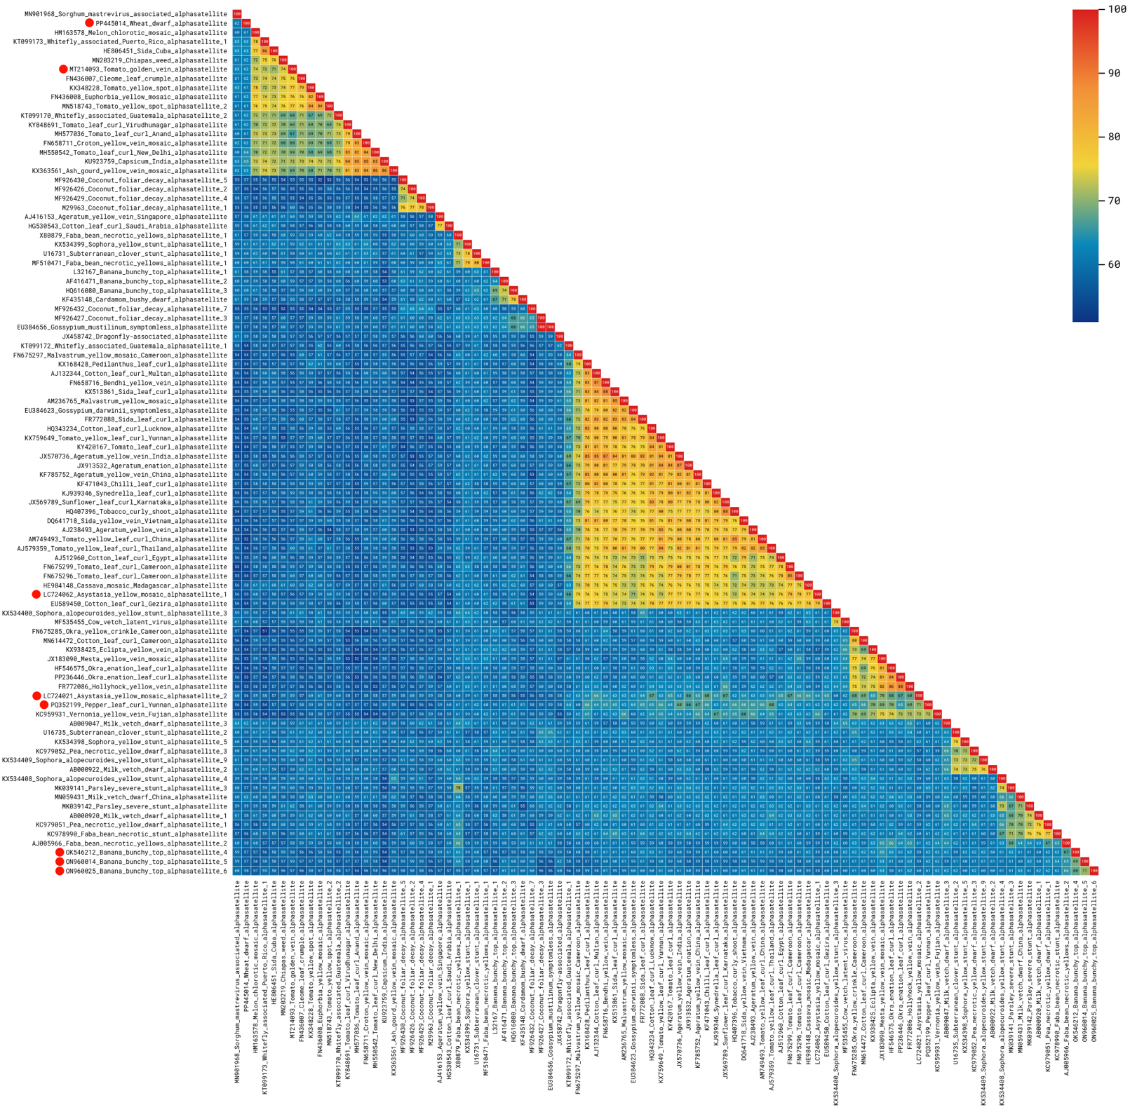

Figure 1. Pairwise nucleotide sequence identities (%) for the full-length genomes of alphasatellites, including the members of the 8 new species being proposed (indicated by the red circles). Identities were calculated with SDT [9] v. 2 (github.com/SDT-org/SDT2/releases/tag/v2.0.0.beta4.20250302.2).

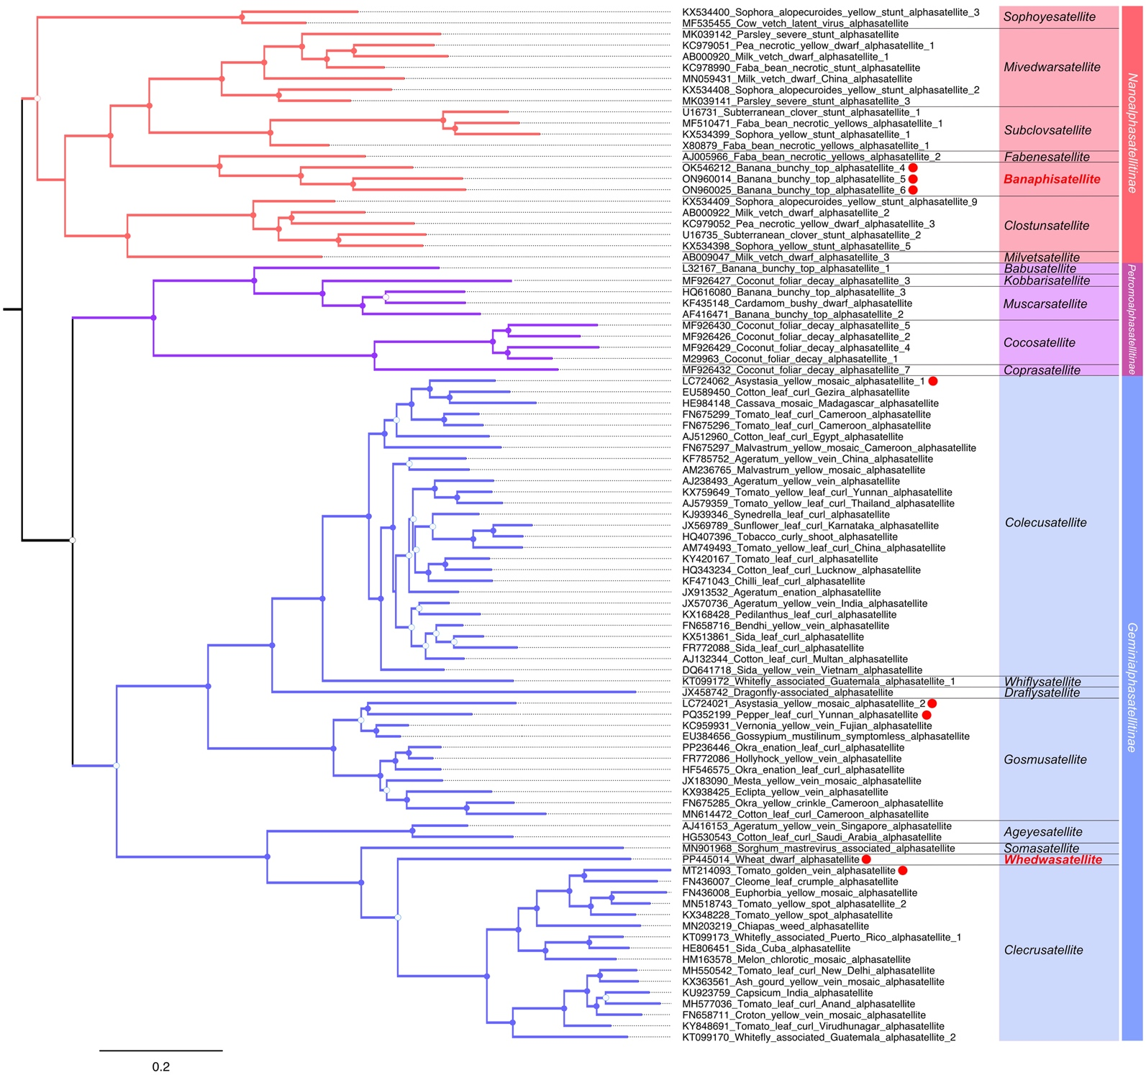

Figure 2. Midpoint-rooted, maximum-likelihood phylogenetic tree based on the complete sequences of alphasatellites, including the members of the 8 new species being proposed (indicated by the red circles). New genera are indicated in red bold font. Filled circles at the branches indicate bootstrap values >85%, open circles indicate values between 50 and 84%. The scale bar indicates nucleotide substitutions per site. Sequences were aligned with MAFFT [10] and the tree was constructed with IQ-TREE [11] using the TIM2+F+I+G4 nucleotide substitution model (determined by ModelFinder [12]) and the ultrafast bootstrap option [13]. The tree was edited in FigTree (tree.bio.ed.ac.uk/software/figtree).

