

The International Committee on Taxonomy of Viruses
Taxonomy Proposal Form, 2025

Part 1a: Details of taxonomy proposals

Title: | Split one genus, and create one genus and 14 species in the family Aspiviridae
Code assigned: | 2025.001P.Ac.v3.Aspiviridae _splitgen_1ng_14nsp

Author(s), affiliation and email address(es):
Given name (+middle initial(s)) | Surname | Affiliation | Email address | Corr. author(s)
Nicolas | Bejerman | UFyMA INTA-CONICET, Argentina | bejerman.nicolas@inta.gob.ar | X
Humberto | Debat | UFyMA INTA-CONICET, Argentina | debat.humberto@inta.gob.ar | X
Selma | Gago-Zachert | BCT, Uni Halle, Germany | selma.gago-zachert@bct.uni-halle.de
John | Hammond | USDA, USA | John.Hammond@usda.gov
Laura | Miozzi | IPSP, CNR, Italy | laura.miozzi@cnr.it
Tomohide | Natsuaki | Utsunomiya University, Japan | natsuaki@cc.utsunomiya-u.ac.jp
Yutaro | Neriya | Utsunomiya University, Japan | neriya@a.utsunomiya-u.ac.jp
Vicente | Pallás | IBMCP, UPV, Spain | vpallas@ibmcp.upv.es
Carina A | Reyes | IBBM-UNLP, Argentina | carirey2306@gmail.com
Mark PS | Rivarez | UBCLFS, Canada | mpsrivarez@gmail.com
Takahide | Sasaya | AFFRC, Japan | tsasaya@affrc.go.jp
Ioannis | Tzanetakis | UARK, USA | itzaneta@uark.edu
Anna Maria | Vaira | IPSP, CNR, Italy | annamaria.vaira@cnr.it
Martin | Verbeek | Wageningen University, The Netherlands | martin.verbeek@wur.nl

Part 1b: Taxonomy Proposal Submission
ICTV Subcommittee:
Animal DNA Viruses and Retroviruses |  | Bacterial viruses
Animal minus-strand and dsRNA viruses |  | Fungal and protist viruses
Animal positive-strand RNA viruses |  | Plant viruses | X
Archaeal viruses |  | General

List the ICTV Study Group(s) that have seen or have been involved in creating this proposal:
Aspiviridae study group

Optional – complete only if formally voted on by an ICTV Study Group:
Study Group | Number of members
Study Group | Votes in support | Votes against | No vote

Submission date: | 16/05/2025

Part 1c: Feedback from ICTV Executive Committee (EC) meeting
Executive Committee Meeting Decision code: | X
A – Accept
Ac – Accept subject to revision by relevant subcommittee chair. No further vote required | X
U – Accept without revision but with re-evaluation and email vote by the EC
Uc – Accept subject to revision and re-evaluation and email vote by the EC
Ud – Deferred to the next EC meeting, with an invitation to revise based on EC comments
J - Reject
W - Withdrawn

Comments from the Executive Committee:
The EC voted Ac for this proposal (see the table above for explanation). It is suggested to retain “Ophiovirus” as genus name and add “Miraophiovirus” as a second new genus name. Since the family name is Aspiviridae there is no need to use Orthoophiovirus to distinguish it. Moreover, the double o is difficult to write/pronounce. Please revise the text and the excel file accordingly. Genus demarcation criteria should be established.

Part 1d: Revised Taxonomy Proposal Submission
Response of proposer:
All suggestions are accepted. Regarding the genus demarcation suggestion, we added the paragraph “Genus demarcation criteria: We proposed that assigned species classified into different genera within the family Aspiviridae form clearly distinct major evolutionary lineages (clades) observed in the ML phylogenetic tree based on RdRp amino acid sequences (Figure 1)”

Revision date: | 12/08/2025

Part 3: TAXONOMIC PROPOSAL

Taxonomic changes proposed:
Establish new taxon | X | Split taxon | X
Abolish taxon |  | Merge taxon
Move taxon |  | Promote taxon
Rename taxon |  | Demote taxon
Move and rename | X

Etymology (origin) of proposed taxonomic names:
Taxon name | Etymology of the term
“Miraophiovirus” | from Mira, which is derived from Mirafiori lettuce big vein virus, and the genus Ophiovirus (from the Greek ophis, “snake”, referring to the snake-like appearance of the virion)
“Ophiovirus allii”, “Ophiovirus arctotis”, “Ophiovirus chrysanthemi”, “Ophiovirus citrulli”, “Ophiovirus daturae”, “Ophiovirus gentianae”, “Ophiovirus osteospermi”, “Miraophiovirus caladeniae”, “Miraophiovirus carotae”, “Miraophiovirus cyrtomii”, “Miraophiovirus erythranthis”, “Miraophiovirus lepidoziae”, “Miraophiovirus violae”, “Miraophiovirus xerochrysi” | Epithets derived from the host

Permission for use of names derived from a living person:
Taxon name | Full name of person from whom the name is derived | Attached

Abstract of Taxonomy Proposal:
Taxonomic rank(s) affected:
Genus Ophiovirus, family Aspiviridae

Description of current taxonomy:
The family Aspiviridae comprises the single genus Ophiovirus. Eight virus species are currently classified in the genus Ophiovirus, six of which infect dicotyledonous plants of widely different taxonomy, and the other two have monocot species as their plant host. The assignment of viruses to this genus is based on the placement of viruses in a Maximum Likelihood tree inferred from complete RdRp or CP protein sequences.

Proposed taxonomic change(s):
Split the genus Ophiovirus, creating one new genus (“Miraophiovirus”) and assigning the current Ophiovirus species to the appropriate genus; create 14 new species in the family Aspiviridae.

Justification:
Recently, 14 new putative ophioviruses were discovered, which we propose to classify into 14 new species. The phylogenetic relationships of the now significantly expanded number of known ophiovirus species provide support for splitting the genus Ophiovirus to establish two genera (Ophiovirus and “Miraophiovirus”) that represent distinct evolutionary lineages.

Text of Taxonomy proposal:
Taxonomic rank(s) affected:
Genus Ophiovirus, family Aspiviridae

Description of current taxonomy:
The family Aspiviridae comprises the single genus Ophiovirus. Eight viruses are currently classified in the genus Ophiovirus, of which six viruses infect dicotyledonous plants of widely different taxonomy and the other two have monocot species as their plant host. The assignment of viruses to this genus is based on the placement of the viruses in the Maximum Likelihood tree inferred from the complete RdRp or CP protein sequences.

Proposed taxonomic change(s):
We propose to split the genus Ophiovirus, creating one new genus (“Miraophiovirus”) and assigning the current Ophiovirus species to the appropriate genus. Moreover, we propose to create 14 new species in the family Aspiviridae.
The two genera are proposed according to the phylogenetic relationship of the existing and new members, because two major clades (or “distinct evolutionary lineages”) are observed in the ML phylogenetic tree based on RdRp sequences (Figure 1)

Demarcation criteria:
Genus demarcation criteria:
We proposed that assigned species classified into different genera within the family Aspiviridae form clearly distinct major evolutionary lineages (clades) observed in the ML phylogenetic tree based on RdRp amino acid sequences (Figure 1)

Species demarcation criteria:
1) We propose that assigned viruses classified into different species within the genus Ophiovirus have both of the following characteristics:
A) amino acid (aa) sequence identity of less than 82% for the RdRp gene;
B) if the RdRP aa identity falls between 82–88%, a coat protein (CP) identity threshold of <85% should be used as an auxiliary criterion to support species-level separation.

2) We propose that viruses classified into different species within the proposed genus “Miraophiovirus”, have the following two characteristics:
A) amino acid sequence identity less than 82% for the RdRp gene;
B) if the RdRP aa identity falls between 82–88%, a coat protein (CP) identity threshold of <85% should be used as an auxiliary criterion to support species-level separation.

Justification:
Recently, 14 new putative ophioviruses have been discovered [1, 2]. The phylogenetic relationships of the now significantly expanded number of known ophioviruses provide support for splitting the genus Ophiovirus to establish two genera that represent distinct evolutionary lineages. We propose to name the new genus “Miraophiovirus” (Figure 1). Of the eight established species within the genus Ophiovirus, six will be reassigned to the genus “Miraophiovirus”. Moreover, the 14 ophiovirus members recently discovered will be classified into 14 new species and assigned to the two genera, where seven will be accommodated in the genus “Ophiovirus”, and the other seven will be accommodated in the genus “Miraophiovirus”.

Genus Ophiovirus
The genomic organization of ophioviruses is similar; all ophioviruses identified to date have three genomic segments [1, 3]. Moreover, the observed phylogenetic relationships suggest a common evolutionary history for ophioviruses, with three major clades observed in the RdRp based tree (Figure 1).
Almost all ophioviruses identified to date infect dicot plants; however, one ophiovirus has a monocot plant as its host [1]. Thus, these viruses likely underwent a host adaptation trajectory that led to preferential infection of dicots during their evolution [1].
We propose to maintain the established species Ophiovirus citri and Ophiovirus vaccinii in the genus Ophiovirus.

In addition to these species, we propose the creation of seven new species within the genus Ophiovirus to accommodate the following recently identified viruses:

Allium ophiovirus (AllOV) was identified from an in silico analysis of transcriptomic data from white garlic (Allium ursinum) tissues from Brno, Czech Republic. The coding-complete genome (CCG) sequence (partial 3’ leader and 5’ trailer) of AllOV comprises three genomic segments of negative-sense RNA; where RNA 1 consists of 7380 nt (BK062657) and encodes the RdRp protein and a small protein of unknown function, RNA 2 consists of 1832 nt (BK062658) and encodes a putative movement protein (MP); while RNA 3 is 1495 nt (BK062659) in size and encodes the CP [1]. The RdRp and CP aa sequences of AllOV have the highest sequence identity with those of blueberry mosaic associated virus (BlMaV), with 52% (Figure 2) and 41% (Figure 3), respectively. Based on the ML tree generated from complete RdRp protein sequences, AllOV is placed within a subclade of the ophioviruses, with BlMaV (Figure 1). This virus is the only ophiovirus identified so far in a monocot host.

Arctotis ophiovirus (ArcOV) was identified from an in silico analysis of transcriptomic data from silver arctotis (Arctotis venusta) tissues from South Africa. The coding-complete genome (CCG) sequence (partial 3’ leader and 5’ trailer) of ArcOV comprises three genomic segments of negative-sense RNA; where RNA 1 consists of 8319 nt (BK062660) and encodes the RdRp protein and a small protein of unknown function, RNA 2 consists of 1738 nt (BK062661) and encodes a putative movement protein (MP); while RNA 3 consists of 1462 nt (BK062662) and encodes the CP [1]. The RdRp and CP aa sequences of ArcOV have the highest sequence identity with those of Osteospermum ophiovirus (OstOV), with 66% (Figure 2) and 67% (Figure 3), respectively. Based on the ML tree generated from complete RdRp protein sequences, ArcOV is placed within a subclade of ophioviruses, with OstOV (Figure 1).

Chrysanthemum ophiovirus (ChrOV) Two strains of this virus, named as ChrOV_indi and ChrOV_mori, were identified from an in silico analysis of transcriptomic data from Indian chrysanthemum (Chrysanthemum indicum) and garden mum (Chrysanthemum morifolium) tissues from Guangzhou and Nanjing, China, respectively. The coding-complete genome (CCG) sequence (partial 3’ leader and 5’ trailer) of ChrOV_indi and ChrOV_mori comprises three genomic segments of negative-sense RNA; where RNA 1 consists of 8240 nt (BK062669) and 8255 nt (BK062672), respectively, and encodes the RdRp protein and a small protein of unknown function, RNA 2 consists of 2143 nt (BK062670) and 2164 nt (BK062673), respectively, and encodes a putative movement protein (MP); while RNA 3 consists of 1572 nt (BK062671) and 1573 nt (BK062674), respectively, and encodes the CP [1]. The RdRp and CP aa sequences of ChrOV_indi and ChrOV_mori share 94% (Figure 2) and 92% (Figure 3) identity with each other, respectively. The RdRp and CP aa sequences of both viruses have the highest sequence identity with those of blueberry mosaic associated virus (BlMaV) RdRp with 66% (Figure 2) and Osteospermum ophiovirus (OstOV) CP with 43% (Figure 3). Based on the ML tree generated from the complete RdRp protein sequences, ChrOV forms a well-supported clade with other ophioviruses (Figure 1).

Citrullus ophiovirus (CitOV) was identified from an in silico analysis of transcriptomic data from watermelon (Citrullus lanatus) tissues from West Virginia, USA. The coding-complete genome (CCG) sequence (partial 3’ leader and 5’ trailer) of CitOV comprises three genomic segments of negative-sense RNA; where RNA 1 is 8510 nt (BK062675) in size and encodes the RdRp protein and a small protein of unknown function, RNA 2 is 1760 nt (BK062676) in size and encodes a putative movement protein (MP); while RNA 3 has 1528 nt (BK062677) and encodes the CP [1]. The RdRp and CP aa sequences of CitOV have the highest sequence identity with those of Osteospermum ophiovirus (OstOV), with 44% (Figure 2) and 37% (Figure 3), respectively. Based on the ML tree generated from the complete RdRp protein sequences, CitOV is placed within a subclade of the ophioviruses, with OstOV, Arctotis ophiovirus (ArcOV) and citrus psorosis virus (Figure 1).

Datura ophiovirus (DatOV) was identified from an in silico analysis of transcriptomic data from sacred datura (Datura wrightii) tissues from California, USA. The coding-complete genome (CCG) sequence (partial 3’ leader and 5’ trailer) of DatOV comprises three genomic segments of negative-sense RNA; where RNA 1 is 8055 nt (BK062682) in size and encodes the RdRp protein and a small protein of unknown function, RNA 2 has 1788 nt (BK062683) and encodes a putative movement protein (MP); while RNA 3 is 1701 nt (BK062684) in size and encodes the CP [1]. The RdRp and CP aa sequences of DatOV have the highest sequence identities with those of Allium ophiovirus (AllOV) RdRp with 47% (Figure 2) and Citrullus ophiovirus (CitOV) CP with 31% (Figure 3). Based on the ML tree generated from the RdRp protein sequences, DatOV is placed within a subclade of the ophioviruses, with AllOV and blueberry mosaic associated virus (Figure 1).

Gentiana ophiovirus (GenOV) was identified from an in silico analysis of transcriptomic data from tube gentian (Gentiana siphonantha) tissues from China. The coding-complete genome (CCG) sequence (partial 3’ leader and 5’ trailer) of GenOV comprises three genomic segments of negative-sense RNA; where RNA 1 is 8043 nt (BK062690) in size and encodes the RdRp protein and a small protein of unknown function, RNA 2 consists of 2077 nt (BK062691) and encodes a putative movement protein (MP); while RNA 3 consists of 1473 nt (BK062692) and encodes the CP [1]. The RdRp and CP aa sequences of GenOV have the highest sequence identity with those of blueberry mosaic associated virus (BlMaV) with 44% (Figure 2) and 35% (Figure 3), respectively. Based on the ML tree generated from complete RdRp protein sequences, GenOV forms a well-supported clade with other ophioviruses (Figure 1).

Osteospermum ophiovirus (OstOV) was identified from an in silico analysis of transcriptomic data from trailing pink daisy (Osteospermum jucundum) tissues from South Africa. The coding-complete genome (CCG) sequence (partial 3’ leader and 5’ trailer) of OstOV comprises three genomic segments of negative-sense RNA; where RNA 1 is 8521 nt (BK062711) in size and encodes the RdRp protein and a small protein of unknown function, RNA 2 is1701 nt (BK062712) in size and encodes a putative movement protein (MP); while RNA 3 consists of 1471 nt (BK062713) and encodes the CP [1]. The RdRp and CP aa sequences of OstOV have the highest sequence identity with those of Arctotis ophiovirus (ArcOV) with 66% (Figure 2) and 67% (Figure 3), respectively. Based on the ML tree generated from the complete RdRp protein sequences, OstOV is placed within a subclade of the ophioviruses, with ArcOV (Figure 1).

AllOV, ArcOV, ChrOV, CitOV, DatOV, GenOV and OstOV meet the demarcation criteria A and B. Thus, we propose to classify AllOV, ArcOV, ChrOV, CitOV, DatOV, GenOV and OstOV in the new species “Ophiovirus allii”, “Ophiovirus arctotis”, “Ophiovirus chrysanthemi”, “Ophiovirus citrulli”, “Ophiovirus daturae”, “Ophiovirus gentianae” and “Ophiovirus osteospermi”, family Aspiviridae.

Genus “Miraophiovirus”
Two distinct genomic organizations are displayed by miraophioviruses; six of of the thirteen miraophioviruses identified to date have four genomic segments, while the other seven have three genomic segments [1-3]. Moreover, the observed phylogenetic relationships suggest a common evolutionary history for miraophioviruses, with five major clades observed in the RdRp based tree (Figure 1).
Regarding their hosts, eight miraophioviruses identified so far have dicot plants as hosts, three other miraophioviruses have monocot plants as hosts, while one miraophiovirus has a fern as host, and the last one has liverwort/moss as host.

We propose that the species Ophiovirus capsici, Ophiovirus freesiae, Ophiovirus lactucae, Ophiovirus mirafiorense, Ophiovirus ranunculi and Ophiovirus tulipae shall be moved into the genus “Miraophiovirus” and be renamed “Miraophiovirus capsici", “Miraophiovirus freesiae", “Miraophiovirus lactucae”, “Miraophiovirus mirafiorense”, “Miraophiovirus ranunculi” and “Miraophiovirus tulipae”.

In addition to those reassigned species, we propose the creation of seven new species within the genus Miraophiovirus to accommodate the following recently identified viruses:

Caladenia ophiovirus (CalOV) was identified from an in silico analysis of transcriptomic data from crab-lipped spider orchid (Caladenia plicata) tissues from Western Australia, Australia. The coding-complete genome (CCG) sequence (partial 3’ leader and 5’ trailer) of CalOV comprises three genomic segments of negative-sense RNA; where RNA 1 is 7488 nt (BK062666) in size and encodes the RdRp protein and a small protein of unknown function, RNA 2 consists of 1760 nt (BK062667) and encodes a putative movement protein (MP); while RNA 3 consists of 1423 nt (BK062668) and encodes the CP [1]. The RdRp and CP aa sequences of CalOV have the highest sequence identity with those of carrot ophiovirus 1 (CaOV1) RdRp with 52% (Figure 2), and ranunculus white mottle virus (RWMV) CP with 41% (Figure 3). Based on the ML tree generated from the complete RdRp protein sequences, CalOV is placed within a subclade of the miraophioviruses, with Erythrante ophiovirus (Figure 1).

carrot ophiovirus 1 (CaOV1) was identified from the analysis of transcriptomic data from carrot (Daucus carota) tissues from Victoria, Australia. The coding-complete genome (CCG) sequence (partial 3’ leader and 5’ trailer) of CaOV1 comprises four genomic segments of negative-sense RNA; where RNA 1 consists of 6606 nt (OM419178) and encodes the RdRp protein and a small protein of unknown function, RNA 2 is 1760 nt (OM419179) in size and encodes a putative movement protein (MP); RNA 3 is 1493 nt (OM419180) in size and encodes the CP; while RNA 4 consists of 1381 nt (OM419181) and encodes a protein of unknown function [2]. The RdRp and CP aa sequences of CaOV1 have the highest sequence identity with those of Mirafiori lettuce big-vein virus (MLBVV), with 80% (Figure 2) and 72% (Figure 3), respectively. Based on the ML tree generated from the complete RdRp protein sequences, CaOV1 is placed within a subclade of the miraophioviruses, with MLBVV and tulip mild mottle mosaic virus (Figure 1).

Cyrtomium ophiovirus (CyrOV) was identified from an in silico analysis of transcriptomic data from holly fern (Cyrtomium fortunei) tissues from Guiyang, China. The coding-complete genome (CCG) sequence (partial 3’ leader and 5’ trailer) of CyrOV comprises three genomic segments of negative-sense RNA; where RNA 1 has 7548 nt (BK062679) and encodes the RdRp protein and a small protein of unknown function, RNA 2 has 1902 nt (BK062680) and encodes a putative movement protein (MP); while RNA 3 has 1749 nt (BK062681) and encodes the CP [1]. The RdRp and CP aa sequences of CyrOV have the highest sequence identity with those of Lepidozia ophiovirus (LepOV), with 42% (Figure 2) and 28% (Figure 3), respectively. Based on the ML tree generated from the complete RdRp protein sequences, CyrOV is placed within a subclade of the miraophioviruses, with LepOV (Figure 1).

Erythranthe ophiovirus (EryOV) was identified from an in silico analysis of transcriptomic data from pardus monkey-flower (Erythranthe pardalis) tissues from North Carolina, USA. The coding-complete genome (CCG) sequence (partial 3’ leader and 5’ trailer) of EryOV comprises three genomic segments of negative-sense RNA; where RNA 1 is 7643 nt (BK062687) in size and encodes the RdRp protein and a small protein of unknown function, RNA 2 consists of 1587 nt (BK062688) and encodes a putative movement protein (MP); while RNA 3 consists of 1651 nt (BK062689) and encodes the CP [1]. The RdRp and CP aa sequences of EryOV have the highest sequence identity with those of carrot ophiovirus 1 (CaOV1) RdRp with 54% (Figure 2), and ranunculus white mottle virus (RWMV) CP with 41% (Figure 3). Based on the ML tree generated from the complete RdRp protein sequences, EryOV is placed within a subclade of the miraophioviruses, with Caladenia ophiovirus (Figure 1).

Lepidozia ophiovirus (LepOV): Three strains of this virus, named LepOV_tri, LepOV_pli and LepOV_sela, were identified from an in silico analysis of transcriptomic data from hairy liverwort (Lepidozia trichoides), basket liverwort (Plicanthus hirtellus) and Krausse´spilke moss (Selaginella kraussiana) tissues from Fujian, China (the first two), and Victoria, Australia (the latter). The coding-complete genome (CCG) sequence (partial 3’ leader and 5’ trailer) of LepOV_tri, LepOV_pli and LepOV_sela comprises three genomic segments of negative-sense RNA; where RNA 1 consists of 7644 nt (BK062699), 7546 nt (BK062702) and 7611 nt (BK062705) and encodes the RdRp protein and a small protein of unknown function, RNA 2 consists of 1872 nt (BK062700), 1497 nt (BK062703) and 1871 nt (BK062706), and encodes a putative movement protein (MP); while RNA 3 is 1581 nt (BK062701), 1555 nt (BK062704) and 1711 nt (BK062705) in size and encodes the CP [1]. The RdRp and CP aa sequences of LepOV_tri, LepOV_pli and LepOV_sela ranged from 87% to 98% for both proteins (Figures 2 and 3). The RdRp aa sequence of the three LepOV strains has the highest sequence identity with that of Cyrtomium ophiovirus (CyrOV) with 42% (Figure 2), and the CP sequence of the three LepOV strains has the highest sequence identity with that of Viola ophiovirus (VioOV) with 29% (Figure 3). Based on the ML tree generated from the complete RdRp protein sequences, LepOV is placed within a subclade of the miraophioviruses, with CyrOV (Figure 1).

Viola ophiovirus (VioOV) was identified from an in silico analysis of transcriptomic data from pansies (Viola x wittrockiana) tissues from Xinxiang, China. The coding-complete genome (CCG) sequence (partial 3’ leader and 5’ trailer) of VioOV comprises three genomic segments of negative-sense RNA; where RNA 1 consists of 7671 nt (BK062735) and encodes the RdRp protein and a small protein of unknown function, RNA 2 consists of 1570 nt (BK062736) and encodes a putative movement protein (MP); while RNA 3 consists of 1576 nt (BK062737) and encodes the CP [1]. The RdRp and CP aa sequences of VioOV have the highest sequence identity with those of Lepidozia ophiovirus (LepOV), with 41% (Figure 2) and 29% (Figure 3), respectively. Based on the ML tree generated from the complete RdRp proteins sequences, VioOV is placed within a subclade of the miraophioviruses, with LepOV and Cyrtomium ophiovirus (Figure 1).

Xerochrysum ophiovirus (XerOV): Three strains of this virus, named XerOV_brac, XerOV_macra and XerOV_visco, were identified from an in silico analysis of transcriptomic data from strawflower (Xerochrysum bracteatum), white strawflower (Xerochrysum macranthum) and sticky everlasting (Xerochrysum viscosum) tissues from New South Wales, Australia (the former) and Western Australia, Australia (the latter two). The coding-complete genome (CCG) sequence (partial 3’ leader and 5’ trailer) of XerOV_brac, XerOV_macra and XerOV_visco comprises three genomic segments of negative-sense RNA; where RNA 1 consists of 7681 nt (BK062740), 7692 nt (BK062743) and 7591 nt (BK062746) and encodes the RdRp protein and a small protein of unknown function; RNA 2 consists of 1577 nt (BK062741), 1646 nt (BK062744) and 1577 nt (BK062747), and encodes a putative movement protein (MP); while RNA 3 consists of 1570 nt (BK062742), 1513 nt (BK062745) and 1522 nt (BK062748) and encodes the CP [1]. The RdRp and CP aa sequences identity of XerOV_brac, XerOV_macra and XerOV_visco ranged from 92% to 94% (Figure 2), and from 87% to 91% (Figure 3), respectively. While the RdRp and CP aa sequences of the three XerOV strains have a highest sequence identity of 41% (Figure 2) and 28% (Figure 3), respectively, with those of the other ophioviruses. Based on the ML tree generated from the complete RdRp protein sequences, the three XerOV strains form a well-supported clade with other miraophioviruses (Figure 1).

CalOV, CaOV1, CyrOV, EryOV LepOV, VioOV and XerOV meet the demarcation criteria A and B. Thus, we propose to classify CalOV, CaOV1, CyrOV, EryOV LepOV, VioOV and XerOV into the new species “Miraophiovirus caladeniae”, “Miraophiovirus carotae”, “Miraophiovirus cyrtomii”, “Miraophiovirus erythranthis”, “Miraophiovirus lepidoziae”, “Miraophiovirus violae” and “Miraophiovirus xerochrysi”, family Aspiviridae.

References:
[1] Bejerman N, Garcia ML, Debat H (2023). Expanding the Repertoire of the Plant-Infecting Ophioviruses through Metatranscriptomics Data. Viruses 15:840, PMID:37112821, doi:10.3390/v15040840.
[2] Fox A, Gibbs A, Fowkes A, Pufal H, McGreig S, Jones R, Boonham N, Adams I (2022). Enhanced Apiaceous Potyvirus Phylogeny, Novel Viruses, and New Country and Host Records from Sequencing Apiaceae Samples. Plants 11:1951, PMID:35956429, doi:10.3390/plants11151951
[3] García ML, Bó ED, da Graça JV, Gago-Zachert S, Hammond J, Moreno P, Natsuaki T, Pallás V, Navarro JA, Reyes CA, Luna GR, Sasaya T, Tzanetakis IE, Vaira AM, Verbeek M, ICTV Report Consortium (2017) ICTV virus taxonomy profle: Ophioviridae. J Gen Virol 98:1161–1162. PMID: 28635587. Doi: 10.1099/jgv.0.000836.

Accompanying files:
Filename | Description of contents
2025.001P.A.v1.Aspiviridae_Ophiovirus_splitgen_1ng_14nsp | Excel sheet

Tables, Figures:

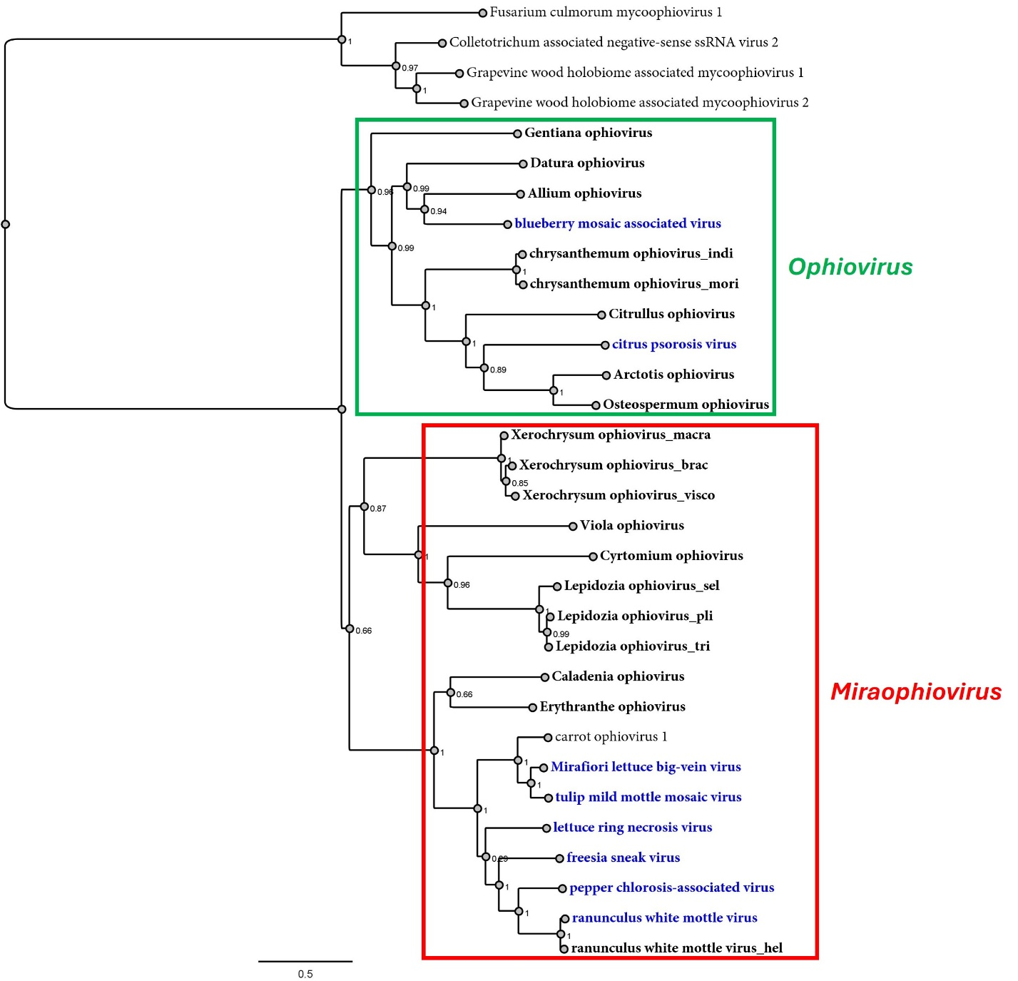
Figure 1 Maximum-likelihood phylogenetic tree based on amino acid sequence alignments of the complete RdRp protein of all aspivirids reported so far constructed with the WAG + G + F model. The scale bar indicates the number of substitutions per site. Bootstrap values following 1000 replicates are given at the nodes, but only the values above 50% are shown. The recently identified viruses [1] are noted in bold black, while the previously unassigned [2] is noted in light grey; while the known members are noted in bold blue font and mycoaspiviruses, which were used as outgroup, are noted in grey font.

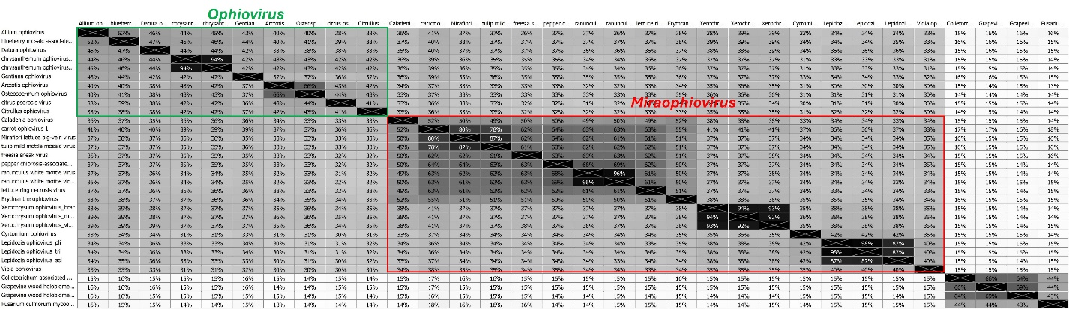

Figure 2 Matrix identity based on the amino acid sequence alignments of the complete RdRp protein of all aspivirids reported so far.

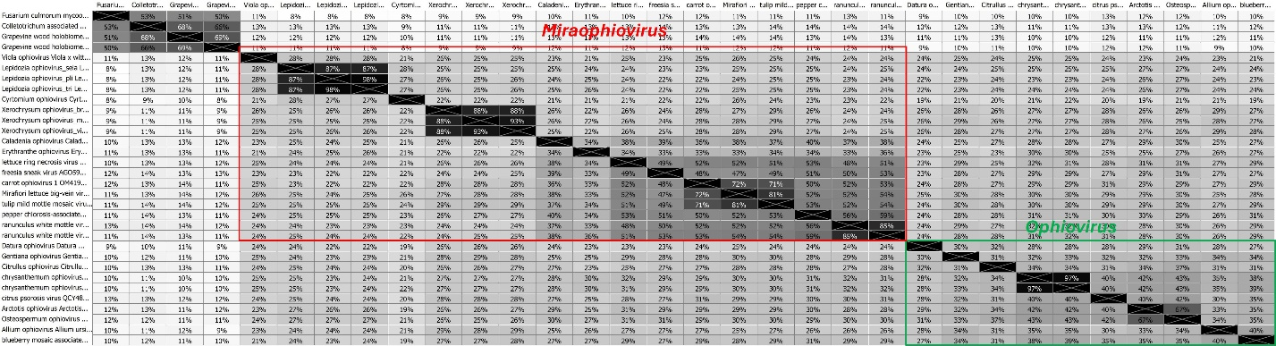
Figure 3 Matrix identity based on the amino acid sequence alignments of the complete N protein of all aspivirids reported so far.

