

The International Committee on Taxonomy of Viruses
Taxonomy Proposal Form, 2024

Part 1a: Details of taxonomy proposals

Title: | Create one new species in the genus Velarivirus (order Martellivirales, family Closteroviridae)
Code assigned: | 2024.019P.A.v1.Closteroviridae_1nsp

Author(s), affiliation and email address(es):
Name | Affiliation | Email address | Corresponding author(s)
Fontdevila N | Plant Pathology Laboratory, TERRA Gembloux Agro-Bio Tech, University of Liege, Belgium | nfpareta@gmail.com
Massart S | Plant Pathology Laboratory, TERRA Gembloux Agro-Bio Tech, University of Liege, Belgium | sebastien.massart@uliege.be | X

Part 1b: Taxonomy Proposal Submission
ICTV Subcommittee:
Animal DNA Viruses and Retroviruses |  | Bacterial viruses
Animal minus-strand and dsRNA viruses |  | Fungal and protist viruses
Animal positive-strand RNA viruses |  | Plant viruses | X
Archaeal viruses |  | General

List the ICTV Study Group(s) that have seen or have been involved in creating this proposal:
Optional – complete only if formally voted on by an ICTV Study Group:
Study Group | Number of members
Study Group | Votes in support | Votes against | No vote

Submission date: | 21/06/2024

Part 1c: Feedback from ICTV Executive Committee (EC) meeting
Executive Committee Meeting Decision code: | X
A – Accept
Ac – Accept subject to revision by relevant subcommittee chair. No further vote required | X
U – Accept without revision but with re-evaluation and email vote by the EC
Uc – Accept subject to revision and re-evaluation and email vote by the EC
Ud – Deferred to the next EC meeting, with an invitation to revise based on EC comments
J - Reject
W - Withdrawn

Comments from the Executive Committee:
Please include the edits highlighted in yellow and correct the “grapevine leafroll-associated 7 virus” to “grapevine leafroll-associated virus 7” in Figure 1. Alternatively, simply delete it from the figure, since the name is reported in the caption.

Part 1d: Revised Taxonomy Proposal Submission
Response of proposer:
Revision date: | 07/10/2024

Part 3: TAXONOMIC PROPOSAL

Name of accompanying Excel module:
2024.019P.A.v1.Closteroviridae_1nsp.xslx

Taxonomic changes proposed:
Establish new taxon | X | Split taxon
Abolish taxon |  | Merge taxon
Move taxon |  | Promote taxon
Rename taxon |  | Demote taxon
Move and rename

Is any taxon name used here derived from that of a living person: |  | N
Taxon name | Person from whom the name is derived | Attached X

Abstract of Taxonomy Proposal:
Taxonomic rank(s) affected:
Genus Velarivirus (order Martellivirales, family Closteroviridae)

Description of current taxonomy:
The family Closteroviridae comprises plant viruses with long, filamentous particles (650-2,200 nm in length) and large positive-sense RNA genomes (mono-, bi-, or tripartite). There are 57 recognized species in the family, classified in one of the seven existing genera (Ampelovirus, Bluvavirus, Closterovirus, Crinivirus, Menthavirus, Olivavirus, and Velarivirus). Within the genus Velarivirus, there are currently eight recognized species.

Proposed taxonomic change(s):
The authors propose adding a ninth species in the genus Velarivirus, named Velarivirus gembloutense, to classify recently identified virus Pyrus virus A (PyVA) in pear trees (Pyrus communis L.).

Justification:
Analysis of the genomic structure of this novel virus (PyVA) and subsequent phylogenetic analyses of the specific HSP70h gene placed PyVA as a novel member of the genus Velarivirus within the family Closteroviridae.

Text of Taxonomy proposal:
Taxonomic rank(s) affected:
Genus Velarivirus (order Martellivirales, family Closteroviridae)

Description of current taxonomy:
The family Closteroviridae comprises plant viruses with long, filamentous particles (650-2,200 nm in length) and large positive-sense RNA genomes (mono-, bi-, or tripartite). Members of this family present a cellular HSP70 homolog (HSP70h) and a duplicated, diverged copy of the coat protein named minor coat protein (CPm). Moreover, their genome is expressed through a +1 ribosomal frameshift and sub-genomic messenger RNAs. There are 57 recognized species in the family, classified in one of the seven existing genera (Ampelovirus, Bluvavirus, Closterovirus, Crinivirus, Menthavirus, Olivavirus, and Velarivirus). Within the genus Velarivirus, there are currently eight recognized species.

Proposed taxonomic change(s):
The authors propose adding a ninth species in the genus Velarivirus , named Velarivirus gembloutense, to classify recently identified virus Pyrus virus A (PyVA) in pear trees (Pyrus communis L.).

Demarcation criteria:
The genus demarcation criteria in the genus include particle size, the size of the CP, serological specificity using discriminatory monoclonal or polyclonal antibodies, genome structure and organization, amino acid (aa) sequence of the relevant gene products (RdRp, CP, HSP70h) differing by more than 25%, the magnitude and specificity of their natural host range, and cytopathological features. The established demarcation criteria for the family Closteroviridae can be found in the ICTV Virus Taxonomy Profile of this family in the Journal of General Virology (Fuchs et al., 2020).

Justification:
Velariviruses (Closteroviridae family) present a large, linear, positive-sense, single-stranded RNA (+ssRNA) genome approximately 16,080 to 17,003 nucleotides (nt) in size. The members of this genus share several common features in their genomic organization. Briefly, they are comprised of nine open reading frames (ORFs) coding for the replication associated proteins (ORF 1a and ORF 1b), a small hydrophobic protein of ca. 4 to 8 kDa with a transmembrane domain, HSP70h, a protein of ca. 60 kDa, CP, CPm, and two additional proteins of, in most of the cases, 25 and 27 kDa, respectively (Figure 1).

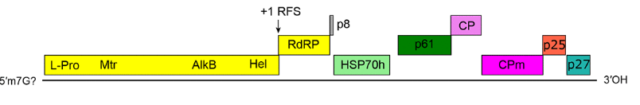
Figure 1. Genome organization of grapevine leafroll-associated virus 7 (GLRaV-7), which is a member of the genus Velarivirus (Fuchs et al., 2020).

Moreover, velariviruses infect mainly woody hosts without inducing apparent symptoms. They are primarily transmitted by grafting and vegetative propagation, as no insect vector is known, and they are not transmitted through seed or mechanically.

Description of the new species candidate
The proposed novel velarivirus member (PyVA) was identified in pear trees during a virome scanning study with HTS. During the analysis of the data, two genomes containing all coding regions were assembled. The two isolates, namely isolate 621-BE (GenBank accession No. OR887736) and 224-BE (OR887735), have a length of 17,061 and 17,142 nt, respectively. The difference in size between the two isolates is due to the incomplete sequencing of the 5’ and 3’ untranslated regions (UTRs), which, although attempted, could not be fully assembled.

The two genomes encode nine putative ORFs (Figure 2A) and have a genomic organization similar to other velariviruses, especially to that of its closes relative Malus domestica virus A (MdoVA). In addition, the electron microscopy of purified viral particles showed them to have an approximate length of 2,000 nm (Figure 2B). The newly identified virus fits the demarcation criteria, as well as the distinguishing properties, for viruses belonging to the genus Velarivirus and family Closteroviridae. PyVA shows 75% aa identity in the RdRp, 60% in the HSP70h, and 41% in the CP (Table 1).

Moreover, a maximum likelihood phylogenetic tree (1,000 bootstrap replicates) using the HSP70h amino acid sequences of known members of the Closteroviridae family was constructed. The phylogenetic analysis showed that PyVA was grouped within the Velarivirus genus.

Regarding its host range, PyVA was successfully transmitted by grafting to healthy plants of of Pyronia veitchii (Cydonia oblonga x Pyrus communis) and to different pear cultivars (Beurré Hardy, Williams, A20, and Jules d’Airoles). On the other hand, there was no transmission to Virginia crab apple, Lord Lambourne (Malus domestica), C7/1 (Cydonia oblonga), Pyrodwarf (Pyrus communis), M9 (Malus domestica), St. Julien (Prunus domestica), and Gisela® 5 (Prunus cerasus x Prunus canescens).

Given that PyVA shows a narrow host range, presents amino acid identity levels below the species demarcation criteria, and has a virion size and genome organization similar to other members of the genus Velarivirus, the authors propose PyVA to be classified in a newly created species Velarivirus gembloutense. The specific epithet chosen derives from the place of isolation of the virus (Gembloux).

References:
Fontdevila Pareta, N., Gailly, C., Blouin, A.G., Buchmann, B., Buenter, M., Candresse, T., Dubuis, N., Kutnjak, D., Lateur, M., Pecman, A., Steyer, S., Massart, S., in publication. Virome scanning of pear germplasm collections identifies a new Velarivirus and extends the geographical spread of three other pear viruses. Phytobiomes J.
Fuchs, M., Bar-Joseph, M., Candresse, T., Maree, H.J., Martelli, G.P., Melzer, M.J., Menzel, W., Minafra, A., Sabanadzovic, S., Report Consortium, I., 2020. ICTV Virus Taxonomy Profile: Closteroviridae. J. Gen. Virol. https://doi.org/10.1099/jgv.0.001397

Tables, Figures:

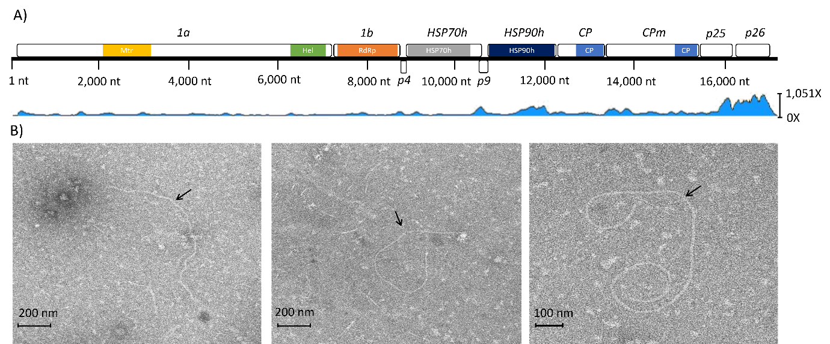

Figure 2. A) Graphic representation of the genomic organization of the novel velarivirus (PyVA, isolate 621-BE), with each box representing a predicted open reading frame (ORF) and the protein domains highlighted in different colors. The names in italics represent the products of the ORFs, the polyprotein 1a/1b complex, and the hypothetical proteins p4, p9, p25, and p26. The coverage of reads mapped to the genome of PyVA is shown in blue below the genome structure (maximum coverage = 1,051X). Abbreviations: methyltransferase (Mtr), helicase (Hel), RNA-dependent RNA polymerase (RdRp), heat-shock protein 70 homolog (HSP70h), heat-shock protein 90 homolog (HSP90h), capsid protein (CP), and minor capsid protein (CPm). B) Electron micrograph of three viral particles of the PyVA, marked with a black arrow. Figure taken from Fontdevila Pareta et al., (in publication) under an open access license.

Figure 3. Maximum likelihood phylogenetic tree (rtREV+F+I+G4 substitution model, MAFFT alignment, 1000 bootstraps) based on the alignment of HSP70h amino acid (aa) sequences of members of the Closteroviridae family and of PyVA (highlighted in red). The phylogenetic analysis was performed using the Galaxy server and visualized using the iTOL v6.8 tool. The HSP70 sequence of Arabidopsis thaliana was used as outgroup to root the tree. Bootstrap values are shown for each branch, and colored labels represent the genus that each virus belongs to as shown in the legend on the left. Figure taken from Fontdevila Pareta et al., (in publication) under an open access license.

Table 1. Percentages of amino acid (aa) identity of 10 proteins between the novel velarivirus (PyVA) and other members of the genus Velarivirus, obtained using a multiple sequence alignment tool (MAFFT). The genomes of cordyline viruses 2, 3, and 4 had partial sequences of the ORF 1a, and the genome of little cherry virus 1 did not have an annotation for p9. Thus, they were not used for the comparison. Table taken from Fontdevila Pareta et al., (in publication) under an open access license.
Genbank nº | Virus | 1a | 1b | p4 | HSP70h | p9 | HSP90h | CP | CPm | p25 | p26
NC_027121 | Areca palm velarivirus 1 (APV-1) | 22% | 56% | 26% | 40% | 13% | 23% | 23% | 13% | 15% | 11%
NC_038421 | Cordyline virus 1 (CoV-1) | 22% | 55% | 36% | 43% | 14% | 28% | 30% | 14% | 15% | 12%
NC_043453 | Cordyline virus 2 (CoV-2) | - | 54% | 24% | 44% | 24% | 31% | 31% | 17% | 15% | 14%
NC_043107 | Cordyline virus 3 (CoV-3) | - | 57% | 15% | 46% | 26% | 31% | 27% | 13% | 17% | 9%
NC_043108 | Cordyline virus 4 (CoV-4) | - | 56% | 16% | 44% | 25% | 26% | 30% | 15% | 21% | 12%
NC_016436 | Grapevine leafroll-associated virus 7 (GLRaV-7) | 23% | 55% | 18% | 42% | 20% | 28% | 26% | 11% | 14% | 10%
NC_001836 | Little cherry virus 1 (LChV-1) | 30% | 60% | 21% | 48% | - | 34% | 21% | 19% | 13% | 15%
NC_055599 | Malus domestica virus A (MdoVA) | 46% | 75% | 61% | 60% | 49% | 52% | 41% | 26% | 32% | 27%

