

The International Committee on Taxonomy of Viruses
Taxonomy Proposal Form, 2024

Part 1a: Details of taxonomy proposals

Title: | Create one new genus to include five new species in the subfamily Betarhabdovirinae (Mononegavirales: Rhabdoviridae)
Code assigned: | 2024.016P.A.v1.Rhabdoviridae_1ngen_5nsp

Author(s), affiliation and email address(es):
Name | Affiliation | Email address | Corresponding author(s)
Bejerman M | UFyMA INTA-CONICET, Argentina | bejerman.nicolas@inta.gob.ar | X
Debat H | UFyMA INTA-CONICET, Argentina | debat.hmberto@inta.gob.ar
Dietzgen R | QAAFI, UQ, Australia | r.dietzgen@uq.edu.au
Freitas-Astua J | EMBRAPA Mandioca e Fruticultura, Brazil | juliana.astua@embrapa.br
Kondo H | Okayama University, Japan | hkondo@rib.okayama-u.ac.jp
Ramos-Gonzalez P | Instituto Biológico de São Paulo, Brazil | plrg1970@gmail.com
Whitfield A | NC State University, USA | awhitfi@ncsu.edu
Walker P | UQ, Australia | peter.walker@uq.edu.au

Part 1b: Taxonomy Proposal Submission
ICTV Subcommittee:
Animal DNA Viruses and Retroviruses |  | Bacterial viruses
Animal minus-strand and dsRNA viruses | X | Fungal and protist viruses
Animal positive-strand RNA viruses |  | Plant viruses | X
Archaeal viruses |  | General -

List the ICTV Study Group(s) that have seen or have been involved in creating this proposal:
Rhabdoviridae Study Group
Optional – complete only if formally voted on by an ICTV Study Group:
Study Group | Number of members
Study Group | Votes in support | Votes against | No vote
Rhabdoviridae SG | 10 | 0 | 4

Submission date: | 10/06/2024

Part 1c: Feedback from ICTV Executive Committee (EC) meeting
Executive Committee Meeting Decision code: | X
A – Accept | X
Ac – Accept subject to revision by relevant subcommittee chair. No further vote required
U – Accept without revision but with re-evaluation and email vote by the EC
Uc – Accept subject to revision and re-evaluation and email vote by the EC
Ud – Deferred to the next EC meeting, with an invitation to revise based on EC comments
J - Reject
W - Withdrawn

Comments from the Executive Committee:

Part 1d: Revised Taxonomy Proposal Submission
Response of proposer:
Revision date: | DD/MM/YYYY

Part 3: TAXONOMIC PROPOSAL

Name of accompanying Excel module:
2024.016P.A.v1.Rhabdoviridae_1ngen_5nsp

Taxonomic changes proposed:
Establish new taxon | X | Split taxon
Abolish taxon |  | Merge taxon
Move taxon |  | Promote taxon
Rename taxon |  | Demote taxon
Move and rename

Is any taxon name used here derived from that of a living person: |  | N
Taxon name | Person from whom the name is derived | Attached X

Abstract of Taxonomy Proposal:
Taxonomic rank(s) affected: Genus and species

Description of current taxonomy: Almost all viruses classified in the subfamily Betarhabdovirinae, family Rhabdoviridae are unsegmented, but plant-associated rhabdoviruses with bi-segmented genomes have also been identified and included in the genera Varicosavirus and Dichorhavirus within the subfamily Betarhabdovirinae. The assignment of viruses to these genera is based on the placement of the viruses on Maximum Likelihood trees inferred from complete L protein sequences.

Proposed taxonomic change(s): Create one new genus to include five new species in the subfamily Betarhabdovirinae, family Rhabdoviridae. These five new species named as Trirhavirus alni, Trirhavirus chrysanthemi, Trirhavirus erysimi, Trirhavirus medicagonis, and Trirhavirus picridis are proposed to be classified in a new genus named Trirhavirus.

Justification: Five novel rhabdoviruses were identified in Alnus rubra, Chrysanthemum morifolium, Erysimum nevadense, Medicago sativa, and Picris echioides [1]. Unexpectedly, these five viruses have tri-segmented genomes, which represent the first tri-segmented genomes among rhabdoviruses. The characterization of these five viruses showed they should be classified as novel species within a novel genus within the subfamily Betarhabdovirinae, family Rhabdoviridae, for which we propose the name “Trirhavirus” [1].

Text of Taxonomy proposal:
Taxonomic rank(s) affected: Genus and species

Description of current taxonomy: Almost all viruses classified in the subfamily Betarhabdovirinae, family Rhabdoviridae are unsegmented, but plant-associated rhabdoviruses with bi-segmented genomes have also been identified and included in the genera Varicosavirus, and Dichorhavirus) within the subfamily Betarhabdovirinae. The assignment of viruses to these genera is based on the placement of the viruses on Maximum Likelihood trees inferred from complete L protein sequences.

Proposed taxonomic change(s): Create one new genus to include five new species in the subfamily Betarhabdovirinae, family Rhabdoviridae. These five new species named as Trirhavirus alni, Trirhavirus chrysanthemi, Trirhavirus erysimi, Trirhavirus medicagonis, and Trirhavirus picridis are proposed to be classified in a new genus named Trirhavirus.

Demarcation criteria: We propose that viruses assigned to different species within the proposed genus Trirhavirus, have one or both of the following characteristics:
A) nucleotide sequence identity lower than 75% for the L ORF; and
B) occupy different ecological niches as evidenced by differences in host plants

Justification:
Genus Trirhavirus
All rhabdoviruses identified to date have unsegmented genomes, except for the dichorhaviruses and varicosaviruses which have bi-segmented genomes. Unexpectedly, five novel rhabdoviruses with tri-segmented genomes were identified in Alnus rubra, Chrysanthemum morifolium, Erysimum nevadense, Medicago sativa, and Picris echioides, respectively, which represent the first tri-segmented genomes among rhabdoviruses [1]. RNA1 of all the tri-segmented viruses has one gene that encodes the L protein. RNA2 of four of these viruses has four genes, and one virus has five genes, where one of those genes encodes the putative nucleoprotein. RNA3 of all tri-segmented viruses has four genes, where the first three encoded proteins are homologous and syntenic to each other [1]. The 30 to 40 nucleotides located at the end of the 5′trailer of each one of the RNA segments of the Alnus, Erysmum and Picris tri-segmented viruses are 99% to 100% identical, and BlastP searches of each encoded protein showed that the L protein sequence of all tri-segmented rhabdoviruses was more similar to the L protein of cytorhabdoviruses than to the L protein of any other rhabdovirus. On the other hand, for every tri-segmented virus, the N protein best hits were the N proteins encoded by varicosaviruses or nucleorhabdoviruses. No similarity hits were found for P2, P3, P4, P6, P7, P8, P9, P10 or P11 in databases even with relaxed parameters. Strikingly, the P5 proteins showed hits, with a percent identity ranging between 28 to 32, against the putative silencing suppressor protein encoded by emaraviruses, which are plant viruses with segmented, linear, single-stranded, negative-sense genomes (family Fimoviridae, order Elliovirales) [1]. Viral RNA silencing suppressors are required for systemic infection of the plant host and the presence of these proteins suggests that the tri-segmented viruses are plant-associated [1]. The consensus gene junction sequences of the tri-segmented rhabdoviruses are highly similar and like those previously reported for cytorhabdoviruses [1]. The phylogenetic analysis based on deduced L protein aa sequences placed all tri-segmented rhabdoviruses into a distinct clade which is basal to all cytorhabdoviruses (Figure 2); while the phylogenetic analysis based on deduced N protein aa sequences placed all tri-segmented rhabdoviruses into a distinct clade which is basal to all plant-associated rhabdoviruses (Figure 3). It is likely that the L and N proteins, which are located on different RNA segments, have distinct evolutionary histories [1]. It is tempting to speculate that the RNA segment encoding the L protein evolved from a cytorhabdovirus ancestor, while the RNA segment encoding the N protein may have evolved from a rhabdovirus ancestor of all tri-segmented viruses, except for the Alnus-associated virus. The presence of an emaravirus-related protein in its RNA2 segment, as well as in the RNA3 segment of the Chrysanthemum- and Medicago-associated tri-segmented viruses leads us to speculate that these segments may have emerged from the recombination of a negative-sense rhabdovirus ancestor and an emaravirus. On the other hand, the RNA3 segment of the viruses from Alnus, Erysimum and Picris may have evolved from a segmented negative-sense rhabdovirus ancestor [1]. Taken together, we propose that these tri-segmented viruses be taxonomically classified into a novel genus within the family Rhabdoviridae, subfamily Betarhabdovirinae for which we propose the name “Trirhavirus”.
This genus is proposed to classify five novel species.

Novel species

- Alnus trirhavirus 1(AlTRV1) was identified from an in-silico analysis of transcriptome data of red alder (Alnus rubra) from Washington, USA. AlTRV1 genome is tri-segmented with a coding-complete genome (CCG) RNA1 of 6,699 nucleotides (nt), RNA2 of 5,289 nt and RNA3 of 4,586 nt (BK064247, BK064248 and BK064249, respectively). RNA1 contains one large open reading frame (ORF) encoding the L polymerase protein while RNA2 contains five ORFs, where the first ORF encodes the putative nucleoprotein, and RNA3 has four ORFs (Figure 1). The nt and amino acid (aa) sequences of AlTRV1 L gene have the highest sequence identity with that of Chrysanthemum trirhavirus 1 (ChTRV1, 63.9% and 58.5%, respectively) (Table 1). Based on ML tree generated from complete L protein sequences, AlTRV1 is placed within a subclade of trirhaviruses with ChTRV1 (Figure 2).
- Chrysanthemum trirhavirus 1 (ChTRV1) was identified from an in-silico analysis of transcriptome data of hardy garden mum (Chrysanthemum morifolium) from Beijing, China. ChTRV1 genome is tri-segmented with a coding-complete genome (CCG) RNA1 of 6,332 nt, RNA2 of 4,222 nt and RNA3 of 5,133 nt (BK064250, BK064251 and BK064252, respectively). RNA1 contains one large ORF encoding the L polymerase protein while RNA2 and RNA3 contain four ORFs, where the first RNA 2´ORF encodes the putative nucleoprotein (Figure 1). The nt and aa sequences of ChTRV1 L gene have the highest sequence identity with that of Alnus trirhavirus 1 (AlTRV1, 63.9% and 58.5%, respectively) (Table 1). Based on ML tree generated from complete L protein sequences, ChTRV1 is placed within a subclade of trirhaviruses with AlTRV1 (Figure 2).
- Erysimum trirhavirus 1 (EryTRV1) was identified from an in-silico analysis of transcriptome data of Sierra Nevada wallflower (Erysimum nevadense) from Granada, Spain. EryTRV1 genome is tri-segmented with a coding-complete genome (CCG) RNA1 of 6,524 nt, RNA2 of 3,989 nt and RNA3 of 4,307 nt (BK064253, BK064254 and BK064255, respectively). RNA1 contains one ORF encoding the L polymerase protein while RNA2 and RNA3 contain four ORFs, where the first RNA 2´ORF encodes the putative nucleoprotein (Figure 1). The nt and aa sequences of EryTRV1 L gene have the highest sequence identity with that of Picris trirhavirus 1 (PiTRV1, 65.8% and 65.9%, respectively) (Table 1). Based on ML tree generated from complete L protein sequences, EryTRV1 is placed within a subclade of trirhaviruses with PiTRV1 (Figure 2).
- Medicago trirhavirus 1 (MeTRV1) was identified from an in-silico analysis of transcriptome data of alfalfa (Medicago sativa) from California, USA. MeTRV1 genome is tri-segmented with a coding-complete genome (CCG) RNA1 of 6,495 nt, RNA2 of 4,565 nt and RNA3 of 4,307 nt (BK064256, BK064257 and BK064258, respectively). RNA1 contains one large ORF encoding the L polymerase protein while RNA2 and RNA3 contain four ORFs, where the first RNA 2´ORF encodes the putative nucleoprotein (Figure 1). The nt and aa sequences of MeTRV1 L gene have the highest sequence identity with that of Picris trirhavirus 1 (PiTRV1, 63.9% and 60.5%, respectively) (Table 1). Based on ML tree generated from complete L protein sequences, MeTRV1 is placed within a subclade of trirhaviruses with Erysimum trirhavirus 1 and PiTRV1 (Figure 2).
- Picris trirhavirus 1(PiTRV1) was identified from an in-silico analysis of transcriptome data of bristly oxtongue (Picris echioides) samples collected in Piran, Slovenia. PiTRV1 genome is tri-segmented with a coding-complete genome (CCG) RNA1 of 6,530 nt, RNA2 of 4,091 nt and RNA3 of 4,259 nt (BK064259, BK064260 and BK064261, respectively). RNA1 contains one large ORF encoding the L polymerase protein while RNA2 and RNA3 contain four ORFs, where the first RNA 2´ORF encodes the putative nucleoprotein (Figure 1). The nt and aa sequences of PiTRV1 L gene have the highest sequence identity with that of Erysimum trirhavirus 1 (EryTRV1, 65.8% and 65.9%, respectively) (Table 1). Based on ML tree generated from complete L protein sequences, PiTRV1 is placed within a subclade of trirhaviruses with EryTRV1 (Figure 2).

AlTRV1, ChTRV1, EryTRV1, MeTRV1 and PiTRV1 meet the demarcation criteria A and B. Thus, we propose to classify AlTRV1, ChTRV1, EryTRV1, MeTRV1 and PiTRV1respectively in the new species Trirhavirus alni, Trirhavirus chrysanthemi, Trirhavirus erysimi, Trirhavirus medicagonis, and Trirhavirus picridis, subfamily Betarhabdovirinae, family Rhabdoviridae.

Derivation of names:
Trirhavirus: from trisegmented rhabdovirus

References:
[1] Bejerman N, Dietzgen R, Debat H (2023). Novel Tri-Segmented Rhabdoviruses: A Data Mining Expedition Unveils the Cryptic Diversity of Cytorhabdoviruses. Viruses 15:2402, PMID:38140643, doi:10.3390/v15122402.

Tables, Figures:

Table 1. L ORF Trirhaviruses. Percent Identity Matrix (nucleotide in left/amino acid in right)- created by SDT v1.2

Virus | AlTRV1 | ChTRV1 | EryTRV1 | MeTRV1 | PiTRV1
AlTRV1 | 100 | 58.5 | 56.1 | 55.4 | 55.1
ChTRV1 | 63.9 | 100 | 57.6 | 56.5 | 58.4
EryTRV1 | 63.7 | 63.2 | 100 | 60.1 | 65.9
MeTRV1 | 62.5 | 63.4 | 63.6 | 100 | 60.5
PiTRV1 | 63.8 | 63.5 | 65.8 | 63.9 | 100
Virus name abbreviations: Alnus trirhavirus 1 (AlTRV1), Chrysanthemum trirhavirus 1 (ChTRV1), Erysimum trirhavirus 1 (EryTRV1), Medicago trirhavirus 1 (MeTRV1), Picris trirhavirus 1 (PiTRV1).

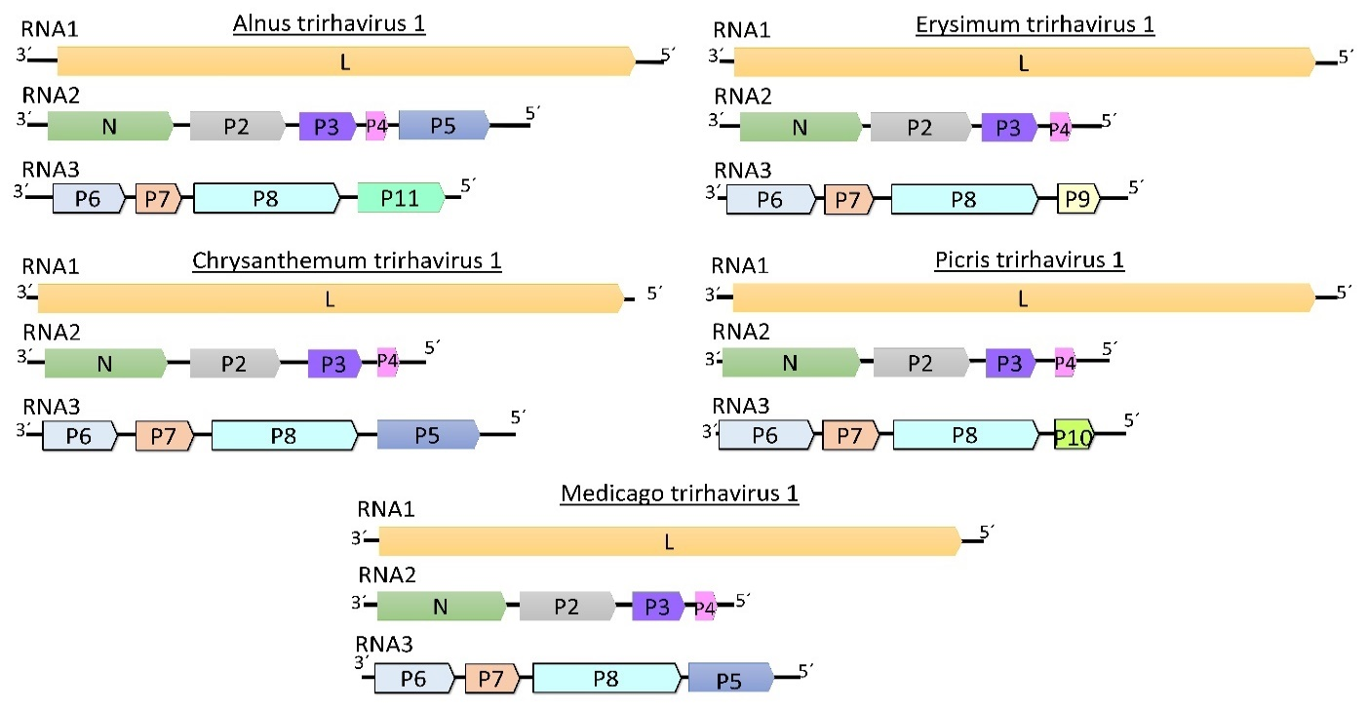

Figure 1. Genome graphs depicting architecture and gene products of proposed viruses to be included in species within the genus Trirhavirus. Abbreviations: N: nucleoprotein; L: RNA-dependent RNA polymerase; P2: protein 2; P3: protein 3; P4: protein 4; P5: protein 5; P6: protein 6; P7: protein 7; P8: protein 8; P9: protein 9; P10: protein 10; P11: protein 11.

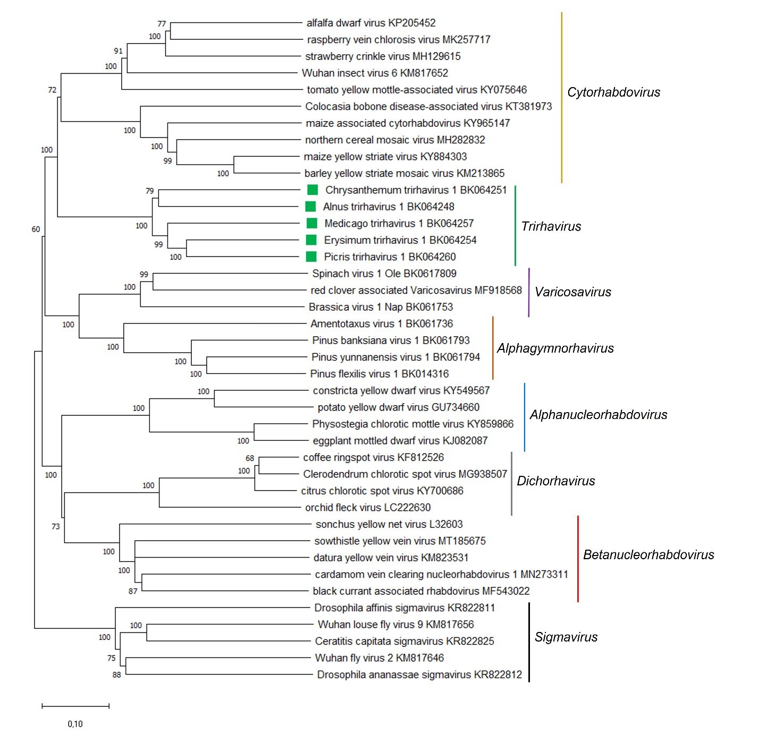

Figure 2. A Maximum Likelihood (ML) phylogenetic tree of plant-infecting rhabdovirus L polymerase protein sequences. Amino acid sequences were aligned using MUSCLE. The resulting alignment was used to generate a phylogenetic tree using MegaX with the best-fit model LG + G + I +F. Five viruses potentially belonging to the new species are indicated with green squares. Numbers at the nodes indicate bootstrap support (1000 replicates). Members of the arthropod-associated genus Sigmavirus were used as outgroup.

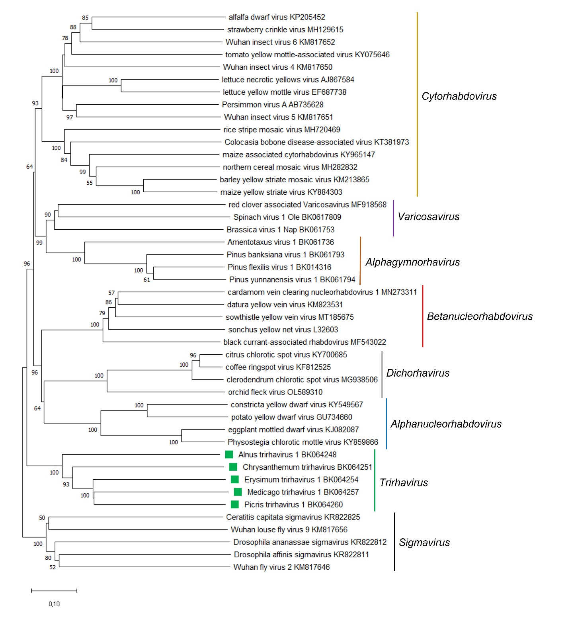

Figure 3. A Maximum Likelihood (ML) phylogenetic tree of plant-infecting rhabdovirus N protein sequences. Amino acid sequences were aligned using MUSCLE. The resulting alignment was used to generate a phylogenetic tree using MegaX with the best-fit model LG + G + I +F. Five viruses potentially belonging to the new species are indicated with green squares. Numbers at the nodes indicate bootstrap support (1000 replicates). Members of the arthropod-associated genus Sigmavirus were used as outgroup.

