

Part 1: TITLE, AUTHORS, APPROVALS, etc

Code assigned: | 2023.021P
Short title: Create five species in the genus Sobemovirus (Sobelivirales:Solemoviridae)
Author(s) and email address(es)
Sõmera M, Sarmiento C, Hebrard E, Fargette D | merike.somera@taltech.ee;  cecilia.sarmiento@taltech.ee;  eugenie.hebrard@ird.fr;  denis.fargette@ird.fr
Corresponding author
Merike Sõmera merike.somera@taltech.ee
List the ICTV Study Group(s) that have seen this proposal
Solemoviridae SG

ICTV Study Group comments and response of proposer
ICTV Study Group votes on proposal
Study Group | Number of members
Study Group | Votes support | Votes against | No vote
Solemoviridae SG | 4 |  | 0
Authority to use the name of a living person
Is any taxon name used here derived from that of a living person (Y/N) | N

Taxon name | Person from whom the name is derived | Permission attached (Y/N)

Submission dates
Date first submitted to SC Chair | June 22, 2023
Date of this revision (if different to above)
ICTV-EC comments and response of the proposer
Following the EC request to reconsider the use of acronyms as species epithets, the Study Group confirmed the decision of using the acronyms as species epithets.

Part 3: TAXONOMIC PROPOSAL
Name of accompanying Excel module
2023.021P.Uc.v1.Sobemovirus_5nsp
Abstract
A search in the NCBI GenBank revealed five new viruses which tentatively belong to the genus Sobemovirus. Analysis of their genome and RdRP sequences confirms that these viruses can be recognized as novel species in the genus Sobemovirus.

Text of proposal
Sobemoviruses are a genetically diverse group of viruses that share several distinct characteristics:
• mechanical transmission, and/or transmission by different insects: beetles, aphids, hoppers, etc., depending on a specific virus;
• spread in different plant tissues;
• close serological relationships between viruses infecting plants from the same family;
• virions are isometric, approx. 30 nm in size;
• their genome is a single-stranded (ss) positive-sense RNA molecule of approximately 4 to 5 kb with a small genome-linked protein (VPg) covalently attached to the 5′ end of the genomic RNA (Fig. 1);
• their most 5´ORF1 encodes a viral suppressor protein;
• the next ORF, ORFx encodes a protein needed for systemic infection and is translated via recognition of non-AUG initiation codon (because of that, it is sometimes not annotated);
• ORF2a encodes a polyprotein that is proteolytically processed to several domains, including a serine protease and a VPg;
• ORF2b encodes a viral RdRP, and is translated via ribosomal frameshifting;
• ORF3 encodes a viral capsid protein (CP).

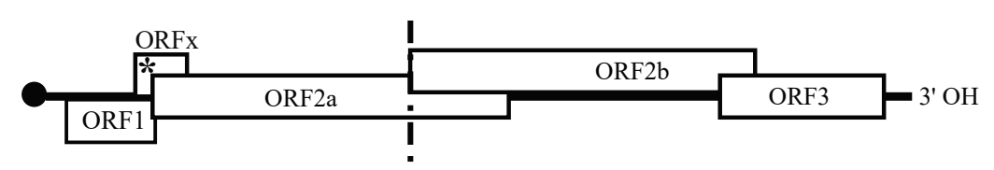
Fig.1. Typical genome organization of sobemovirus genome.

The current list of sobemoviruses includes 21 species. Our search in the NCBI GenBank database revealed five more tentative species belonging to the genus Sobemovirus not yet recognized by the ICTV.
Most of these new viruses have the complete or near-complete genomes sequenced, and showing a genome organization characteristic of sobemoviruses.

The species demarcation criteria for the genus Sobemovirus are the following:

- Species are distinguished by the host range of member viruses combined with analysis of their genome sequences;
- The threshold for species demarcation based on complete genome sequences is <75% nucleotide identity between viruses belonging to different species;
- Serological relatedness between viruses may help in distinguishing species.

The descriptions of the new species candidates given as follows:

Cynosurus mottle virus (CnMoV) isolate PV-104 was collected from crested dogstail (Cynosurus cristatus) near Betzdorf (Sieg), Germany in 1970s by W. Huth, and stored at the DSMZ-Leipzig collection as DSMZ:PV-0728. Historical sample was sequenced using
high-throughput sequencing (HTS). Assembled genome (OM323988) is composed of 4419 nt. CnMoV has a genome organization characteristic of sobemoviruses. The genome ends were verified by RACE. Phylogenetic analysis of sobemoviral genomes indicates it clusters together with CfMV (48.1% of sequence identity) and with one yet unrecognized sobemovirus that was sequenced from a pool of different grasses recently, a Poaceae Liege sobemovirus (PLSV, GenBank Acc. No. ON137710; 69.8% of sequence identity) (Table 1; Fig.2). CnMoV is mechanically transmissible (Sõmera et al 2023, unpublished). Hence, the recognition of CnMoV as the member of Sobemovirus CNMOV is consistent with the species demarcation criteria in genus Sobemovirus.

Mimosa mosaic virus (MimMV) was isolated from mimosa (Mimosa sensitiva) sample collected in Santo Antônio do Tauá, Pará state of Brazil in 2015. The MimMV genome (OP456085) is composed of 4595 nt. It was sequenced using HTS and confirmed by Sanger sequencing. The genome ends were verified with RACE. MiMMV has a genome organization characteristic of sobemoviruses. Phylogenetic analysis based on the predicted amino acid (aa) sequences of the P2b protein (encoded by ORF2b) showed 52.7% aa sequence identity to that of blueberry shoestring virus (BSSV). The virus is mechanically transmissible (Kaufmann et al 2023). Phylogenetic analysis of sobemoviral genomes indicates it clusters with BSSV (39.2% of sequence identity) (Table 1; Fig. 2). Hence, the recognition of MiMMV as the member of Sobemovirus MIMMV is consistent with the species demarcation criteria in genus Sobemovirus.

Pistacia sobemovirus (PisSV)–4 sobemo-like virus isolates (MT334602, MT334603, MW548580, MW548581) were discovered from transcriptome data of pistachio (Pistacia chinensis) collected in China in 2015 (Mohammadi et al unpublished). BLASTN analysis at the NCBI site reveals that the genomic sequences of these four isolates share 90-96% of identity with each other. The genome of exemplar species is of 4547 nt (MT334602), and it has an organization characteristic of sobemoviruses. Our BLASTN analyses of translated amino acid sequences of PisSV indicate that ORF1 encoded protein shares no homology with any other known proteins; ORF2a encoded polyprotein shares 34.7% of identities with of coverage of 88% with P2a of cymbidium chlorotic spot virus (AKN81081); ORF2b encoded RdRP shares 50.9% of identities with of coverage of 93% with that of subterranean clover mottle virus (NP_736581); and, ORF3 encoded CP shares 34.9% of identities with of coverage of 89% with CP of cymbidium chlorotic mosaic virus (CyCMV; WCF44389). Phylogenetic analysis of sobemoviral genomes indicates it clusters together with CyCMV (39.4% of sequence identity) (Table2; Fig.2). Hence, the recognition of PisSV as the member of Sobemovirus PISSV is consistent with the species demarcation criteria in genus Sobemovirus.

Poaceae Liege sobemovirus (PLSV) was recently sequenced from a pool of different grasses collected at the Belgian Natural Park Burdinale-Mehaigne, near Latinne in Belgium in 2018 using HTS. The genome is composed of 4439 nt, and the genome organization is characteristic of sobemoviruses (ON137710; Maclot et al 2023). MUSCLE multiple alignment analysis indicates it shares 69.8% of sequence identity with the genome sequence of CnMoV (OM323988; described herein before) (Table 1). Hence, the recognition of PLSV as the member of Sobemovirus PLSV is consistent with the species demarcation criteria in genus Sobemovirus.

Xufa yellow dwarf virus (XYDV) was sequenced from xufa (Cyperus esculentus) sample collected in Valencia, Spain in 2016 using HTS. The partial genome sequence of assembled genome (ON828429) is composed of 3072 nt. Phylogenetic analysis of sobemoviral coat protein amino acid sequences indicated XYDV is most closely related to ryegrass mottle virus (Rubio et al 2022). In addition, our BLASTN analysis of translated amino acid sequences of XYDV indicates that ORF2ab encoded polyprotein (lacking the N-terminal sequence) shares 53.7% of identities with that of Rottboellia yellow mottle virus (YP_009142784) with coverage of 98% with P2ab of Rottboellia yellow mottle virus, and 51.8% of identities with that of ryegrass mottle virus (YP_007438853) with coverage of 98%. Likewise, MUSCLE multiple alignment analysis of sobemoviral RdRP sequences indicate XYDV RdRP shares 61.4% of sequence identity with that of RoMoV, and 57.9% of identity with that of RGMoV, respectively (Table 2). Hence, we suggest the recognition of XYDV as the member of Sobemovirus XYDV.

Supporting evidence
Table 1. Identity percentages seen between nucleotide sequences of viral genomes of recognized and tentative new sobemoviruses retrieved from NCBI GenBank. Multiple sequence alignment was obtained using MUSCLE algorithm.
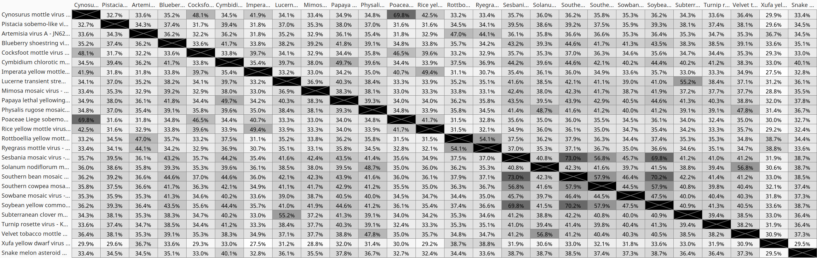

Table 2. Identity percentages seen between amino acid sequences of viral RdRPs translated from ORF2b extracted from the genomes of recognized and tentative new sobemoviruses. Multiple sequence alignment was obtained using MUSCLE algorithm.
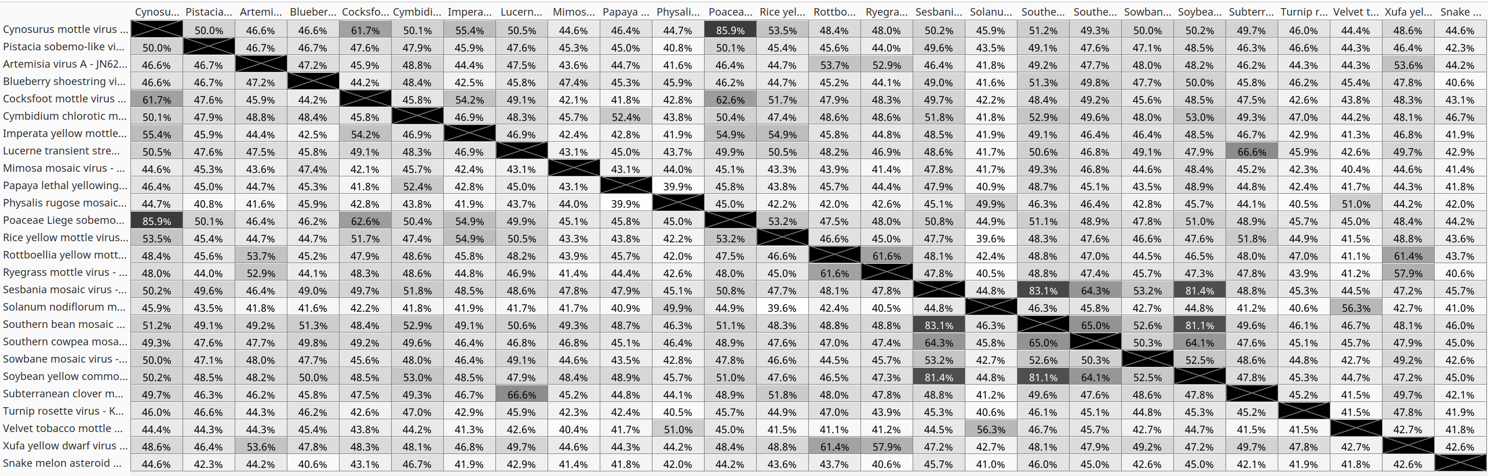

Fig. 2. Phylogenetic tree base on multiple alignment of sobemoviral RdRP sequences generated using Neighbor-Jointing Method. Branch labels indicate substitutions per site.
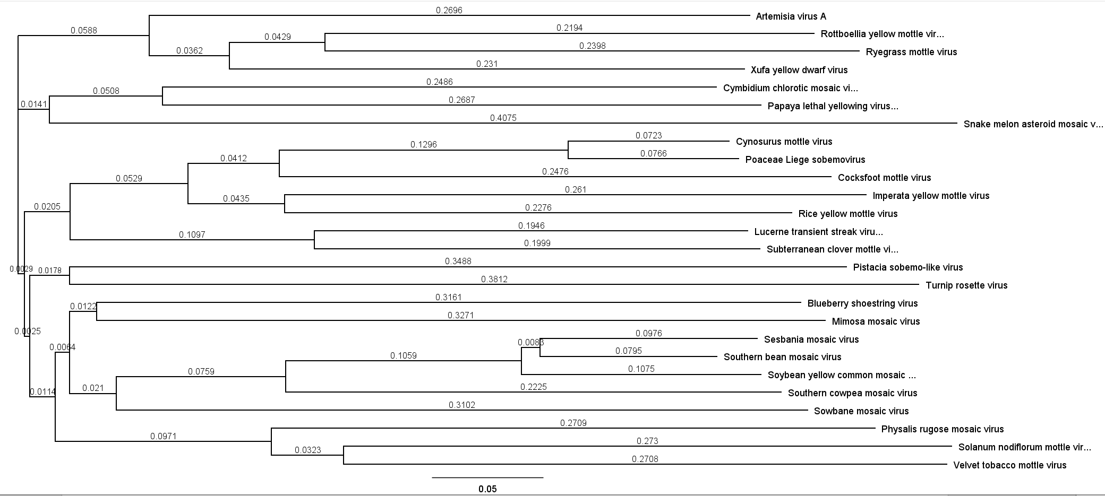

References
Sõmera M et al (2023) Sequencing and biological characterization of Cynosurus mottle virus historical isolates from Germany. Unpublished

Kauffmann CM et al (2023) Complete genome sequence of mimosa mosaic virus, a new sobemovirus infecting Mimosa sensitiva L. Arch Virol 168:28. DOI: 10.1007/s00705-022-05683-5. PMID: 36598574

Mohammadi M et al (2023) Transcriptome data analysis revealed novel viruses for genus Pistacia in Iran, China, and Italy. Unpublished

Maclot F et al (2023). Long-Term Anthropogenic Management and Associated Loss of Plant Diversity Deeply Impact Virome Richness and Composition of Poaceae Communities. Microbiol Spectr 11:e0485022. DOI: 10.1128/spectrum.04850-22. PMID: 36916941

Rubio L et al (2022) Discovery and Diagnosis of a New Sobemovirus Infecting Cyperus esculentus Showing Leaf Yellow Mosaic and Dwarfism Using Small-RNA High Throughput Sequencing. Plants 11:2002. DOI: 10.3390/plants11152002. PMID: 35956480

