

Part 1: TITLE, AUTHORS, APPROVALS, etc

Code assigned: | 2022.016P
Short title: Create three new species in the genus Cilevirus, family Kitaviridae (Martellivirales)

Author(s) and email address(es)
Ramos-González PL, Freitas-Astúa J, Li J-M, Peters J, Rodrigues JC, Roy A., Melzer M. | plrg1970@gmail.com; juliana.astua@embrapa.br; lijunmin@nbu.edu.cn, j.peters2@uq.edu.au, jose_carlos@mac.com, avijit.roy@usda.gov,  melzer@hawaii.edu

Author(s) institutional address(es) (optional)
Instituto Biologico de São Paulo [PLRG]
Embrapa Mandioca e Fruticultura [JFA]
Ningbo University [JML]
University of Queensland [JP]
Universidad de Puerto Rico [JCR]
US Department of Agriculture [AR]
University of Hawaii [MM]

Corresponding author
Ramos-González PL

List the ICTV Study Group(s) that have seen this proposal
Kitaviridae Study Group

ICTV Study Group comments and response of proposer
ICTV Study Group votes on proposal
Study Group | Number of members
Study Group | Votes support | Votes against | No vote
Kitaviridae | 6 | 0 | 1

Authority to use the name of a living person
Is any taxon name used here derived from that of a living person (Y/N) | N

Taxon name | Person from whom the name is derived | Permission attached (Y/N)

Submission dates
Date first submitted to SC Chair | May 10, 2022
Date of this revision (if different to above) | May 18, 2022

ICTV-EC comments and response of the proposer

Part 3: TAXONOMIC PROPOSAL

Name of accompanying Excel module
2022.016P.N.v1. Cilevirus_3ns.xlxs

Abstract
This proposal classifies Solanum violifolium ringspot virus, Ligustrum chlorotic spot virus, and Ligustrum leprosis virus, into three new species of the genus Cilevirus, family Kitaviridae (Martellivirales). The genomes of these viruses are divided into two single-strand (+) RNA molecules. RNA1 segments, ca. 8.7 kb, contain two open reading frames (ORFs), RNA-dependent RNA polymerase (RdRp) and p31 or p32, organized as those in most members of the genus. The RNA2 segments, ca. 3.6 kb, have three major ORFs in the order 5’-p61-p32(mp)-p24-3’ and lack a ca. 1.0 kb fragment at the 5’-end, present in other cileviruses e.g. citrus leprosis virus C. The genomes of the novel viruses and their encoded proteins share relatively low nucleotide and amino acid sequence identities between each other and with other cileviruses. Phylogenetic analyses using the RdRp proteins place the new viruses in an intermediary clade within established members of the genus Cilevirus.

Text of proposal
Viruses classified in the family Kitaviridae, order Martellivirales, infect plants, and have linear single-stranded (ss) positive (+) split RNA genomes. They are assigned to the genera Cilevirus, Higrevirus, or Blunervirus (Quito-Avila et al., 2021). Most of the kitavirids cause non-systemic diseases in which only the locally infected tissues typically develop chlorotic and/or necrotic lesions. Most of the cileviruses are transmitted by mites of the genus Brevipalpus (Freitas-Astúa et al., 2018).
The genomes of the cileviruses citrus leprosis virus (CiLV-C), citrus leprosis virus C2 (CiLV-C2), and passionfruit ringspot virus (PfGSV) are divided into two molecules in which RNA1, ca. 9 kb, comprises two open reading frames (ORFs), RdRp and p29 (putative coat protein), whereas RNA2, ca. 5 kb, includes four canonical ORFs (p15, p61, p32, and p24) (Figure 1). ORF p32 encodes the movement protein whereas p61 and p24 encode proteins that are likely involved in the virion structure. P24 is a transmembrane (TM) protein and P61 is a putative glycoprotein. P15 might act as an RNA silencing suppressor and, as in the case of P61, its ectopic expression induces morphofunctional modification in plant tissues.
Another cilevirus, Hibiscus yellow blotch virus (HYBV), has a genomic organization that differs from those commonly observed in typical cileviruses. HYBV lacks the genomic region upstream of the ORF p61, including the ORF p15, while its ORF ortholog of p29 is located at the 3’-end of the RNA2 instead of its regular locus at the 3’-end of RNA1 (Olmedo-Velarde et al., 2021).

1- Solanum violifolium ringspot virus (SvRSV): SvRSV was first identified in Piracicaba, State of São Paulo (SP), Brazil, in 2007 (Ferreira et al., 2007). SvRSV-infected leaves show chlorotic spots which can turn into necrotic lesions, and occasionally, when senescent, they can display green islands. Experimentally, SvRSV can be successfully transmitted to Arabidopsis thaliana and other plants of the families Solanaceae, Amaranthaceae, and Malvaceae, mechanically or by using viruliferous mites of the species B. yothersi (formerly classified as B. phoenicis (Ferreira et al., 2007; Arena et al., 2017). The virus is also transmitted by B. obovatus, which seems to be its natural vector (Ferreira et al., 2007). Virions from SvRSV have enveloped particles of 45–46 nm in width and 80-100 nm in length. Virus particles of up to 120–150 nm long are sporadically observed in infected S. violifolium plants (Ferreira et al., 2007; Ramos-González et al., 2022).

The full genomes of SvRSV isolate Prb1 (GenBank accession numbers OK626439 and OK626440) and isolate Crb1 (OK626441 and OK626442) were obtained. RNA1 of SvRSV_Prb1 (8,658 nts) has two ORFs: RdRp and p31 (likely encoding the coat protein), whereas RNA2 (3,622 nts) has three ORFs: p62 (putative glycoprotein), p33 (movement protein), and p23 (likely a transmembrane protein with the SP24 motive) (Figure 1). Deduced amino acid sequences of proteins encoded by each ORF show identity values not exceeding 55% with their orthologues in either definitive or other tentative members of the genus (Table 1). Based on an maximum likelihood (ML) tree generated from RdRp protein sequences, isolates of SvRSV are placed in an independent branch within subclades with other cileviruses (Figure 2).

2- Ligustrum chlorotic spot virus (LigCSV): LigCSV was identified in branches of privet shrubs of the species Ligustrum lucidum and L. japonicum showing leaves with chlorotic spots. Plants were collected in São Paulo, SP, and Curitiba, PR, Brazil, in 2018, but plants of these species with similar symptoms had been detected in Curitiba, PR, Brazil, since 1976 (Lima et al., 1991; Lima Neto et al., 1994). LigCSV virions are enveloped, ca. 53 nm wide and ca. 66 nm long, and they have commonly been observed in electron-dense vacuolated structures called viroplasms or inside cisternae of the endoplasmic reticulum. LigCSV is transmitted by B. papayensis mites. Besides Ligustrum spp., the virus can also infect Arabidopsis thaliana plants (Ramos-González et al., 2022).
Full genomes of two isolates of LigCSV have RNA1 and RNA2 molecules of 8.4-8.7 nts and 3.6 nts long, respectively, and they show the same organization as those in SvRSV (Figure 1). RNA1 of LigCSV_SPa1 (OK626447 and OK626448) and LigCSV_Crb1 (OK626449 and OK626450) are more conserved (ca. 99% nucleotide sequence identity) than their RNA2 molecules (ca. 94% nucleotide sequence identity) (Ramos-González et al., 2022). The deduced amino acid sequences of each ORF from LigCSV have the highest sequence identities with that of the tentative cilevirus Ligustrum leprosis virus (LigLV), but values never reach 85%, predetermined as the demarcation threshold for species in the genus Cilevirus (Table 1). Based on an ML tree generated from complete RdRp protein sequences, LigCSV forms a well-supported subclade with the tentative cilevirus LigLV, placed in an intermediary position between those comprising SvRSV and the definitive cileviruses CiLV-C, CiLV-C2 and PfGSV (Figure 2).

3- Ligustrum leprosis virus (LigLV): LigLV was detected in leaves mainly showing chlorotic spots of a privet shrub of the species L. sinense collected in the city of La Falda, Córdoba, Argentina, in 2019. Privets with similar symptoms were first observed at the end of the 1930s, in Argentina, when the disease was called “lepra explosiva de la ligustrina” (Vergani, 1942). Symptoms of the disease are reminiscent of those observed in sweet orange trees (Citrus sinensis) affected by the cileviruses CiLV-C or CiLV-C2. Virions of LigLV are enveloped spheroidal particles ca. 40 x 55 nm in size, which can be regularly observed in non-vacuolated viroplasms (Ramos-González et al., 2022).
LigLV is likely transmitted by mites of the genus Brevipalpus. The disease was successfully transmitted in experiments carried out using viruliferous Tenuipalpus pseudocuneatus Blanchard, a mites species later synonymized with Brevipalpus obovatus (Vergani, 1942; Welbourn et al., 2003). In LigLV-infected privets collected in La Falda, mites of the species B. tucuman were identified (Ramos-González et al., 2022).
LigLV genome is divided into two RNA molecules 8.9 and 3.4 nts long, respectively. RNA1 (OK626451) has the same organization observed in the typical cileviruses CiLV-C, CiLV-C2, and PfGSV, but the arrange of the RNA2 (OK626452) is as that observed in the tentative cileviruses SvRSV and LigCSV (Figure 1). RNA2 of LigLV also shows six putative small ORFs which encode tentative short proteins containing deduced transmembrane domains. Higher values of nucleotide and deduced amino acid sequence identity of LigLV are with the genome and deduced proteins from isolates of LigCSV. Amino acid sequence identity percentages are below 85%, considered the threshold for species demarcation in the genus Cilevirus (Table 1).
In ML trees generated using RdRp protein sequences, LigLV forms a well-supported subclade with isolates of LigCSV and is placed between clades comprising the tentative cilevirus SvRSV and definitive members of the genus Cilevirus, i.e., CiLV-C, CiLV-C2 and PfGSV (Figure 2).

We propose to classify SvRSV, LigCSV, and LigLV in the new species Cilevirus solani, Cilevirus ligustri, and Cilevirus australis, respectively, in the genus Cilevirus, family Kitaviridae. The species epithets for Cilevirus solani and Cilevirus ligustri are derived from the Latinized forms of the names of hosts where these viruses were first detected. In the case of Cilevirus australis, the epithet refers to both the place where the disease caused by LigLV was first described (Vergani, 1942) and the geographic origin of the sample from which the virus was characterized, i.e. Argentina. The epithet australis may mean "of the south", in this case, from the Southern region of South America: Argentina.

The current demarcation criteria for species of the genus Cilevirus are based on:
- The extent of the serological relationship as determined by immunodiffusion and/or ELISA
- Less than 85% aa sequence identity for the proteome
- Natural host range
- Artificial host range reactions
- Vector species and transmission

While the information on the serological relationship between these viruses is not available, the three viruses described in this proposal meet the criteria B, C, and E.

Supporting evidence

Table 1. Nucleotide (nt) and deduced amino acid (aa) identities between SvRSV_Prb1, LigCSV_SPa1, and LigLV_Cdb1, and other tentative and definitive members of the family Kitaviridae.

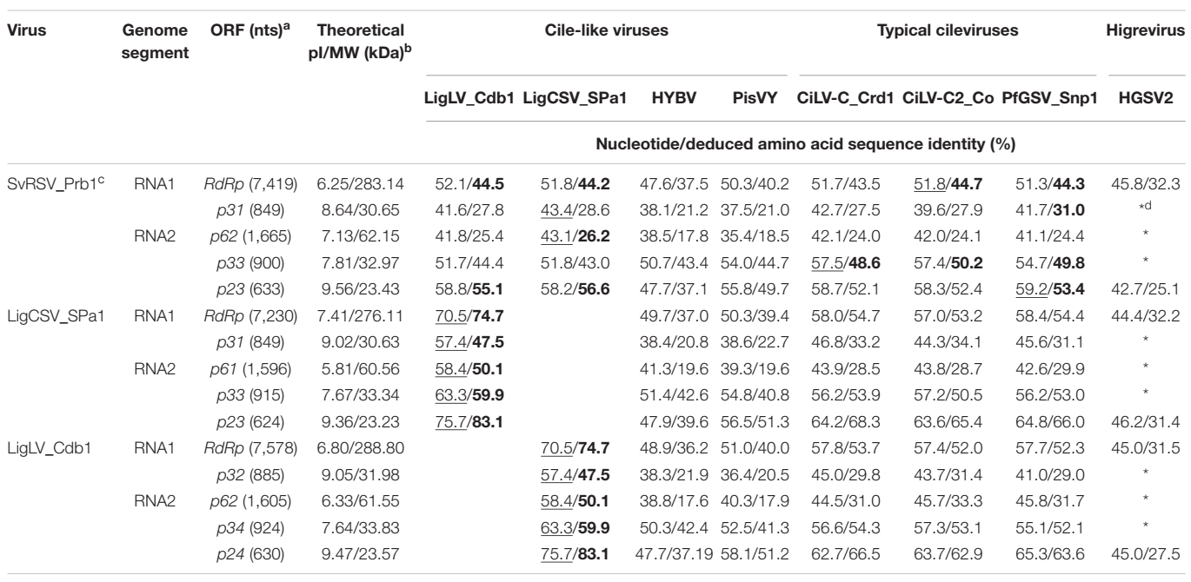
The highest values of nt and aa identity in each row are underlined and highlighted in bold. ªLength (nts) of each ORF including the stop codon. ^{b}The isoelectric point (pI) and molecular weight (MW) in kDa of the deduced polypeptides were assessed using the Compute pI/Mw tool available at https://web.expasy.org/compute_pi/. ^{c}GenBank or RefSeq accession numbers of each molecule are the following: SvRSV_Prb1 (OK626439 and OK626440), SvRSV_Crb1 (OK626441 and OK626442), LigCSV_SPa1 (OK626447 and OK626448), LigCSV_Crb1 (OK626449 and OK626450), LigLV_Cdb1 (OK626451 and OK626452), CiLV-C_Crd1 (NC008169 and NC008170), CiLV-C2_Co (NC038848 and NC038849), PfGSV_Snp1 (MK804171 and MK804172), HYBV (MT472637 and MT472638), PisVY (Pistachio virus Y; MT362606 and MT362605), and hibiscus green spot virus (HGSV2; NC_016141, NC_016142, and NC_016143). ^{d}Absence of orthologue genes. (Reprinted from Ramos-González et al., 2022).

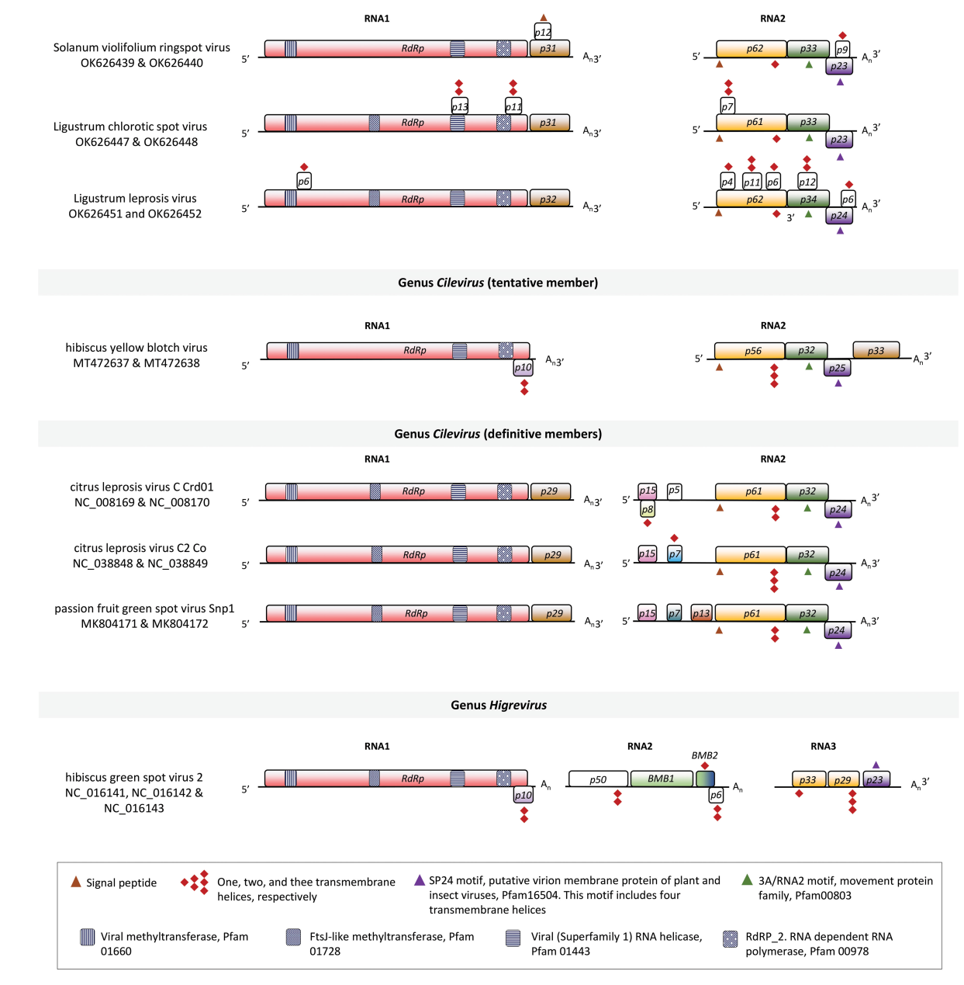
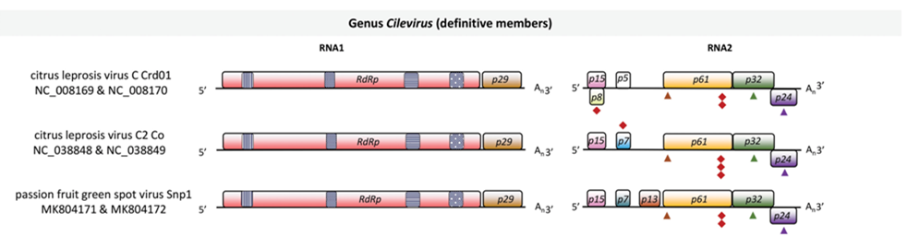
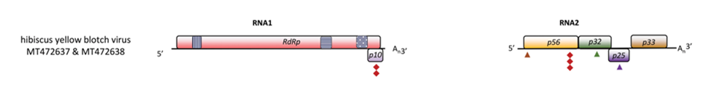
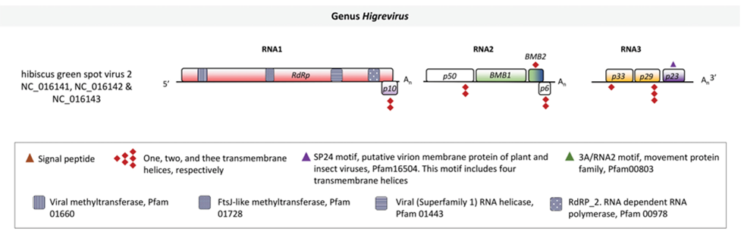
Figure 1. Genomic maps of Solanum violifolium ringspot virus, Ligustrum chlorotic spot virus, Ligustrum leprosis virus, and other definitive members of the family Kitaviridae. Open reading frames (ORFs) are represented by boxes. Colors indicate a putative conserved functional or structural relationship between ORFs from different viruses. In citrus leprosis virus C, genus Cilevirus, RdRp: RNA dependent-RNA polymerase, p29: putative coat protein, p15: putative RNA silencing suppressor, p61: putative glycoprotein, likely a structural protein of the virion, p32: movement protein, p24: putative structural protein of the virion. White boxes indicate unknown features. Symbols of black pattern-filled boxes, triangles, and diamonds depict relevant amino acid motifs as described in the legend box. (Modified from Ramos-González et al., 2022).

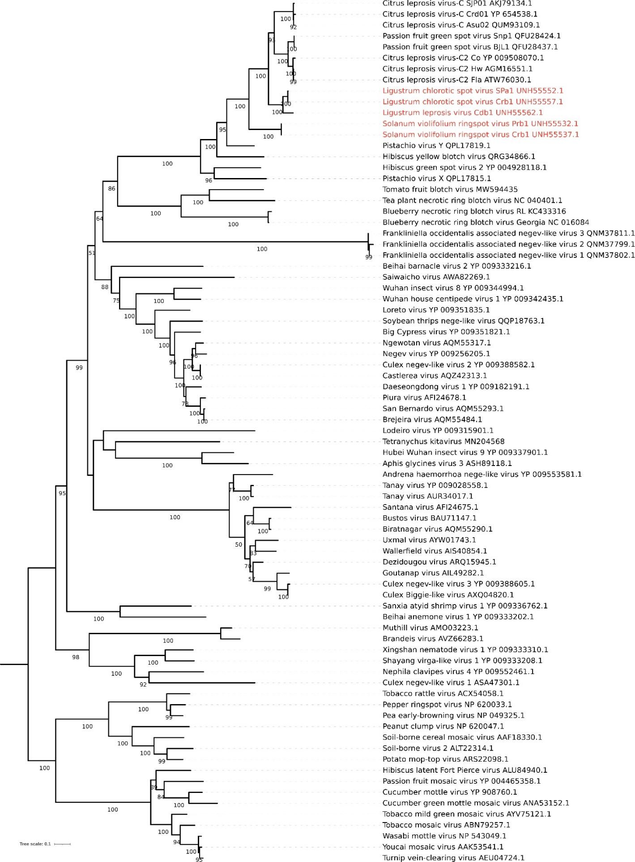

Figure 2. Phylogenetic reconstruction for viruses of the family Kitaviridae. Isolates of Solanum violifolium ringspot virus, Ligustrum chlorotic spot virus, and Ligustrum leprosis virus are highlighted in red. Branches comprising definitive and tentative kitavirids are inside the blue box. The maximum-likelihood phylogenetic tree is based on the deduced amino acid sequences of the RNA-dependent RNA polymerase. The tree was rooted using viruses of the family Virgaviridae as an external group. Phylogenetic informative regions of the multiple sequence alignment included 546 residues that were selected using BMGE software (Criscuolo & Gribaldo, 2010) and its evolutionary history was inferred based on the model LG+F+I+G4 (Le & Gascuel, 2008). The bootstrap support values (1,000 replications) of branches greater than 50% are indicated next to the corresponding nodes. The scale bar specifies the average number of amino acid substitutions per site.

References
Arena GD, Ramos-González PL, Nunes MA et al., 2017. Arabidopsis thaliana as a model host for Brevipalpus mite-transmitted viruses. Scientia Agricola 74, 85–89.
Criscuolo A, Gribaldo S, 2010. BMGE (Block Mapping and Gathering with Entropy): a new software for selection of phylogenetic informative regions from multiple sequence alignments. BMC Evolutionary Biology 10, 210.
Ferreira P de TO, Locali-Fabris EC, Freitas-Astúa J et al., 2007. Caracterização de um vírus baciliforme isolado de Solanum violaefolium transmitido pelos ácaros Brevipalpus phoenicis e Brevipalpus obovatus (Acari: Tenuipalpidae). Summa Phytopathologica 33, 264–269.
Freitas-Astúa J, Ramos-González PL, Arena GD, Tassi AD, Kitajima EW, 2018. Brevipalpus-transmitted viruses: parallelism beyond a common vector or convergent evolution of distantly related pathogens? Current Opinion in Virology 33, 66–73.
Le SQ, Gascuel O, 2008. An improved general amino acid replacement matrix. Molecular Biology and Evolution 25, 1307–1320.
Lima MLRZC, Lima Neto VC, Souza VB V., 1991. The causal agent of the Ligustrum ringspot disease. Phytopathology 81, 1216.
Lima Neto VC, Lima MLRZC, Sousa VB V., 1994. O agente causador do anel do Ligustrum. Revista do Setor de Ciências Agrárias 13, 221–224.
Olmedo-Velarde A, Hu J, Melzer MJ, 2021. A Virus Infecting Hibiscus rosa-sinensis Represents an Evolutionary Link Between Cileviruses and Higreviruses. Frontiers in Microbiology 12, 988.
Quito-Avila DF, Freitas-Astúa J, Melzer MJ, 2021. Bluner-, Cile-, and Higreviruses (Kitaviridae). Encyclopedia of Virology, 247–251.
Ramos-González PL, Chabi-Jesus C, Tassi AD et al., 2022. A Novel Lineage of Cile-Like Viruses Discloses the Phylogenetic Continuum Across the Family Kitaviridae. Frontiers in Microbiology 13, 836076.
Vergani AR, 1942. La transmisión de la lepra explosiva de la ligustrina por ácaros. Rev. Agri. Agron. 9, 292–294.
Welbourn WC, Ochoa R, Kane EC, Erbe EF, 2003. Morphological observations on Brevipalpus phoenicis (Acari: Tenuipalpidae) including comparisons with B. californicus and B. obovatus. Experimental & applied acarology 30, 107–33.

