
This Word module should be used for all taxonomic proposals.
Please complete Part 1 and:
either Part 3 for proposals to create new taxa or change existing taxa
or Part 2 for proposals of a general nature.
Submit the completed Word module, together with the accompanying Excel module named in Part 3, to the appropriate ICTV Subcommittee Chair.
For guidance, see the notes written in blue, below, and the help notes in file Taxonomic_Proposals_Help_2018.
Part 1: TITLE, AUTHORS, etc

Code assigned: | 2018.023P |  | (to be completed by ICTV officers)
Short title: Eleven new species in the genus Badnavirus, two new species in the genus Caulimovirus and a nomenclature change in the genus Badnavirus.
Author(s):
Pierre-Yves Teycheney, CIRAD, UMR AGAP, Station de Neufchateau, 97130 Capesterre Belle-Eau, Guadeloupe, France
Emmanuelle Muller, CIRAD, UMR BGPI, Campus International de Baillarguet, TA A54/K 34398 Montpellier cedex 5, France
Marie Umber, INRA, UR ASTRO, 97170 Petit-Bourg (Guadeloupe), France
Andrew Geering, Queensland Alliance for Agriculture and Food Innovation, The University of Queensland, GPO Box 267, Brisbane, Queensland 4001, Australia

Corresponding author with e-mail address:
Pierre-Yves Teycheney teycheney@cirad.fr
List the ICTV study group(s) that have seen this proposal:
A list of study groups and contacts is provided at http://www.ictvonline.org/subcommittees.asp . If in doubt, contact the appropriate subcommittee chair (there are six virus subcommittees: animal DNA and retroviruses, animal ssRNA-, animal ssRNA+, fungal and protist, plant, bacterial and archaeal) |  | Caulimoviridae Study Group
ICTV Study Group comments (if any) and response of the proposer:
Date first submitted to ICTV: |  |  | 07-06-2018
Date of this revision (if different to above):

ICTV-EC comments and response of the proposer:

Part 2: NON-STANDARD
Text of proposal:

Part 3: PROPOSED TAXONOMY

Name of accompanying Excel module: 2018.023P.N.v1.Caulimoviridae_13sp.xlsx
The taxonomic changes you are proposing should be presented on an accompanying Excel module, 2017_TP_Template_Excel_module. Please enter the file name of the completed module in this box.
Supporting material:
1. Eleven new species in the genus Badnavirus and two new species in the genus Caulimovirus

Angelica bushy stunt virus (AnBSV) can be considered a new species in the genus Caulimovirus for the following reasons:
- AnBSV has a circular 8,300 bp dsDNA genome with seven putative ORFs (ORFs 1 to 7) containing conserved domains/motifs, which are typical features of caulimoviruses (Fig. 1).
- The AnBSV genome harbors a tRNA^{Met} primer binding site.
- In phylogenetic analyses using the RT/RNAseH domain nucleotide sequence, AnBSV groups within the genus Caulimovirus. Its closest relative is Lamium leaf distortion virus (Fig. 8).
- AnBSV nucleotide sequence corresponding to the reverse trancriptase / RNaseH domain shares a maximum identity of 72.7% with those of other caulimoviruses (Table 1), which is below the 80% threshold for discrimination of strains and species within the genus Caulimovirus.

Figure 1. Linearized representation of the genome organization of Angelica bushy stunt virus (AnBSV). Conserved domains/motifs, such as the movement protein (MP), aphid transmission factor (ATF), caulimovirus DNA binding protein (DNAb), peptidase, reverse transcriptase, viroplasmin, and the cysteine motif are shown. From Lim et al. (2017).

Birch leaf roll-associated virus (BLRaV) can be considered a new species in the genus Badnavirus for the following reasons:
- BLRaV has a circular 7,863 bp dsDNA genome with with three major open reading frames (ORFs) and a fourth potential ORF overlapping with the end of ORF3.
- The BLRaV genome harbours a tRNA^{Met} primer binding site.
- The putative polyprotein encoded by ORF3 harbours conserved domains/motifs typical of zinc finger, aspartic protease, reverse transcriptase and RNAse H (Fig. 2)
- In phylogenetic analyses using the RT/RNAseH domain nucleotide sequence, BLRaV groups within the genus Badnavirus. Its closest relative is the proposed new species Grapevine vein-clearing virus (GVCV) (Fig. 8).
- BLRaV nucleotide sequence corresponding to the reverse trancriptase / RNaseH domain shares a maximum identity of 66.7% with those of other badnaviruses (Table 1), which is below the 80% threshold for discrimination of strains and species within the genus Badnavirus.

Figure 2. Genome organization of the Birch leaf roll-associated virus (BLRaV) genome. Open reading frames are shown, together with the tRNA primer binding site (defining position 1 nt on the genome) and the functional motifs identified in the ORF3 polyprotein. RT: reverse transcriptase; RNase H: ribonuclease H. From Rumbou et al. (2018).

Canna yellow mottle associated virus 1 (CaYMAV) can be considered a new species in the genus Badnavirus for the following reasons:
- CaYMAV has a circular 6,966 bp dsDNA genome with three open reading frames (ORFs).
- The CaYMAV genome harbours a tRNA^{Met} primer binding site.
- CaYMAV putative polyprotein encoded by ORF3 harbours conserved domains/motifs typical of zinc finger, aspartic protease, reverse transcriptase and RNAse H (Fig. 3)
- In phylogenetic analyses using the RT/RNAseH domain nucleotide sequence, CaYMAV groups within the genus Badnavirus. Its closest relative is Banana streak MY virus (BSMYV) (Fig. 8).
- CaYMAV nucleotide sequence corresponding to the reverse trancriptase / RNaseH domain shares a maximum identity of 71.7% with those of other badnaviruses (Table 1), which is below the 80% threshold for discrimination of strains and species within the genus Badnavirus

Figure 3. Linearized representation of the genome organization of Canna yellow mottle associated virus (CaYMAV).
Open reading frames are shown, together with the tRNA primer binding site (defining position 1 nt on the genome) and the functional motifs identified in the ORF3 polyprotein. ZnF: zinc finger; Pro: aspartic protease; RT: reverse transcriptase; RNase H: ribonuclease H. From Wijayasekara et al. (2018).

Blackberry virus F (BVF) can be considered a new species in the genus Badnavirus for the following reasons:
- BVF has a circular 7,633 bp dsDNA genome with four open reading frames (ORFs).
- The BVF genome carries a tRNA^{MET} binding-site sequence (TGGTATCAGAGCTTATAA₁₋₁₈), characteristic for all known badnaviruses.
- BVF ORF3 encodes a polyprotein of estimated Mw 223 kDa that contains key badnavirus motifs, including those involved in movement, coat protein zinc-finger domain, pepsin-like aspartate protease, reverse transcription and RNase H.
- In phylogenetic analyses using the RT/RNAseH domain nucleotide sequence, BVF groups within the genus Badnavirus. Its closest relative is Pelargonium vein banding virus (PVBV) (Fig. 8).
- BVF nucleotide sequence corresponding to the reverse trancriptase / RNaseH domain shares a maximum identity of 70.9% with those of other badnaviruses (Table 1), which is below the 80% threshold for discrimination of strains and species within the genus Badnavirus.

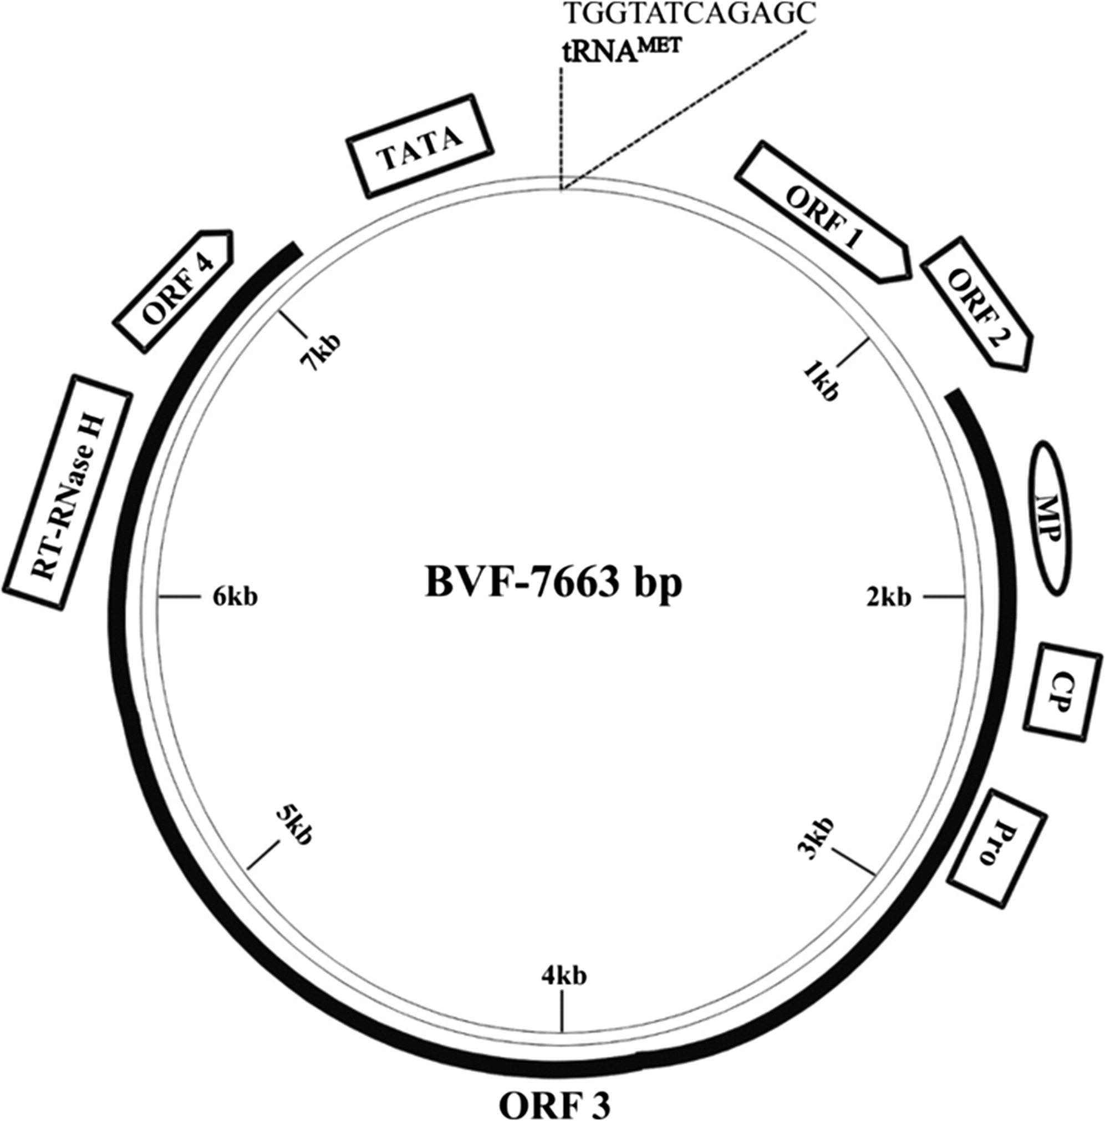

Figure 4. Schematic representation of the blackberry virus F (BVF) genome showing relative positions of tRNA binding site TATA box (denoted by box); open reading frame (ORF)1; ORF2; ORF3, with movement protein (MP), capsid protein zinc-finger domain (CP), pepsin-like asparate protease (Pro), reverse transcription (RT), and RNase H (RNase H) motifs; and ORF4. From Shahid et al. (2017).

Cacao swollen shoot CE virus (CSSCEV), Cacao swollen shoot Ghana M virus (CSSGMV), Cacao swollen shoot Ghana N virus (CSSGNV), Cacao swollen shoot Ghana Q virus (CSSGQV) and Cacao bacilliform Sri Lanka virus (CBSLV) can be considered new species in the genus Badnavirus for the following reasons:
- Their genomes are typical of the genus Badnavirus and share the same organization as those of previously reported cacao swollen shoot viruses. They consist of circular double-stranded DNA molecules of 7.0-7.3 kbp with five open reading frames (ORFs). ORF3 encodes a large polyprotein containing the conserved domains of movement protein, capsid protein, aspartic protease, reverse transcriptase (RT) and ribonuclease H (RH).
- In phylogenetic analyses, these viruses group within the genus Badnavirus (Fig. 8). They differ by more than 20% in the RT-RH region from previously recognized badnaviruses and from each other (Table 1), thus being below the 80% nt threshold for demarcation of species. Phylogenetic trees of cocoa badnaviruses are provided in Figures 2 and 3 in Muller et al. (2018).

Cacao swollen shoot CE virus (CSSCEV) was reported as partial sequences from cocoa badnavirus subgroup E in Kouakou et al. (2012) and Abrokwah et al. (2016). Based on phylogenetic analyses, CSSCEV is the same species as the one described as a new species by Chingandu et al. (2017) and for which the name cacao red vein virus was proposed by these authors. CSSCEV nucleotide sequence corresponding to the RT/RNAse H domain shares 82.3%, 82.9%, 84.5% and 87.5% identity with those of Cacao red vein virus isolates CI286, GH67, CI275 and GH64, respectively.

Dioscorea bacilliform ES virus (DBESV) and Dioscorea bacilliform AL virus 2 (DBALV 2) can be considered new species in the genus Badnavirus for the following reasons:
- DBESV and DBALV 2 have circular dsDNA genomes of 8106 bp and 7871 bp, respectively, with three open reading frames (ORFs).
- Both DBESV and DBALV 2 genomes harbour a tRNA^{Met} primer binding site.
- DBESV and DBALV 2 putative polyproteins encoded by their respective ORFs3 harbor conserved domains/motifs typical of badnavirus movement protein (MP), capsid protein (CP), zinc finger (Zn), aspartic protease (AP), reverse transcriptase (RT) and ribonuclease H (RNaseH) (Fig. 5).
- In phylogenetic analyses using the RT/RNAseH domain nucleotide sequence, DBESV and DBALV 2 group within the genus Badnavirus. They are most closely related to each other (Fig. 8) than to any other species in the genus Badnavirus.
- DBESV and DBALV 2 nucleotide sequences corresponding to their reverse trancriptase / RNaseH domains each share a maximum identitiy of 74.1% with those of other badnaviruses (Table 1), which is below the 80% threshold for discrimination of species within the genus Badnavirus.

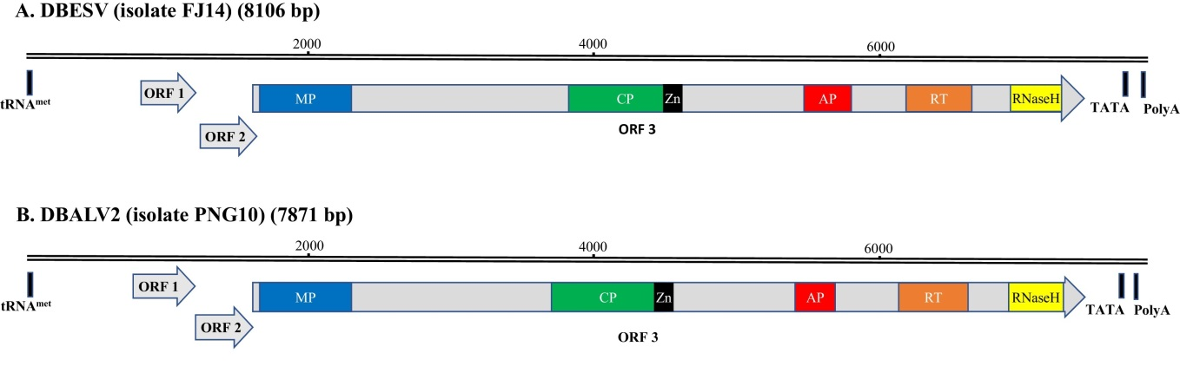

Figure 5. Linearized representation of the genome organization Dioscorea bacilliform ES virus (DBESV; A) and Dioscorea bacilliform AL virus 2 (DBALV2; B). The putative tRNAmet-binding site (tRNAmet), TATA box and polyadenylation signal (polyA) are shown. Conserved motifs within ORF3-encoded polyprotein are shown: movement protein (MP), capsid protein (CP), zinc finger (Zn), aspartic protease (AP), reverse transcriptase (RT) and ribonuclease H (RNaseH). From Sukal et al. (2017).

Jujube mosaic-associated virus (JuMaV) can be considered a new species in the genus Badnavirus for the following reasons:
- JuMaV has a circular dsDNA genomes of 7194 bp with five open reading frames (ORFs).
- JuMaV genomic organization, primer binding sites and ORF sizes are similar to those reported for other badnaviruses, except for ORF3, which is split into ORF3a and ORF3b with a 70-nt intergenic region
- JuMaV putative proteins encoded by ORF 3a and ORF 3b harbour conserved domains/motifs typical of badnavirus movement protein, zinc finger, aspartic protease, reverse transcriptase and ribonuclease H (Fig. 6)
- In phylogenetic analyses using the RT/RNAseH domain nucleotide sequence, JuMaV groups within the genus Badnavirus. Its closest relative is Bougainvillea chlorotic vein-banding virus (BCVBV) (Fig. 8).
- JuMaV nucleotide sequence corresponding to its reverse trancriptase / RNaseH domain shares a maximum identity of 68.4% with those of other badnaviruses (Table 1), which is below the 80% threshold for discrimination of strains and species within the genus Badnavirus

Figure 6. Linearized representation of the genome Jujube mosaic-associated virus (JuMaV). Conserved motifs are marked as follows: movement protein (black star), zinc finger (black circle), aspartic protease (black triangle), reverse transcriptase (black diamond) and ribonuclease H (black square). From Du et al. (2017).

Rudbeckia flower distortion virus (RuFDV) can be considered a new species in the genus Caulimovirus for the following reasons:
- RuFDV has 42–45 nm icosahedral particles characteristic of the genus Caulimovirus.
- The dsDNA genome of RuFDV is 8222 bp in size and contains 7 open reading frames (ORFs), similarly to other members of the genus Caulimovirus. The putative movement protein is encoded by ORF2, whereas the MP of other caulimoviruses is encoded by ORF1 (Fig. 7).
- RuFDV ORF5 encodes a polyprotein containing aspartic protease, reverse transcriptase (RT) and RNase H (RH) domains that is characteristic of viruses in the family Caulimoviridae.
- In phylogenetic analyses using the RT/RNAseH domain nucleotide sequence, RuFDV groups within the genus Caulimovirus. Its closest relative is Strawberry vein banding virus (SVBV) (Fig. 8).
- RuFDV nucleotide sequence corresponding to its reverse trancriptase / RNaseH domain shares a maximum identity of 61.9% with those of other badnaviruses (Table 1), which is below the 80% threshold for discrimination of strains and species within the genus Caulimovirus

Figure 7. Comparison of the genome organisation of Rudbeckia flower distortion virus (RuFDV) with the type species of other genera with isometric virions in the Caulimoviridae. Abbreviations are: ORF, open reading frame; MP, movement protein; CP, capsid protein; RYVV, Rose yellow veins virus (genus Rosadnavirus); CaMV, Cauliflower mosaic virus (genus Caulimovirus); SbCMV, Soybean chlorotic mottle virus (genus Soymovirus); CsVMV, Cassava vein mosaic virus (genus Cavemovirus); PVCV, Petunia vein clearing virus (genus Petuvirus). An open box represents an ORF and the upward-pointing arrow, the position of the tRNA^{MET} consensus sequence. The replicase polyprotein contains the aspartic protease, reverse transcriptase and RNaseH enzyme precursors. From Lockhart et al., 2017.

2. A nomenclature change in the genus Badnavirus

Species Cacao swollen shoot virus was the first described virus species responsible for the swollen shoot disease of cocoa (Hagen et al., 1993) and corresponds to reference isolate ToAgou1-93 (Genbank accession number L14546). This isolate originates from Togo and was later shown to belong to subgroup B of cacao swollen shoot viruses.

Two additional Cacao swollen shoot virus species were added to the taxonomy in 2015: Cacao swollen shoot TA virus (isolate Wobe 12, originating from Togo and belonging to subgroup A; Genbank accession number AJ781003; Muller & Sackey, 2005) and Cacao swollen shoot CD virus (isolate CI152, originating from Cote d’Ivoire and belonging to subgroup D; Genbank accession number: JN606110; Muller & Sackey, 2005). The creation of an additional five new CSSV species (CSSCEV, CSSGMV, CSSGNV, CSSGQV and CSSGRV) is proposed in 2018 (Muller et al., 2018).

By convention, CSSV species names include the first letter of the name of the country of origin where the viral species was first described (C: Côte d’Ivoire; G: Ghana; T: Togo) and the code letter corresponding to the Cacao swollen shoot virus subgroup to which these species belong. For coherence it is proposed to change the name Cacao swollen shoot virus to Cacao swollen shoot Togo B virus (CSSTBV).

Figure 8. Phylogenetic tree showing placement of angelica bushy stunt virus (AnBSV), birch leaf roll-associated virus (BLRaV), blackberry virus F (BVF), canna yellow mottle associated virus (CaYMAV), cacao swollen shoot CE virus (CSSCEV), cacao swollen shoot Ghana M virus (CSSGMV), cacao swollen shoot Ghana N virus CSSGNV), cacao swollen shoot Ghana Q virus (CSSGQV), cacao bacilliform Sri Lanka virus (CBSLV), dioscorea bacilliform ES virus (DBESV), dioscorea bacilliform AL virus 2 (DBALV 2), jujube mosaic-associated virus (JuMaV) and rudbeckia flower distortion virus (RuFDV) in genera Badnavirus and Caulimovirus. Maximum likelihood analysis with 1000 bootstrap sets were performed on nucleotide sequences corresponding to the RT-RNase H domains. Type species of other genera in the Caulimoviridae family are also included. Sequences of the proposed new species are shown in red boxes.
Table 1. Percent nucleotide identities for the Caulimoviridae in ORF3 nucleotide sequences corresponding to the conserved RT/RNAseH domain. Proposed new species are highlighted in yellow.

References:
Abrokwah F, Dzahini-Obiatey H, Galyuon I, Osae-Awuku F, Muller E (2016) Geographical distribution of Cacao swollen shoot virus molecular variability in Ghana. Plant Dis 100: 2011-2017.
Bömer M, Rathnayake AI, Visendi P, Silva G, Seal SE (2018) Complete genome sequence of a new member of the genus Badnavirus, Dioscorea bacilliform RT virus 3, reveals the first evidence of recombination in yam badnaviruses. Arch Virol 163: 533-538. doi: 10.1007/s00705-017-3605-9.
Chingandu N, Kouakou K, Aka R, Ameyaw G, Gutierrez OA, Herrmann HW, Brown JK (2017) The proposed new species, Cacao red vein virus, and three previously recognized badnavirus species are associated with cacao swollen shoot disease. Virol J 14: 199.
Du K, Liu S, Chen Z, Fan Z, Wang H, Tian G, Zhou (2017) Full genome sequence of jujube mosaic-associated virus, a new member of the family Caulimoviridae. Arch Virol 162: 3221-3224. doi: 10.1007/s00705-017-3438-6.
Hagen LS, Jacquemond M, Lepingle A, Lot H, Tepfer M (1993). Nucleotide sequence and genomic organization of cacao swollen shoot virus. Virology 196: 619-28.
Kouakou K, Kebe I, Kouassi N, Aké S, Cilas C, Muller E (2012) Geographical distribution of cacao swollen shoot virus (CSSV) molecular variability in Côte d'Ivoire. Plant Dis 96: 1445-1450.
Lim S, Baek D, Igori D, Moon JS (2017) Complete genome sequence of a putative new caulimovirus which exists as endogenous pararetroviral sequences in Angelica dahurica. Arch Virol 162: 3837-3842.
Muller E, Sackey S (2005) Molecular variability analysis of five new complete cacao swollen shoot virus genomic sequences. Arch Virol 150:53-66.
Muller E, Ravel S, Agret C, Abrokwah F, Dzahini-Obiatey H, Galyuon I, Kouakou K, Jeyaseelan EC, Allainguillaume J, Wetten A (2018). Next generation sequencing elucidates cacao badnavirus diversity and reveals the existence of more than ten viral species. Virus Res 244: 235-251.
Rumbou A, Candresse T, Marais A, Theil S, Langer J, Jalkanen R, et al. (2018) A novel badnavirus discovered from Betula sp. affected by birch leaf-roll disease. PLoS ONE 13: e0193888.
Shahid MS, Aboughanem-Sabanadzovic N, Sabanadzovic S, Tzanetakis IE (2017) Genomic characterization and population structure of a badnavirus infecting blackberry. Plant Dis 101: 110-115.
Sukal A, Kidanemariam D, Dale J, James A, Harding R (2017) Characterization of badnaviruses infecting Dioscorea spp. in the Pacific reveals two putative novel species and the first report of dioscorea bacilliform RT virus 2. Virus Res 238:29-34.
Wijayasekara D, Hoyt P, Gimondo A, Dunn B, Thapa A, Jones H, Verchot J (2018) Molecular characterization of two badnavirus genomes associated with Canna yellow mottle disease. Virus Res 243:19-24.

