
This form should be used for all taxonomic proposals. Please complete all those modules that are applicable.
For guidance, see the notes written in blue and the separate document “Help with completing a taxonomic proposal”

Please try to keep related proposals within a single document.

Part 1: TITLE, AUTHORS, etc

Code assigned: | 2018.020P |  |  |  | (to be completed by ICTV officers)
Short title: One (1) new species in one (1) new genus (Coguvirus) in the order Bunyavirales (e.g. 6 new species in the genus Zetavirus)
Modules attached  (Modules 1, 4 and either 2 or 3 are required. |  | 1 2 3 4
Author(s):
Di Serio, Francesco; francesco.diserio@ipsp.cnr.it
Navarro, Beatriz; beatriz.navarro@ipsp.cnr.it
Minutolo, Maria; minutolm@unina.it
Alioto, Daniela; alioto@unina.it
Corresponding author with e-mail address:
Francesco Di Serio, francesco.diserio@ipsp.cnr.it
List the ICTV study group(s) that have seen this proposal:
A list of study groups and contacts is provided at http://www.ictvonline.org/subcommittees.asp . If in doubt, contact the appropriate subcommittee chair (there are six virus subcommittees: animal DNA and retroviruses, animal ssRNA-, animal ssRNA+, fungal and protist, plant, bacterial and archaeal) |  |  | ICTV Bunyavirales Study Group
ICTV Study Group comments (if any) and response of the proposer:
Date first submitted to ICTV: |  |  |  | 28/01/2018
Date of this revision (if different to above):

ICTV-EC comments and response of the proposer:

Part 2: PROPOSED TAXONOMY
Present the proposed new taxonomy on accompanying spreadsheet
Name of accompanying spreadsheet: 2018.020P.N.v1.Coguvirus.xlsx
Please display the taxonomic changes you are proposing on the accompanying spreadsheet module 2017_TP_Template_Excel_module. Submit both this and the spreadsheet to the appropriate ICTV Subcommittee Chair.

Part 4: APPENDIX: supporting material
additional material in support of this proposal
Please explain the reasons for the taxonomic changes you are proposing and provide evidence to support them. The following information should be provided, where relevant:
- Species demarcation criteria: Explain how new species differ from others in the genus and demonstrate that these differences meet the criteria previously established for demarcating between species. If no criteria have previously been established, and if there will now be more than one species in the genus, please state the demarcation criteria you are proposing.
- Higher taxa:
  - There is no formal requirement to state demarcation criteria when proposing new genera or other higher taxa. However, a similar concept should apply in pursuit of a rational and consistent virus taxonomy.
  - Please indicate the origin of names assigned to new taxa at genus level and above.
  - For each new genus a type species must be designated to represent it. Please explain your choice.
- Supporting evidence: The use of Figures and Tables is strongly recommended (note that copying from publications will require permission from the copyright holder). For phylogenetic analysis, try to provide a tree where branch length is related to genetic distance.

A new species, Citrus coguvirus, in a new genus, Coguvirus (order Bunyavirales)

Proposal of the new species Citrus coguvirus
A novel virus has been identified in citrus and named Citrus concave gum-associated virus (CCGaV) because of its close association with citrus concave gum disease (Navarro et al., 2017). CCGaV is an RNA virus with a bisegmented genome: RNA1 encodes the RNA-dependent RNA polymerase (RdRp, p195) in the viral complementary (vc) strand, while RNA2 is a bicistronic ambisense RNA that encodes a putative movement protein (MP, p46) in the viral (v) strand and the nucleoprotein (NP, p39) in the vc strand (Figure 1). CCGaV produces flexuous non-enveloped virions (Figure 2).
Overall pairwise identity of proteins encoded by CCGaV with those of previously reported negative sense (ns) RNA viruses range from 17.82 to 25.98% (Table 1). CCGaV should be considered as a representative member of a novel virus species because amino acid (aa) sequence identities between proteins encoded by this virus and the corresponding proteins of previously reported nsRNA viruses are very low. We propose to call this novel species Citrus coguvirus. The term Citrus refer to the genus of the host plant in which the virus has been first identified, the term “coguvirus” derives from the name of the novel genus that should be created to classify this novel species (see below). The name Citrus coguvirus has not been used previously for any other virus species.

Proposal of the new genus Coguvirus (order Bunyavirales)
CCGaV is clearly related to bunyaviruses by having:
i) A multipartite, negative/ambisense single-stranded RNA genome (two segments) (Figure 1);
ii) Proteins with aa sequence identity with bunyaviral orthologous proteins; in particular, five conserved motifs (A–E) in the amino acid sequence of its RdRp similar to those encoded in bunyaviral L segments (Figure 3), and a NP with a stretch of 218 amino acids (from amino acid 90 to 307) closely related to a conserved domain in the NPs of tenuiviruses and phleboviruses;
iii) Genomic RNAs sharing stretches (up to 26 nt) of almost identical nucleotides at their 5’ and 3’ ends, with the very last nine nucleotides being almost identical to those reported previously at the 5’ and 3’ RNA termini of classified bunyaviruses (phleboviruses and tenuiviruses) and forming similar panhandle structures (Figure 4);
iv) A genomic bicistronic ambisense RNA containing an AU rich intergenic region (IR) (Figure 1) likely involved in the regulation of transcription termination during mRNA synthesis, as also reported for ambisense genomic components of other bunyaviruses; and
v) An IR sequence stretch (CUCUGCU) resembling the terminal transcription signal (TTS) reported previously for several phleboviruses (Figure 5).

The differences between CCGaV and other bunyaviruses are:
i) The genomic organization of CCGaV. In fact, a bicistronic ambisense RNA encoding both the CP and the MP has not been reported for other bunyaviruses. However, CCGaV RNA2 shares a similar expression strategy (including identical transcription termination signals) with ambisense RNAs of phleboviruses. The different genomic organization with respect to other bunyaviruses infecting plants can be explained by the likely modular evolution of nsRNA genomes (Navarro et al., 2017);
ii) Most bunyaviruses, but not CCGaV, produce enveloped virions. However, tenuiviruses (family Phenuiviridae) also produce non-enveloped virions. Therefore, the two differences reported above should not preclude the assignment of CCGaV to the order Bunyavirales.

Among bunyaviruses, CCGaV is most related to members of the genera Phlebovirus and Tenuivirus of the family Phenuiviridae by having:
i) The structural features reported above, which have been also reported for other viruses of this family (phleboviruses and tenuiviruses);
ii) Octanucleotides at 5' (5'-ACACAAAG) and 3' (CUUUGUGU-3') termini highly conserved in genomes of members of both Phlebovirus and Tenuivirus genera (Figure 4);
iii) Close phylogenetic relationships with members of this family, as shown by maximum likelihood phylogenetic analyses of the CCGaV-encoded RdRp and NP, which consistently place CCGaV in the same cluster with phenuiviruses, tenuiviruses, goukoviruses, and phasiviruses (Figures 5 and 6).

However, relevant differences between CCGaV and members of genera in the family Phenuiviridae do exist, including:
a) The number of genomic components, which are two in CCGaV; in contrast, members of the family Phenuiviridae have genomes composed of at least three segments;
b) The absence of a gene coding for a glycoprotein in CCGaV. Although enveloped tenuiviruses
have not been found, these viruses encode glycoproteins related to those of phleboviruses;
c) A putative MP phylogenetically related to members of the non-bunyaviral family Ophioviridae and not to members of the genus Tenuivirus (Figure 7);
d) The absence of data supporting arthropod-mediated transmission of CCGaV and/or of the associated disease in citrus.

These differences argue against the inclusion of Citrus coguvirus within the family Phenuiviridae. Moreover, the member of this species does not fulfill the criteria for inclusion in any existing genus and/or family of the order Bunyavirales. Therefore, we propose that Citrus coguvirus is classified in a new floating (ie, unassigned to a family) genus in the order. The name proposed for this new genus is Coguvirus.

Species demarcation criteria:
Similarly to other bunyavirus genera, a threshold of <90% aa identity for the core polymerase domain is proposed as a species demarcation criterion within the new genus Coguvirus.

Origin of the name of new genus: The name of the genus Coguvirus derives from the name of concave gum-associated virus, a member of the type species Citrus coguvirus.

Table 1: Pairwise identity of best BLASTP matches with CCGaV proteins.
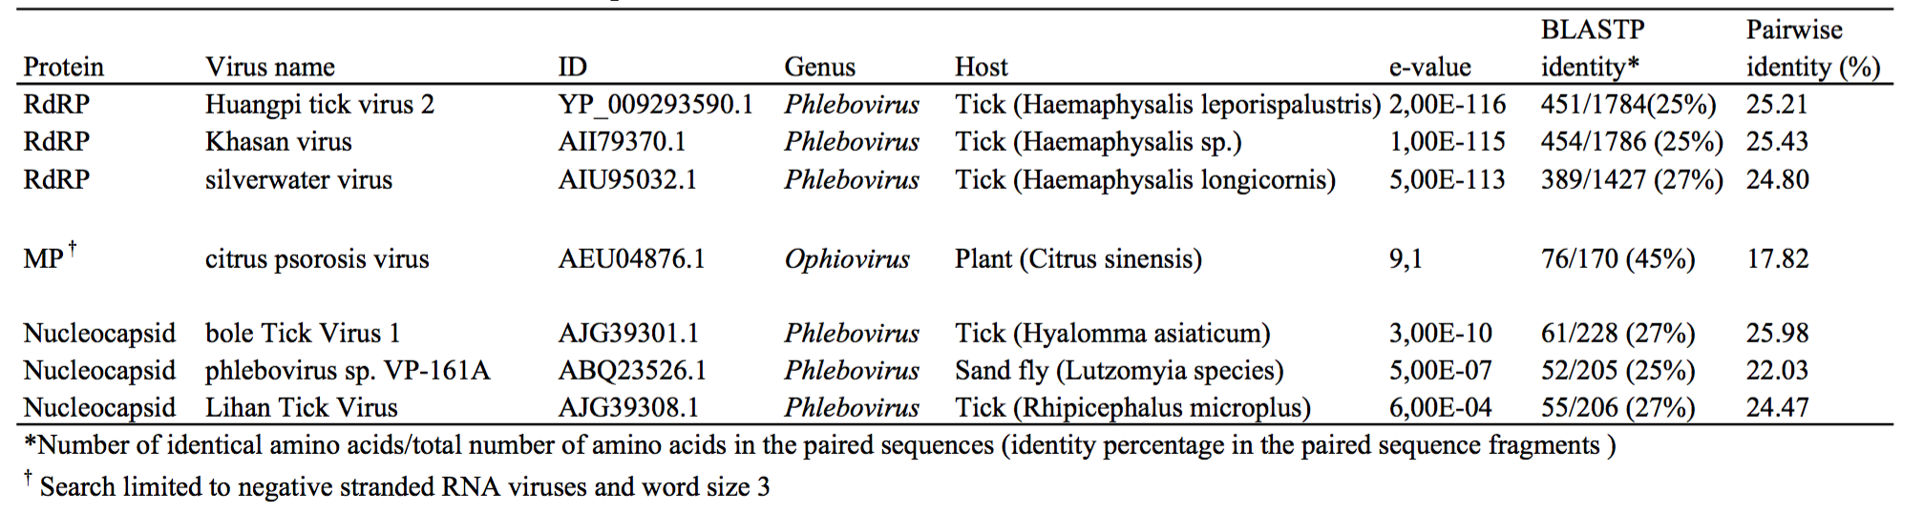
This table is adapted from Navarro et al., Molecular Plant Pathology 2018, 19: 1075-1089.

Figure 1. Citrus concave gum-associated virus genome organization and expression strategy. (a) Schematic diagram. MP, movement protein; NP, nucleocapsid protein; ORF, open reading frame; RdRp, RNA-dependent RNA polymerase; vRNA, viral RNA; vcRNA, viral complementary RNA. (Adapted from Navarro et al., Molecular Plant Pathology 2018, 19: 1075-1089, Doi: 10.1111/mpp.12587).

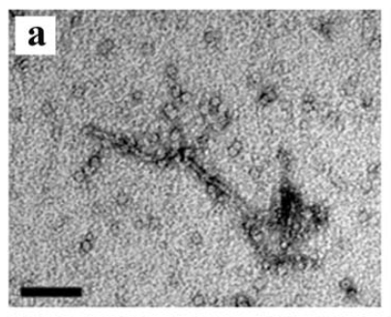

Figure 2. Electron micrograph of Citrus concave gum-associated virus (CCGaV) particles. (a) Negative staining of a particle from the sap of an infected citrus tree. (Adapted from Navarro et al., Molecular Plant Pathology 2018, 19: 1075-1089, Doi: 10.1111/mpp.12587).

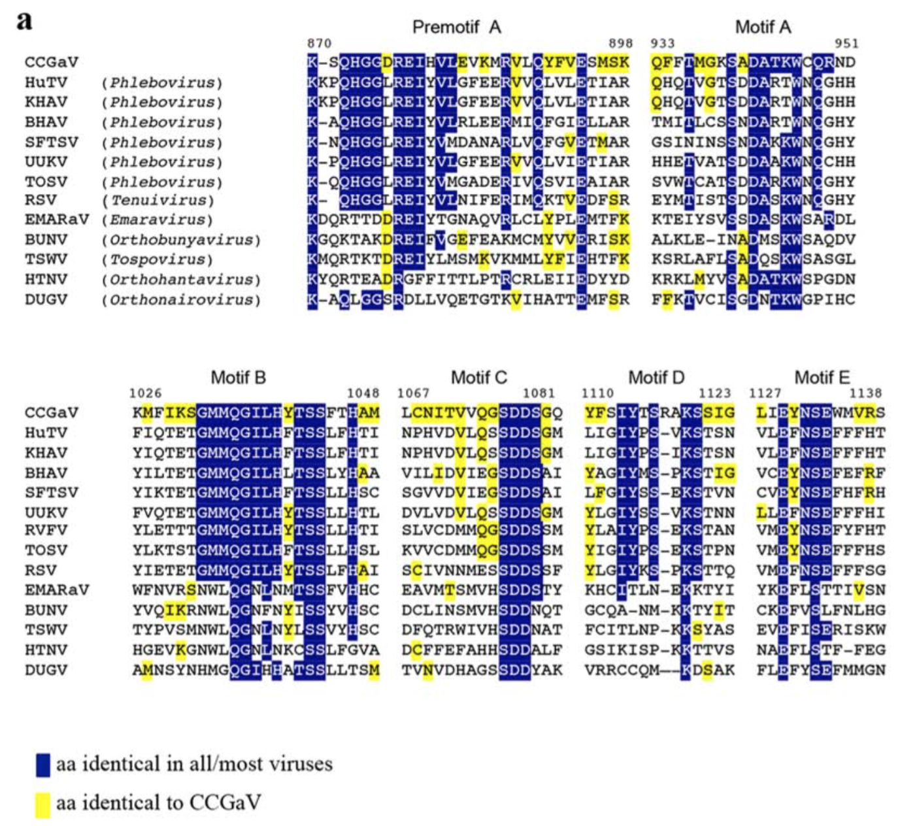

Figure 3. Relationships of Citrus concave gum-associated virus RNA-dependent RNA polymerase (RdRp) with those of other negative-stranded RNA (nsRNA) viruses. (a) Multiple alignment of RdRp conserved motifs. Positions in the CCGaV RdRp are reported. aa, amino acids; BHAV, Bhanja virus; BUNV, Bunyamwera virus; DUGV, Dugbe virus; EMARaV, European mountain ash ringspot-associated virus; HTNV, Hantaan virus; HuTV, Huángpí tick virus 2; KHAV, Khasan virus; RSV, rice stripe virus; RVFV, Rift Valley fever virus; SFTSV, severe fever with thrombocytopenia syndrome virus; TOSV, Toscana virus; TSWV, tomato spotted wilt virus; UUKV, Uukuniemi virus. (Adapted from Navarro et al., Molecular Plant Pathology 2018, 19: 1075-1089, Doi: 10.1111/mpp.12587).

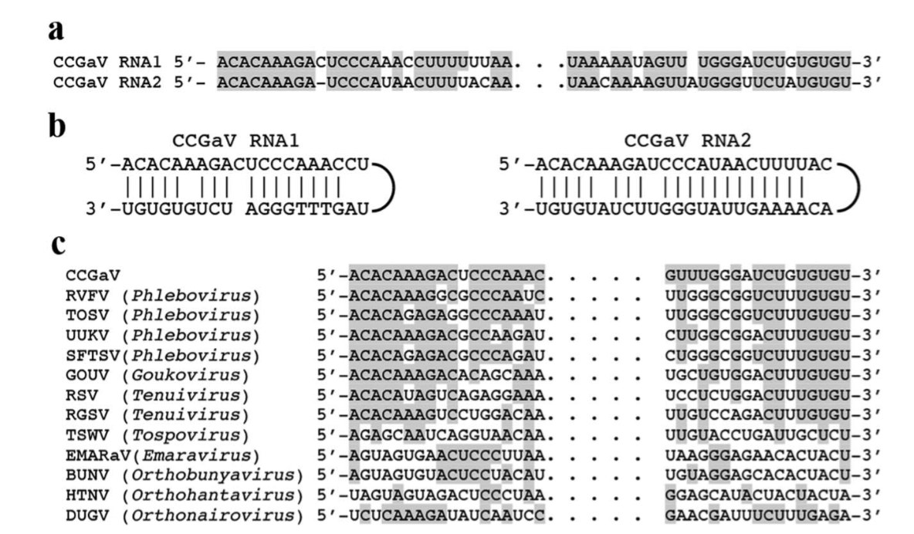

Figure 4. Terminal sequences of Citrus concave gum-associated virus genomic RNAs. (a) Alignment of 5' (left) and 3' (right) termini of CCGaV RNAs. (b) Panhandle structures formed by the 5' and 3' termini of CCGaV RNAs. (c) Alignment of CCGaV RNA1 termini with those of other negative-stranded RNA (nsRNA) viruses. Identical nucleotides are in grey. BUNV, Bunyamwera virus; DUGV, Dugbe virus; EMARaV, European mountain ash ringspot-associated virus; GOUV, Gouleako virus; HTNV, Hantaan virus; RGSV, rice grassy stunt virus; RSV, rice stripe virus; RVFV, Rift Valley fever virus; SFTSV, severe fever with thrombocytopenia syndrome; TOSV, Toscana virus; TSWV, tomato spotted wilt virus; UUKV, Uukuniemi virus. (From Navarro et al., Molecular Plant Pathology 2018, 19: 1075-1089, Doi: 10.1111/mpp.12587).

Figure 5. Phylogenetic analysis based on the RdRp conserved domain. CCGaV, representative members of order Bunyavirales and several unclassified nsRNA viruses are considered. The RdRp-based phylogenetic tree was inferred using the maximum likelihood (ML) method based on the best-fit LG amino acid substitution model, with a gamma distribution of rate variation with four categories and a subtree pruning and regrafting topology searching algorithm. The analysis was implemented in MEGA7. The name of viruses, the accession number and the respective host organisms (invertebrate, I; vertebrate, V; invertebrate and vertebrate, IV; plant, P; plant and invertebrate, PI; fungus, F) are shown at the branch tip. The number at each node is the result of bootstrap analysis (100 replicates). Tree branches are proportional to genetic distances between sequences; the scale bar indicates substitutions per amino acid site. The names of recognized genera and of a novel lineage (phlebo-like viruses) related to phleboviruses are reported on the right. (From Navarro et al., Molecular Plant Pathology 2018, 19: 1075-1089, Doi: 10.1111/mpp.12587).

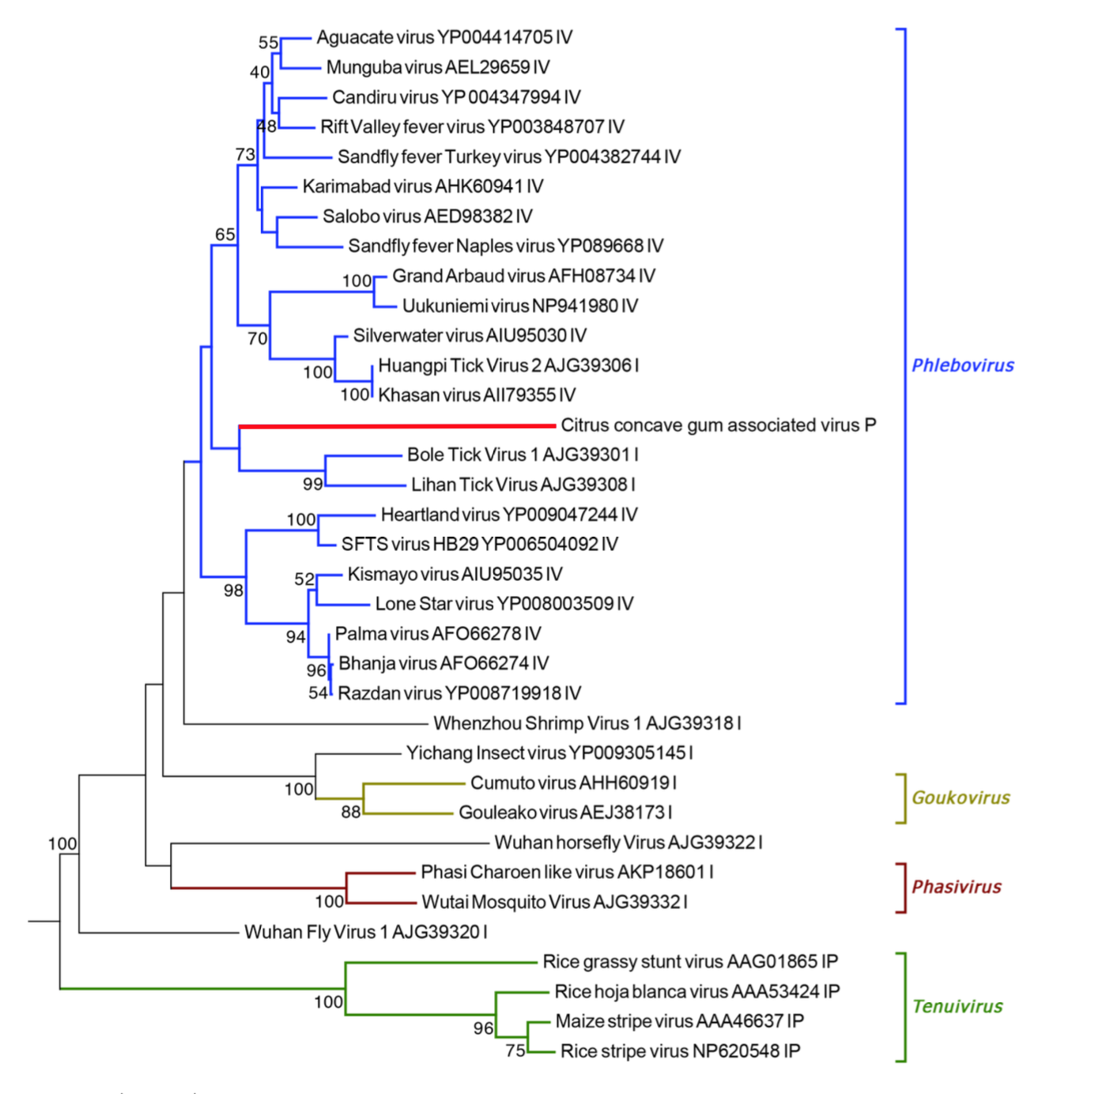

Figure 6. Maximum likelihood phylogenetic tree inferred with p39 of Citrus concave gum-associated virus (CCGaV) and the NP proteins of representative viruses of the genera Phlebovirus (family Phenuiviridae), Goukovirus, Phasivirus and Tenuivirus (family Phenuiviridae) and some unclassified phlebo-like viruses. The phylogenetic tree was inferred using MEGA7 adopting the protein best-fit substitution model LG+G. The number at each node is the result of bootstrap analysis (1,000 replicates). Tree branches are proportional to genetic distances between sequences and the scale bar at the bottom indicates substitutions per amino acid site. Square brackets delimit clusters of viruses belonging to the same genus, the name of which is on the right. The CCGaV branch is highlighted with red color. (From Navarro et al., Molecular Plant Pathology 2018, 19: 1075-1089, Doi: 10.1111/mpp.12587).

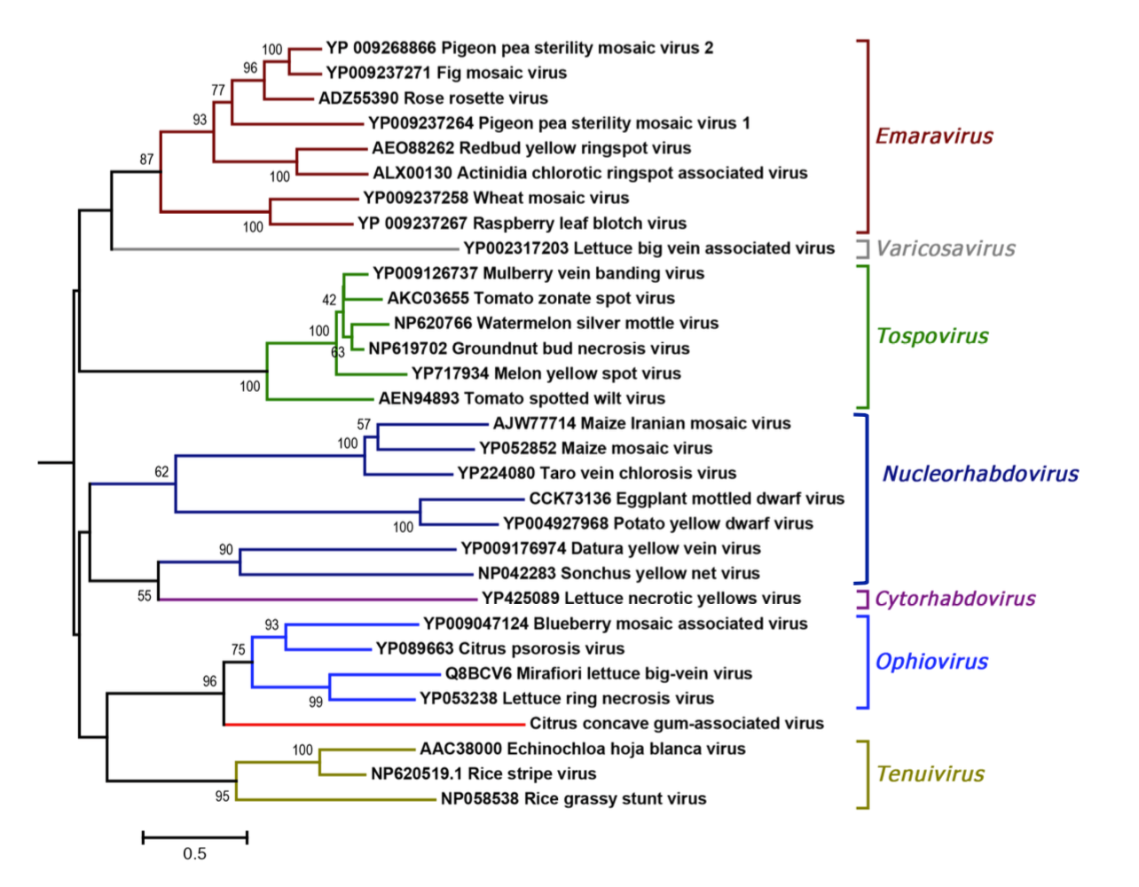

Figure 7. Maximum likelihood phylogenetic tree inferred with the putative movement protein (MP) of Citrus concave gum-associated virus (CCGaV) and the MP of representative plant-infecting viruses of the genera Emaravirus, Ophiovirus, Tenuivirus, Orthotospovirus, Nucleorhabdovirus, Cytorhabdovirus and Varicosavirus. The tree was generated in the CLC Main Workbench 7.7.3 package (protein best-fit substitution model JTT). The number at each node is the result of bootstrap analysis (1,000 replicates). Tree branches are proportional to genetic distances between sequences and the scale bar at the bottom indicates substitutions per amino acid site. Square brackets delimit clusters of viruses belonging to the same genus, the name of which is on the right. The CCGaV branch is highlighted with red color. (From Navarro et al., Molecular Plant Pathology 2018, 19: 1075-1089, Doi: 10.1111/mpp.12587).

References:
Navarro B, Minutolo M, De Stradis A, Palmisano F, Alioto D, Di Serio F (2018) The first phlebo-like virus infecting plants: a case study on the adaptation of negative-stranded RNA viruses to new hosts. Molecular Plant Pathology 19: 1075-1089, Doi: 10.1111/mpp.12587

