

The International Committee on Taxonomy of Viruses
Taxonomy Proposal Form, 2025

Part 1a: Details of taxonomy proposals

Title: | Create 2 suborders, 4 genera and 9 species within the order Imitervirales
Code assigned: | 2025.011.F.A.v2.Imitervirales_newtaxa

Author(s), affiliation and email address(es):
Given name (+middle initial(s)) | Surname | Affiliation | Email address | Corr. author(s)
Victoria F | Queiroz | Department of Biological Sciences, Virginia Tech, Blacksburg, United States of America  Departamento de Microbiologia, Instituto de Ciências Biológicas, Universidade Federal de Minas Gerais, Belo Horizonte, Brazil | queirozvictoriaf@gmail.com
Frank O | Aylward | Department of Biological Sciences, Virginia Tech, Blacksburg, United States of America | faylward@vt.edu | X
Jônatas S | Abrahão | Departamento de Microbiologia, Instituto de Ciências Biológicas, Universidade Federal de Minas Gerais, Belo Horizonte, Brazil | jonatas.abrahao@gmail.com
Corina | Brussaard | Department of Biology, Lund University, Lund, Sweden.  Department of Marine Microbiology and Biogeochemistry, Royal Netherlands Institute for Sea Research (NIOZ), Texel, Netherlands.  Institute for Biodiversity and Ecosystem Dynamics (IBED), University of Amsterdam, Amsterdam, Netherlands. | corina.brussaard@nioz.nl
Matthias | Fischer | Max Planck Institute for Marine Microbiology in Bremen, Germany | mfischer@mpi.bremen.de
Rohit | Ghai | Department of Aquatic Microbial Ecology, Institute of Hydrobiology, Biology Centre of the Czech Academy of Sciences, 370 05 České Budějovice, Czech Republic. | ghai.rohit@gmail.com
Mohammad | Moniruzzaman | Department of Marine Biology and Ecology, University of Miami, Coral Gables, Miami, United States of America | m.monir@miami.edu
Hiroyuki | Ogata | Bioinformatics Center, Institute for Chemical Research, Kyoto University, Kyoto, Japan | ogata@kuicr.kyoto-u.ac.jp
Frederik | Schulz | DOE Joint Genome  Institute, Lawrence Berkeley National Laboratory, Alameda, United States of America | fschulz@lbl.gov
Curtis | Suttle | Departments of Earth, Ocean and Atmospheric Sciences, Botany, Microbiology and Immunology, and the Institute for the Oceans and Fisheries, University of British Columbia, Vancouver, BC, Canada | suttle@science.ubc.ca

Part 1b: Taxonomy Proposal Submission
ICTV Subcommittee:
Animal DNA Viruses and Retroviruses |  | Bacterial viruses
Animal minus-strand and dsRNA viruses |  | Fungal and protist viruses | X
Animal positive-strand RNA viruses |  | Plant viruses
Archaeal viruses |  | General

List the ICTV Study Group(s) that have seen or have been involved in creating this proposal:
Optional – complete only if formally voted on by an ICTV Study Group:
Study Group | Number of members
Study Group | Votes in support | Votes against | No vote

Submission date:

Part 1c: Feedback from ICTV Executive Committee (EC) meeting
Executive Committee Meeting Decision code: | X
A – Accept | X
Ac – Accept subject to revision by relevant subcommittee chair. No further vote required
U – Accept without revision but with re-evaluation and email vote by the EC
Uc – Accept subject to revision and re-evaluation and email vote by the EC
Ud – Deferred to the next EC meeting, with an invitation to revise based on EC comments
J - Reject
W - Withdrawn

Comments from the Executive Committee:

Part 1d: Revised Taxonomy Proposal Submission
Response of proposer:
Revision date:

Part 3: TAXONOMIC PROPOSAL

Taxonomic changes proposed:
Establish new taxon | X | Split taxon
Abolish taxon |  | Merge taxon
Move taxon | X | Promote taxon
Rename taxon |  | Demote taxon
Move and rename

Etymology (origin) of proposed taxonomic names:
Taxon name | Etymology of the term
“Orthomivirineae” | Prefix derived from Greek meaning "straight" or "correct"
“Catovirus” | After the most closely related representative with a name already used in the literature
“Catovirus klosterense” | After location of isolation: Klosterneuburg, Austria
“Moumouvirus maliense” | Isolate name modified to Latinized singular form
“Moumouvirus lavasanguinense” | Isolate name modified to Latinized singular form
“Megavirus caiporense” | Isolate name modified to Latinized singular form
“Paramivirineae” | Prefix derived from Greek meaning "related" or "similar"
“Budvirus” | After location of isolation: Bud, Czechia
“Budvirus rimovense” | After location of isolation: Rimov reservoir
“Punuivirus” | After the Incan mythology deity: Puñuy
“Punuivirus latens” | After the latent infection strategy of this virus
“Criusvirus” | After Greek titan: Crius
“Criusvirus kaneoense” | After location of isolation: Kanoehe bay, Hawaii
“Tethysvirus bergenense” | After location: Bergen, Norway
“Tethysvirus norvegense” | After location: Norway

Permission for use of names derived from a living person:
Taxon name | Full name of person from whom the name is derived | Attached

Abstract of Taxonomy Proposal:
Taxonomic rank(s) affected:
Order, Suborder, genus and species.

Description of current taxonomy:
The Imitervirales order currently comprises 4 families, 3 subfamilies, 14 genera and 22 species (proposal #2022.004F).

Proposed taxonomic change(s):
Here, we propose to create 4 new genera and 9 new species following the currently valid demarcation criteria, and create 2 suborders to accommodate the existing viral families of the order Imitervirales.

Justification:
A new knowledge generated in the past few years require updates in the taxonomy of the order Imitervirales by adding new isolates and representatives that had not been previously classified. In order to accurately depict the novel knowledge, we propose to reorganize the order by creating 2 suborders, 4 genera and 9 new species to classify new viruses in this order.

Text of Taxonomy proposal:
Taxonomic rank(s) affected:
Suborder, genus and species.
Two new suborders: “Orthomivirineae” and “Paramivirineae”, in the order Imitervirales;
Four new genera: “Catovirus” in the subfamiliy Klosneuvirinae, “Criusvirus” in the family Mesomimiviridae, “Budvirus” and “Punuivirus” in the family Allomimiviridae;
Nine new species: “Punuivirus latens”, “Budvirus rimovense”, “Tethysvirus bergenense”, “Tethysvirus norvegense”, “Criusvirus kaneoense”, “Catovirus klosterense”, “Megavirus caiporense”, “Moumouvirus maliense” and “Moumouvirus lavasanguinense”.

Description of current taxonomy:
The order Imitervirales currently comprises our families: Allomimiviridae, Mesomimiviridae, Mimiviridae, and Schizomimiviridae.
The family Mimiviridae comprises three subfamilies: Aliimimivirinae, Klosneuvirinae, and Megamimivirinae. A total of 14 genera and 22 species distributed along these 4 families and 3 subfamilies.

Proposed taxonomic change(s):
Currently, all large dsDNA viruses, popularly known as ‘giant viruses’, are classified in the phylum Nucleocytoviricota. This phylum comprises three recognized classes, namely Pokkesviricetes, Mriyaviricetes and Megaviricetes. Among the orders classified within the latter, the order Imitervirales draws attention due to the diversity, abundance and ubiquity of its members. Following the major reorganization of the order Imitervirales in 2022 (2022.004F.A.Imitervirales_reorg), additional representatives have been fully sequenced or newly isolated and sequenced [1-10].

To formally incorporate these newly characterized viruses into the existing taxonomy, we analyzed 18 new representatives together with the 43 genomes used in the previous classification. We employed both a concatenated phylogenetic approach and pairwise average nucleotide identity (ANI) analyses, following the previously established methodology and taxonomic demarcation criteria [11, 12]. Based on these results, we propose the establishment of four new genera and nine new species. Additionally, we classified several isolates within already recognized species. The proposed species and their respective isolates are listed in Table 1.

Proposed taxa:
The order Imitervirales
We propose the establishment of two new suborders: “Orthomivirineae”, comprising the family Mimiviridae, and “Paramivirineae”, comprising the families Allomimiviridae, Mesomimiviridae, and Schizomimiviridae (Figure 1).

The family Mimiviridae
This family comprises three subfamilies (Aliimimivirinae, Klosneuvirinae and Megamimivirinae).

The subfamily Klosneuvirinae
Currently, there are three recognized genera in the subfamily Klosneuvirinae (Fadolivirus, Theiavirus and Yasminevirus). We propose the creation of a fourth genus “Catovirus” comprising one new species “Catovirus klosterense” (Figures 2, 3), to classify the recent isolate catovirus naegleriensis [7].

The subfamily Megamimivirinae
There are five genera (Cotonvirus, Megavirus, Mimivirus, Moumouvirus, and Tupanvirus) and 11 recognized species within this subfamily.
We propose the creation of two new species within the genus Moumouvirus, namely “Moumouvirus maliense”, comprising two isolates moumouvirus maliensis and borely moumouvirus, and the species “Moumouvirus lavasanguinense”, comprising the isolate moumouvirus lavasanguinem (Figures 2, 3)[8].
We also propose the creation of one species within the genus Megavirus, “Megavirus caiporense”, comprising the isolated megavirus caiporense (Figures 2, 3) [9].

The family Mesomimiviridae
We propose the creation of two species, “Tethysvirus bergenense” and “Tethysvirus norvegense”, within the genus Tethysvirus, currently the sole genus of this family. The species will comprise the isolates Prymnesium kappa virus (PkV-RF02) and Haptolina ericina virus (HeV-RF02) (Figures 2, 4)[10].
Furthermore, we propose the creation of a second genus within this family, the genus “Criusvirus” and the species “Criusvirus kaneoense”, to comprise the recent isolate FloV-SA2 (Figures 2, 4) [3].

The family Allomimiviridae
Currently this family comprises two genera: Heliosvirus and Oceanusvirus. We further propose the creation of the genera “Budvirus” and “Punuivirus”, with one species each “Budvirus rimovense” and “Punuivirus latens” respectively, to classify the recent isolates budvirus and punuivirus (Figures 2, 5) [1, 2].

Demarcation criteria:
Following the previously accepted criteria, representatives showing a pairwise ANI greater than 95% across more than 75% of their predicted genes compared to existing species were classified within the same species (2022.004F.A.Imitervirales_reorg). The ones that did not meet this threshold were assigned to new species. Accordingly, five new isolates meet the criteria to be classified within the species Megavirus chilense, two within Mimivirus bradfordmassiliense, and one within Mimivirus lagoaense. Among the species proposed here within already established genera, “Moumouvirus maliense” includes two isolates that meet the classification criteria, while “Moumouvirus lavasanguinense”, “Tethysvirus bergenense”, “Tethysvirus norvegense”, and “Megavirus caiporense” each contain a single isolate (Table 1 and Figures 2 and 3).

Using the previously established phylogenetic approach, we constructed a tree based on seven conserved marker genes: DNA polymerase family B (PolB), RNA polymerase large subunit (RNAPL), A32-like packaging enzyme (A32), topoisomerase family II (TopoII), Virus Late Transcription Factor 3 (VLTF3), Transcription Factor IIB (TFIIB), and a superfamily II helicase (SFII), which have been shown to produce high-fidelity phylogenetic trees for the phylum Nucleocytoviricota [12]. In accordance with current taxonomic practices, higher taxa are delineated based on approximately equivalent phylogenetic depths (i.e., distance from the root). Applying these criteria, as well as the accepted threshold of >80% bootstrap support [2022.004F.A.Imitervirales_reorg], four newly analyzed isolates did not cluster within any previously established genera. As such, we propose the creation of four new genera, each represented by a single species and its corresponding isolate (see Table 1 and Figures 2–5). We also propose the creation of two suborders, the suborder “Orthomivirineae”, comprising the family Mimiviridae, and the suborder “Paramivirineae”, encompassing the families Allomimiviridae, Mesomimiviridae, and Schizomimiviridae (Figure 1).

Justification:
A new knowledge generated in the past few years require updates in the taxonomy of the order Imitervirales by adding new isolates and representatives that had not been previously classified. In order to accurately depict the novel knowledge, we propose to reorganize the order by creating 2 suborders, 4 genera and 9 new species to classify new viruses in this order of “giant viruses”.

References:
1- Helena H Vieira, Paul-Adrian Bulzu, Vojtěch Kasalický, Markus Haber, Petr Znachor, Kasia Piwosz, Rohit Ghai, Isolation of a widespread giant virus implicated in cryptophyte bloom collapse, The ISME Journal, Volume 18, Issue 1, January 2024, wrae029, https://doi.org/10.1093/ismejo/wrae029
2- Maria P. Erazo-Garcia et al., Cryptic infection of a giant virus in a unicellular green alga. Science 0, eads6303 DOI: 10.1126/science.ads6303
3- Thomy, J., Schvarcz, C.R., McBeain, K.A. et al. Eukaryotic viruses encode the ribosomal protein eL40. npj Viruses 2, 51 (2024). https://doi.org/10.1038/s44298-024-00060-2
4- Alempic, J.-M.; Lartigue, A.; Goncharov, A.E.; Grosse, G.; Strauss, J.; Tikhonov, A.N.; Fedorov, A.N.; Poirot, O.; Legendre, M.; Santini, S.; et al. An Update on Eukaryotic Viruses Revived from Ancient Permafrost. Viruses 2023, 15, 564. https://doi.org/10.3390/v15020564
5- Isolation of viruses, including mollivirus, with the potential to infect Acanthamoeba from a Japanese warm temperate zone
Morimoto D, Tateishi N, Takahashi M, Nagasaki K (2024) Isolation of viruses, including mollivirus, with the potential to infect Acanthamoeba from a Japanese warm temperate zone. PLOS ONE 19(3): e0301185. https://doi.org/10.1371/journal.pone.0301185
6- Azevedo, B.L.d.; Júnior, J.P.A.; Ullmann, L.S.; Rodrigues, R.A.L.; Abrahão, J.S. The Discovery of a New Mimivirus Isolate in Association with Virophage-Transpoviron Elements in Brazil Highlights the Main Genomic and Evolutionary Features of This Tripartite System. Viruses 2022, 14, 206. https://doi.org/10.3390/v14020206
7- Arthofer, P., Panhölzl, F., Delafont, V. et al. A giant virus infecting the amoeboflagellate Naegleria. Nat Commun 15, 3307 (2024). https://doi.org/10.1038/s41467-024-47308-2
8- Sandra Jeudy, Lionel Bertaux, Jean-Marie Alempic, Audrey Lartigue, Matthieu Legendre, Lucid Belmudes, Sébastien Santini, Nadège Philippe, Laure Beucher, Emanuele G Biondi, Sissel Juul, Daniel J Turner, Yohann Couté, Jean-Michel Claverie, Chantal Abergel, Exploration of the propagation of transpovirons within Mimiviridae reveals a unique example of commensalism in the viral world, The ISME Journal, Volume 14, Issue 3, March 2020, Pages 727–739, https://doi.org/10.1038/s41396-019-0565-y
9- de Aquino ILM, Serafim MSM, Machado TB, Azevedo BL, Cunha DES, Ullmann LS, Araújo JP, Abrahão JS.2023.Diversity of Surface Fibril Patterns in Mimivirus Isolates. J Virol97:e01824-22.https://doi.org/10.1128/jvi.01824-22
10- Ruth-Anne Sandaa, Haina Wang, Lingjie Meng et al. Discovery from in-depth molecular analyses of giant viruses: Haptophyte-infecting viruses change the genome condensing proteins of dinoflagellates, 30 January 2025, PREPRINT (Version 1) available at Research Square https://doi.org/10.21203/rs.3.rs-3957437/v1
11- Aylward, F.O., Abrahão, J.S., Brussaard, C.P. et al. Taxonomic update for giant viruses in the order Imitervirales (phylum Nucleocytoviricota). Arch Virol 168, 283 (2023). https://doi.org/10.1007/s00705-023-05906-3
12- Aylward FO, Moniruzzaman M, Ha AD, Koonin EV (2021) A phylogenomic framework for charting the diversity and evolution of giant viruses. PLoS Biol 19:e3001430
13- Minh BQ, Schmidt HA, Chernomor O, et al (2020) IQ-TREE 2: New Models and Efficient Methods for Phylogenetic Inference in the Genomic Era. Mol Biol Evol 37:1530–1534. https://doi.org/10.1093/MOLBEV/MSAA015
14- Letunic I, Bork P, Gmbh BS (2021) Interactive Tree Of Life (iTOL) v5: an online tool for phylogenetic tree display and annotation. Nucleic Acids Res 1–4. https://doi.org/10.1093/nar/gkab301

Accompanying files:
Filename | Description of contents
2025.###F.v2.Imitervirales_newtaxa.xlsx | ICTV’s official accompanying Excel module

Tables, Figures:
<Start here>
Table 1. Proposed taxonomy highlighted in yellow
Suborder | Family | Subfamily | Genus | Species | Virus Isolate | NCBI Access.
Paramivirineae | Allomimiviridae | - | Heliosvirus | Heliosvirus raunefjordenense | Pyramimonas orientalis virus 01B | MT663534:  MT663543
Paramivirineae | Allomimiviridae | - | Oceanusvirus | Oceanusvirus kaneohense | Tetraselmis virus 1 | KY322437
Paramivirineae | Allomimiviridae | - | Punuivirus | Punuivirus latens | punuivirus cr2937 | PV354230.1
Paramivirineae | Allomimiviridae | - | Budvirus | Budvirus rimovense | budvirus | OY749542.1
Paramivirineae | Mesomimiviridae | - | Tethysvirus | Tethysvirus hollandense | Phaeocystis globosa virus PgV-16T | KC662249
 |  |  |  |  | Phaeocystis globosa virus PgV-12T | HQ634147
 |  |  |  |  | Phaeocystis globosa virus PgV-14T | HQ634144
 |  |  |  | Tethysvirus ontarioense | Chrysochromulina parva virus BQ2 | MH918795
 |  |  |  | Tethysvirus raunefjordenense | Chrysochromulina ericina virus CeV-01B | KT820662
 |  |  |  | Tethysvirus bergenense | Prymnesium kappa virus isolate RF02 | PV100843
 |  |  |  | Tethysvirus norvegense | Haptolina ericina virus isolate RF02 | PV100843
Paramivirineae | Mesomimiviridae | - | Criusvirus | Criusvirus kaneoense | Florenciella sp. virus | PP542043.1
Paramivirineae | Schizomimiviridae | - | Biavirus | Biavirus raunefjordenense | Prymnesium kappa virus RF01 | HG999358
Paramivirineae | Schizomimiviridae | - | Kratosvirus | Kratosvirus quantuckense | Aureococcus anophagefferens virus isolate BtV-01 | KJ645900
Orthomivirineae | Mimiviridae | Aliimimivirinae | Rheavirus | Rheavirus sinusmexicani | Cafeteria roenbergensis virus BV-PW1 | GU244497
Orthomivirineae | Mimiviridae | Klosneuvirinae | Fadolivirus | Fadolivirus algeromassiliense | fadolivirus FV1/VV64 | MT418680
Orthomivirineae | Mimiviridae | Klosneuvirinae | Theiavirus | Theiavirus salishense | Bodo saltans virus strain NG1 | MF782455
Orthomivirineae | Mimiviridae | Klosneuvirinae | Yasminevirus | Yasminevirus saudimassiliense | yasminevirus sp. GU-2018 | UPSH01000001
Orthomivirineae | Mimiviridae | Klosneuvirinae | Catovirus | Catovirus klosterense | catovirus naegleriensis | OZ003748.1
Orthomivirineae | Mimiviridae | Megamimivirinae | Cotonvirus | Cotonvirus japonicum | cotonvirus japonicus | AP024483
Orthomivirineae | Mimiviridae | Megamimivirinae | Megavirus | Megavirus baoshanense | megavirus baoshan strain SH | MH046811
 |  |  |  | Megavirus chilense | megavirus chilensis | JN258408
 |  |  |  |  | megavirus lba isolate LBA111 | JX885207
 |  |  |  |  | megavirus terra1 genome | KF527229
 |  |  |  |  | megavirus courdo11 | JX975216
 |  |  |  |  | Acanthamoeba polyphaga mimivirus ASM381511v1 | MG602508
 |  |  |  |  | Acanthamoeba polyphaga mimivirus ASM381513v1 | MG602507
 |  |  |  |  | megavirus vitis isolate vigne | MG807319
 |  |  |  |  | megavirus sp. strain Yana14 | OQ411602
 |  |  |  |  | megavirus Me1-1 | BTIZ0100000(1-4).1
 |  |  |  |  | megavirus Me1-2 | BTJA0100000(1-8).1
 |  |  |  |  | mimivirus sp. isolate 2401 | PQ010613.1
 |  |  |  |  | mimivirus sp. strain daqing | MT663335.2
 |  |  |  | Megavirus powaiense | Powai lake megavirus isolate 1 | KU877344
 |  |  |  | Megavirus caiporense | megavirus caiporensis | OP925046.1
Orthomivirineae | Mimiviridae | Megamimivirinae | Mimivirus | Mimivirus bradfordmassiliense | Acanthamoeba polyphaga mimivirus ViralProj60053 | HQ336222
 |  |  |  |  | mimivirus terra2 genome | KF527228
 |  |  |  |  | Acanthamoeba castellanii mamavirus Hal-V | JF801956
 |  |  |  |  | Acanthamoeba castellanii mimivirus kasaii | AP017644
 |  |  |  |  | Acanthamoeba castellanii mimivirus shirakomae | AP017645
 |  |  |  |  | Acanthamoeba polyphaga mimivirus M4 | JN036606
 |  |  |  |  | Acanthamoeba polyphaga mimivirus Oyster | KM982401
 |  |  |  |  | Acanthamoeba polyphaga mimivirus | AY653733
 |  |  |  |  | hirudovirus strain Sangsue | KF493731
 |  |  |  |  | mimivirus Bombay isolate 1 | KU761889
 |  |  |  |  | Niemeyer virus | KT599914
 |  |  |  |  | Samba virus | KF959826
 |  |  |  |  | Acanthamoeba polyphaga mimivirus strain Amazonia | KM982403
 |  |  |  |  | mimivirus reunion isolate Queen | MW004169.1
 |  |  |  |  | mimivirus argentum | OL770070.1
 |  |  |  | Mimivirus lagoaense | Acanthamoeba polyphaga mimivirus Kroon | KM982402
 |  |  |  |  | mimivirus U306 | LT717347.1
Orthomivirineae | Mimiviridae | Megamimivirinae | Moumouvirus | Moumouvirus australiense | moumouvirus australiensis isolate 10A | MG807320
 |  |  |  | Moumouvirus goulettemassiliense | moumouvirus goulette | KC008572
 |  |  |  | Moumouvirus moumou | Acanthamoeba polyphaga moumouvirus | JX962719
 |  |  |  |  | Saudi moumouvirus | KY110734
 |  |  |  | Moumouvirus maliense | moumouvirus maliensis | MK978772.1
 |  |  |  |  | Borely moumouvirus isolate B60 | MN175499.1
 |  |  |  | Moumouvirus lavasanguinense | moumouvirus lavasanguinem | LC813553
Orthomivirineae | Mimiviridae | Megamimivirinae | Tupanvirus | Tupanvirus altamarinense | tupanvirus deep ocean | MF405918
 |  |  |  | Tupanvirus salinum | tupanvirus soda lake | KY523104

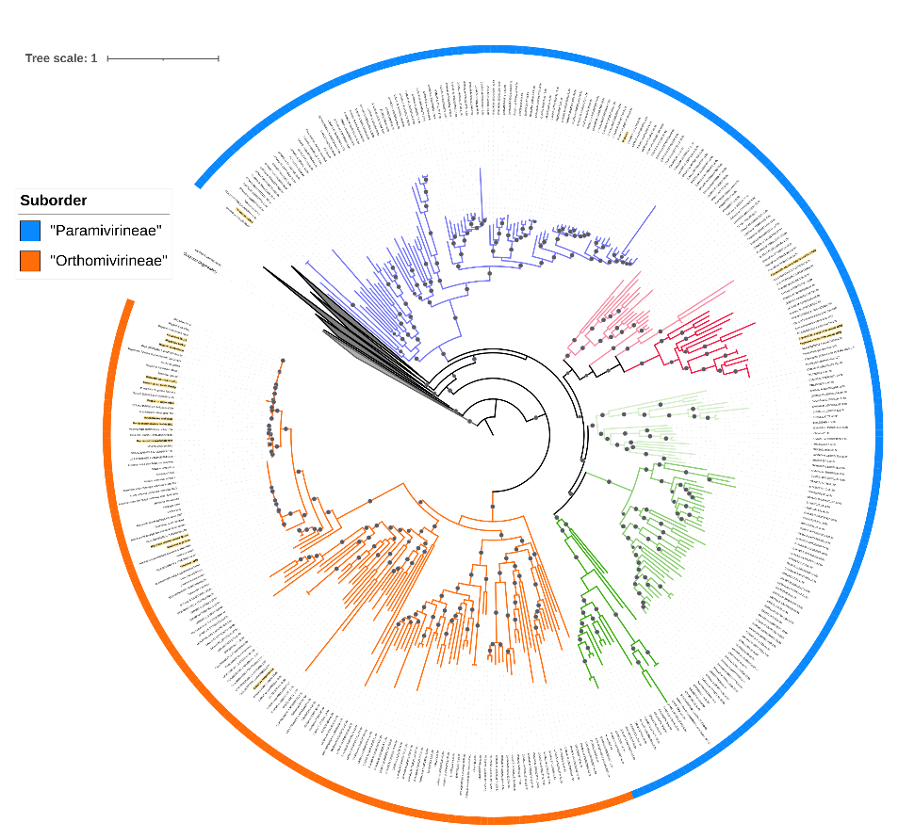
Figure 1. Phylogeny of the order Imitervirales, based on a concatenated alignment of seven marker genes (RNAPL, A32, VLTF3, TFIIB, SFII, TopoII, DNAPolB)[11]. The tree was constructed using a subset of the Giant Virus Database (https://faylward.github.io/GVDB/) and the ncldv_markersearch workflow (https://github.com/faylward/ncldv_markersearch) [12]. The Maximum Likelihood based phylogeny (LG+F+R10) was constructed using IQ-TREE multicore version 2.3.6 [13]. The branch supports were computed by 1000 ultrafast bootstrap. The phylogenetic tree was visualized and edited using iTOL, the clades compose only by MAGs were collapsed [14]. The color strip surrounding the tree highlights the proposed suborders: Suborder “Paramivirineae” is shown in blue and includes the families Allomimiviridae, Mesomimiviridae, and Schizomimiviridae; Suborder “Orthomivirineae” is shown in orange and includes the family Mimiviridae. Branches corresponding to Mimiviridae are colored orange; branches corresponding to Schizomimiviridae are green; branches representing Allomimiviridae and related representatives are blue; and branches representing Mesomimiviridae and related representatives are pink. Bootstrap values greater than 90 are indicated by gray circles.

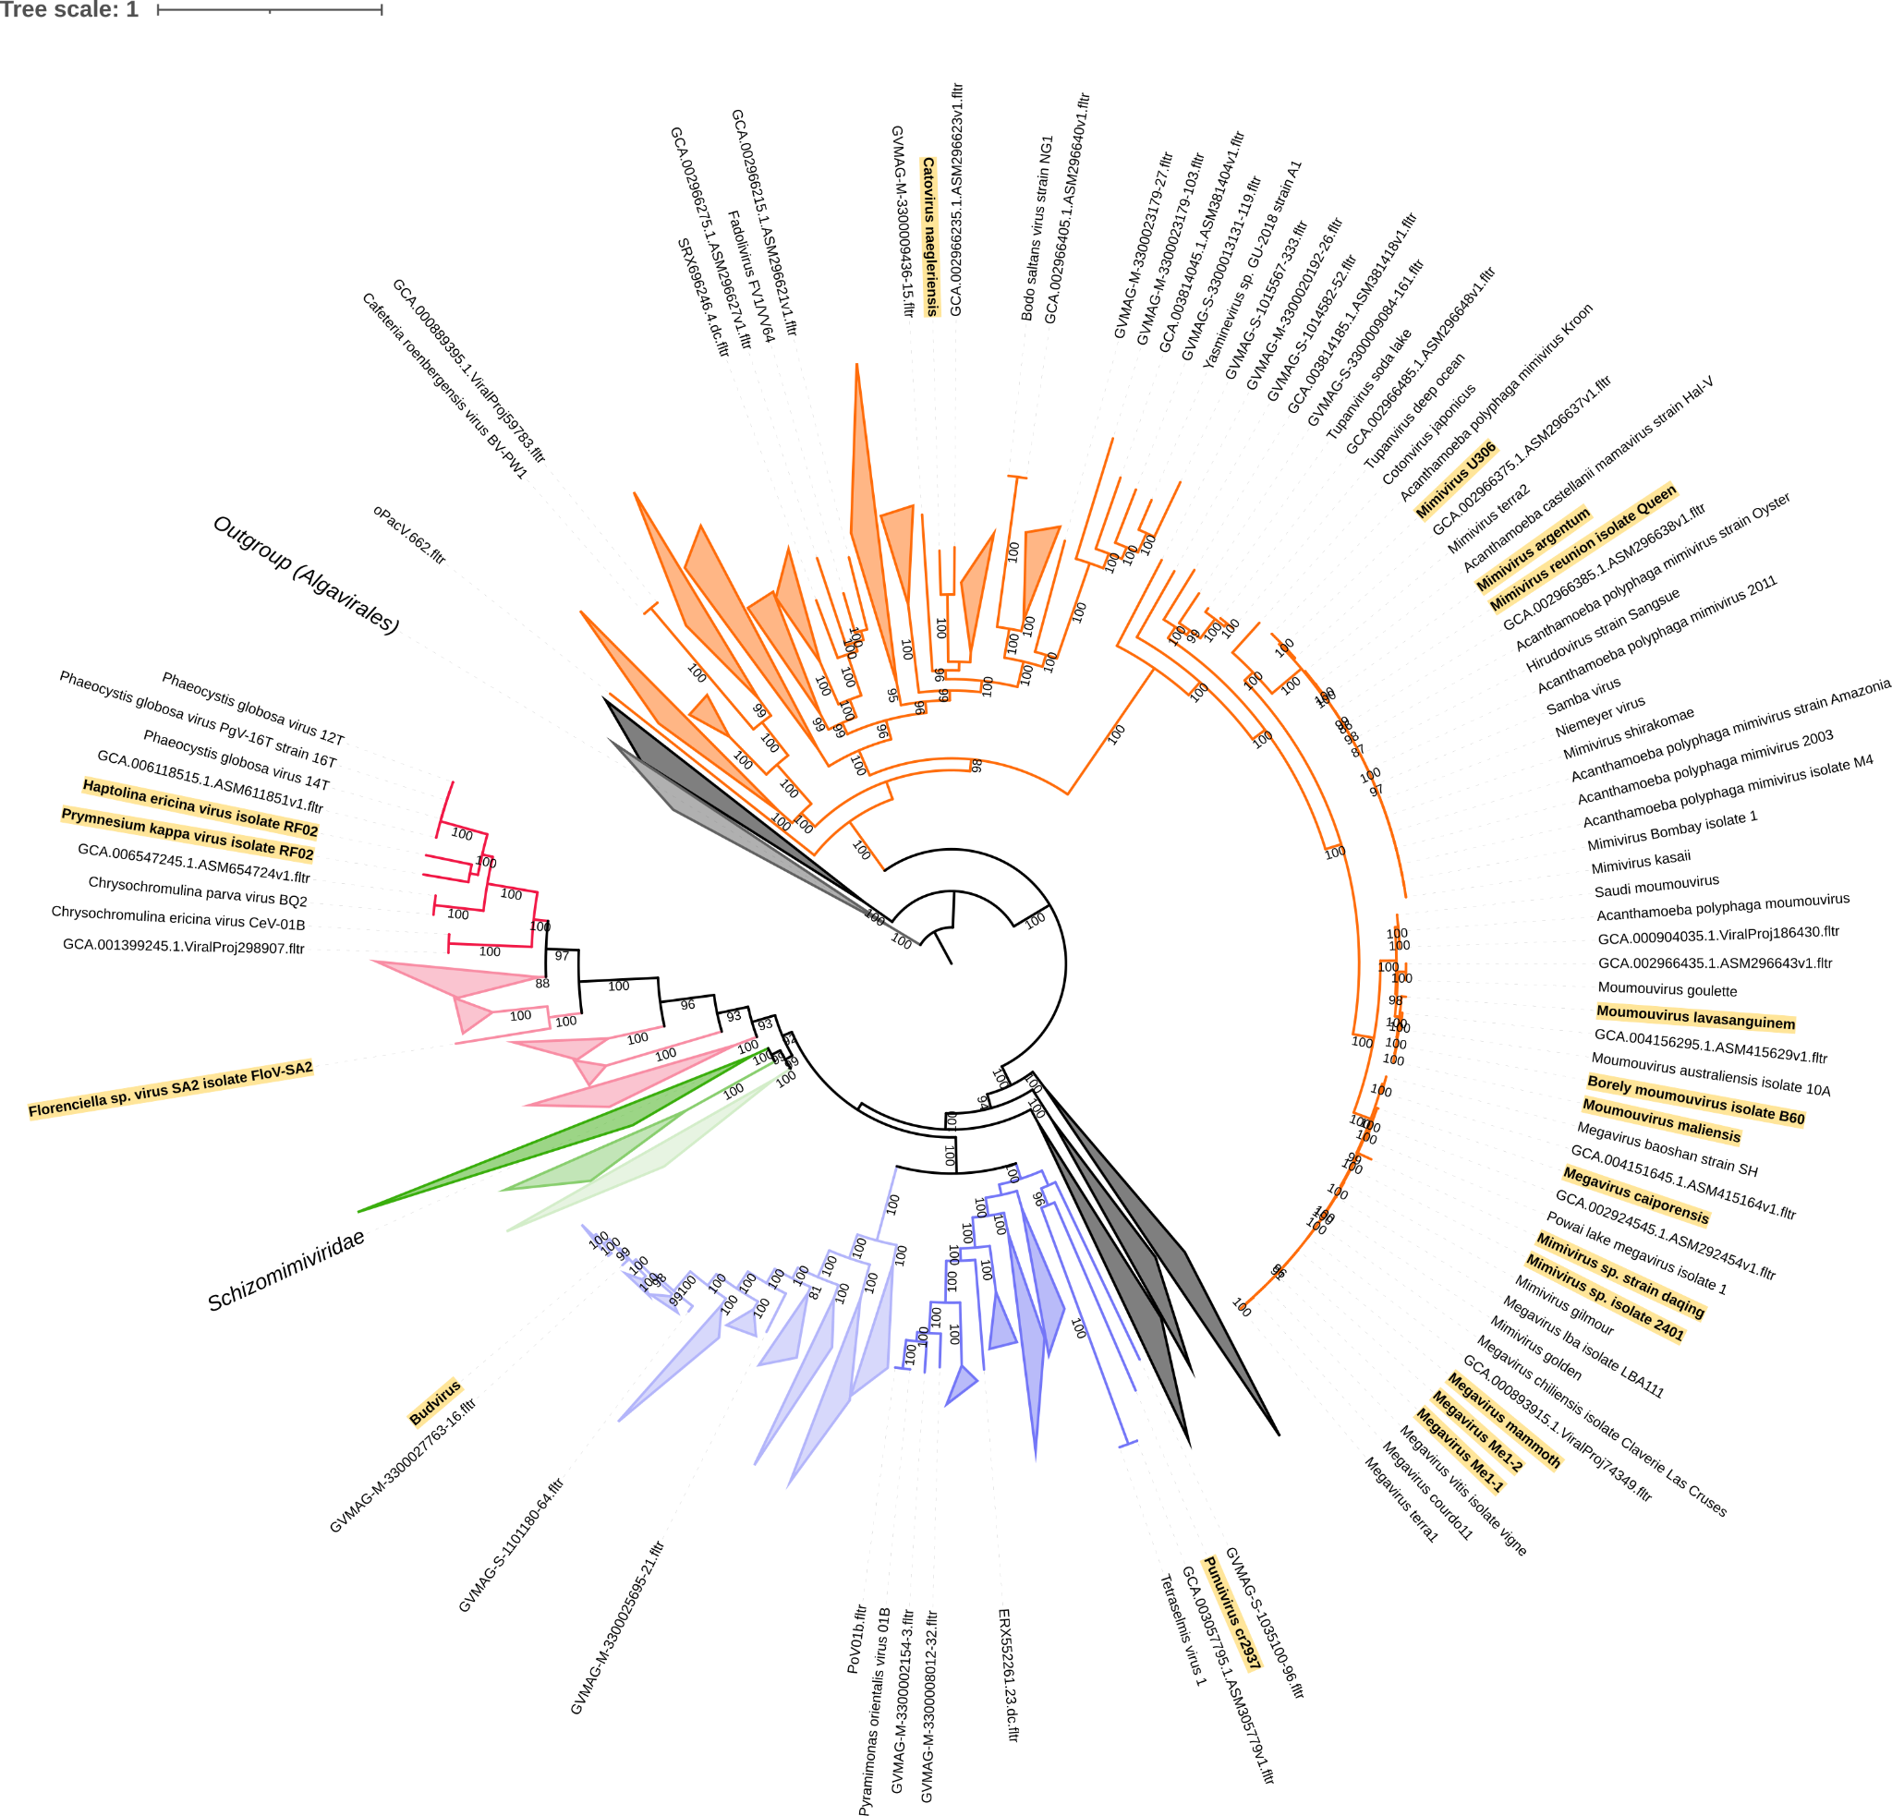

Figure 2. Phylogeny of the order Imitervirales, based on a concatenated alignment of seven marker genes (see figure one for details). Branches corresponding to Mimiviridae are colored orange; branches corresponding to Schizomimiviridae are green; branches representing Allomimiviridae and related representatives are blue; and branches representing Mesomimiviridae and related representatives are pink. Isolates classified in this proposal are highlighted in yellow.
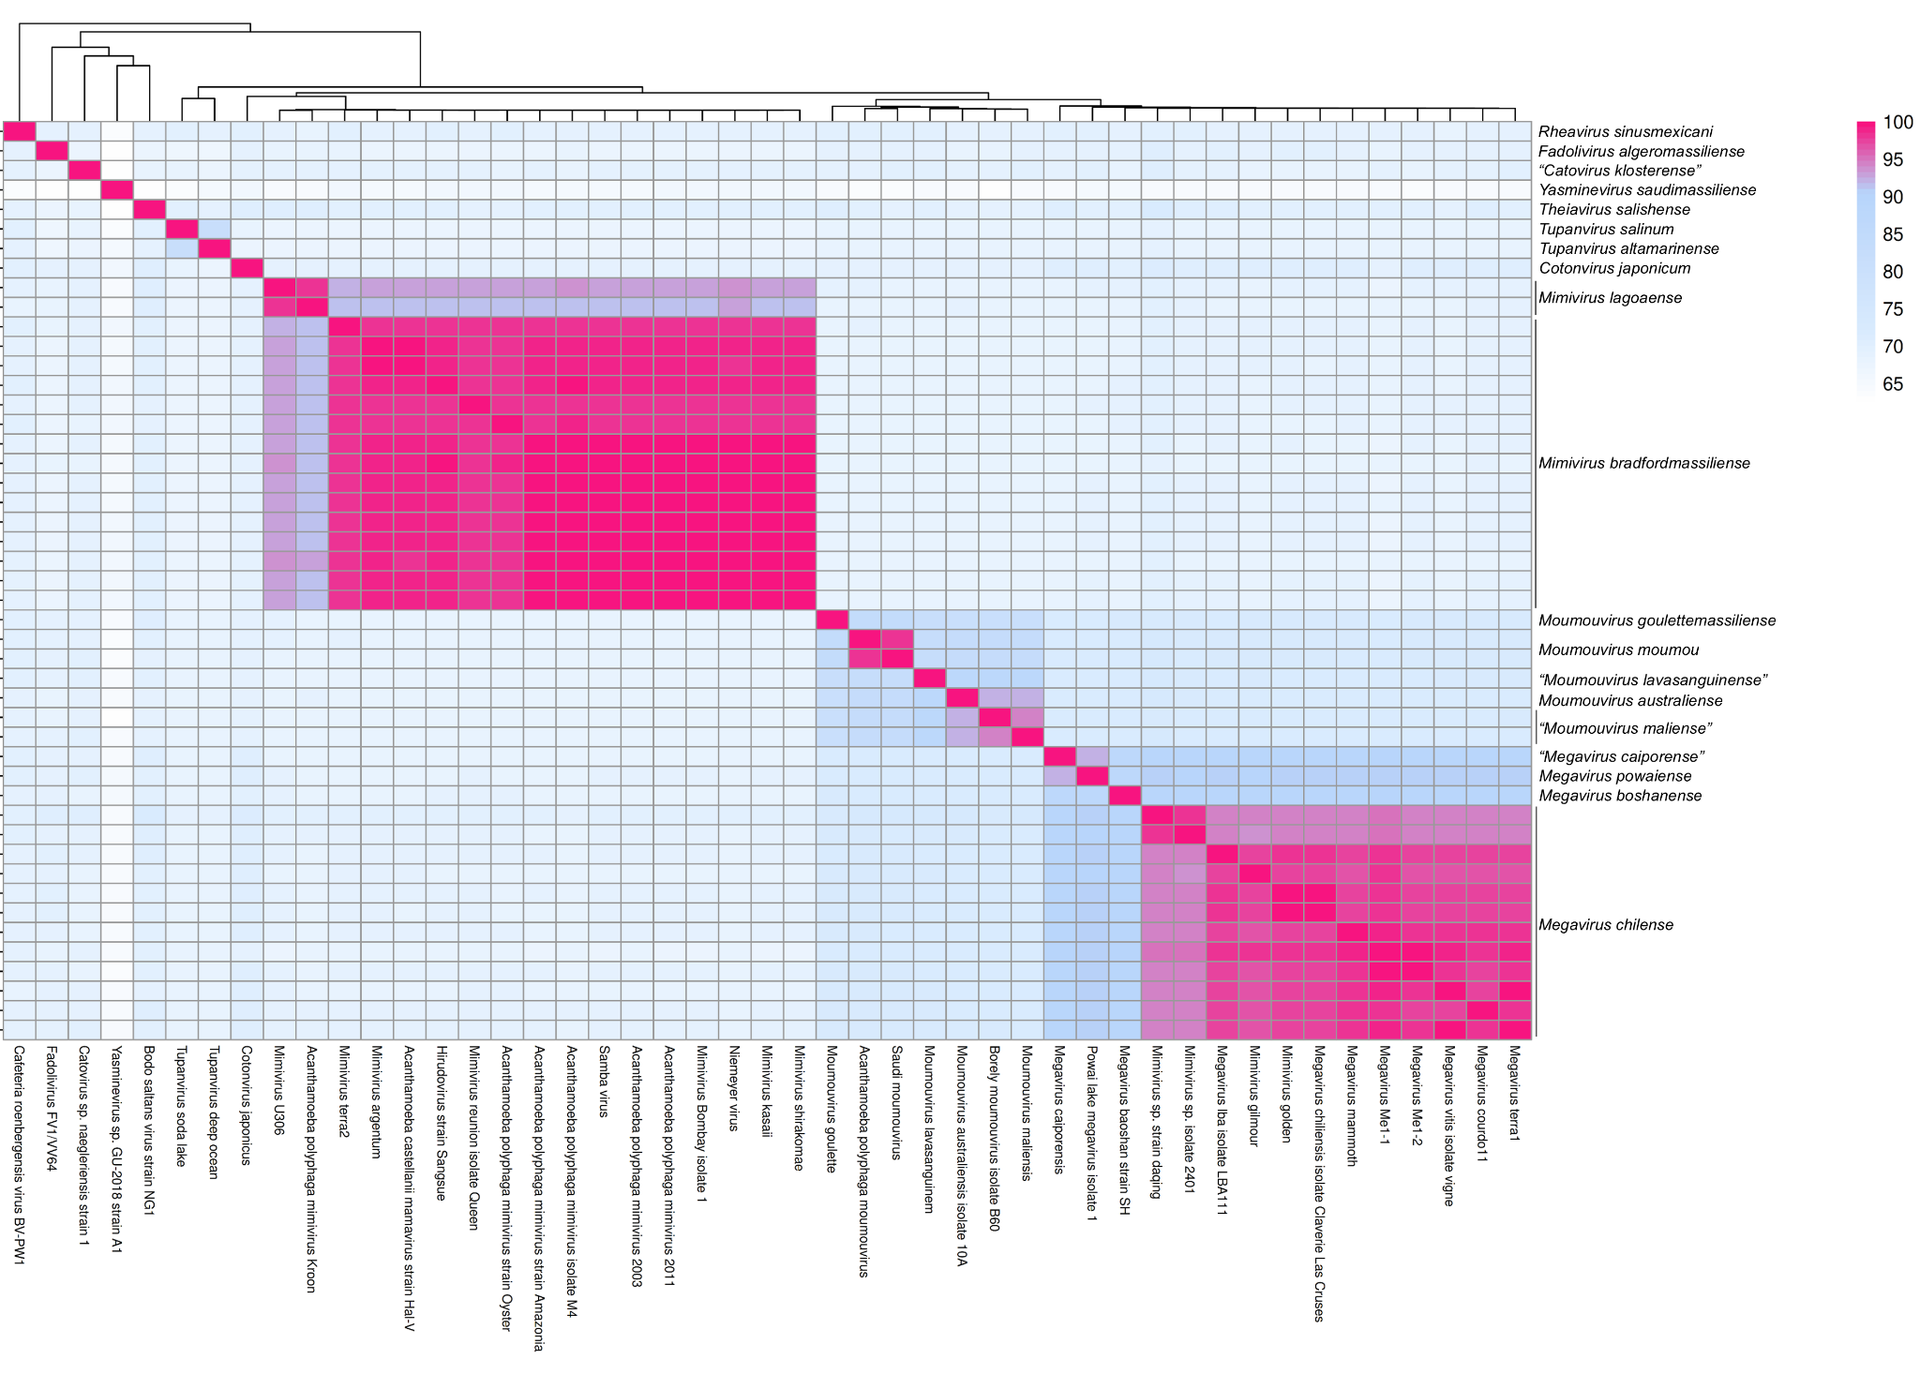
Figure 3. Pairwise Average Nucleotide Identity (ANI) of viral isolates in the family Mimiviridae. Isolate names are shown in columns and species names are shown in rows.

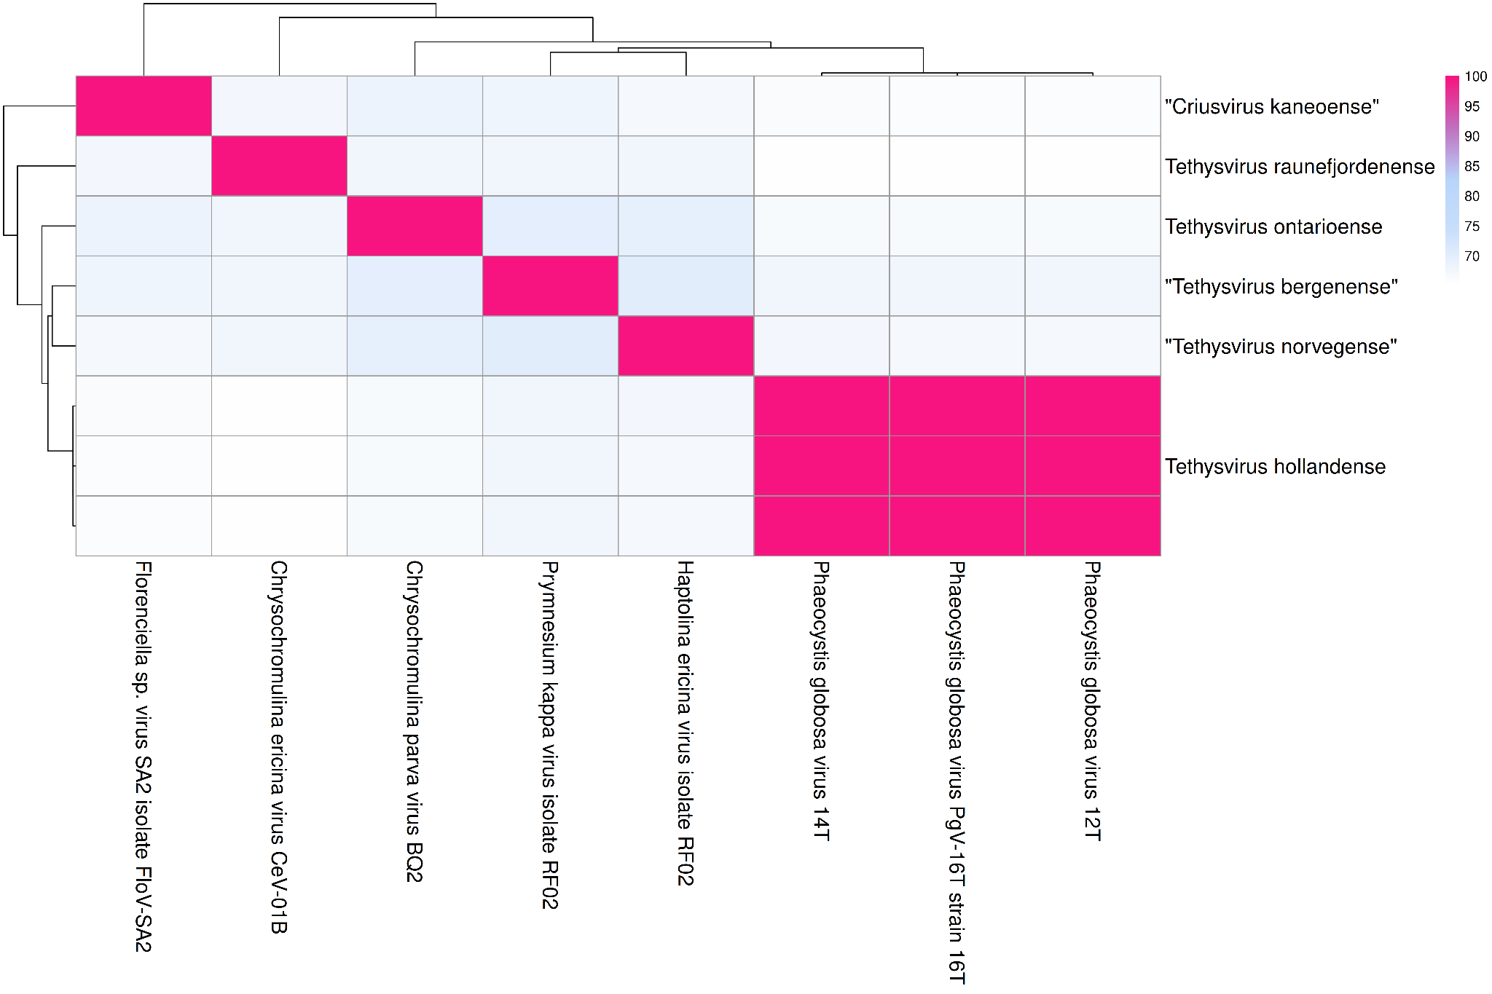

Figure 4. Pairwise Average Nucleotide Identity (ANI) of viral isolates in the family Mesomimiviridae. Isolate names are shown in columns and species names are shown in rows.

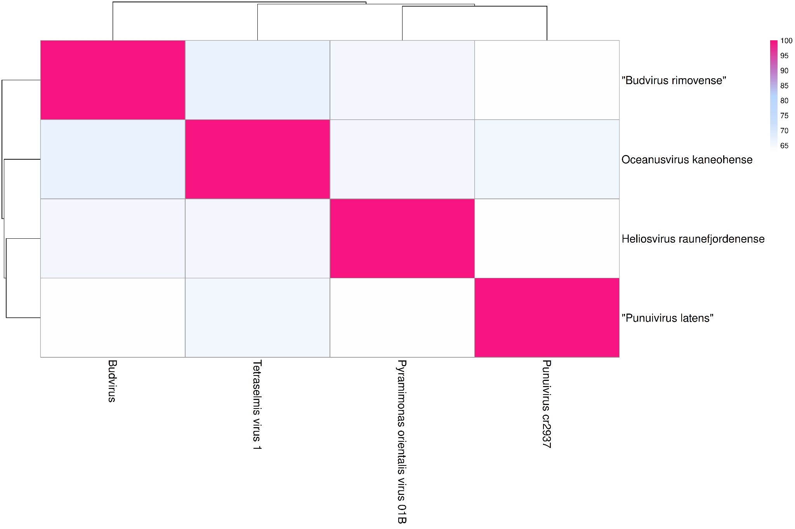
Figure 5. Pairwise Average Nucleotide Identity (ANI) of viral isolates in the family Allomimiviridae. Isolate names are shown in columns and species names are shown in rows.

