

Part 1a: Details of taxonomy proposals

Title: | Polymycoviridae_reorganization
Code assigned: | 2025.006F.Ac.v3.Polymycoviridae_3ngen_18nsp

Author(s), affiliation and email address(es):
Given name (+middle initial(s)) | Surname | Affiliation | Email address | Corr. author(s)
Poliane | Alfenas-Zerbini | Department of Microbiology, Universidade Federal de Viçosa, Viçosa, Brazil | palfenas@ufv.br | X
Cauê N. | Oliveira | Department of Microbiology, Universidade Federal de Viçosa, Viçosa, Brazil | caue.oliveira@ufv.br
Ioly | Kotta-Loizou | Department of Clinical, Pharmaceutical and Biological Science, University of Hertfordshire, Hatfield, UK | i.kotta-loizou13@imperial.ac.uk
Robert H. A. | Coutts | Department of Clinical, Pharmaceutical and Biological Science, University of Hertfordshire, Hatfield, UK | r.coutts@herts.ac.uk
Sead | Sabanadzovic | Department of Agricultural Science and Plant Protection, Mississippi State University, Mississippi State, USA | SSabanadzovic@entomology.msstate.edu

Part 1b: Taxonomy Proposal Submission
ICTV Subcommittee:
Animal DNA Viruses and Retroviruses |  | Bacterial viruses
Animal minus-strand and dsRNA viruses |  | Fungal and protist viruses | X
Animal positive-strand RNA viruses |  | Plant viruses
Archaeal viruses |  | General -

List the ICTV Study Group(s) that have seen or have been involved in creating this proposal:

Submission date: | 13/06/2025

Part 1c: Feedback from ICTV Executive Committee (EC) meeting
Executive Committee Meeting Decision code: | X
A – Accept
Ac – Accept subject to revision by relevant subcommittee chair. No further vote required | X
U – Accept without revision but with re-evaluation and email vote by the EC
Uc – Accept subject to revision and re-evaluation and email vote by the EC
Ud – Deferred to the next EC meeting, with an invitation to revise based on EC comments
J - Reject
W - Withdrawn

Comments from the Executive Committee:
Please address a few typos present in the proposal.

Part 1d: Revised Taxonomy Proposal Submission

Response of proposer:
All suggestions were addressed and included in this version.

Revision date: | 22/09/2025

Part 3: TAXONOMIC PROPOSAL
https://ictv.global/taxonomy/templates
Taxonomic changes proposed:
Establish new taxon | X | Split taxon | X
Abolish taxon |  | Merge taxon
Move taxon |  | Promote taxon
Rename taxon |  | Demote taxon
Move and rename | X

Etymology (origin) of proposed taxonomic names:
Taxon name | Etymology of the term
“Polymycovirus” | Polymycovirus; the prefix “poly”, representing the number of segments. The “myco” was not altered since it is the virus host.
“Multimycovirus” | It is a variation of the original genus Polymycovirus; in this case, the prefix “poly” was replaced with “multi”, representing the number of segments. The “myco” was not altered since it is the virus host.
“Plurimycovirus” | It is a variation of the original genus Polymycovirus; in this case, the prefix “poly” was replaced with “pluri”, representing the number of segments. The “myco” was not altered since it is the virus host.

Permission for use of names derived from a living person:
Taxon name | Full name of person from whom the name is derived | Attached

Abstract of Taxonomy Proposal:
Taxonomic rank(s) affected:
This proposal affects the family Polymycoviridae and its sole genus Polymycovirus.

Description of current taxonomy:
Polymycoviridae comprises a single genus, Polymycovirus, with 10 species recognized by the ICTV.

Proposed taxonomic change(s):
We propose to split genus Polymycovirus into three genera namely, Polymycovirus, “Multimycovirus”, and “Plurimycovirus” in the family Polymycoviridae. Consequently, we propose to move and rename the 5 established species in the family Polymycoviridae based on the novel genus they are assigned in. Additionally, we propose to establish 18 novel species in the family Polymycoviridae, 4 in the genus Polymycovirus, 13 in the genus “Multimycovirus”, and 1 in the genus “Plurimycovirus”.

Justification:
We propose reorganization of the family by splitting the genus Polymycovirus into three novel genera to better reflect the evolutionary relationships among classified and novel polymycovirus-related isolates. Additionally, we propose establishing 18 new species in the Polymycoviridae family, representing almost threefold fold increase in species number in this taxon. We believe that this new organization will facilitate further work on classifying the increasing number of polymycovirids.

- Text of Taxonomy proposal:

Taxonomic rank(s) affected:
This proposal affects primarily the family Polymycoviridae [1]. Its sole genus Polymycovirus is split into 3 genera Polymycovirus, “Multimycovirus” and “Plurimycovirus”. Five of ten currently established species are moved to newly created genera and renamed accordingly. Additionally, 18 novel species (nsp) are established in these 3 genera.

Description of current taxonomy:
Polymycoviridae is an orphan family of mycoviruses within the realm Riboviria, not yet assigned to order-kingdom taxa [1]. Polymycoviridae is phylogenetically related to Hadakaviridae family of mycoviruses (phylum Pisuviricota, kingdom Orthornavirae, realm Riboviria) [2]. Ideas to group these families at a high level have already been proposed [3]. Currently, Polymycoviridae comprises a single genus, Polymycovirus, with 10 species recognized by the ICTV [1].

Proposed taxonomic change(s):
We propose reorganization of the family Polymycoviridae by splitting the genus Polymycovirus genus into 3 genera: Polymycovirus, “Multimycovirus” and “Plurimycovirus”. Additionally, we propose establishing 18 new species in these 3 genera (Table 1).
As recommended by the ICTV, the amino acid sequence of RNA-dependent RNA polymerase (RdRP), the hallmark protein of non-reverse transcribing viruses across the entire Riboviria realm, was used for phylogenetic analyses of the members of the family Polymycoviridae, with Hadakaviridae serving as an outgroup [4,5]. The phylogenetic analyses included the representative isolates of the 10 established species in the family Polymycoviridae and other related isolates whose complete genome sequences were available in the National Center for Biotechnology Information (NCBI) databases. The maximum likelihood phylogenetic tree of the RdRP amino acid sequences revealed the existence of at least three well-supported monophyletic clades, each proposed to represent genera in the Polymycoviridae family (Figure 1A). This was supported by the heat map showing the pairwise identity values of the RdRP amino acid sequences (Figure 1B).
The proposed genus Polymycovirus comprises 4 new and 5 established species, Polymycovirus penicompactii, Polymycovirus beauveriae, Polymycovirus fusarii, Polymycovirus colletotrichi, and Polymycovirus cladosporii (Table 1).
The proposed genus “Multimycovirus” is the biggest genus in the family as it comprises 17 species of which 13 new. Four species previously classified in the genus Polymycovirus (Polymycovirus aspelaei, Polymycovirus aspergilli, Polymycovirus botryosphaeriae, and Polymycovirus magnaporthis) are moved into this genus and renamed accordingly (Table 1).
The proposed genus “Plurimycovirus” is the smallest genus within Polymycoviridae; it comprises a well-supported monophyletic clade containing 2 species of which 1 species is new, while the established species Polymycovirus penidigitati, previously classified in the genus Polymycovirus was renamed “Plurimycovirus penidigitati” to reflect new taxonomic position (Table 1).

The novel proposed genera and species are summarized in Table 1 and visualized in Figures 1A and 1B.

Demarcation criteria:
The species demarcation criteria remain the same as the ones originally established for the Polymycoviridae family: i.e., viral isolates sharing more than 70% identity in the RdRP amino acid sequence represent a single species [1]. To be classified in the proposed genera Polymycovirus, “Multimycovirus”, or “Plurimycovirus”, a virus should cluster in a highly supported monophyletic clade with another virus of these genera.

Justification:
Interest in mycovirus studies has increased in recent years due to their potential as biocontrol agents. Therefore, several novel polymycovirus-related sequences have been available in NCBI but not classified yet [1]. Taxonomy is a human-made tool to organize biological entities into groups with more similarity and a closer evolutionary history [5]. Therefore, we propose reorganization of the family by splitting the genus Polymycovirus into three novel genera to better reflect the evolutionary relationships among these viruses - including novel polymycovirus-related isolates. We believe this new arrangement will facilitate further work on classifying the increasing number of polymycovirids. Additionally, we propose establishing 18 new species in the Polymycoviridae family, representing almost threefold fold increase in species number in the family.
References:
[1] I. Kotta-Loizou and R. H. A. Coutts, “ICTV Virus Taxonomy Profile: Polymycoviridae 2022,” Journal of General Virology, vol. 103, no. 5, p. 001747, May 2022, doi: 10.1099/JGV.0.001747/CITE/REFWORKS.
[2] Y. Sato et al., “ICTV Virus Taxonomy Profile: Hadakaviridae 2023,” Journal of General Virology, vol. 104, no. 1, p. 001820, Jan. 2023, doi: 10.1099/JGV.0.001820/CITE/REFWORKS.
[3] C. N. Oliveira, Y. de Sousa Santos, R. R. de Rezende, and P. Alfenas-Zerbini, “Identification of a novel polymycovirus infecting the entomopathogenic fungus Metarhizium robertsii,” Archives of Virology, vol. 170, no. 3, pp. 1–8, Feb. 2025, doi: 10.1007/S00705-025-06240-6.
[4] E. V. Koonin et al., “Global organization and proposed megataxonomy of the virus world,” Microbiology and Molecular Biology Reviews, vol. 84, no. 2, May 2020, doi: 10.1128/MMBR.00061-19/SUPPL_FILE/MMBR.00061-19-S0001.PDF.
[5] P. Simmonds et al., “Four principles to establish a universal virus taxonomy,” PLoS Biology, vol. 21, no. 2, p. e3001922, Feb. 2023, doi: 10.1371/JOURNAL.PBIO.3001922.

Accompanying files:
Filename | Description of contents
Polymycoviridae_3nGen_18nsp.xlsx | Obligatory Excel template to submit the proposal

Tables, Figures:
<Start here>

Table 1: Current and proposed taxonomy of the family Polymycoviridae. text – original taxonomy; purple text – new genera; green text – moved/renamed species; red text – new species.
CURRENT TAXONOMY | PROPOSED TAXONOMY
 | Species: Polymycovirus aspeflavi
 | Species: Polymycovirus erynecati
 | Species: Polymycovirus metarhizii
 | Species: Polymycovirus turcicalternatae
 | Genus: Multimycovirus (previously part of Polymycovirus)
 | Species: Multimycovirus alternatae
 | Species: Multimycovirus aspelaei
 | Species: Multimycovirus aspergilli
 | Species: Multimycovirus beauvessianae
 | Species: Multimycovirus botryosphaeriae
 | Species: Multimycovirus camesinensis
 | Species: Multimycovirus priphillostictae
 | Species: Multimycovirus secuphyllostictae
 | Species: Multimycovirus cladoplasmoniae
 | Species: Multimycovirus erynecati
 | Species: Multimycovirus magnaporthis
 | Species: Multimycovirus magnaporyzae
 | Species: Multimycovirus metabrunnei
 | Species: Multimycovirus miniphaeoacremonii
 | Species: Multimycovirus talaromyci
 | Species: Multimycovirus trichodermae
 | Species: Multimycovirus turcicae
 | Genus: Plurimycovirus (previously part of Polymycovirus)
 | Species: Plurimycovirus cladosporii
 | Species: Plurimycovirus penidigitati

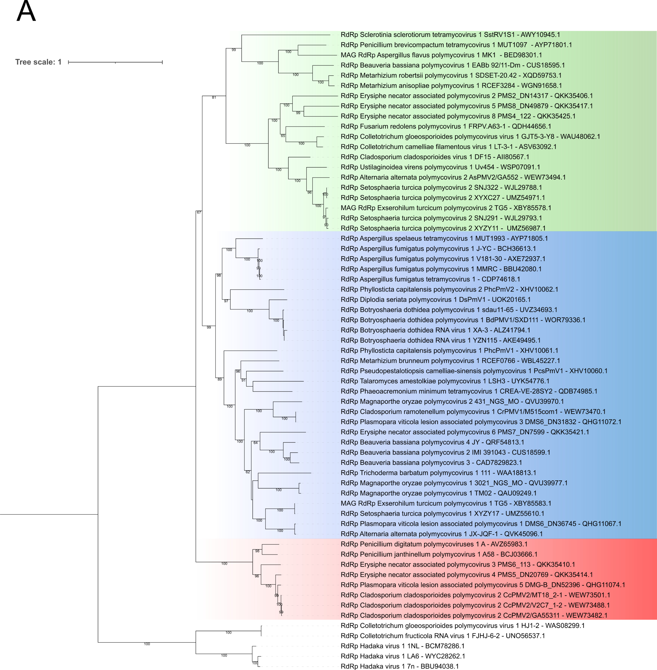

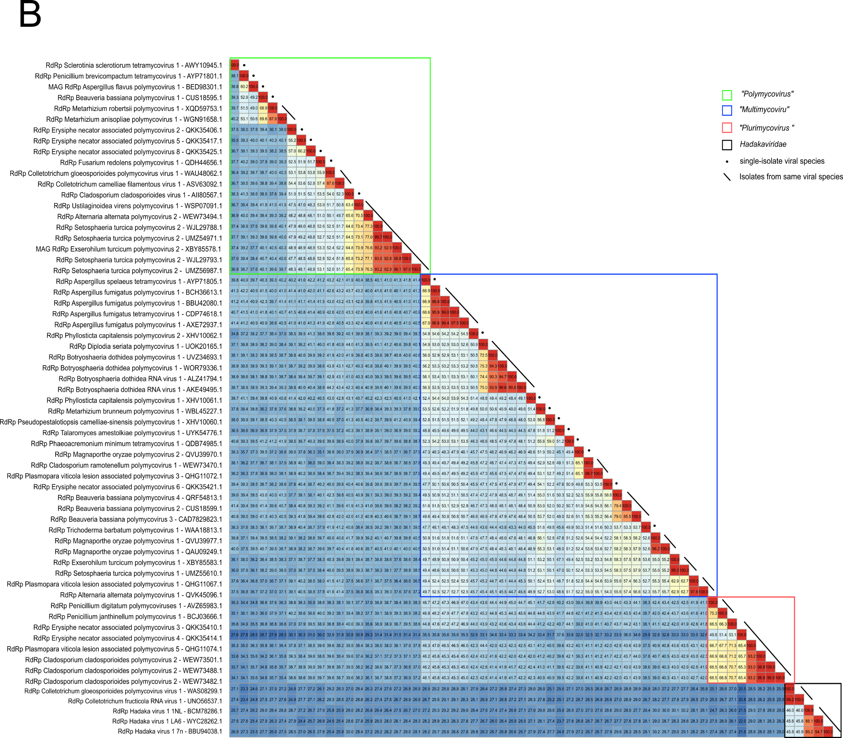

Figure 1: (A) Phylogenetic analyses of the RdRP amino acid sequences of members of the Polymycoviridae and Hadakaviridae families. The sequences were downloaded from NCBI on April 10th, 2025. MAFFT v7.471 was used for multiple sequence alignment. The ML phylogenetic tree was constructed using IQ-TREE v1.6.11, which calculates the best evolutionary model (LG+F+I+G4). The proposed novel genera are indicated in green for Polymycovirus, blue for “Multimycovirus”, and red for “Plurimycovirus”. (B) Heat map with the pairwise identity values of the RdRP amino acid sequences of members of the Polymycoviridae and Hadakaviridae families. STD v1.3 was used to perform the pairwise alignment.

