

The International Committee on Taxonomy of Viruses
Taxonomy Proposal Form, 2024

Part 1a: Details of taxonomy proposals

Title: | Create a new class, Orpoviricetes, including two new orders, four families, seven genera and 26 new species in kingdom Orthornavirae (realm Riboviria)
Code assigned: | 2024.008F.Uc.v2.Orpoviricetes_newclass

Author(s), affiliation and email address(es):
Name | Affiliation | Email address | Corresponding author(s)
Botella L | Forest Protection and Wildlife Management  Mendel University in Brno, Czechia | qqbotell@mendelu.cz
Turina M | Institute for Sustainable Plant Protection-CNR, Torino, Italy.  Department of Plant Protection, School of Agriculture, The University of Jordan, Amman, Jordan | massimo.turina@ipsp.cnr.it
Hejna O | Department of Genetics and Biotechnologies, University of South Bohemia, Czechia | hejna@fzt.jcu.cz
Krupovic M | Institut Pasteur, Université Paris Cité, Archaeal Virology Unit, Paris, France | mart.krupovic@pasteur.fr
Neri U | The Shmunis School of Biomedicine and Cancer Research, Tel Aviv University | uri.neri@gmail.com
Poimala A | Natural Resources Institute Finland (Luke), Helsinki, Finland | anna.poimala@luke.fi
Shamsi W | Department of Molecular Biology and Genetics, Aarnhus University, Aarhus, Denmark. | wajeeha.shamsi@mbg.au.dk
Sabanadzovic S | Department of Agricultural Science and Plant Protection, Mississippi State University, Mississippi, USA  Institute for Genomics, Biocomputing and Biotechnology, Mississippi State University, Mississippi, USA | SSabanadzovic@entomology.msstate.edu
Sutela S | Natural Resources Institute Finland (Luke), Helsinki, Finland | suvi.sutela@luke.fi
Vainio E | Natural Resources Institute Finland (Luke), Helsinki, Finland | eeva.vainio@luke.fi
Forgia M | Institute for Sustainable Plant Protection, CNR, Torino, Italy | marco.forgia@ipsp.cnr.it | X

Part 1b: Taxonomy Proposal Submission
ICTV Subcommittee:
Animal DNA Viruses and Retroviruses |  | Bacterial viruses
Animal minus-strand and dsRNA viruses |  | Fungal and protist viruses | x
Animal positive-strand RNA viruses |  | Plant viruses
Archaeal viruses |  | General -

List the ICTV Study Group(s) that have seen or have been involved in creating this proposal:
Optional – complete only if formally voted on by an ICTV Study Group:
Study Group | Number of members
Study Group | Votes in support | Votes against | No vote

Submission date: | 20/06/2024

Part 1c: Feedback from ICTV Executive Committee (EC) meeting
Executive Committee Meeting Decision code: | X
A – Accept
Ac – Accept subject to revision by relevant subcommittee chair. No further vote required
U – Accept without revision but with re-evaluation and email vote by the EC
Uc – Accept subject to revision and re-evaluation and email vote by the EC | X
Ud – Deferred to the next EC meeting, with an invitation to revise based on EC comments
J - Reject
W - Withdrawn

Comments from the Executive Committee:
Correct the sequence information: valid GenBank submission needed. Avoid/eliminate TSA-based isolates. Correct Excel. Consider simpler genus nomenclature.

Part 1d: Revised Taxonomy Proposal Submission
Response of proposer:
All suggestions from the EC were accepted and properly addressed in this version.

Revision date: | 17/10/2024

Part 3: TAXONOMIC PROPOSAL

Name of accompanying Excel module:
2024.008F.Uc.v2.Orpoviricetes_newclass.xlsx

Taxonomic changes proposed:
Establish new taxon | x | Split taxon
Abolish taxon |  | Merge taxon
Move taxon |  | Promote taxon
Rename taxon |  | Demote taxon
Move and rename

Is any taxon name used here derived from that of a living person: |  | N
Taxon name | Person from whom the name is derived | Attached X

Abstract of Taxonomy Proposal:
“Ormycoviruses” are recently identified RNA viruses that infect fungi and oomycetes. Their genomes consist of two monocistronic single-stranded (ss) RNA segments, with RNA1 encoding a putative RNA-directed RNA polymerase (RdRP) and RNA2 encoding a hypothetical protein with an unknown function. Ormycoviruses are unique in that they exhibit variations in the conserved motif C of the RdRP, such as NDD, GDQ, and HDD, which are not commonly found in other RNA viruses. This variation, coupled with their significant evolutionary divergence from other RNA viruses, supports the classification of ormycoviruses into a new class within the kingdom Orthornavirae. Therefore, we propose the establishment of the floating class "Orpoviricetes," which includes two orders, and four families, encompassing seven genera and 26 new species to initiate official classification of this group of viruses.

Taxonomic rank(s) affected: Riboviria, Orthornavirae

Description of current taxonomy: Kingdom Orthornavirae includes six phyla which were established based on phylogenetic analysis of the RdRP and comparative analysis of the viral genomes and encoded proteins.

Proposed taxonomic change(s): Creation of a new class “Orpoviricetes”, two new orders, five families and seven genera which collectively accommodates 26 new species.

Justification: Viruses from the kingdom Orthornavirae, which encompasses RNA viruses that encode RNA-directed RNA polymerases (RdRPs), generally have highly conserved motif C. This motif, often containing the core triplet GDD, is critical for the catalytic activity of the RdRP enzyme. Other triplets more rarely occurring are NDD, SDD, GDN, IDD, ADN, and ADD (in order of frequency; Olendraite et al. 2023). However, “ormycoviruses” exhibit unique variations in the core amino acid triad of motif C (e.g., NDD, GDQ, and HDD, shown in Figure 1 and 2) not found in other RNA viruses. Based on the significant variations in the conserved motif C and the high divergence from other RNA viruses (not conserved enough to be retrieved by BLAST searches using any of the RdRP encoded by viruses classified in the six currently recognized phyla), there is a strong case for considering “ormycoviruses” as members of, at least, a distinct class. Variations within the C motifs are rare but not unprecedented in other RNA viruses, so there is still a need to carry out phylogenetic and structural analyses to confirm whether ormycoviruses have diverged from viruses within existing phyla or have diverged prior to the radiation of viruses classified in the six currently established phyla. Therefore, as an initial step in the official classification of these viruses, we propose to classify them within a new class non-assigned to an existing phylum within the kingdom Orthornavirae. This classification would reflect their unique evolutionary pathway and potentially distinct biological characteristics.

Text of Taxonomy proposal:
Ormycoviruses were first detected through a pipeline focused on the identification of viral ORFans (metagenomically-derived de novo assembled contigs encoding putative proteins without resemblance to known sequences in public data repositories). With this approach, a 2392 bp contig encoding a putative protein of 766 aa was detected in the yeast Starmerella bacillaris (Crucitti et al. 2021). Similar contigs were also found in RNA samples from powdery mildew of horticultural plants (Erysiphe-infected plants) and from downy mildew infected grapevines (Forgia et al., 2022). These contigs, lacking matches in existing databases, were concluded to be part of an RNA viral genome, as supported by the absence of corresponding DNA in the infected samples. In particular, structure predictions and comparisons revealed that putative proteins from the ORFan contigs had distant homology to viral RdRP, thus called “ormycoviruses” as a contraction for ‘ORFan mycovirus’. Further searches revealed a second segment encoding a putative ORFan protein of unknown function associated with each RdRP-coding segment, completing the bipartite genomes of the ormycoviruses.
Since then, ormycoviruses have been consistently documented in a broad spectrum of fungi and oomycetes, including ectomycorrhizal fungi, basidiomycetes, ascomycetes, and downy mildew-associated samples collected from grapevines (Table S1) (Forgia et al. 2022; Pagnoni et al. 2023; Sahin et al. 2024). At this time, only fungi and oomycetes are confirmed hosts of ormycoviruses, although they have been also detected in a seaweed transcriptomic study (Dekker et al. preprint). In the recent works that greatly expanded the RNA virosphere, these viruses were either missed (Chen et al. 2022) or found, but considered too distant from existing ones to be placed in the comprehensive phylogeny derived (Neri et al. 2022). The absence of close relatives underscores their distinct evolutionary pathway.

Ormycoviruses are not closely related to other classified viruses but exhibit significant homology and evolutionary relationships among themselves. Phylogenetic analyses show that ormycoviruses share a common evolutionary origin and might have evolved separately from other virus groups (Figure 2).
Ormycovirus genomes consist of two monocistronic single-stranded (ss) RNA segments. RNA1 the larger one (~2.5-3.5 kb), encodes the RNA-directed RNA Polymerase (RdRP) while, RNA2, the smaller one (~1.5-2 kb), encodes a hypothetical protein (HP) of unknown function (Figure 1). Both segments share highly conserved 5′ and 3′ UTR regions, each 20-35 nucleotides long. Both segments have a full nucleotide sequence pairwise identity of ~25-30%.
RdRP
A characteristic and defining feature of ormycoviruses is that they lack the 'GDD' catalytic triad in the motif C (or motif VI), the most conserved region in RdRPs throughout RNA viruses. Instead, they exhibit ‘NDD’, ‘SDD’, ‘ADD’, and ‘GDQ’, with the latter one apparently being specific to “Gammaormycoviridae” (Figure 2 and Figure 4).
HP
RNA2 encodes a hypothetical protein which seems to have low amino acid conservation and possibly also low overall structural conservation. The two proposed orders do not share conserved motifs within their respective HPs. While certain level of conservation is observed between HPs encoded by members of the proposed family “Betaormycoviridae” (proposed order “Formycovirales”), the order “Bormycovirales” is characterized by a high level of interspecific divergence (data not shown).

The analysis of reads mapping to genome segments of Starmella bacillaris ormycovirus 1 (SbOMV1) and other betaormycoviruses (proposed to be classified in the new family “Betaormycoviridae”) indicates a replication strategy favouring higher accumulation of the negative sense strands for both RNA1 and RNA2 (Forgia et al. 2022). This trait is common among betaormycoviruses but not shared by alpha- and gamma-ormycoviruses, and it is consistent across multiple stranded total RNA-seq libraries (Forgia et al. 2022). Although this could suggest their classification as negative sense RNA viruses, the actual definition of negative sense viruses requires the presence/characterization of viral particles (virions) and encapsidation of negative sense genomic segment, which were not found in case of SbOMV1. Therefore, SbOMV1 cannot be unequivocally defined as a negative sense RNA virus.

Focusing only on several well-annotated ormycovirus sequences at this time, we propose a single class with two orders, four families and seven genera to include 26 species, based upon a <90%-identity (>10% divergence) threshold in pairwise alignment of the amino acid sequence of the RdRP as the species demarcation criterion (Figure 3).

Primary distinction among genera is based on phylogenetic analyses. All viruses assigned to different genera proposed herein form monophyletic clades in phylogenetic analyses performed using their RdRP protein sequences.
Primary distinction among the families is based on phylogenetic analyses. All viruses assigned to different families proposed in this document form monophyletic clades in phylogenetic analyses performed on their RdRP sequences.

Family level justification: classifying viruses into families rather than genera is justified by the need for a broader, more comprehensive organization of ormycoviricot diversity that needs to account for very low sequence conservation of the RdRP, the different combinations of aa in the catalytic triplet in motif C of the RdRP, and the structural variation of the HP encoded by RNA2.

The authors of this proposal have agreed to the following set of minimal criteria that any virus would need to meet to represent a new species. These criteria may change in the future as the knowledge of these viruses grow over the time. The criteria are:
1) The viral genome sequence must be deposited in GenBank in an appropriate manner (e.g., TPA if appropriate).
2) The viral genome sequence must be, or appear to be, complete or coding complete (for both RNA1 and RNA2).
3) For viral genome sequences assembled from high-throughput sequencing reads, and not validated in full by Sanger sequencing, read numbers, RPKM values, and/or coverage depth values for the sequence must be specified, or the read data must be available at NCBI such that these values can be independently determined by scientists interested in the topic.
4) As pointed above, viral genome sequences that share <90% amino acid RdRP sequence identity will be assigned to different virus species regardless of whether assigned to the same or different host species.

Taxonomic rank(s) affected: Class, order, family, genus, species

Description of current taxonomy: currently unclassified

Proposed taxonomic change(s):

Realm: Riboviria
Kingdom: Orthonavirae
One Class: Orpoviricetes (“Orpo” means “orphan” in Finnish)
Two Orders:
order Bormycovirales – “B” is randomly selected to construct the order name.
three families, five genera and twelve species.
Family Alphaormycoviridae: two genera; nine species.
Family Deltaormycoviridae: one genus; four species.

order Formycovirales – “F” is randomly selected to construct the order name.
two families, two genera, fourteen species.
Family Betaormycoviridae: two genera; seven species.
Family Gammaormycoviridae: two genera; six species.

Justification: Complete classification and etymology can be seen in the template proposal (Table 1)
References:
Chen, Y. M., Sadiq, S., Tian, J. H., Chen, X., Lin, X. D., Shen, J. J., Chen, H., Hao, Z. Y., Wille, M., Zhou, Z. C., Wu, J., Li, F., Wang, H. W., Yang, W. di, Xu, Q. Y., Wang, W., Gao, W. H., Holmes, E. C., & Zhang, Y. Z. (2022). RNA viromes from terrestrial sites across China expand environmental viral diversity. Nature Microbiology 2022 7:8, 7 (8), 1312–1323. https://doi.org/10.1038/s41564-022-01180-2

Crucitti, D., Chiapello, M., Oliva, D., Forgia, M., Turina, M., Carimi, F., la Bella, F., & Pacifico, D. (2022). Identification and molecular characterization of novel mycoviruses in Saccharomyces and non-Saccharomyces yeasts of oenological interest. Viruses, 14 (1). https://doi.org/10.3390/v14010052

Dekker, R. J., de Leeuw, W. C., van Olst, M., Ensink, W. A., van Leeuwen, S., Cohen, J., Timmermans, K. R., Breit, T. M., & Jonker, M. J. (n.d.). Discovery of novel RNA viruses in commercially relevant seaweeds Alaria esculenta and Saccharina latissima. https://doi.org/10.1101/2024.05.22.594653

Neri, U., Wolf, Y. I., Roux, S., Camargo, A. P., Lee, B., Kazlauskas, D., Chen, I. M., Ivanova, N., Zeigler Allen, L., Paez-Espino, D., Bryant, D. A., Bhaya, D., Narrowe, A. B., Probst, A. J., Sczyrba, A., Kohler, A., Séguin, A., Shade, A., Campbell, B. J., … Gophna, U. (2022). Expansion of the global RNA virome reveals diverse clades of bacteriophages. Cell, 185 (21), 4023-4037.e18. https://doi.org/10.1016/j.cell.2022.08.023

Forgia, M., Chiapello, M., Daghino, S., Pacifico, D., Crucitti, D., Oliva, D., Ayllon, M., & Turina, M. (2022). Three new clades of putative viral RNA-dependent RNA polymerases with rare or unique catalytic triads discovered in libraries of ORFans from powdery mildews and the yeast of oenological interest Starmerella bacillaris. Virus Evolution, 8 (1). https://doi.org/10.1093/ve/veac038

Olendraite, I., Brown, K., & Firth, A. E. (2023). Identification of RNA Virus-Derived RdRp Sequences in Publicly Available Transcriptomic Data Sets. Molecular Biology and Evolution, 40 (4). https://doi.org/10.1093/molbev/msad060

Pagnoni, S., Oufensou, S., Balmas, V., Bulgari, D., Gobbi, E., Forgia, M., Migheli, Q., & Turina, M. (2023). A collection of Trichoderma isolates from natural environments in Sardinia reveals a complex virome that includes negative-sense fungal viruses with unprecedented genome organizations. Virus Evolution, 9 (2). https://doi.org/10.1093/ve/vead042

Sahin, E., Edis, G., Keskin, E., & Akata, I. (2024). Molecular characterization of the complete genome of a novel ormycovirus infecting the ectomycorrhizal fungus Hortiboletus rubellus. Archives of Virology, 169 (5), 110. https://doi.org/10.1007/s00705-024-06027-1

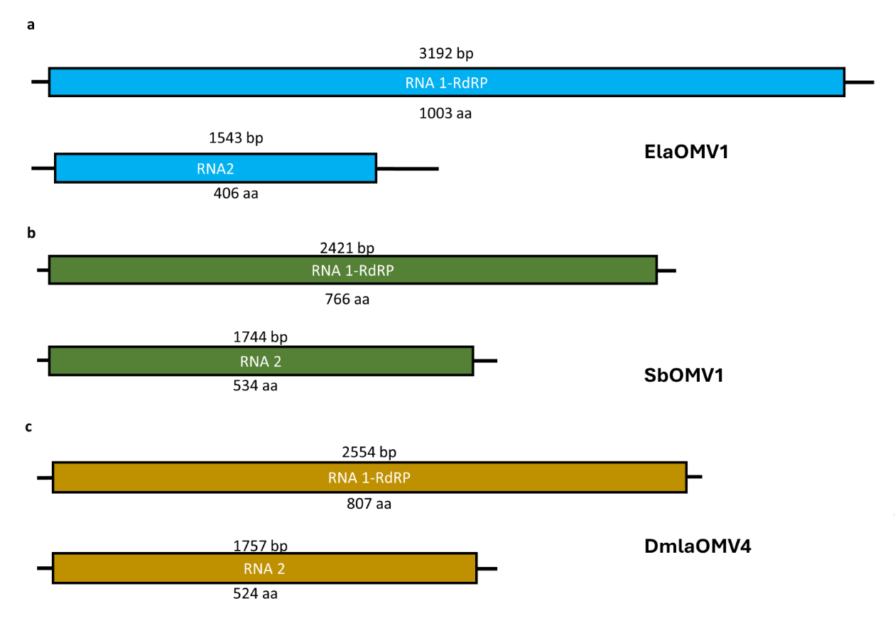Figure 1. Figure 1 Genome organization of three representative ormycovirus: A) genome organization of Erysiphe lesion associated ormycovirus 1 (ElaOMV1), an alphaormycovirid; B) genome organization of Starmerella bacillaris ormycovirus 1(SbOMV1), a betaormycovirid; C) genome organization of downy mildew lesion associated ormycovirus 4 (DmlaOMV4), a gammaormycovirid. Numbers at the beginning and at the end of the ORF box show the starting and ending position of the ORF on the genomic fragment.

Figure 2. Maximum Likelihood phylogenetic tree of the proposed ormycovirus taxa and the order Lenarnaviricota. All RdRP sequences were aligned using MAFFT, and the phylogenetic tree was constructed with IQ-Tree 2.3.4. Bootstrap support values are indicated above each node, and substitution rates are shown below. Next to each virus ID, the catalytic triad from motif C of the Palm-domain is displayed in parenthesis.

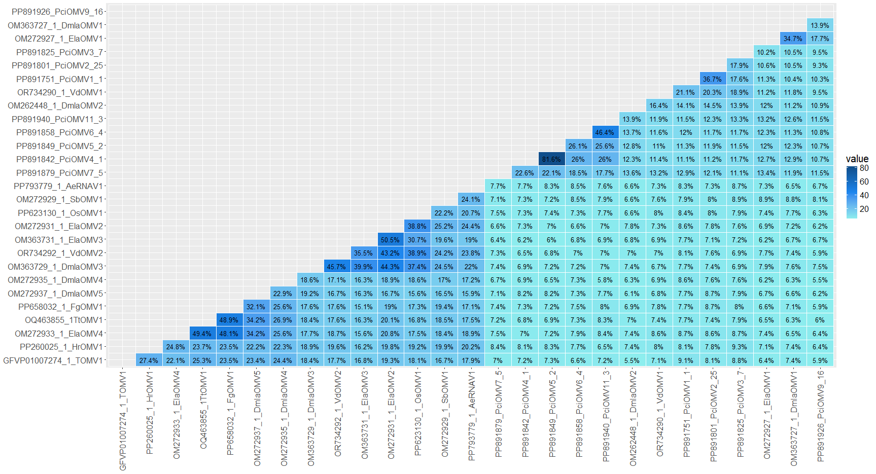
Figure 3. Pairwise identity matrix obtained from comparisons of putative proteins encoded by ormycovirus RNA1. Protein alignment was built using MAFFT and identity is shown in percentage for each pairwise comparison. Virus names are abbreviated, and their complete name can be consulted in Table 1 and Table S1.
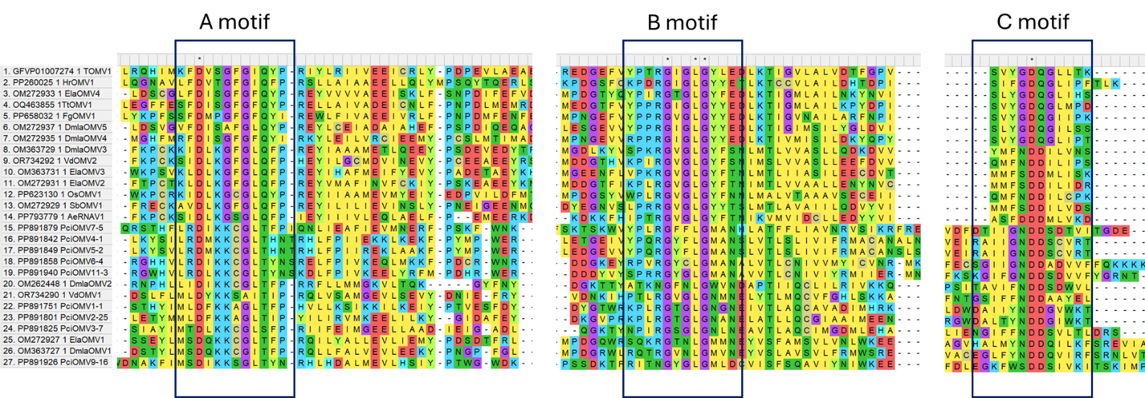

Figure 4. Amino acid alignment of the putative conserved domains of the RdRP palm-domain motifs A, B, and C in ormycoviruses. Virus names are abbreviated or indicated by their accession numbers.

Table S1. Information about the ormycoviruses classified in this proposal (those with RNA1 and RNA2 -reported in red font) and other putative ormycoviruses registered in the GenBank.

Organism name in GenBank | Acronym | Segment | Length (nt) | GenBank nos. | Assigned host | C-motif Triplet
Erysiphe lesion associated ormycovirus 1 | ElaOMV1 | RNA 1 | 3192 | OM272927 | Erysiphe-associated lesions | NDD
Erysiphe lesion associated ormycovirus 1 | ElaOMV1 | RNA 2 | 1543 | OM272928 | Erysiphe-associated lesions | NDD
Erysiphe lesion associated ormycovirus 2 | ElaOMV2 | RNA 1 | 2478 | OM272931 | Erysiphe-associated lesions | SDD
Erysiphe lesion associated ormycovirus 2 | ElaOMV2 | RNA 2 | 1875 | OM272932 | Erysiphe-associated lesions | SDD
Erysiphe lesion associated ormycovirus 3 | ElaOMV4 | RNA 1 | 2058 | OM363731 | Erysiphe-associated lesions | SDD
Erysiphe lesion associated ormycovirus 3 | ElaOMV4 | RNA 2 | 1871 | OM363732 | Erysiphe-associated lesions | SDD
Erysiphe lesion associated ormycovirus 4 | ElaOMV4 | RNA 1 | 2548 | OM272933 | Erysiphe-associated lesions | GDD
Erysiphe lesion associated ormycovirus 4 | ElaOMV4 | RNA 2 | 1881 | OM272934 | Erysiphe-associated lesions | GDD
Downy mildew lesion associated ormycovirus 1 | DmlaOMV1 | RNA 1 | 3040 | OM363727 | Plasmopara viticola-associated lesion | NDD
Downy mildew lesion associated ormycovirus 1 | DmlaOMV1 | RNA 2 | 1555 | OM363728 | Plasmopara viticola-associated lesion | NDD
Downy mildew lesion associated ormycovirus 2 | DmlaOMV2 | RNA 1 | 2259 | OM262448 | Plasmopara viticola-associated lesion | NDD
Downy mildew lesion associated ormycovirus 2 | DmlaOMV2 | RNA 2 | 1759 | BankIt2841927 | Plasmopara viticola-associated lesion | NDD
Downy mildew lesion associated ormycovirus 3 | DmlaOMV3 | RNA 1 | 2406 | OM363729 | Plasmopara viticola-associated lesion | NDD
Downy mildew lesion associated ormycovirus 3 | DmlaOMV3 | RNA 2 | 1771 | OM363730 | Plasmopara viticola-associated lesion | NDD
Downy mildew lesion associated ormycovirus 4 | DmlaOMV4 | RNA 1 | 2554 | OM272935 | Plasmopara viticola-associated lesion | GDQ
Downy mildew lesion associated ormycovirus 4 | DmlaOMV4 | RNA 2 | 1757 | OM272936 | Plasmopara viticola-associated lesion | GDQ
Downy mildew lesion associated ormycovirus 5 | DmlaOMV5 | RNA 1 | 2406 | OM272937 | Plasmopara viticola-associated lesion | GDQ
Downy mildew lesion associated ormycovirus 5 | DmlaOMV5 | RNA 2 | 1788 | OM272938 | Plasmopara viticola-associated lesion | GDQ
Downy mildew lesion associated ormycovirus 6a | DmlaOMV6 | RNA 1 | 3325 | OM262449 | Plasmopara viticola-associated lesion | NDD
Downy mildew lesion associated ormycovirus 7a | DmlaOMV7 | RNA 1 | 2956 | OM262450 | Plasmopara viticola-associated lesion | NDD
Starmerella bacillaris ormycovirus 1 | SbOMV1 | RNA 1 | 2392 | OM272929 | Starmerella bacillaris | SDD
Starmerella bacillaris ormycovirus 1 | SbOMV1 | RNA 2 | 1726 | OM272930 | Starmerella bacillaris | SDD
Termitomyces ormycovirus 1 | TOMV1 | RNA 1 | 2802 | GFVP01007274.1 | Termitomyces sp. | GDQ
Termitomyces ormycovirus 1 | TOMV1 | RNA 2 | 1976 | GFVP01025626.1 | Termitomyces sp. | GDQ
Uromyces appendiculatus ormycovirus 2a | UaOMV2 | RNA 1 | 2661 | GACI01004785.1 | Uromyces appendiculatus | NDD
Ambispora leptoticha ormycovirus 1a | AlOMV1 | RNA 1 | 1266 | GGIK01050282.1 | Ambispora leptoticha | NDD
Uromyces appendiculatus ormycovirus 1a | UaOMV1 | RNA 1 | 3034 | GACI01002316.1 | Uromyces appendiculatus | NDD
Auricularia auricula-judae ormycovirus 1a | AajOMV1 | RNA 1 | 3430 | GFZV01012939.1 | Auricularia auricula-judae | HDD
Erysiphe pisi ormycovirus 1 | EpOMV1 | RNA 1 | 1844 | GHEC01009306.1 | Erysiphe pisi | SDD
Erysiphe pisi ormycovirus 1 | EpOMV1 | RNA 2 | 1858 | GHEC01007241.1 | Erysiphe pisi | SDD
Ophiocordyceps sinensis ormycovirus 1 | OsOMV1 | RNA 1 | 2506 | PP623130 | Ophiocordyceps sinensis | NDD
Ophiocordyceps sinensis ormycovirus 1 | OsOMV1 | RNA 2 | 2156 | PP623131 | Ophiocordyceps sinensis | NDD
Puccinia striiformis ormycovirus 1a | PsOMV1 | RNA 1 | 1837 | GAIR01011407.1 | Puccinia striiformis | ADD
Trichoderma tomentosum ormycovirus 1 | TtOV1 | RNA 1 | 2645 | USW07208.1 | Trichoderma tomentosum | GDQ
Trichoderma tomentosum ormycovirus 1 | TtOV1 | RNA 2 | 1893 | USW07213.1 | Trichoderma tomentosum | GDQ
Hortiboletus rubellus ormycovirus 1 | HrOMV1 | RNA 1 | 2662 | PP260025 | Hortiboletus rubellus | GDQ
Hortiboletus rubellus ormycovirus 1 | HrOMV1 | RNA 2 | 1959 | PP260026 | Hortiboletus rubellus | GDQ
Verticillium dahliae ormycovirus 1 | VdOMV1 | RNA 1 | 3359 | OR734290 | Verticillium dahliae | NDD
Verticillium dahliae ormycovirus 1 | VdOMV1 | RNA 2 | 1538 | OR734291 | Verticillium dahliae | NDD
Verticillium dahliae ormycovirus 2 | VdOMV2 | RNA 1 | 2457 | OR734292 | Verticillium dahliae | ADD
Verticillium dahliae ormycovirus 2 | VdOMV2 | RNA 2 | 1729 | OR734293 | Verticillium dahliae | ADD
Phytophthora cinnamomi ormycovirus 1-1 | PciOMV1 | RNA 1 | 3270 | PP891751 | Phytophthora cinnamomi | NDD
Phytophthora cinnamomi ormycovirus 1-1 | PciOMV1 | RNA 2 | 1450 | PP891713 | Phytophthora cinnamomi | NDD
Phytophthora cinnamomi ormycovirus 2-25 | PciOMV2 | RNA 1 | 3333 | PP891801 | Phytophthora cinnamomi | NDD
Phytophthora cinnamomi ormycovirus 2-25 | PciOMV2 | RNA 2 | 1569 | PP891774 | Phytophthora cinnamomi | NDD
Phytophthora cinnamomi ormycovirus 3-7 | PciOMV3 | RNA 1 | 3045 | PP891825 | Phytophthora cinnamomi | NDD
Phytophthora cinnamomi ormycovirus 3-7 | PciOMV3 | RNA 2 | 1443 | PP891808 | Phytophthora cinnamomi | NDD
Phytophthora cinnamomi ormycovirus 4-1 | PciOMV4 | RNA 1 | 3052 | PP891842 | Phytophthora cinnamomi | NDD
Phytophthora cinnamomi ormycovirus 4-1 | PciOMV4 | RNA 2 | 1904 | PP891839 | Phytophthora cinnamomi | NDD
Phytophthora cinnamomi ormycovirus 5-2 | PciOMV5 | RNA 1 | 3094 | PP891849 | Phytophthora cinnamomi | NDD
Phytophthora cinnamomi ormycovirus 5-2 | PciOMV5 | RNA 2 | 1900 | PP891846 | Phytophthora cinnamomi | NDD
Phytophthora cinnamomi ormycovirus 6-4 | PciOMV6 | RNA 1 | 2853 | PP891858 | Phytophthora cinnamomi | NDD
Phytophthora cinnamomi ormycovirus 6-4 | PciOMV6 | RNA 2 | 1789 | PP891851 | Phytophthora cinnamomi | NDD
Phytophthora cinnamomi ormycovirus 7-5 | PciOMV7 | RNA 1 | 3206 | PP891879 | Phytophthora cinnamomi | NDD
Phytophthora cinnamomi ormycovirus 7-5 | PciOMV7 | RNA2 | 1792 | PP891862 | Phytophthora cinnamomi | NDD
Phytophthora cinnamomi ormycovirus 8-2 | PciOMV8 | RNA 1 | 3153 | PP891894 | Phytophthora cinnamomi | NDD
Phytophthora cinnamomi ormycovirus 9-16 | PciOMV9 | RNA 1 | 3171 | PP891926 | Phytophthora cinnamomi | SDD
Phytophthora cinnamomi ormycovirus 9-16 | PciOMV9 | RNA 2 | 1527 | PP891910 | Phytophthora cinnamomi | SDD
Phytophthora cinnamomi ormycovirus 10-3 | PciOMV10 | RNA 1 | 2307 | PP891929 | Phytophthora cinnamomi | SDD
Phytophthora cinnamomi ormycovirus 11-3 | PciOMV11 | RNA 1 | 2936 | PP891940 | Phytophthora cinnamomi | NDD
Phytophthora cinnamomi ormycovirus 11-3 | PciOMV11 | RNA 2 | 1311 | PP891934 | Phytophthora cinnamomi | NDD
Phytophthora cinnamomi monormycovirus 1 | PciMOMV1 | RNA 1/RNA2 | 4912 | PP891689 | Phytophthora cinnamomi | NDD
Fusarium graminearum ormycovirus 1 | FgOMV1 | RNA 1 | 2620 | PP658032 | Fusarium graminearum | GDQ
Fusarium graminearum ormycovirus 1 | FgOMV1 | RNA 2 | 1833 | PP658033 | Fusarium graminearum | GDQ
Alaria esculenta RNA virus 1 | AeRV1 | RNA 1 | 2420 | PP793779 | Alaria esculenta | DDD
Alaria esculenta RNA virus 1 | AeRV1 | RNA 2 | 2040 | PP793780 | Alaria esculenta | DDD
Saccharina latissima RNA virus 1 | SlRV1 | RNA 1 | 2414 | PP793781 | Saccharina latissima | DDD
Lactarius tabidus ormycovirus 1 strain K35 | LtOMV1-K35 | RNA 1 | 3501 | BankIt2840839 | Lactarius tabidus | NDD
Lactarius tabidus ormycovirus 1 strain K35 | LtOMV1-K35 | RNA 2 | 1797 | BankIt2840839 | Lactarius tabidus | NDD

