

Part 1: TITLE, AUTHORS, APPROVALS, etc

Code assigned: | 2023.011F
Short title: Create 3 new families, 3 genera, and 7 new species within the order Pimascovirales (phylum Nucleocytoviricota).
Author(s) and email address(es)
Queiroz VF, Rodrigues RAL, Abrahão JS | victoriafq18@gmail.com; rodriguesral07@gmail.com; jonatas.abrahao@gmail.com
Author(s) institutional address(es) (optional)
Universidade Federal de Minas Gerais, Instituto de Ciências Biológicas, Laboratório de Vírus. Av. Antônio Carlos, 6627, Pampulha. Code: 31270-901.

Corresponding author
Jônatas S. Abrahão, jonatas.abrahao@gmail.com
List the ICTV Study Group(s) that have seen this proposal
Fungal and Protist Viruses SC Chair

ICTV Study Group comments and response of proposer
ICTV Study Group votes on proposal
Study Group | Number of members
Study Group | Votes support | Votes against | No vote
Authority to use the name of a living person
Is any taxon name used here derived from that of a living person (Y/N)

Taxon name | Person from whom the name is derived | Permission attached (Y/N)

Submission dates
Date first submitted to SC Chair | 19 June, 2023
Date of this revision (if different to above) | 20 October, 2023
ICTV-EC comments and response of the proposer
Please consider changing the names of some taxa to avoid the same “stem” (e.g. Cedratvirus, Cedratviridae).

Response:
The authors changed names of genera to address/accept the suggestion.

Part 2: NON-TAXONOMIC PROPOSAL
Text of proposal

Part 3: TAXONOMIC PROPOSAL
Name of accompanying Excel module
2023.011F.v2.Pimascovirales_newfam.xlsx

Abstract
Orpheovirus, pithoviruses, and cedratviruses are ovoid-shaped “giant viruses” that cluster together with viruses within the order Pimascovirales. However, currently, none of these viruses are formally classified by ICTV. Here, we propose to create 3 new families, 3 new genera, and 7 new species with binomial names within the order Pimascovirales to include these viruses in the formal classification. We present morphological, genomic, and phylogenetic evidence supporting our proposal.

Text of proposal
Despite being genomically and morphologically very diverse, giant viruses that infect amoeba are members of the monophyletic phylum Nuclecytoviricota [1]. In the last decade, new representatives of this phylum have been rapidly described, but many of the emerging viral taxa are not yet allocated in recognized taxonomic families [2–7]. That is the case of orpheovirus, pithovirus, and cedratvirus which cluster together within the order Pimascovirales [3, 8–13].
Currently, the order Pimascovirales comprises three classified families, namely Ascoviridae, Iridoviridae, and Marseilleviridae [14]. Since the discovery of the first pithovirus, the potential for the creation of a new family within this order arose, given the differences that it had in comparison to other members of the order [15]. In the following years, the discovery of cedratviruses, a new group of viruses that clustered with pithoviruses expanded the diversity of the new putative family ‘Pithoviridae’ [9–12]. Although cedratviruses resemble pithoviruses, they have many different morphological and genomic features, but only in 2018 with the discovery of orpheovirus, the creation of a new family different than ‘Pithoviridae’ was suggested, given the divergence that orpheovirus had from both pithoviruses and cedratviruses [13]. However, to date, none of the families has been properly classified or had their demarcation criteria established. Here, we propose the classification of isolates from these three viral groups, which have the complete genome available on public databases. Nevertheless, is worth noting that many viruses that cluster with orpheovirus, pithovirus, and cedratvirus have already been detected by metagenomics and some other isolates have already been described [16–20].
Proposed family Pithoviridae
Etymology: ‘Pitho-’ from Greek pithos, a kind of large amphora.
We formally propose to create the family ‘Pithoviridae’. Along with the proposal of the family, we propose the creation of one genus ‘Alphapithovirus’ and two species in this family. ‘Alphapithovirus siberiense’ and ‘Alphapithovirus massiliense’. The name of the species refers to the names of the founding isolates already used in the literature with a suffix change to be standardized with the classified species Yaravirus brasiliense [8, 15, 21].
Pithovirus sibericum was isolated in 2014 from a Siberian permafrost layer dating back over 30,000 years [15]. Two years later, pithovirus massiliensis was isolated from sewage samples collected at La Ciotat [8]. Both viruses were isolated in a culture of Acanthamoeba castellanii and presented long ovoid-shaped particles (~1.5 μm in length), resembling the format of the Greek pottery which inspired their names. In one apex of the particle is located a single cork that works as a delivery portal [8, 15]. Even though these viruses are separated by thousands of years, the global synteny is conserved (Fig. 1). Their pairwise ANI and AAI are 84.6% and 84.7% respectively, and their gene sharing level was 78% (Fig. 2). The main characteristics of the double stranded DNA genome of these viruses are listed in table 1.
Proposed family Cedratviridae
Etymology: ‘Cedrat-’ from French cédrat, citron.
We also propose to create the family ‘Cedratviridae’, likewise the genus ‘Alphacedratvirus’ and four species, within this genus. ‘Alphacedratvirus aljazairense’, comprising the isolate cedratvirus A11, ‘Alphacedratvirus franciense’ comprising cedratvirus lausannensis and cedratvirus zaza, ‘Alphacedratvirus brasiliense’ comprising brazilian cedratvirus and ‘Alphacedratvirus rossiense’ comprising cedratvirus kamchatka.
The first cedratvirus was isolated in 2016 from water samples collected in different regions of Algeria, and named cedratvirus A11 [9]. To standardize the nomenclature, we propose naming the species, founded by the isolate cedratvirus A11, ‘Alphacedratvirus aljazairense’. ‘Aljazair-’due to the Romanized form of the name Algeria in Arabic, al-Jazāʾir. The other proposed species also follow the pattern from where the isolated sample was collected. In the following years, other cedratviruses were isolated from water samples from France (cedratvirus lausannensis and cedratvirus zaza), and Brazil (Brazilian cedratvirus), and a soil sample collected from Russia (cedratvirus kamchatka) [9–12].
Isolated in cultures of Acanthamoeba castellanii, cedratviruses also present long ovoid-shaped particles (~1 μm in length). However, they differ morphologically from pithovirus for having two apical corks, one at each end of the particle [9–12]. Once more, the particle morphology served as an inspiration for the naming [9]. There is a conserved synteny between all proposed species, but a higher degree of conservation between the species ‘Alphacedratvirus aljazairense’ and ‘Alphacedratvirus franciense’ is evident (Fig. 1). The pairwise ANI and AAI values ​​of all cedratviruses are >70% and their gene sharing level is >67% (Fig. 2). The main characteristics of the double stranded DNA genome of these viruses are available in table 1.
Proposed family Orpheoviridae
Etymology: ‘Orpheo-’ inspired by the Greek legend of Orpheus.
Lastly, we propose the creation of the family ‘Orpheoviridae’, the genus ‘Alphaorpheovirus’, and the species ‘Alphaorpheovirus massiliense’. This taxon comprises only one viral isolate and the name orpheovirus is frequently used in the literature [13, 22].
Different from the other viruses of amoeba of the order Pimascovirales isolated in amoebas of the genus Acanthamoeba, orpheovirus was isolated in a culture of Vermamoeba vermiformis, from samples of rat stool from France, at the same GPS coordinates where pithovirus massiliensis had been collected [13]. Similar to pithoviruses and cedratviruses, orpheoviruses have ovoid particles of approximately 1 μm in length. However, in contrast to the others, the delivery portal is an ostiole located at one of the apexes of the particle [13, 22]. Also, orpheovirus has a completely different genome size, composition, gene content, and genetic organization (Fig. 1 and 2).
Proposed demarcation criteria
We propose that isolates that have a pairwise ANI >95% should be considered members of the same species. Therefore, in our proposal, the species ‘Cedratvirus franciense’ contain two viral isolates: cedratvirus lausannensis and cedratvirus zaza. All other isolates included here should be considered as individual species.

In consensus with the newly recognized family Mamonoviridae, we propose that representatives of the same genus within the families proposed here should have a pairwise ANI >70% and similar morphological traits. Thus, here each family has only one proposed genus.
Families should be monophyletic clades. Inclusion in the families should be validated according to comparative genomic analysis similar to the ones performed in this study, and phylogenetic analyses based on 7 marker genes (DNA PolB, MCP, DEAD/SNF2-like, DNA topoII, RNAPS, TIFIIB, VLTF3) defined to be the best markers for phylogenetic reconstructions of giant viruses [23] (Fig. 3). Future genomes can be included in the phylogenomic analysis even if they differ and lack a subset of these genes.

We acknowledge that the proposed demarcation criteria are adaptable and subject to future reassessment as new viruses are isolated and have their complete genomes sequenced.

Supporting evidence

Table 1. Main genomic characteristics of the isolated viruses of the three proposed viral families
Viral isolate | Genome size | GC% | Coding density | CDS | ORFans | tRNAs
Pithovirus sibericum | 610033 | 35.80% | 69% | 532 | 34.58% | 0
Pithovirus massiliensis | 683254 | 35.40% | 67% | 667 | 22.03% | 0
Cedratvirus A11 | 589068 | 42.59% | 84% | 763 | 32.76% | 1
Cedratvirus lausannensis | 575161 | 42.78% | 86% | 752 | 14.76% | 0
Cedratvirus zaza | 560887 | 42.73% | 86% | 717 | 9.62% | 0
Brazilian cedratvirus | 460038 | 42.88% | 89% | 677 | 20.97% | 0
Cedratvirus kamchatka | 466767 | 40.62% | 85% | 647 | 15.76% | 1
Orpheovirus | 1473655 | 24.99% | 70% | 1520 | 45.78% | 2

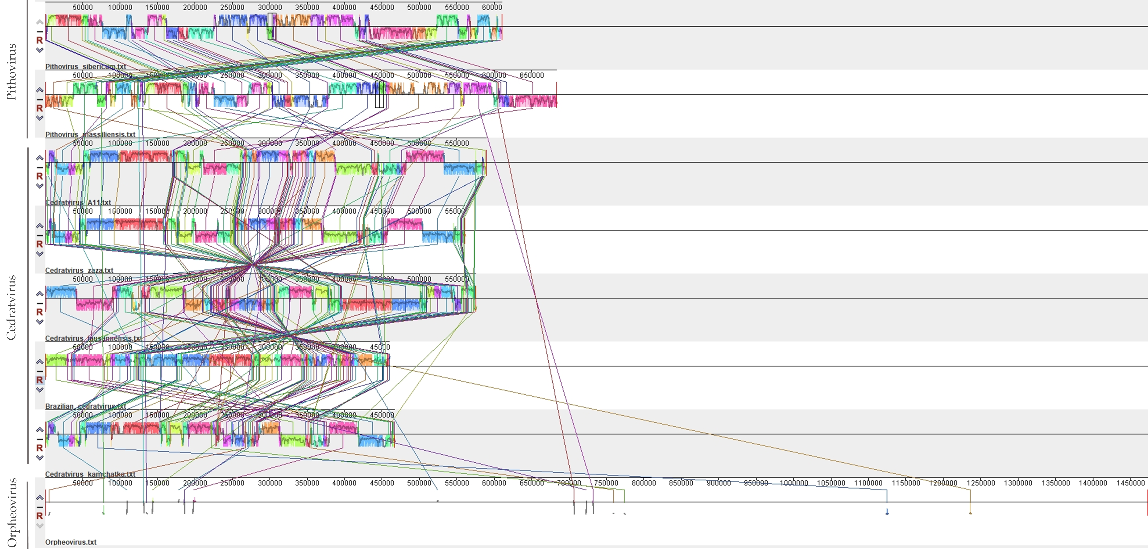

Figure 1. Genomic synteny analysis. Comparison of the genome organization between viral isolates of the three proposed families. The schematic whole genome alignment diagram was obtained using the Mauve software package [24].

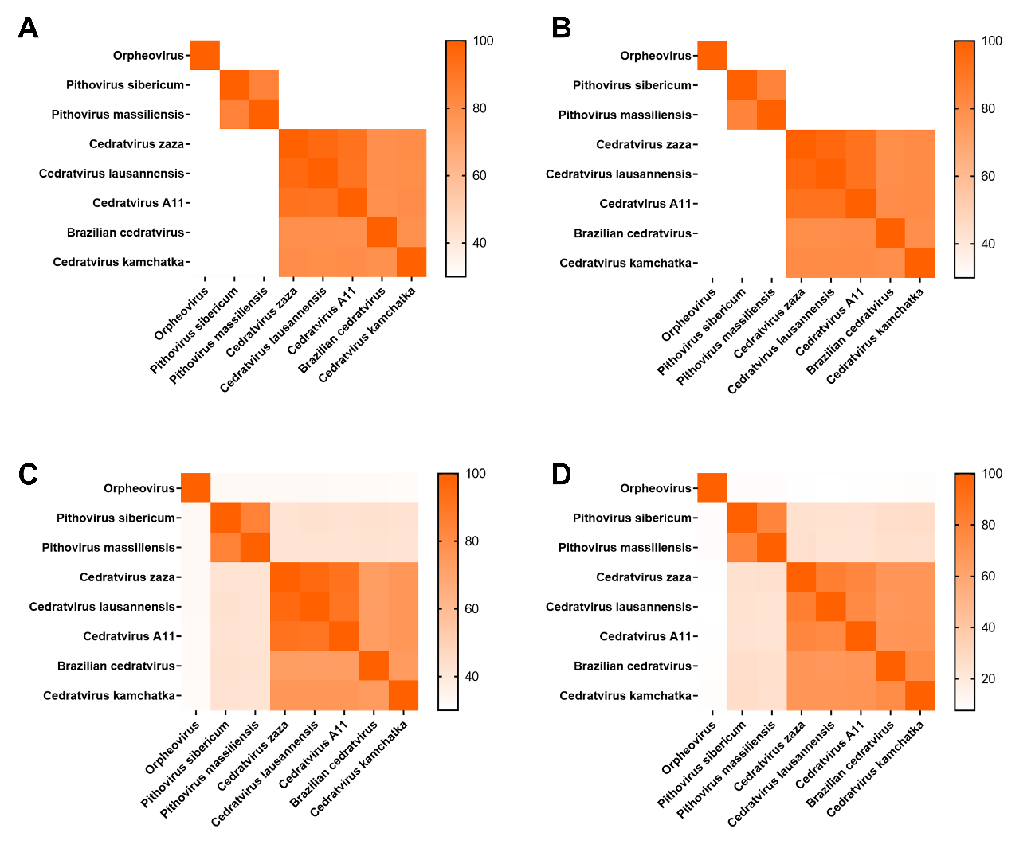
Figure 2. (A and B) Pairwise genomic and ORFs Average Nucleotide Identity (ANI). ANI values <70% were set to 0 [25]; (C) Pairwise Average Nucleotide Identity (AAI) [25]; (D) Normalized gene sharing level [26].

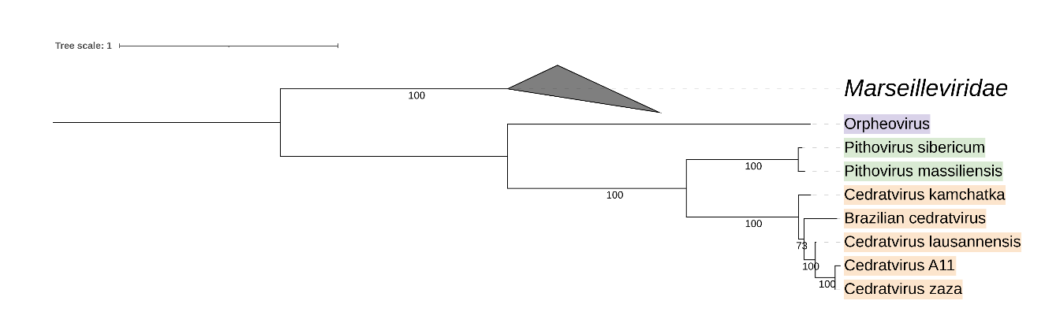

Figure 3. Maximum Likelihood based phylogenetic tree of 7 marker genes constructed using IQ-TREE multicore version 2.2.0 [27]. The best-fit model was VT+F+R3 chosen according to BIC [28]. The branch supports were computed by 1000 ultrafast bootstrap. The phylogenetic tree was visualized and edited using iTOL [29]. Members of the three proposed new families are indicated by different shades.

References
1. Koonin E V., Dolja V V., Krupovic M, et al (2020) Global Organization and Proposed Megataxonomy of the Virus World. Microbiol Mol Biol Rev 84:. https://doi.org/10.1128/mmbr.00061-19
2. Philippe N, Legendre M, Doutre G, et al (2013) Pandoraviruses: Amoeba viruses with genomes up to 2.5 Mb reaching that of parasitic eukaryotes. Science (80- ) 341:281–286. https://doi.org/10.1126/science.1239181
3. Legendre M, Lartigue A, Bertaux L, et al (2015) In-depth study of Mollivirus sibericum, a new 30,000-y-old giant virus infecting Acanthamoeba. Proc Natl Acad Sci 112:E5327–E5335. https://doi.org/10.1073/PNAS.1510795112
4. Andreani J, Khalil JYB, Sevvana M, et al (2017) Pacmanvirus, a New Giant Icosahedral Virus at the Crossroads between Asfarviridae and Faustoviruses
5. Reteno DG, Benamar S, Khalil JB, et al (2015) Faustovirus, an Asfarvirus-Related New Lineage of Giant Viruses Infecting Amoebae. J Virol 89:6585. https://doi.org/10.1128/JVI.00115-15
6. Bajrai L, Benamar S, Azhar E, et al (2016) Kaumoebavirus, a New Virus That Clusters with Faustoviruses and Asfarviridae
7. Rolland C, Andreani J, Sahmi-Bounsiar D, et al (2021) Clandestinovirus: A Giant Virus With Chromatin Proteins and a Potential to Manipulate the Cell Cycle of Its Host Vermamoeba vermiformis. Front Microbiol 0:2224. https://doi.org/10.3389/FMICB.2021.715608
8. Levasseur A, Andreani J, Delerce J, et al (2016) Comparison of a Modern and Fossil Pithovirus Reveals Its Genetic Conservation and Evolution. Genome Biol Evol 8:2333–9. https://doi.org/10.1093/gbe/evw153
9. Andreani J, Aherfi S, Bou Khalil J, et al (2016) Cedratvirus, a Double-Cork Structured Giant Virus, is a Distant Relative of Pithoviruses. Viruses 8:300. https://doi.org/10.3390/v8110300
10. Bertelli, Claire1. Bertelli C, Mueller L, Thomas V, Pillonel T, Jacquier N GG 2017. C lausannensis-digging into P diversity. EM, Mueller L, Thomas V, et al (2017) Cedratvirus lausannensis - digging into Pithoviridae diversity
11. Rodrigues RAL, Andreani J, Andrade AC dos SP, et al (2018) Morphologic and Genomic Analyses of New Isolates Reveal a Second Lineage of Cedratviruses. J Virol 92:. https://doi.org/10.1128/jvi.00372-18
12. Jeudy S, Rigou S, Alempic JM, et al (2020) The DNA methylation landscape of giant viruses. Nat Commun 2020 111 11:1–12. https://doi.org/10.1038/s41467-020-16414-2
13. Andreani J, Khalil JYB, Baptiste E, et al (2018) Orpheovirus IHUMI-LCC2: A New Virus among the Giant Viruses
14. ICTV (2021) ICTV - Taxonomy
15. Legendre M, Bartoli J, Shmakova L, et al (2014) Thirty-thousand-year-old distant relative of giant icosahedral DNA viruses with a pandoravirus morphology. Proc Natl Acad Sci U S A 111:4274–4279. https://doi.org/10.1073/pnas.1320670111
16. Boudjemaa H, Andreani J, Bitam I, Scola B La (2020) Diversity of Amoeba-Associated Giant Viruses Isolated in Algeria. Divers 2020, Vol 12, Page 215 12:215. https://doi.org/10.3390/D12060215
17. Rigou S, Santini S, Abergel C, et al (2022) Past and present giant viruses diversity explored through permafrost metagenomics. Nat Commun 2022 131 13:1–13. https://doi.org/10.1038/s41467-022-33633-x
18. Alempic JM, Lartigue A, Goncharov AE, et al (2023) An Update on Eukaryotic Viruses Revived from Ancient Permafrost. Viruses 2023, Vol 15, Page 564 15:564. https://doi.org/10.3390/V15020564
19. Bäckström D, Yutin N, Jørgensen SL, et al (2019) Virus Genomes from Deep Sea Sediments Expand the Ocean Megavirome and Support Independent Origins of Viral Gigantism. American Society for Microbiology
20. Silva LK dos S, Andrade AC dos SP, Dornas FP, et al (2018) Cedratvirus getuliensis replication cycle: an in-depth morphological analysis. Nature Publishing Group
21. de Miranda Boratto PV, Oliveira GP, Abrahão JS (2022) “Yaraviridae”: a proposed new family of viruses infecting Acanthamoeba castellanii. Arch Virol 167:711–715. https://doi.org/10.1007/S00705-021-05326-1/FIGURES/3
22. Souza F, Rodrigues R, Reis E, et al (2019) In-depth analysis of the replication cycle of Orpheovirus. Virol J 16:158. https://doi.org/10.1186/s12985-019-1268-8
23. Aylward FO, Moniruzzaman M, Ha AD, Koonin E V. (2021) A phylogenomic framework for charting the diversity and evolution of giant viruses. PLoS Biol 19:. https://doi.org/10.1371/JOURNAL.PBIO.3001430
24. Darling AE, Mau B, Perna NT (2010) progressiveMauve: Multiple Genome Alignment with Gene Gain, Loss and Rearrangement. PLoS One 5:e11147. https://doi.org/10.1371/JOURNAL.PONE.0011147
25. Rodriguez-R LM, Konstantinidis KT (2016) The enveomics collection: a toolbox for specialized analyses of microbial genomes and metagenomes. https://doi.org/10.7287/PEERJ.PREPRINTS.1900V1
26. Zhang R, Takemura M, Murata K, Ogata H (2023) “Mamonoviridae”, a proposed new family of the phylum Nucleocytoviricota. Arch Virol 168:1–6. https://doi.org/10.1007/S00705-022-05633-1/FIGURES/3
27. Minh BQ, Schmidt HA, Chernomor O, et al (2020) IQ-TREE 2: New Models and Efficient Methods for Phylogenetic Inference in the Genomic Era. Mol Biol Evol 37:1530–1534. https://doi.org/10.1093/MOLBEV/MSAA015
28. Kalyaanamoorthy S, Minh BQ, Wong TKF, et al (2017) ModelFinder: fast model selection for accurate phylogenetic estimates. Nat Methods 2017 146 14:587–589. https://doi.org/10.1038/nmeth.4285
29. Letunic I, Bork P, Gmbh BS (2021) Interactive Tree Of Life (iTOL) v5: an online tool for phylogenetic tree display and annotation. Nucleic Acids Res 1–4. https://doi.org/10.1093/nar/gkab301
30. Postler TS, Rubino L, Adriaenssens EA, Dutilh B, Harrach B, Junglen S, Kropinski AM, Krupovic M, Wada J, Crane A, Kuhn JH, Mushegian A, Rumnieks J, Sabanadzovic S, Simmonds P, Varsani A, Zerbini MF, Callanan J, Pallen MJ, Draper LA, Hill C, Stockdale SR, 2022. Guidance for creation of individual and batch Latinized binomial virus species names. J Gen Virol 103 (12) https://doi.org/10.1099/jgv.0.001800

