

The International Committee on Taxonomy of Viruses
Taxonomy Proposal Form, 2025

Part 1a: Details of taxonomy proposals

Title: | Create 32 new species in the genus Friunavirus (class Caudoviricetes, order Autographivirales, family Autoscriptoviridae, subfamily Beijerinckvirinae)
Code assigned: | 2025.085B.A.v2.Friunavirus_32ns

Author(s), affiliation and email address(es):
Given name (+middle initial(s)) | Surname | Affiliation | Email address | Corresponding author(s)
Michał J. | Wójcicki | Bacteriophage Laboratory, Department of Phage Therapy, Hirszfeld Institute of Immunology and Experimental Therapy, Polish Academy of Sciences, Wroclaw, Poland | michal.wojcicki@hirszfeld.pl | X
Martyna A. | Cieślik | Bacteriophage Laboratory, Department of Phage Therapy, Hirszfeld Institute of Immunology and Experimental Therapy, Polish Academy of Sciences, Wroclaw, Poland | martyna.cieslik@hirszfeld.pl
Edyta | Pawlak | Laboratory of Immunopathology, Department of Experimental Therapy, Hirszfeld Institute of Immunology and Experimental Therapy, Polish Academy of Sciences, Wroclaw, Poland | edyta.pawlak@hirszfeld.pl
Iwona | Gientka | Department of Biotechnology and Food Microbiology, Institute of Food Sciences, Warsaw University of Life Sciences (WULS-SGGW), Warsaw, Poland | iwona_gientka@sggw.edu.pl
Andrzej | Górski | Bacteriophage Laboratory, Department of Phage Therapy, Hirszfeld Institute of Immunology and Experimental Therapy, Polish Academy of Sciences, Wroclaw, Poland | andrzej.gorski@hirszfeld.pl
Ewa M. | Jończyk-Matysiak | Bacteriophage Laboratory, Department of Phage Therapy, Hirszfeld Institute of Immunology and Experimental Therapy, Polish Academy of Sciences, Wroclaw, Poland | ewa.jonczyk-matysiak@hirszfeld.pl

Part 1b: Taxonomy Proposal Submission
ICTV Subcommittee:
Animal DNA Viruses and Retroviruses |  | Bacterial viruses | X
Animal minus-strand and dsRNA viruses |  | Fungal and protist viruses
Animal positive-strand RNA viruses |  | Plant viruses
Archaeal viruses |  | General

List the ICTV Study Group(s) that have seen or have been involved in creating this proposal:
Caudoviricetes Study Group
Optional – complete only if formally voted on by an ICTV Study Group:
Study Group | Number of members
Study Group | Votes in support | Votes against | No vote

Submission date: | 20/06/2025

Part 1c: Feedback from ICTV Executive Committee (EC) meeting
Executive Committee Meeting Decision code: | X
A – Accept | x
Ac – Accept subject to revision by relevant subcommittee chair. No further vote required
U – Accept without revision but with re-evaluation and email vote by the EC
Uc – Accept subject to revision and re-evaluation and email vote by the EC
Ud – Deferred to the next EC meeting, with an invitation to revise based on EC comments
J - Reject
W - Withdrawn

Comments from the Executive Committee:

Part 1d: Revised Taxonomy Proposal Submission
Response of proposer:
Revision date:

Part 3: TAXONOMIC PROPOSAL

Taxonomic changes proposed:
Establish new taxon | X | Split taxon
Abolish taxon |  | Merge taxon
Move taxon |  | Promote taxon
Rename taxon |  | Demote taxon
Move and rename

Etymology (origin) of proposed taxonomic names:
Taxon name | Etymology of the term
Friunavirus 1137KEN02 | species name derived from the phage name in the GenBank database – Acinetobacter phage vB_Ab_1137_KEN_02
Friunavirus 1137KEN05 | species name derived from the phage name in the GenBank database – Acinetobacter phage vB_Ab_1137_KEN_05
Friunavirus 1137KEN03 | species name derived from the phage name in the GenBank database – Acinetobacter phage vB_Ab_1137_KEN_03
Friunavirus 5899STDY8049184 | species name derived from the phage name in the GenBank database – Acinetobacter phage MD-2021b strain 5899STDY8049184
Friunavirus NC12 | species name derived from the phage name in the GenBank database – Acinetobacter phage AB_NC12
Friunavirus 5899STDY8049183 | species name derived from the phage name in the GenBank database – Acinetobacter phage MD-2021b strain 5899STDY8049183
Friunavirus TCUAN2 | species name derived from the phage name in the GenBank database – Acinetobacter phage TCUAN2
Friunavirus 5899STDY8049180 | species name derived from the phage name in the GenBank database – Acinetobacter phage MD-2021b strain 5899STDY8049180
Friunavirus 1137KEN06 | species name derived from the phage name in the GenBank database – Acinetobacter phage vB_Ab_1137_KEN_06
Friunavirus Margaret | species name derived from the phage name in the GenBank database – Acinetobacter phage vB_AbaP_Margaret
Friunavirus phiAB440 | species name derived from the phage name in the GenBank database – Acinetobacter phage phiAB440
Friunavirus Tama | species name derived from the phage name in the GenBank database – Acinetobacter phage vB_AbaP_Tama
Friunavirus Fanak | species name derived from the phage name in the GenBank database – Acinetobacter phage vB_AbaP_Fanak
Friunavirus Bhz16 | species name derived from the phage name in the GenBank database – Acinetobacter phage vB_AbaS-Bhz16
Friunavirus A43Y | species name derived from the phage name in the GenBank database – Acinetobacter phage A43Y
Friunavirus Acba19 | species name derived from the phage name in the GenBank database – Acinetobacter phage Acba_19
Friunavirus APK44 | species name derived from the phage name in the GenBank database – Acinetobacter phage vB_AbaP_APK44
Friunavirus ZC2 | species name derived from the phage name in the GenBank database – Acinetobacter phage vB_Aba_ZC2
Friunavirus 164KEN02 | species name derived from the phage name in the GenBank database – Acinetobacter phage vB_Ab_164_KEN_02
Friunavirus 5899STDY8049177 | species name derived from the phage name in the GenBank database – Acinetobacter phage MD-2021b strain 5899STDY8049177
Friunavirus 5899STDY8049181 | species name derived from the phage name in the GenBank database – Acinetobacter phage MD-2021b strain 5899STDY8049181
Friunavirus Fishpie | species name derived from the phage name in the GenBank database – Acinetobacter phage vB_AbaP_Fishpie
Friunavirus EAB11 | species name derived from the phage name in the GenBank database – Acinetobacter phage vB_AbaA_EAB11
Friunavirus 02KEN01 | species name derived from the phage name in the GenBank database – Acinetobacter phage vB_Ab_02_KEN_01
Friunavirus ABW132 | species name derived from the phage name in the GenBank database – Acinetobacter phage vB_AbaP_ABW132
Friunavirus A31Y | species name derived from the phage name in the GenBank database – Acinetobacter phage A31Y
Friunavirus ABW311 | species name derived from the phage name in the GenBank database – Acinetobacter phage vB_AbaP_ABW311
Friunavirus W8 | species name derived from the phage name in the GenBank database – Acinetobacter phage vB_AbaP_W8
Friunavirus Ab11 | species name derived from the phage name in the GenBank database – Acinetobacter phage Ab11
Friunavirus AbaSI4 | species name derived from the phage name in the GenBank database – Acinetobacter phage vB_AbaSI_4

Permission for use of names derived from a living person
Taxon name | Full name of person from whom the name is derived | Attached

Abstract of Taxonomy Proposal:
Taxonomic rank(s) affected:
Realm Duplodnaviria, kingdom Heunggongvirae, phylum Uroviricota, class Caudoviricetes, order Autographivirales, family Autoscriptoviridae, subfamily Beijerinckvirinae.

Description of current taxonomy:
The subfamily Beijerinckvirinae comprises four genera (i.e., Aristophanesvirus, Daemvirus, Friunavirus, Pettyvirus) and 68 species. Currently, the Friunavirus genus includes 65 species.

Proposed taxonomic change(s):
We performed a genomic analysis of phages deposited in the NCBI database. We propose to create 30 new species in the genus Friunavirus.

Justification:
Based on DNA and protein similarity, the 30 proposed new species are coherent and together with the 65 known species can be classified in the genus Friunavirus.

Text of Taxonomy proposal:
Taxonomic rank(s) affected:
Realm Duplodnaviria, kingdom Heunggongvirae, phylum Uroviricota, class Caudoviricetes, order Autographivirales, family Autoscriptoviridae, subfamily Beijerinckvirinae.

Description of current taxonomy:
The subfamily Beijerinckvirinae comprises four genera (i.e., Aristophanesvirus, Daemvirus, Friunavirus, Pettyvirus) and 68 species. Currently, the Friunavirus genus includes 65 species.

Proposed taxonomic change(s):
We performed a genomic analysis of phages deposited in the NCBI database. We propose to create 30 new species in the genus Friunavirus.

Demarcation criteria:
Species demarcation criteria: Two phages are assigned to the same species if their genomes are more than 95% identical over their genome length for isolates.
These values can be calculated by several tools, such as BLASTn [1] – usually calculated using the intergenomic distance calculator VIRIDIC [2].

Genus demarcation criteria: In search for criteria that create cohesive and distinct genera that are reproducible and monophyletic, the Bacterial Viruses Subcommittee has established 70% nucleotide identity of the genome length as the cut-off for genera. Genus-level groupings should always be monophyletic in the signature genes, as tested with a phylogenetic tree [3].

Justification:
Based on DNA and protein similarity, the 30 proposed new species are coherent and together with the 65 known species can be classified in the genus Friunavirus.

References:
- Sayers EW, Beck J, Bolton EE, Bourexis D, Brister JR, Canese K, Comeau DC, Funk K, Kim S, Klimke W, Marchler-Bauer A, Landrum M, Lathrop S, Lu Z, Madden TL, O'Leary N, Phan L, Rangwala SH, Schneider VA, Skripchenko Y, Wang J, Ye J, Trawick BW, Pruitt KD, Sherry ST. Database resources of the National Center for Biotechnology Information. Nucleic Acids Res. 2021, 49(D1):D10-D17.
- Moraru C, Varsani A, Kropinski AM. VIRIDIC - a novel tool to calculate the intergenomic similarities of prokaryote-infecting viruses. Viruses 2020, 12(11):1268.
- Turner D, Kropinski AM, Adriaenssens EM. A roadmap for genome-based phage taxonomy. Viruses 2021, 13(3):506.
- Nishimura Y, Yoshida T, Kuronishi M, Uehara H, Ogata H, Goto S. ViPTree: the viral proteomic tree server. Bioinformatics 2017, 33(15):2379-2380.
- Rohwer F, Edwards R. The Phage Proteomic Tree: a genome-based taxonomy for phage. J. Bacteriol. 2002, 184(16):4529-35.
- Turner D, Reynolds D, Seto D, Mahadevan P. CoreGenes3.5: a webserver for the determination of core genes from sets of viral and small bacterial genomes. BMC Res. Notes. 2013, 6:140.

Accompanying files:
Filename | Description of contents
Friunavirus_30_ns.xlsx | To present the proposed taxonomic changes as a comparison of new taxonomic structures.

Tables, Figures:

Figure 1. VIRIDIC heat map: VIRIDIC (Virus Intergenomic Distance Calculator [2]; http://rhea.icbm.uni-oldenburg.de/VIRIDIC/) computes pairwise intergenomic distances/similarities amongst phage genomes. Phages belonging to the same species (nucleotide similarity above 95%) are marked with a red frame.
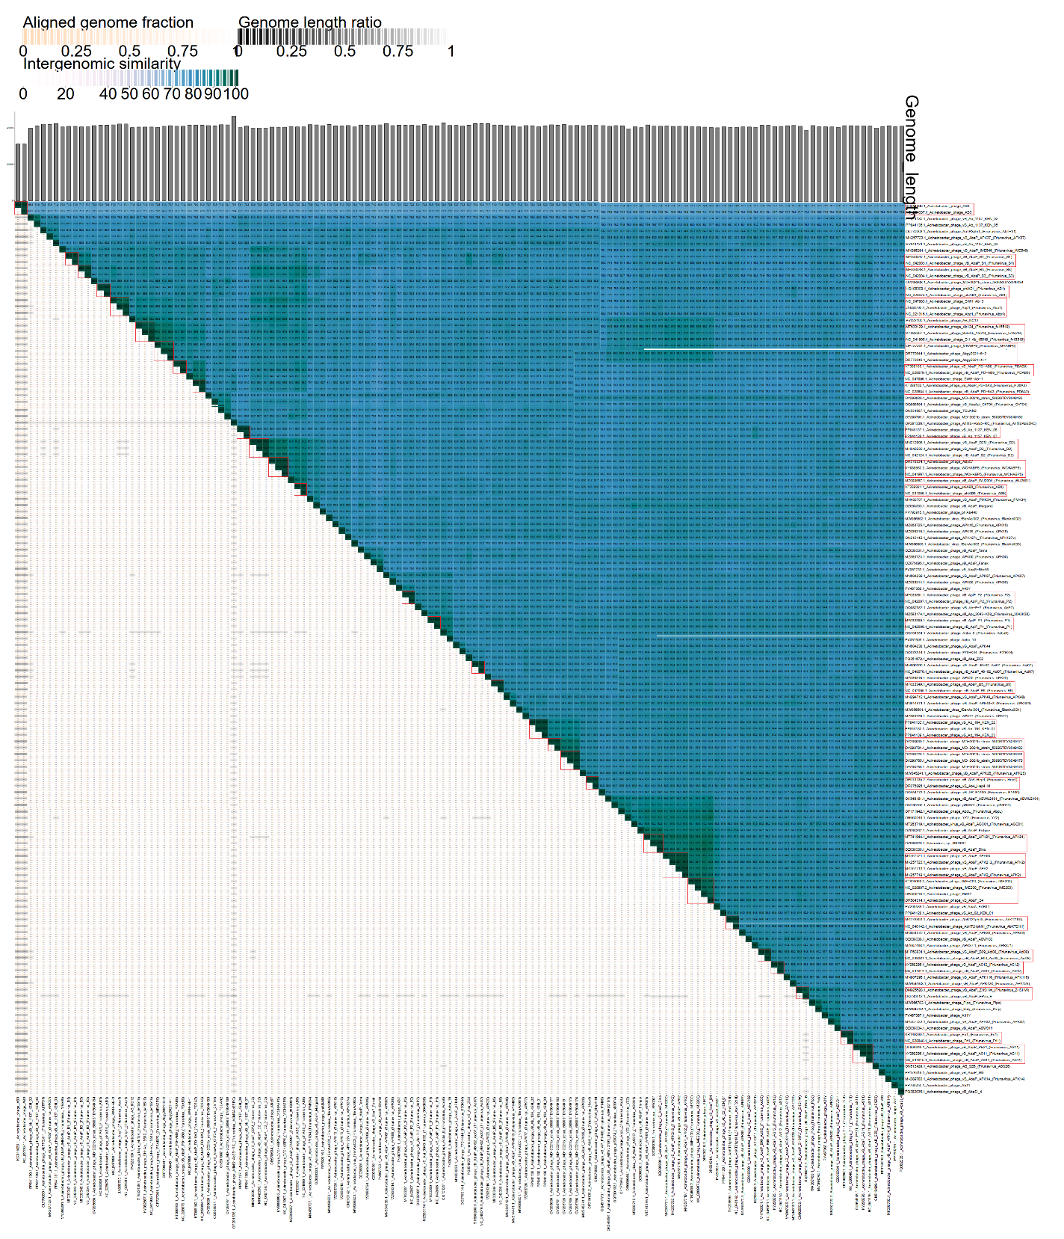

Figure 2. ViPTree analysis*: ViPTree analysis (https://www.genome.jp/viptree/; [4]) is based upon Rohwer and Edwards (2002) Phage Proteomic Tree [5]. The phages of interest are indicated with a red stars.

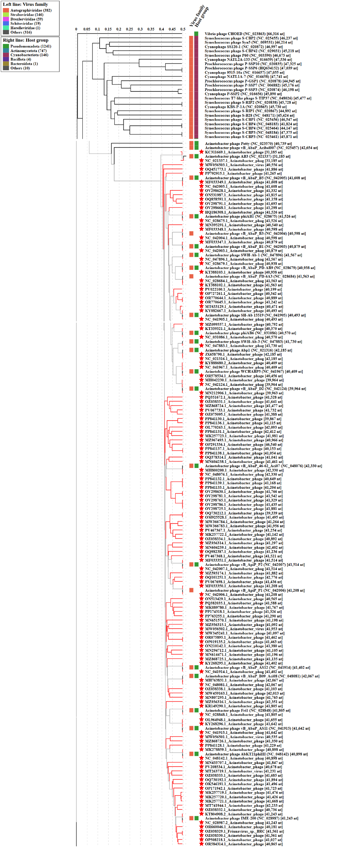
* The Autographiviridae family shown in Figure 2 (automatically labeled by the software) is outdated. In 2025, the Autographiviridae family was elevated to the rank of order and renamed Autographivirales.

Genome summary:

Phage name | RefSeq No. | INSDC | Size (bp) | GC% | Protein | Overall % DNA sequence identity (*) | Overall % homologous proteins (**)
Acinetobacter phage vB_AbaP_B1 (Friunavirus B1; reference genome) | NC_042003.1 | NC_042003 | 40,879 | 39.1 | 51 | 100.0 | 100.00
Acinetobacter phage AB3 |  | KC311669 | 31,185 | 39.2 | 29 | 71.5 | 49.02
Acinetobacter phage vB_Ab_1137_KEN_02 |  | PP841130 | 39,867 | 39.4 | 60 | 79.3 | 76.47
Acinetobacter phage vB_Ab_1137_KEN_05 |  | PP841136 | 41,115 | 39.3 | 66 | 81.9 | 84.31
Acinetobacter phage vB_Ab_1137_KEN_03 |  | PP841131 | 42,412 | 39.3 | 64 | 81.1 | 84.31
Acinetobacter phage MD-2021b strain 5899STDY8049184 |  | OV298668 | 41,298 | 39.2 | 49 | 83.6 | 84.31
Acinetobacter phage AB_NC12 |  | PV022100 | 40,199 | 39.5 | 49 | 85.8 | 86.27
Acinetobacter phage SWH-Ab-1 |  | NC_047896 | 41,567 | 39.4 | 48 | 85.4 | 84.31
Acinetobacter phage MD-2021b strain 5899STDY8049183 |  | OV298628 | 41,332 | 39.1 | 47 | 80.8 | 78.43
Acinetobacter phage TCUAN2 |  | ON531987 | 41,815 | 39.1 | 68 | 84.4 | 84.31
Acinetobacter phage MD-2021b strain 5899STDY8049180 |  | OV298791 | 41,693 | 39.4 | 48 | 84.3 | 84.31
Acinetobacter phage vB_Ab_1137_KEN_06 |  | PP841137 | 40,153 | 39.2 | 55 | 81.1 | 82.35
Acinetobacter phage vB_AbaP_Margaret |  | OZ038333 | 41,685 | 39.2 | 62 | 84.1 | 86.27
Acinetobacter phage phiAB440 |  | PP792915 | 41,265 | 39.0 | 50 | 83.4 | 84.31
Acinetobacter phage vB_AbaP_Tama |  | OZ038331 | 41,641 | 39.5 | 66 | 85.7 | 86.27
Acinetobacter phage vB_AbaP_Fanak |  | OZ075095 | 41,388 | 39.2 | 59 | 82.8 | 82.35
Acinetobacter phage vB_AbaS-Bhz16 |  | PV067733 | 41,732 | 39.3 | 60 | 81.8 | 82.35
Acinetobacter phage A43Y |  | PV467368 | 41,521 | 39.2 | 46 | 79.3 | 72.55
Acinetobacter phage Acba_19 |  | PV067698 | 41,436 | 39.1 | 47 | 81.4 | 78.43
Acinetobacter phage vB_AbaP_APK44 |  | MN604238 | 41,461 | 39.1 | 50 | 83.1 | 88.24
Acinetobacter phage vB_Aba_ZC2 |  | PQ351672 | 41,528 | 39.1 | 55 | 89.5 | 94.12
Acinetobacter phage vB_Ab_164_KEN_02 |  | PP841133 | 41,204 | 39.2 | 58 | 81.7 | 82.35
Acinetobacter phage MD-2021b strain 5899STDY8049177 |  | OV298630 | 41,766 | 39.3 | 49 | 82.1 | 84.31
Acinetobacter phage MD-2021b strain 5899STDY8049181 |  | OV298725 | 41,881 | 39.1 | 48 | 81.7 | 84.31
Acinetobacter phage vB_AbaP_Fishpie |  | OZ038332 | 40,736 | 39.4 | 57 | 84.1 | 88.24
Acinetobacter phage vB_AbaA_EAB11 |  | PV208534 | 40,678 | 39.3 | 38 | 82.8 | 52.94
Acinetobacter phage vB_Ab_02_KEN_01 |  | PP841128 | 41,229 | 39.3 | 60 | 82.3 | 90.20
Acinetobacter phage vB_AbaP_ABW132 |  | OZ038338 | 41,103 | 39.1 | 63 | 80.1 | 82.35
Acinetobacter phage A31Y |  | PV467367 | 41,254 | 39.3 | 49 | 83.5 | 80.39
Acinetobacter phage vB_AbaP_ABW311 |  | OZ038334 | 40,892 | 39.5 | 58 | 82.3 | 86.27
Acinetobacter phage vB_AbaP_W8 |  | PP174318 | 41,326 | 39.2 | 48 | 80.9 | 84.31
Acinetobacter phage Ab11 |  | PP763255 | 41,290 | 39.3 | 58 | 81.2 | 84.31
Acinetobacter phage vB_AbaSI_4 |  | PQ382035 | 41,588 | 39.2 | 51 | 80.8 | 84.31
(*) determined using VIRIDIC [2]
(**) determined using CoreGenes 3.5 [6]

