

The International Committee on Taxonomy of Viruses
Taxonomy Proposal Form, 2025

Part 1a: Details of taxonomy proposals

Title: | Create four new species in the genus Justusliebigvirus (class Caudoviricetes, subfamily Stephanstirmvirinae)
Code assigned: | 2025.080B.A.v2.Justusliebigvirus_4ns

Author(s), affiliation and email address(es):
Given name (+middle initial(s)) | Surname | Affiliation | Email address | Corresponding author(s)
Michał J. | Wójcicki | Bacteriophage Laboratory, Department of Phage Therapy, Hirszfeld Institute of Immunology and Experimental Therapy, Polish Academy of Sciences, Wroclaw, Poland | michal.wojcicki@hirszfeld.pl | X
Iwona | Gientka | Department of Biotechnology and Food Microbiology, Institute of Food Sciences, Warsaw University of Life Sciences (WULS-SGGW), Warsaw, Poland | iwona_gientka@sggw.edu.pl | X
Barbara | Sokołowska | Department of Microbiology, Prof. Wacław Dąbrowski Institute of Agricultural and Food Biotechnology - State Research Institute, Warsaw, Poland | barbara.sokolowska@ibprs.pl | X

Part 1b: Taxonomy Proposal Submission
ICTV Subcommittee:
Animal DNA Viruses and Retroviruses |  | Bacterial viruses | X
Animal minus-strand and dsRNA viruses |  | Fungal and protist viruses
Animal positive-strand RNA viruses |  | Plant viruses
Archaeal viruses |  | General

List the ICTV Study Group(s) that have seen or have been involved in creating this proposal:
Caudoviricetes Study Group
Optional – complete only if formally voted on by an ICTV Study Group:
Study Group | Number of members
Study Group | Votes in support | Votes against | No vote

Submission date: | 27/03/2025

Part 1c: Feedback from ICTV Executive Committee (EC) meeting
Executive Committee Meeting Decision code: | X
A – Accept | x
Ac – Accept subject to revision by relevant subcommittee chair. No further vote required
U – Accept without revision but with re-evaluation and email vote by the EC
Uc – Accept subject to revision and re-evaluation and email vote by the EC
Ud – Deferred to the next EC meeting, with an invitation to revise based on EC comments
J - Reject
W - Withdrawn

Comments from the Executive Committee:

Part 1d: Revised Taxonomy Proposal Submission
Response of proposer:
Revision date:

Part 3: TAXONOMIC PROPOSAL

Taxonomic changes proposed:
Establish new taxon | X | Split taxon
Abolish taxon |  | Merge taxon
Move taxon |  | Promote taxon
Rename taxon |  | Demote taxon
Move and rename

Etymology (origin) of proposed taxonomic names:
Taxon name | Etymology of the term
Justusliebigvirus UAB1 | species name derived from the phage name in the GenBank database – Salmonella phage UAB_1
Justusliebigvirus SD2 | species name derived from the phage name in the GenBank database – Escherichia phage SD2
Justusliebigvirus KKP3264 | species name derived from the phage name in the GenBank database – Serratia phage KKP_3264
Justusliebigvirus JLBYU50 | species name derived from the phage name in the GenBank database – Escherichia phage JLBYU50

Permission for use of names derived from a living person
Taxon name | Full name of person from whom the name is derived | Attached

Abstract of Taxonomy Proposal:
Taxonomic rank(s) affected:
Realm Duplodnaviria, kingdom Heunggongvirae, phylum Uroviricota, class Caudoviricetes

Description of current taxonomy:
The subfamily Stephanstirmvirinae comprises two genera, Justusliebigvirus and Phapecoctavirus, and 19 species. Currently, the Justusliebigvirus genus includes six species: Justusliebigvirus VEcB, Justusliebigvirus PHB05, Justusliebigvirus PD06, Justusliebigvirus alia, Justusliebigvirus phi92, and Justusliebigvirus muut.

Proposed taxonomic change(s):
We performed a genomic analysis of phages deposited in the NCBI database. We propose to create four new species in the genus Justusliebigvirus (class Caudoviricetes, subfamily Stephanstirmvirinae).

Justification:
Based on DNA and protein similarity, the proposed four new species are coherent and together with the six known species (Justusliebigvirus VEcB, Justusliebigvirus PHB05, Justusliebigvirus PD06, Justusliebigvirus alia, Justusliebigvirus phi92, and Justusliebigvirus muut) can be classified in the genus Justusliebigvirus.

Text of Taxonomy proposal:
Taxonomic rank(s) affected:
Realm Duplodnaviria, kingdom Heunggongvirae, phylum Uroviricota, class Caudoviricetes

Description of current taxonomy:
The subfamily Stephanstirmvirinae comprises two genera (i.e. Justusliebigvirus and Phapecoctavirus) and 19 species. Currently, the Justusliebigvirus genus includes six species: Justusliebigvirus VEcB, Justusliebigvirus PHB05, Justusliebigvirus PD06, Justusliebigvirus alia, Justusliebigvirus phi92, and Justusliebigvirus muut.

Proposed taxonomic change(s):
We performed a genomic analysis of phages deposited in the NCBI database. We propose to create four new species in the genus Justusliebigvirus.

Demarcation criteria:
Species demarcation criteria: Two phages are assigned to the same species if their genomes are more than 95% identical over their genome length for isolates.
These values can be calculated by several tools, such as BLASTn [1] – usually calculated using the intergenomic distance calculator VIRIDIC [2].

Genus demarcation criteria: In search for criteria that create cohesive and distinct genera that are reproducible and monophyletic, the Bacterial Viruses Subcommittee has established 70% nucleotide identity of the genome length as the cut-off for genera. Genus-level groupings should always be monophyletic in the signature genes, as tested with a phylogenetic tree [3].

Justification:
Based on DNA and protein similarity, the proposed four new species are coherent and together with the six known species (Justusliebigvirus VEcB, Justusliebigvirus PHB05, Justusliebigvirus PD06, Justusliebigvirus alia, Justusliebigvirus phi92, and Justusliebigvirus muut) can be classified in the genus Justusliebigvirus.

References:
- Sayers EW, Beck J, Bolton EE, Bourexis D, Brister JR, Canese K, Comeau DC, Funk K, Kim S, Klimke W, Marchler-Bauer A, Landrum M, Lathrop S, Lu Z, Madden TL, O'Leary N, Phan L, Rangwala SH, Schneider VA, Skripchenko Y, Wang J, Ye J, Trawick BW, Pruitt KD, Sherry ST. Database resources of the National Center for Biotechnology Information. Nucleic Acids Res. 2021, 49(D1):D10-D17.
- Moraru C, Varsani A, Kropinski AM. VIRIDIC - a novel tool to calculate the intergenomic similarities of prokaryote-infecting viruses. Viruses 2020, 12(11):1268.
- Turner D, Kropinski AM, Adriaenssens EM. A roadmap for genome-based phage taxonomy. Viruses 2021, 13(3):506.
- Nishimura Y, Yoshida T, Kuronishi M, Uehara H, Ogata H, Goto S. ViPTree: the viral proteomic tree server. Bioinformatics 2017, 33(15):2379-2380.
- Rohwer F, Edwards R. The Phage Proteomic Tree: a genome-based taxonomy for phage. J. Bacteriol. 2002, 184(16):4529-35.
- Turner D, Reynolds D, Seto D, Mahadevan P. CoreGenes3.5: a webserver for the determination of core genes from sets of viral and small bacterial genomes. BMC Res. Notes. 2013, 6:140.

Accompanying files:
Filename | Description of contents
Justusliebigvirus_4ns.xlsx | To present the proposed taxonomic changes as a comparison of new taxonomic structures.
Tables, Figures:

Figure 1. VIRIDIC heat map: VIRIDIC (Virus Intergenomic Distance Calculator [2]; http://rhea.icbm.uni-oldenburg.de/VIRIDIC/) computes pairwise intergenomic distances/similarities amongst phage genomes. Phages belonging to the same species (nucleotide similarity above 95%) are marked with a colored frames. The currently distinguished six species belonging to the genus Justusliebigvirus are marked with colored species names.

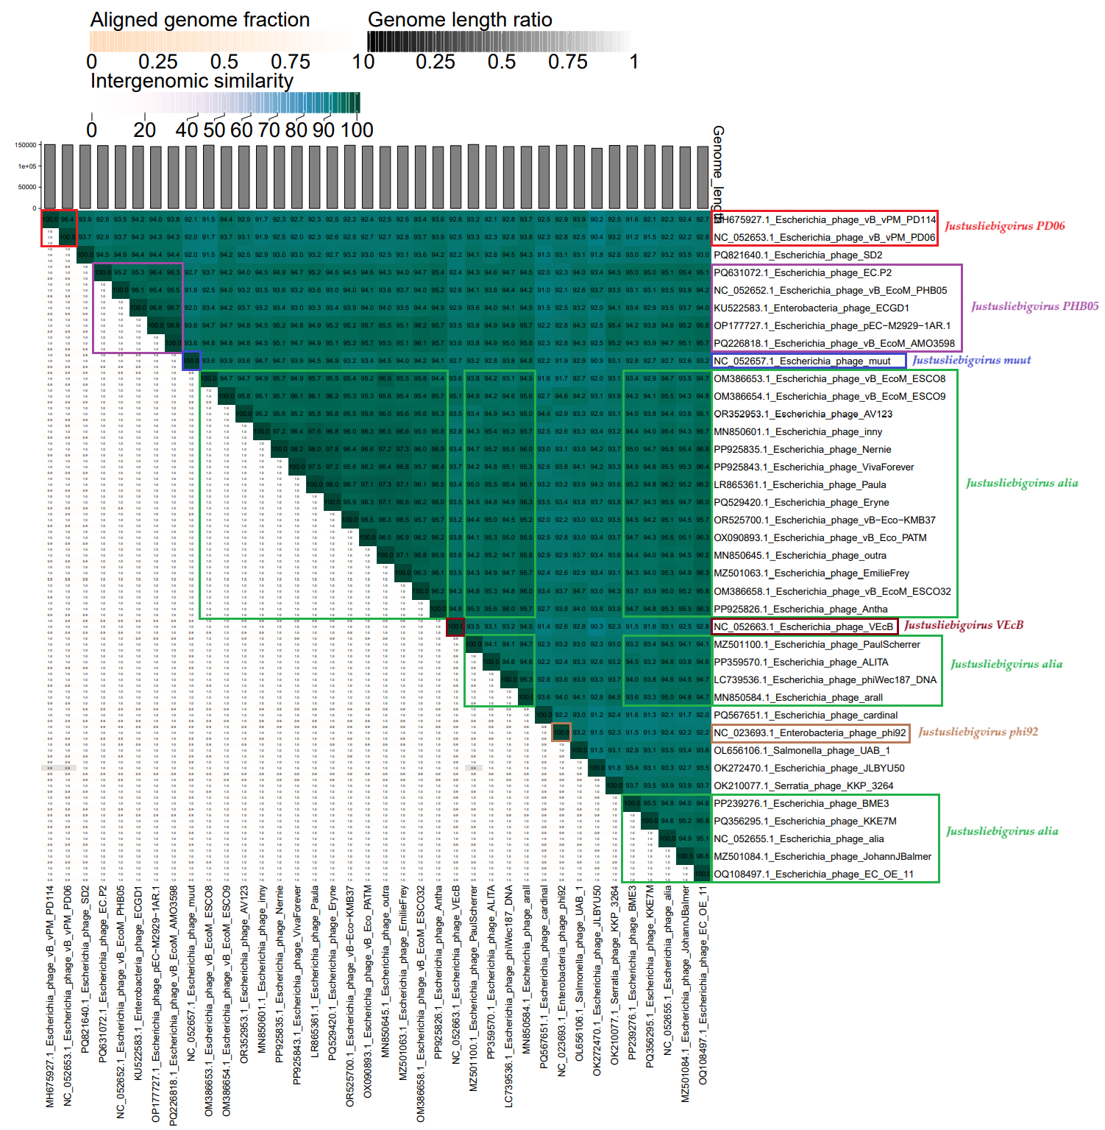

Figure 2. ViPTree analysis*: ViPTree analysis (https://www.genome.jp/viptree/; [4]) is based upon Rohwer and Edwards (2002) Phage Proteomic Tree [5]. The phage of interest is indicated with a red stars and a colored bars.

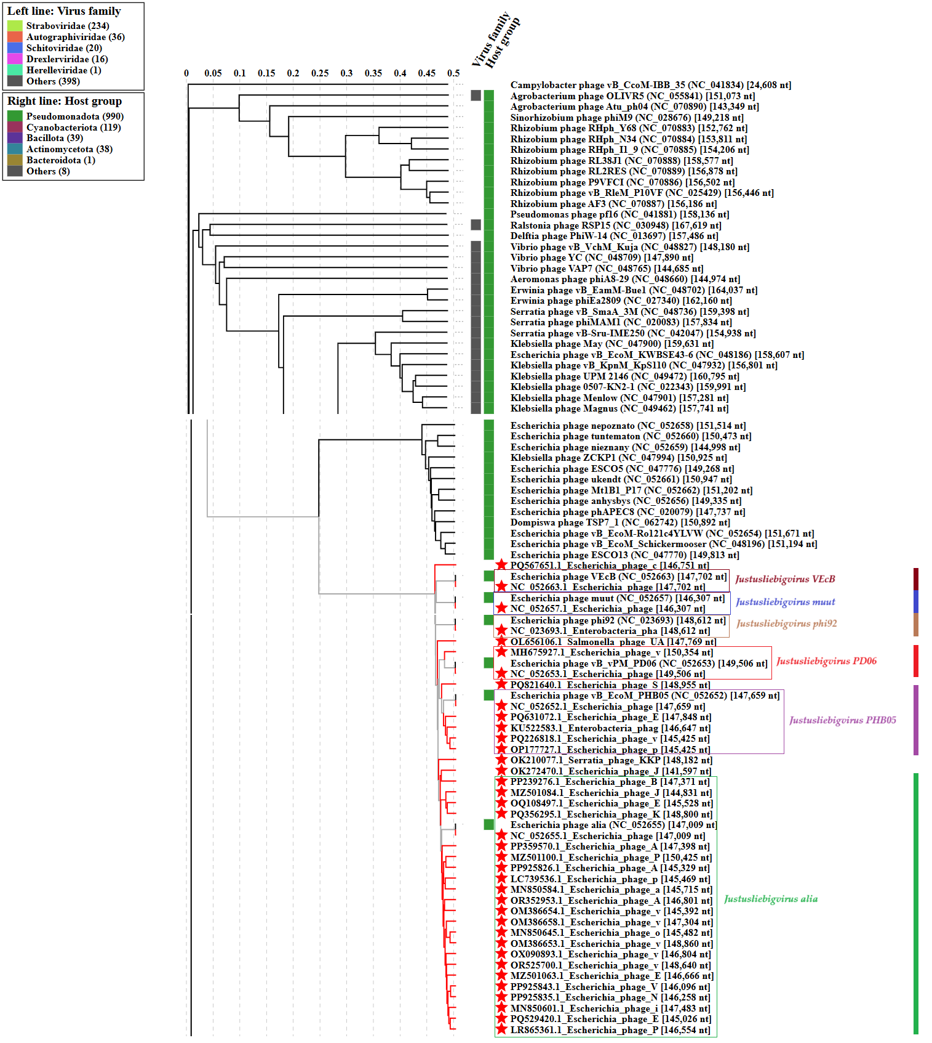

* The Autographiviridae family shown in Figure 2 (automatically labeled by the software) is outdated. In 2025, the Autographiviridae family was elevated to the rank of order and renamed Autographivirales.

Genome summary:

Phage name | RefSeq No. | INSDC | Size (bp) | GC% | Protein | Overall % DNA sequence identity (*) | Overall % homologous proteins (**)
Escherichia phage VEcB (Justusliebigvirus VEcB; reference genome) | NC_052663.1 | NC_052663 | 147,702 | 37.6 | 249 | 100.0 | 100.0
Salmonella phage UAB_1 |  | OL656106 | 147,769 | 37.4 | 246 | 92.8 | 93.57
Escherichia phage SD2 |  | PQ821640 | 148,955 | 37.5 | 246 | 92.2 | 92.37
Serratia phage KKP_3264 |  | OK210077 | 148,182 | 37.5 | 236 | 92.3 | 89.96
Escherichia phage JLBYU50 |  | OK272470 | 141,597 | 37.5 | 239 | 90.3 | 90.36
(*) determined using VIRIDIC [2]
(**) determined using CoreGenes 3.5 [6]

