

The International Committee on Taxonomy of Viruses
Taxonomy Proposal Form, 2025

Part 1a: Details of taxonomy proposals

Title: | Create one new species in the genus Tequintavirus
Code assigned: | 2025.076B.A.v2.Tequintavirus_1ns

Author(s), affiliation and email address(es):
Given name (+middle initial(s)) | Surname | Affiliation | Email address | Corr. author(s)
Emilia Andrea V. | Sabban | Department of Science and Technology, Industrial Technology Development Institute, Taguig City, Philippines | dost.eavsabban@gmail.com | X
Stephen Kyle C. | Arcan | Department of Science and Technology, Industrial Technology Development Institute, Taguig City, Philippines | arcan.stephenkyle@gmail.com
Adonis N. | Eclipse | Department of Science and Technology, Industrial Technology Development Institute, Taguig City, Philippines | aneclipse1@gmail.com
Dexter Bryan L. | Esliza | Department of Science and Technology, Industrial Technology Development Institute, Taguig City, Philippines | dlesliza@gmail.com
Paul Jeremy C. | Lanete | Department of Science and Technology, Industrial Technology Development Institute, Taguig City, Philippines | pjclanete@gmail.com
Lindley C. | Susi | Department of Science and Technology, Science Education Institute, Taguig City, Philippines | lindleysusi@gmail.com
Gelito Joseph M. | Sikat | Department of Science and Technology, Industrial Technology Development Institute, Taguig City, Philippines | gjmsikat@itdi.dost.gov.ph | X

Part 1b: Taxonomy Proposal Submission
ICTV Subcommittee:
Animal DNA Viruses and Retroviruses |  | Bacterial viruses | X
Animal minus-strand and dsRNA viruses |  | Fungal and protist viruses
Animal positive-strand RNA viruses |  | Plant viruses
Archaeal viruses |  | General -

List the ICTV Study Group(s) that have seen or have been involved in creating this proposal: https://ictv.global/sc
Optional – complete only if formally voted on by an ICTV Study Group:
Study Group | Number of members
Study Group | Votes in support | Votes against | No vote

Submission date: | 29/08/2024

Part 1c: Feedback from ICTV Executive Committee (EC) meeting
Executive Committee Meeting Decision code: | X
A – Accept | x
Ac – Accept subject to revision by relevant subcommittee chair. No further vote required
U – Accept without revision but with re-evaluation and email vote by the EC
Uc – Accept subject to revision and re-evaluation and email vote by the EC
Ud – Deferred to the next EC meeting, with an invitation to revise based on EC comments
J - Reject
W - Withdrawn

Comments from the Executive Committee:

Part 1d: Revised Taxonomy Proposal Submission
Response of proposer:
Revision date:

Part 3: TAXONOMIC PROPOSAL
https://ictv.global/taxonomy/templates
Taxonomic changes proposed:
Establish new taxon | X | Split taxon
Abolish taxon |  | Merge taxon
Move taxon |  | Promote taxon
Rename taxon |  | Demote taxon
Move and rename

Etymology (origin) of proposed taxonomic names:
Taxon name | Etymology of the term
Tequintavirus vipecosubii | The proposed binomial name of the new species is derived from the site of isolation in the Philippines: Tequintavirus vipecosubii isolated from a sewage facility in Subic.

Permission for use of names derived from a living person:
Taxon name | Full name of person from whom the name is derived | Attached

Abstract of Taxonomy Proposal:
Taxonomic rank(s) affected:
Species

Description of current taxonomy:
The genus Tequintavirus is classified within the subfamily Markadamsvirinae, family Demerecviridae. The genus is currently comprised of 70 species.

Proposed taxonomic change(s):
Create one new species Tequintavirus vipecosubii in the genus Tequintavirus.

Justification:
A new species, represented by Escherichia phage vB_EcoS_I14, is proposed based on a 95% intergenomic similarity threshold. This newly identified species is most closely related to Tequintavirus S131 (GenBank MH370378.1), sharing 80.1% similarity. This taxonomic proposal is grounded in the principles of phylogenetic analysis and genomic comparison, providing a robust classification for this newly isolated bacteriophage.

- Text of Taxonomy proposal:

Taxonomic rank(s) affected:
Species

Description of current taxonomy:
The genus Tequintavirus is classified within the subfamily Markadamsvirinae, family Demerecviridae. The genus is currently comprised of 70 species.

Proposed taxonomic change(s):
Create one new species Tequintavirus vipecosubii in the genus Tequintavirus.

Demarcation criteria:
Species demarcation: Two phages are classified as the same species if their genomes share more than 95% identity across their entire length, as determined by VIRIDIC. [1, 2].

Justification:
A new species, represented Escherichia phage vB_EcoS_I14, is proposed based on a 95% intergenomic similarity threshold. This newly identified species is most closely related to Tequintavirus S131 (GenBank MH370378.1), sharing 80.1% similarity (Figure 1, Figure 2). This taxonomic proposal is grounded in the principles of phylogenetic analysis and genomic comparison, providing a robust classification for this newly discovered bacteriophage. All annotated sequences and raw reads were compiled and deposited into GenBank with accession numbers as listed in Table 1.

References:
1. Turner D., Kropinski AM, Adriaenssens EM (2021) A roadmap for genome-based phage taxonomy Viruses, 13(3), 506. https://doi.org/10.3390/v13030506

2. Moraru C, Varsani A, Kropinski AM (2020) VIRIDIC — A Novel Tool to Calculate the Intergenomic Similarities of prokaryote-infecting viruses. Viruses 12(11):1268. https://doi.org/10.3390/v12111268

Accompanying files:
Filename | Description of contents

Tables, Figures:
<Start here>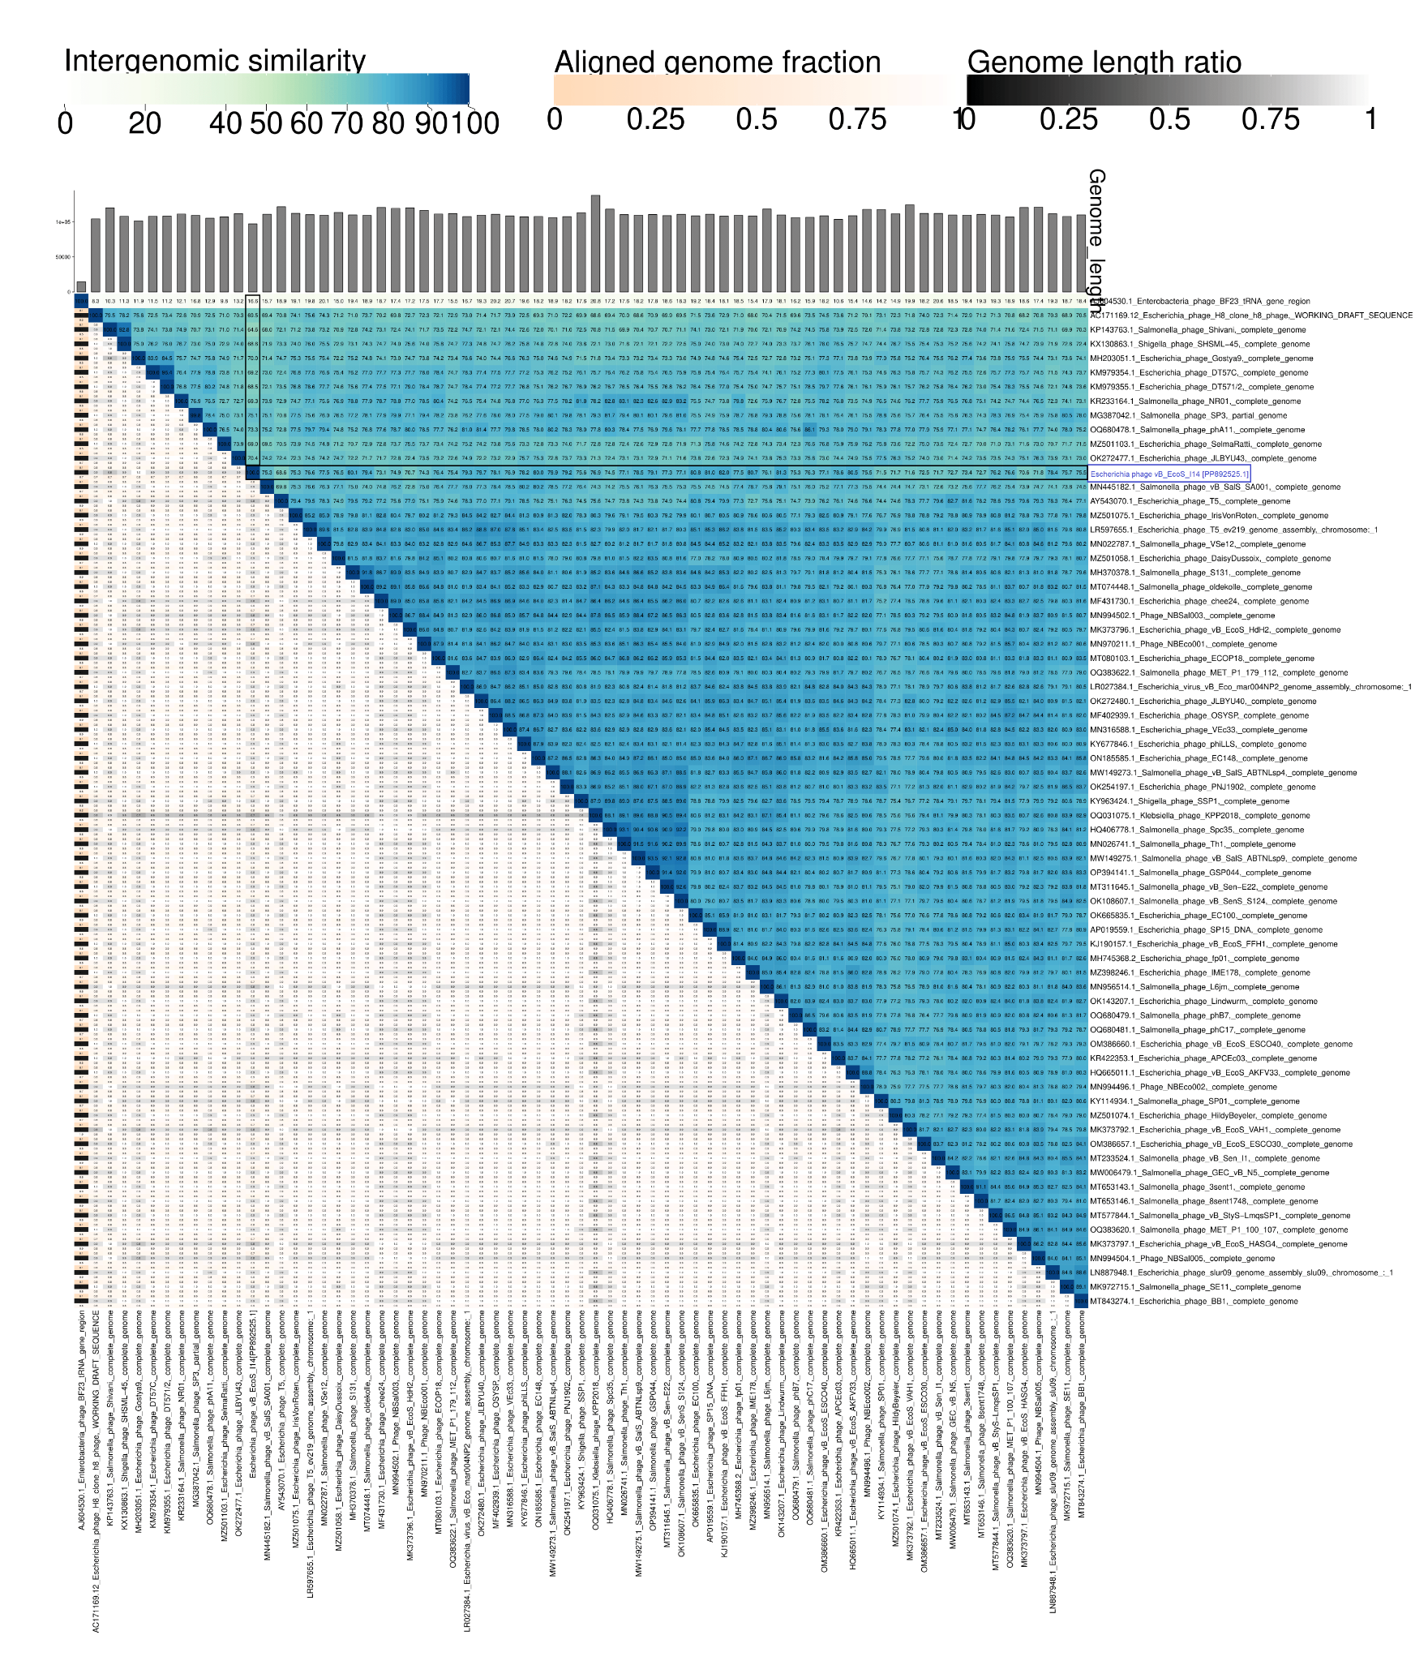

Figure 1. Intergenomic similarity scores (VIRIDIC) of phages classified within the genus Tequintavirus.
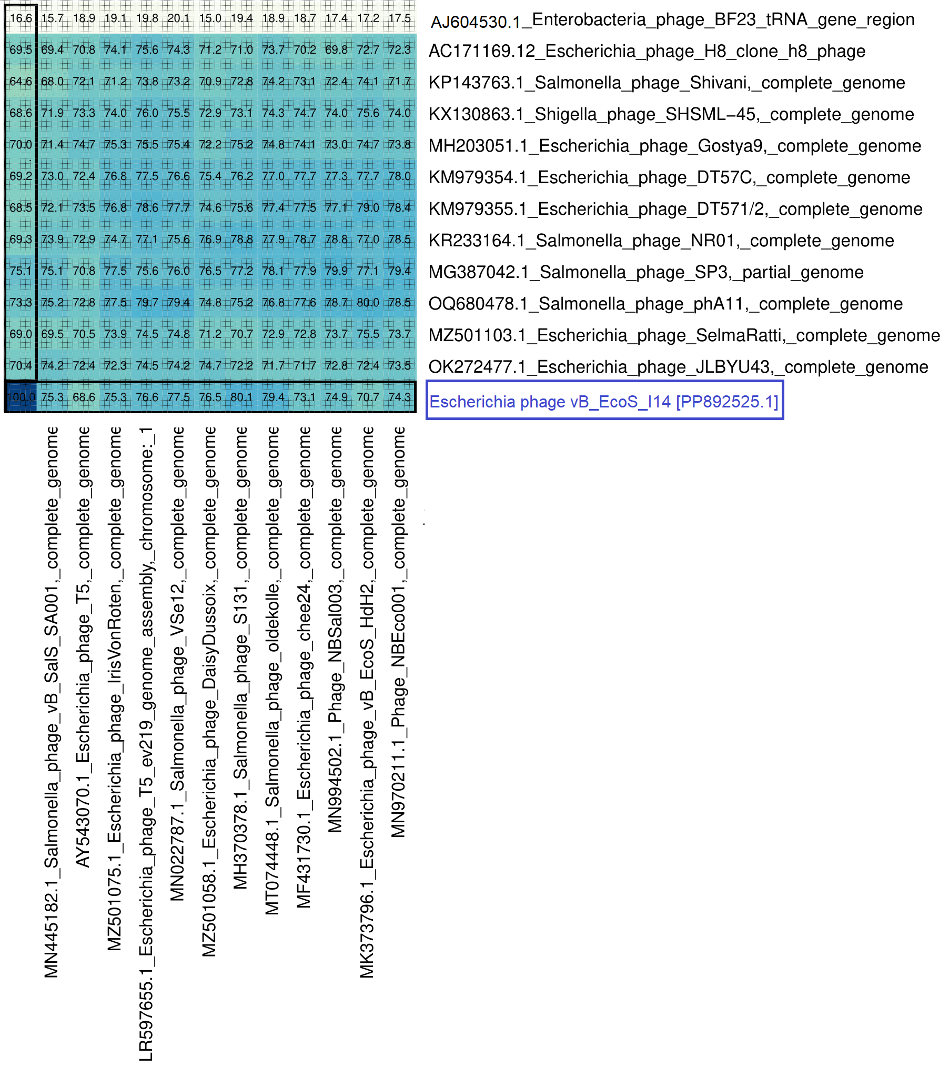
Figure 2. Closeup image from Figure 1 of closely related species of Escherichia phage vB_EcoS_I14

Table 1. Summary of molecular features of Escherichia phage vB_EcoS_I14.

 | Escherichia phage vB_EcoS_I14
Genome size (bp)  GC content (%)  Coverage  No. of CDS  No. of genes with predicted function  No. of tRNAs  Lifestyle prediction  Taxonomic identity  Temperate marker genes  Presence of antibiotic resistance genes  Presence of virulence genes  BioProject accession no.  SRA accession no.  GenBank accession no. | 97,251  38.88%  68.328727x  169  69  25  lytic  Tequintavirus sp.  -  -  -  PRJNA1123417  SRR30124319  PP892525

