

The International Committee on Taxonomy of Viruses
Taxonomy Proposal Form, 2025

Part 1a: Details of taxonomy proposals

Title: | Create a new genus (Tabiovirus) with eight species in the Class Caudoviricetes
Code assigned: | 2025.075B.Ac.v3.Tabiovirus_1ng_8ns

Author(s), affiliation and email address(es):
Given name (+middle initial(s)) | Surname | Affiliation | Email address | Corr. author(s)
Andrew M. | Kropinski | Department of Pathobiology, The Ontario Veterinary College, University of Guelph, Guelph, Ontario, Canada | Phage.Canada@gmail.com | x
Cristina | Moraru | Carl von Ossietzky Universität Oldenburg, Germany | liliana.cristina.moraru@uol.de

Part 1b: Taxonomy Proposal Submission
ICTV Subcommittee:
Animal DNA Viruses and Retroviruses |  | Bacterial viruses | x
xAnimal minus-strand and dsRNA viruses |  | Fungal and protist viruses
Animal positive-strand RNA viruses |  | Plant viruses
Archaeal viruses |  | General -

List the ICTV Study Group(s) that have seen or have been involved in creating this proposal: https://ictv.global/sc
Caudoviricetes Study Group
Optional – complete only if formally voted on by an ICTV Study Group:
Study Group | Number of members
Study Group | Votes in support | Votes against | No vote

Submission date: | 15/06/2025

Part 1c: Feedback from ICTV Executive Committee (EC) meeting
Executive Committee Meeting Decision code: | X
A – Accept
Ac – Accept subject to revision by relevant subcommittee chair. No further vote required | x
U – Accept without revision but with re-evaluation and email vote by the EC
Uc – Accept subject to revision and re-evaluation and email vote by the EC
Ud – Deferred to the next EC meeting, with an invitation to revise based on EC comments
J - Reject
W - Withdrawn

Comments from the Executive Committee:
Please improve the abstract quality.

Part 1d: Revised Taxonomy Proposal Submission
Response of proposer:
The text of the abstract has been amended.

Revision date: | 01/09/2025

https://ictv.global/taxonomy/templates
Taxonomic changes proposed:
Establish new taxon | x | Split taxon
Abolish taxon |  | Merge taxon
Move taxon |  | Promote taxon
Rename taxon |  | Demote taxon
Move and rename

Etymology (origin) of proposed taxonomic names:
Taxon name | Etymology of the term
Tabiovirus | The name is derived from Xathomonas phage Tabio

Permission for use of names derived from a living person:
Taxon name | Full name of person from whom the name is derived | Attached

Abstract of Taxonomy Proposal:
Taxonomic rank(s) affected:
Genus, species

Description of current taxonomy:
The bacterial viruses described in this proposal are currently unclassified

Proposed taxonomic change(s):
To create one new genus Tabiovirus with eight species of Xanthomonas phages

Justification: Based on analysis with ViPTree and VIRIDIC, we propose the creation of one new genus, Tabiovirus and eight new species of Xanthomonas phages.

- Text of Taxonomy proposal:

Taxonomic rank(s) affected:
Realm Duplodnaviria, kingdom Heunggongvirae, phylum Uroviricota, class Caudoviricetes

Description of current taxonomy:
The bacterial viruses described in this proposal are currently unclassified

Proposed taxonomic change(s):
To create one new genus Tabiovirus with eight species of Xanthomonas phages

Demarcation criteria:
Genus demarcation criteria: An intergenomic similarity cut-off of 70%, a combination of average nucleotide identity and alignment fraction is used to determine genera demarcation. Members of the same genus have >70% intergenomic similarity and cluster tightly in marker gene phylogenies.

Species demarcation criteria: A demarcation value of 95% intergenomic similarity was used to define different species according to intergenomic similarity. Members of the same species have >95% intergenomic similarity [8].

Justification: Based on analysis with ViPTree and VIRIDIC, we propose the creation of one new genus, Tabiovirus and eight new species of Xanthomonas phages
References:
1. Sayers EW, Beck J, Bolton EE, Bourexis D, Brister JR, Canese K, Comeau DC, Funk K, Kim S, Klimke W, Marchler-Bauer A, Landrum M, Lathrop S, Lu Z, Madden TL, O'Leary N, Phan L, Rangwala SH, Schneider VA, Skripchenko Y, Wang J, Ye J, Trawick BW, Pruitt KD, Sherry ST. Database resources of the National Center for Biotechnology Information. Nucleic Acids Res. 2021 Jan 8;49(D1):D10-D17. doi: 10.1093/nar/gkaa892. PMID: 33095870
2. Moraru C, Varsani A, Kropinski AM. VIRIDIC-A Novel Tool to Calculate the Intergenomic Similarities of Prokaryote-Infecting Viruses. Viruses. 2020 Nov 6;12(11):1268. doi: 10.3390/v12111268. PMID: 33172115; PMCID: PMC7694805. http://kronos.icbm.uni-oldenburg.de/viridic/
3. Turner D, Kropinski AM, Adriaenssens EM. A Roadmap for Genome-Based Phage Taxonomy. Viruses. 2021 Mar 18;13(3):506. doi: 10.3390/v13030506. PMID: 33803862; PMCID: PMC8003253.
4. Nishimura Y, Yoshida T, Kuronishi M, Uehara H, Ogata H, Goto S. ViPTree: the viral proteomic tree server. Bioinformatics. 2017; 33(15):2379-2380. doi:10.1093/bioinformatics/btx157. PubMed PMID: 28379287. https://www.genome.jp/viptree/
5. Rohwer F, Edwards R. The Phage Proteomic Tree: a genome-based taxonomy for phage. J Bacteriol. 2002 Aug;184(16):4529-35. PubMed PMID: 12142423
6. Lemoine F, Correia D, Lefort V, Doppelt-Azeroual O, Mareuil F, Cohen-Boulakia S, Gascuel O. NGPhylogeny.fr: new generation phylogenetic services for non-specialists. Nucleic Acids Res. 2019 Jul 2;47(W1):W260-W265. doi: 10.1093/nar/gkz303. PMID: 31028399; PMCID: PMC6602494.
7. Letunic I, Bork P. Interactive Tree Of Life (iTOL) v5: an online tool for phylogenetic tree display and annotation. Nucleic Acids Res. 2021 Jul 2;49(W1):W293-W296. doi: 10.1093/nar/gkab301. PMID: 33885785; PMCID: PMC8265157.

Accompanying files:
Filename | Description of contents

Tables, Figures:
Table 1. Characteristics of the phages described in the proposal
Phage name | Host | Morphotype | Lifestyle | Accession No. | Genome size | No. proteins | No. tRNA
Xanthomonas phage JUN5 | Not listed | unknown | unknown | OK913679.1 | 42912 bp | 57 | 0
Xanthomonas phage Tenjo | Xanthomonas albilineans | unknown | unknown | LR743531.1 | 43850 bp | 57 | 0
Xanthomonas phage Tabio | Xanthomonas albilineans | unknown | unknown | LR743528.1 | 43458 bp | 56 | 0
Xanthomonas phage 10KY502B | Xanthomonas citri | unknown | unknown | OQ622092.1 | 43262 bp | 42(*) | 1
Xanthomonas phage MET23-P3 | unknown | unknown | unknown | OK913680.1 | 43010 bp | 55 | 0
Xanthomonas phage Olaya | Xanthomonas albilineans CFBP2523 | unknown | unknown | MW802488.1 | 43722 bp | 55 | 0
Xanthomonas citri phage Cp2 | Xanthomonas citri | unknown | unknown | AB720064.1 | 42963 bp | 40(*) | 0
Xanthomonas phage SAC | Xanthomonas citri | unknown | unknown | PV012638.1 | 43900 bp | 55 | 0
(*) underannotated

Specific references:
Ahmad AA, Ogawa M, Kawasaki T, Fujie M, Yamada T. Characterization of bacteriophages Cp1 and Cp2, the strain-typing agents for Xanthomonas axonopodis pv. citri. Appl Environ Microbiol. 2014 Jan;80(1):77-85. doi: 10.1128/AEM.02310-13. Epub 2013 Oct 11. PMID: 24123743; PMCID: PMC3911001.
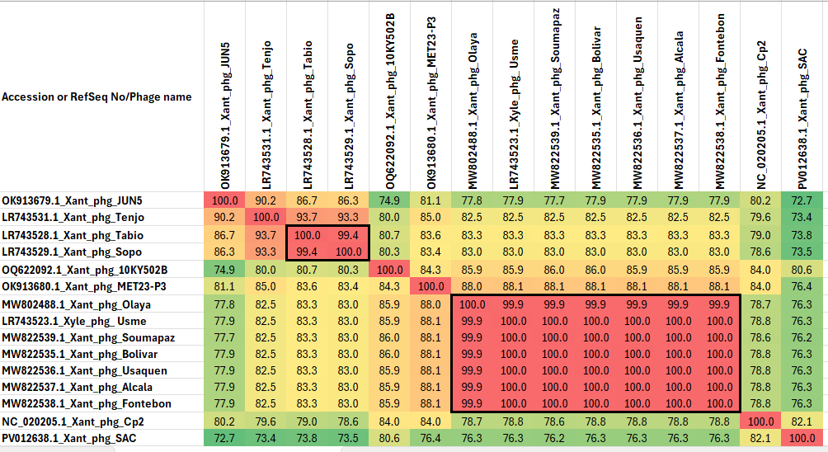Figure 1. VIRIDIC heat map (Virus Intergenomic Distance Calculator; VIRIDIC (Virus Intergenomic Distance Calculator; [3]; http://rhea.icbm.uni-oldenburg.de/VIRIDIC/) heatmap for this group of phages. It computes pairwise intergenomic distances/similarities amongst phage genomes. Data values which are bordered in black correspond to strains. Abbreviations: Xant = Xanthomonas; Xyle = Xylella; phg = phage.
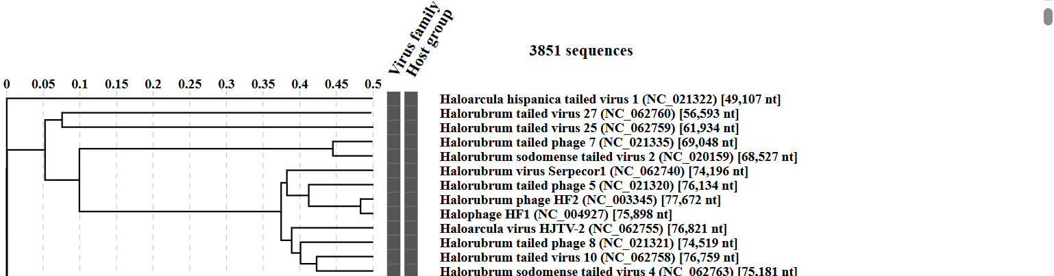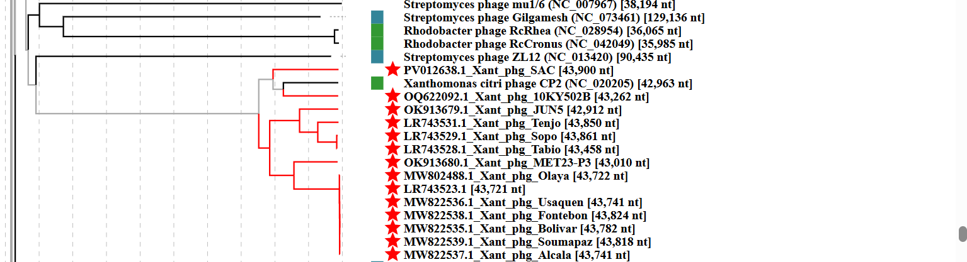Figure 2: ViPTree analysis (https://www.genome.jp/viptree/; [4]) is based upon Rohwer and Edwards (2002) Phage Proteomic Tree [5]. The phages of interest are indicated with red stars.

