

The International Committee on Taxonomy of Viruses
Taxonomy Proposal Form, 2025

Part 1a: Details of taxonomy proposals

Title: | Create six new genera of Paracoccus phages (Class: Caudoviricetes)
Code assigned: | 2025.056B.A.v2.Paracoccus_phages_7ng_7ns

Author(s), affiliation and email address(es):
Given name (+middle initial(s)) | Surname | Affiliation | Email address | Corr. author(s)
Andrew M. | Kropinski | Department of Pathobiology, University of Guelph, Guelph, Ontario, Canada | Phage.Canada@gmail.com | x
Cristina | Moraru | Carl von Ossietzky Universität Oldenburg, Germany | liliana.cristina.moraru@uol.de

Part 1b: Taxonomy Proposal Submission
ICTV Subcommittee:
Animal DNA Viruses and Retroviruses |  | Bacterial viruses | x
xAnimal minus-strand and dsRNA viruses |  | Fungal and protist viruses
Animal positive-strand RNA viruses |  | Plant viruses
Archaeal viruses |  | General -

List the ICTV Study Group(s) that have seen or have been involved in creating this proposal: https://ictv.global/sc
Caudoviricetes Study Group
Optional – complete only if formally voted on by an ICTV Study Group:
Study Group | Number of members
Study Group | Votes in support | Votes against | No vote

Submission date: | 15/05/2025

Part 1c: Feedback from ICTV Executive Committee (EC) meeting
Executive Committee Meeting Decision code: | X
A – Accept | x
Ac – Accept subject to revision by relevant subcommittee chair. No further vote required
U – Accept without revision but with re-evaluation and email vote by the EC
Uc – Accept subject to revision and re-evaluation and email vote by the EC
Ud – Deferred to the next EC meeting, with an invitation to revise based on EC comments
J - Reject
W - Withdrawn

Comments from the Executive Committee:

Part 1d: Revised Taxonomy Proposal Submission
Response of proposer:
Revision date:

Part 3: TAXONOMIC PROPOSAL
https://ictv.global/taxonomy/templates
Taxonomic changes proposed:
Establish new taxon | x | Split taxon
Abolish taxon |  | Merge taxon
Move taxon |  | Promote taxon
Rename taxon |  | Demote taxon
Move and rename

Etymology (origin) of proposed taxonomic names:
Taxon name | Etymology of the term
Peeyeiunavirus | Name derived from the first virus of its type - Paracoccus phage vB_PyeM_Pyei1
Peethiunavirus | Name derived from the first virus of its type - Paracoccus phage vB_PthS_Pthi1
Peebenunavirus | Name derived from the first virus of its type - Paracoccus phage vB_PbeS_Pben1
Peesulunavirus | Name derived from the first virus of its type - Paracoccus phage vB_PsuS_Psul1
Peekonunavirus | Name derived from the first virus of its type - Paracoccus phage vB_PkoS_Pkon1
Klepvirus | Name derived from the first virus of its type - Paracoccus phage vB_PmaP_KLEP18−1

Permission for use of names derived from a living person:
Taxon name | Full name of person from whom the name is derived | Attached

Abstract of Taxonomy Proposal:
Taxonomic rank(s) affected:
Genus, species

Description of current taxonomy:
There is no taxonomy for these lytic phages isolated against Paracoccus species

Proposed taxonomic change(s):
Create six new genera Peeyeiunavirus, Peethiunavirus, Peebenunavirus, Peesulunavirus, Peekonunavirus and Klepvirus each containing a single new species

Justification:
Based on the results of analyzing these phage genomes using VIRIDIC and ViPTree, we propose to establish seven new genera that each consist of a single species. These assignments meet the established demarcation criteria for defining new genera and species.

- Text of Taxonomy proposal:

Taxonomic rank(s) affected:
Genus, species

Description of current taxonomy:
There is no taxonomy for these lytic phages isolated against Paracoccus species

Proposed taxonomic change(s):
Create six new genera Peeyeiunavirus, Peethiunavirus, Peebenunavirus, Peesulunavirus, Peekonunavirus and Klepvirus each containing a single new species

Demarcation criteria:
Genus demarcation criteria: An intergenomic similarity cut-off of 70%, a combination of average nucleotide identity and alignment fraction is used to determine genera demarcation. Members of the same genus have >70% intergenomic similarity and cluster tightly in marker gene phylogenies.
Species demarcation criteria: A demarcation value of 95% intergenomic similarity was used to define different species according to intergenomic similarity. Members of the same species have >95% intergenomic similarity [8].

Justification: Based on the results of analyzing these phage genomes using VIRIDIC and ViPTree, we propose to establish seven new genera that each consist of a single species. These assignments meet the established demarcation criteria for defining new genera and species [8].

References:

1. Sayers EW, Beck J, Bolton EE, Bourexis D, Brister JR, Canese K, Comeau DC, Funk K, Kim S, Klimke W, Marchler-Bauer A, Landrum M, Lathrop S, Lu Z, Madden TL, O'Leary N, Phan L, Rangwala SH, Schneider VA, Skripchenko Y, Wang J, Ye J, Trawick BW, Pruitt KD, Sherry ST. Database resources of the National Center for Biotechnology Information. Nucleic Acids Res. 2021 Jan 8;49(D1):D10-D17. doi: 10.1093/nar/gkaa892. PMID: 33095870
2. O'Leary NA, Wright MW, Brister JR, Ciufo S, Haddad D, McVeigh R, et al. Reference sequence (RefSeq) database at NCBI: current status, taxonomic expansion, and functional annotation. Nucleic Acids Res. 2016;44(D1):D733-45. doi: 10.1093/nar/gkv1189. PMID: 26553804.
3. Moraru C, Varsani A, Kropinski AM. VIRIDIC-A Novel Tool to Calculate the Intergenomic Similarities of Prokaryote-Infecting Viruses. Viruses. 2020 Nov 6;12(11):1268. doi: 10.3390/v12111268. PMID: 33172115; PMCID: PMC7694805. http://kronos.icbm.uni-oldenburg.de/viridic/
4. Nishimura Y, Yoshida T, Kuronishi M, Uehara H, Ogata H, Goto S. ViPTree: the viral proteomic tree server. Bioinformatics. 2017; 33(15):2379-2380. doi:10.1093/bioinformatics/btx157. PubMed PMID: 28379287. https://www.genome.jp/viptree/
5. Rohwer F, Edwards R. The Phage Proteomic Tree: a genome-based taxonomy for phage. J Bacteriol. 2002 Aug;184(16):4529-35. PubMed PMID: 12142423
6. Turner D, Reynolds D, Seto D, Mahadevan P. CoreGenes3.5: a webserver for the determination of core genes from sets of viral and small bacterial genomes. BMC Res Notes. 2013;6:140. doi: 10.1186/1756-0500-6-140. PMID: 23566564.
7. Davis P, Seto D, Mahadevan P. CoreGenes5.0: An Updated User-Friendly Webserver for the Determination of Core Genes from Sets of Viral and Bacterial Genomes. Viruses. 2022 Nov 16;14(11):2534. doi: 10.3390/v14112534. PMID: 36423143; PMCID: PMC9693508.
8. Turner D, Kropinski AM, Adriaenssens EM. A Roadmap for Genome-Based Phage Taxonomy. Viruses. 2021 Mar 18;13(3):506. doi: 10.3390/v13030506. PMID: 33803862; PMCID: PMC8003253.
Lemoine F, Correia D, Lefort V, Doppelt-Azeroual O, Mareuil F, Cohen-Boulakia S, Gascuel O. NGPhylogeny.fr: new generation phylogenetic services for non-specialists. Nucleic Acids Res. 2019 Jul 2;47(W1):W260-W265. doi: 10.1093/nar/gkz303. PMID: 31028399; PMCID: PMC6602494.
9. Letunic I, Bork P. Interactive Tree Of Life (iTOL): an online tool for phylogenetic tree display and annotation. Bioinformatics. 2007 Jan 1;23(1):127-8. doi: 10.1093/bioinformatics/btl529. Epub 2006 Oct 18. PMID: 17050570.
10. Zhou T, Xu K, Zhao F, Liu W, Li L, Hua Z, Zhou X. itol.toolkit accelerates working with iTOL (Interactive Tree of Life) by an automated generation of annotation files. Bioinformatics. 2023 Jun 1;39(6):btad339. doi: 10.1093/bioinformatics/btad339. PMID: 37225402; PMCID: PMC10243930.

Accompanying files:
Filename | Description of contents

Tables, Figures:
<Start here>

Table 1A. Characteristics of the phages described in the proposal (Peeyeiunavirus)
Phage name | Host | Morphotype | Lifestyle | Accession No. | Genome size | No. proteins | No. tRNA
Paracoccus phage vB_PyeM_Pyei1 | Paracoccus yeei CCUG 32053 | Myovirus | Temperate | MK291445.1 | 50161 bp | 75 | 0

Table 1B. Characteristics of the phages described in the proposal (Peethiunavirus)
Phage name | Host | Morphotype | Lifestyle | Accession No. | Genome size | No. proteins | No. tRNA
Paracoccus phage vB_PthS_Pthi1 | Paracoccus thiocyanatus JCM 20756 | Siphovirus | Temperate | MK291444.1 | 39547 bp | 52 | 0

Table 1C. Characteristics of the phages described in the proposal (Peebenunavirus)
Phage name | Host | Morphotype | Lifestyle | Accession No. | Genome size | No. proteins | No. tRNA
Paracoccus phage vB_PbeS_Pben1 | Paracoccus bengalensis DSM 17099 | Siphovirus | Temperate | MK291441.1 | 39879 bp | 71 | 1

Table 1D. Characteristics of the phages described in the proposal (Peesulunavirus)
Phage name | Host | Morphotype | Lifestyle | Accession No. | Genome size | No. proteins | No. tRNA
Paracoccus phage vB_PsuS_Psul1 | Paracoccus sulfuroxidans JCM 14013 | Siphovirus | Temperate | MK291443.1 | 37901 bp | 57 | 0

Table 1E. Characteristics of the phages described in the proposal (Peekonunavirus)
Phage name | Host | Morphotype | Lifestyle | Accession No. | Genome size | No. proteins | No. tRNA
Paracoccus phage vB_PkoS_Pkon1 | Paracoccus kondratievae NCIMB 13773T | Siphovirus | Temperate | MK291442.1 | 49723 bp | 79

Table 1F. Characteristics of the phages described in the proposal (Klepvirus)
Phage name | Host | Morphotype | Lifestyle | Accession No. | Genome size | No. proteins | No. tRNA
Paracoccus phage vB_PmaP_KLEP18−1 | Paracoccus marcusii strain KR4M-18 | Podovirus | Lytic | OM654376.2 | 39110 bp | 67 | 0

Speciffic References:

Xu Y, Zhang R, Jiao N. Complete genome sequence of Paracoccus marcusii phage vB_PmaS-R3 isolated from the South China Sea. Stand Genomic Sci. 2015 Nov 10;10:94. doi: 10.1186/s40793-015-0089-7. PMID: 26561517; PMCID: PMC4641407. [R3]

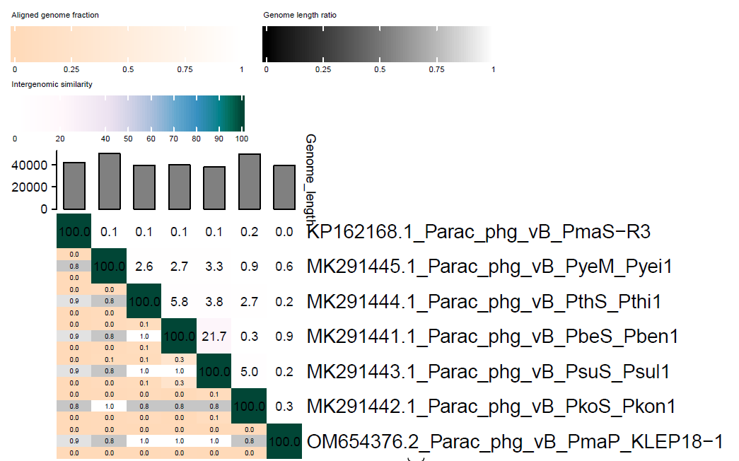

Figure 1. VIRIDIC heat map of this group of orphan phages. VIRIDIC (Virus Intergenomic Distance Calculator; VIRIDIC (Virus Intergenomic Distance Calculator; [3]; http://rhea.icbm.uni-oldenburg.de/VIRIDIC/) computes pairwise intergenomic distances/similarities amongst phage genomes. Data values which are bordered in black correspond to strains. Abbreviations: Parac = Paracoccus; phg = phage.
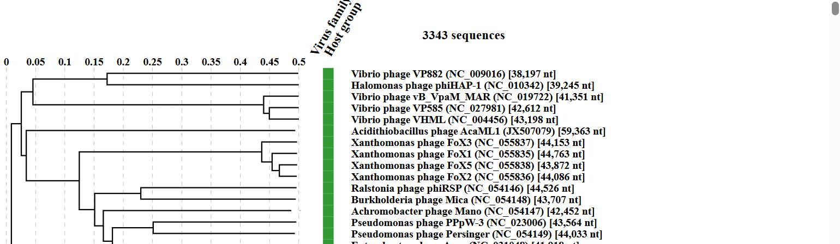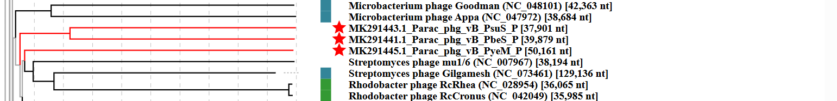
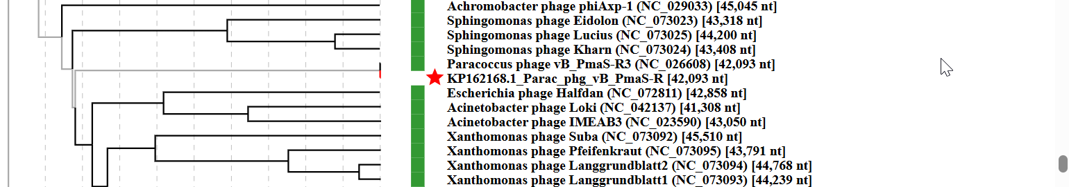

Figure 2. ViPTree analysis: ViPTree analysis (https://www.genome.jp/viptree/; [4]) is based upon Rohwer and Edwards (2002) Phage Proteomic Tree [5]. The taxon under discussion is indicated with a red bar. Abbreviations: phg = phage; Parac = Paracoccus

