

The International Committee on Taxonomy of Viruses
Taxonomy Proposal Form, 2025

Part 1a: Details of taxonomy proposals

Title: | Create a new subfamily (Jianjiangvirinae) with two genera and 22 species (Class Caudoviricetes)
Code assigned: | 2025.027B.Ac.v3.Jianjiangvirinae_1nsf_2ng_22ns

Author(s), affiliation and email address(es):
Given name (+middle initial(s)) | Surname | Affiliation | Email address | Corr. author(s)
Andrew M. | Kropinski | Department of Pathobiology, University of Guelph, Guelph, Ontario, Canada | Phage.Canada@gmail.com | x
Cristina | Moraru | Carl von Ossietzky Universität Oldenburg, Germany | liliana.cristina.moraru@uol.de
Juntao | Shen | Center for Synthetic Microbiome,  Shenzhen Institute of Advanced Technology, Chinese Academy of Sciences, China | jt.shen1@siat.ac.cn

Part 1b: Taxonomy Proposal Submission
ICTV Subcommittee:
Animal DNA Viruses and Retroviruses |  | Bacterial viruses | x
Animal minus-strand and dsRNA viruses |  | Fungal and protist viruses
Animal positive-strand RNA viruses |  | Plant viruses
Archaeal viruses |  | General -

List the ICTV Study Group(s) that have seen or have been involved in creating this proposal: https://ictv.global/sc
Caudoviricetes Study Group

Optional – complete only if formally voted on by an ICTV Study Group:
Study Group | Number of members
Study Group | Votes in support | Votes against | No vote

Submission date: | 15/06/2025

Part 1c: Feedback from ICTV Executive Committee (EC) meeting
Executive Committee Meeting Decision code: | X
A – Accept
Ac – Accept subject to revision by relevant subcommittee chair. No further vote required | x
U – Accept without revision but with re-evaluation and email vote by the EC
Uc – Accept subject to revision and re-evaluation and email vote by the EC
Ud – Deferred to the next EC meeting, with an invitation to revise based on EC comments
J - Reject
W - Withdrawn

Comments from the Executive Committee:
Please improve the quality of the abstract, there is a lack of phylogenetic tree (not necessary but would improve the proposal).

Part 1d: Revised Taxonomy Proposal Submission
Response of proposer:
We have included additional text in the abstract

Revision date: | 01/09/2025

Part 3: TAXONOMIC PROPOSAL
https://ictv.global/taxonomy/templates
Taxonomic changes proposed:
Establish new taxon | x | Split taxon
Abolish taxon |  | Merge taxon
Move taxon |  | Promote taxon
Rename taxon |  | Demote taxon
Move and rename

Etymology (origin) of proposed taxonomic names:
Taxon name | Etymology of the term
Jianjiangvirinae | All of these Bacteroides phages were identified in the Shenzhen Institute of Synthetic Biology, Guangdong, China. We have chosen to name these taxa after the main rivers of that province
Luojiangvirus | Named after a tributary of Jian(jiang) River – the Luojiang River
Caojiangvirus | Named after a tributary of the Jian(jiang) River – Caojiang (River)

Permission for use of names derived from a living person:
Taxon name | Full name of person from whom the name is derived | Attached

Abstract of Taxonomy Proposal:
Taxonomic rank(s) affected:
Subfamily, genus, species

Description of current taxonomy:
There is no taxonomy for these lytic phages isolated against Bacteroides caccae and Bacteroides ovatus from sewage

Proposed taxonomic change(s):
Add two new genera (Luojiangvirus and Caojiangvirus) and 22 new species to a new subfamily

Justification:
In accord with the established demarcation criteria for delineating a new subfamily, genus and species [3] these Bacteroides phages, isolated in China, fall into two new genera (Luojiangvirus and Caojiangvirus) in a new subfamily which we have chosen to call Pearlrivervirinae.

- Text of Taxonomy proposal:

Taxonomic rank(s) affected:
Subfamily, genus, species

Description of current taxonomy:
There is no current taxonomy for these lytic phages isolated against Bacteroides caccae and Bacteroides ovatus from sewage

Proposed taxonomic change(s):
Add two new genera (Luojiangvirus and Caojiangvirus) and 22 new species to a new subfamily

Demarcation criteria: The Bacterial and Archaeal Virus Subcommittee established 70% average nucleotide identity (ANI) threshold for genus classification or 95% ANI for species [8]. Subfamilies are to be created when two or more genera are related below the family level. In practical terms, this usually means that they share a low degree of sequence similarity (usually about 40-50%) and that the genera form a clade in a marker tree phylogeny [8].

Justification: In accord with our definition of what constitutes a new subfamily, genus and species [3] these Bacteroides phages, isolated in China, fall into two new genera (Luojiangvirus and Caojiangvirus) in a new subfamily which we have chosen to call Jianjiangvirinae.

References:
1. Sayers EW, Beck J, Bolton EE, Bourexis D, Brister JR, Canese K, Comeau DC, Funk K, Kim S, Klimke W, Marchler-Bauer A, Landrum M, Lathrop S, Lu Z, Madden TL, O'Leary N, Phan L, Rangwala SH, Schneider VA, Skripchenko Y, Wang J, Ye J, Trawick BW, Pruitt KD, Sherry ST. Database resources of the National Center for Biotechnology Information. Nucleic Acids Res. 2021 Jan 8;49(D1):D10-D17. doi: 10.1093/nar/gkaa892. PMID: 33095870
2. O'Leary NA, Wright MW, Brister JR, Ciufo S, Haddad D, McVeigh R, et al. Reference sequence (RefSeq) database at NCBI: current status, taxonomic expansion, and functional annotation. Nucleic Acids Res. 2016;44(D1):D733-45. doi: 10.1093/nar/gkv1189. PMID: 26553804.
3. Moraru C, Varsani A, Kropinski AM. VIRIDIC-A Novel Tool to Calculate the Intergenomic Similarities of Prokaryote-Infecting Viruses. Viruses. 2020 Nov 6;12(11):1268. doi: 10.3390/v12111268. PMID: 33172115; PMCID: PMC7694805. http://kronos.icbm.uni-oldenburg.de/viridic/
4. Nishimura Y, Yoshida T, Kuronishi M, Uehara H, Ogata H, Goto S. ViPTree: the viral proteomic tree server. Bioinformatics. 2017; 33(15):2379-2380. doi:10.1093/bioinformatics/btx157. PubMed PMID: 28379287. https://www.genome.jp/viptree/
5. Rohwer F, Edwards R. The Phage Proteomic Tree: a genome-based taxonomy for phage. J Bacteriol. 2002 Aug;184(16):4529-35. PubMed PMID: 12142423
6. Turner D, Reynolds D, Seto D, Mahadevan P. CoreGenes3.5: a webserver for the determination of core genes from sets of viral and small bacterial genomes. BMC Res Notes. 2013;6:140. doi: 10.1186/1756-0500-6-140. PMID: 23566564.
7. Davis P, Seto D, Mahadevan P. CoreGenes5.0: An Updated User-Friendly Webserver for the Determination of Core Genes from Sets of Viral and Bacterial Genomes. Viruses. 2022 Nov 16;14(11):2534. doi: 10.3390/v14112534. PMID: 36423143; PMCID: PMC9693508.
8. Turner D, Kropinski AM, Adriaenssens EM. A Roadmap for Genome-Based Phage Taxonomy. Viruses. 2021 Mar 18;13(3):506. doi: 10.3390/v13030506. PMID: 33803862; PMCID: PMC8003253.
Lemoine F, Correia D, Lefort V, Doppelt-Azeroual O, Mareuil F, Cohen-Boulakia S, Gascuel O. NGPhylogeny.fr: new generation phylogenetic services for non-specialists. Nucleic Acids Res. 2019 Jul 2;47(W1):W260-W265. doi: 10.1093/nar/gkz303. PMID: 31028399; PMCID: PMC6602494.
9. Letunic I, Bork P. Interactive Tree Of Life (iTOL): an online tool for phylogenetic tree display and annotation. Bioinformatics. 2007 Jan 1;23(1):127-8. doi: 10.1093/bioinformatics/btl529. Epub 2006 Oct 18. PMID: 17050570.
10. Zhou T, Xu K, Zhao F, Liu W, Li L, Hua Z, Zhou X. itol.toolkit accelerates working with iTOL (Interactive Tree of Life) by an automated generation of annotation files. Bioinformatics. 2023 Jun 1;39(6):btad339. doi: 10.1093/bioinformatics/btad339. PMID: 37225402; PMCID: PMC10243930.

Accompanying files:
Filename | Description of contents
Jianjiangvirinae_1nsf_2ng_22ns.xlsx | Data for this proposal

Tables, Figures:
<Start here>Table 1. Table of members of the subfamily Jianjiangvirinae

Accession No. | Phage name | Taxon
OP172651.1 | Bacteroides phage BC679P5 | Luojiangvirus BC679P5
OP172644.1 | Bacteroides phage BC669P1 | Luojiangvirus BC669P1
OP172645.1 | Bacteroides phage BC669P2 | Luojiangvirus BC669P2
OP172647.1 | Bacteroides phage BC679P1 | Luojiangvirus BC679P1
OP172648.1 | Bacteroides phage BC679P2 | Luojiangvirus BC679P2
OP172646.1 | Bacteroides phage BC669P3 | Luojiangvirus BC669P3
OP172649.1 | Bacteroides phage BC679P3 | Luojiangvirus BC679P3
OP172699.1 | Bacteroides phage BO668P2 | Caojiangvirus BO668P2
OP172684.1 | Bacteroides phage BK687P4 | Caojiangvirus BK687P4
OP172682.1 | Bacteroides phage BK687P2 | Caojiangvirus BK687P2
OP172683.1 | Bacteroides phage BK687P3 | Caojiangvirus BK687P3
OP172691.1 | Bacteroides phage BK745P1 | Caojiangvirus BK745P1
OP172693.1 | Bacteroides phage BK745P4 | Caojiangvirus BK745P4
OP172643.1 | Bacteroides phage BC422P2 | Caojiangvirus BC422P2
OP172681.1 | Bacteroides phage BK687P1 | Caojiangvirus BK687P1
OP172685.1 | Bacteroides phage BK687P5 | Caojiangvirus BK687P5
OP172692.1 | Bacteroides phage BK745P3 | Caojiangvirus BK745P3
OP172688.1 | Bacteroides phage BK735P2 | Caojiangvirus BK735P2
OP172689.1 | Bacteroides phage BK735P3 | Caojiangvirus BK735P3
OP172698.1 | Bacteroides phage BO668P1 | Caojiangvirus BO668P1
OP172687.1 | Bacteroides phage BK735P1 | Caojiangvirus BK735P1
OP172690.1 | Bacteroides phage BK735P4 | Caojiangvirus BK735P4

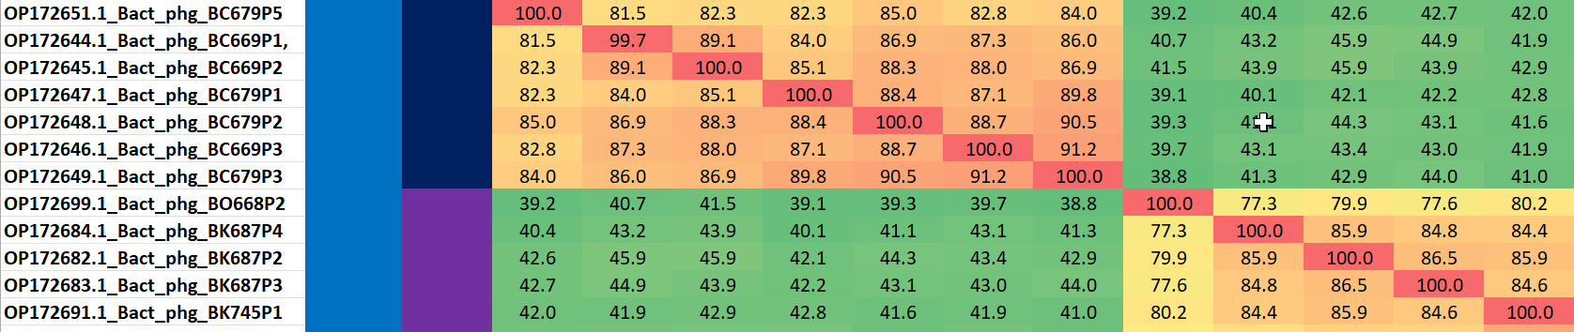

Figure 1. Partial VIRIDIC heatmap of this group of phages. VIRIDIC (Virus Intergenomic Distance Calculator; VIRIDIC (Virus Intergenomic Distance Calculator; [3]; http://rhea.icbm.uni-oldenburg.de/VIRIDIC/) computes pairwise intergenomic distances/similarities amongst phage genomes. Data values which are bordered in black correspond to strains. Abbreviations: Bact = Bacteroides; phg = phage. The complete VIRIDIC heatmap accompanies this proposal as Jianjiangvirinae_VIRIDIC heatmap.xlsx.
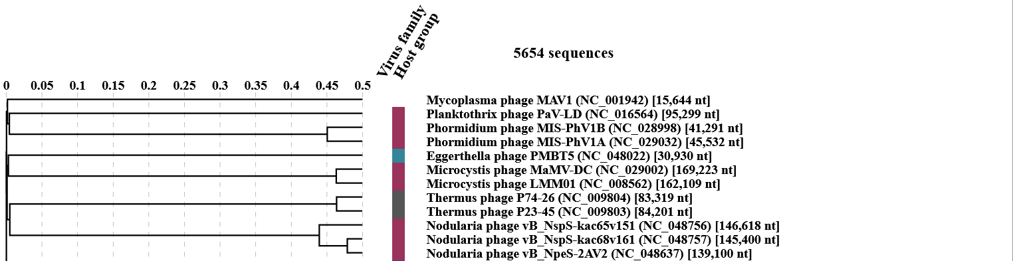
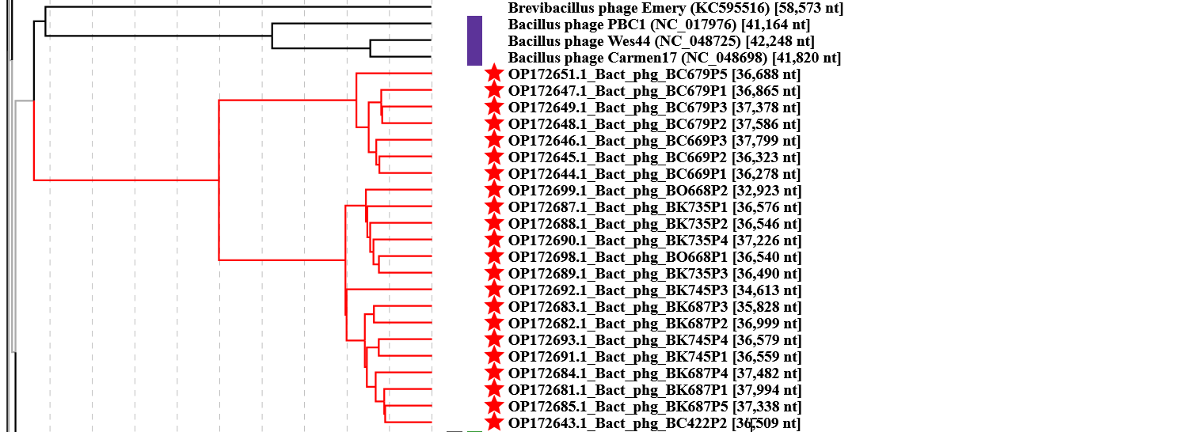
Figure 2. ViPTree analysis: ViPTree analysis (https://www.genome.jp/viptree/; [4]) is based upon Rohwer and Edwards (2002) Phage Proteomic Tree [5]. The taxon under discussion is indicated with a red bar. Abbreviations: phg = phage; Bact = Bacteroides

CoreGenes 5 Analysis [7]: revealed that the phages listed in Table 1 share 29 protein homologs, all listed as hypothetical proteins except for the terminase, large subunit. This indicates that approximately 62% of the phage-encoded proteins are conserved.

