

The International Committee on Taxonomy of Viruses
Taxonomy Proposal Form, 2025

Part 1a: Details of taxonomy proposals

Title: | Create 10 new species and abolish one species (Class: Caudoviricetes)
Code assigned: | 2025.025B.Ac.v2.Caudoviricetes_10ns_1rms

Author(s), affiliation and email address(es):
Given name (+middle initial(s)) | Surname | Affiliation | Email address | Corr. author(s)
Ivan M. | Pchelin | Department of Molecular Microbiology, Institute of Experimental Medicine, Saint Petersburg, Russia | arcella.oraia@gmail.com | X

Part 1b: Taxonomy Proposal Submission
ICTV Subcommittee:
Animal DNA Viruses and Retroviruses |  | Bacterial viruses | X
Animal minus-strand and dsRNA viruses |  | Fungal and protist viruses
Animal positive-strand RNA viruses |  | Plant viruses
Archaeal viruses |  | General

List the ICTV Study Group(s) that have seen or have been involved in creating this proposal:
Optional – complete only if formally voted on by an ICTV Study Group:
Study Group | Number of members
Study Group | Votes in support | Votes against | No vote

Submission date: | 12/06/2025

Part 1c: Feedback from ICTV Executive Committee (EC) meeting
Executive Committee Meeting Decision code: | X
A – Accept
Ac – Accept subject to revision by relevant subcommittee chair. No further vote required | x
U – Accept without revision but with re-evaluation and email vote by the EC
Uc – Accept subject to revision and re-evaluation and email vote by the EC
Ud – Deferred to the next EC meeting, with an invitation to revise based on EC comments
J - Reject
W - Withdrawn

Comments from the Executive Committee:
A little more detail is required for the species being abolished, including the name of the current exemplar, and the name of the species that virus would then be assigned to. There is mention at one point in the text of three species being abolished. Please update text.

Part 1d: Revised Taxonomy Proposal Submission
Response of proposer:
The text has been amended
Revision date: | 01/09/2025

Part 3: TAXONOMIC PROPOSAL

Taxonomic changes proposed:
Establish new taxon | X | Split taxon
Abolish taxon | X | Merge taxon
Move taxon |  | Promote taxon
Rename taxon |  | Demote taxon
Move and rename

Etymology (origin) of proposed taxonomic names:
Taxon name | Etymology of the term
Pakpunavirus mediocris | In Latin, the species epithet means “ordinary” or “normal”
Pakpunavirus js | The species epithet is derived from the exemplar virus name
Pakpunavirus hhbs181 | The species epithet is derived from the exemplar virus name
Pakpunavirus hhbs91 | The species epithet is derived from the exemplar virus name
Pbunavirus hhbs511 | The species epithet is derived from the exemplar virus name
Pbunavirus hhbs122 | The species epithet is derived from the exemplar virus name
Webervirus gbh029 | The species epithet is derived from the exemplar virus name
Drulisvirus gbh038 | The species epithet is derived from the exemplar virus name
Drulisvirus gbh001 | The species epithet is derived from the exemplar virus name
Przondovirus gbh014 | The species epithet is derived from the exemplar virus name

Abstract of Taxonomy Proposal:
Taxonomic rank(s) affected:
Species

Proposed taxonomic change(s):
We propose to;
- Abolish one species, Pbunavirus pv141
- Create of 10 new species in existing genera

Justification:
The proposed species share ≤95% genome similarity with the existing ones. By genome similarity and clustering analysis, all these potential new species reside within existing genera. The species Pbunavirus pv141 is proposed for removal since it shares >95% genome similarity with other existing species in that genus.

Text of Taxonomy proposal:
Taxonomic rank(s) affected:
Species

Proposed taxonomic change(s):
We propose the removal of one existing species and establishment of 10 new species.

Demarcation criteria:
Species were demarcated from pairwise intergenomic distances and employing current ICTV BVS demarcation criteria where species are defined as genomes exhibiting ≤95% similarity and genera as possessing ≥70% similarity over their genome length [1].

Justification:
The proposed species share ≤95% genome similarity with the existing ones. By genome similarity and clustering analysis, all these potential new species reside within existing genera. The species Pbunavirus pv141 is proposed for removal since it shares >95% genome similarity with other existing species in that genus.
References:
[1] Turner D, Kropinski AM, Adriaenssens EM. A Roadmap for Genome-Based Phage Taxonomy. Viruses. 2021; 13(3): 506. doi: 10.3390/v13030506.

Accompanying files:
Filename | Description of contents

Tables, Figures:

Table 1. Summary of proposed changes.

 | Virus name | Genome accession | Proposal | Nucleotide identity evidence | Clustering evidence
1 | Pbunavirus pv141 | MN615700 | Abolish species | Figure 1, VIRIDIC | Figure 2, ViPTree
2 | Pakpunavirus hhbs91 | PQ287655 | Create new species | Figure 1, VIRIDIC | Figure 2, ViPTree
3 | Pakpunavirus mediocris | PQ758387 | Create new species | Figure 1, VIRIDIC | Figure 2, ViPTree
4 | Pakpunavirus js | OQ210008 | Create new species | Figure 1, VIRIDIC | Figure 2, ViPTree
5 | Pakpunavirus hhbs181 | PQ287651 | Create new species | Figure 1, VIRIDIC | Figure 2, ViPTree
6 | Pbunavirus hhbs511 | PQ287641 | Create new species | Figure 1, VIRIDIC | Figure 2, ViPTree
7 | Pbunavirus hhbs122 | PQ287652 | Create new species | Figure 1, VIRIDIC | Figure 2, ViPTree
8 | Webervirus gbh029 | OU342755 | Create new species | Table 2, taxMyPhage | Figure 3, ViPTree
9 | Drulisvirus gbh038 | OU509533 | Create new species | Table 2, taxMyPhage | Figure 4, ViPTree
10 | Drulisvirus gbh001 | OU509534 | Create new species | Table 2, taxMyPhage | Figure 4, ViPTree
11 | Przondovirus gbh014 | OU342754 | Create new species | Table 2, taxMyPhage | Figure 5, ViPTree

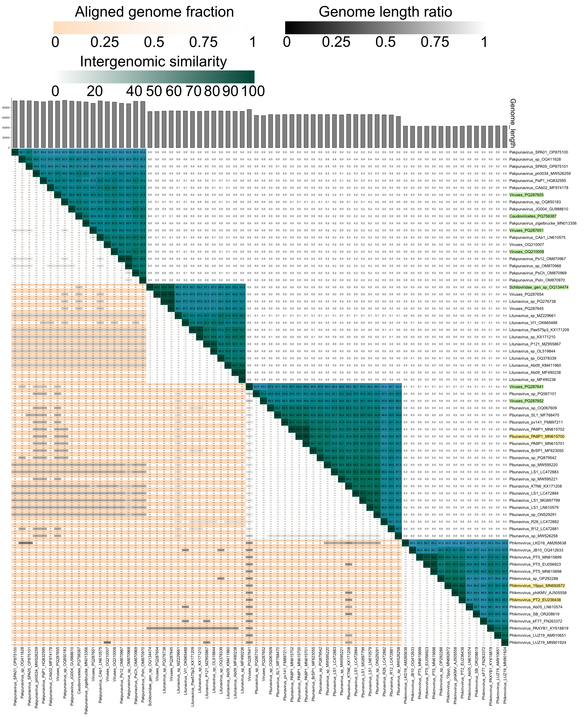
Figure 1. VIRIDIC analysis of Pseudomonas phages. The sequences related to species to be removed are highlighted yellow. The exemplar GenBank accession numbers of the proposed new species are shown in green.

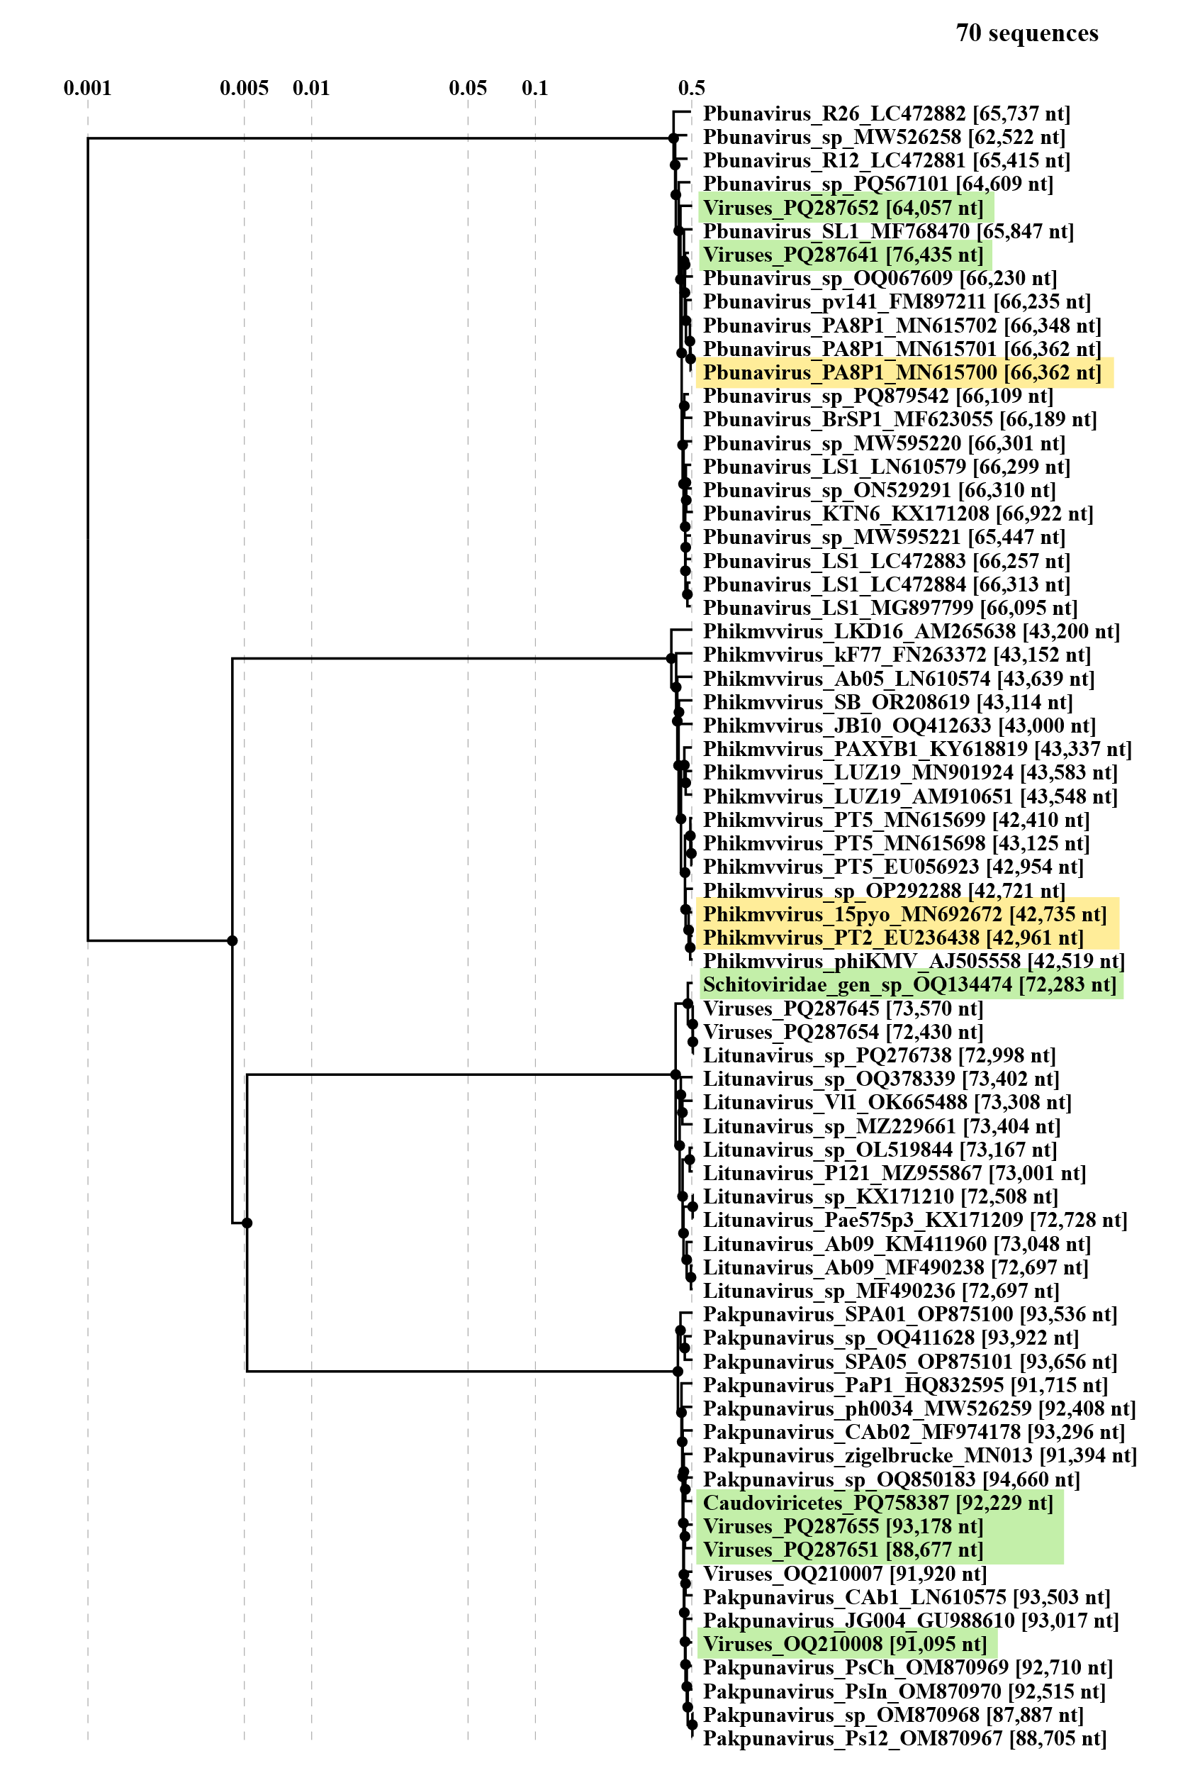Figure 2. ViPTree 4.0 analysis of Pseudomonas phages. The sequences related to species mergers are highlighted yellow. The exemplar GenBank accession numbers of the proposed new species are shown in green.

Bacteriophage | Genome | Class | Family | Genus | Species | Proposed species
vB_Kpn_GBH029 | OU342755.1 | Caudoviricetes | Drexlerviridae | Webervirus | new | Webervirus gbh029
vB_Kpn_GBH038 | OU509533.1 | Caudoviricetes | Autoscriptoviridae | Drulisvirus | new | Drulisvirus gbh038
vB_Kpn_GBH001 | OU509534.1 | Caudoviricetes | Autoscriptoviridae | Drulisvirus | new | Drulisvirus gbh001
vB_Kpn_GBH014 | OU342754.1 | Caudoviricetes | Autotranscriptaviridae | Przondovirus | new | Przondovirus gbh014

Table 2. Taxonomic identity of Klebsiella bacteriophages as determined by the taxMyPhage 3.3.6 tool (https://ptax.ku.dk/, accessed on 09 June 2025) and the proposed names of new species.
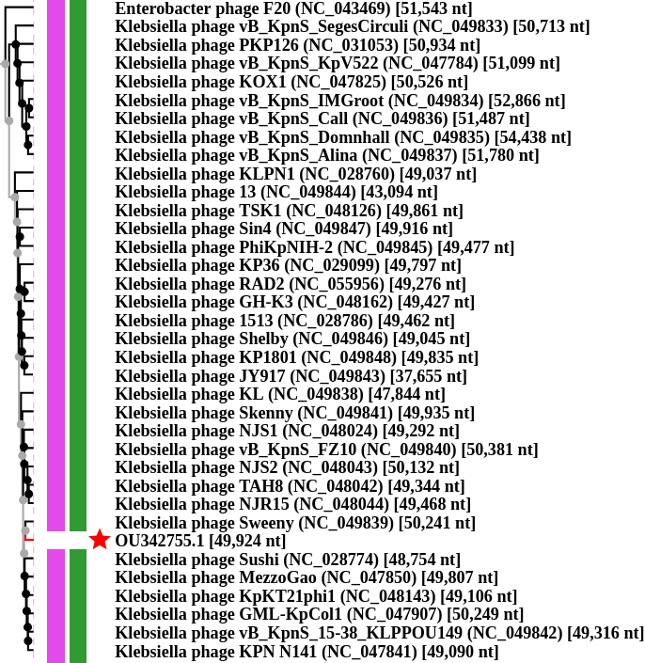Figure 3. ViPTree 4.0 phylogenomic analysis of Klebsiella phage vB_Kpn_GBH029 (OU342755). The sequence clusters with Webervirus genomes of bacteriophages Klebsiella phage Sweeny (Webervirus sweeny) and Klebsiella phage Sushi (Webervirus sushi).

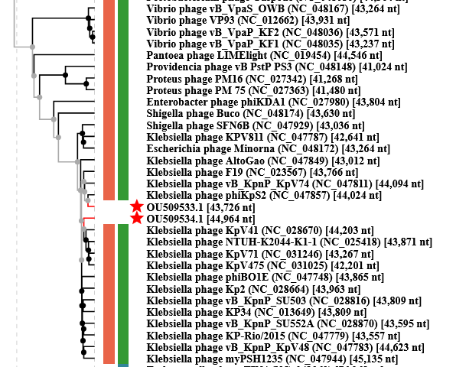
Figure 4. ViPTree 4.0 phylogenomic analysis of Klebsiella phage vB_Kpn_GBH038 (OU509533) and Klebsiella phage vB_Kpn_GBH001 (OU509534). The two sequences cluster with Drulisvirus genomes of bacteriophages phiKpS2 (Drulisvirus KpS2) and vB_KpnP_KpV41 (Drulisvirus KpV41).

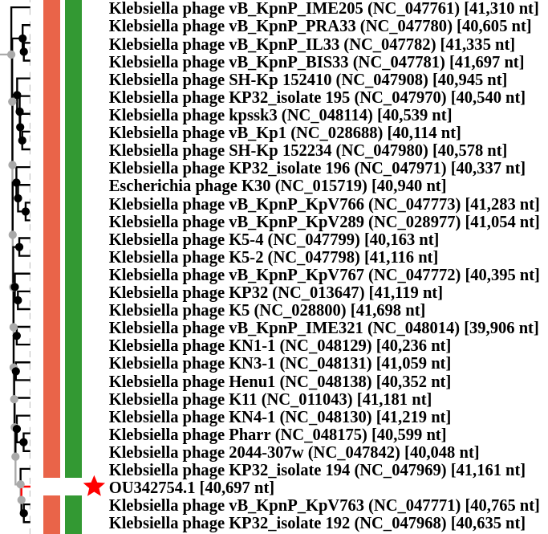

Figure 5. ViPTree 4.0 phylogenomic analysis of Klebsiella phage vB_Kpn_GBH014 (OU342754). The sequence clusters with Przondovirus genomes of Klebsiella phage KP32 (Przondovirus KP32i194) and Klebsiella phage vB_KpnP_KpV763 (Przondovirus KpV763).

