

The International Committee on Taxonomy of Viruses
Taxonomy Proposal Form, 2025

Part 1a: Details of taxonomy proposals

Title: | Create one new species in the genus Gelderlandvirus (class Caudoviricetes, order Pantevenvirales, family Straboviridae, subfamily Tevenvirinae)
Code assigned: | 2025.021B.Uc.v3.Gelderlandvirus_1ns

Author(s), affiliation and email address(es):
Given name (+middle initial(s)) | Surname | Affiliation | Email address | Corresponding author(s)
Iwona | Gientka | Department of Biotechnology and Food Microbiology, Institute of Food Sciences, Warsaw University of Life Sciences (WULS-SGGW), Warsaw, Poland | iwona_gientka@sggw.edu.pl | X
Michał J. | Wójcicki | Bacteriophage Laboratory, Department of Phage Therapy, Hirszfeld Institute of Immunology and Experimental Therapy, Polish Academy of Sciences, Wroclaw, Poland | michal.wojcicki@hirszfeld.pl | X

Part 1b: Taxonomy Proposal Submission
ICTV Subcommittee:
Animal DNA Viruses and Retroviruses |  | Bacterial viruses | X
Animal minus-strand and dsRNA viruses |  | Fungal and protist viruses
Animal positive-strand RNA viruses |  | Plant viruses
Archaeal viruses |  | General

List the ICTV Study Group(s) that have seen or have been involved in creating this proposal:
Caudoviricetes Study Group
Optional – complete only if formally voted on by an ICTV Study Group:
Study Group | Number of members
Study Group | Votes in support | Votes against | No vote

Submission date: | 20/03/2025

Part 1c: Feedback from ICTV Executive Committee (EC) meeting
Executive Committee Meeting Decision code: | X
A – Accept
Ac – Accept subject to revision by relevant subcommittee chair. No further vote required
U – Accept without revision but with re-evaluation and email vote by the EC
Uc – Accept subject to revision and re-evaluation and email vote by the EC | x
Ud – Deferred to the next EC meeting, with an invitation to revise based on EC comments
J - Reject
W - Withdrawn

Comments from the Executive Committee:
Genus in-filling (2 species). We are concerned about the difference in genome sizes. Escherichia phage UoN_LG358_1 is only 136kb in size which is 14% smaller than the genus reference genome and 16% smaller than the other newly classified genome. Can the authors verify genome completeness of the genome.

Part 1d: Revised Taxonomy Proposal Submission
Response of proposer:
We have reviewed the genome of Escherichia phage UoN_LG358_1 and it is incomplete. Therefore, we have revised our proposal to include only one new species.

Revision date: | 22/08/2025

Part 3: TAXONOMIC PROPOSAL

Taxonomic changes proposed:
Establish new taxon | X | Split taxon
Abolish taxon |  | Merge taxon
Move taxon |  | Promote taxon
Rename taxon |  | Demote taxon
Move and rename

Etymology (origin) of proposed taxonomic names:
Taxon name | Etymology of the term
Gelderlandvirus SEA1 | Species name derived from the phage name in the GenBank database – Salmonella phage SEA1

Permission for use of names derived from a living person
Taxon name | Full name of person from whom the name is derived | Attached

Abstract of Taxonomy Proposal:
Taxonomic rank(s) affected:
Realm Duplodnaviria, kingdom Heunggongvirae, phylum Uroviricota, class Caudoviricetes, order Pantevenvirales, family Straboviridae, subfamily Tevenvirinae.

Description of current taxonomy:
Currently, the order Pantevenvirales includes three families: Ackermannviridae, Kyanoviridae, and Straboviridae. Within the Straboviridae family, three subfamilies have been distinguished: Emmerichvirinae, Tevenvirinae, and Twarogvirinae. The Tevenvirinae subfamily comprises 15 genera and 148 species. Currently, the Gelderlandvirus genus includes five species: Gelderlandvirus cgg41, Gelderlandvirus melville, Gelderlandvirus s16, Gelderlandvirus stml198, and Gelderlandvirus stp4a.

Proposed taxonomic change(s):
Follwing a genomic analysis of phages deposited in the NCBI database we propose to create one new species in the genus Gelderlandvirus.

Justification:
Based on DNA and protein similarity, the one proposed new species is coherent and together with the five known species (Gelderlandvirus cgg41, Gelderlandvirus melville, Gelderlandvirus s16, Gelderlandvirus stml198, and Gelderlandvirus stp4a) can be classified in the genus Gelderlandvirus.

Text of Taxonomy proposal:
Taxonomic rank(s) affected:
Realm Duplodnaviria, kingdom Heunggongvirae, phylum Uroviricota, class Caudoviricetes, order Pantevenvirales, family Straboviridae, subfamily Tevenvirinae.

Description of current taxonomy:
Currently, the order Pantevenvirales includes three families: Ackermannviridae, Kyanoviridae, and Straboviridae. Within the Straboviridae family, three subfamilies have been distinguished: Emmerichvirinae, Tevenvirinae, and Twarogvirinae. The Tevenvirinae subfamily comprises 15 genera and 148 species. Currently, the Gelderlandvirus genus includes five species: Gelderlandvirus cgg41, Gelderlandvirus melville, Gelderlandvirus s16, Gelderlandvirus stml198, and Gelderlandvirus stp4a.

Proposed taxonomic change(s):
Following a genomic analysis of phages deposited in the NCBI database we propose to create one new species in the genus Gelderlandvirus.

Demarcation criteria:
Species demarcation criteria: Two phages are assigned to the same species if their genomes are more than 95% identical over their genome length for isolates.
These values can be calculated by several tools, such as BLASTn [1] – usually calculated using the intergenomic distance calculator VIRIDIC [2].

Genus demarcation criteria: In search for criteria that create cohesive and distinct genera that are reproducible and monophyletic, the Bacterial Viruses Subcommittee has established 70% nucleotide identity of the genome length as the cut-off for genera. Genus-level groupings should always be monophyletic in the signature genes, as tested with a phylogenetic tree [3].

Justification:
Based on DNA and protein similarity, the one proposed new species is coherent and together with the five known species (Gelderlandvirus cgg41, Gelderlandvirus melville, Gelderlandvirus s16, Gelderlandvirus stml198, and Gelderlandvirus stp4a) can be classified in the genus Gelderlandvirus.

References:
- Sayers EW, Beck J, Bolton EE, Bourexis D, Brister JR, Canese K, Comeau DC, Funk K, Kim S, Klimke W, Marchler-Bauer A, Landrum M, Lathrop S, Lu Z, Madden TL, O'Leary N, Phan L, Rangwala SH, Schneider VA, Skripchenko Y, Wang J, Ye J, Trawick BW, Pruitt KD, Sherry ST. Database resources of the National Center for Biotechnology Information. Nucleic Acids Res. 2021, 49(D1):D10-D17.
- Moraru C, Varsani A, Kropinski AM. VIRIDIC - a novel tool to calculate the intergenomic similarities of prokaryote-infecting viruses. Viruses 2020, 12(11):1268.
- Turner D, Kropinski AM, Adriaenssens EM. A roadmap for genome-based phage taxonomy. Viruses 2021, 13(3):506.
- Nishimura Y, Yoshida T, Kuronishi M, Uehara H, Ogata H, Goto S. ViPTree: the viral proteomic tree server. Bioinformatics 2017, 33(15):2379-2380.
- Rohwer F, Edwards R. The Phage Proteomic Tree: a genome-based taxonomy for phage. J. Bacteriol. 2002, 184(16):4529-35.
- Turner D, Reynolds D, Seto D, Mahadevan P. CoreGenes3.5: a webserver for the determination of core genes from sets of viral and small bacterial genomes. BMC Res. Notes. 2013, 6:140.

Accompanying files:
Filename | Description of contents
2025.021B.N.Gelderlandvirus_1ns.xlsx | To present the proposed taxonomic changes as a comparison of new taxonomic structures.
Tables, Figures:

Figure 1. VIRIDIC heat map: VIRIDIC (Virus Intergenomic Distance Calculator [2]; http://rhea.icbm.uni-oldenburg.de/VIRIDIC/) computes pairwise intergenomic distances/similarities amongst phage genomes. Phages belonging to the same species (nucleotide similarity above 95%) are marked with a red frame. The currently distinguished five species belonging to the genus Gelderlandvirus are marked in blue.

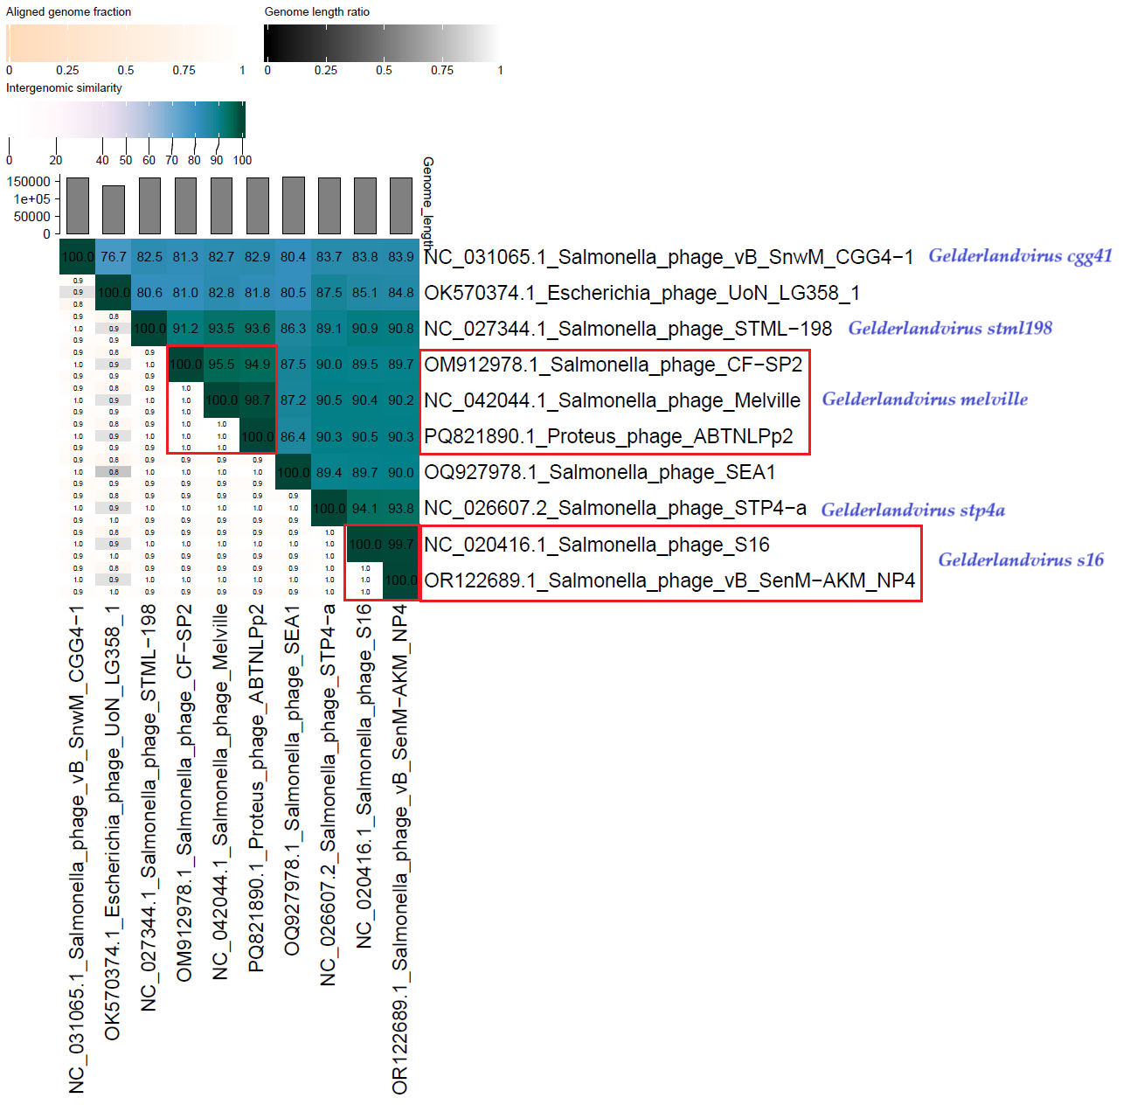

Figure 2. ViPTree analysis*: ViPTree analysis (https://www.genome.jp/viptree/; [4]) is based upon Rohwer and Edwards (2002) Phage Proteomic Tree [5]. The phages of interest are indicated with a red stars and a blue bar.

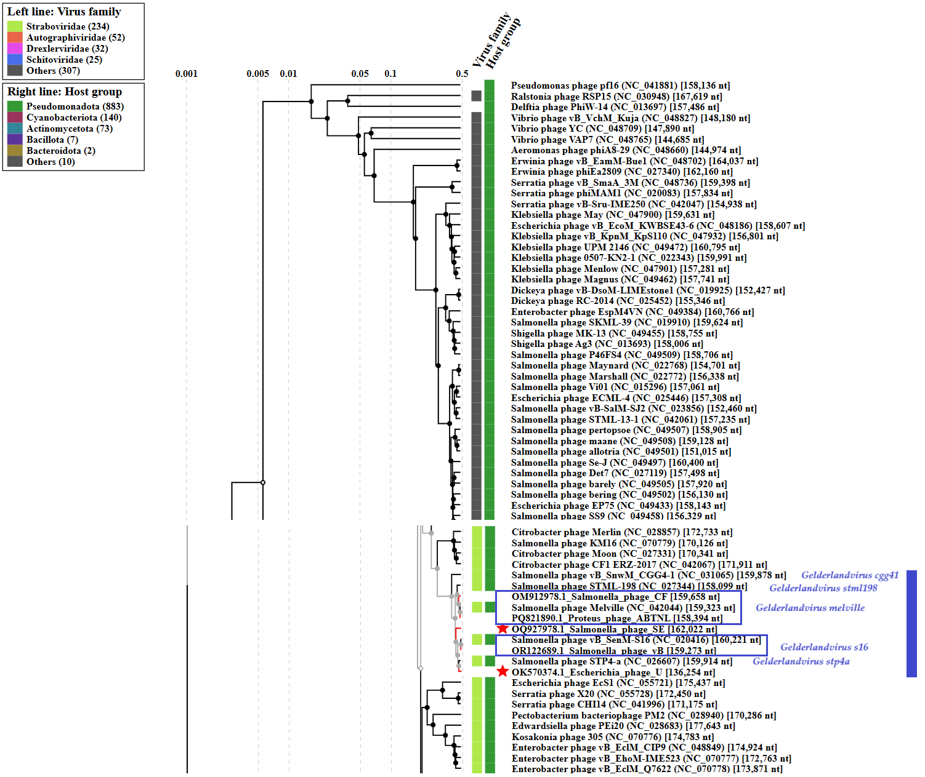

* The Autographiviridae family shown in Figure 2 (automatically labeled by the software) is outdated. In 2025, the Autographiviridae family was elevated to the rank of order and renamed Autographivirales.

We have reviewed the genome of Escherichia phage UoN_LG358_1 and it is incomplete. Therefore, we are not including it in the proposal as a new species in the genus Gelderlandvirus.

Genome summary:

Phage name | RefSeq No. | INSDC | Size (bp) | GC% | Protein | Overall % DNA sequence identity (*) | Overall % homologous proteins (**)
Salmonella phage STML-198 (Gelderlandvirus  stml198; reference genome) | NC_027344 .1 | NC_027344 | 158,099 | 36.9 | 255 | 100.0 | 100.0
Salmonella phage SEA1 |  | OQ927978 | 162,022 | 37.0 | 261 | 86.3 | 87.84
(*) determined using VIRIDIC [2]
(**) determined using CoreGenes 3.5 [6]

