

The International Committee on Taxonomy of Viruses
Taxonomy Proposal Form, 2025

Part 1a: Details of taxonomy proposals

Title: | Create a new subfamily, Frobishervirinae with one existing genus, Samwavirus, and one new genus, Branvirus (Class: Caudoviricetes)
Code assigned: | 2025.020B.Ac.v3.Frobishervirinae_1nsf_1ng_1ns

Author(s), affiliation and email address(es):
Given name (+middle initial(s)) | Surname | Affiliation | Email address | Corr. author(s)
Andrew M. | Kropinski | Department of Pathobiology, University of Guelph, Guelph, Ontario, Canada | Phage.Canada@gmail.com | X
Cristina | Moraru | Carl von Ossietzky Universität Oldenburg, Germany | liliana.cristina.moraru@uol.de

Part 1b: Taxonomy Proposal Submission
ICTV Subcommittee:
Animal DNA Viruses and Retroviruses |  | Bacterial viruses | x
Animal minus-strand and dsRNA viruses |  | Fungal and protist viruses
Animal positive-strand RNA viruses |  | Plant viruses
Archaeal viruses |  | General -

List the ICTV Study Group(s) that have seen or have been involved in creating this proposal: https://ictv.global/sc
Caudoviricetes Study Group

Optional – complete only if formally voted on by an ICTV Study Group:
Study Group | Number of members
Study Group | Votes in support | Votes against | No vote

Submission date: | 15/06/2025

Part 1c: Feedback from ICTV Executive Committee (EC) meeting
Executive Committee Meeting Decision code: | X
A – Accept
Ac – Accept subject to revision by relevant subcommittee chair. No further vote required | x
U – Accept without revision but with re-evaluation and email vote by the EC
Uc – Accept subject to revision and re-evaluation and email vote by the EC
Ud – Deferred to the next EC meeting, with an invitation to revise based on EC comments
J - Reject
W - Withdrawn

Comments from the Executive Committee:
Please improve the quality of the abstract, there is a lack of phylogenetic tree (not necessary but would improve the proposal).

Part 1d: Revised Taxonomy Proposal Submission
Response of proposer:
Phylogenetic tree not possible so Clinker alignment added.

Revision date: | August 19, 2025

Part 3: TAXONOMIC PROPOSAL
https://ictv.global/taxonomy/templates
Taxonomic changes proposed:
Establish new taxon | x | Split taxon
Abolish taxon |  | Merge taxon
Move taxon | x | Promote taxon
Rename taxon |  | Demote taxon
Move and rename

Etymology (origin) of proposed taxonomic names:
Taxon name | Etymology of the term
Frobishervirinae | Named in honour of Martin Frobisher, Jr for his work on Corynebacterium phages and education
Branvirus | The taxon name is derived from the name of bacteriophage, Corynebacterium phage Bran

Permission for use of names derived from a living person:
Taxon name | Full name of person from whom the name is derived | Attached

Abstract of Taxonomy Proposal:
Taxonomic rank(s) affected:
Subfamily, genus, species

Description of current taxonomy:
The genus Samwavirus was created via Taxonomy Proposal 2019.027B and contains five species. Corynebacterium phage Bran is currently unclassified.

Proposed taxonomic change(s):
Create a new subfamily “Frobishervirinae” containing one new genus “Branvirus” with a single species. Move the existing genus Samwavirus into the subfamily “Frobishervirinae”

Justification: VIRIDIC and Clinker analyses reveal that there is sufficient evidence to create a subfamily for Branvirus and Samwavirus [8]

- Text of Taxonomy proposal:

Taxonomic rank(s) affected:
Realm Duplodnaviria, kingdom Heunggongvirae, phylum Uroviricota, class Caudoviricetes

Description of current taxonomy:
The genus Samwavirus was created via Taxonomy Proposal 2019.027B and contains five species. Corynebacterium phage Bran is currently unclassified.

Proposed taxonomic change(s):
Create a new subfamily “Frobishervirinae” containing one new genus “Branvirus” with a single species. Move the existing genus Samwavirus into the subfamily “Frobishervirinae”

Demarcation criteria:
The Bacterial and Archaeal Virus Subcommittee established 70% average nucleotide identity (ANI) threshold for genus classification or 95% ANI for species [8]. Subfamilies are to be created when two or more genera are related below the family level. In practical terms, this usually means that they share a low degree of sequence similarity (usually about 40-50%) and that the genera form a clade in a marker tree phylogeny [8].

Justification:
VIRIDIC and Clinker analyses reveal that there is sufficient evidence to create a subfamily for Branvirus and Samwavirus [8]

References:
1. Sayers EW, Beck J, Bolton EE, Bourexis D, Brister JR, Canese K, Comeau DC, Funk K, Kim S, Klimke W, Marchler-Bauer A, Landrum M, Lathrop S, Lu Z, Madden TL, O'Leary N, Phan L, Rangwala SH, Schneider VA, Skripchenko Y, Wang J, Ye J, Trawick BW, Pruitt KD, Sherry ST. Database resources of the National Center for Biotechnology Information. Nucleic Acids Res. 2021 Jan 8;49(D1):D10-D17. doi: 10.1093/nar/gkaa892. PMID: 33095870
2. O'Leary NA, Wright MW, Brister JR, Ciufo S, Haddad D, McVeigh R, et al. Reference sequence (RefSeq) database at NCBI: current status, taxonomic expansion, and functional annotation. Nucleic Acids Res. 2016;44(D1):D733-45. doi: 10.1093/nar/gkv1189. PMID: 26553804.
3. Moraru C, Varsani A, Kropinski AM. VIRIDIC-A Novel Tool to Calculate the Intergenomic Similarities of Prokaryote-Infecting Viruses. Viruses. 2020 Nov 6;12(11):1268. doi: 10.3390/v12111268. PMID: 33172115; PMCID: PMC7694805. http://kronos.icbm.uni-oldenburg.de/viridic/
4. Nishimura Y, Yoshida T, Kuronishi M, Uehara H, Ogata H, Goto S. ViPTree: the viral proteomic tree server. Bioinformatics. 2017; 33(15):2379-2380. doi:10.1093/bioinformatics/btx157. PubMed PMID: 28379287. https://www.genome.jp/viptree/
5. Rohwer F, Edwards R. The Phage Proteomic Tree: a genome-based taxonomy for phage. J Bacteriol. 2002 Aug;184(16):4529-35. PubMed PMID: 12142423
6. Turner D, Reynolds D, Seto D, Mahadevan P. CoreGenes3.5: a webserver for the determination of core genes from sets of viral and small bacterial genomes. BMC Res Notes. 2013;6:140. doi: 10.1186/1756-0500-6-140. PMID: 23566564.
7. Davis P, Seto D, Mahadevan P. CoreGenes5.0: An Updated User-Friendly Webserver for the Determination of Core Genes from Sets of Viral and Bacterial Genomes. Viruses. 2022 Nov 16;14(11):2534. doi: 10.3390/v14112534. PMID: 36423143; PMCID: PMC9693508.
8. Turner D, Kropinski AM, Adriaenssens EM. A Roadmap for Genome-Based Phage Taxonomy. Viruses. 2021 Mar 18;13(3):506. doi: 10.3390/v13030506. PMID: 33803862; PMCID: PMC8003253.
Lemoine F, Correia D, Lefort V, Doppelt-Azeroual O, Mareuil F, Cohen-Boulakia S, Gascuel O. NGPhylogeny.fr: new generation phylogenetic services for non-specialists. Nucleic Acids Res. 2019 Jul 2;47(W1):W260-W265. doi: 10.1093/nar/gkz303. PMID: 31028399; PMCID: PMC6602494.
9. Letunic I, Bork P. Interactive Tree Of Life (iTOL): an online tool for phylogenetic tree display and annotation. Bioinformatics. 2007 Jan 1;23(1):127-8. doi: 10.1093/bioinformatics/btl529. Epub 2006 Oct 18. PMID: 17050570.
10. Zhou T, Xu K, Zhao F, Liu W, Li L, Hua Z, Zhou X. itol.toolkit accelerates working with iTOL (Interactive Tree of Life) by an automated generation of annotation files. Bioinformatics. 2023 Jun 1;39(6):btad339. doi: 10.1093/bioinformatics/btad339. PMID: 37225402; PMCID: PMC10243930
11. van den Belt M, Gilchrist C, Booth TJ, Chooi YH, Medema MH, Alanjary M. CAGECAT: The CompArative GEne Cluster Analysis Toolbox for rapid search and visualisation of homologous gene clusters. BMC Bioinformatics. 2023 May 3;24(1):181.

Accompanying files:
Filename | Description of contents

Tables, Figures:
<Start here>Table 1. Properties of phage Bran

Phage name | Host | Morphotype | Lifestyle | Accession No. | Genome size | No. proteins | No. tRNA
Corynebacterium phage Bran | Corynebacterium xerosis ATCC 373 | Siphovirus | Temperate | MK977714.1 | 44484 bp | 69 | 1

Corynebacterium phage Bran was isolated from Birmingham (AL, USA) soil by Kelly Kim in 2018, as part of the Science Education Alliance-Phage Hunters Advancing Genomics and Evolutionary Science program. This temperate siphovirus was assigned to Cluster EP by the Actinobacteriophage Database. Its genome possesses 17 nt 3'-cohesive termini (CCCCAGCGCCTCGGGTA).

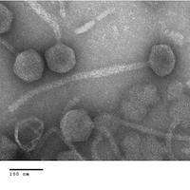
Figure 1. Electron micrograph: Electron micrographs of negatively stained Corynebacterium phage Bran (https://phagesdb.org/phages/Bran/). Limited permission was granted by The Actinobacteriophages Database (https://phagesdb.org/), funded by the Howard Hughes Medical Institute, to use this electron micrograph for this taxonomy proposal; it cannot be reused without permission of The Actinobacteriophages Database.

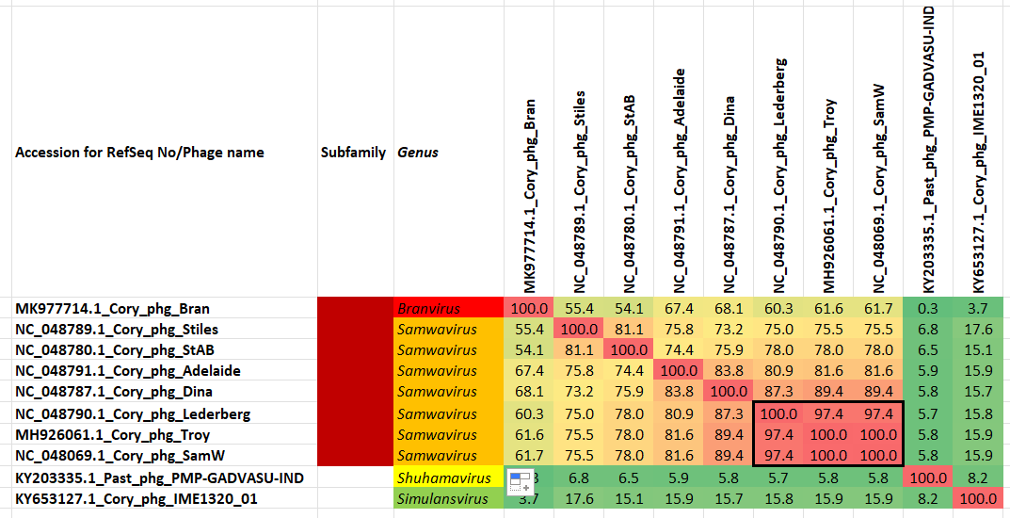

Figure 2. VIRIDIC heatmap of this group of phages. VIRIDIC (Virus Intergenomic Distance Calculator; VIRIDIC (Virus Intergenomic Distance Calculator; [3]; http://rhea.icbm.uni-oldenburg.de/VIRIDIC/) computes pairwise intergenomic distances/similarities amongst phage genomes. Data values which are bordered in black correspond to strains. Abbreviations: phg = phage Cory = Corynebacterium; Past = Pasteurella.

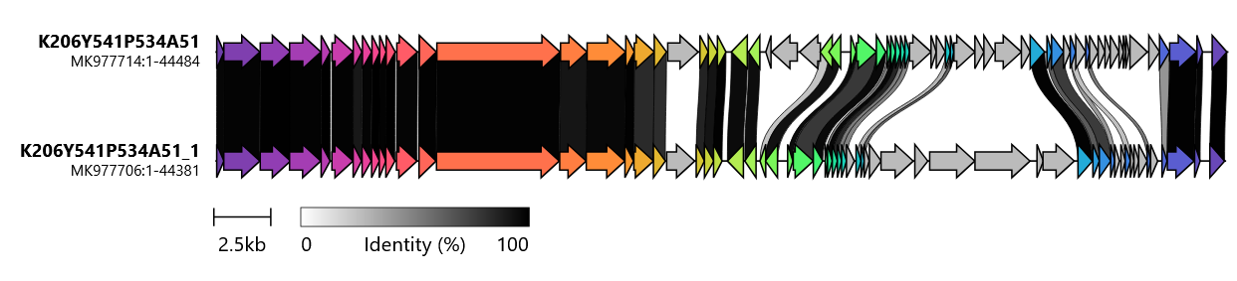
Figure 3. Clinker alignment of the genomes of Corynebacterium phages Bran (Top) and Dina (Bottom) [11] reveals that these mosaic genomes possess highly conserved 5’ termini (morphogenesis genes and highly variable 3’ ends.

CoreGenes 5 Analysis [7]: revealed that the phages defined by Branvirus and Samwavirus share 29 protein homologs, which include large subunit terminase, portal protein, head maturation protease, major capsid protein, head-tail connector protein, head-to-tail adaptor, head-to-tail stopper, head closure, major tail protein, two tail assembly chaperones, tail tape measure protein, and holin. This indicates that approximately 48% of the phage-encoded proteins are conserved.

This taxon is named in honour of Martin Frobisher, Jr. D.Sc. who received his SB degree from Johns Hopkins University in Hygiene in 1922 and then went on to get a D.Sc. in bacteriology. In his career her was Chief, Bacteriology Laboratories, The Communicable Disease Center, United States Public Health Service; Associate Professor of Bacteriology, Emory University; Lecturer in Bacteriology, Johns Hopkins University. He is noted for his work on Corynebacterium diphtheriae and its phages and being the author of Fundamentals of Bacteriology and Fundamentals of Microbiology. From 1937-1948 he was the Editor-in-chief of the American Journal of Hygiene.

