

The International Committee on Taxonomy of Viruses
Taxonomy Proposal Form, 2025

Part 1a: Details of taxonomy proposals

Title: | Create one new genus, Evaavirus, with a single species (Class Caudoviricetes).
Code assigned: | 2025.017B.Ac.v3.Evaavirus_1ng_1ns

Author(s), affiliation and email address(es):
Given name (+middle initial(s)) | Surname | Affiliation | Email address | Corr. author(s)
Andrew M. | Kropinski | Department of Pathobiology, University of Guelph, Guelph, Ontario, Canada | Phage.Canada@gmail.com | x
Ipek | Kurtböke | University of the Sunshine Coast - Faculty of Science, Health, Education and Engineering, Australia | ikurtbok@usc.edu.au

Part 1b: Taxonomy Proposal Submission
ICTV Subcommittee:
Animal DNA Viruses and Retroviruses |  | Bacterial viruses | x
Animal minus-strand and dsRNA viruses |  | Fungal and protist viruses
Animal positive-strand RNA viruses |  | Plant viruses
Archaeal viruses |  | General -

List the ICTV Study Group(s) that have seen or have been involved in creating this proposal: https://ictv.global/sc
Actinophages Study Group

Optional – complete only if formally voted on by an ICTV Study Group:
Study Group | Number of members
Study Group | Votes in support | Votes against | No vote

Submission date: | 015/06/2025

Part 1c: Feedback from ICTV Executive Committee (EC) meeting
Executive Committee Meeting Decision code: | X
A – Accept
Ac – Accept subject to revision by relevant subcommittee chair. No further vote required | x
U – Accept without revision but with re-evaluation and email vote by the EC
Uc – Accept subject to revision and re-evaluation and email vote by the EC
Ud – Deferred to the next EC meeting, with an invitation to revise based on EC comments
J - Reject
W - Withdrawn

Comments from the Executive Committee:
Please improve the quality of the abstract. It might be nice to see some comparison to Sourvirus to support the justification section. Typo in taxon name in "etymology" section. Should have intergenomic distance information or comparison with members of Sourvirus to evidence need for distinct genus.

Part 1d: Revised Taxonomy Proposal Submission
Response of proposer:
VIRIDIC heatmap added with final discussion on its relationship to Gordonia phage Sour

Revision date: | August 18, 2025

Part 3: TAXONOMIC PROPOSAL
https://ictv.global/taxonomy/templates
Taxonomic changes proposed:
Establish new taxon | x | Split taxon
Abolish taxon |  | Merge taxon
Move taxon |  | Promote taxon
Rename taxon |  | Demote taxon
Move and rename

Etymology (origin) of proposed taxonomic names:
Taxon name | Etymology of the term
Evaavirus | Name derived from that of the first isolate phage of its type; Gordonia phage Evaa

Permission for use of names derived from a living person:
Taxon name | Full name of person from whom the name is derived | Attached

Abstract of Taxonomy Proposal:
Taxonomic rank(s) affected:
Genus, species

Description of current taxonomy:
The bacterial virus described in this proposal is currently unclassified

Proposed taxonomic change(s):
Create one new genus, "Evaavirus” including one new species.

Justification: While the Actinobacteriophage Database groups lytic Gordonia phage Evaa in Cluster DR our BLASTN analysis reveals that it is sufficiently different from Sourvirus to deserve recognition as a separate genus. This is supported by VIRIDIC analysis which reveals that it only shares 44% overall DNA sequence identity with Sourvirus sour.

- Text of Taxonomy proposal:

Taxonomic rank(s) affected:
Genus, species

Description of current taxonomy:
The bacterial virus described in this proposal is currently unclassified

Proposed taxonomic change(s):
Create one new genus, "Evaavirus” including one new species.

Demarcation criteria:
Genus demarcation criteria: An intergenomic similarity cut-off of 70%, a combination of average nucleotide identity and alignment fraction is used to determine genera demarcation. Members of the same genus have >70% intergenomic similarity and cluster tightly in marker gene phylogenies.
Species demarcation criteria: A demarcation value of 95% intergenomic similarity was used to define different species according to intergenomic similarity. Members of the same species have >95% intergenomic similarity.

Justification: While the Actinobacteriophage Database groups lytic Gordonia phage Evaa in Cluster DR our BLASTN analysis reveals that it is sufficiently different from Sourvirus to deserve recognition as a separate genus. This is supported by VIRIDIC analysis which reveals that it only shares 44% overall DNA sequence identity with Sourvirus sour.

References:
1. Sayers EW, Beck J, Bolton EE, Bourexis D, Brister JR, Canese K, Comeau DC, Funk K, Kim S, Klimke W, Marchler-Bauer A, Landrum M, Lathrop S, Lu Z, Madden TL, O'Leary N, Phan L, Rangwala SH, Schneider VA, Skripchenko Y, Wang J, Ye J, Trawick BW, Pruitt KD, Sherry ST. Database resources of the National Center for Biotechnology Information. Nucleic Acids Res. 2021 Jan 8;49(D1):D10-D17. doi: 10.1093/nar/gkaa892. PMID: 33095870
2. O'Leary NA, Wright MW, Brister JR, Ciufo S, Haddad D, McVeigh R, et al. Reference sequence (RefSeq) database at NCBI: current status, taxonomic expansion, and functional annotation. Nucleic Acids Res. 2016;44(D1):D733-45. doi: 10.1093/nar/gkv1189. PMID: 26553804.
3. Moraru C, Varsani A, Kropinski AM. VIRIDIC-A Novel Tool to Calculate the Intergenomic Similarities of Prokaryote-Infecting Viruses. Viruses. 2020 Nov 6;12(11):1268. doi: 10.3390/v12111268. PMID: 33172115; PMCID: PMC7694805. http://kronos.icbm.uni-oldenburg.de/viridic/
4. Nishimura Y, Yoshida T, Kuronishi M, Uehara H, Ogata H, Goto S. ViPTree: the viral proteomic tree server. Bioinformatics. 2017; 33(15):2379-2380. doi:10.1093/bioinformatics/btx157. PubMed PMID: 28379287. https://www.genome.jp/viptree/
5. Rohwer F, Edwards R. The Phage Proteomic Tree: a genome-based taxonomy for phage. J Bacteriol. 2002 Aug;184(16):4529-35. PubMed PMID: 12142423
6. Turner D, Reynolds D, Seto D, Mahadevan P. CoreGenes3.5: a webserver for the determination of core genes from sets of viral and small bacterial genomes. BMC Res Notes. 2013;6:140. doi: 10.1186/1756-0500-6-140. PMID: 23566564.
7. Davis P, Seto D, Mahadevan P. CoreGenes5.0: An Updated User-Friendly Webserver for the Determination of Core Genes from Sets of Viral and Bacterial Genomes. Viruses. 2022 Nov 16;14(11):2534. doi: 10.3390/v14112534. PMID: 36423143; PMCID: PMC9693508.
8. Turner D, Kropinski AM, Adriaenssens EM. A Roadmap for Genome-Based Phage Taxonomy. Viruses. 2021 Mar 18;13(3):506. doi: 10.3390/v13030506. PMID: 33803862; PMCID: PMC8003253.
Lemoine F, Correia D, Lefort V, Doppelt-Azeroual O, Mareuil F, Cohen-Boulakia S, Gascuel O. NGPhylogeny.fr: new generation phylogenetic services for non-specialists. Nucleic Acids Res. 2019 Jul 2;47(W1):W260-W265. doi: 10.1093/nar/gkz303. PMID: 31028399; PMCID: PMC6602494.
9. Letunic I, Bork P. Interactive Tree Of Life (iTOL): an online tool for phylogenetic tree display and annotation. Bioinformatics. 2007 Jan 1;23(1):127-8. doi: 10.1093/bioinformatics/btl529. Epub 2006 Oct 18. PMID: 17050570.
10. Zhou T, Xu K, Zhao F, Liu W, Li L, Hua Z, Zhou X. itol.toolkit accelerates working with iTOL (Interactive Tree of Life) by an automated generation of annotation files. Bioinformatics. 2023 Jun 1;39(6):btad339. doi: 10.1093/bioinformatics/btad339. PMID: 37225402; PMCID: PMC10243930.

Accompanying files:
Filename | Description of contents
Evaavirus_1ng_1ns | Data for this proposal

Tables, Figures:
<Start here>

Table 1. Characteristics of the phage described in the proposal
Prophage name | Host | Morphotype | Lifestyle | Accession No. | Genome size | No. proteins | No. tRNA
Gordonia phage Eva | Gordonia terrae 3612 | Siphovirus | Lytic | OP434461.1 | 61187 bp | 83 | 1

Figure 1. Electron micrograph: Electron micrographs of negatively stained Gordonia phage Evaa (https://phagesdb.org/phages/Evaa/). Limited permission was granted by The Actinobacteriophages Database (https://phagesdb.org/), funded by the Howard Hughes Medical Institute, to use this electron micrograph for this taxonomy proposal; it cannot be reused without permission of The Actinobacteriophages Database.

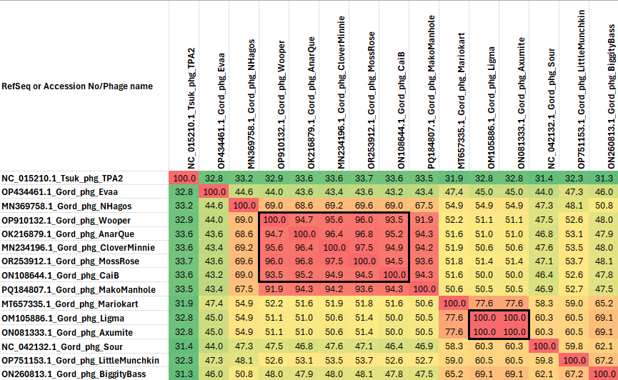

Figure 2. VIRIDIC heatmap of this group of phages. VIRIDIC (Virus Intergenomic Distance Calculator; VIRIDIC (Virus Intergenomic Distance Calculator; [3]; http://rhea.icbm.uni-oldenburg.de/VIRIDIC/) computes pairwise intergenomic distances/similarities amongst phage genomes. Data values which are bordered in black correspond to strains. Abbreviations: phg = phage; Gord = Gordonia; Tsuk = Tsukamurella.

Conclusions: While the Actinobacteriophage Database groups all these viruses into Cluster DR our analysis reveals that the “Sour-like viruses” are extremely diverse with the closest relatives of Evaa being NHagos and Wooper which belong to unclassified genera.

