

The International Committee on Taxonomy of Viruses
Taxonomy Proposal Form, 2025

Part 1a: Details of taxonomy proposals

Title: | Create a new subfamily (Cardingvirinae) with two genera and 18 species (Caudoviricetes)
Code assigned: | 2025.007B.Ac.v3.Cardingvirinae_1nsf_2ng_18ns

Author(s), affiliation and email address(es):
Given name (+middle initial(s)) | Surname | Affiliation | Email address | Corr. author(s)
Andrew M. | Kropinski | Department of Pathobiology, University of Guelph, Guelph, Ontario, Canada | Phage.Canada@gmail.com
Cristina | Moraru | Carl von Ossietzky Universität Oldenburg, Germany | liliana.cristina.moraru@uol.de
Nina | Chanisvili | G. Eliava Institute of Bacteriophages, Microbiology and Virology, Tbilisi, Georgia | nina.chanishvili@gmail.com | x

Part 1b: Taxonomy Proposal Submission
ICTV Subcommittee:
Animal DNA Viruses and Retroviruses |  | Bacterial viruses | x
Animal minus-strand and dsRNA viruses |  | Fungal and protist viruses
Animal positive-strand RNA viruses |  | Plant viruses
Archaeal viruses |  | General -

List the ICTV Study Group(s) that have seen or have been involved in creating this proposal: https://ictv.global/sc
Caudoviricetes Study Group

Optional – complete only if formally voted on by an ICTV Study Group:
Study Group | Number of members
Study Group | Votes in support | Votes against | No vote

Submission date: | 15/06/2025

Part 1c: Feedback from ICTV Executive Committee (EC) meeting
Executive Committee Meeting Decision code: | X
A – Accept
Ac – Accept subject to revision by relevant subcommittee chair. No further vote required | x
U – Accept without revision but with re-evaluation and email vote by the EC
Uc – Accept subject to revision and re-evaluation and email vote by the EC
Ud – Deferred to the next EC meeting, with an invitation to revise based on EC comments
J - Reject
W - Withdrawn

Comments from the Executive Committee:
Please improve the quality of the abstract, there is a lack of phylogenetic tree (not necessary but would improve the proposal).

Part 1d: Revised Taxonomy Proposal Submission
Response of proposer:
Corrected

Revision date: | August 19, 2025

https://ictv.global/taxonomy/templates
Taxonomic changes proposed:
Establish new taxon | x | Split taxon
Abolish taxon |  | Merge taxon
Move taxon |  | Promote taxon
Rename taxon |  | Demote taxon
Move and rename

Etymology (origin) of proposed taxonomic names:
Taxon name | Etymology of the term
Cardingvirinae | Named in honour of Professor Simon Carding
Gotuavirus | Named after the address of the Eliava institute where phage UZM3 was isolated
Kherlenvirus | Named after the Kherlen River in China

Permission for use of names derived from a living person:
Taxon name | Full name of person from whom the name is derived | Attached
Cardingvirinae | Professor Simon Richard Carding | X

Abstract of Taxonomy Proposal:
Taxonomic rank(s) affected:
Subfamily, genus, species

Description of current taxonomy:
There is no current taxonomy for these lytic phages isolated against Bacteroides fragilis

Proposed taxonomic change(s):
Add two new genera, “Kherlenvirus” and “Gotuavirus”, and 18 new species to a new subfamily “Cardingvirinae”

Justification: On the basis of VIRIDIC, CoreGenes and phylogenetic analyses and in keeping with the criteria which we have established for creation of new species, genera and subfamilies these previously unclassified Bacteroides lytic siphoviruses belong to two genera in a new subfamily [8].

- Text of Taxonomy proposal:

Taxonomic rank(s) affected:
Subfamily, genus, species

Description of current taxonomy:
There is no current taxonomy for these lytic phages isolated against Bacteroides fragilis.

Proposed taxonomic change(s): Add two new genera, “Kherlenvirus” and “Gotuavirus”, and 18 new species to a new subfamily “Cardingvirinae”

Demarcation criteria:
Sub-family demarcation criteria: Subfamilies are to be created when two or more genera are related below the family level. In practical terms, this usually means that they share a low degree of sequence similarity (usually about 40-50%) and that the genera form a clade in a marker tree phylogeny [8].

Genus demarcation criteria: An intergenomic similarity cut-off of 70%, a combination of average nucleotide identity and alignment fraction, is used to determine genera demarcation. Members of the same genus have >70% intergenomic similarity and cluster tightly in marker gene phylogenies.

Species demarcation criteria: A demarcation value of 95% intergenomic similarity was used to define different species according to intergenomic similarity. Members of the same genus have >95% intergenomic similarity [8].

Justification:
On the basis of VIRIDIC, CoreGenes and phylogenetic analyses and in keeping with the criteria which we have established for creation of new species, genera and subfamilies these previously unclassified Bacteroides lytic siphoviruses belong to two genera in a new subfamily [8]. Analysis using CoreGenes 5 [7] revealed that the phages listed in Table 1 share 32 protein homologs, almost all listed as hypothetical proteins, except for thymidylate synthase. This indicates that approximately 50% of the phage-encoded proteins are conserved within the proposed subfamily.
These viruses conform to the criteria established [8] for creating genera and subfamilies

References:
1. Sayers EW, Beck J, Bolton EE, Bourexis D, Brister JR, Canese K, Comeau DC, Funk K, Kim S, Klimke W, Marchler-Bauer A, Landrum M, Lathrop S, Lu Z, Madden TL, O'Leary N, Phan L, Rangwala SH, Schneider VA, Skripchenko Y, Wang J, Ye J, Trawick BW, Pruitt KD, Sherry ST. Database resources of the National Center for Biotechnology Information. Nucleic Acids Res. 2021 Jan 8;49(D1):D10-D17. doi: 10.1093/nar/gkaa892. PMID: 33095870
2. O'Leary NA, Wright MW, Brister JR, Ciufo S, Haddad D, McVeigh R, et al. Reference sequence (RefSeq) database at NCBI: current status, taxonomic expansion, and functional annotation. Nucleic Acids Res. 2016;44(D1):D733-45. doi: 10.1093/nar/gkv1189. PMID: 26553804.
3. Moraru C, Varsani A, Kropinski AM. VIRIDIC-A Novel Tool to Calculate the Intergenomic Similarities of Prokaryote-Infecting Viruses. Viruses. 2020 Nov 6;12(11):1268. doi: 10.3390/v12111268. PMID: 33172115; PMCID: PMC7694805. http://kronos.icbm.uni-oldenburg.de/viridic/
4. Nishimura Y, Yoshida T, Kuronishi M, Uehara H, Ogata H, Goto S. ViPTree: the viral proteomic tree server. Bioinformatics. 2017; 33(15):2379-2380. doi:10.1093/bioinformatics/btx157. PubMed PMID: 28379287. https://www.genome.jp/viptree/
5. Rohwer F, Edwards R. The Phage Proteomic Tree: a genome-based taxonomy for phage. J Bacteriol. 2002 Aug;184(16):4529-35. PubMed PMID: 12142423
6. Turner D, Reynolds D, Seto D, Mahadevan P. CoreGenes3.5: a webserver for the determination of core genes from sets of viral and small bacterial genomes. BMC Res Notes. 2013;6:140. doi: 10.1186/1756-0500-6-140. PMID: 23566564.
7. Davis P, Seto D, Mahadevan P. CoreGenes5.0: An Updated User-Friendly Webserver for the Determination of Core Genes from Sets of Viral and Bacterial Genomes. Viruses. 2022 Nov 16;14(11):2534. doi: 10.3390/v14112534. PMID: 36423143; PMCID: PMC9693508.
8. Turner D, Kropinski AM, Adriaenssens EM. A Roadmap for Genome-Based Phage Taxonomy. Viruses. 2021 Mar 18;13(3):506. doi: 10.3390/v13030506. PMID: 33803862; PMCID: PMC8003253.
Lemoine F, Correia D, Lefort V, Doppelt-Azeroual O, Mareuil F, Cohen-Boulakia S, Gascuel O. NGPhylogeny.fr: new generation phylogenetic services for non-specialists. Nucleic Acids Res. 2019 Jul 2;47(W1):W260-W265. doi: 10.1093/nar/gkz303. PMID: 31028399; PMCID: PMC6602494.
9. Letunic I, Bork P. Interactive Tree Of Life (iTOL): an online tool for phylogenetic tree display and annotation. Bioinformatics. 2007 Jan 1;23(1):127-8. doi: 10.1093/bioinformatics/btl529. Epub 2006 Oct 18. PMID: 17050570.
10. Zhou T, Xu K, Zhao F, Liu W, Li L, Hua Z, Zhou X. itol.toolkit accelerates working with iTOL (Interactive Tree of Life) by an automated generation of annotation files. Bioinformatics. 2023 Jun 1;39(6):btad339. doi: 10.1093/bioinformatics/btad339. PMID: 37225402; PMCID: PMC10243930
11. Dereeper A, Guignon V, Blanc G, Audic S, Buffet S, Chevenet F, Dufayard JF, Guindon S, Lefort V, Lescot M, Claverie JM, Gascuel O. Phylogeny.fr: robust phylogenetic analysis for the non-specialist. Nucleic Acids Res. 2008 Jul 1;36(Web Server issue):W465-9. doi: 10.1093/nar/gkn180. Epub 2008 Apr 19. PMID: 18424797; PMCID: PMC2447785.

Accompanying files:
Filename | Description of contents
2025.007B.Cardingvirinae_1nsf_2ng_18ns | Data file for this proposal
2025.007B.Cardingvirinae_VIRIDIC_heatmap.xlsx | VIRIDIC intergenomic similarity data
2025.007B.Cardingvirinae_LoA.pdf | Letter of acceptance of Professor Simon Carding

Tables, Figures:
<Start here>Table 1. Phages which belong to this subfamily
Accession No. | Phage name | Taxon | Host taxon
OP172666.1 | Bacteroides phage BF486P1 | Kherlenvirus BF486P1 | Bacteroides fragilis
OP172680.1 | Bacteroides phage BK649P1 | Kherlenvirus BK649P1 | Bacteroides fragilis
OP172673.1 | Bacteroides phage BF695P2 | Kherlenvirus BF695P2 | Bacteroides fragilis
OP172675.1 | Bacteroides phage BF698P1 | Kherlenvirus BF698P1 | Bacteroides fragilis
OP172676.1 | Bacteroides phage BF698P3 | Kherlenvirus BF698P3 | Bacteroides fragilis
NC_011222.1 | Bacteroides phage B40-8 | Gotuavirus B408 | Bacteroides fragilis
OP172663.1 | Bacteroides phage BF10P2 | Gotuavirus BF10P2 | Bacteroides fragilis
OP172664.1 | Bacteroides phage BF10P3 | Gotuavirus BF10P3 | Bacteroides fragilis
OP172678.1 | Bacteroides phage BF766P1 | Gotuavirus BF766P1 | Bacteroides fragilis
MW916539.1 | Bacteroides phage GEC_vB_Bfr_VA7 | Gotuavirus VA7 | Bacteroides fragilis
MN078104.1 | Bacteroides phage Barc2635 | Gotuavirus Barc2635 | Bacteroides fragilis
MW314138.1 | Bacteroides phage vB_BfraS_NCTC | Gotuavirus NCTC | Bacteroides fragilis
OP172665.1 | Bacteroides phage BF344P1 | Gotuavirus BF344P1 | Bacteroides fragilis
OP172679.1 | Bacteroides phage BF766P4 | Gotuavirus BF766P4 | Bacteroides fragilis
OP172677.1 | Bacteroides phage BF702P1 | Gotuavirus BF702P1 | Bacteroides fragilis
HE608841.1 | Bacteroides phage B124-14 | Gotuavirus B12414 | Bacteroides fragilis
MT630433.1 | Bacteroides phage vB_BfrS_23 | Gotuavirus gv23 | Bacteroides fragilis
OQ116603.1 | Bacteroides phage vB_BfrS_UZM3 | Gotuavirus UZM3 | Bacteroides fragilis
Specific reference: Bakuradze N, Makalatia K, Merabishvili M, Togoshvili L, Chanishvili N. SELECTION OF THE ACTIVE PHAGES AGAINST B. FRAGILIS FOR FURTHER STUDY OF THRAPEUTIC PERPECTIVES. Georgian Med News. 2018 Dec;(285):111-116. PMID: 30702082. [Bacteroides phage GEC_vB_Bfr_VA7]; Hawkins SA, Layton AC, Ripp S, Williams D, Sayler GS. Genome sequence of the Bacteroides fragilis phage ATCC 51477-B1. Virol J. 2008 Aug 18;5:97. doi: 10.1186/1743-422X-5-97. PMID: 18710568; PMCID: PMC2535602. [Bacteroides phage B40-8]; Ogilvie LA, Caplin J, Dedi C, Diston D, Cheek E, Bowler L, Taylor H, Ebdon J, Jones BV. Comparative (meta)genomic analysis and ecological profiling of human gut-specific bacteriophage φB124-14. PLoS One. 2012;7(4):e35053. doi: 10.1371/journal.pone.0035053. Epub 2012 Apr 25. PMID: 22558115; PMCID: PMC3338817. [Bacteroides phage B124-14]

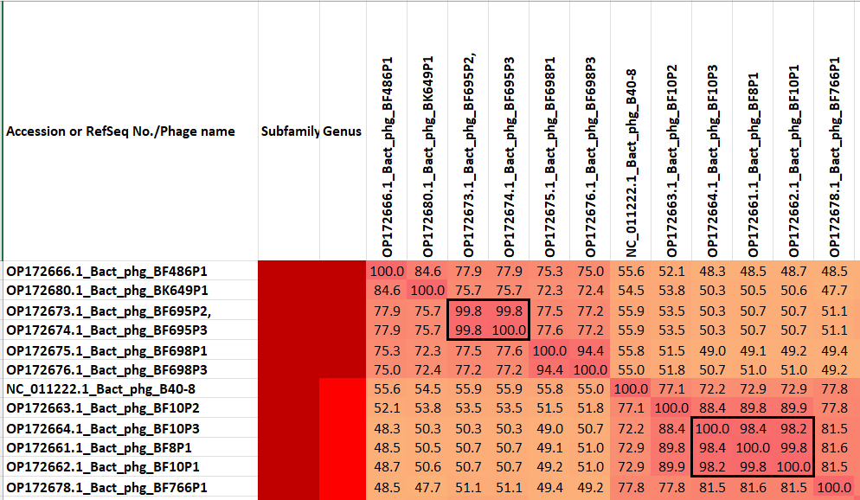

Figure 1. Partial VIRIDIC heatmap of this group of phages. VIRIDIC (Virus Intergenomic Distance Calculator; VIRIDIC (Virus Intergenomic Distance Calculator; [3]; http://rhea.icbm.uni-oldenburg.de/VIRIDIC/) computes pairwise intergenomic distances/similarities amongst phage genomes. Data values which are bordered in black correspond to strains. Abbreviations: phg = phage Bact = Bacteroides. The complete VIRIDIC heatmap accompanies this proposal as 2025.007B.Cardingvirinae_VIRIDIC_heatmap.xlsx.

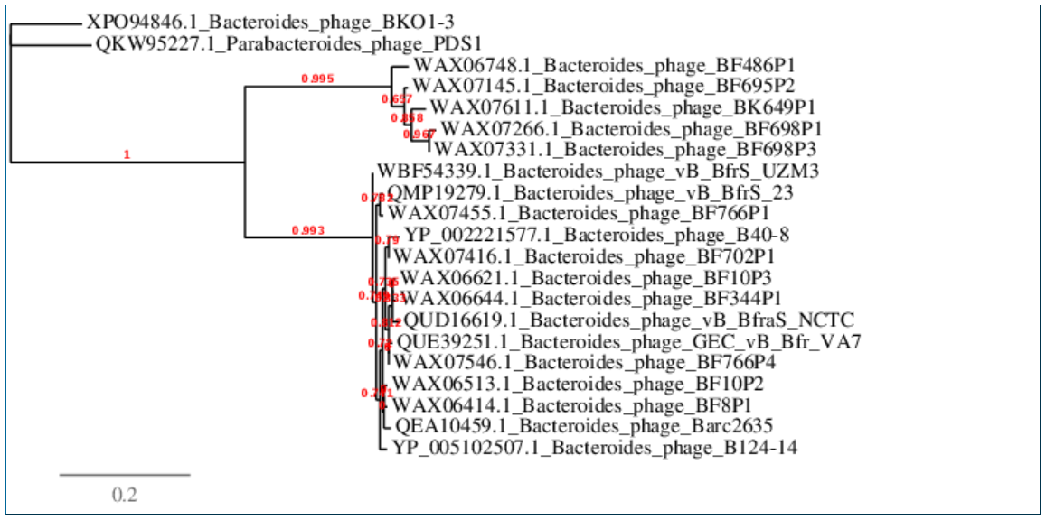
Figure 2. Phylogenetic tree constructed with major capsid proteins from these and related phages using “One Click” phylogeny.fr at http://phylogeny.lirmm.fr/phylo_cgi/simple_phylogeny.cgi [11]

This taxon is named in honour of British immunologist-microbiologist Professor Simon Richard Carding (b. 1958, UK) who completed postgraduate work at the MRC’s Clinical Research Centre studying muscle associated carbohydrate binding proteins in Duchenne Muscular Dystrophy. He then undertook postdoctoral work in the USA at New York University and Yale University in molecular and mucosal immunology prior to becoming a faculty member in the Department of Microbiology and then the Veterinary School of Medicine at the University of Pennsylvania. Returning to the UK and the University of Leeds he developed a programme of research focusing on commensal gut bacteria in health and disease based on Bacteroides spp. Now at the Quadram Institute and University of East Anglia his research focuses on understanding how gut bacteria and viruses communicate with their host and the role that Bacteroides-generated microvesicles play in this crosstalk within and beyond the gut.

(Photo provided by the honouree)

