

The International Committee on Taxonomy of Viruses
Taxonomy Proposal Form, 2025

Part 1a: Details of taxonomy proposals

Title: | Create a new subfamily Alphabravovirinae containing two new genera, Siouxcentervirus and Merionvirus and the existing genus Mapvirus (Caudoviricetes)
Code assigned: | 2025.001B.Ac.v3.Alphabravovirinae_1nsf_2ng_2ns

Author(s), affiliation and email address(es):
Given name (+middle initial(s)) | Surname | Affiliation | Email address | Corr. author(s)
Andrew M. | Kropinski | Department of Pathobiology, University of Guelph, Guelph, Ontario, Canada | Phage.Canada@gmail.com | x
Cristina | Moraru | Carl von Ossietzky Universität Oldenburg, Germany | liliana.cristina.moraru@uol.de
Ipek | Kurtböke | University of the Sunshine Coast - Faculty of Science, Health, Education and Engineering, Australia | ikurtbok@usc.edu.au

Part 1b: Taxonomy Proposal Submission
ICTV Subcommittee:
Animal DNA Viruses and Retroviruses |  | Bacterial viruses | x
Animal minus-strand and dsRNA viruses |  | Fungal and protist viruses
Animal positive-strand RNA viruses |  | Plant viruses
Archaeal viruses |  | General -

List the ICTV Study Group(s) that have seen or have been involved in creating this proposal: https://ictv.global/sc
Actinophages Study Group

Optional – complete only if formally voted on by an ICTV Study Group:
Study Group | Number of members
Study Group | Votes in support | Votes against | No vote

Submission date: | 015/06/2025

Part 1c: Feedback from ICTV Executive Committee (EC) meeting
Executive Committee Meeting Decision code: | X
A – Accept
Ac – Accept subject to revision by relevant subcommittee chair. No further vote required | x
U – Accept without revision but with re-evaluation and email vote by the EC
Uc – Accept subject to revision and re-evaluation and email vote by the EC
Ud – Deferred to the next EC meeting, with an invitation to revise based on EC comments
J - Reject
W - Withdrawn

Comments from the Executive Committee:
Please improve the quality of the abstract, there is a lack of phylogenetic tree (not necessary but would improve the proposal).

Part 1d: Revised Taxonomy Proposal Submission
Response of proposer:
Corrected

Revision date: | August 19, 2025

Part 3: TAXONOMIC PROPOSAL
https://ictv.global/taxonomy/templates
Taxonomic changes proposed:
Establish new taxon | x | Split taxon
Abolish taxon |  | Merge taxon
Move taxon |  | Promote taxon
Rename taxon |  | Demote taxon
Move and rename

Etymology (origin) of proposed taxonomic names:
Taxon name | Etymology of the term
Alphabravovirinae | Named after Actinobacteriophage Database Cluster AB
Siouxcentervirus | Named after the city where the first example of this type of virus was isolated
Merionvirus | Named after the region of the city where the first example of this type of virus was isolated

Permission for use of names derived from a living person:
Taxon name | Full name of person from whom the name is derived | Attached

Abstract of Taxonomy Proposal:
Taxonomic rank(s) affected:
Subfamily, genus, species

Description of current taxonomy:
The genus Mapvirus was originally established under the name Ff47virus in 2015 (proposal 2015.004a-dB.A.v2.Ff47virus) and renamed in 2018 (proposal 2018.007B.A.v4.rename137gen6sp). The genus is currently comprised of two species. The other viruses described in this proposal are unclassified lytic siphoviruses which are related to phages of the genus Mapvirus

Proposed taxonomic change(s):
Create two new genera (Siouxcentervirus, Merionvirus) and assign these genera and Mapvirus to a new subfamily, Alphabravovirinae.

Justification: On the basis of VIRIDIC, ViPTree, CoreGenes and phylogenetic analyses this proposal is in accord with the demarcation of a subfamily [8].

- Text of Taxonomy proposal:

Taxonomic rank(s) affected:
Subfamily, genus, species

Description of current taxonomy:
The genus Mapvirus was originally established under the name Ff47virus in 2015 (proposal 2015.004a-dB.A.v2.Ff47virus) and renamed in 2018 (proposal 2018.007B.A.v4.rename137gen6sp). The genus is currently comprised of two species. The other viruses described in this proposal are unclassified lytic siphoviruses which are related to phages of the genus Mapvirus

Proposed taxonomic change(s):
Create two new genera (Siouxcentervirus, Merionvirus) and assign these genera and Mapvirus to a new subfamily, Alphabravovirinae.

Demarcation criteria:
The Bacterial and Archaeal Virus Subcommittee established 70% average nucleotide identity (ANI) threshold for genus classification or 95% ANI for species [8]. Subfamilies are to be created when two or more genera are related below the family level. In practical terms, this usually means that they share a low degree of sequence similarity (usually about 40-50%) and that the genera form a clade in a marker tree phylogeny [8].

Justification: On the basis of VIRIDIC, ViPTree, CoreGenes and phylogenetic analyses this proposal is in accord with our definition of a subfamily [8].

References:
1. Sayers EW, Beck J, Bolton EE, Bourexis D, Brister JR, Canese K, Comeau DC, Funk K, Kim S, Klimke W, Marchler-Bauer A, Landrum M, Lathrop S, Lu Z, Madden TL, O'Leary N, Phan L, Rangwala SH, Schneider VA, Skripchenko Y, Wang J, Ye J, Trawick BW, Pruitt KD, Sherry ST. Database resources of the National Center for Biotechnology Information. Nucleic Acids Res. 2021 Jan 8;49(D1):D10-D17. doi: 10.1093/nar/gkaa892. PMID: 33095870
2. O'Leary NA, Wright MW, Brister JR, Ciufo S, Haddad D, McVeigh R, et al. Reference sequence (RefSeq) database at NCBI: current status, taxonomic expansion, and functional annotation. Nucleic Acids Res. 2016;44(D1):D733-45. doi: 10.1093/nar/gkv1189. PMID: 26553804.
3. Moraru C, Varsani A, Kropinski AM. VIRIDIC-A Novel Tool to Calculate the Intergenomic Similarities of Prokaryote-Infecting Viruses. Viruses. 2020 Nov 6;12(11):1268. doi: 10.3390/v12111268. PMID: 33172115; PMCID: PMC7694805. http://kronos.icbm.uni-oldenburg.de/viridic/
4. Nishimura Y, Yoshida T, Kuronishi M, Uehara H, Ogata H, Goto S. ViPTree: the viral proteomic tree server. Bioinformatics. 2017; 33(15):2379-2380. doi:10.1093/bioinformatics/btx157. PubMed PMID: 28379287. https://www.genome.jp/viptree/
5. Rohwer F, Edwards R. The Phage Proteomic Tree: a genome-based taxonomy for phage. J Bacteriol. 2002 Aug;184(16):4529-35. PubMed PMID: 12142423
6. Turner D, Reynolds D, Seto D, Mahadevan P. CoreGenes3.5: a webserver for the determination of core genes from sets of viral and small bacterial genomes. BMC Res Notes. 2013;6:140. doi: 10.1186/1756-0500-6-140. PMID: 23566564.
7. Davis P, Seto D, Mahadevan P. CoreGenes5.0: An Updated User-Friendly Webserver for the Determination of Core Genes from Sets of Viral and Bacterial Genomes. Viruses. 2022 Nov 16;14(11):2534. doi: 10.3390/v14112534. PMID: 36423143; PMCID: PMC9693508.
8. Turner D, Kropinski AM, Adriaenssens EM. A Roadmap for Genome-Based Phage Taxonomy. Viruses. 2021 Mar 18;13(3):506. doi: 10.3390/v13030506. PMID: 33803862; PMCID: PMC8003253.
Lemoine F, Correia D, Lefort V, Doppelt-Azeroual O, Mareuil F, Cohen-Boulakia S, Gascuel O. NGPhylogeny.fr: new generation phylogenetic services for non-specialists. Nucleic Acids Res. 2019 Jul 2;47(W1):W260-W265. doi: 10.1093/nar/gkz303. PMID: 31028399; PMCID: PMC6602494.
9. Letunic I, Bork P. Interactive Tree Of Life (iTOL): an online tool for phylogenetic tree display and annotation. Bioinformatics. 2007 Jan 1;23(1):127-8. doi: 10.1093/bioinformatics/btl529. Epub 2006 Oct 18. PMID: 17050570.
10. Zhou T, Xu K, Zhao F, Liu W, Li L, Hua Z, Zhou X. itol.toolkit accelerates working with iTOL (Interactive Tree of Life) by an automated generation of annotation files. Bioinformatics. 2023 Jun 1;39(6):btad339. doi: 10.1093/bioinformatics/btad339. PMID: 37225402; PMCID: PMC10243930.
11. Dereeper A, Guignon V, Blanc G, Audic S, Buffet S, Chevenet F, Dufayard JF, Guindon S, Lefort V, Lescot M, Claverie JM, Gascuel O. Phylogeny.fr: robust phylogenetic analysis for the non-specialist. Nucleic Acids Res. 2008 Jul 1;36(Web Server issue):W465-9. doi: 10.1093/nar/gkn180. Epub 2008 Apr 19. PMID: 18424797; PMCID: PMC2447785.

Accompanying files:
Filename | Description of contents
Alphabravovirinae | Data for this proposal

Tables, Figures:
<Start here>
Table 1A. Characteristics of new species in the genus Siouxcentervirus
Phage name |  | Host | Morphotype | Lifestyle | Accession No. | Genome size | No. proteins | No. tRNA
 | Mycobacterium phage JacoRen57 | Mycobacterium smegmatis mc2 155 | Siphovirus | Lytic | MK279840.1 | 52411 bp | 73 | o

Table 1B. Characteristics of new species in the genus Merionvirus
Phage name | Host | Morphotype | Lifestyle | Accession No. | Genome size | No. proteins | No. tRNA
Mycobacterium phage NoShow | Mycobacterium smegmatis mc#155 | Siphovirus | Lytic | ON108645.1 | 52825 bp | 80 | 0
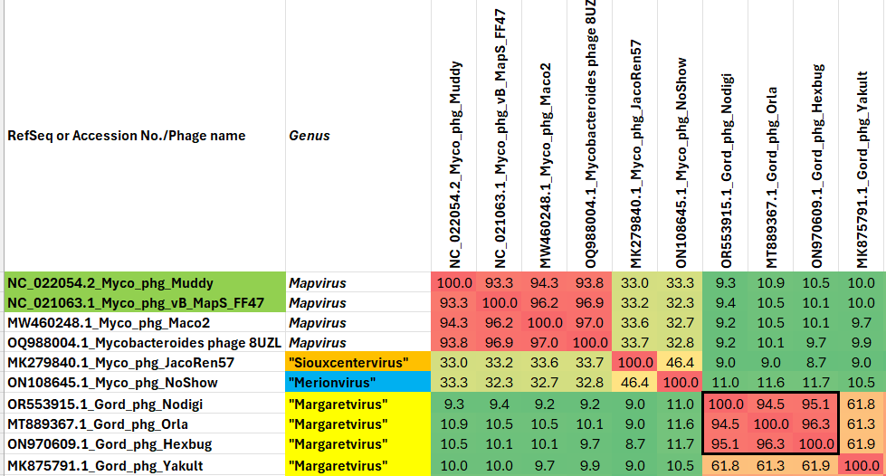Figure 1. VIRIDIC heat map of a group of phages with the one under discussion. VIRIDIC (Virus Intergenomic Distance Calculator; VIRIDIC (Virus Intergenomic Distance Calculator; [3]; http://rhea.icbm.uni-oldenburg.de/VIRIDIC/) computes pairwise intergenomic distances/similarities amongst phage genomes. Data values which are bordered in black correspond to strains. The names in the first column which are highlighted in green correspond to currently recognized species.

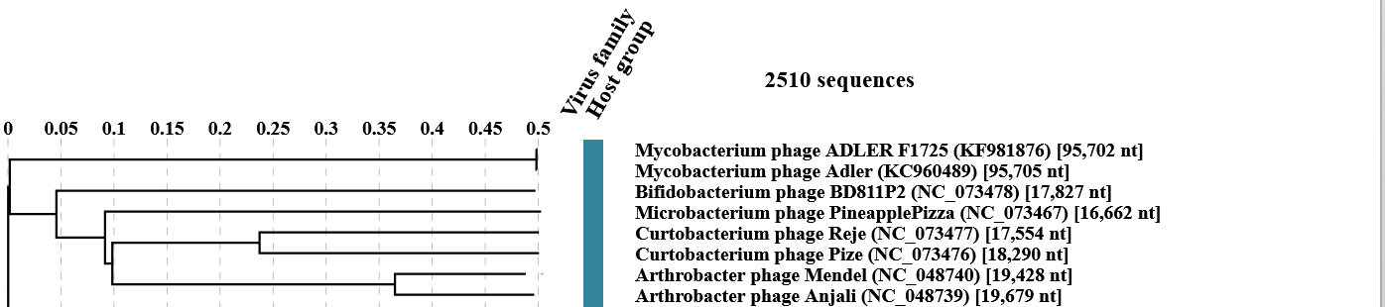
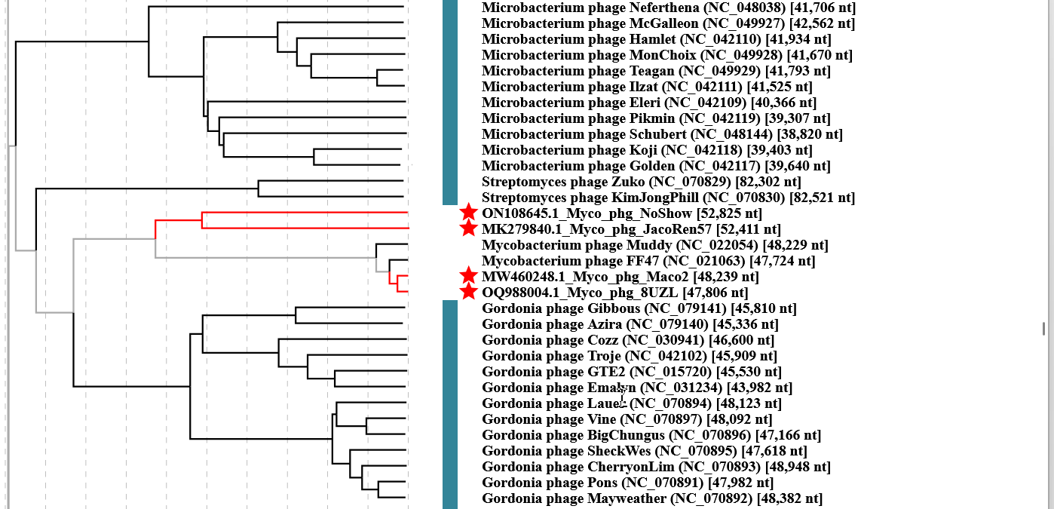

Figure 2. ViPTree analysis (https://www.genome.jp/viptree/; [4]) is based upon Rohwer and Edwards (2002) Phage Proteomic Tree [5]. The phages belonging to the subfamily are indicated with red bar.

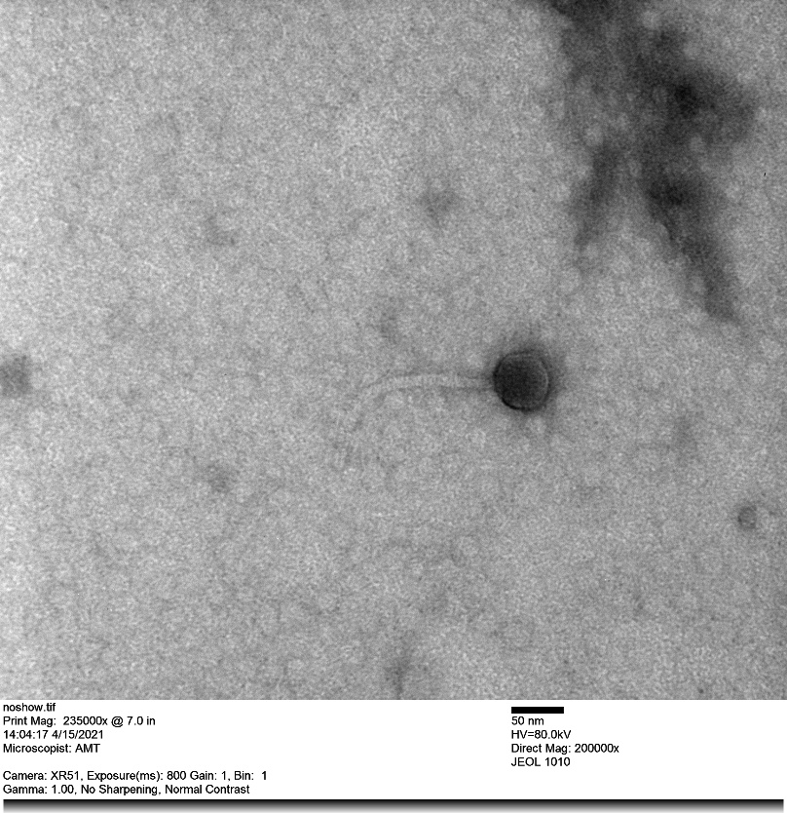
Figure 3. Electron micrograph: Electron micrographs of negatively stained Mycobacterium phage NoShow (https://phagesdb.org/phages/NoShow/). Limited permission was granted by The Actinobacteriophages Database (https://phagesdb.org/), funded by the Howard Hughes Medical Institute, to use this electron micrograph for this taxonomy proposal; it cannot be reused without permission of The Actinobacteriophages Database.

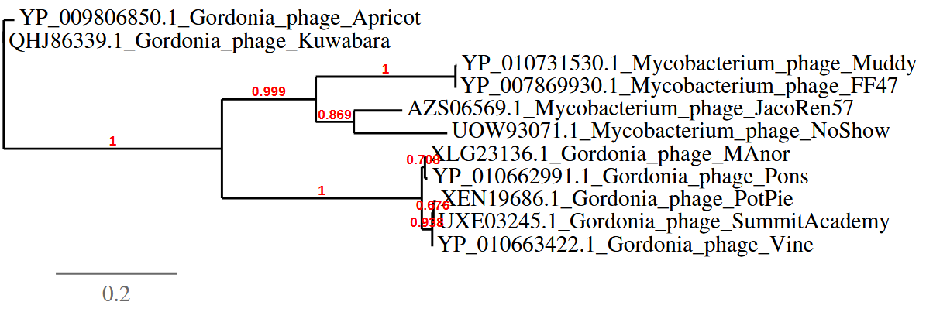
Figure 4. Phylogenetic tree constructed with large subunit terminase proteins from these and related phages using “One Click” phylogeny.fr at http://phylogeny.lirmm.fr/phylo_cgi/simple_phylogeny.cgi [11]

CoreGenes 3.5 Analysis [6]: revealed that the phages listed in Table 1 share 35 protein homologs, including DNA helicase, thymidylate kinase dUTPase, thymidylate synthase, DNA polymerase, DNA helicase, 3 minor tail proteins, tape measure protein, major tail protein, tail terminator, head-to-tail stopper, major capsid protein, head-to-tail adaptor,
scaffolding protein, portal protein, terminase large subunit, terminase small subunit. This indicates that approximately 50.7% of the phage-encoded proteins are conserved.

