

The International Committee on Taxonomy of Viruses
Taxonomy Proposal Form, 2024

Part 1a: Details of taxonomy proposals

Title: | Create one new genus, Lacfervirus, in the class Caudoviricetes
Code assigned: | 2024.042B

Author(s), affiliation and email address(es):
Name | Affiliation | Email address | Corresponding author(s) X
Qiannan Wen | Key Laboratory of Dairy Biotechnology and Engineering, Ministry of Education, Inner Mongolia Agricultural University, 306 Zhaowuda Road, Hohhot 010018, China | wenqiannan2020@126.com
Xia Chen | Key Laboratory of Dairy Biotechnology and Engineering, Ministry of Education, Inner Mongolia Agricultural University, 306 Zhaowuda Road, Hohhot 010018, China | chenxia8280@163.com | X

Part 1b: Taxonomy Proposal Submission
ICTV Subcommittee:
Animal DNA Viruses and Retroviruses |  | Bacterial viruses | X
Animal minus-strand and dsRNA viruses |  | Fungal and protist viruses
Animal positive-strand RNA viruses |  | Plant viruses
Archaeal viruses |  | General -

List the ICTV Study Group(s) that have seen or have been involved in creating this proposal:
Qiannan Wen
Xia Chen

Optional – complete only if formally voted on by an ICTV Study Group:
Study Group | Number of members
Study Group | Votes in support | Votes against | No vote

Submission date: | 05/06/2023

Part 1c: Feedback from ICTV Executive Committee (EC) meeting
Executive Committee Meeting Decision code: | X
A – Accept | X
Ac – Accept subject to revision by relevant subcommittee chair. No further vote required
U – Accept without revision but with re-evaluation and email vote by the EC
Uc – Accept subject to revision and re-evaluation and email vote by the EC
Ud – Deferred to the next EC meeting, with an invitation to revise based on EC comments
J - Reject
W - Withdrawn

Comments from the Executive Committee:

Part 1d: Revised Taxonomy Proposal Submission
Response of proposer:
Revision date: | DD/MM/YYYY

Part 3: TAXONOMIC PROPOSAL

Name of accompanying Excel module:
2024.042B.A.v1.Lacfervirus_ng.xlsx

Taxonomic changes proposed:
Establish new taxon |  | Split taxon
Abolish taxon |  | Merge taxon
Move taxon |  | Promote taxon
Rename taxon |  | Demote taxon
Move and rename

Is any taxon name used here derived from that of a living person: |  | Y/N
Taxon name | Person from whom the name is derived | Attached X

Abstract of Taxonomy Proposal:
Taxonomic rank(s) affected:
Realm Duplodnaviria, kingdom Heunggongvirae, phylum Uroviricota, class Caudoviricetes

Description of current taxonomy:
The virus classified in this proposal does not have a current taxonomic assignment.

Proposed taxonomic change(s):
We propose a new genus, Lacfervirus, comprised of a single species, Lactobacillus phage LFP01 in the class Caudoviricetes.

Justification:
The genome of Lactobacillus phage LFP01 has very low homology to all other bacteriophage sequences in the GenBank database. A complete genome sequence comparison using the BLASTn method revealed that the genome of Lactobacillus phage LFP01 had a maximum nucleotide identity of 92.83% and 55% coverage with Lactobacillus phage LF1. The low homology indicated that the newly sequenced bacteriophage likely represents a new genus with a single species, and conforms to the recommendations outlined in [2].

- Text of Taxonomy proposal:

Taxonomic rank(s) affected:
Realm Duplodnaviria, kingdom Heunggongvirae, phylum Uroviricota, class Caudoviricetes

Description of current taxonomy:
The virus classified in this proposal does not have a current taxonomic assignment.

Proposed taxonomic change(s):
We propose a new genus, Lacfervirus, comprised of a single species, Lactobacillus phage LFP01 in the class Caudoviricetes.

Demarcation criteria:
Species demarcation criteria: Two phages are assigned to the same species if their genomes are more than 95% identical over their genome length for isolates. These values can be calculated by a number of tools, such as BLASTn – usually calculated using intergenomic distance calculator VIRIDIC (1).Genus demarcation criteria: In search for criteria that create cohesive and distinct genera that are reproducible and monophyletic, the Bacterial Viruses Subcommittee has established 70% nucleotide identity of the genome length as the cut-off for genera. Genus-level groupings should always be monophyletic in the signature genes, as tested with a phylogenetic tree. (2)

Justification:
The genome has very low homology to all other bacteriophage sequences in the GenBank database. A complete genome sequence comparison using the BLASTn method revealed that the genome of Lactobacillus phage LFP01 had a maximum nucleotide identity of 92.83% and 55% coverage with Lactobacillus phage LF1. The low homology indicated that the newly sequenced bacteriophage likely represents a new genus with a single species, and conforms to the recommendations outlined in [2].

Source of the name of this taxon: The genus is named after the combination of the first three letters of the genus and species name of Lactobacillus fermentum, Lacfervirus. This phage was induced from L. fermentum IMAU32646 with mitomycin-C

References:
(1) Moraru C, Varsani A, Kropinski AM. VIRIDIC-A Novel Tool to Calculate the Intergenomic Similarities of Prokaryote-Infecting Viruses. Viruses. 2020 Nov 6;12(11):1268. doi: 10.3390/v12111268. PMID: 33172115
(2) Turner D, Kropinski AM, Adriaenssens EM. A Roadmap for Genome-Based Phage Taxonomy. Viruses. 2021 Mar 18;13(3):506. doi: 10.3390/v13030506. PMID: 33803862
(3) Moraru C, Varsani A, Kropinski AM. VIRIDIC-A Novel Tool to Calculate the Intergenomic Similarities of Prokaryote-Infecting Viruses. Viruses. 2020 Nov 6;12(11):1268. doi: 10.3390/v12111268. PMID: 33172115

Tables, Figures:

GenBank Summary:
Phage name | Genbank accession No. | Size (Kb) | GC% | CDS | tRNAs
Lactobacillus phage LFP01 | OR048821 | 40.562 | 46.25% | 54 | 0

BLASTN homologs: The genome has very low homology to all other bacteriophage sequences in the GenBank database. A complete genome sequence comparison using the BLASTn method revealed that the genome of Lactobacillus phage LFP01 had a maximum nucleotide identity of 92.83% and 55% coverage with Lactobacillus phage LF1. The low homology indicated that the newly sequenced bacteriophage likely represents a new genus with a single species.

VIRIDIC heat map: VIRIDIC (Virus Intergenomic Distance Calculator; VIRIDIC (Virus Intergenomic Distance Calculator; (3); http://rhea.icbm.uni-oldenburg.de/VIRIDIC/) computes pairwise intergenomic distances/similarities amongst phage genomes.

VIRIDIC heat map showed that this phage merely had an intergenomic similarity of 50.1% with Lactobacillus phage LF1 (Fig. 3), well below the proposed threshold for a new genus of 70% (2).

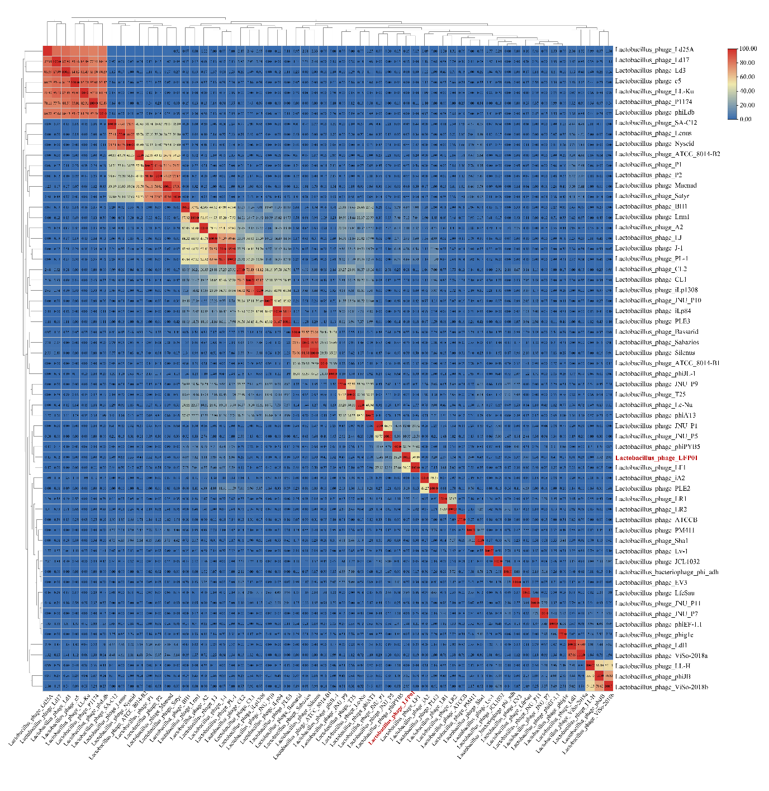
Electron micrograph:
Transmission electron microscopy showed that this phage possesses an isometric capsid (diameter; 78.19 ± 3.78 nm) and a long, non-contractile tail (length; 220.42 ± 1.10 nm, width; 9.04 ± 0.27 nm).

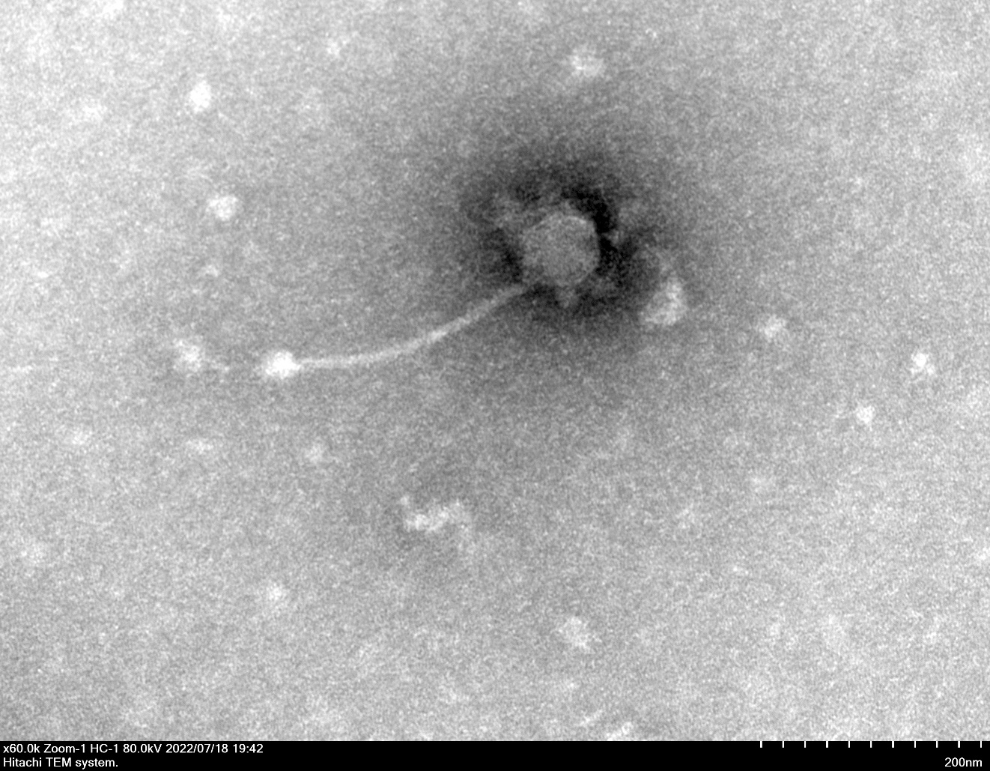

Phylogeny:
Phylogenetic trees of Lactobacillus phage LFP01 were constructed with 1000 bootstrap replicates using neighbor-joining method based on the (a) terL and (b) MCP sequences. Different color representing the viral genus. L. fermentum phage LFP01 is marked in red. There are twenty-one phage genomes that are not annotated to the MCP.

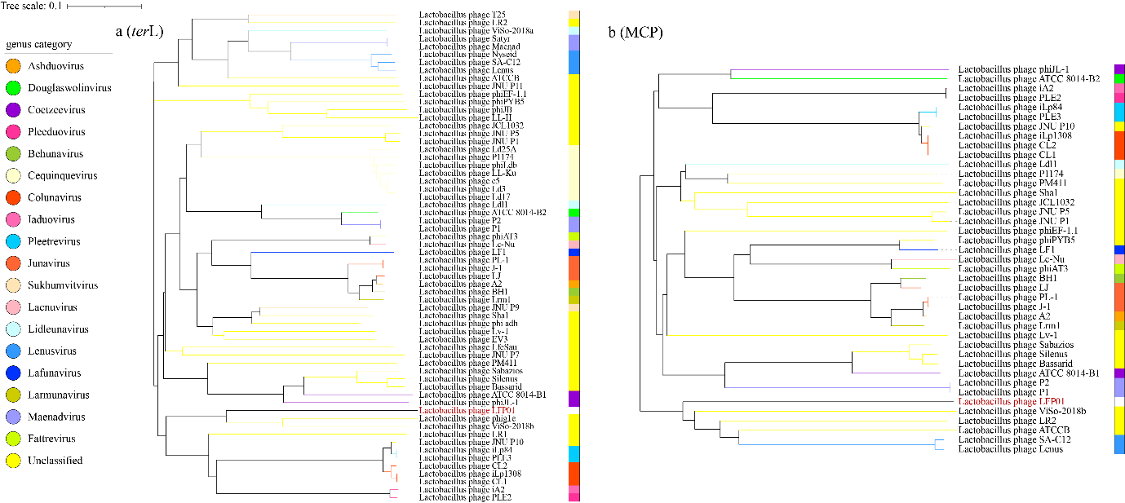

Protein-sharing network
Protein-sharing network diagram of phage LFP01 benchmarked against ICTV-accepted viral taxonomy. (a) Each node represents a viral genome, and the connection between nodes represents the relationship between them. (b) The protein cluster where LFP01 was located. Different shape representing the viral genus and each distinct color representing phages with different hosts. Every line has a value, and the greater the value, the more similar they are. L. fermentum phage LFP01 is marked in blue.

