

The International Committee on Taxonomy of Viruses
Taxonomy Proposal Form, 2024

Part 1a: Details of taxonomy proposals

Title: | Create two new species - Camvirus vanseggelen and Camvirus verabelle [subfamily Arquatrovirinae, class Caudoviricites].
Code assigned: | 2024.041B

Author(s), affiliation and email address(es):
Name |  | Affiliation | Email address | Corresponding author(s) X
Kempff A | Leiden University, The Netherlands |  | annabelkempff@gmail.com | X
van Neer V | Leiden University, The Netherlands |  | vanneervera@gmail.com | X
Ongenae V | Leiden University, The Netherlands |  | v.m.a.ongenae@biology.leidenuniv.nl | X
Rozen DE | Leiden University, The Netherlands |  | d.e.rozen@biology.leidenuniv.nl
Briegel A | Leiden University, The Netherlands |  | a.briegel@biology.leidenuniv.nl
Claessen D | Leiden University, The Netherlands |  | d.claessen@biology.leidenuniv.nl

Part 1b: Taxonomy Proposal Submission
ICTV Subcommittee:
Animal DNA Viruses and Retroviruses |  | Bacterial viruses
Animal minus-strand and dsRNA viruses |  | Fungal and protist viruses
Animal positive-strand RNA viruses |  | Plant viruses
Archaeal viruses |  | General -

List the ICTV Study Group(s) that have seen or have been involved in creating this proposal:
Actinophages Study Group
Optional – complete only if formally voted on by an ICTV Study Group:
Study Group | Number of members
Study Group | Votes in support | Votes against | No vote

Submission date: | 02/04/2024

Part 1c: Feedback from ICTV Executive Committee (EC) meeting
Executive Committee Meeting Decision code: | X
A – Accept | X
Ac – Accept subject to revision by relevant subcommittee chair. No further vote required
U – Accept without revision but with re-evaluation and email vote by the EC
Uc – Accept subject to revision and re-evaluation and email vote by the EC
Ud – Deferred to the next EC meeting, with an invitation to revise based on EC comments
J - Reject
W - Withdrawn

Comments from the Executive Committee:

Part 1d: Revised Taxonomy Proposal Submission
Response of proposer:
Revision date: | DD/MM/YYYY

Part 3: TAXONOMIC PROPOSAL

Name of accompanying Excel module:
2024.041B.A.v1.Camvirus_2ns.xlsx

Taxonomic changes proposed:
Establish new taxon | X | Split taxon
Abolish taxon |  | Merge taxon
Move taxon |  | Promote taxon
Rename taxon |  | Demote taxon
Move and rename

Is any taxon name used here derived from that of a living person: |  | Y/N
Taxon name | Person from whom the name is derived | Attached X

Abstract of Taxonomy Proposal:
Taxonomic rank(s) affected:
Realm Duplodnaviria, kingdom Heunggongvirae, phylum Uroviricota, class Caudoviricetes

Description of current taxonomy:
The genus Camvirus is classified within the subfamily Arquatrovirinae, class Caudoviricetes

Proposed taxonomic change(s):
Create two new species in the genus Camvirus

Justification:
We have defined two new species, Camvirus vanseggelen and Camvirus verabelle, based upon phages isolated for host Streptomyces coelicolor from soil samples in the Netherlands at longitude N52°23’31” and latitude E4°34’49”. Camvirus vanseggelen contains a linear dsDNA genome of 50426 bp (65,5% G+C) encoding 73 proteins. Camvirus verabelle contains a linear dsDNA genome of 49832 bp (65,0% G+C) encoding 73 proteins. These new species can be included in the genus Camvirus together with Streptomyces phage Alsaber, Streptomyces phage Amela, Streptomyces phage phiCAM, Streptomyces phage Endor1, Streptomyces phage Endor2, Streptomyces phage Joe, Streptomyces phage Saftant and Streptomyces phage Sitrop.

- Text of Taxonomy proposal:
Taxonomic rank(s) affected:
Realm Duplodnaviria, kingdom Heunggongvirae, phylum Uroviricota, class Caudoviricetes

Description of current taxonomy:
The genus Camvirus is classified within the subfamily Arquatrovirinae, class Caudoviricetes

Proposed taxonomic change(s):
Create two new species in the genus Camvirus

Demarcation criteria:
Species demarcation criteria: Two phages are assigned to the same species if their genomes are more than 95% identical over their genome length for isolates.
These values can be calculated by a number of tools, such as BLASTn [1] – usually calculated using intergenomic distance calculator VIRIDIC [2].

Genus demarcation criteria: In search for criteria that create cohesive and distinct genera that are reproducible and monophyletic, the Bacterial Viruses Subcommittee has established 70% nucleotide identity of the genome length as the cut-off for genera. Genus-level groupings should always be monophyletic in the signature genes, as tested with a phylogenetic tree. [3]

Family demarcation criteria: The family is represented by a cohesive and monophyletic group in the main predicted proteome-based clustering tools (ViPTree, GRAViTy dendrogram, vConTACT2 network). Members of the family share a significant number of orthologous genes (the number will depend on the genome sizes and number of coding sequences of members of the family; usually ca. 10%) [3].

Justification:
The phages detailed in this proposal conform to current demarcation criteria [3].

References:
1. Sayers EW, Beck J, Bolton EE, Bourexis D, Brister JR, Canese K, Comeau DC, Funk K, Kim S, Klimke W, Marchler-Bauer A, Landrum M, Lathrop S, Lu Z, Madden TL, O'Leary N, Phan L, Rangwala SH, Schneider VA, Skripchenko Y, Wang J, Ye J, Trawick BW, Pruitt KD, Sherry ST. Database resources of the National Center for Biotechnology Information. Nucleic Acids Res. 2021 Jan 8;49(D1):D10-D17. doi: 10.1093/nar/gkaa892. PMID: 33095870
2. Moraru C, Varsani A, Kropinski AM. VIRIDIC-A Novel Tool to Calculate the Intergenomic Similarities of Prokaryote-Infecting Viruses. Viruses. 2020 Nov 6;12(11):1268. doi: 10.3390/v12111268. PMID: 33172115; PMCID: PMC7694805. http://kronos.icbm.uni-oldenburg.de/viridic/
3. Turner D, Kropinski AM, Adriaenssens EM. A Roadmap for Genome-Based Phage Taxonomy. Viruses. 2021 Mar 18;13(3):506. doi: 10.3390/v13030506. PMID: 33803862; PMCID: PMC8003253.
4. Ongenae, V., Azeredo, J., Kropinski, A. M., Rozen, D., Briegel, A., & Claessen, D. (2022). Genome sequence and characterization of Streptomyces phage Pablito, representing a new species within the genus Janusvirus. Scientific Reports, 12(1), 17785.
5. Nishimura, Y., Yoshida, T., Kuronishi, M., Uehara, H., Ogata, H., & Goto, S. (2017). ViPTree: the viral proteomic tree server. Bioinformatics, 33(15), 2379–2380. https://doi.org/10.1093/bioinformatics/btx157
6. Turner D, Reynolds D, Seto D, Mahadevan P. CoreGenes3.5: a webserver for the determination of core genes from sets of viral and small bacterial genomes. BMC Res Notes. 2013;6:140. doi: 10.1186/1756-0500-6-140. PMID: 23566564.

Tables, Figures:
- To add two new species (Camvirus vanseggelen and Camvirus verabelle) tin the genus Camvirus.

Origin of the name of this taxon:

Vanseggelen is an old Dutch family name, while Verabelle is an uncommon girl’s name.

Historical aspects: These temperate phages were isolated in the Netherlands using host Streptomyces coelicolor. They are both siphoviruses.

Electron micrograph:

Phage Verabelle Phage Vanseggelen
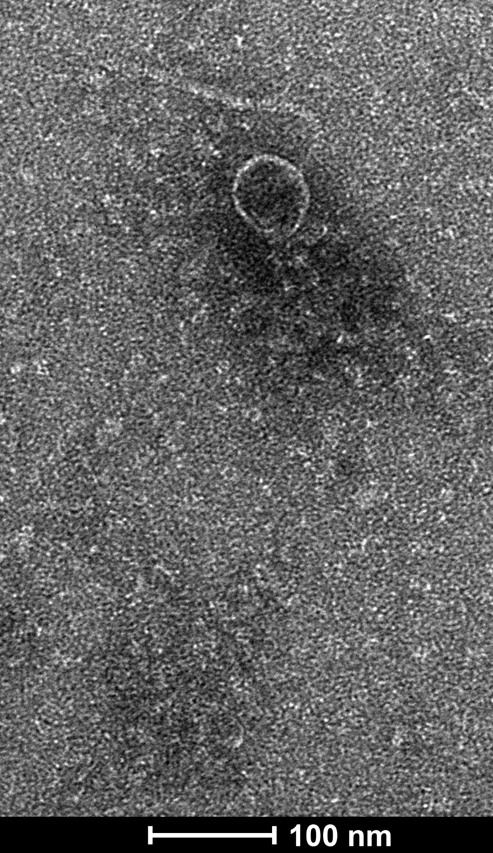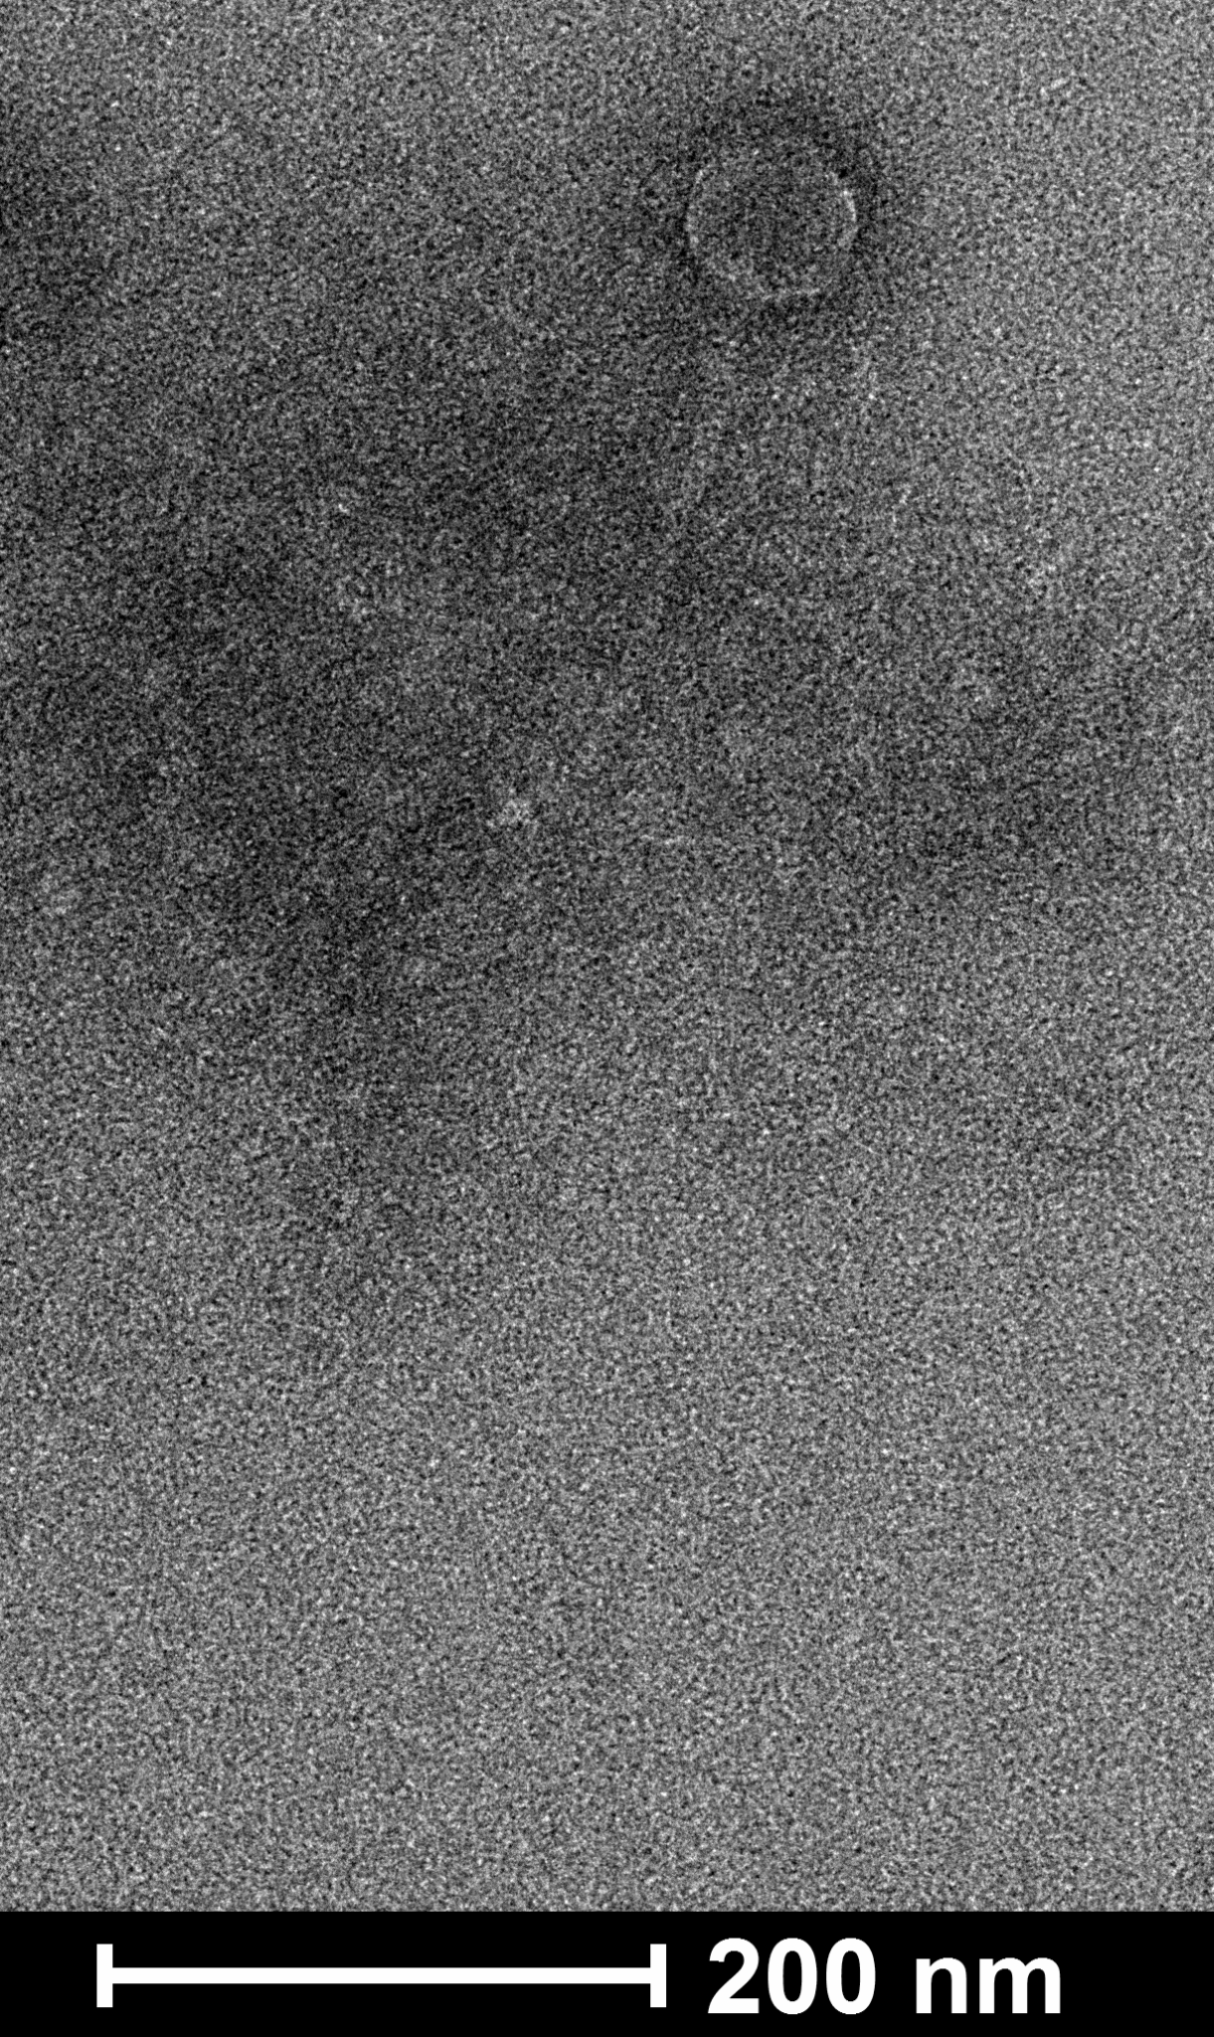

Genome summary:

Phage name | RefSeq No. | INSDC | Size (Kb) | GC% | Protein | Overall % DNA sequence identity (*) | Overall % homologous proteins (**)
Streptomyces phage phiCAM | NC_041856.1 | JX889246 | 50.348 | 65.6 | 72 | 100 | 100
Streptomyces phage Vanseggelen |  | OQ970438 | 50.426 | 65.5 | 73 | 74.3 | 84.8
Streptomyces phage Verabelle |  | OQ970439 | 49.832 | 65.0 | 73 | 74.5 | 91.7

(*) determined using VIRIDIC [2]
(**) determined using CoreGenes 3.5 [6]

VIRIDIC heat map: VIRIDIC (Virus Intergenomic Distance Calculator; VIRIDIC (Virus Intergenomic Distance Calculator; [2]; http://rhea.icbm.uni-oldenburg.de/VIRIDIC/) computes pairwise intergenomic distances/similarities amongst phage genomes.
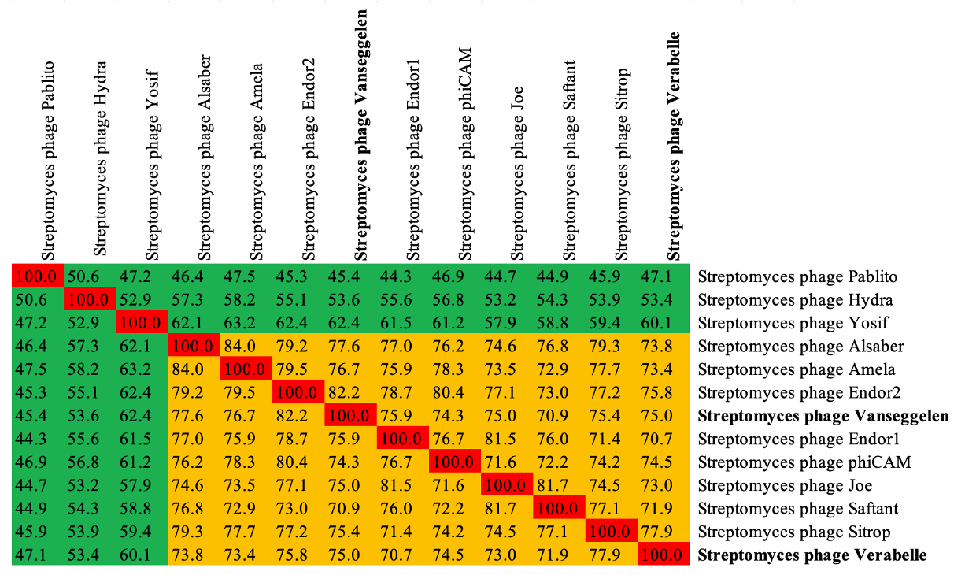

Phylogeny: The phylogenetic tree was constructed using the whole genome sequences from the top 10 phages with the most similar genome sequences. Streptomyces phage Pablito [4] was chosen as an outlier. ViPTree was used to construct a viral proteomic tree [5].

