

The International Committee on Taxonomy of Viruses
Taxonomy Proposal Form, 2024

Part 1a: Details of taxonomy proposals

Title: | Create a new family, Stackebrandtviridae, for a group of Gordonia phages (Class: Caudoviricetes)
Code assigned: | 2024.034B

Author(s), affiliation and email address(es):
Name | Affiliation | Email address | Corresponding author(s) X
Kurtböke, I | University of the Sunshine Coast, Australia | ikurtbok@usc.edu.au
Moraru C | Carl von Ossietzky Universität Oldenburg, Germany | liliana.cristina.moraru@uol.de
Tolstoy I | National Center for Biotechnology Information, MD, USA | tolstoy@ncbi.nlm.nih.gov
Kropinski AM | University of Guelph, Ontario, Canada [AMK] | Phage.Canada@gmail.com | x

Part 1b: Taxonomy Proposal Submission
ICTV Subcommittee:
Animal DNA Viruses and Retroviruses |  | Bacterial viruses | x
Animal minus-strand and dsRNA viruses |  | Fungal and protist viruses
Animal positive-strand RNA viruses |  | Plant viruses
Archaeal viruses |  | General -

List the ICTV Study Group(s) that have seen or have been involved in creating this proposal:
Actinophages Study group

Optional – complete only if formally voted on by an ICTV Study Group:
Study Group | Number of members
Study Group | Votes in support | Votes against | No vote

Submission date: | 15/06/2024

Part 1c: Feedback from ICTV Executive Committee (EC) meeting
Executive Committee Meeting Decision code: | X
A – Accept
Ac – Accept subject to revision by relevant subcommittee chair. No further vote required | X
U – Accept without revision but with re-evaluation and email vote by the EC
Uc – Accept subject to revision and re-evaluation and email vote by the EC
Ud – Deferred to the next EC meeting, with an invitation to revise based on EC comments
J - Reject
W - Withdrawn

Comments from the Executive Committee:
Minor corrections to the text required (table 1 legend).

Part 1d: Revised Taxonomy Proposal Submission
Response of proposer:
Corrected.

Revision date: | 30/09/2024

Part 3: TAXONOMIC PROPOSAL

Name of accompanying Excel module:
2024.034B.A.v2.Stackebrandtviridae_nf.xlsx

Taxonomic changes proposed:
Establish new taxon | x | Split taxon
Abolish taxon |  | Merge taxon
Move taxon |  | Promote taxon
Rename taxon |  | Demote taxon
Move and rename

Is any taxon name used here derived from that of a living person: |  | Y/N
Taxon name | Person from whom the name is derived | Attached X
Stackebrandtviridae | Erco Stackebrandt | Y

Abstract of Taxonomy Proposal:
Taxonomic rank(s) affected:
Realm Duplodnaviria, kingdom Heunggongvirae, phylum Uroviricota, class Caudoviricetes

Description of current taxonomy:
At present the following taxa exist as floating genera in the order Caudoviricetes; Wizardvirus, Clownvirus, Vididuovirus, Dexdertvirus, Zitchvirus, Kroosvirus and Leonardvirus

Proposed taxonomic change(s):
A. To create one new species in the genus Wizardvirus
B. To create a new subfamily, Frickvirinae with two genera (Clownvirus and Wizardvirus)
C. To add one new species to the genus Vididuovirus
D. To add one new species to the genus Dexdertvirus
E. To add four new species to the genus Zitchvirus
F. To add one new species to the genus Leonardvirus
G. To create a new subfamily, Schenleyvirinae, for the above four genera and Kroosvirus.
H. To create a new family, Stackebrandtviridae, for the above-mentioned taxa.

Justification:
Members of the Actinobacteriophage Database Cluster DC (https://phagesdb.org/clusters/DC/) are temperate Gordonia phages for which we have created two genera. The related lytic viruses of Cluster DE (https://phagesdb.org/clusters/DE/) have resulted in five new genera. Agrees with characteristics of a new family laid out in [10]

- Text of Taxonomy proposal:
Taxonomic rank(s) affected: Species, Subfamily and Family

Description of current taxonomy:

Members of the Actinobacteriophage Database Cluster DC (https://phagesdb.org/clusters/DC/) are temperate Gordonia phages for which we have created two genera. The related lytic viruses of Cluster DE (https://phagesdb.org/clusters/DE/) have resulted in five new genera.

Proposed taxonomic change(s):
A. To create one new species in the genus Wizardvirus
B. To create a new subfamily, Frickvirinae with two genera (Clownvirus and Wizardvirus)
C. To add one new species to the genus Vididuovirus
D. To add one new species to the genus Dexdertvirus
E. To add four new species to the genus Zitchvirus
F. To add one new species to the genus Leonardvirus
G. To create a new subfamily, Schenleyvirinae, for the above four genera and Kroosvirus.
H. To create a new family, Stackebrandtviridae, for the above mentioned taxa.

Demarcation criteria:
Species demarcation criteria: Two phages are assigned to the same species if their genomes are more than 95% identical over their genome length for isolates.
These values can be calculated by a number of tools, such as BLASTn [1,2] – usually calculated using intergenomic distance calculator VIRIDIC [3].

Genus demarcation criteria: In search for criteria that create cohesive and distinct genera that are reproducible and monophyletic, the Bacterial Viruses Subcommittee has established 70% nucleotide identity of the genome length as the cut-off for genera. Genus-level groupings should always be monophyletic in the signature genes, as tested with a phylogenetic tree. [10]

Subfamily demarcation criteria: Subfamilies are to be created when two or more genera are related below the family level. In practical terms, this usually means that they share a low degree of sequence similarity (usually about 40-50%) and that the genera form a clade in a marker tree phylogeny. [10]

Family demarcation criteria: The family is represented by a cohesive and monophyletic group in the main predicted proteome-based clustering tools (VirClust, ViPTree, GRAViTy dendrogram, vConTACT2 network). Members of the family share a significant number of orthologous genes (the number will depend on the genome sizes and number of coding sequences of members of the family). [10]

Justification: In conformity to [10]

References:
1. Sayers EW, Beck J, Bolton EE, Bourexis D, Brister JR, Canese K, Comeau DC, Funk K, Kim S, Klimke W, Marchler-Bauer A, Landrum M, Lathrop S, Lu Z, Madden TL, O'Leary N, Phan L, Rangwala SH, Schneider VA, Skripchenko Y, Wang J, Ye J, Trawick BW, Pruitt KD, Sherry ST. Database resources of the National Center for Biotechnology Information. Nucleic Acids Res. 2021 Jan 8;49(D1):D10-D17. doi: 10.1093/nar/gkaa892. PMID: 33095870
2. O'Leary NA, Wright MW, Brister JR, Ciufo S, Haddad D, McVeigh R, et al. Reference sequence (RefSeq) database at NCBI: current status, taxonomic expansion, and functional annotation. Nucleic Acids Res. 2016;44(D1):D733-45. doi: 10.1093/nar/gkv1189. PMID: 26553804.
3. Moraru C, Varsani A, Kropinski AM. VIRIDIC-A Novel Tool to Calculate the Intergenomic Similarities of Prokaryote-Infecting Viruses. Viruses. 2020 Nov 6;12(11):1268. doi: 10.3390/v12111268. PMID: 33172115; PMCID: PMC7694805. http://kronos.icbm.uni-oldenburg.de/viridic/
4. Nishimura Y, Yoshida T, Kuronishi M, Uehara H, Ogata H, Goto S. ViPTree: the viral proteomic tree server. Bioinformatics. 2017; 33(15):2379-2380. doi:10.1093/bioinformatics/btx157. PubMed PMID: 28379287. https://www.genome.jp/viptree/
5. Rohwer F, Edwards R. The Phage Proteomic Tree: a genome-based taxonomy for phage. J Bacteriol. 2002 Aug;184(16):4529-35. PubMed PMID: 12142423
6. Turner D, Reynolds D, Seto D, Mahadevan P. CoreGenes3.5: a webserver for the determination of core genes from sets of viral and small bacterial genomes. BMC Res Notes. 2013;6:140. doi: 10.1186/1756-0500-6-140. PMID: 23566564.
7. Davis P, Seto D, Mahadevan P. CoreGenes5.0: An Updated User-Friendly Webserver for the Determination of Core Genes from Sets of Viral and Bacterial Genomes. Viruses. 2022 Nov 16;14(11):2534. doi: 10.3390/v14112534. PMID: 36423143; PMCID: PMC9693508.
8. Dereeper A, Guignon V, Blanc G, Audic S, Buffet S, Chevenet F, Dufayard JF, Guindon S, Lefort V, Lescot M, Claverie JM, Gascuel O. Phylogeny.fr: robust phylogenetic analysis for the non-specialist. Nucleic Acids Res. 2008;36(Web Server issue):W465-9. doi: 10.1093/nar/gkn180. Epub 2008 Apr 19. PMID: 18424797.
9. Anisimova M, Gascuel O. Approximate likelihood-ratio test for branches: A fast, accurate, and powerful alternative. Syst Biol. 2006;55(4):539-52. PMID: 16785212. DOI: 10.1080/10635150600755453.
10. Turner D, Kropinski AM, Adriaenssens EM. A Roadmap for Genome-Based Phage Taxonomy. Viruses. 2021 Mar 18;13(3):506. doi: 10.3390/v13030506. PMID: 33803862; PMCID: PMC8003253.
11. Bin Jang H, Bolduc B, Zablocki O, Kuhn JH, Roux S, Adriaenssens EM, Brister JR, Kropinski AM, Krupovic M, Lavigne R, Turner D, Sullivan MB. Taxonomic assignment of uncultivated prokaryotic virus genomes is enabled by gene-sharing networks. Nat Biotechnol. 2019 Jun;37(6):632-639. doi: 10.1038/s41587-019-0100-8. Epub 2019 May 6. PMID: 31061483.
12. Bolduc B, Jang HB, Doulcier G, You ZQ, Roux S, Sullivan MB. vConTACT: an iVirus tool to classify double-stranded DNA viruses that infect Archaea and Bacteria. PeerJ. 2017 May 3;5:e3243. doi: 10.7717/peerj.3243. PMID: 28480138; PMCID: PMC5419219.
13. Moraru C. VirClust-A Tool for Hierarchical Clustering, Core Protein Detection and Annotation of (Prokaryotic) Viruses. Viruses. 2023 Apr 19;15(4):1007. doi: 10.3390/v15041007. PMID: 37112988; PMCID: PMC10143988.
14. Letunic I, Bork P. Interactive Tree Of Life (iTOL): an online tool for phylogenetic tree display and annotation. Bioinformatics. 2007 Jan 1;23(1):127-8. doi: 10.1093/bioinformatics/btl529. Epub 2006 Oct 18. PMID: 17050570.
15. Zhou T, Xu K, Zhao F, Liu W, Li L, Hua Z, Zhou X. itol.toolkit accelerates working with iTOL (Interactive Tree of Life) by an automated generation of annotation files. Bioinformatics. 2023 Jun 1;39(6):btad339. doi: 10.1093/bioinformatics/btad339. PMID: 37225402; PMCID: PMC10243930.
16. Nguyen LT, Schmidt HA, von Haeseler A, and Minh BQ (2015) IQ-TREE: A fast and effective stochastic algorithm for estimating maximum likelihood phylogenies. Molecular Biology and Evolution, 32:268-274. https://doi.org/10.1093/molbev/msu300
17. Hoang DT, Chernomor O, von Haeseler A, Minh BQ, Vinh LS (2018) UFBoot2: Improving the ultrafast bootstrap approximation. Molecular Biology and Evolution, 35:518–522. https://doi.org/10.1093/molbev/msx281
18. Kalyaanamoorthy S, Minh BQ, Wong TKF, von Haeseler A, and Jermiin JS (2017) ModelFinder: Fast Model Selection for Accurate Phylogenetic Estimates, Nature Methods, 14:587–589. https://doi.org/10.1038/nmeth.4285

Tables, Figures:
<Start here>
Figure 1. VIRIDIC heat map of a portion of the members of this family: VIRIDIC (Virus Intergenomic Distance Calculator; VIRIDIC (Virus Intergenomic Distance Calculator; [3]; http://rhea.icbm.uni-oldenburg.de/VIRIDIC/) computes pairwise intergenomic distances/similarities amongst phage genomes. Data values which are bordered in black correspond to strains. Abbreviations: phg = phage; Gord = Gordonia. Since this figure does not represent the full set of Felix-O1-like phages we have appended the complete VIRIDIC heatmap (Stackebrandtviridae_2024_VIRIDIC_heatmap). The coloured accession numbers and phage names in Column A represent ICTV-recognized species.

The results indicate:
- The existence of eight genera with sequence similarity ranging from 12.4 – 100%
- The existence of two subfamilies (Clownvirus-Wizardvirus; Dexertvirus-Kroosvirus-Leonardvirus-Vididuovirus-Zitchvirus) plus an outlying genus, Lidlbeanievirus

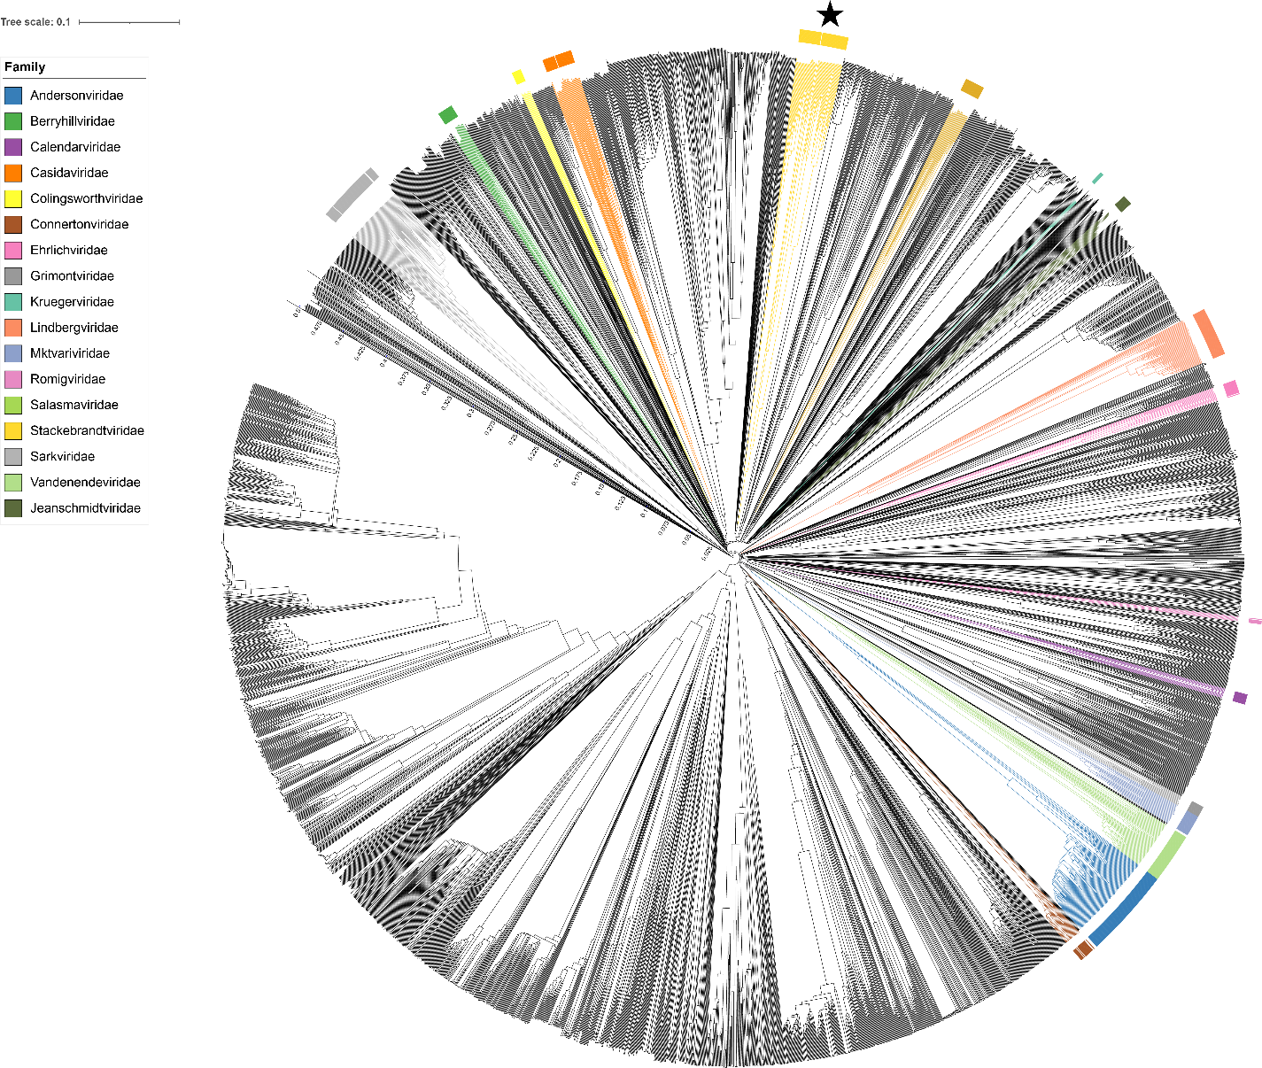

Figure 2. ViPTree [4] analysis Proteomic tree of 4,408 bacterial viruses with proposed viral families labeled by the coloured ring. The Stackebrandtviridae are marked with a star symbol. The hierarchical tree was created using ViPTreeGen (version 1.1.2) [4] and annotated using iToL [15-16]. The tree is based on a dissimilarity matrix generated by pairwise tBLASTx scores between each of the genomes.
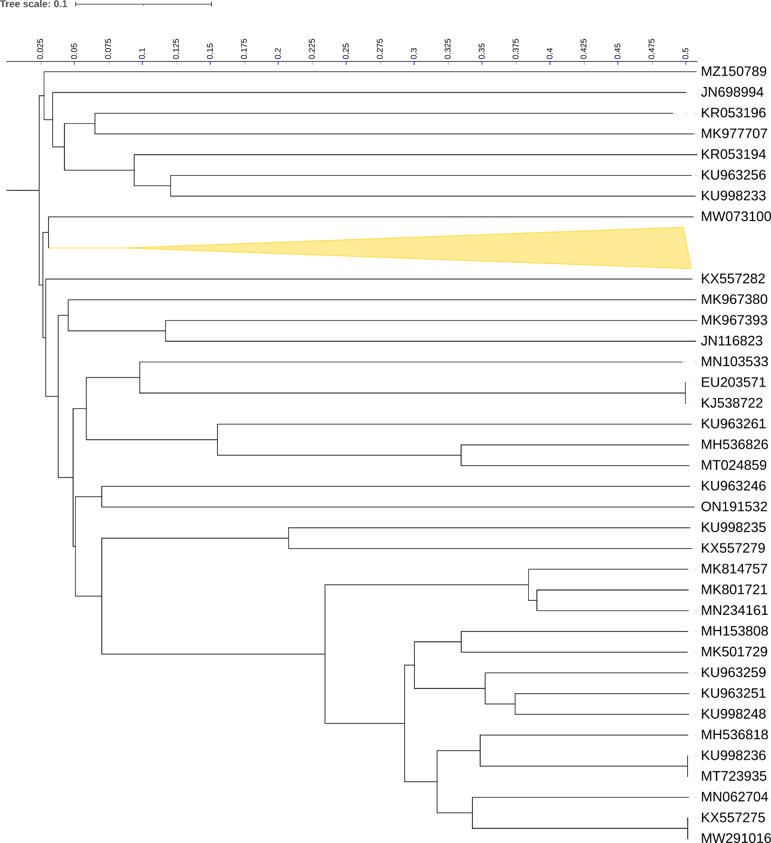
Figure 3. ViPTree [4] hierarchical tree pruned to show the proposed Stackebrandtviridae, shown as a collapsed clade in yellow, alongside neighbouring clades.
Figure 4. VirClust protein heatmap of representative species of each genus. At the first level, proteins are grouped based on their reciprocal BLASTP similarities into protein clusters, or PCs. At the second level, PCs are grouped based on their Hidden Markov Model (HMM) similarities into protein superclusters, or PSCs. AT the third, still experimental level, PSCs are grouped based on their HMM similarities into protein super-superclusters, or PSSCs [13].
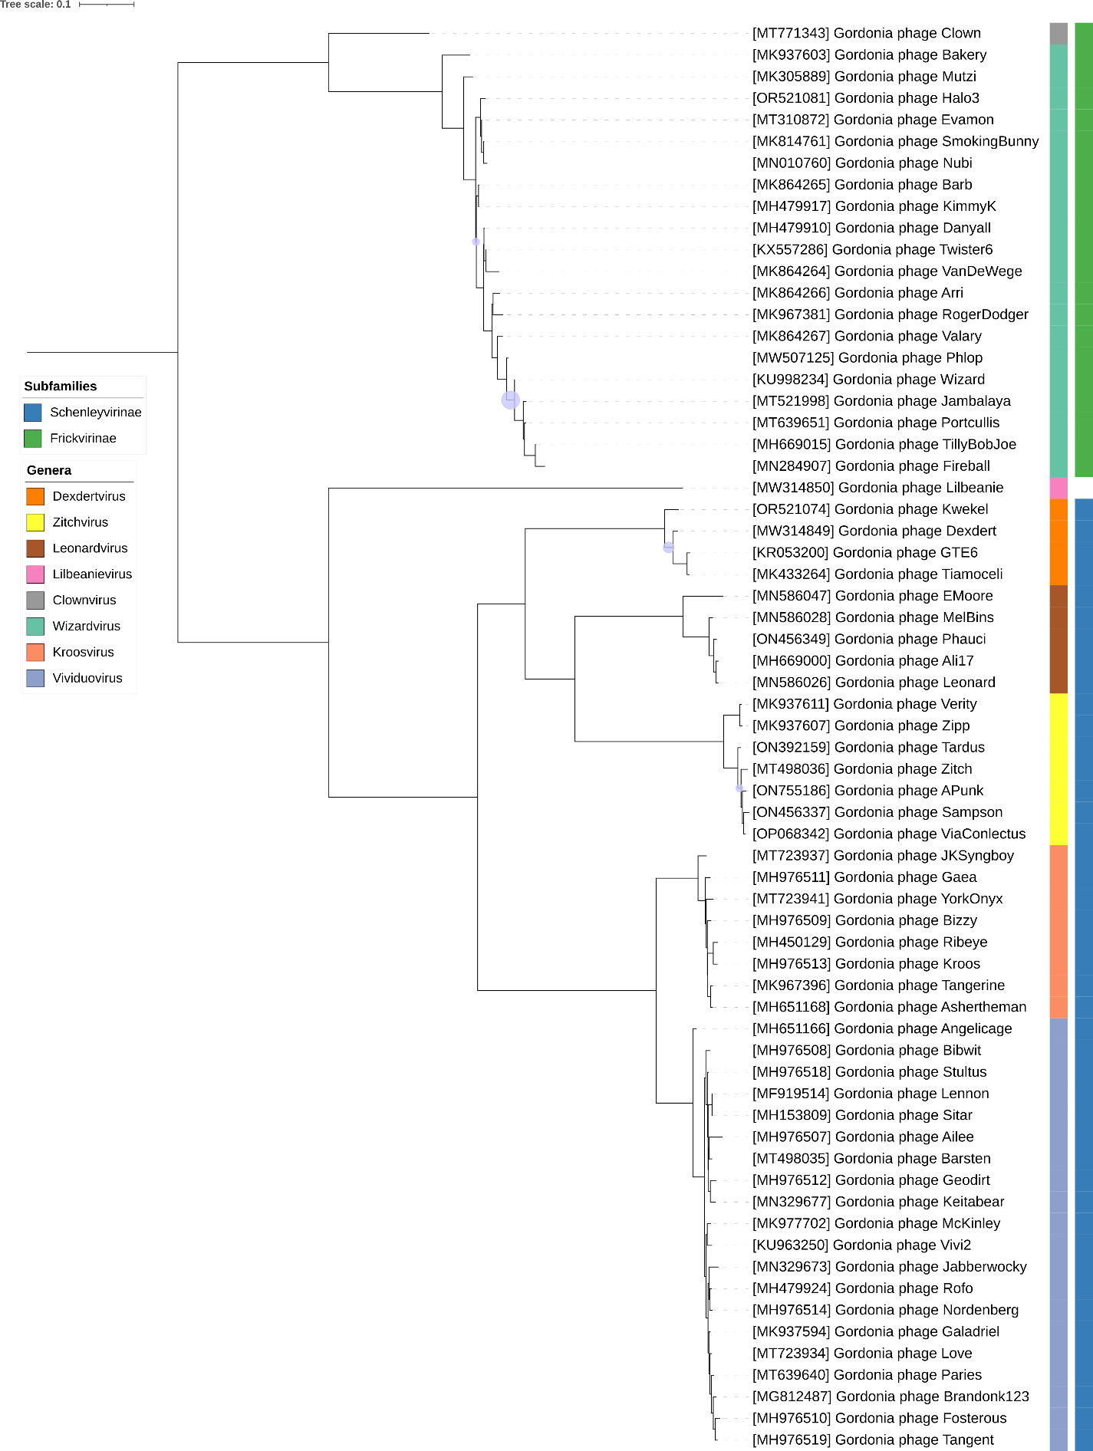
Figure 5. Core genome phylogeny of the proposed Stackebrandtviridae family of bacterial viruses. A partitioned protein ML phylogeny was created from 18 genes present in all species of the proposed family. Alignments were performed using MAFFT in e-insi mode and trimmed using trimAl with a gap threshold of 0.5. The tree was calculated using IQ-Tree2 with 1000 ultrafast (UF) bootstrap replicates and SH-Alrt tests with -m TEST to optimise models for each alignment [16-18]. The tree is rooted at the midpoint and UF bootstrap support ≥ 95% are shown. The coloured strips indicate proposed genera and subfamilies.

Table 1. Signature genes in the proposed Stackebrandtviridae family of bacterial viruses. Genes were identified by clustering with MMSeqs2, with thresholds of 35% sequence similarity and 50% coverage.
protein cluster | No. of genomes (66 total) | Percentage of genomes present in protein cluster | Predicted gene function
1 | 66 | 100% | hypothetical protein
2 | 66 | 100% | major tail protein
3 | 66 | 100% | hypothetical protein
4 | 66 | 100% | hypothetical protein
5 | 66 | 100% | portal protein
6 | 66 | 100% | Terminase, large subunit
7 | 66 | 100% | hypothetical protein
8 | 66 | 100% | hypothetical protein
9 | 66 | 100% | head-to-tail adaptor
10 | 66 | 100% | hypothetical protein
11 | 66 | 100% | hypothetical protein
12 | 66 | 100% | MuF-like minor capsid protein
13 | 66 | 100% | tail assembly chaperone
14 | 66 | 100% | major capsid protein
15 | 66 | 100% | tape measure protein
16 | 65 | 98.48% | hypothetical protein
17 | 65 | 98.48% | hypothetical protein
18 | 65 | 98.48% | HTH domain protein

Proposals Data:
A. To create one new species in the genus Wizardvirus
B. To create a new subfamily, Frickvirinae with two genera (Clownvirus and Wizardvirus)
C. To add one new species to the genus Vididuovirus
D. To add one new species to the genus Dexdertvirus
E. To add four new species to the genus Zitchvirus
F. To add one new species to the genus Leonardvirus
G. To create a new subfamily, Schenleyvirinae, for the above four genera and Kroosvirus.
H. To create a new family, Stackebrandtviridae, for the above mentioned taxa.

Taxonomic Proposals:
- To create one new species in the genus Wizardvirus

Origin of the name of this taxon: NA

Historical aspects: This genus was created through TaxoProp 2021.092B.R.Wizardvirus_new_species

Genomic characterization:

Phage name | INSDC | Size (Kb) | Protein | Overall % DNA sequence identity (*) | Overall % homologous proteins (**)
Gordonia phage Wizard | KU998234.1 | 58.31 | 89 | 100 | 100
Gordonia phage Halo3 | OR521081.1 | 59.18 | 93 | 93.7 | 95.5
(*) determined using VIRIDIC [3]
(**) determined using CoreGenes 3.5 [6]

Conclusion: The DNA sequence similarity value is consistent with membership in the same genus

- To create a new subfamily, Frickvirinae with two genera (Clownvirus and Wizardvirus)

Origin of the name of this taxon: This and the next subfamily taxa are named after the isolation source of phage Wizard: garden soil from the Frick Fine Arts Building on Schenley Drive in Pittsburgh, PA (USA)

Historical aspects: The genus Clownvirus was created through TaxoProp 2021.018B.R.Clownvirus. Phages Wizard and Clown share 42.2% DNA sequence similarity.

Conclusion: The overall DNA sequence similarity is consistent with a subfamily.

- To add one new species to the genus Vividuovirus

Origin of the name of this taxon: NA

Historical aspects: The genus Vividuovirus was created through TaxoProp 2018.058B.A.v1.Vividuovirus.

Genomic characterization:

Phage name | INSDC | Size (Kb) | Protein | Overall % DNA sequence identity (*) | Overall % homologous proteins (**)
Gordonia phage Vivi2 | KU963250.1 | 59.34 | 89 | 100 | 100
Gordonia phage Sitar | MH153809.1 | 59.64 | 84 | 82.2 | 84.3
(*) determined using VIRIDIC [3]
(**) determined using CoreGenes 3.5 [6]

Conclusion: The DNA sequence similarity value is consistent with membership in the same genus

- To add one new species to the genus Dexdertvirus

Origin of the name of this taxon: NA

Historical aspects: The genus Dexdertvirus was created through TaxoProp 2021.024B.R.Dexdertvirus

Genomic characterization:

Phage name | INSDC | Size (Kb) | Protein | Overall % DNA sequence identity (*) | Overall % homologous proteins (**)
Gordonia phage Dexdert | MW314849.1 | 55.01 | 82 | 100 | 100
Gordonia phage Kwekel | OR521074.1 | 56.41 | 87 | 86.8 | 96.3
(*) determined using VIRIDIC [3]
(**) determined using CoreGenes 3.5 [6]

Conclusion: The DNA sequence similarity value is consistent with membership in the same genus

- To add four new species to the genus Zitchvirus

Origin of the name of this taxon: NA

Historical aspects: The genus Zitchvirus was created through TaxoProp 2021.095B.R.Zitchvirus

Genomic characterization:

Phage name | INSDC | Size (Kb) | Protein | Overall % DNA sequence identity (*) | Overall % homologous proteins (**)
Gordonia phage Zitch | MT498036.1 | 58.93 | 91 | 100 | 100
Gordonia phage Tardus | ON392159.1 | 59.81 | 90 | 82.5 | 82.4
Gordonia phage ViaConlectus | OP068342.1 | 58.89 | 88 | 83.5 | 84.6
Gordonia phage Sampson | ON456337.1 | 60.15 | 91 | 80.3 | 83.5
Gordonia phage APunk | ON755186.1 | 59.15 | 88 | 83.7 | 85.7
(*) determined using VIRIDIC [3]
(**) determined using CoreGenes 3.5 [6]

Conclusion: The DNA sequence similarity value is consistent with membership in the same genus

- To add one new species to the genus Leonardvirus

Origin of the name of this taxon: NA

Historical aspects: The genus Leonardvirus was created through TaxoProp 2021.047B.R.Leonardvirus

Genomic characterization:

Phage name | INSDC | Size (Kb) | Protein | Overall % DNA sequence identity (*) | Overall % homologous proteins (**)
Gordonia phage Leonard | MN586026.1 | 59.27 | 87 | 100 | 100
Gordonia phage Phauci | ON456349.1 | 56.33 | 79 | 88.1 | 89.7
(*) determined using VIRIDIC [3]
(**) determined using CoreGenes 3.5 [6]

Conclusion: The DNA sequence similarity value is consistent with membership in the same genus

- To create a new subfamily, Schenleyvirinae, for the above four genera and Kroosvirus.

Origin of the name of this taxon: This and the one described above subfamily taxa are named after the isolation source of phage Wizard: garden soil from the Frick Fine Arts Building on Schenley Drive in Pittsburgh, PA (USA)

Historical aspects: The genus Kroosvirus was created through TaxoProp 2021.045B.R.Kroosvirus

Conclusion: The DNA sequence similarity value is consistent with membership in the same subfamily

- To create a new family, Stackebrandtviridae, for the above mentioned taxa and Lilbeanievirus.

Origin of the name of this taxon: This taxon is named in honour of Prof. em. Dr. Erko Stackebrandt (b. 1944 in Hamburg). Ph.D. in Microbiology from the Ludwig-Maximilians University Munich in 1974. Former Chair in Microbiology at the Universities of Kiel (1984-1990) and Queensland (Australia, 1990-1993). Professor at the Technical University of Braunschweig (1993-2009), former Director of the DSMZ (1993-2009). He has been involved in the systematics, molecular phylogeny and ecology of archaea and bacteria for more than 40 years. He has published more than 700 papers in refereed journals and he has written more than 100 book chapters. He is an editor of two Springer journals including serving as Editor in-Chief of Archives of Microbiology and Current Microbiology. His research resulted in the ratification of the genus Gordonia.



(credit: https://www.rd-alliance.org/users/erkostackebrandt)

Conclusion: The DNA and protein similarity values are consistent with membership in the same family

