

The International Committee on Taxonomy of Viruses
Taxonomy Proposal Form, 2024

Part 1a: Details of taxonomy proposals

Title: | Create a new family, Trautnerviridae, subfamily Polsinellivirinae and two genera (Rivavirus, and Splendidrerdvirus) [class Caudoviricetes]
Code assigned: | 2024.030B

Author(s), affiliation and email address(es):
Name | Affiliation | Email address | Corresponding author(s) X
Cook R | Quadram Institute Bioscience, UK | Ryan.Cook@quadram.ac.uk
Tavares P | I2BC Institute for Integrative Biology of the Cell, France | paulo.tavares@i2bc.paris-saclay.fr
Lurz R | Max Planck Institute for Molecular Genetics, Germany | lurz@mailbox.org
Barylski J | Adam Mickiewicz University, Poznan, Poland | Jakub.Barylski@gmail.com
Moraru C | Carl von Ossietzky Universität Oldenburg, Germany | liliana.cristina.moraru@uol.de
Tolstoy I | National Center for Biotechnology Information, MD, USA | tolstoy@ncbi.nlm.nih.gov
Kropinski AM | University of Guelph, Ontario, Canada [AMK] | Phage.Canada@gmail.com | x

Part 1b: Taxonomy Proposal Submission
ICTV Subcommittee:
Animal DNA Viruses and Retroviruses |  | Bacterial viruses | x
Animal minus-strand and dsRNA viruses |  | Fungal and protist viruses
Animal positive-strand RNA viruses |  | Plant viruses
Archaeal viruses |  | General -

List the ICTV Study Group(s) that have seen or have been involved in creating this proposal:
Caudoviricetes Study Group

Optional – complete only if formally voted on by an ICTV Study Group:
Study Group | Number of members
Study Group | Votes in support | Votes against | No vote

Submission date: | 25/05/2024

Part 1c: Feedback from ICTV Executive Committee (EC) meeting
Executive Committee Meeting Decision code: | X
A – Accept
Ac – Accept subject to revision by relevant subcommittee chair. No further vote required | X
U – Accept without revision but with re-evaluation and email vote by the EC
Uc – Accept subject to revision and re-evaluation and email vote by the EC
Ud – Deferred to the next EC meeting, with an invitation to revise based on EC comments
J - Reject
W - Withdrawn

Comments from the Executive Committee:
Change name from Romigviridae to Trautnerviridae

Part 1d: Revised Taxonomy Proposal Submission
Response of proposer:
At request of committee name changed from Romigviridae to Trautnerviridae

Revision date: | 30/09/2024

Part 3: TAXONOMIC PROPOSAL

Name of accompanying Excel module:
2024.030B.A.v2.Trautnerviridae_nf.xlsx

Taxonomic changes proposed:
Establish new taxon | x | Split taxon
Abolish taxon |  | Merge taxon
Move taxon |  | Promote taxon
Rename taxon |  | Demote taxon
Move and rename

Is any taxon name used here derived from that of a living person: |  | Y
Taxon name | Person from whom the name is derived | Attached X
Rivavirus | Silvano Riva | Y

Abstract of Taxonomy Proposal:
Taxonomic rank(s) affected:
Realm Duplodnaviria, kingdom Heunggongvirae, phylum Uroviricota, class Caudoviricetes

Description of current taxonomy:
The viruses classified in this proposal do not have a current taxonomic assignment.

Proposed taxonomic change(s):
A. To create a new genus, Rivavirus, with three species
B. To create a new genus, Spendidredvirus, with two species
C. To create a new subfamily, Polsinellivirinae, with these two genera (Rivavirus and Spendidredvirus)
D. To create a new single-species genus, Prospektnaukivirus
E. To create a new family, Trautnerviridae, for these taxa

Justification: Bacillus phage SPP1 was isolated in 1966; sequenced in 1997 (corrected in 2018); and, has been the subject of numerous morphological and physiologically studies; yet has remained unclassified. In this proposal it has been assigned to a new genus, Rivavirus, together with phage SplendidRed (Splendidredvirus), form a new subfamily, Polsinellivirinae. The members of this taxon are siphoviruses which have genomes of 42.8 – 46.3 kb (43.7 - 44.6 mol% G+C) and encode 74-77 proteins and no tRNAs. As a result of detailed genomic, proteomic and phylogenetic analyses using VIRIDIC, ViPTree, VirClust we further propose to create a new family named Trautnerviridae named in honour of Thomas A. Trautner. Conforms to conditions laid out in [10]

- Text of Taxonomy proposal:
Taxonomic rank(s) affected:
Realm Duplodnaviria, kingdom Heunggongvirae, phylum Uroviricota, class Caudoviricetes

Description of current taxonomy:
The viruses classified in this proposal do not have a current taxonomic assignment.

Proposed taxonomic change(s):
A. To create a new genus, Rivavirus, with three species
B. To create a new genus, Spendidredvirus, with two species
C. To create a new subfamily, Polsinellivirinae, with these two genera (Rivavirus and Spendidredvirus)
D. To create a new single-species genus, Prospektnaukivirus
E. To create a new family, Trautnerviridae, for these taxa

Demarcation criteria:
Species demarcation criteria: Two phages are assigned to the same species if their genomes are more than 95% identical over their genome length for isolates. These values can be calculated by a number of tools, such as BLASTn [1,2] – usually calculated using intergenomic distance calculator VIRIDIC [3].

Genus demarcation criteria: In search for criteria that create cohesive and distinct genera that are reproducible and monophyletic, the Bacterial Viruses Subcommittee has established 70% nucleotide identity of the genome length as the cut-off for genera. Genus-level groupings should always be monophyletic in the signature genes, as tested with a phylogenetic tree. [10] In the case of temperate phages such as these a lesser value of ca. 60% DNA sequence similar was chosen.

Subfamily demarcation criteria: Subfamilies are to be created when two or more genera are related below the family level. In practical terms, this usually means that they share a low degree of sequence similarity (usually about 40-50%) and that the genera form a clade in a marker tree phylogeny. [10]

Family demarcation criteria: The family is represented by a cohesive and monophyletic group in the main predicted proteome-based clustering tools (VirClust, ViPTree, GRAViTy dendrogram, vConTACT2 network). Members of the family share a significant number of orthologous genes (the number will depend on the genome sizes and number of coding sequences of members of the family). [10]

Justification:
Bacillus phage SPP1 was isolated in 1966; sequenced in 1997 (corrected in 2018); and, has been the subject of numerous morphological and physiologically studies; yet has remained unclassified. In this proposal it has been assigned to a new genus, Rivavirus, together with phage SplendidRed (Splendidredvirus), form a new subfamily, Polsinellivirinae. The members of this taxon are siphoviruses which have genomes of 42.8 – 46.3 kb (43.7 - 44.6 mol% G+C) and encode 74-77 proteins and no tRNAs. As a result of detailed genomic, proteomic and phylogenetic analyses using VIRIDIC, ViPTree, VirClust we further propose to create a new family named Trautnerviridae named in honour of Thomas A. Trautner. Conforms to conditions laid out in [10]

References:
1. Sayers EW, Beck J, Bolton EE, Bourexis D, Brister JR, Canese K, Comeau DC, Funk K, Kim S, Klimke W, Marchler-Bauer A, Landrum M, Lathrop S, Lu Z, Madden TL, O'Leary N, Phan L, Rangwala SH, Schneider VA, Skripchenko Y, Wang J, Ye J, Trawick BW, Pruitt KD, Sherry ST. Database resources of the National Center for Biotechnology Information. Nucleic Acids Res. 2021 Jan 8;49(D1):D10-D17. doi: 10.1093/nar/gkaa892. PMID: 33095870
2. O'Leary NA, Wright MW, Brister JR, Ciufo S, Haddad D, McVeigh R, et al. Reference sequence (RefSeq) database at NCBI: current status, taxonomic expansion, and functional annotation. Nucleic Acids Res. 2016;44(D1):D733-45. doi: 10.1093/nar/gkv1189. PMID: 26553804.
3. Moraru C, Varsani A, Kropinski AM. VIRIDIC-A Novel Tool to Calculate the Intergenomic Similarities of Prokaryote-Infecting Viruses. Viruses. 2020 Nov 6;12(11):1268. doi: 10.3390/v12111268. PMID: 33172115; PMCID: PMC7694805. http://kronos.icbm.uni-oldenburg.de/viridic/
4. Nishimura Y, Yoshida T, Kuronishi M, Uehara H, Ogata H, Goto S. ViPTree: the viral proteomic tree server. Bioinformatics. 2017; 33(15):2379-2380. doi:10.1093/bioinformatics/btx157. PubMed PMID: 28379287. https://www.genome.jp/viptree/
5. Rohwer F, Edwards R. The Phage Proteomic Tree: a genome-based taxonomy for phage. J Bacteriol. 2002 Aug;184(16):4529-35. PubMed PMID: 12142423
6. Turner D, Reynolds D, Seto D, Mahadevan P. CoreGenes3.5: a webserver for the determination of core genes from sets of viral and small bacterial genomes. BMC Res Notes. 2013;6:140. doi: 10.1186/1756-0500-6-140. PMID: 23566564.
7. Davis P, Seto D, Mahadevan P. CoreGenes5.0: An Updated User-Friendly Webserver for the Determination of Core Genes from Sets of Viral and Bacterial Genomes. Viruses. 2022 Nov 16;14(11):2534. doi: 10.3390/v14112534. PMID: 36423143; PMCID: PMC9693508.
8. Dereeper A, Guignon V, Blanc G, Audic S, Buffet S, Chevenet F, Dufayard JF, Guindon S, Lefort V, Lescot M, Claverie JM, Gascuel O. Phylogeny.fr: robust phylogenetic analysis for the non-specialist. Nucleic Acids Res. 2008;36(Web Server issue):W465-9. doi: 10.1093/nar/gkn180. Epub 2008 Apr 19. PMID: 18424797.
9. Anisimova M, Gascuel O. Approximate likelihood-ratio test for branches: A fast, accurate, and powerful alternative. Syst Biol. 2006;55(4):539-52. PMID: 16785212. DOI: 10.1080/10635150600755453.
10. Turner D, Kropinski AM, Adriaenssens EM. A Roadmap for Genome-Based Phage Taxonomy. Viruses. 2021 Mar 18;13(3):506. doi: 10.3390/v13030506. PMID: 33803862; PMCID: PMC8003253.
11. Bin Jang H, Bolduc B, Zablocki O, Kuhn JH, Roux S, Adriaenssens EM, Brister JR, Kropinski AM, Krupovic M, Lavigne R, Turner D, Sullivan MB. Taxonomic assignment of uncultivated prokaryotic virus genomes is enabled by gene-sharing networks. Nat Biotechnol. 2019 Jun;37(6):632-639. doi: 10.1038/s41587-019-0100-8. Epub 2019 May 6. PMID: 31061483.
12. Bolduc B, Jang HB, Doulcier G, You ZQ, Roux S, Sullivan MB. vConTACT: an iVirus tool to classify double-stranded DNA viruses that infect Archaea and Bacteria. PeerJ. 2017 May 3;5:e3243. doi: 10.7717/peerj.3243. PMID: 28480138; PMCID: PMC5419219.
13. Moraru C. VirClust-A Tool for Hierarchical Clustering, Core Protein Detection and Annotation of (Prokaryotic) Viruses. Viruses. 2023 Apr 19;15(4):1007. doi: 10.3390/v15041007. PMID: 37112988; PMCID: PMC10143988.
14. Letunic I, Bork P. Interactive Tree Of Life (iTOL): an online tool for phylogenetic tree display and annotation. Bioinformatics. 2007 Jan 1;23(1):127-8. doi: 10.1093/bioinformatics/btl529. Epub 2006 Oct 18. PMID: 17050570.
15. Zhou T, Xu K, Zhao F, Liu W, Li L, Hua Z, Zhou X. itol.toolkit accelerates working with iTOL (Interactive Tree of Life) by an automated generation of annotation files. Bioinformatics. 2023 Jun 1;39(6):btad339. doi: 10.1093/bioinformatics/btad339. PMID: 37225402; PMCID: PMC10243930.
16. Nguyen LT, Schmidt HA, von Haeseler A, and Minh BQ (2015) IQ-TREE: A fast and effective stochastic algorithm for estimating maximum likelihood phylogenies. Molecular Biology and Evolution, 32:268-274. https://doi.org/10.1093/molbev/msu300
17. Hoang DT, Chernomor O, von Haeseler A, Minh BQ, Vinh LS (2018) UFBoot2: Improving the ultrafast bootstrap approximation. Molecular Biology and Evolution, 35:518–522. https://doi.org/10.1093/molbev/msx281
18. Kalyaanamoorthy S, Minh BQ, Wong TKF, von Haeseler A, and Jermiin JS (2017) ModelFinder: Fast Model Selection for Accurate Phylogenetic Estimates, Nature Methods, 14:587–589. https://doi.org/10.1038/nmeth.4285
19. Riva S, Polsinelli M, Falaschi A. A new phage of Bacillus subtilis with infectious DNA having separable strands. J Mol Biol. 1968 Jul 28;35(2):347-56. doi: 10.1016/s0022-2836(68)80029-4. PMID: 5000316.
20. Godinho LM, El Sadek Fadel M, Monniot C, Jakutyte L, Auzat I, Labarde A, Djacem K, Oliveira L, Carballido-Lopez R, Ayora S, Tavares P. The Revisited Genome of Bacillus subtilis Bacteriophage SPP1. Viruses. 2018 Dec 11;10(12):705. doi: 10.3390/v10120705. PMID: 30544981; PMCID: PMC6316719.
21. Morelli G, Fisseau C, Behrens B, Trautner TA, Luh J, Ratcliff SW, Allison DP, Ganesan AT. The genome of B. subtilis phage SSP1: the topology of DNA molecules. Mol Gen Genet. 1979 Jan 10;168(2):153-61. doi: 10.1007/BF00431441.
22. Tavares P, Lurz R, Stiege A, Rückert B, Trautner TA. Sequential headful packaging and fate of the cleaved DNA ends in bacteriophage SPP1. J Mol Biol. 1996 Dec 20;264(5):954-67. doi: 10.1006/jmbi.1996.0689.
23. Zsigray RM, Miss AL, Landman OE. Penetration of a bacteriophage into Bacillus subtilis: blockage of infection by deoxyribonuclease. J Virol. 1973 Jan;11(1):69-77. doi: 10.1128/JVI.11.1.69-77.1973.
24. Jacobson ED, Landman OE. Interaction of protoplasts, L forms, and bacilli of Bacillus subtilis with 12 strains of bacteriophage. J Bacteriol. 1975 Oct;124(1):445-8. doi: 10.1128/jb.124.1.445-448.1975.
24.
25. Steensma HY, Blok J. Effect of calcium ions on the infection of Bacillus subtilis by bacteriophage SF 6. J Gen Virol. 1979 Feb;42(2):305-14. doi: 10.1099/0022-1317-42-2-305.
26. Santos MA, Almeida J, de Lencastre H, Morelli G, Kamke M, Trautner TA. Genomic organization of the related Bacillus subtilis bacteriophages SPP1, 41c, rho 15, and SF6. J Virol. 1986 Nov;60(2):702-7. doi: 10.1128/JVI.60.2.702-707.1986.
27. Delesalle VA, Tomko BE, Vill AC, Lichty KB, Krukonis GP. Forty Years without Family: Three Novel Bacteriophages with High Similarity to SPP1 Reveal Decades of Evolutionary Stasis since the Isolation of Their Famous Relative. Viruses. 2022 Sep 23;14(10):2106. doi: 10.3390/v14102106. PMID: 36298661; PMCID: PMC9607348.
28. Handoko YA, Wardani AK, Sutrisno A, Widjanarko SB, Thurgood TL, Thompson DW, Sharma R, Grose JH. Genome Sequences of Two Bacillus Phages Isolated from Indonesia. Microbiol Resour Announc. 2019 Dec 12;8(50):e01058-19. doi: 10.1128/MRA.01058-19. PMID: 31831605; PMCID: PMC6908790.
29. Marks TJ, Hamilton PT. Characterization of a thermophilic bacteriophage of Geobacillus kaustophilus. Arch Virol. 2014 Oct;159(10):2771-5. doi: 10.1007/s00705-014-2101-8. Epub 2014 May 6. PMID: 24796554.

Tables, Figures:
Figure 1. VIRIDIC heat map: VIRIDIC (Virus Intergenomic Distance Calculator; VIRIDIC (Virus Intergenomic Distance Calculator; [3]; http://rhea.icbm.uni-oldenburg.de/VIRIDIC/) computes pairwise intergenomic distances/similarities amongst phage genomes. Data values which are bordered in black correspond to strains. Abbreviations: phg = phage; Ther = Thermus; Brev = Brevibacillus; Baci = Bacillus; Geob = Geobacillus

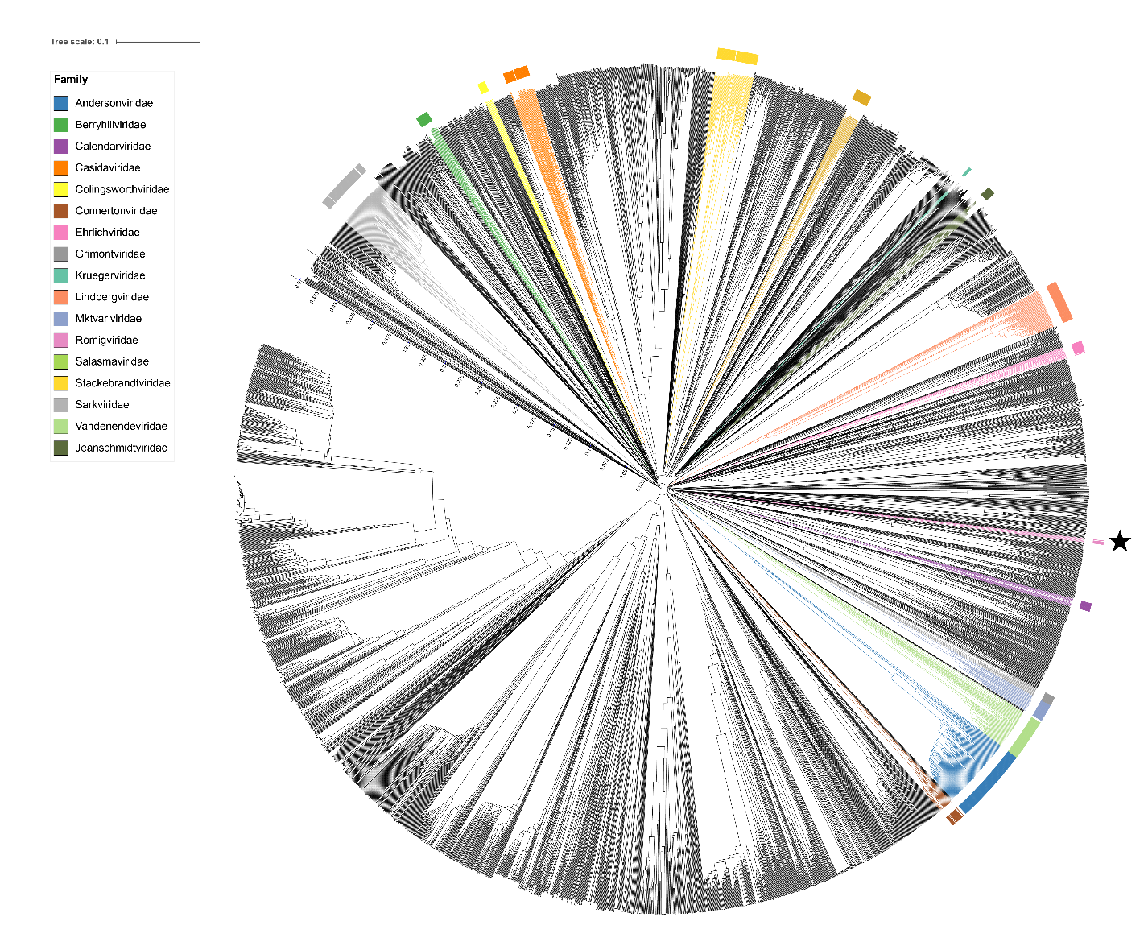

Figure 2. ViPTree [4] analysis Proteomic tree of 4,408 bacterial viruses with proposed viral families labeled by the coloured ring. The Trautnerviridae are marked with a star symbol. The hierarchical tree was created using ViPTreeGen (version 1.1.2) [4] and annotated using iToL [15-16]. The tree is based on a dissimilarity matrix generated by pairwise tBLASTx scores between each of the genomes.
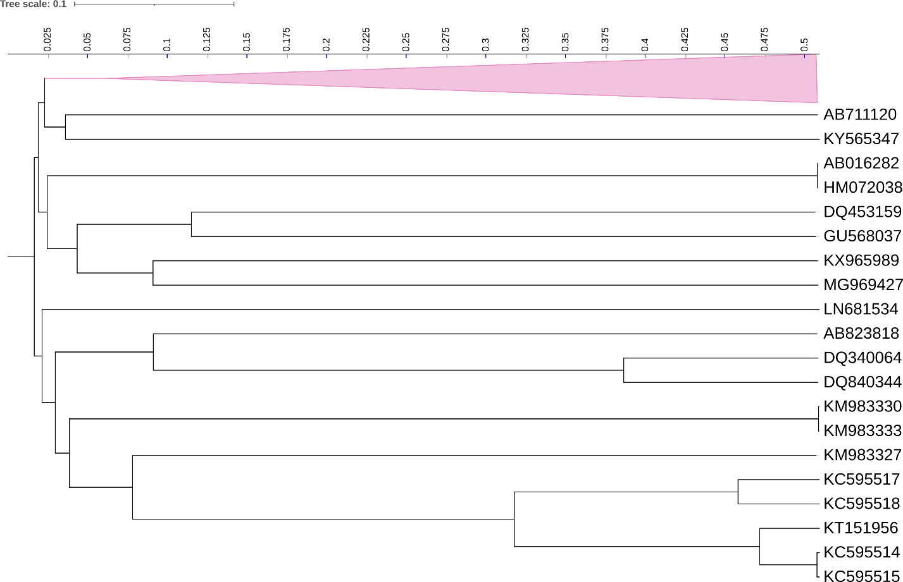
Figure 3. ViPTree [4] hierarchical tree pruned to show the proposed Trautnerviridae, shown as a pink coloured collapsed clade, alongside neighbouring clades.

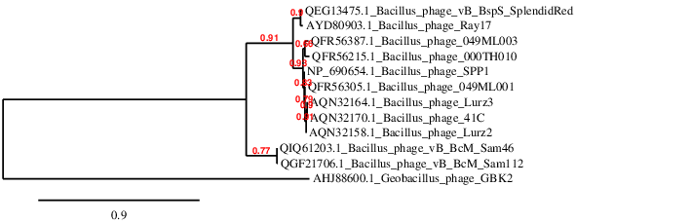

Figure 4. Phylogeny: The phylogenetic tree was constructed using the large subunit terminase proteins from these and related phages with phylogeny.fr in “one click” mode [8]. "The "One Click mode" targets users that do not wish to deal with program and parameter selection. By default, the pipeline is already set up to run and connect programs recognized for their accuracy and speed (MUSCLE for multiple alignment and PhyML for phylogeny) to reconstruct a robust phylogenetic tree from a set of sequences." It also includes the use of Gblocks to eliminate poorly aligned positions and divergent regions. "The usual bootstrapping procedure is replaced by a new confidence index that is much faster to compute. See: Anisimova M., Gascuel O. Approximate likelihood ratio test for branches: A fast, accurate and powerful alternative [9] for details.” Please note that Bacillus phages 41C, Lurz2 and Lurz3 [13] are represented by only partial sequences in GenBank.

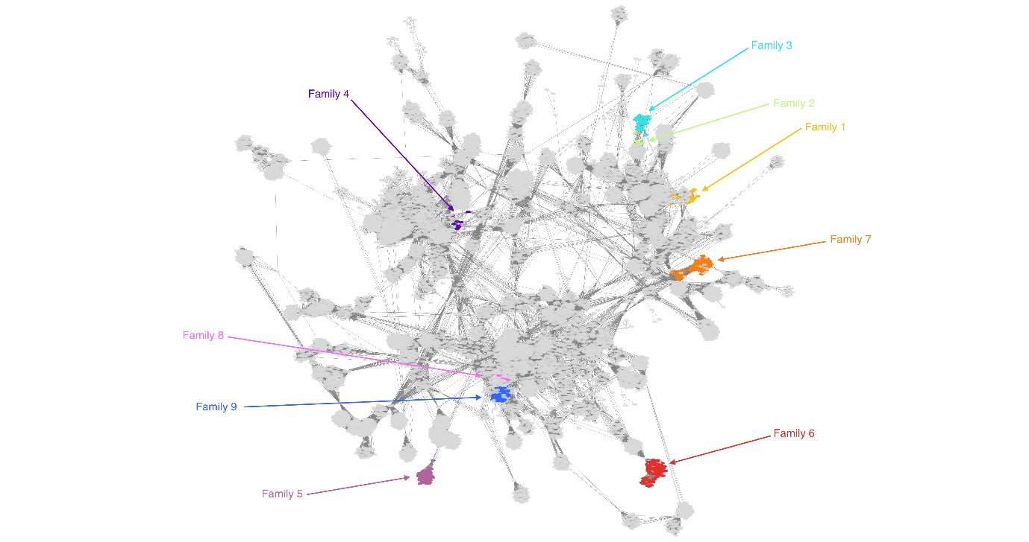

Figure 5. vConTACT v.2.0: is a network-based application utilizing whole genome gene-sharing profiles for virus taxonomy that integrates distance-based hierarchical clustering and confidence scores for all taxonomic predictions [11,12]. A. Family_4 (purple arrow) is the subject of this proposal. B. Data on VC_105_0.

Figure 5. VirClust protein heatmap: at the first level, proteins are grouped based on their reciprocal BLASTP similarities into protein clusters, or PCs. At the second level, PCs are grouped based on their Hidden Markov Model (HMM) similarities into protein superclusters, or PSCs. AT the third, still experimental level, PSCs are grouped based on their HMM similarities into protein super-superclusters, or PSSC [13}. The middle group are the phages which are the subject of this proposal, But, we consider that this actually represents an Order.
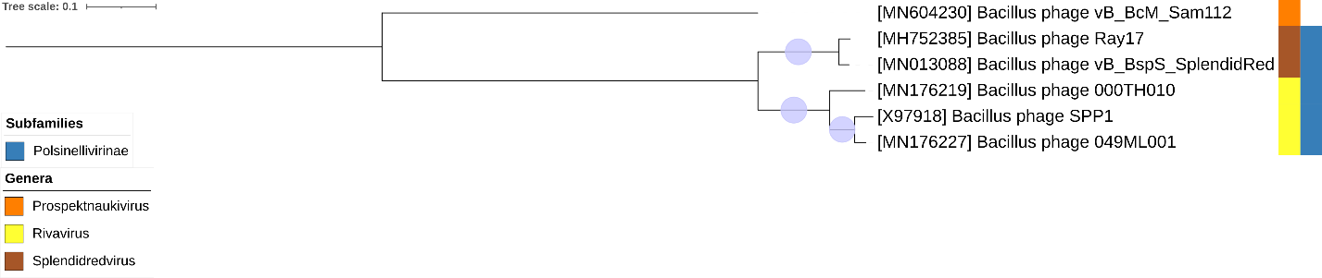
Figure 6. Core genome phylogeny of the proposed Trautnerviridae family of bacterial viruses. A partitioned protein ML phylogeny was created from 13 genes present in all species of the proposed family. Alignments were performed using MAFFT in e-insi mode and trimmed using trimAl with a gap threshold of 0.5. The tree was calculated using IQ-Tree2 with 1000 ultrafast (UF) bootstrap replicates and SH-Alrt tests with -m TEST to optimise models for each alignment [16-18]. The tree is rooted at the midpoint and UF bootstrap support ≥ 95% are shown. The coloured strips indicate proposed genera and subfamilies.

Table 1. Signature genes in the proposed Trautnerviridae family of bacterial viruses. Genes were identified by clustering with MMSeqs2, with thresholds of 35% sequence similarity and 50% coverage.
protein cluster | No. of genomes (6 total) | Percentage of genomes present in protein cluster | Predicted gene function
1 | 6 | 100% | hypothetical protein
2 | 6 | 100% | putative excisionase
3 | 6 | 100% | ssDNA binding protein
4 | 6 | 100% | helicase loader
5 | 6 | 100% | hypothetical protein
6 | 6 | 100% | terminase large subunit
7 | 6 | 100% | 5'-3' exonuclease
8 | 6 | 100% | replisome organizer
9 | 6 | 100% | terminase small subunit
10 | 6 | 100% | hypothetical protein
11 | 6 | 100% | major capsid protein
12 | 6 | 100% | putative ATP-binding protein
13 | 6 | 100% | putative recombinase

Taxonomic Proposals:
- To create a new genus, Rivavirus, with three species
- To create a new genus, Spendidredvirus, with two species
- To create a new subfamily, Polsinellivirinae, with these two genera (Rivavirus and Spendidredvirus)
- To create a new single-species genus, Prospektnaukivirus
- To create a new family, Trautnerviridae, for these taxa

Proposal A. To create a new genus, Rivavirus, with three species

Origin of the name of this taxon: This taxon is named in honour of Silvano Riva, born in Milan (Italy) in 1939. Graduated in Physics at the University of Milan in 1962. Postdoctoral fellow at the University of Pavia, Institute of Genetics (1964-1967). Research associate University of Chicago, Department of Biophysics (1968-1969). Research associate Stanford University, Department of Genetics (1969-1970). From 1970 to 1972, Chief Researcher at Lepetit Pharma Com (Milan). From 1972 on, Researcher with the Italian National Research Council (CNR), from 1990 Research Director. From 1987 to retirement in 2007: Director of the Institute of Molecular Genetics, CNR, Pavia. Italy. From 2008 to the present: President of the Fondazione Adriano Buzzati-Traverso.

Historical aspects: Bacillus subtilis siphophage SPP1 (Subtilis Phage Pavia 1) was isolated in 1966 by Silvano Riva and Mario Polsinelli from soil in the Botanical Garden of Pavia University, Italy [19]. Extensive genetic, biochemical and structural biology studies on the molecular mechanisms of SPP1 DNA replication and phage particle assembly rendered it a model system for tailed phages research. This led to the proposal of SPP1 as the reference species for a new SPP1-like viruses genus of the Siphoviridae family [20]. The SPP1 viral particle has an isometric icosahedral capsid with a diameter of 61 nm and a 190 nm-long non-contractile tail. Its double-stranded DNA (dsDNA) genome has 44,016 bp. The DNA molecules packaged in viral particles are terminally redundant and partially circularly permuted, resulting from a headful packaging mechanism [21 - 24]. Phage 41c isolated from soil, phage ρ15 isolated by D Birdsell and J Hoch, and phage SF6 [25, 26] isolated from garden soil are genetically close relatives of SPP1 as shown by DNA heteroduplexes hybridization. SPP1-related phages Lurz2 and Lurz3 were isolated from soil compost of Dr Rudi Lurz garden in Berlin, Germany. DNA sequencing of terminase genes showed the relatedness of SPP1 with Bacillus subtilis phages Lurz2 (KX618230), Lurz3 (KX618231) and 41c (KX618232) relatedness. Véronique A. Delesalle et al. [27] isolated and sequenced Bacillus phages 049ML00, 049ML003 and 000TH010 from Arizona (USA) soil..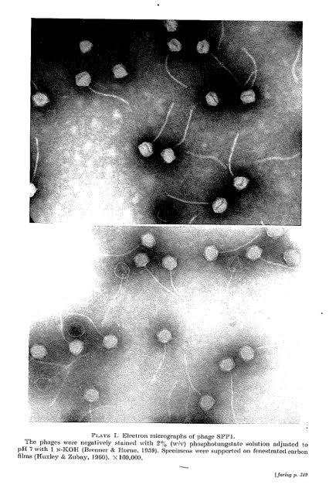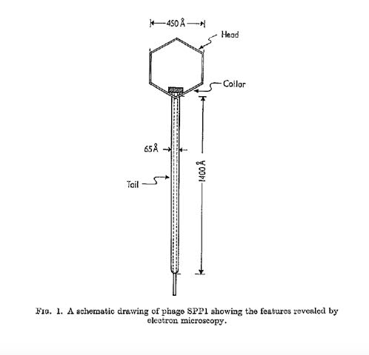
Electron micrograph: Electron micrographs and interpretative diagram of negatively stained phage SPP1. Limited permission is granted by Dr. Silvano Riva [19] to use these pictures for this taxonomy proposal; they cannot be reused without permission.

Phage name | RefSeq | INSDC | Size (Kb) | GC% | Protein | Overall % DNA sequence identity (*) | Overall % homologous proteins (**)
Bacillus phage SPP1 | NC_004166.2 | X97918.2 | 44.01 | 43.7 | 97 | 100 | 100
Bacillus phage 000TH010 |  | MN176219.1 | 46.28 | 43.8 | 90 | 71.8 | 59.8
Bacillus phage 049ML001 |  | MN176227.1 | 45.24 | 43.7 | 82 | 83.6 | 62.9
(*) determined using VIRIDIC [3]
(**) determined using CoreGenes 3.5 [6]
Table 2. Genomic summary of phage SPP1 and related phages

Proposal B. To create a new genus, Spendidredvirus, with two species

Origin of the name of this taxon: This taxon is named directly after the first isolate of its type, Bacillus phage SplendidRed.

Historical aspects: Bacillus lytic siphophage vB_BspS_SplendidRed was isolated from soil a red chili plantation in Getasan Village, Semarang District, Central Java State, Indonesia [28]. Its relative, Bacillus amyloliquefaciens phage Ray17 was isolated from soil in the USA.

Phage name | RefSeq | INSDC | Size (Kb) | GC% | Protein | Overall % DNA sequence identity (*) | Overall % homologous proteins (**)
Bacillus phage vB_BspS_  SplendidRed |  | MN013088.1 | 42.86 | 44.6 | 76 | 100 | 100
Bacillus phage Ray17 |  | MH752385.1 | 43.73 | 44.6 | 74 | 87.2 | 88.2
(*) determined using VIRIDIC [3]
(**) determined using CoreGenes 3.5 [6]
Table 3. Genomic summary of phage SplendidRay and related phages

Proposal D. To create a new single-species genus, Prospektnaukivirus

Origin of the name of this taxon: This taxon is named after the address Prospekt Nauki, 5,
Pushchino, Moscow Region 142290, Russia where at the G.K. Skryabin Institute of Biochemistry and Physiology of Microorganisms the first virus of its type, Bacillus phage vB_BcM_Sam112 was identified

Historical aspects: Bacillus phage vB_BcM_Sam112 was identified as a prophage in Bacillus cereus VKM B-370 by O. Kazantseva et al.

Genomic summary:

Phage name | RefSeq | INSDC | Size (Kb) | GC% | Protein
Bacillus phage vB_BcM_Sam112 |  | MN604230.1 | 45.0 | 41.6 | 75

Proposal E. To create a new subfamily, Polsinellivirinae, with two genera (Rivavirus and Spendidredvirus)

Origin of the name of this taxon: This taxon is named in honour of Mario Polsinelli (1924 – 2021) “The scientist Mario Polsinelli, world-renowned geneticist, who with his studies accompanied the transition from classical genetics to genomics, has died at the age of 97. The announcement of his death, which took place on Thursday 11 November, was given by the University of Florence, where he was professor emeritus of genetics. Polsinelli - born in 1924 in Arpino, in the province of Frosinone - after graduating in Agriculture he soon turned his interest towards genetics and microbiology, first at the University of Pavia and then at the University of Florence where he was full professor of Genetics from 1973 to 1999. A pioneer of studies on the genetics of microorganisms, fungi and bacteria, which he has always supported with potential biotechnological applications in the medical and agricultural fields … At the University of Florence, he directed the 'Leo Pardi' Institute of Animal Biology and Genetics and was one of the promoters of the establishment of the degree course in Biotechnology. He was twice president of the Italian Genetic Association and one of the founders, as well as president, of the Italian Society of General Microbiology and Microbial Biotechnology. He also founded the Cortona School of Genetics and promoted numerous meetings dedicated to young researchers.” (derived from by Paolo Martini; https://notizie.tiscali.it/regioni/toscana/articoli/scienze-a-morto-mario-polsinelli-genetista-fama-mondiale/)

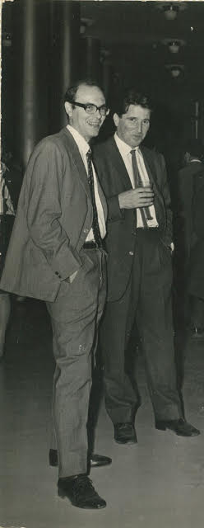
(Photograph of Silvano Riva (left) and Mario Polsinelli (right) in Rome in 1966 at the meeting where they communicated the isolation of SPP1 phage. Kindly provided by Prof. S. Riva, not for copying without written permission).

Rationale: Based upon our criteria for defining viral taxa [10] the lytic Bacillus phages which we have classified to the Rivavirus and Splendidredvirus genera are sufficiently related to be grouped in a subfamily (Fig.1, Fig 2). On average the members of this taxon have genomes of 44.4 kb (44.1 mol% G+C) and encode 84 proteins and no tRNAs. CoreGenes 5.0 [7] analysis with the Bidirectional Best Hit chosen reveals 44 homologous proteins or 45.4% conserved proteins.

Proposal E. To create a new family, Trautnerviridae, for these taxa

Origin of the name of this taxon: This taxon is named in honour of Thomas A Trautner (b.
Göttingen, Germany, 1932, d. Berlin, Germany, 2023). Tom Trautner carried out
doctoral studies on phage genetics at the Max-Planck-Institut für biophysikalische Chemie and
obtained his PhD from the University of Göttingen in 1957. He continued phage research at
Stanford School of Medicine and in the University of Cologne. From 1963 to 1967, he was
Assistant Professor at the Department of Molecular Biology and Virus Laboratory at the University
of California, Berkeley. In 1965, he was appointed Director at the Max Planck Institute for
Molecular Genetics (MPIMG) in Berlin, a position that he occupied until his retirement in 2000. The
Trautner Department rapidly became a highly recognized research center for more than 3 decades
that attracted scientists from all around the world to work on phage biology, DNA replication, gene
expression, and DNA restriction-modification in procaryotes. Tom Trautner was vice-president of
the Max Planck Society, section Biology and Medicine, between 1990 and 1996. He was an EMBO
member since 1967, a Member of Academia Europaea since 1989, and a Member of the Berlin-
Brandenburgische Akademie der Wissenschaften since 1996.

Tom Trautner maintained a deep interest throughout his career on phages and on their central role
for molecular biology research. He pioneered the use of transfection (“transformation leading to
infection”) to investigate the mechanisms of DNA recombination, mismatch repair and DNA uptake in Bacillus subtilis. In transfection, phage DNA is uptake by competent bacteria leading to
production of infectious virions. The capacity to isolate complementary strands of denatured
bacteriophage SPP1 DNA followed by annealing of strands from different phage mutants to
assemble DNA heteroduplexes for transfection was instrumental for those studies. This initial
interest led to several decades of Tom Trautner’s research on SPP1 genome organization, gene
expression, DNA replication, recombination, and viral particle assembly. Works of Tom Trautner
and of the network of researchers that he nucleated established SPP1 as one of the best-
understood phage biological systems.


Rationale: Based upon our criteria for defining viral taxa [10] all of these unique lytic Bacillus siphophages are sufficiently related to be grouped in a family (Fig.1, Fig 2, Fig. 4, Table 1). The members of this taxon have genomes of 42.8 – 46.3 kb (43.7 - 44.6 mol% G+C) and encode 74-77 proteins and no tRNAs. Furthermore, vConTACT v.2.0 analysis (Fig. 4) indicates that this is a cohesive group. The nearest neighbour is Geobacillus phage GNK2.

