

The International Committee on Taxonomy of Viruses
Taxonomy Proposal Form, 2024

Part 1a: Details of taxonomy proposals

Title: | Create a new family, Hodgkinviridae, for a group of lytic Microbacterium phages (Class: Caudoviricetes)
Code assigned: | 2024.016B

Author(s), affiliation and email address(es):
Name | Affiliation | Email address | Corresponding author(s) X
Kurtböke, I | University of the Sunshine Coast, Australia | ikurtbok@usc.edu.au
Moraru C | Carl von Ossietzky Universität Oldenburg, Germany | liliana.cristina.moraru@uol.de
Tolstoy I | National Center for Biotechnology Information, MD, USA | tolstoy@ncbi.nlm.nih.gov
Kropinski AM | University of Guelph, Ontario, Canada [AMK] | Phage.Canada@gmail.com | x

Part 1b: Taxonomy Proposal Submission
ICTV Subcommittee:
Animal DNA Viruses and Retroviruses |  | Bacterial viruses | x
Animal minus-strand and dsRNA viruses |  | Fungal and protist viruses
Animal positive-strand RNA viruses |  | Plant viruses
Archaeal viruses |  | General -

List the ICTV Study Group(s) that have seen or have been involved in creating this proposal:
Actinophages Study group

Optional – complete only if formally voted on by an ICTV Study Group:
Study Group | Number of members
Study Group | Votes in support | Votes against | No vote

Submission date: | 27/05/2024

Part 1c: Feedback from ICTV Executive Committee (EC) meeting
Executive Committee Meeting Decision code: | X
A – Accept
Ac – Accept subject to revision by relevant subcommittee chair. No further vote required | X
U – Accept without revision but with re-evaluation and email vote by the EC
Uc – Accept subject to revision and re-evaluation and email vote by the EC
Ud – Deferred to the next EC meeting, with an invitation to revise based on EC comments
J - Reject
W - Withdrawn

Comments from the Executive Committee:
Abolition of subfamily Kutznervirinae is missing from the text of the proposal. Please re-evaluate members of the Metamorphoovirus and Kozievirus as these are not monophyletic by the core-gene phylogeny.

Part 1d: Revised Taxonomy Proposal Submission
Response of proposer:
Abolition of Kutznervirinae has been reversed. Reanalysis of Metamorphoovirus and Kozievirus reveals that they are coherent using inter-genomic nucleotide similarity.

Revision date: | 30/09/2024

Part 3: TAXONOMIC PROPOSAL

Name of accompanying Excel module:
2024.016B.A.v2.Hodgkinviridae_nf.xlsx

Taxonomic changes proposed:
Establish new taxon | x | Split taxon
Abolish taxon |  | Merge taxon
Move taxon |  | Promote taxon
Rename taxon |  | Demote taxon
Move and rename

Is any taxon name used here derived from that of a living person: |  | Y
Taxon name | Person from whom the name is derived | Attached X
Hodgkinviridae | Jonathan Hodgkin | Y

Abstract of Taxonomy Proposal:
Taxonomic rank(s) affected:
Realm Duplodnaviria, kingdom Heunggongvirae, phylum Uroviricota, class Caudoviricetes

Description of current taxonomy:
The genera Momentomorivirus, Ouhwahvirus and Meganvirus exist as floating genera in the class Caudoviricetes

Proposed taxonomic change(s):
- To create a new single-species genus, Fuzzbustervirus
- To add a single new species to the genus Kozievirus
- To split the genus Momentomorivirus in two, creating Margaeryvirus
- To add a single new species to the genus Meganvirus
- To add two species to the genus Quhwahvirus
- To create a new family, Hodgkinviridae, for these genera and Metamorphovirus

Justification:
Using VIRIDIC, ViPTree, VIRCLUST and vConTACT v.3.0 we have established that this is a cohesive group of lytic Microbacterium siphoviruses which share ≥12.2% DNA sequence similarity and 14 common proteins.

- Text of Taxonomy proposal:
Taxonomic rank(s) affected: Species, Genus and Family

Description of current taxonomy:

Currently phages of this type are recognized in three genera: Kozievirus, Metamorphoovirus, Momentomorivirus, Meganvirus and Quhwahvirus. These are lytic siphoviruses with circularly permuted genomes infecting Microbacterium species.

Proposed taxonomic change(s):
- To create a new single-species genus, Fuzzbustervirus
- To add a single new species to the genus Kozievirus
- To split the genus Momentomorivirus in two, creating Margaeryvirus
- To add a single new species to the genus Meganvirus
- To add two species to the genus Quhwahvirus
- To create a new family, Hodgkinviridae, for these genera and Metamorphovirus

Demarcation criteria:
Species demarcation criteria: Two phages are assigned to the same species if their genomes are more than 95% identical over their genome length for isolates.
These values can be calculated by a number of tools, such as BLASTn [1,2] – usually calculated using intergenomic distance calculator VIRIDIC [3].

Genus demarcation criteria: In search for criteria that create cohesive and distinct genera that are reproducible and monophyletic, the Bacterial Viruses Subcommittee has established 70% nucleotide identity of the genome length as the cut-off for genera. Genus-level groupings should always be monophyletic in the signature genes, as tested with a phylogenetic tree. [10]

Subfamily demarcation criteria: Subfamilies are to be created when two or more genera are related below the family level. In practical terms, this usually means that they share a low degree of sequence similarity (usually about 40-50%) and that the genera form a clade in a marker tree phylogeny. [10]

Family demarcation criteria: The family is represented by a cohesive and monophyletic group in the main predicted proteome-based clustering tools (VirClust, ViPTree, GRAViTy dendrogram, vConTACT2 network). Members of the family share a significant number of orthologous genes (the number will depend on the genome sizes and number of coding sequences of members of the family). [10]

Justification:
Using VIRIDIC, ViPTree, VIRCLUST and vConTACT v.3.0 we have established that this is a cohesive group of lytic Microbacterium siphoviruses which share ≥12.2% DNA sequence similarity and 14 common proteins.

References:
1. Sayers EW, Beck J, Bolton EE, Bourexis D, Brister JR, Canese K, Comeau DC, Funk K, Kim S, Klimke W, Marchler-Bauer A, Landrum M, Lathrop S, Lu Z, Madden TL, O'Leary N, Phan L, Rangwala SH, Schneider VA, Skripchenko Y, Wang J, Ye J, Trawick BW, Pruitt KD, Sherry ST. Database resources of the National Center for Biotechnology Information. Nucleic Acids Res. 2021 Jan 8;49(D1):D10-D17. doi: 10.1093/nar/gkaa892. PMID: 33095870
2. O'Leary NA, Wright MW, Brister JR, Ciufo S, Haddad D, McVeigh R, et al. Reference sequence (RefSeq) database at NCBI: current status, taxonomic expansion, and functional annotation. Nucleic Acids Res. 2016;44(D1):D733-45. doi: 10.1093/nar/gkv1189. PMID: 26553804.
3. Moraru C, Varsani A, Kropinski AM. VIRIDIC-A Novel Tool to Calculate the Intergenomic Similarities of Prokaryote-Infecting Viruses. Viruses. 2020 Nov 6;12(11):1268. doi: 10.3390/v12111268. PMID: 33172115; PMCID: PMC7694805. http://kronos.icbm.uni-oldenburg.de/viridic/
4. Nishimura Y, Yoshida T, Kuronishi M, Uehara H, Ogata H, Goto S. ViPTree: the viral proteomic tree server. Bioinformatics. 2017; 33(15):2379-2380. doi:10.1093/bioinformatics/btx157. PubMed PMID: 28379287. https://www.genome.jp/viptree/
5. Rohwer F, Edwards R. The Phage Proteomic Tree: a genome-based taxonomy for phage. J Bacteriol. 2002 Aug;184(16):4529-35. PubMed PMID: 12142423
6. Turner D, Reynolds D, Seto D, Mahadevan P. CoreGenes3.5: a webserver for the determination of core genes from sets of viral and small bacterial genomes. BMC Res Notes. 2013;6:140. doi: 10.1186/1756-0500-6-140. PMID: 23566564.
7. Davis P, Seto D, Mahadevan P. CoreGenes5.0: An Updated User-Friendly Webserver for the Determination of Core Genes from Sets of Viral and Bacterial Genomes. Viruses. 2022 Nov 16;14(11):2534. doi: 10.3390/v14112534. PMID: 36423143; PMCID: PMC9693508.
8. Dereeper A, Guignon V, Blanc G, Audic S, Buffet S, Chevenet F, Dufayard JF, Guindon S, Lefort V, Lescot M, Claverie JM, Gascuel O. Phylogeny.fr: robust phylogenetic analysis for the non-specialist. Nucleic Acids Res. 2008;36(Web Server issue):W465-9. doi: 10.1093/nar/gkn180. Epub 2008 Apr 19. PMID: 18424797.
9. Anisimova M, Gascuel O. Approximate likelihood-ratio test for branches: A fast, accurate, and powerful alternative. Syst Biol. 2006;55(4):539-52. PMID: 16785212. DOI: 10.1080/10635150600755453.
10. Turner D, Kropinski AM, Adriaenssens EM. A Roadmap for Genome-Based Phage Taxonomy. Viruses. 2021 Mar 18;13(3):506. doi: 10.3390/v13030506. PMID: 33803862; PMCID: PMC8003253.
11. Bin Jang H, Bolduc B, Zablocki O, Kuhn JH, Roux S, Adriaenssens EM, Brister JR, Kropinski AM, Krupovic M, Lavigne R, Turner D, Sullivan MB. Taxonomic assignment of uncultivated prokaryotic virus genomes is enabled by gene-sharing networks. Nat Biotechnol. 2019 Jun;37(6):632-639. doi: 10.1038/s41587-019-0100-8. Epub 2019 May 6. PMID: 31061483.
12. Bolduc B, Jang HB, Doulcier G, You ZQ, Roux S, Sullivan MB. vConTACT: an iVirus tool to classify double-stranded DNA viruses that infect Archaea and Bacteria. PeerJ. 2017 May 3;5:e3243. doi: 10.7717/peerj.3243. PMID: 28480138; PMCID: PMC5419219.
13. Moraru C. VirClust-A Tool for Hierarchical Clustering, Core Protein Detection and Annotation of (Prokaryotic) Viruses. Viruses. 2023 Apr 19;15(4):1007. doi: 10.3390/v15041007. PMID: 37112988; PMCID: PMC10143988.
14. Letunic I, Bork P. Interactive Tree Of Life (iTOL): an online tool for phylogenetic tree display and annotation. Bioinformatics. 2007 Jan 1;23(1):127-8. doi: 10.1093/bioinformatics/btl529. Epub 2006 Oct 18. PMID: 17050570.
15. Zhou T, Xu K, Zhao F, Liu W, Li L, Hua Z, Zhou X. itol.toolkit accelerates working with iTOL (Interactive Tree of Life) by an automated generation of annotation files. Bioinformatics. 2023 Jun 1;39(6):btad339. doi: 10.1093/bioinformatics/btad339. PMID: 37225402; PMCID: PMC10243930.
16. Nguyen LT, Schmidt HA, von Haeseler A, and Minh BQ (2015) IQ-TREE: A fast and effective stochastic algorithm for estimating maximum likelihood phylogenies. Molecular Biology and Evolution, 32:268-274. https://doi.org/10.1093/molbev/msu300
17. Hoang DT, Chernomor O, von Haeseler A, Minh BQ, Vinh LS (2018) UFBoot2: Improving the ultrafast bootstrap approximation. Molecular Biology and Evolution, 35:518–522. https://doi.org/10.1093/molbev/msx281
18. Kalyaanamoorthy S, Minh BQ, Wong TKF, von Haeseler A, and Jermiin JS (2017) ModelFinder: Fast Model Selection for Accurate Phylogenetic Estimates, Nature Methods, 14:587–589. https://doi.org/10.1038/nmeth.4285
19. Hodgkin J. Jonathan Hodgkin. Curr Biol. 2004 Apr 6;14(7):R259-60. doi: 10.1016/j.cub.2004.03.015. PMID: 15062112.
20. Akimkina T, Venien-Bryan C, Hodgkin J. Isolation, characterization and complete nucleotide sequence of a novel temperate bacteriophage Min1, isolated from the nematode pathogen Microbacterium nematophilum. Res Microbiol. 2007 Sep;158(7):582-90. doi: 10.1016/j.resmic.2007.06.005. Epub 2007 Jul 13. PMID: 17869067.

Tables, Figures:

Figure 1. VIRIDIC heat map of a portion of the members of this family: VIRIDIC (Virus Intergenomic Distance Calculator; VIRIDIC (Virus Intergenomic Distance Calculator; [3]; http://rhea.icbm.uni-oldenburg.de/VIRIDIC/) computes pairwise intergenomic distances/similarities amongst phage genomes. Data values which are bordered in black correspond to strains. Abbreviations: phg = phage; Micr = Microbacterium. Since this figure is difficult to read we have appended the complete VIRIDIC heatmap (Hodgkinviridae_2024_VIRIDIC_heatmap). The yellow highlighted accession numbers and phage names in Column A represent ICTV-recognized species, while the blue box in Column B represents the extent of this family.
Conclusion: The Rogerhendrixvirus represented by NC_047977.1 (Microbacterium phage Hendrix) do not belong to this family since their genomes ca. 98 kb i.e. significantly larger than those of the Hodgkinviridae.
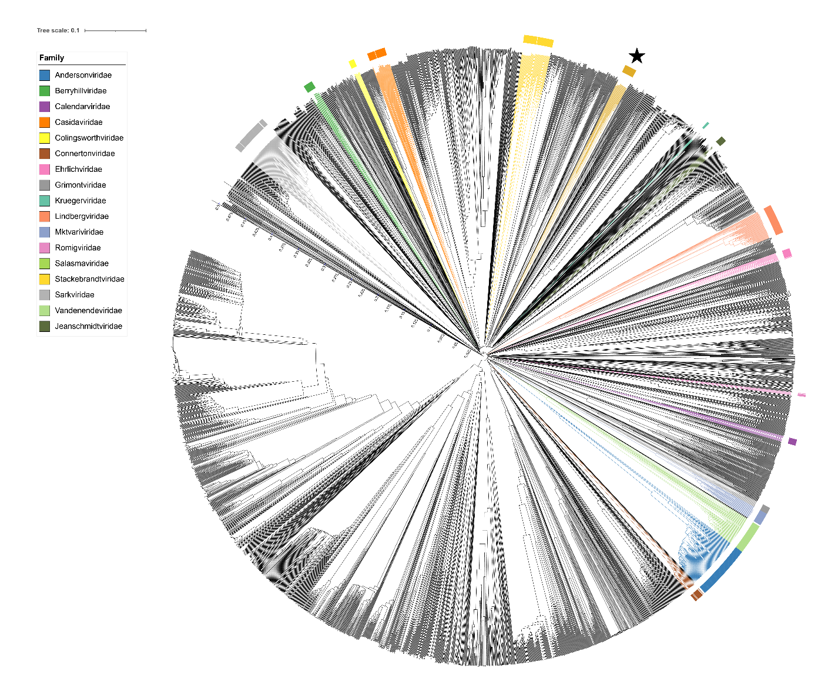
Figure 2. ViPTree [4] analysis Proteomic tree of 4,408 bacterial viruses with proposed viral families labeled by the coloured ring. The Hodgkinviridae are marked with a star symbol. The hierarchical tree was created using ViPTreeGen (version 1.1.2) [4] and annotated using iToL [15-16]. The tree is based on a dissimilarity matrix generated by pairwise tBLASTx scores between each of the genomes.
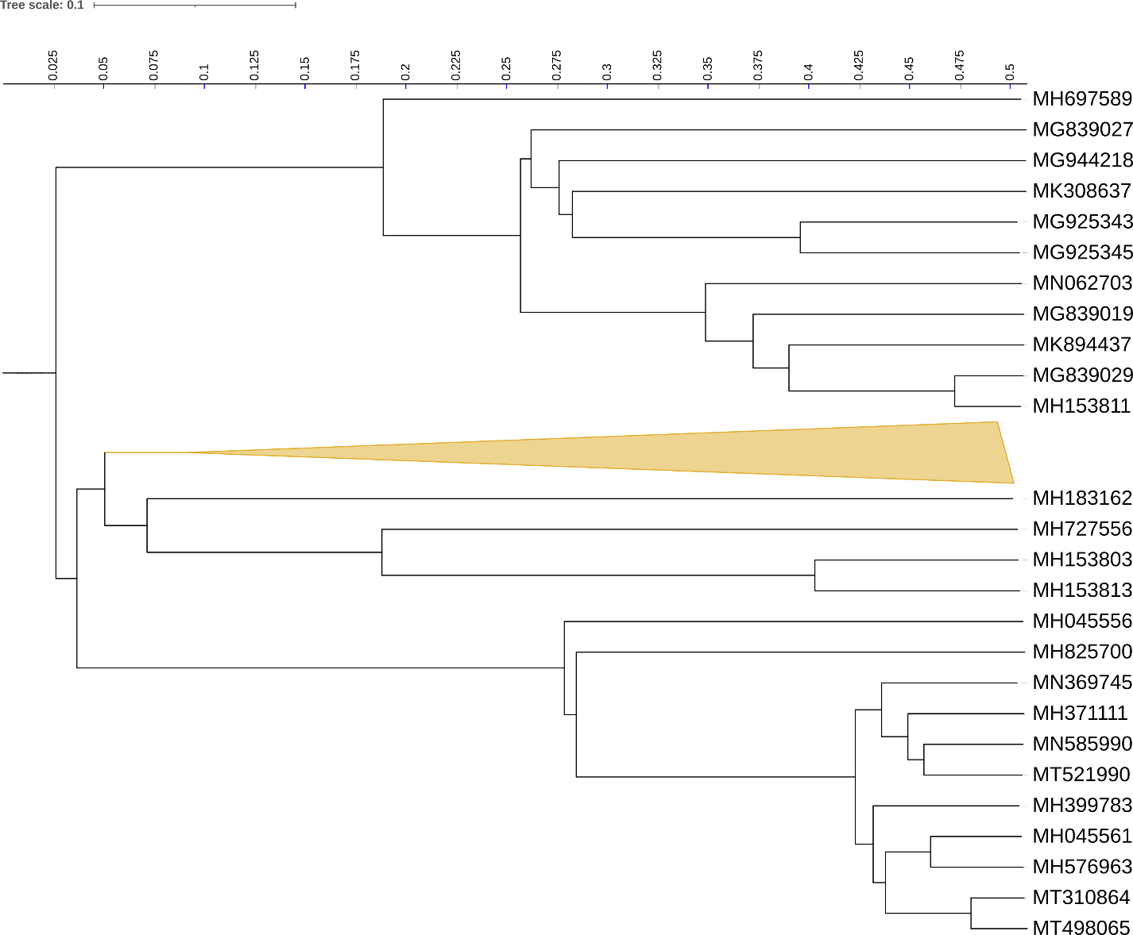
Figure 3. Figure 3. ViPTree [4] hierarchical tree pruned to show the proposed Hodgkinviridae alongside neighboring clades.

Figure 4. VirClust protein heatmap of the Hodgkinviridae: at the first level, proteins are grouped based on their reciprocal BLASTP similarities into protein clusters, or PCs. At the second level, PCs are grouped based on their Hidden Markov Model (HMM) similarities into protein superclusters, or PSCs. AT the third, still experimental level, PSCs are grouped based on their HMM similarities into protein super-superclusters, or PSSC [13}.
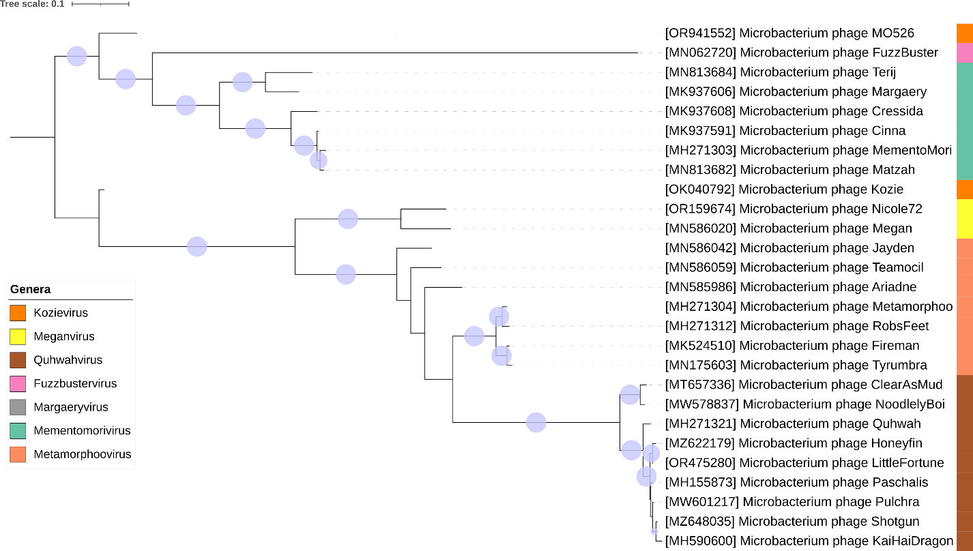
Figure 5. Core genome phylogeny of the proposed Hodgkinviridae family of bacterial viruses. A partitioned protein ML phylogeny was created from 14 genes present in all species of the proposed family. Alignments were performed using MAFFT in e-insi mode and trimmed using trimAl with a gap threshold of 0.5. The tree was calculated using IQ-Tree2 with 1000 ultrafast (UF) bootstrap replicates and SH-Alrt tests with -m TEST to optimise models for each alignment [16-18]. The tree is rooted at the midpoint and UF bootstrap support ≥ 95% are shown. The coloured strips indicate proposed genera and subfamilies.

Table 1. Signature genes in the proposed Hodgkinviridae family of bacterial viruses. Genes were identified by clustering with MMSeqs2, with thresholds of 35% sequence similarity and 50% coverage.
protein cluster | No. of genomes (27 total) | Percentage of genomes present in protein cluster | Predicted gene function
1 | 27 | 100% | hypothetical protein
2 | 27 | 100% | hypothetical protein
3 | 27 | 100% | major capsid protein
4 | 27 | 100% | head-to-tail adaptor
5 | 27 | 100% | MuF-like minor capsid protein
6 | 27 | 100% | hypothetical protein
7 | 27 | 100% | portal protein
8 | 27 | 100% | Terminase, large subunit
9 | 27 | 100% | minor tail protein
10 | 27 | 100% | minor tail protein
11 | 27 | 100% | hypothetical protein
12 | 27 | 100% | capsid maturation protease
13 | 27 | 100% | major tail protein
14 | 27 | 100% | hypothetical protein

Proposals Data:
A. To create a new single-species genus, Fuzzbustervirus
B. To add a single new species to the genus Kozievirus (subfamily: Kutznervirinae)
C. To split the genus Mementomorivirus in two, creating Margaeryvirus (subfamily: Kutznervirinae)
D. To add a single new species to the genus Meganvirus
E. To add two species to the genus Quhwahvirus
F. To create a new family, Hodgkinviridae, for these genera and Metamorphoovirus

Taxonomic Proposals:

- To create a new single-species genus, Fuzzbustervirus

Origin of the name of this taxon: This taxon was named after a virus of its type Microbacterium phage FuzzBuster

Historical aspects: Microbacterium siphophage FuzzBuster was isolated from Cullowhee, NC USA soil by Brooklynn Herold using Microbacterium foliorum NRRL B-24224 as the host at the Western Carolina University. It is lytic and was isolated as part of the Science Education Alliance-Phage Hunters Advancing Genomics and Evolutionary Science program. Phage FuzzBuster is considered a Singleton by The Actinobacteriophage Database. It possesses circularly permuted genome.

Genomic characterization:

Phage name | INSDC | Size (kb) | %GC | Protein | Overall % DNA sequence identity (*) | Overall % homologous proteins (**)
Microbacterium phage FuzzBuster | MN062720.1 | 54.8 | 68.0 | 85 | 100 | 100

- To add a single new species to the genus Kozievirus (subfamily: Kutznervirinae)

Origin of the name of this taxon: NA

Historical aspects: The genus Kozievirus was generated as a result of Taxonomy Proposal 2023.043B.Kutznervirinae_nsf. Microbacterium phage MO526 was isolated from water by F. Wang et al. (Jilin University, China) using Microbacterium oxydans as the host.

Genomic characterization:

Phage name | INSDC | Size (kb) | %G+C | Protein | Overall % DNA sequence identity (*) | Overall % homologous proteins (**)
Microbacterium phage Kozie | OK040792.1 | 53.1 | 71.1 | 88 | 100 | 100
Microbacterium phage MO526 | OR941552.1 | 53.2 | 71.1 | 88 | 79.5 | 90.9
(*) determined using VIRIDIC [3]
(**) determined using CoreGenes 3.5 [6]

- To split the genus Mementomorivirus in two, creating Margaeryvirus (subfamily: Kutznervirinae)

Rationale: This genus created through Taxonomy Proposal 2021.001B.R.abolish_Caudovirales but a reexamination of the proteomic and genomic data suggests that this genus should be split.

Origin of the name of the new taxon: This new taxon was named after the first virus of its type Microbacterium phage Margaery. We retain the existing genus, Memementomorivirus. The following VIRIDIC heatmap clearly indicates that Cressida-Terrij group represents two genera – Mementomorivirus and Margaeryvirus.

Historical aspects: Microbacterium phage Margaery was isolated from soil by Emily Kukan (University of Pittsburgh) using Microbacterium paraoxydans NWU1 as the host. It is lytic and was isolated as part of the Phage Hunters Integrating Research and Education program. Phage Margaery is a member of the EI cluster as defined by The Actinobacteriophage Database and possesses a Circularly Permuted genome

Genomic characterization:

Phage name | INSDC | Size (kb) | %G+C | Protein | Overall % DNA sequence identity (*) | Overall % homologous proteins (**)
Microbacterium phage Margaery | MK937606.1 | 56.0 | 69.5 | 96 | 100 | 100
Microbacterium phage Terij | MN813684.1 | 55.7 | 70.2 | 84 | 80 | 92.7

(*) determined using VIRIDIC [3]
(**) determined using CoreGenes 3.5 [6]

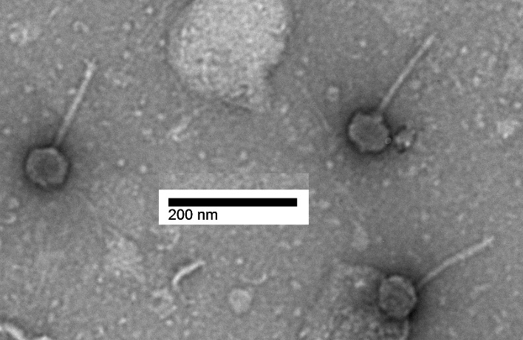
Electron micrograph: Electron micrographs of negatively stained Microbacterium phage Terij (https://phagesdb.org/phages/Terij/) Limited permission was granted by The Actinobacteriophages Database (https://phagesdb.org/), funded by the Howard Hughes Medical Institute, to use this electron micrograph for this taxonomy proposal; it cannot be reused without permission of The Actinobacteriophages Database.

- To add a single new species to the genus Meganvirus

Origin of the name of this taxon: N/A

Historical aspects: This genus was created through Taxonomy Proposal 2023.043B.Kutznervirinae_ndf

Genomic characterization:

Phage name | INSDC | Size (kb) | %G+C | Protein | Overall % DNA sequence identity (*) | Overall % homologous proteins (**)
Microbacterium phage Megan | MN586020.1 | 55.2 | 69.6 | 90 | 100 | 100
Microbacterium phage Nicole72 | OR159674.1 | 55.4 | 69.7 | 90 | 72.6 | 87.8

- To add two species to the genus Quhwahvirus

Origin of the name of this taxon: N/A

Historical aspects: This taxon was created through Taxonomy Proposal 2019.023B.

Genomic characterization:

Phage name | INSDC | Size (kb) | %G+C | Protein | Overall % DNA sequence identity (*) | Overall % homologous proteins (**)
Microbacterium phage Quhwah | MH271321.1 | 53.5 | 68.8 | 95 | 100 | 100
Microbacterium phage Pulchra | MW601217.1 | 53.3 | 68.8 | 91 | 91.2 | 87.4
Microbacterium phage LittleFortune | OR475280.1 | 53.2 | 69.0 | 92 | 91.7 | 87.4
(*) determined using VIRIDIC [3]
(**) determined using CoreGenes 3.5 [6]

F. To create a new family, Hodgkinviridae, for these genera and Metamorphoovirus

Origin of the name of this taxon: This taxon is named in honour of British biochemist Professor Jonathan Alan Hodgkin (b. 1949, UK). “…did a PhD with Sydney Brenner at The Medical Research Council Laboratory of Molecular Biology in Cambridge, studying behavioural genetics in the nematode Caenorhabditis elegans. Later, after a couple of years working with myxobacteria as a postdoctoral fellow in Dale Kaiser's laboratory at Stanford, he returned to LMB as a staff member, where he remained for most of the subsequent two decades. In the year 2000, he moved to Oxford as Professor of Genetics in the Department of Biochemistry, switching his major research interests from developmental genetics and sex determination to the study of host-pathogen interactions in the worm.” [19]. In 1990 he was elected a Fellow of the Royal Society (FRS) and in 2011, he received the Genetics Society Medal. Hodgkin was a member of the Faculty of 1000. He was awarded the Edward Novitski Prize by the Genetics Society of America in 2017. He is currently an emeritus fellow of Keble College, Oxford. His group characterized “the first bacteriophage to be reported for the coryneform genus Microbacterium” [20]


(Photo reproduced from https://royalsociety.org/people/jonathan-hodgkin-11628/).

Rationale: Using VIRIDIC, ViPTree, VIRCLUST and vConTACT v.3.0 we have established that this is a cohesive group of lytic Microbacterium siphoviruses which share ≥12.2% DNA sequence similarity and 14 common proteins.

