

The International Committee on Taxonomy of Viruses
Taxonomy Proposal Form, 2024

Part 1a: Details of taxonomy proposals

Title: | Move newly classified viral genera into Chimalliviridae family and fix previous error
Code assigned: | 2024.007B

Author(s), affiliation and email address(es):
Name | Affiliation | Email address | Corresponding author(s) X
Prichard A | Department of Biological Sciences, University of California San Diego, La Jolla, USA | aprichar@ucsd.edu
Pogliano J | Department of Biological Sciences, University of California San Diego, La Jolla, USA | jpogliano@ucsd.edu | X

Part 1b: Taxonomy Proposal Submission
ICTV Subcommittee:
Animal DNA Viruses and Retroviruses |  | Bacterial viruses | X
Animal minus-strand and dsRNA viruses |  | Fungal and protist viruses
Animal positive-strand RNA viruses |  | Plant viruses
Archaeal viruses |  | General -

List the ICTV Study Group(s) that have seen or have been involved in creating this proposal:
Optional – complete only if formally voted on by an ICTV Study Group:
Study Group | Number of members
Study Group | Votes in support | Votes against | No vote

Submission date: | DD/MM/YYYY

Part 1c: Feedback from ICTV Executive Committee (EC) meeting
Executive Committee Meeting Decision code: | X
A – Accept | X
Ac – Accept subject to revision by relevant subcommittee chair. No further vote required
U – Accept without revision but with re-evaluation and email vote by the EC
Uc – Accept subject to revision and re-evaluation and email vote by the EC
Ud – Deferred to the next EC meeting, with an invitation to revise based on EC comments
J - Reject
W - Withdrawn

Comments from the Executive Committee:

Part 1d: Revised Taxonomy Proposal Submission
Response of proposer:
Revision date: | DD/MM/YYYY

Part 3: TAXONOMIC PROPOSAL

Name of accompanying Excel module:
2024.007B.N.v1.Chimalliviridae_15mg.xlsx

Taxonomic changes proposed:
Establish new taxon |  | Split taxon
Abolish taxon |  | Merge taxon
Move taxon | X | Promote taxon
Rename taxon |  | Demote taxon
Move and rename

Is any taxon name used here derived from that of a living person: |  | N
Taxon name | Person from whom the name is derived | Attached X

Abstract of Taxonomy Proposal:
Taxonomic rank(s) affected:
We propose to move fifteen genera into the Chimallivirdae family and remove one genus from this family.

Description of current taxonomy:
Last year, we submitted a proposal to create a new viral family called Chimallivirdae and re-assigned currently classified viruses into this family. This proposal was accepted, but in the meantime, more viruses that belong in this family have been officially recognized and classified by the ICTV. Since these proposals were submitted in the same year as ours, and there was no existing family that was appropriate for them to be assigned to at the time, these viruses were not assigned to any viral families. However, we believe that these viruses belong to the now-recognized Chimallivirdae family.

Proposed taxonomic change(s):
Members of the newly created genera Miamivirus, Nimduovirus, Meadowvirus, Branisovskavirus, Ferozepurvirus, Chaoshanvirus, Ludhianavirus, Siatvirus, Maaswegvirus, Eowynvirus, Miltoncavirus, Phabiovirus, Serwervirus, Tepukevirus, and Pawinskivirus should be added to the family Chimallivirdae. Additionally, the genus Takahashivirus should be removed from the family Chimallivirus, as it was included in our proposal excel sheet last year by mistake and should not belong to this family.

Justification:
We have redone the phylogenetic analysis used to support the creation of the Chimallivirdae family and included these newly classified genera. This shows that these new genera belong in the family Chimallivirdae, while Takahashivirus PBS1, which we included by mistake, does not.

Text of Taxonomy proposal:
The Chimallivirdae family was accepted this past year as a viral family characterized by a core genome of 68 genes that share some synteny across divergent family members, as described in the Chimallivirdae family proposal last year and in Prichard et al. 2023 (1). All currently characterized members of this family replicate by forming a nucleus-like structure (1-7) made up of the protein chimallin (8), providing a biological relevance to the genome similarity seen in the phages of this family. However, while the formation of a chimallin-based phage nucleus as a key component of the phage replication cycle may be indicative of belonging to this family, the monophyletic clustering of this family (Figures 1 & 2A) and shared core genes (1,9) are the main defining characteristics of the Chimallivirdae.

Since the acceptance of the Chimallivirdae family, several phage species have been newly classified with the ICTV that cluster with this group (Figure 1). We propose that these newly accepted phage species belong to the Chimallivirdae family based on the criteria we proposed last year when we proposed the classification of the family: shared core genes (1,9) and phylogenetic clustering (Figure 2). The phage species that have been newly classified and that we propose belong in the Chimallivirdae family according to our analysis are Siatvirus Lz245, Maaswegvirus Kp24, Eowynvirus eowyn, Pawinskivirus PS119XW, Miltoncavirus PhiPA3, Phabiovirus phabio, Serwervirus 201phi21, Tepukevirus Psa21, Ferozepurvirus pAEv1810, Ferozepurvirus PS1, Chaoshanvirus ZPAH34, Ludhianavirus D6, Ludhianavirus D3, Ludhianavirus Lah10, Meadowvirus AH04, Branisovskavirus Kc263, Nimduovirus N1M2, and Miamivirus miami. These phages are marked with the word “new” in Figure 1 and with red stars in Figure 2A.

Additionally, as a correction to our proposal last year, we accidentally included Takahashivirus PBS1 on our spreadsheet, when in reality (and as seen in our figures), it is not part of the Chimallivirdae cluster (Figure 1 & 2B). This phage should be removed from the family because it does not share significant conservation of the Chimallivirdae core genome (1), and it does not cluster with this family on phylogenetic trees (Figures 1 & 2B).

References:
- Prichard A, Lee J, Laughlin TG, Lee A, Thomas KP, Sy AE, Spencer T, Asavavimol A, Cafferata A, Cameron M, Chiu N, Davydov D, Desai I, Diaz G, Guereca M, Hearst K, Huang L, Jacobs E, Johnson A, Kahn S, Koch R, Martinez A, Norquist M, Pau T, Prasad G, Saam K, Sandhu M, Sarabia AJ, Schumaker S, Sonin A, Uyeno A, Zhao A, Corbett KD, Pogliano K, Meyer J, Grose JH, Villa E, Dutton R, Pogliano J. Identifying the core genome of the nucleus-forming bacteriophage family and characterization of Erwinia phage RAY. Cell Rep. 2023 May 30;42(5):112432. doi: 10.1016/j.celrep.2023.112432. Epub 2023 Apr 28. PMID: 37120812; PMCID: PMC10299810.
- Chaikeeratisak V, Nguyen K, Khanna K, Brilot AF, Erb ML, Coker JK, Vavilina A, Newton GL, Buschauer R, Pogliano K, Villa E, Agard DA, Pogliano J. Assembly of a nucleus-like structure during viral replication in bacteria. Science. 2017 Jan 13;355(6321):194-197. doi: 10.1126/science.aal2130. PMID: 28082593; PMCID: PMC6028185.
- Chaikeeratisak V, Nguyen K, Egan ME, Erb ML, Vavilina A, Pogliano J. The Phage Nucleus and Tubulin Spindle Are Conserved among Large Pseudomonas Phages. Cell Rep. 2017 Aug 15;20(7):1563-1571. doi: 10.1016/j.celrep.2017.07.064. PMID: 28813669; PMCID: PMC6028189.
- Malone LM, Warring SL, Jackson SA, Warnecke C, Gardner PP, Gumy LF, Fineran PC. A jumbo phage that forms a nucleus-like structure evades CRISPR-Cas DNA targeting but is vulnerable to type III RNA-based immunity. Nat Microbiol. 2020 Jan;5(1):48-55. doi: 10.1038/s41564-019-0612-5. Epub 2019 Dec 9. PMID: 31819217.
- Birkholz EA, Laughlin TG, Armbruster E, Suslov S, Lee J, Wittmann J, Corbett KD, Villa E, Pogliano J. A cytoskeletal vortex drives phage nucleus rotation during jumbo phage replication in E. coli. Cell Rep. 2022 Aug 16;40(7):111179. doi: 10.1016/j.celrep.2022.111179. PMID: 35977483; PMCID: PMC9891218.
- Thammatinna K, Sinprasertporn A, Naknaen A, Samernate T, Nuanpirom J, Chanwong P, Somboonwiwat K, Pogliano J, Sathapondecha P, Thawonsuwan J, Nonejuie P, Chaikeeratisak V. Nucleus-forming vibriophage cocktail reduces shrimp mortality in the presence of pathogenic bacteria. Sci Rep. 2023 Oct 19;13(1):17844. doi: 10.1038/s41598-023-44840-x. PMID: 37857653; PMCID: PMC10587174.
- Prichard A, Sy A, Meyer J, Villa E, Pogliano J. Asesino: a nucleus-forming phage that lacks PhuZ. bioRxiv [Preprint]. 2024 May 11:2024.05.10.593592. doi: 10.1101/2024.05.10.593592. PMID: 38766163; PMCID: PMC11100802.
- Laughlin TG, Deep A, Prichard AM, Seitz C, Gu Y, Enustun E, Suslov S, Khanna K, Birkholz EA, Armbruster E, McCammon JA, Amaro RE, Pogliano J, Corbett KD, Villa E. Architecture and self-assembly of the jumbo bacteriophage nuclear shell. Nature. 2022 Aug;608(7922):429-435. doi: 10.1038/s41586-022-05013-4. Epub 2022 Aug 3. PMID: 35922510; PMCID: PMC9365700.
- Jang HB, Fagutao FF, Nho SW, Park SB, Cha IS, Yu JE, Lee JS, Im SP, Aoki T, Jung TS. Phylogenomic network and comparative genomics reveal a diverged member of the ΦKZ-related group, marine vibrio phage ΦJM-2012. J Virol. 2013 Dec;87(23):12866-78. doi: 10.1128/JVI.02656-13. Epub 2013 Sep 25. PMID: 24067958; PMCID: PMC3838149.
- Meier-Kolthoff JP, Göker M. VICTOR: genome-based phylogeny and classification of prokaryotic viruses. Bioinformatics. 2017 Nov 1;33(21):3396-3404. doi: 10.1093/bioinformatics/btx440. PMID: 29036289; PMCID: PMC5860169.
- Nishimura Y, Yoshida T, Kuronishi M, Uehara H, Ogata H, Goto S. ViPTree: the viral proteomic tree server. Bioinformatics. 2017 Aug 1;33(15):2379-2380. doi: 10.1093/bioinformatics/btx157. PMID: 28379287.

Tables, Figures:

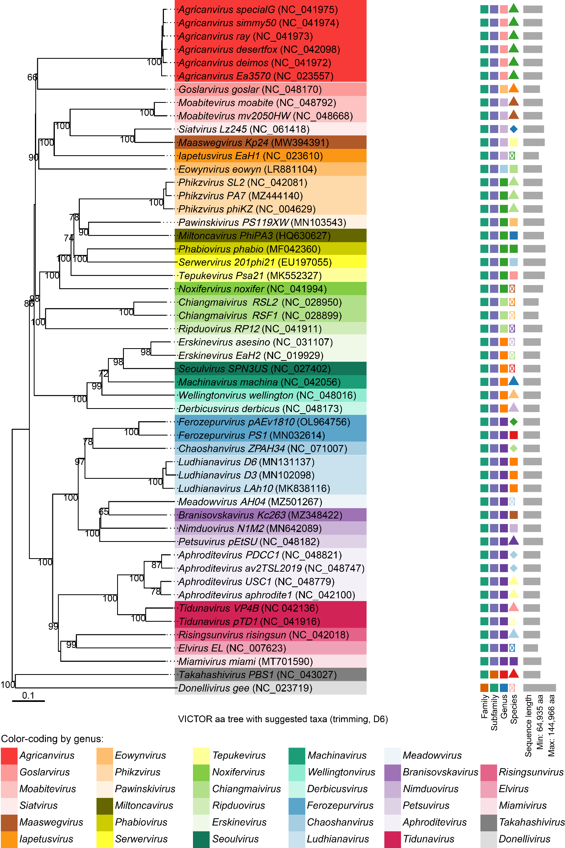
new
new
new
new
new
Figure 1. VICTOR analysis. All phages currently recognized by the ICTV that encode chimallin homologs are shown in this tree made using VICTOR (10). These phages cluster together and are separate from phages that do not share the Chimallivirdae core genome such as Takahashivirus PBS1 and Donellivirus gee (included as outgroup representatives). Newly classified phages that we propose to be members of the Chimallivirdae family are marked with “new”.
A
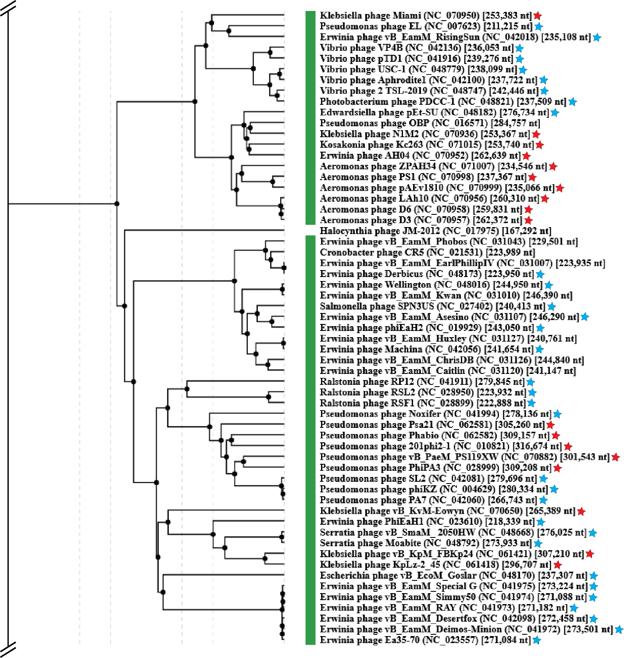B
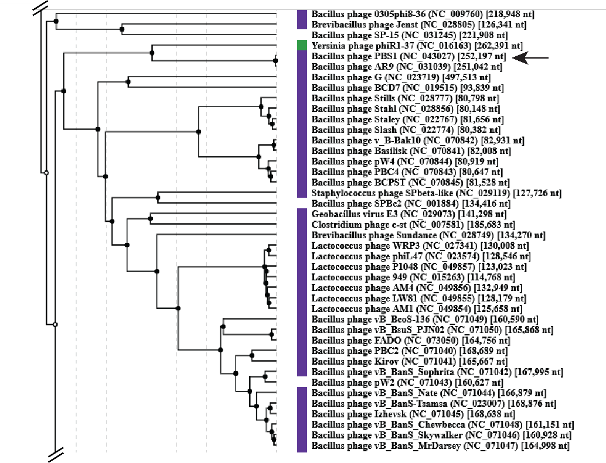
Figure 2. ViPTree Clustering. (A) A branch of a ViPTree (11) phylogenetic tree showing the Chimallivirdae clade. Current Chimallivirdae members are marked with blue stars, and proposed Chimallivirdae members are marked with red stars. Unclassified phages that are not part of this proposal are not marked. (B) PBS1 does not cluster with the Chimallivirdae family. It is on a distant branch of the ViPTree, marked with an arrow.

