

Part 1: TITLE, AUTHORS, APPROVALS, etc

Code assigned: | 2023.069B
Short title: Create a new family called Toyamaviridae including three new genera and three new species (Caudoviricetes)
Author(s) and email address(es)
Nishijima S, Nagata N | nishijima.suguru@gmail.com; nnagata_ncgm@yahoo.co.jp
Author(s) institutional address(es) (optional)
Waseda University, Japan [SN]
Tokyo Medical University, Japan [NN]
Corresponding author
Nishijima, S
List the ICTV Study Group(s) that have seen this proposal
Caudoviricetes Study Group

ICTV Study Group comments and response of proposer
ICTV Study Group votes on proposal
Study Group | Number of members
Study Group | Votes support | Votes against | No vote
Authority to use the name of a living person

Is any taxon name used here derived from that of a living person (Y/N) | N

Taxon name | Person from whom the name is derived | Permission attached (Y/N)

Submission dates
Date first submitted to SC Chair | January 31, 2023
Date of this revision (if different to above) | Sep 20 2023
ICTV-EC comments and response of the proposer
The EC has assessed and approved the proposal with the following comments that should be addressed before the ratification vote:

- Please update in the Excel file the virus name to the format “Genusname sp. isolate XXX” where XXX is a unique alphanumeric code. E.g., “uncultured phage 1827_77749” would become “Satomivirus sp. isolate 1827_77749”
Response: We have updated the virus names accordingly.

- The EC noticed that all exemplar virus genome gene products were over-annotated (see Table 1). If the evidence is low (low probability, e-value higher than 10⁻³, low bitscore), then these gene products should be annotated as “hypothetical protein”. Please consider updating the GenBank records as they will now be used as high-quality representative records.
Response: We have annotated “hypothetical protein” for genes with low confidence values (probability < 90%). The same threshold was applied for genes in GenBank.

Part 2: NON-TAXONOMIC PROPOSAL
Text of proposal

Part 3: TAXONOMIC PROPOSAL
Name of accompanying Excel module
2023.069B.A.v1.Toyamaviridae_nf.xlsx
Abstract
Shotgun metagenomic analysis has uncovered a diverse range of double-stranded DNA (dsDNA) viruses within the human gut. Recently, the analysis revealed a highly-abundant and prevalent dsDNA viral clade in the human gut, such as Crassvirales (realm: Duplodnaviria, kingdom: Heunggongvirae, phylum: Uroviricota, class: Caudoviricetes). In a large-scale cohort study on the Japanese gut microbiome, we identified 228 high-quality dsDNA phage genomes that shared conserved genomic structures among them. These genomes exhibited an average size of approximately 53.1k bp and a GC content of 38.7%, and were detected in approximately 72.5% of the individuals in the cohort. Comparative analysis with known phages in GenBank showed that they formed a cluster distinct from other known viral clades. Within this clade, 62.0% of protein clusters were shared among the phages, while 1.2% of protein clusters were shared with the other known phages. Here, we propose the establishment of a new dsDNA virus family Toyamaviridae including three new genera and species.

Text of proposal
Family demarcation criteria:
The proposed family was defined primarily based on a gene-sharing network approach using vConTACT2 as well as percentages of shared genes. Phylogenetic trees were constructed based on conserved proteins (large terminase, major capsid protein, and portal protein) to confirm the phylogenetic uniqueness of the proposed family compared to any known families.

Genus demarcation criteria:
The proposed genera were defined based on clustering using a threshold with an average nucleotide identity (ANI) of 70% over their full genome length [1].

Species demarcation criteria:
The proposed species were defined based on clustering using a threshold with an ANI of >95% over their full genome length [1].

Supporting evidence

In a large-scale metagenomic analysis of the human gut microbiome (n = 4,198) [2], we obtained 228 high-quality phage genomes (checkV [3] completeness > 70% and contamination < 10%) which shared similar genomic structure and gene homologues among them. Of the 228 genomes, five genomes had terminal redundancy (>97% identity over 70 bp), which is a hallmark for a complete phage genome. The genome sizes ranged from 45.0 to 73.8k bp, GC content varying between 40.2 to 52.2%, and they showed no sequence similarity to known phage genomes in GenBank at the nucleotide level (<95% average nucleotide identity). Clustering of these genomes with a 95% ANI threshold resulted in 13 viral operational taxonomic units (vOTUs), where three vOTUs included the complete phage genomes (vOTUs 2, 4, and 8). These three vOTUs with complete genomes had <70% ANIs to each other, the threshold to define phage genera [1], suggesting that they belong to different genera. Therefore, we propose these phages as one new family (Toyamaviridae), three genera, and three species (Ushigomevirus gakusyuin, Wadatovirus soudai, and Totsukavirus waseda) in this proposal. In the following analysis, we analyzed these three vOTUs with complete genomes as well as the other 10 vOTUs that include only incomplete genomes to demonstrate that they were quite different from other known phages. A representative genomic structure of a proposed species, Totsukavirus waseda, is shown in Figure 1.

Figure 1: Genome map of the representative phage in Toyamaviridae. From inner to outer, the circles represent GC skew (green for positive and orange for negative), GC content, hit to CRISPR spacer, the strand of encoded genes (blue and yellow for positive and negative strand, respectively), and functional category of the genes annotated by the eggNOG mapper [4].

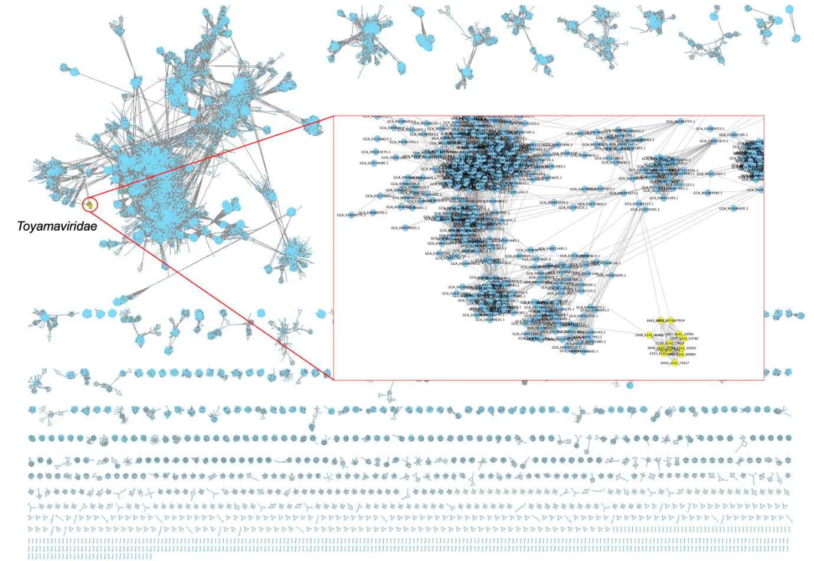

Figure 2: The gene-sharing network was constructed using vConTACT2 including all known phages in GenBank (n = 55,804) and our phages. The obtained network was visualized by Cytoscape with the default option. Blue and yellow colors represent known and our phages, respectively.
To determine whether the phages belong to any existing viral group, we conducted a gene-sharing network analysis using vConTACT2 [5] together with all viral sequences in GenBank (n = 55,804). The obtained network clearly revealed a distinct cluster of the 13 vOTUs, separate from other known phages (Figure 2). Although three vOTUs had edges with known phages, the edge weight (1.0–3.5) was substantially lower than the average edge weight within the cluster (73.0).

Figure 3: Percentages of shared proteins between phages. Red and blue colors in the heatmap show higher and lower percentages of shared protein clusters between the two phages. In addition to Toyamaviridae, 98 known phages in GenBank, which encoded large terminase homologues of Toyamaviridae (DIAMOND [6] with the default option), were included in this analysis. The protein clusters were defined as follows: first, we performed all-vs-all protein similarity searches of Toyamaviridae phages and the known phages using DIAMOND. Then, protein clusters were defined based on the protein similarities using the Markov clustering algorithm using MCL [7] with the inflation factor of 2. The percentages of the shared protein clusters between two phages were calculated and they were visualized using the pheatmap function in R. The dendrogram on the heatmap was generated with the default parameters in the function.
To further examine the relationships between our phages and known phages, we employed percentage of shared protein clusters, a method to assess viral clades relationships (Figure 3) [8]. We defined protein clusters based on the Markov clustering algorithm with MCL (inflation factor of 2) [7] and calculated the pairwise percentage of shared clusters between two phages. The dendrogram based on these percentages distinctly revealed a cluster of our phages separate from other known phages. An average of 44.5% of proteins were shared within the family, while only 0.27% of proteins were shared with other known phages.

Figure 4: Phylogenetic trees based on homologs of large terminase proteins (a) and portal proteins (b). The homologs of these proteins were searched in GenBank with DIAMOND (e-value < 1E-5) and the closest genes identified were used as an outgroup in the tree. The proteins were aligned with MAFFT [9], trimmed with trimAl [10], and the phylogenetic trees were constructed with IQ-TREE (default parameters for all tools). The generated tree was visualized by iTOL [11]. Bootstrap values with > 50% are shown in the figure.
To further explore the detailed taxonomic relationship among the family, we constructed a phylogenetic tree based on large terminase genes. The genes were aligned using MAFFT [9], trimmed using trimAl [10] and the tree was constructed using IQ-TREE [12] (default parameters for all tools), in which we added the closest gene in Genbank (GCA_002610165) as an outgroup (Figure 4a). The resulting tree showed that the three taxonomies we propose were distinct to each other with high bootstrap values. The phylogenetic relationship aligns consistently with the dendrogram we constructed based on shared protein percentages (Figure 3). We also constructed a phylogenetic tree based on portal proteins and confirmed the consistent phylogenetic relationships in the family (Figure 4b). We also attempted to construct a phylogenetic tree based on major capsid protein (MCP), but could not because no conserved MCP across all vOTUs was identified (see table 1 below).

Table 1 | Functional annotation of the nine core genes in Toyamaviridae. Nine proteins that shared among all the 13 vOTUs were annotated using HHsearch against the Pfam database. The gene annotation of the representative species (Totsukavirus waseda, figure 1) is shown in the table.
Gene  number | Gene  length | Pfam ID | Pfam description | Probability | e-value | score
00006 | 657 | PF16510.5 | Phage P22-like portal protein | 100 | 7.00E-50 | 417
00028 | 898 | PF11134.8 | Phage stabilisation protein | 99.9 | 1.10E-29 | 286.4
00005 | 5391 | PF18763.1 | ddrB-like ParB superfamily domain | 99.9 | 2.60E-31 | 301.1
00009 | 698 | PF03354.15 | Phage Terminase | 99.9 | 1.60E-30 | 271.2
00003 | 159 | - | Hypothetical protein | - | - | -
00027 | 176 | - | Hypothetical protein | - | - | -
00011 | 144 | - | Hypothetical protein | - | - | -
00012 | 263 | - | Hypothetical protein | - | - | -
00015 | 212 | - | Hypothetical protein | - | - | -

To identify the core gene set within the family, we examined the protein clusters constructed above and identified a set of nine genes that were conserved across all the 13 vOTUs. These conserved genes were functionally annotated using the Pfam database [13] and the HHsearch tool [14], a method with high sensitivity that is frequently employed for phage gene annotations. Among the nine core genes, four were functionally annotated with a high degree of confidence (probability > 90%). This included key genes for tailed phages, such as the terminase (PF03354) and the portal protein (PF16510). Additionally, a gene encoding a phage stabilization protein (PF11134) and another for a ddrB-like ParB superfamily domain protein of large size (PF18763) were part of the core gene set. These core genes accounted for 41.3% of the total genomic region in this family on average.

Consequently, we propose a new family, Toyamaviridae, including three new genera and species (Ushigomevirus gakusyuin, Wadatovirus soudai, and Totsukavirus waseda). The name "Toyama" derives from the name of the city where the research institute of the co-author in the study is located. The names used for the genera (Wadato, Totsuka, Ushigome) are former names to call the region. Species names (gakusyuin, soudai, and waseda) come from school names around the region.

Based on computational analysis using CRISPR spacer matching [15], their hosts were predicted to be Bacteroidetes phylum, which is one of the major clades in the human gut. Also, they were predicted to have a lysogenic lifestyle based on the encoded genes (BACPHLIP [16]).

References
1. Turner D, Kropinski AM, Adriaenssens EM (2021) A Roadmap for Genome-Based Phage Taxonomy. Viruses 13.: https://doi.org/10.3390/v13030506
2. Nishijima S, Nagata N, Kiguchi Y, et al (2022) Extensive gut virome variation and its associations with host and environmental factors in a population-level cohort. Nat Commun 13:5252
3. Nayfach S, Camargo AP, Schulz F, et al (2020) CheckV assesses the quality and completeness of metagenome-assembled viral genomes. Nat Biotechnol. https://doi.org/10.1038/s41587-020-00774-7
4. Huerta-Cepas J, Forslund K, Coelho LP, et al (2017) Fast Genome-Wide Functional Annotation through Orthology Assignment by eggNOG-Mapper. Mol Biol Evol 34:2115–2122
5. Bin Jang H, Bolduc B, Zablocki O, et al (2019) Taxonomic assignment of uncultivated prokaryotic virus genomes is enabled by gene-sharing networks. Nat Biotechnol 37:632–639
6. Buchfink B, Xie C, Huson DH (2015) Fast and sensitive protein alignment using DIAMOND. Nat Methods 12:59–60
7. Van Dongen S (2008) Graph Clustering Via a Discrete Uncoupling Process. SIAM J Matrix Anal Appl 30:121–141
8. Guerin E, Shkoporov A, Stockdale SR, et al (2018) Biology and Taxonomy of crAss-like Bacteriophages, the Most Abundant Virus in the Human Gut. Cell Host Microbe 24:653–664.e6
9. Katoh K, Rozewicki J, Yamada KD (2019) MAFFT online service: multiple sequence alignment, interactive sequence choice and visualization. Brief Bioinform 20:1160–1166
10. Capella-Gutiérrez S, Silla-Martínez JM, Gabaldón T (2009) trimAl: a tool for automated alignment trimming in large-scale phylogenetic analyses. Bioinformatics 25:1972–1973
11. Letunic I, Bork P (2019) Interactive Tree Of Life (iTOL) v4: recent updates and new developments. Nucleic Acids Res 47:W256–W259
12. Minh BQ, Schmidt HA, Chernomor O, et al (2020) IQ-TREE 2: New Models and Efficient Methods for Phylogenetic Inference in the Genomic Era. Mol Biol Evol 37:1530–1534
13. El-Gebali S, Mistry J, Bateman A, et al (2019) The Pfam protein families database in 2019. Nucleic Acids Res 47:D427–D432
14. Steinegger M, Meier M, Mirdita M, et al (2019) HH-suite3 for fast remote homology detection and deep protein annotation. BMC Bioinformatics 20:473
15. Edwards RA, McNair K, Faust K, et al (2016) Computational approaches to predict bacteriophage-host relationships. FEMS Microbiol Rev 40:258–272
16. Hockenberry AJ, Wilke CO (2021) BACPHLIP: predicting bacteriophage lifestyle from conserved protein domains. PeerJ 9:e11396

