

Part 1: TITLE, AUTHORS, APPROVALS, etc

Code assigned: | 2023.066B
Short title: Create new phage species in the genus Tequatrovirus
Author(s) and email address(es)
Nada MAL, Ancla JB, Yadao NMR, De Paz VP, Manalaysay JG, Samante FLD, Bigol UG | mikeangelounada@gmail.com; anclajoseph8492@gmail.com;  nmry.dost.vip@gmail.com;  virgdepazimperial@gmail.com;  jessicamanalaysay@gmail.com;  fdsamante@up.edu.ph;  ugbigol@itdi.dost.gov.ph
Author(s) institutional address(es) (optional)
Industrial Technology Development Institute, Department of Science and Technology (DOST – ITDI), DOST Compound, Taguig, 1631, Philippines

Corresponding author
Michael Angelou L. Nada
List the ICTV Study Group(s) that have seen this proposal

Bacterial Viruses Subcommittee, Tevenviruses Study Group

ICTV Study Group comments and response of proposer

ICTV Study Group votes on proposal
Study Group | Number of members
Study Group | Votes support | Votes against | No vote
Authority to use the name of a living person
Is any taxon name used here derived from that of a living person (Y/N) | N

Taxon name | Person from whom the name is derived | Permission attached (Y/N)

Submission dates
Date first submitted to SC Chair | May 2023
Date of this revision (if different to above)
ICTV-EC comments and response of the proposer

Part 2: NON-TAXONOMIC PROPOSAL
Text of proposal

Part 3: TAXONOMIC PROPOSAL

Name of accompanying Excel module
2023.066B.N.v1.Tequatrovirus_1ns.xlsx
Abstract
Building on the species demarcation criteria of 95%, we proposed a creation of a new phage species from genus Tequatrovirus. The three isolates namely Escherichia phage vB_VIPECOOM01, Escherichia phage vB_VIPECOOM02, and Escherichia phage vB_VIPECOOM03, are the same species with genomic similarity of 100%. Genome comparison showed that the three Escherichia phages are only 94.1% similar to the existing phage genome Tequatrovirus ecnp1 (Accession no. MK886800.1) suggesting that the isolates are new phage species from the genus Tequatrovirus.
Text of proposal
Species demarcation criteria: Two phages are assigned to the same species if their genomes are more than 95% identical over their genome length for isolates using VIRIDIC [1, 2].

Genus demarcation criteria: In search for criteria that create cohesive and distinct genera that are reproducible and monophyletic, the ICTV Bacterial Viruses Subcommittee has established 70% nucleotide identity of the genome length as the cut-off for genera. Genus-level groupings should always be monophyletic in the signature genes, as tested with a phylogenetic tree [1, 2].

Supporting evidence

Origin of the name of this taxon:
Create new phage species in the genus Tequatrovirus. The proposed binomial name of Tequatrovirus vipecoom was after the name of the three Escherichia phage isolates vB_VIPECOOM01, vB_VIPECOOM02, and vB_VIPECOOM03.

Electron micrograph: N/A

Genome summary:

Phage name | NCBI accession no | Genome length  (bp) | GC content | CDS | tRNA
Escherichia phage vB_VIPECOOM03 | OQ721911 | 168,519 | 35.49 | 269 | 10

VIRIDIC heat map: Taxonomic classification of phage genomes was first identified via blastn search in NCBI database and by using MASH distances in pharokka [3] utilizing the INPHARED database [4]. After which, all Tequatrovirus phage species were downloaded from NCBI database and intergenomic similarities were calculated using VIRIDIC (Virus Intergenomic Distance Calculator). A zoom-in image of the three isolates (blue font), the closest relative (red font), and the percent similarity values (94.1%) were shown below suggesting that the isolates are new species.

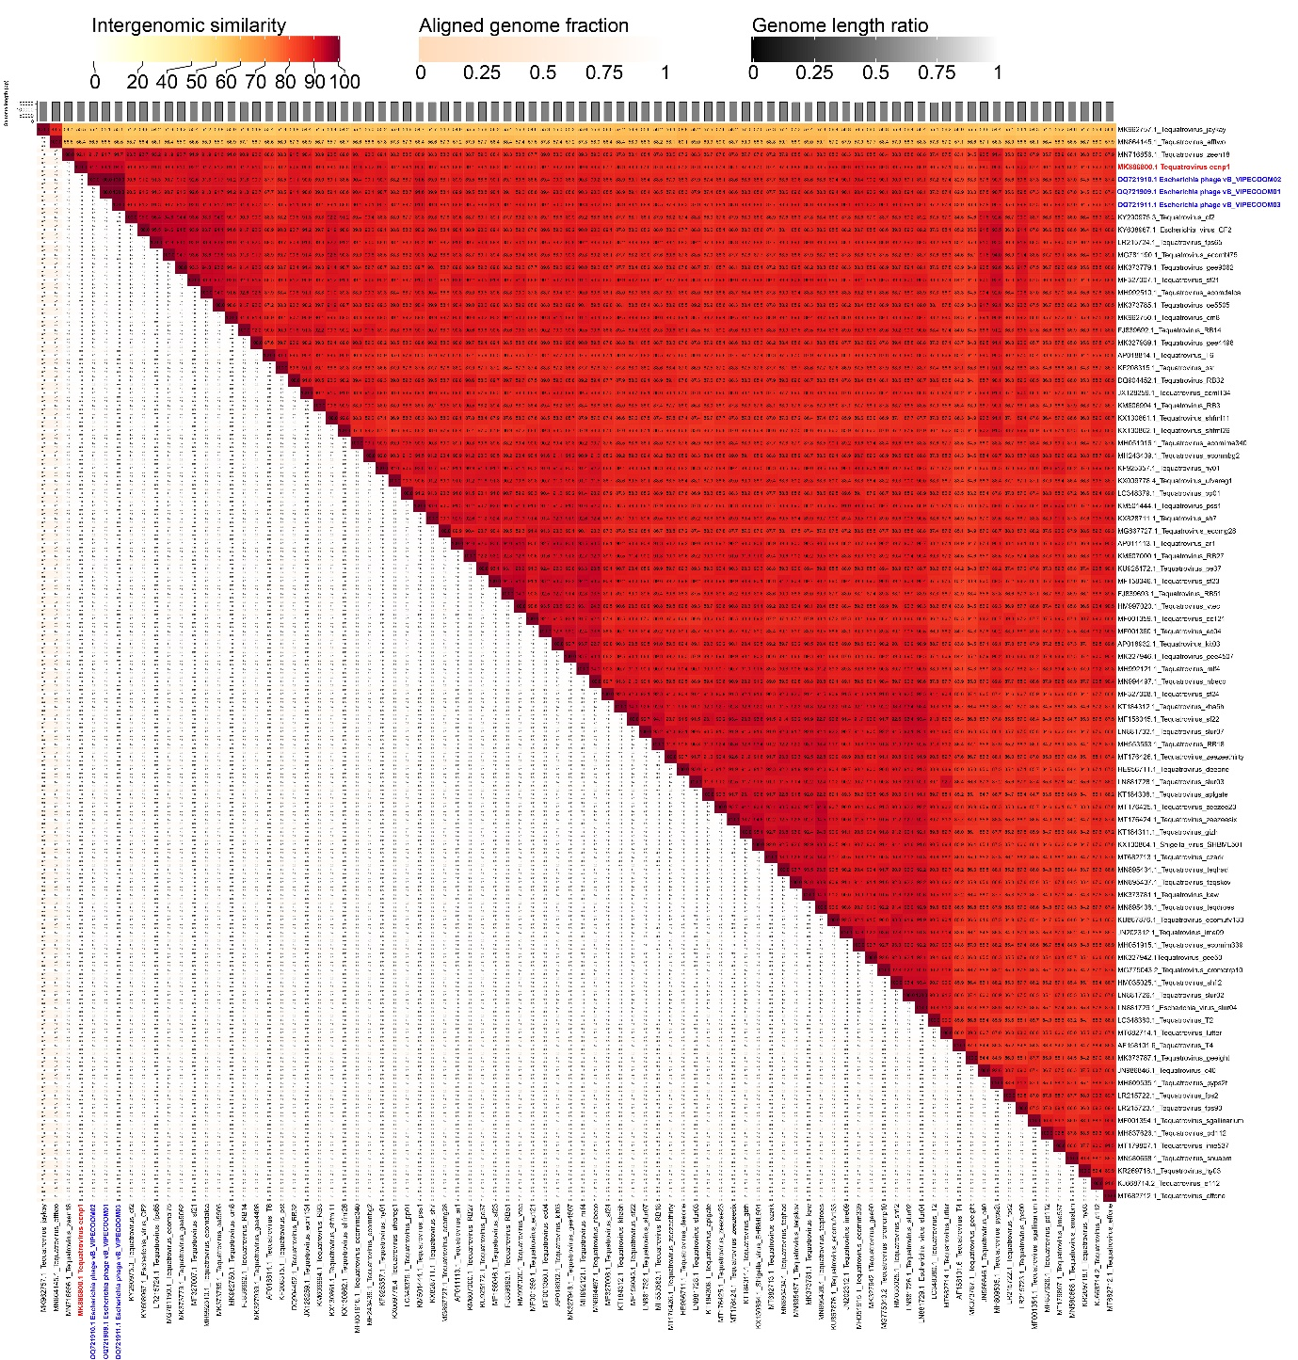

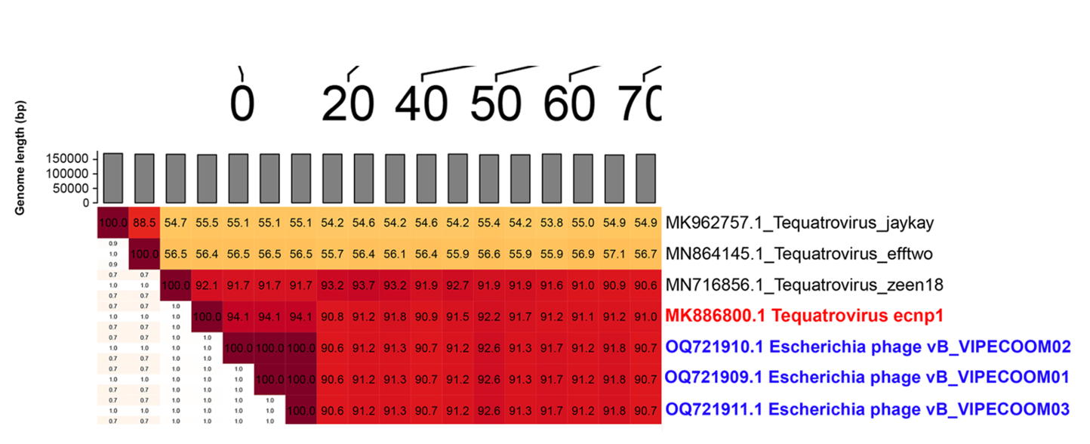

Table 2. Closest relative identified by Pharokka using the INPHARED database.
Phage name | Mash distance | Mash matching  hashes | Closest relative and accession number
Escherichia phage vB_VIPECOOM03 | 0.0220623 | 459/1000 | Escherichia phage EcNP1 (NC_054910)

References
1. Turner D., Kropinski AM, Adriaenssens EM (2021) A roadmap for genome-based phage taxonomy Viruses, 13(3), 506. https://doi.org/10.3390/v13030506

2. Moraru C, Varsani A, Kropinski AM (2020) VIRIDIC — A Novel Tool to Calculate the Intergenomic Similarities of prokaryote-infecting viruses. Viruses 12(11):1268. https://doi.org/10.3390/v12111268

3. Bouras G, Nepal R, Houtak G, Psaltis AJ, Wormald PJ, Vreugde S (2023) Pharokka: a fast scalable bacteriophage annotation tool. Bioinformatics 39(1):btac776. https://doi.org/10.1093/bioinformatics/btac776

4. Cook R, Brown N, Redgwell T, Rihtman B, Barnes M, Clokie M, Stekel DJ, Hobman J, Jones MA, Millard A (2021) INfrastructure for a PHAge REference Database: Identification of Large-Scale Biases in the Current Collection of Cultured Phage Genomes. Phage, 2(4), 214-223. https://doi.org/10.1089/phage.2021.0007

