

Part 1: TITLE, AUTHORS, APPROVALS, etc

Code assigned: | 2023.058B
Short title: To create one new genus and two species within family Salasmaviridae (Caudoviricetes)
Author(s) and email address(es)
Łobocka M, Stefańczyk S, Adriaenssens EM, Kropinski AM, Turner D | lobocka@ibb.waw.pl;  e.stefanczyk@ibb.waw.pl;  evelien.adriaenssens@quadram.ac.uk;  Phage.Canada@gmail.com; dann2.turner@uwe.ac.uk
Author(s) institutional address(es) (optional)
Institute of Biochemistry and Biophysics of the Polish Academy of Sciences Poland [ES]
Institute of Biochemistry and Biophysics of the Polish Academy of Sciences Poland [MŁ]
Quadram Institute Bioscience, UK [EMA]
University of Guelph, Canada [AMK]
University of the West of England [DT]
Corresponding author
Malgorzata Łobocka
List the ICTV Study Group(s) that have seen this proposal

Salasmaviridae, Rountreeviridae, Guelinviridae Study Group, Bacterial Viruses Subcommittee
ICTV Study Group comments and response of proposer
ICTV Study Group votes on proposal
Study Group | Number of members
Study Group | Votes support | Votes against | No vote
Salasmaviridae, Rountreeviridae, Guelinviridae Study Group | 2 | 0 | 0
Authority to use the name of a living person
Is any taxon name used here derived from that of a living person (Y/N) | N

Taxon name | Person from whom the name is derived | Permission attached (Y/N)

Submission dates
Date first submitted to SC Chair | June 2023
Date of this revision (if different to above)
ICTV-EC comments and response of the proposer
Part 2: NON-TAXONOMIC PROPOSAL
Text of proposal

Part 3: TAXONOMIC PROPOSAL
Name of accompanying Excel module
2023.058B.N.v1.Salasmaviridae_ng.xlsx
Abstract
The family Salasmaviridae of the Bacillus phage phi-29-like podoviruses is divided into 3 subfamilies which together inlude 24 species grouped in 7 genera. This proposal expands the Salasmaviridae family with an additional single species genus and two species.

Text of proposal
Species demarcation criteria: Two phages are assigned to the same species if their genomes are more than 95% identical over their genome length for isolates.
These values can be calculated by a number of tools, such as BLASTn [1,2] – usually calculated using intergenomic distance calculator VIRIDIC [3].

Genus demarcation criteria: In search for criteria that create cohesive and distinct genera that are reproducible and monophyletic, the Bacterial Viruses Subcommittee has established 70% nucleotide identity of the genome length as the cut-off for genera. Genus-level groupings should always be monophyletic in the signature genes, as tested with a phylogenetic tree. [10]

Subfamily demarcation criteria: Subfamilies are to be created when two or more genera are related below the family level. In practical terms, this usually means that they share a low degree of sequence similarity (usually about 40-50%) and that the genera form a clade in a marker tree phylogeny. [10]

Supporting evidence

A. Create a new species Gaunavirus syybuna within genus Gaunavirus

B. Create a new genus Bahkauvirus with single species Bahkauvirus chedec

C. Create a new species Hemphillvirus bece5 within Hemphillvirus genus

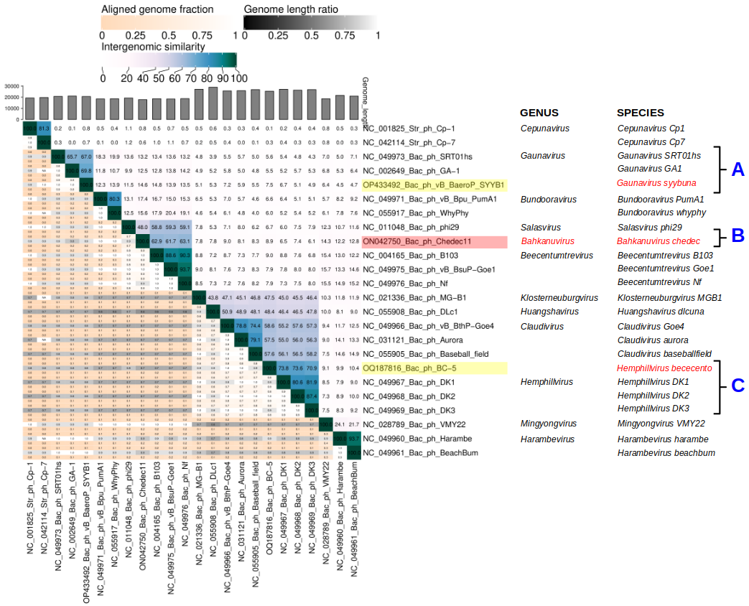

Figure 1. VIRIDIC heat map: VIRIDIC (Virus Intergenomic Distance Calculator; VIRIDIC (Virus Intergenomic Distance Calculator; [3]; http://rhea.icbm.uni-oldenburg.de/VIRIDIC/) computes pairwise intergenomic distances/similarities amongst phage genomes. The reference strains listed with NCBI Accessions starting with "NC_" contain additional information about their genera and species. Proposal data concerning expansion of a given genus are marked with capital A, B and C letters shown in blue, phages of new species are highlighted in yellow while phages of new genera are highlited in red. Proposed names of new taxons are in red.

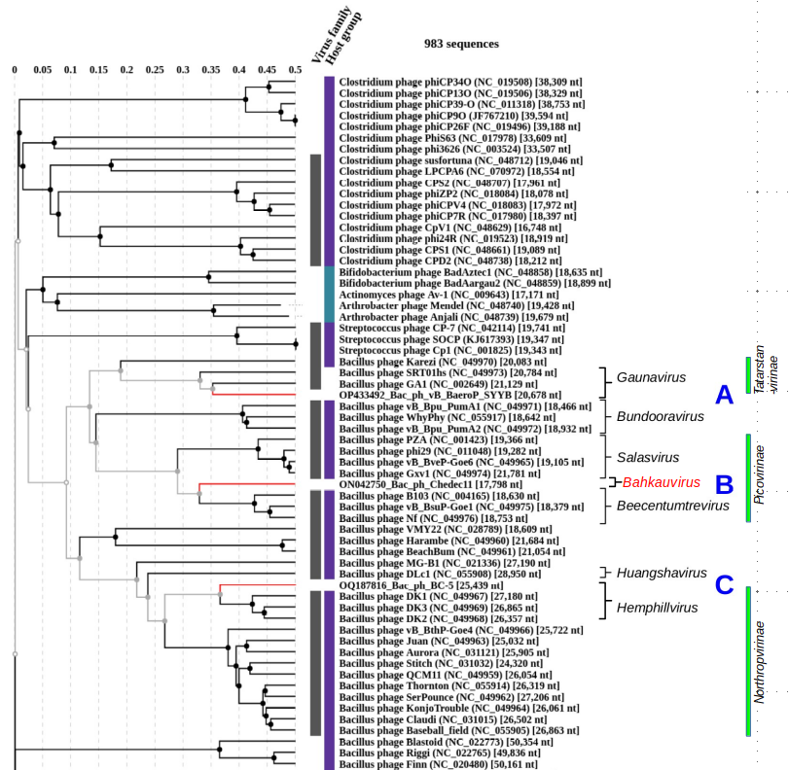

Figure 2. ViPTree analysis: ViPTree analysis (https://www.genome.jp/viptree/; [4]) is based upon Rohwer and Edwards (2002) famous Phage Proteomic Tree [5]. The phages of interest are indicated with red lines. Relevant genera and subfamilies are indicated on the right to the tree. Proposed name of the new genus is in red.

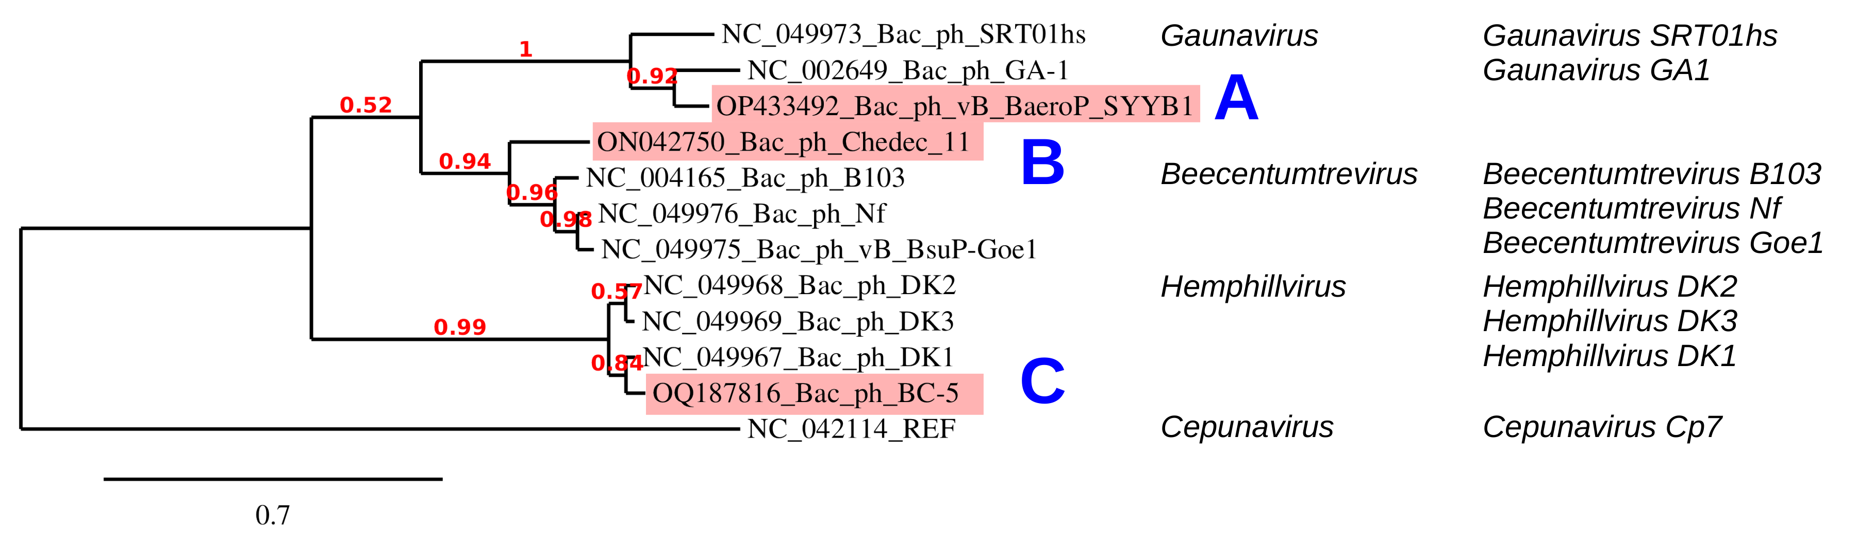
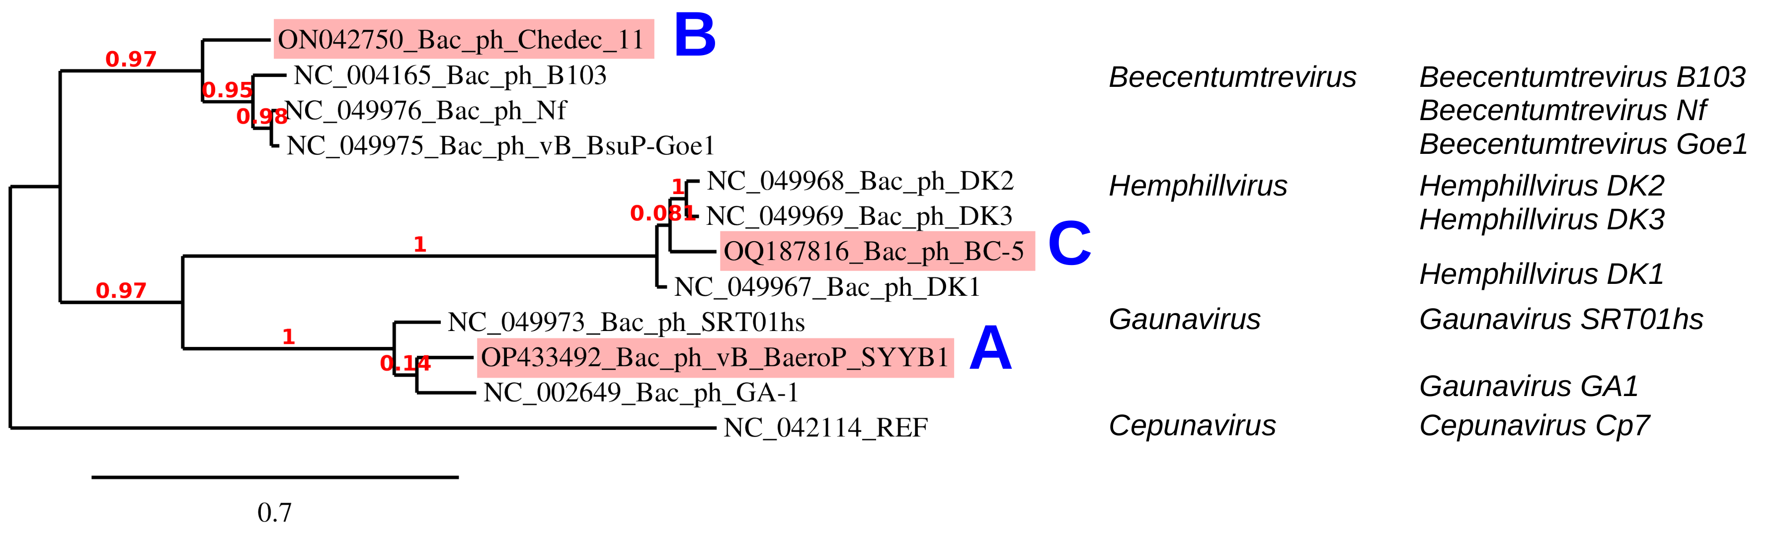

Figure 3. Phylogeny: The phylogenetic trees were constructed using the major capsid (upper) and DNA polymerase (lower) proteins of the new and related phages with phylogeny.fr in “one click” mode [8]. "The "One Click mode" targets users that do not wish to deal with program and parameter selection. By default, the pipeline is already set up to run and connect programs recognized for their accuracy and speed (MUSCLE for multiple alignment and PhyML for phylogeny) to reconstruct a robust phylogenetic tree from a set of sequences." It also includes the use of Gblocks to eliminate poorly aligned positions and divergent regions. "The usual bootstrapping procedure is replaced by a new confidence index that is much faster to compute. See: Anisimova M., Gascuel O. Approximate likelihood ratio test for branches: A fast, accurate and powerful alternative [9] for details.”

A. Create new species Gaunavirus syybuna within the Gaunavirus genus of subfamily Tatarstanvirinae

Origin of the name of this taxon: The name of this species was derived from the name of its only phage isolate Bacillus phage vB_BaeroP_SYYB1

Historical aspects: The Gaunavirus was established within the Taxonomy Proposal 2020.143B.R.Salasmaviridae

Genome summary:

Phage name | INSDC | Size (Kb) | GC% | Protein | Overall % DNA sequence identity (*) | Overall % homologous proteins (**)
Bacillus phage vB_BaeroP_SYYB1 | OP433492.1 | 20.68 | 35.1 | 33 | 69.8 | 81.8

(*) determined using VIRIDIC [3], (**) determined using CoreGenes 3.5 [6]
and compared with the most similar known phage Gaunavirus GA1 (NC_002649.1)

B. Create new genus Bahkauvirus with single species Bahkauvirus chedec within subfamily Picovirinae

Origin of the name of this taxon: The Bacillus phage Chedec 11 phage was isolated from Bacillus subtilis extracted from a sewage sample. Bahkau is a german folklore monster known to lurk near fountains, streams and sewers (https://en.wikipedia.org/wiki/Bahkauv).

Historical aspects: The subfamily Picovirinae was initially established within the Taxonomy Proposal 2008.011a-gB.V3.Picovirinae as a part of family Podoviridae. It was transferred, with only one of its initial genera (Salasvirus) and one new genus Beecentumtrevirus to new family Salasmaviridae based on Taxonomy Proposal 2020.143B.R.Salasmaviridae. Here we propose to add one single species genus to this subfamily.

Genome summary:

Phage name | INSDC | Size (Kb) | GC% | Protein | Overall % DNA sequence identity (*) | Overall % homologous proteins (**)
Bacillus phage Chedec 11 | ON042750.1 | 17.8 | 38.4 | 20 | 63.1 | 95

(*) determined using VIRIDIC [3], (**) determined using CoreGenes 3.5 [6]
and compared with the most similar known phage Beecentumtrevirus Nf (NC_049976.1)

C. Create new species Hemphillvirus bece5 within Hemphillvirus genus of Northropvirinae subfamily

Origin of the name of this taxon: The name of this species is derived from the name of single representative of this genus, Bacillus phage BC-5.

Historical aspects: The Hemphillvirus genus was established within the Taxonomy Proposal 2020.143B.R.Salasmaviridae and assigned in the same proposal to the subfamily Northropvirinae

Genome summary:

Phage name | INSDC | Size (Kb) | GC% | Protein | Overall % DNA sequence identity (*) | Overall % homologous proteins (**)
Bacillus phage BC-5 | OQ187816.1 | 25.4 | 30.6 | 41 | 73.8 | 92.7

(*) determined using VIRIDIC [3], (**) determined using CoreGenes 3.5 [6]
and compared with the most similar known phage Hemphillvirus DK1 (NC_049967.1)

References

1. Sayers EW, Beck J, Bolton EE, Bourexis D, Brister JR, Canese K, Comeau DC, Funk K, Kim S, Klimke W, Marchler-Bauer A, Landrum M, Lathrop S, Lu Z, Madden TL, O'Leary N, Phan L, Rangwala SH, Schneider VA, Skripchenko Y, Wang J, Ye J, Trawick BW, Pruitt KD, Sherry ST. Database resources of the National Center for Biotechnology Information. Nucleic Acids Res. 2021 Jan 8;49(D1):D10-D17. doi: 10.1093/nar/gkaa892. PMID: 33095870
2. O'Leary NA, Wright MW, Brister JR, Ciufo S, Haddad D, McVeigh R, et al. Reference sequence (RefSeq) database at NCBI: current status, taxonomic expansion, and functional annotation. Nucleic Acids Res. 2016;44(D1):D733-45. doi: 10.1093/nar/gkv1189. PMID: 26553804.
3. Moraru C, Varsani A, Kropinski AM. VIRIDIC-A Novel Tool to Calculate the Intergenomic Similarities of Prokaryote-Infecting Viruses. Viruses. 2020 Nov 6;12(11):1268. doi: 10.3390/v12111268. PMID: 33172115; PMCID: PMC7694805. http://kronos.icbm.uni-oldenburg.de/viridic/
4. Nishimura Y, Yoshida T, Kuronishi M, Uehara H, Ogata H, Goto S. ViPTree: the viral proteomic tree server. Bioinformatics. 2017; 33(15):2379-2380. doi:10.1093/bioinformatics/btx157. PubMed PMID: 28379287. https://www.genome.jp/viptree/
5. Rohwer F, Edwards R. The Phage Proteomic Tree: a genome-based taxonomy for phage. J Bacteriol. 2002 Aug;184(16):4529-35. PubMed PMID: 12142423
6. Turner D, Reynolds D, Seto D, Mahadevan P. CoreGenes3.5: a webserver for the determination of core genes from sets of viral and small bacterial genomes. BMC Res Notes. 2013;6:140. doi: 10.1186/1756-0500-6-140. PMID: 23566564.
7. Davis P, Seto D, Mahadevan P. CoreGenes5.0: An Updated User-Friendly Webserver for the Determination of Core Genes from Sets of Viral and Bacterial Genomes. Viruses. 2022 Nov 16;14(11):2534. doi: 10.3390/v14112534. PMID: 36423143; PMCID: PMC9693508.
8. Dereeper A, Guignon V, Blanc G, Audic S, Buffet S, Chevenet F, Dufayard JF, Guindon S, Lefort V, Lescot M, Claverie JM, Gascuel O. Phylogeny.fr: robust phylogenetic analysis for the non-specialist. Nucleic Acids Res. 2008;36(Web Server issue):W465-9. doi: 10.1093/nar/gkn180. Epub 2008 Apr 19. PMID: 18424797.
9. Anisimova M, Gascuel O. Approximate likelihood-ratio test for branches: A fast, accurate, and powerful alternative. Syst Biol. 2006;55(4):539-52. PMID: 16785212. DOI: 10.1080/10635150600755453.
10. Turner D, Kropinski AM, Adriaenssens EM. A Roadmap for Genome-Based Phage Taxonomy. Viruses. 2021 Mar 18;13(3):506. doi: 10.3390/v13030506. PMID: 33803862; PMCID: PMC8003253.

