

Part 1: TITLE, AUTHORS, APPROVALS, etc

Code assigned: | 2023.054B
Short title: To expand the subfamily Queuovirinae and add new species to the genus Nipunavirus [Caudoviricetes]
Author(s) and email address(es)
Turner D, Moraru C, Tolstoy I, Thaller MC, Fraziano M, Migliore L, D’Andrea MM, Kropinski AM | Dann2.Turner@uwe.ac.uk; liliana.cristina.moraru@uol.de; tolstoy@ncbi.nlm.nih.gov; mcthaller@gmail.com; fraziano@bio.uniroma2.it; luciana.migliore@uniroma2.it; marco.dandrea@uniroma2.it; Phage.Canada@gmail.com
Author(s) institutional address(es) (optional)

University of the West of England, Bristol, UK [DT]
Carl von Ossietzky Universität Oldenburg, Germany [CM]
National Center for Biotechnology Information, MD, USA [IT]
University of Rome “Tor Vergata”, Rome, Italy [MCT, MF, LM, MMD]
University of Guelph, Ontario, Canada [AMK]

Corresponding author
Andrew M. Kropinski
List the ICTV Study Group(s) that have seen this proposal

Caudoviricetes Study Group

ICTV Study Group comments and response of proposer

ICTV Study Group votes on proposal

Study Group | Number of members
Study Group | Votes support | Votes against | No vote
Authority to use the name of a living person

Is any taxon name used here derived from that of a living person (Y/N) | N

Taxon name | Person from whom the name is derived | Permission attached (Y/N)

Submission dates
Date first submitted to SC Chair | May 2023
Date of this revision (if different to above)
ICTV-EC comments and response of the proposer

Part 2: NON-TAXONOMIC PROPOSAL
Text of proposal

Part 3: TAXONOMIC PROPOSAL
Name of accompanying Excel module
2023.054B.N.v1.Queuovirinae_reorg.xlsx
Abstract

BLASTN and TBLASTX analyses have revealed that the subfamily Queuovirinae is more diverse than revealed two years ago and may indeed contain both myo- and siphoviral members. In this proposal we define three new genera – Micathvirus, Torvergatavirus and Shandongvirus, and move one existing genus Iggyvirus into the subfamily. A unique feature of these phages is that they encode a cluster of genes involved in Queuosine (2-Amino-5-({[(1S,4S,5R)-4,5-dihydroxycyclopent-2-en-1-yl]amino}methyl)-7-[(2R,3R,4S,5R)-3,4-dihydroxy-5-(hydroxymethyl)oxolan-2-yl]-3,7-dihydro-4H-pyrrolo[2,3-d]pyrimidin-4-one) synthesis.
Text of proposal
Species demarcation criteria: Two phages are assigned to the same species if their genomes are more than 95% identical over their genome length for isolates.
These values can be calculated by a number of tools, such as BLASTn [1,2] – usually calculated using intergenomic distance calculator VIRIDIC [3].

Genus demarcation criteria: In search for criteria that create cohesive and distinct genera that are reproducible and monophyletic, the Bacterial Viruses Subcommittee has established 70% nucleotide identity of the genome length as the cut-off for genera. Genus-level groupings should always be monophyletic in the signature genes, as tested with a phylogenetic tree [10].

Supporting evidence

Proposal:
- Add four (4) new species to the genus Nipunavirus.
- Create a new single species genus, Micathvirus
- Create a new single species genus, Torvergatavirus
- Create a new single species genus, Shangdongvirus
- Move the genus Iggyvirus

Figure 1. VIRIDIC heat map: VIRIDIC (Virus Intergenomic Distance Calculator; VIRIDIC (Virus Intergenomic Distance Calculator; [3]; http://rhea.icbm.uni-oldenburg.de/VIRIDIC/) computes pairwise intergenomic distances/similarities amongst phage genomes. Data values which are bordered in black correspond to strains. Abbreviations: phg = phage; Sten = Stenotrophomonas; Pseu = Pseudomonas; Sphi = Sphingomonas; Xant = Xanthomonas; Serr = Serratia; Burk = Burkholderia

Figure 2. ViPTree analysis: ViPTree analysis (https://www.genome.jp/viptree/; [4]) is based upon Rohwer and Edwards (2002) Phage Proteomic Tree [5]. The phages of interest are indicated with red lines and stars.

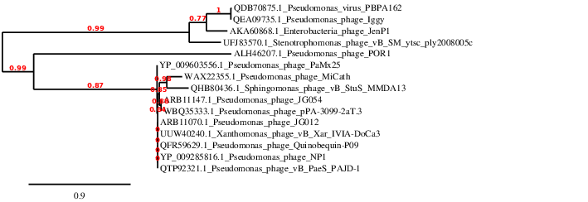

Figure 3. Phylogeny: The phylogenetic tree was constructed using the large subunit terminase proteins from these and related phages with phylogeny.fr in “one click” mode [8]. "The "One Click mode" targets users that do not wish to deal with program and parameter selection. By default, the pipeline is already set up to run and connect programs recognized for their accuracy and speed (MUSCLE for multiple alignment and PhyML for phylogeny) to reconstruct a robust phylogenetic tree from a set of sequences." It also includes the use of Gblocks to eliminate poorly aligned positions and divergent regions. "The usual bootstrapping procedure is replaced by a new confidence index that is much faster to compute. See: Anisimova M., Gascuel O. Approximate likelihood ratio test for branches: A fast, accurate and powerful alternative [9] for details.”
Taxonomic Proposals:

- Add four (4) new species to the genus Nipunavirus.

Historical aspects: This taxon was created through Taxonomy Proposal 2020.128B.R.Queuovirinae. Pseudomonas aeruginosa phages JG054, vB_PaeS_PAJD-1 and Quinobequin-P09 were isolated in Germany, China and USA, respectively. Xanthomonas arboricola pv. juglandis phage vB_Xar_IVIA-DoCa3 was isolated in Spain.

Genome summary:

Phage name | RefSeq No. | INSDC | Size (Kb) | GC% | Protein | Overall % DNA sequence identity (*) | Overall % homologous proteins (**)
Pseudomonas phage NP1 | NC_031058.1 | KX129925.1 | 58.57 | 58.4 | 74 | 100 | 100
Pseudomonas phage JG054 |  | KX898400.1 | 57.84 | 57.6 | 74 | 82.1 | 91.9
Xanthomonas phage vB_Xar_IVIA-DoCa3 |  | ON911540.2 | 58.11 | 58.5 | 75 | 91.2 | 95.9
Pseudomonas phage vB_PaeS_PAJD-1 |  | MW835180.1 | 57.92 | 58.3 | 72 | 92.8 | 94.6
Pseudomonas phage Quinobequin-P09 |  | MN504636.1 | 58.28 | 58.3 | 86 | 92.1 | 93.2

Conclusion: On the basis of DNA (Fig. 1) and protein (Fig. 2) similarity; and phylogenetic analysis of the TerL proteins (Fig. 3) this is a cohesive genus.

- Create a new single species genus, Micathvirus

Origin of the name of this taxon: This taxon is named after the first virus of its type, Pseudomonas phage MiCath

Historical aspects: This lytic phage was isolated against Pseudomonas putida from garden soil in CA, USA. The phages which constitute this subfamily are siphoviruses, with the exception of MiCath which possesses a 455 aa protein (WAX22430) which is a tail sheath protein, as shown by HHpred analysis. This is a feature which MiCath only shares with POR1.

Electron micrograph: N/A

Genome summary:

Phage name | INSDC | Size (Kb) | GC% | Protein | Overall % DNA sequence identity (*) | Overall % homologous proteins (**)
Pseudomonas phage MiCath | OP882271.1 | 60.96 | 55.7 | 97 | 100 | 100

Conclusion: A genus comprising a single species is proposed on the basis of DNA (Fig. 1) and protein (Fig. 2) similarity; and phylogenetic analysis of the TerL proteins (Fig. 3).

- Create a new single species genus, Torvergatavirus

Origin of the name of this taxon: This taxon is named after University of Rome
'Tor Vergata' where the first virus of its type, Sphingomonas phage vB_StuS_MMDA13 was isolated [Marmo et al. 2020].

Historical aspects: This lytic siphophage was isolated against Sphingomonas turrisvirgatae (DSM 105457T) and was obtained by a screening of fresh surface waters collected in a pond near Viterbo (Italy). “TEM analysis showed morphological features typical of the B2 morphotype of the Siphoviridae family members, with an icosahedral elongated head (≈70 × 55 nm) and a long, flexible, helical, non-contractile and striated tail of about 140 nm ending with an apparent baseplate connected to short terminal fibers” [Marmo, Thaller et al. 2020]

Electron micrograph: Figure 4. Electron micrographs of negatively stained phage vB_StuS_MMDA13 kindly provided by Professor Marco M. D'Andrea, Department of Biology, University of Rome - Tor Vergata, Via della Ricerca Scientifica s.n.c., 00133 Rome, Italy. This figure cannot be reproduced without written permission from Professor D'Andrea.

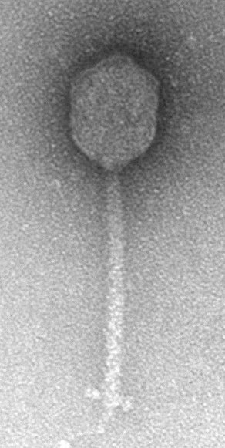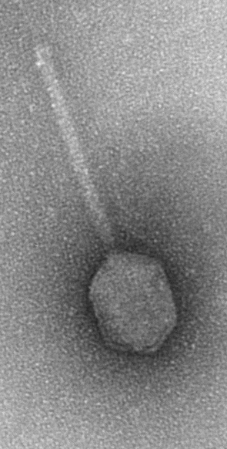

Genome summary:

Phage name | INSDC | Size (Kb) | GC% | Protein | Overall % DNA sequence identity (*) | Overall % homologous proteins (**)
Sphingomonas phage vB_StuS_MMDA13 | MN820898.1 | 63.74 | 59.3 | 89 | 100 | 100

Conclusion: A genus comprising a single species is proposed on the basis of DNA (Fig. 1) and protein (Fig. 2) similarity; and phylogenetic analysis of the TerL proteins (Fig. 3).

Reference: Marmo P, Thaller MC, Di Lallo G, Henrici De Angelis L, Poerio N, De Santis F, Fraziano M, Migliore L, D'Andrea MM. Characterization of vB_StuS_MMDA13, a Newly Discovered Bacteriophage Infecting the Agar-Degrading Species Sphingomonas turrisvirgatae. Viruses. 2020 Aug 15;12(8):894. doi: 10.3390/v12080894. PMID: 32824138; PMCID: PMC7472734.

- Create a new single species genus, Shangdongvirus

Origin of the name of this taxon: This taxon is named after Shangdong, the location in China where the submitters of the phage genome of phage Stenotrophomonas phage vB_SM_ytsc_ply2008005c work.

Historical aspects: This lytic phage was isolated against Stenotrophomonas maltophilia in China.

Electron micrograph: N/A.

Genome summary:

Phage name | INSDC | Size (Kb) | GC% | Protein | Overall % DNA sequence identity (*) | Overall % homologous proteins (**)
Stenotrophomonas phage vB_SM_ytsc_ply2008005c | OK562670.1 | 42.32 | 63.0 | 54 | 100 | 100

Conclusion: On the basis of DNA (Fig. 1) and protein (Fig. 2) similarity; and phylogenetic analysis of the TerL proteins (Fig. 3) this is a cohesive genus which is distinct from all others in this subfamily.

- Move the genus Iggyvirus
On the basis of DNA (Fig. 1) and protein (Fig. 2) similarity; and phylogenetic analysis of the TerL proteins (Fig. 3), Pseudomonas phages Iggy and PBPA162 in the genus Iggyvirus should be assigned to the subfamily Queuovirinae.

References

1. Sayers EW, Beck J, Bolton EE, Bourexis D, Brister JR, Canese K, Comeau DC, Funk K, Kim S, Klimke W, Marchler-Bauer A, Landrum M, Lathrop S, Lu Z, Madden TL, O'Leary N, Phan L, Rangwala SH, Schneider VA, Skripchenko Y, Wang J, Ye J, Trawick BW, Pruitt KD, Sherry ST. Database resources of the National Center for Biotechnology Information. Nucleic Acids Res. 2021 Jan 8;49(D1):D10-D17. doi: 10.1093/nar/gkaa892. PMID: 33095870
2. O'Leary NA, Wright MW, Brister JR, Ciufo S, Haddad D, McVeigh R, et al. Reference sequence (RefSeq) database at NCBI: current status, taxonomic expansion, and functional annotation. Nucleic Acids Res. 2016;44(D1):D733-45. doi: 10.1093/nar/gkv1189. PMID: 26553804.
3. Moraru C, Varsani A, Kropinski AM. VIRIDIC-A Novel Tool to Calculate the Intergenomic Similarities of Prokaryote-Infecting Viruses. Viruses. 2020 Nov 6;12(11):1268. doi: 10.3390/v12111268. PMID: 33172115; PMCID: PMC7694805. http://kronos.icbm.uni-oldenburg.de/viridic/
4. Nishimura Y, Yoshida T, Kuronishi M, Uehara H, Ogata H, Goto S. ViPTree: the viral proteomic tree server. Bioinformatics. 2017; 33(15):2379-2380. doi:10.1093/bioinformatics/btx157. PubMed PMID: 28379287. https://www.genome.jp/viptree/
5. Rohwer F, Edwards R. The Phage Proteomic Tree: a genome-based taxonomy for phage. J Bacteriol. 2002 Aug;184(16):4529-35. PubMed PMID: 12142423
6. Turner D, Reynolds D, Seto D, Mahadevan P. CoreGenes3.5: a webserver for the determination of core genes from sets of viral and small bacterial genomes. BMC Res Notes. 2013;6:140. doi: 10.1186/1756-0500-6-140. PMID: 23566564.
7. Davis P, Seto D, Mahadevan P. CoreGenes5.0: An Updated User-Friendly Webserver for the Determination of Core Genes from Sets of Viral and Bacterial Genomes. Viruses. 2022 Nov 16;14(11):2534. doi: 10.3390/v14112534. PMID: 36423143; PMCID: PMC9693508.
8. Dereeper A, Guignon V, Blanc G, Audic S, Buffet S, Chevenet F, Dufayard JF, Guindon S, Lefort V, Lescot M, Claverie JM, Gascuel O. Phylogeny.fr: robust phylogenetic analysis for the non-specialist. Nucleic Acids Res. 2008;36(Web Server issue):W465-9. doi: 10.1093/nar/gkn180. Epub 2008 Apr 19. PMID: 18424797.
9. Anisimova M, Gascuel O. Approximate likelihood-ratio test for branches: A fast, accurate, and powerful alternative. Syst Biol. 2006;55(4):539-52. PMID: 16785212. DOI: 10.1080/10635150600755453.
10. Turner D, Kropinski AM, Adriaenssens EM. A Roadmap for Genome-Based Phage Taxonomy. Viruses. 2021 Mar 18;13(3):506. doi: 10.3390/v13030506. PMID: 33803862; PMCID: PMC8003253.

