

Part 1: TITLE, AUTHORS, APPROVALS, etc

Code assigned: | 2023.053B
Short title: Create five (5) new species in the genus Przondovirus (Caudoviricetes)
Author(s) and email address(es)
Claire K. A. Elek, Teagan L. Brown, Thanh Le Viet, Rhiannon Evans, David J. Baker, Andrea Telatin, Sumeet K. Tiwari, Haider Al-Khanaq, Gaëtan Thilliez, Robert A. Kingsley, Lindsay J. Hall, Mark A. Webber, and Evelien M. Adriaenssens | Claire.Elek@quadram.ac.uk; teaganlbrown@gmail.com; Thanh.Le-Viet@quadram.ac.uk; Rhiannon.Evans@quadram.ac.uk; David.Baker@quadram.ac.uk; Andrea.Telatin@quadram.ac.uk; Sumeet.Tiwari@quadram.ac.uk; Haider.Al-Khanaq@quadram.ac.uk; Gaetan.Thilliez@quadram.ac.uk; Rob.Kingsley@quadram.ac.uk; Lindsay.Hall@quadram.ac.uk; Mark.Webber@quadram.ac.uk; Evelien.Adriaenssens@quadram.ac.uk
Author(s) institutional address(es) (optional)
Quadram Institute Bioscience, Rosalind Franklin Road, Norwich Research Park, Norwich, UK [All authors]
University of East Anglia, Norwich Research Park, Norwich, UK [CKAE; LJH; MAW]
Chair of Intestinal Microbiome, ZIEL—Institute for Food and Health, School of Life Sciences, Technical University of Munich, Freising, Germany [LJH]
Corresponding author
Evelien M. Adriaenssens

List the ICTV Study Group(s) that have seen this proposal

Caudoviricetes Study Group

ICTV Study Group comments and response of proposer

No comments

ICTV Study Group votes on proposal

Study Group | Number of members
Study Group | Votes support | Votes against | No vote
Authority to use the name of a living person

Is any taxon name used here derived from that of a living person (Y/N) | N

Taxon name | Person from whom the name is derived | Permission attached (Y/N)

Submission dates
Date first submitted to SC Chair | June 2023
Date of this revision (if different to above)
ICTV-EC comments and response of the proposer
Part 2: NON-TAXONOMIC PROPOSAL
Text of proposal

Part 3: TAXONOMIC PROPOSAL
Name of accompanying Excel module
2023.053B.N.v1.Przondovirus_5ns.xlsx
Abstract
There are currently 29 species within the Przondovirus genus. With this proposal we add another ten przondoviruses, assigned to five new species. The average genome sizes for members of this taxon are: 41.103 kb (52.64 mol%G+C) encoding for 55 proteins.
Text of proposal
Demarcation criteria
Species demarcation criteria: Two phages are assigned to the same species if their genomes are more than 95% identical over their genome length for isolates.
These values were calculated using intergenomic distance calculator VIRIDIC (1).

Genus demarcation criteria: In search for criteria that create cohesive and distinct genera that are reproducible and monophyletic, the Bacterial Viruses Subcommittee has established 70% nucleotide identity of the genome length as the cut-off for genera. Genus-level groupings should always be monophyletic in the signature genes, as tested with a phylogenetic tree (2).

Five new species in the genus Przondovirus
Comparison of the genomes of 10 new phages (Table 1) with reference phages from GenBank (3) showed high levels of sequence similarity with phages from the genus Przondovirus in the subfamily Studiervirinae, family Autographiviridae. The assignment to the genus Przondovirus was confirmed using nucleotide similarity with existing members of the genus at over 70% nucleotide similarity (Fig. 1) and phylogenetic analysis of the hallmark RNA polymerase gene showing robust clustering (Fig. 2).

Using the demarcation criteria for at the species level, six phages (Oda, Toyotomi, Mera, Speegle, Cornelius, and Tokugawa) were assigned to the new species Przondovirus oda, while phages Emom, Amrap, Saitama and Whistle each were the sole representatives of four new species (Table 1).

Supporting evidence
Figures are reproduced from our pre-print, copyright lies with the authors (4).

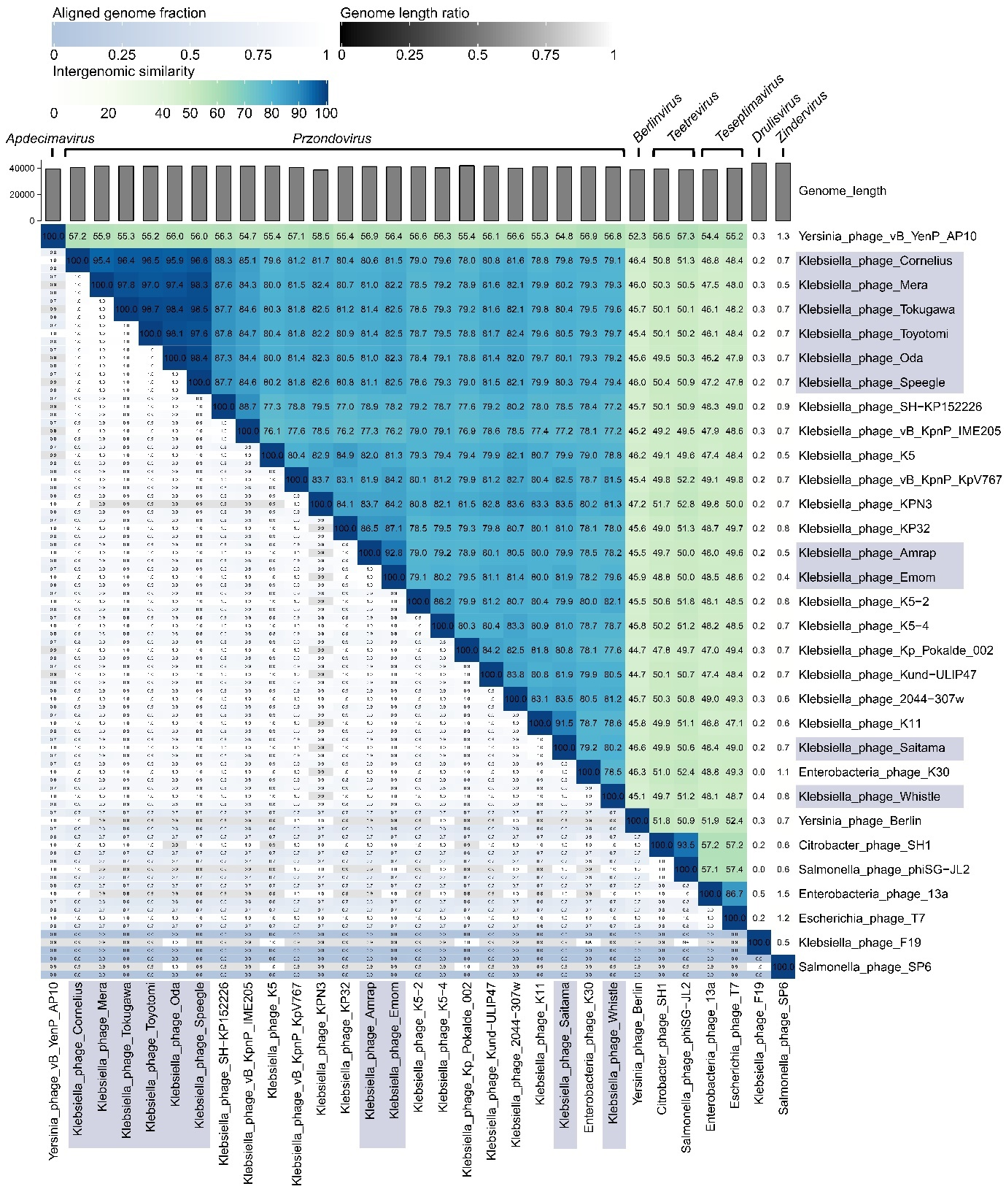

Fig. 1. Nucleotide-based intergenomic similarities of przondoviruses in the collection and a selection of related phages within the Studiervirinae subfamily, using VIRIDIC. A heatmap of hierarchical clustering of the intergenomic similarity values was generated and given as percentage values (right half, blue-green heatmap). Each genome pair is represented by three values (left half), where the top and bottom (blue scale) represent the aligned genome fraction for the genome in the row and column, respectively, where darker colour indicates a lower fraction of the genome was aligned. The middle value (grey scale) represents the genome length ratio for each genome pair, where darker colour indicates increasing distance between phages. The new przondovirus isolates are highlighted in blue-grey.

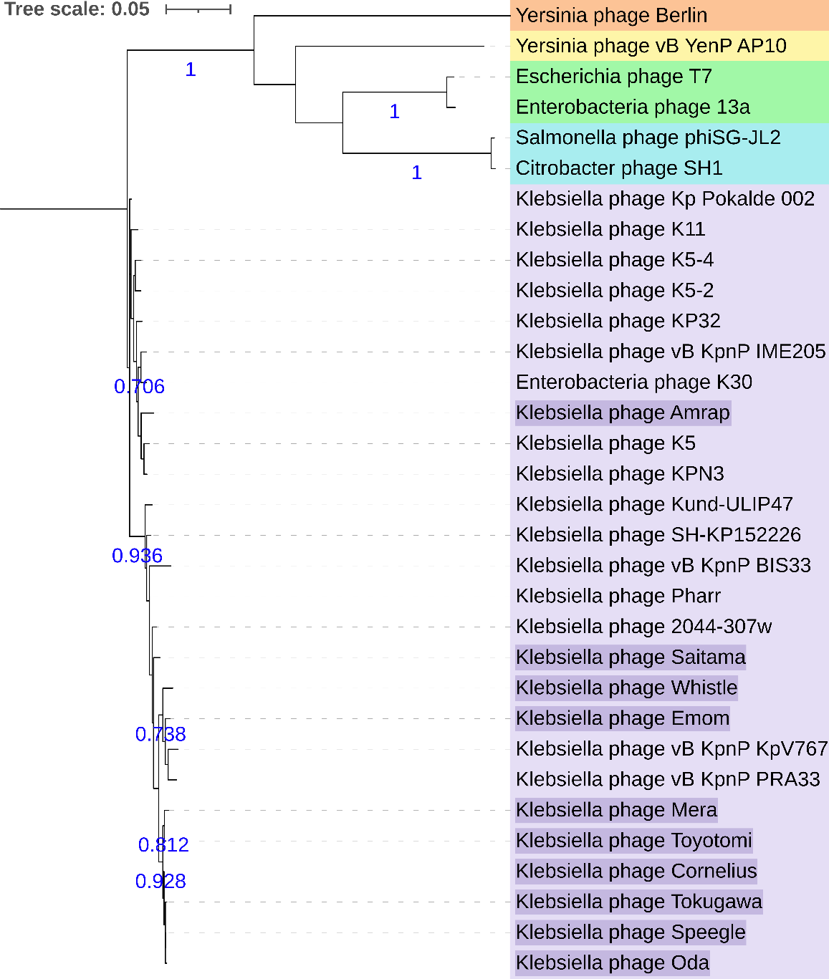

Fig. 2. Maximum-likelihood phylogeny of the RNA polymerase for przondoviruses in this study and a selection of related Studiervirinae phages. All phages for this proposal (purple highlight) clustered with related przondoviruses (purple). Outgroups, Berlinvirus (orange), Apidecimavirus (yellow), Teseptimavirus (green), and Teetrevirus (blue). Tree is midpoint rooted. Bootstrap support values at ≥0.7 are given in blue (500 replicates). Scale bar represents number of amino acid substitutions per site.

Table 1. New przondoviruses
Phage Name | Genome size (bp) | GC content (%) | No. CDS | Accession | Species
Klebsiella phage Oda | 41,642 | 52.64 | 58 | OQ579023 | Przondovirus oda
Klebsiella phage Toyotomi | 41,268 | 52.64 | 55 | OQ579024 | Przondovirus oda
Klebsiella phage Mera | 41,400 | 52.58 | 56 | OQ579025 | Przondovirus oda
Klebsiella phage Speegle | 41,395 | 52.64 | 58 | OQ579026 | Przondovirus oda
Klebsiella phage Cornelius | 40,437 | 52.72 | 55 | OQ579027 | Przondovirus oda
Klebsiella phage Tokugawa | 41,414 | 52.64 | 56 | OQ579028 | Przondovirus oda
Klebsiella phage Saitama | 40,741 | 53.06 | 51 | OQ579029 | Przondovirus saitama
Klebsiella phage Emom | 40,788 | 52.56 | 53 | OQ579030 | Przondovirus emom
Klebsiella phage Amrap | 41,209 | 52.47 | 57 | OQ579031 | Przondovirus amrap
Klebsiella phage Whistle | 40,735 | 52.40 | 54 | OQ579032 | Przondovirus whistle

References
1. Moraru C, Varsani A, Kropinski AM. VIRIDIC - a novel tool to calculate the intergenomic similarities of prokaryote-infecting viruses. Viruses. 2020; 12(11): 1268. doi: 10.3390/v12111268.
2. Turner D, Kropinski AM, Adriaenssens EM. A roadmap for genome-based phage taxonomy. Viruses. 2021; 13(3). doi: 10.3390/v13030506.
3. Sayers EW, Beck J, Bolton EE, Bourexis D, Brister JR, Canese K et al. Database resources of the National Center for Biotechnology Information. Nucleic Acids Res. 2020; 49(D1): D10-D17. doi: 10.1093/nar/gkaa892.
4. Elek CKA, Brown TL, Viet TL, Evans R, Baker DJ, Telatin A et al. A hybrid and poly-polish workflow for the complete and accurate assembly of phage genomes: a case study of ten przondoviruses. [Pre-print]. 2023. Doi: 10.1101/2023.03.09.531871.

