

Part 1: TITLE, AUTHORS, APPROVALS, etc

Code assigned: | 2023.045B
Short title: Create one new genus (Layangcvirus) and news species (Layangcvirus LY3) in the subfamily Northropvirinae

Author(s) and email address(es)
Yang M | ymy@scau.edu.cn;
Author(s) institutional address(es) (optional)
South China Agricultural University, Guangzhou, China [MY]

Corresponding author
Meiyan Yang

List the ICTV Study Group(s) that have seen this proposal
Bacterial Viruses Subcommittee,
Caudoviricetes Study Group

ICTV Study Group comments and response of proposer
ICTV Study Group votes on proposal
Study Group | Number of members
Study Group | Votes support | Votes against | No vote
Authority to use the name of a living person
Is any taxon name used here derived from that of a living person (Y/N) | N

Taxon name | Person from whom the name is derived | Permission attached (Y/N)

Submission dates
Date first submitted to SC Chair | May 2023
Date of this revision (if different to above)
ICTV-EC comments and response of the proposer
Part 2: NON-TAXONOMIC PROPOSAL
Text of proposal

Part 3: TAXONOMIC PROPOSAL
Name of accompanying Excel module
2023.045B.N.v1.Layangcvirus_ng.xlsx
Abstract
In this study, a new phage vB_BceP_LY3 was isolated from the Datansha Wastewater Treatment Plant in Guangzhou, China, with low similarity and coverage (76.15% similarity and 22% coverage) to the known Bacillus phage SerPounce. For accuracy, further comparisons were performed using VIRIDIC, which showed that the similarity of vB_BceP_LY3 was less than 46.5%, well below the defined threshold of 70% in this genus. More importantly, the results of vConTACT2 analysis revealed that vB_BceP_LY3 formed a new subset of VC clusters with phages of the subfamily Northropvirinae, which was further supported by the phylogenetic tree of the terminase large subunit. In summary, we propose to create a genus Layangcvirus within the subfamily Northropvirinae.

Text of proposal
Species demarcation criteria: The intergenomic similarity matrix made with the VIRIDIC tool, possibly better estimating the intergenomic similarities [1]. Its defining threshold is default 95% for species and 70% for genus [2].

Origin of genus name: The origin of names etymology (Layang) is derived from the Chinese word for Bacillus cereus. The 'c' immediately after it represents the third taxon discovered by our group. The genus will represent a new Bacillus cereus phage taxon.

Supporting evidence
Source of the name of this taxon: Bacillus cereus phage vB_BceP_LY3 isolated from Datansha Wastewater Treatment Plant, Guangzhou, China.

VIRIDIC heat map: VIRIDIC (Virus Intergenomic Distance Calculator; [2]) computes pairwise intergenomic distances/similarities amongst phage genomes. VIRDIC analysis of strains with high similarity after BLAST comparison showed that Bacillus phage vB_BceP_LY3 had the highest similarity with Claudivirus (SerPounce, Aurora and KonjoTrouble) and Hemphillvirus(DLn1, DK2 and DK3) phage, but both were well below the genus level (< 70%) similarity threshold. Therefore, phage vB_BceP_LY3 was an unclassified phage in the subfamily Northropvirinae.

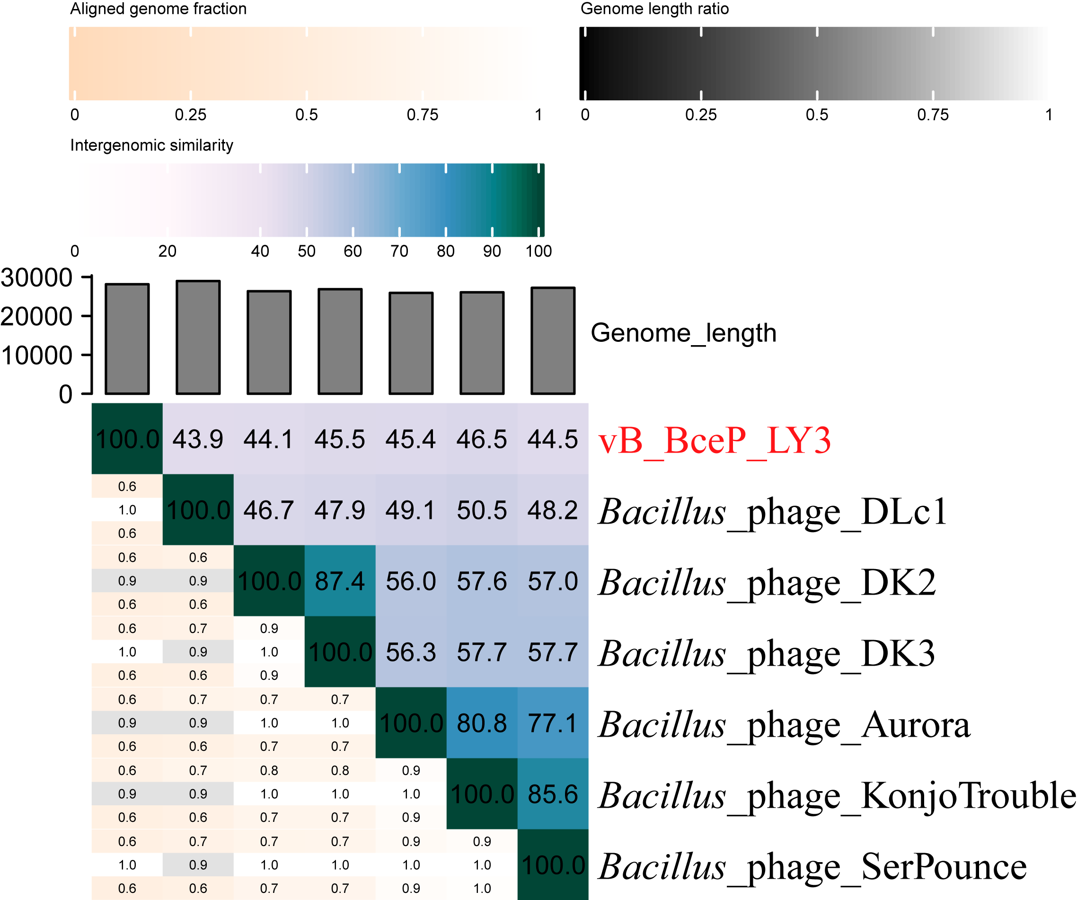
Figure 1. The heat map by VIRIDIC analysis

vConTACT2 analysis: vConTACT2 [3] is a network based on the shared proteins for virus classification. There are 18,324 phages (nodes) in Figure 2A, which show 835,836 relationships between them (connecting lines), and twenty-three phages with association with phage vB_BceP_LY3 were selected for analysis (Figure 2B). and these phages separated from the core viral cluster and formed a small cluster independently, both belonging to the family Salasmaviridae. It is known that the phages associated with phage vB_BceP_LY3 are both Bacillus phages and belong to two viral clusters (VC_782_0 and VC_785_0). Among them, vB_BceP_LY3 belongs to VC_785_0, a cluster containing the genus Huangshavirus under the family Salasmaviridae and the genera Claudivirus, Hemphillvirus and Klosterneuburgvirus under the subfamily Northropvirinae, family Salasmaviridae.

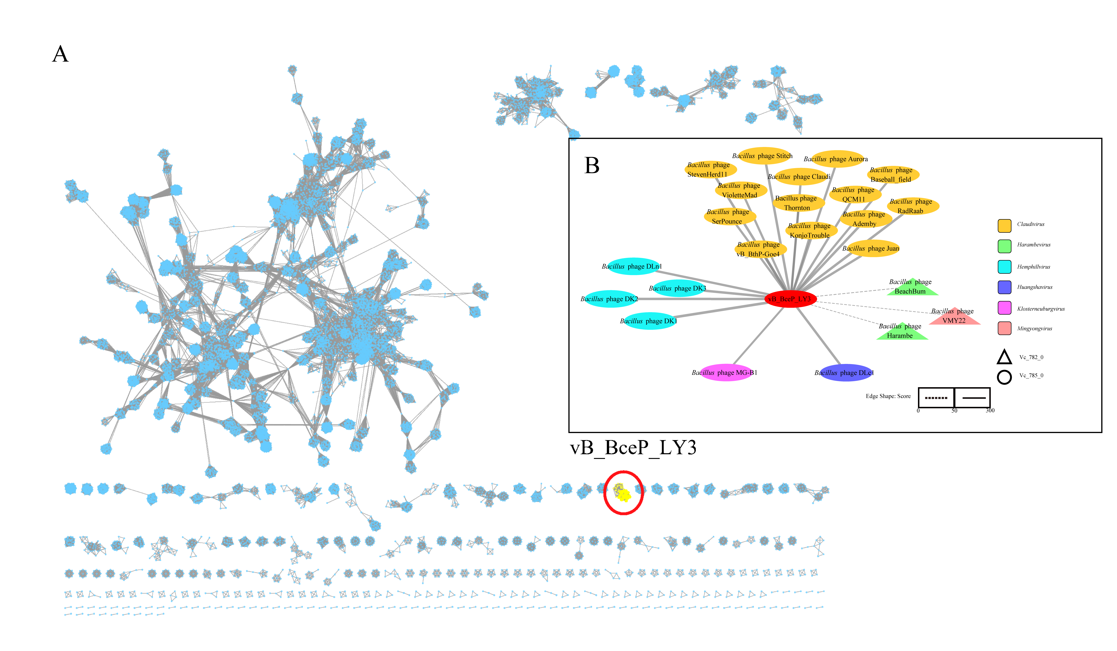
Figure 2. The gene sharing networks analysis

Phylogenetic analysis: Phylogenetic tree was conducted using the maximum likelihood estimation method in IQ-TREE by terminase large subunit(terL). The results indicate that phage vB_BceP_LY3 is located in the same branch as the family Salasmaviridae, especially the subfamily Northropvirinae phages, which are most recently evolutionarily related to the Claudivirus genus phages. In conclusion, we propose to create a genus Layangcvirus under the subfamily Northropvirinae.

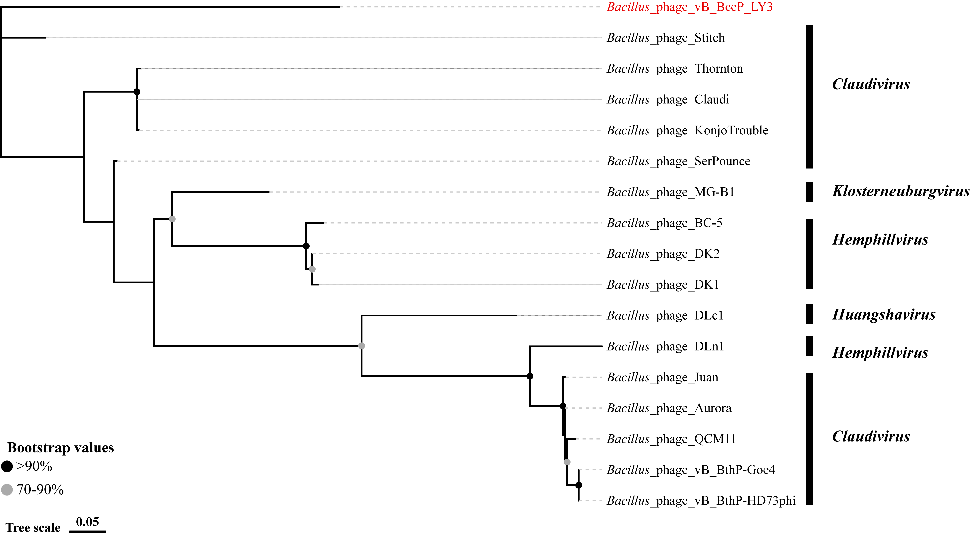

Figure 3. Phylogenetic tree of phage vB_BceP_LY3 based on the terminase large subunit

GenBank Summary:

Phage name | INSDC | Size (Kb) | GC% | Protein | tRNAs
Bacillus phage vB_BceP_LY3 | ON366412 | 28.1 | 29.92 | 47 | 0

Electron micrograph:

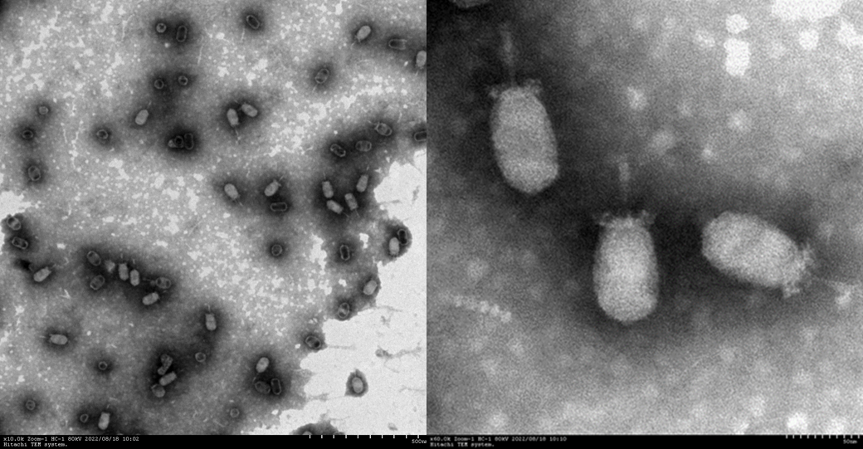

References
- Timoshina OY, Shneider MM, Evseev PV, Shchurova AS, Shelenkov AA, Mikhaylova YV, Sokolova OS, Kasimova AA, Arbatsky NP, Dmitrenok AS, Knirel YA, Miroshnikov KA, Popova AV. Novel Acinetobacter baumannii Bacteriophage Aristophanes Encoding Structural Polysaccharide Deacetylase. Viruses. 2021 Aug 26;13(9):1688. doi: 10.3390/v13091688. PMID: 34578271; PMCID: PMC8471582.
- Moraru C, Varsani A, Kropinski AM. VIRIDIC-A Novel Tool to Calculate the Intergenomic Similarities of Prokaryote-Infecting Viruses. Viruses. 2020 Nov 6;12(11):1268. doi: 10.3390/v12111268. PMID: 33172115; PMCID: PMC7694805.
- Bin Jang H, Bolduc B, Zablocki O, et al. Taxonomic assignment of uncultivated prokaryotic virus genomes is enabled by gene-sharing networks. Nat Biotechnol. 2019;37(6):632-639. doi:10.1038/s41587-019-0100-8 PMID: 31061483

