

Part 1: TITLE, AUTHORS, APPROVALS, etc

Code assigned: | 2023.044B
Short title: Create two new genera (Layangavirus and Layangbvirus) and two species (Layangavirus LY1 and Layangbvirus LY5)in the subfamily Gutmannvirinae.
Author(s) and email address(es)
Yang M | ymy@scau.edu.cn
Author(s) institutional address(es) (optional)
South China Agricultural University, Guangzhou, China [MY]

Corresponding author
Meiyan Yang

List the ICTV Study Group(s) that have seen this proposal
Bacterial Viruses Subcommittee, Caudoviricetes Study Group

ICTV Study Group comments and response of proposer
ICTV Study Group votes on proposal
Study Group | Number of members
Study Group | Votes support | Votes against | No vote
Authority to use the name of a living person

Is any taxon name used here derived from that of a living person (Y/N) | N

Taxon name | Person from whom the name is derived | Permission attached (Y/N)

Submission dates
Date first submitted to SC Chair | May 2023
Date of this revision (if different to above)
ICTV-EC comments and response of the proposer
Part 2: NON-TAXONOMIC PROPOSAL
Text of proposal

Part 3: TAXONOMIC PROPOSAL
Name of accompanying Excel module
2023.044B.N.v1.Layangavirus_Layangbvirus_2ng.xlsx
Abstract
In this study, a new phage vB_BceS_LY1 and vB_BceS_LY5 was isolated from the Datansha Wastewater Treatment Plant in Guangzhou, China, with low similarity and coverage (79.2% similarity and 56% coverage; 72.32% similarity and 25% coverage) to the known phages Wes44 and PBC1. For accuracy, further comparisons were performed using VIRIDIC, which showed that the similarity of vB_BceS_LY1 and vB_BceS_LY5 was less than 63.2% and 55.7%, well below the defined threshold of 70% in this genus. More importantly, the results of vConTACT2 analysis revealed that vB_BceS_LY1 and vB_BceS_LY5 formed a new subset of VC clusters with phages of the subfamily Gutmannvirinae, which was further supported by the phylogenetic tree of the terminase large subunit. In summary, we propose to create two genera Layangavirus and Layangbvirus under the subfamily Gutmannvirinae.

Text of proposal
Species demarcation criteria: The intergenomic similarity matrix made with the VIRIDIC tool, possibly better estimating the intergenomic similarities [1]. Its defining threshold is default 95% for species and 70% for genus [2].
Origin of names assigned to new genus: The origin of names etymology (Layang) is derived from the Chinese word for Bacillus cereus. The immediately following 'a' and 'b' represent different taxa. They will represent two different groups of phages isolated from Bacillus cereus.

Supporting evidence

Source of the name of this taxon: Bacillus cereus phage vB_BceS_LY1 and vB_BceS_LY5 isolated from Datansha Wastewater Treatment Plant, Guangzhou, China.

VIRIDIC heat map: VIRIDIC (Virus Intergenomic Distance Calculator; [2]) computes pairwise intergenomic distances/similarities amongst phage genomes. VIRDIC analysis of strains with high similarity after BLAST comparison showed that Bacillus phage vB_BceS_LY1 and vB_BceS_LY5 had the highest similarity with Bacillus phage Carmen17 (Carmenvirus), Bacillus phage Wes44 (Carmenvirus) and Bacillus phage PBC1 (Pebcunavirus), but below the genus level (< 70%) similarity threshold. Therefore, phages vB_BceS_LY1 and vB_BceS_LY5 represent two new unclassified phages in the subfamily Gutmannvirinae, respectively.

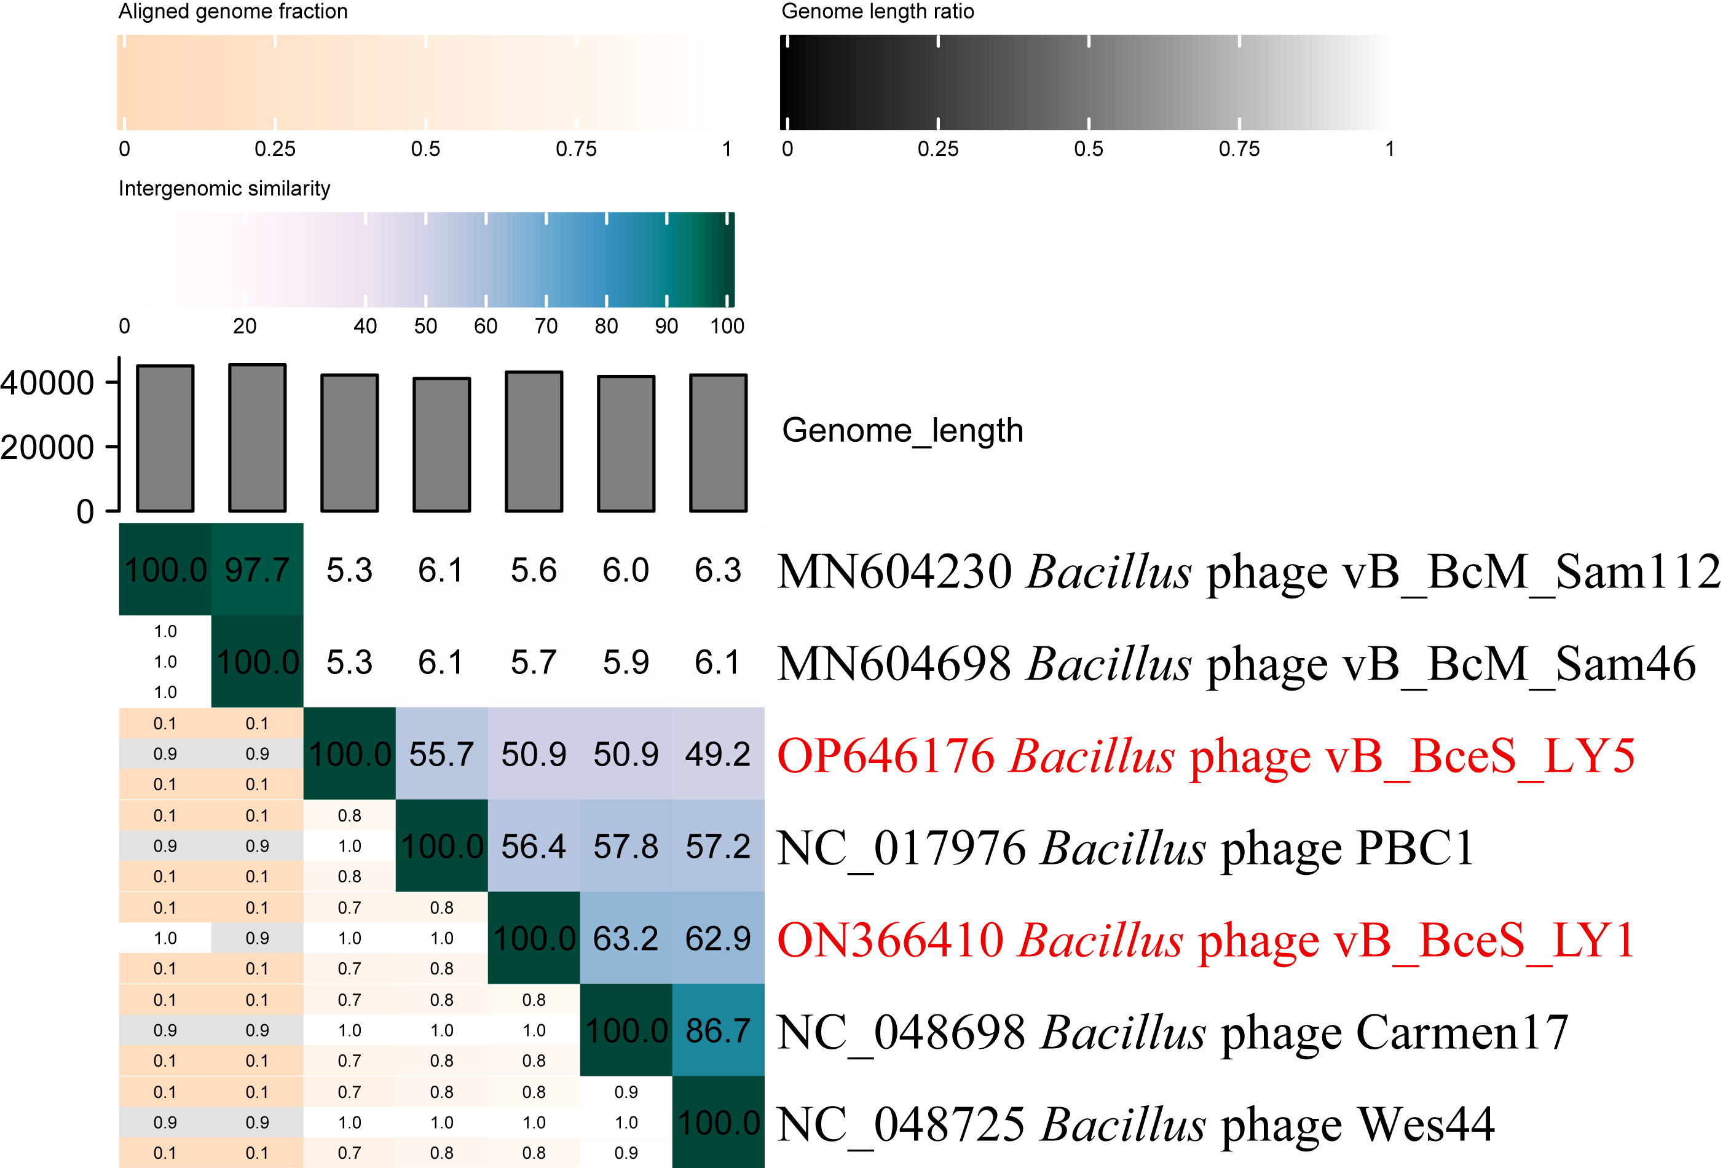

Figure 1. The heat map by VIRIDIC analysis

vConTACT2 analysis: vConTACT2 [3] is a network based on the shared proteins for virus classification. There are 19,790 phages (nodes) in Figure 2A, which show 911,770 relationships between them (connecting lines), and 35 phages with association with phage vB_BceS_LY1 and vB_BceS_LY5 were selected for analysis (Figure 2B). The phage vB_BceS_LY1 and vB_BceS_LY5 both belong to VC_865_0 and has a strong association (socre >100) with the Carmenvirus (Carmen17 and Wes44) and Pebcunavirus (PBC1) phage belonging to the subfamily Gutmannvirinae within it.

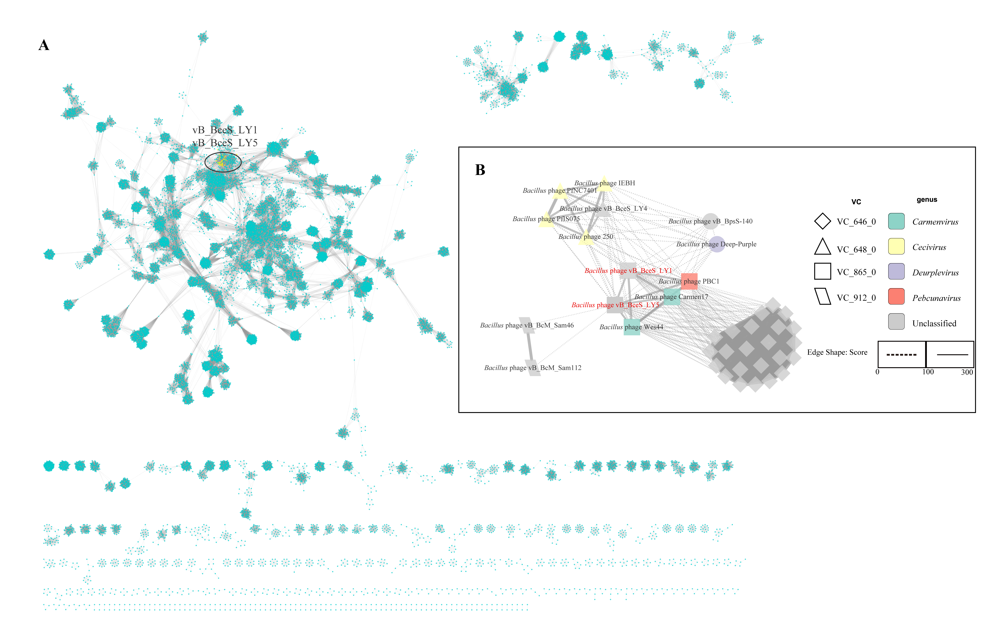
Figure 2. The gene sharing networks analysis

Phylogenetic analysis: Phylogenetic tree was conducted using the maximum likelihood estimation method in IQ-TREE by terminase large subunit(terL). It showed that phage vB_BceS_LY1 and vB_BceS_LY5 was distinguished from Carmenvirus (Carmen17, Wes44) and Pebcunavirus (PBC1). In conclusion, we recommend establishing two genera (Layangavirus and Layangbvirus) within the subfamily Gutmannvirinae.

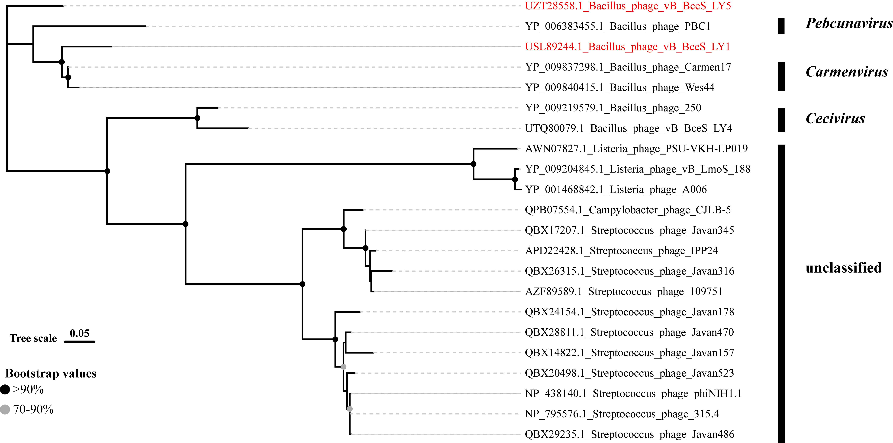
Figure 3. Phylogenetic tree of phage vB_BceS_LY1 and vB_BceS_LY5 based on the terminase large subunit

GenBank Summary:

Phage name | INSDC | Size (Kb) | GC% | Protein | tRNAs
Bacillus phage vB_BceS_LY1 | ON366410 | 43.1 | 42.36 | 57 | 0
Bacillus phage vB_BceS_LY5 | OP646176 | 42.2 | 42.37 | 53 | 0

References
- Timoshina OY, Shneider MM, Evseev PV, Shchurova AS, Shelenkov AA, Mikhaylova YV, Sokolova OS, Kasimova AA, Arbatsky NP, Dmitrenok AS, Knirel YA, Miroshnikov KA, Popova AV. Novel Acinetobacter baumannii Bacteriophage Aristophanes Encoding Structural Polysaccharide Deacetylase. Viruses. 2021 Aug 26;13(9):1688. doi: 10.3390/v13091688. PMID: 34578271; PMCID: PMC8471582.
- Moraru C, Varsani A, Kropinski AM. VIRIDIC-A Novel Tool to Calculate the Intergenomic Similarities of Prokaryote-Infecting Viruses. Viruses. 2020 Nov 6;12(11):1268. doi: 10.3390/v12111268. PMID: 33172115; PMCID: PMC7694805.
- Bin Jang H, Bolduc B, Zablocki O, et al. Taxonomic assignment of uncultivated prokaryotic virus genomes is enabled by gene-sharing networks. Nat Biotechnol. 2019;37(6):632-639. doi:10.1038/s41587-019-0100-8 PMID: 31061483

