

Part 1: TITLE, AUTHORS, APPROVALS, etc

Code assigned: | 2023.041B
Short title: Create one new genus (Keyvirus) including two new species in the family Demerecviridae
Author(s) and email address(es)
Zlatohurska MA, Gorb TY, Romaniuk LV, Shenderovska NA, Faidiuk YV, Kropinski AM, Kushkina AI, Tovkach FI | zlatohurska@gmail.com; tanyagorb@gmail.com; lyuromanyuk@gmail.com;  Nataliia.Korol@uf.ua;  i.v.faidiuk@gmail.com; phage.Canada@gmail.com; a.kushkina@gmail.com; fedir.i.tovkach@gmail.com
Author(s) institutional address(es) (optional)
D. K. Zabolotny Institute of Microbiology and Virology, National Academy of Sciences of Ukraine, Ukraine [ZMA, GTY, RLV, SNA, FYV, KAI, TFI]
Pharmaceutical Corporation YURiA-PHARM, Ukraine [SNA]
Taras Shevchenko National University of Kyiv, Ukraine [FYV]
University of Guelph, Canada [AMK]

Corresponding author
Zlatohurska MA
List the ICTV Study Group(s) that have seen this proposal

Caudoviricetes Study Group

ICTV Study Group comments and response of proposer

ICTV Study Group votes on proposal

Study Group | Number of members
Study Group | Votes support | Votes against | No vote
Authority to use the name of a living person

Is any taxon name used here derived from that of a living person (Y/N) | N

Taxon name | Person from whom the name is derived | Permission attached (Y/N)

Submission dates
Date first submitted to SC Chair | 12 Aug 2022
Date of this revision (if different to above)
ICTV-EC comments and response of the proposer

Part 2: NON-TAXONOMIC PROPOSAL
Text of proposal

Part 3: TAXONOMIC PROPOSAL
Name of accompanying Excel module
2023.041B.A.v1.Keyvirus_ng.xlsx
Abstract
Here we create one new genus comprising two new species in the family Demerecviridae.

Text of proposal
The new genus contains two species ‒ Erwinia phage Key and Pantoea phage AAS21. Phage Key was isolated from quince samples with symptoms of fire blight collected during the period of active plant vegetation in the Zakarpattia region of Ukraine in 2012 [1, 2]. Phage AAS21 was originally isolated from the outwash of jostaberries collected in Lithuania in 2017 [3].

We have used 95% DNA sequence identity as the criterion for species demarcation in genus [4]. According to the scored phylogenomic distances calculated using VIRIDIC, Key and AAS21 phages shared 92.2% nucleotide identity over the entire genome length, while the maximum similarity between them and other phages was about 30%.

As supported by the phylogenetic analyses based on concatenated amino acid sequences of conserved phage proteins and whole-genome comparison, phages Key and AAS21 were not grouped into clusters with known T5-like phages forming a separate branch.

Phage AAS21 was published first [3]. Its name seems too complicated in pronunciation, so we propose to name the new genus after the second representative, the phage Key. This virus was called so because the curved form of its tail resembled authors a key to the lock. From another point, the initial phage isolate was heterogeneous and phage Key was the dominant representative (“a key factor”).

Supporting evidence
VIRIDIC analysis. The nucleotide identity of Key, AAS21 and other T5-like phages was analyzed using VIRIDIC with default settings [5].
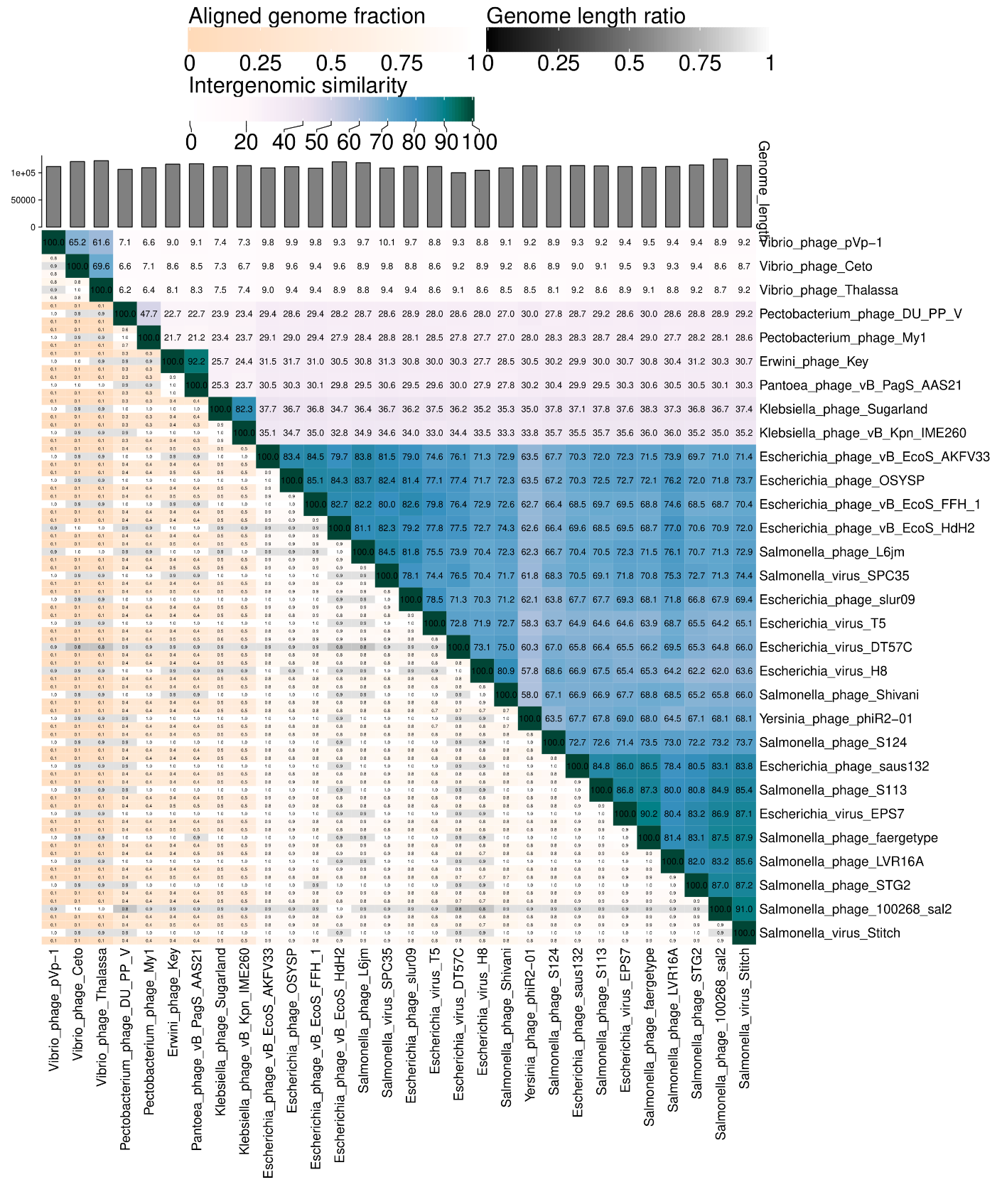

Phylogeny. The genome-based phylogeny of phages Key, AAS21 and 28 representatives of the family Demerecviridae was performed by VICTOR [6].
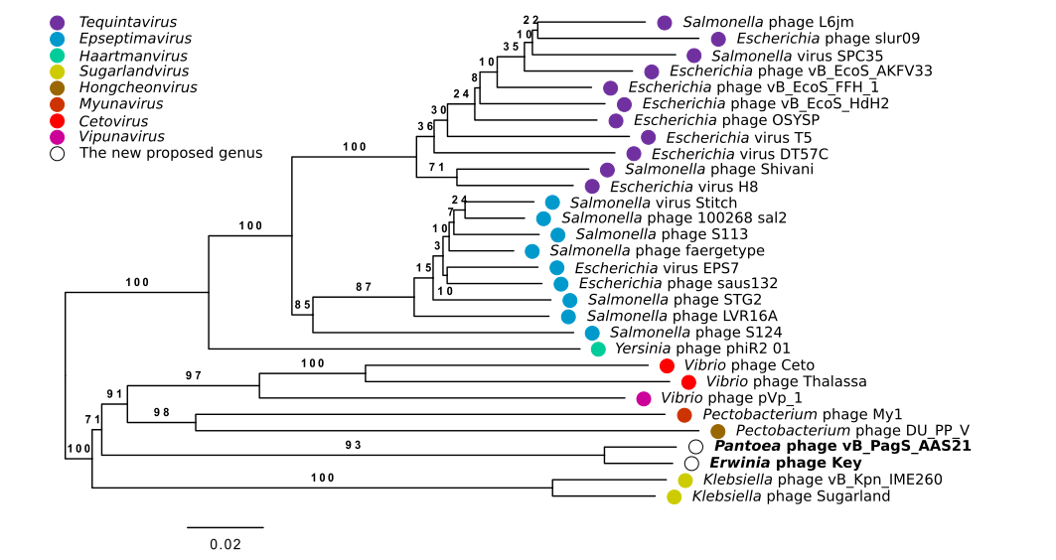
Phylogenetic analysis of studied phages was also carried out based on comparison of concatenated amino acid sequences of conserved phage proteins commonly used as the phylogenetic markers, namely the terminase large subunit protein, portal protein, and major capsid protein [7]. Phylogenetic trees were created in MEGA XI with the maximum likelihood algorithm after alignment with Clustal W and evaluated with the bootstrap test (500) [8].
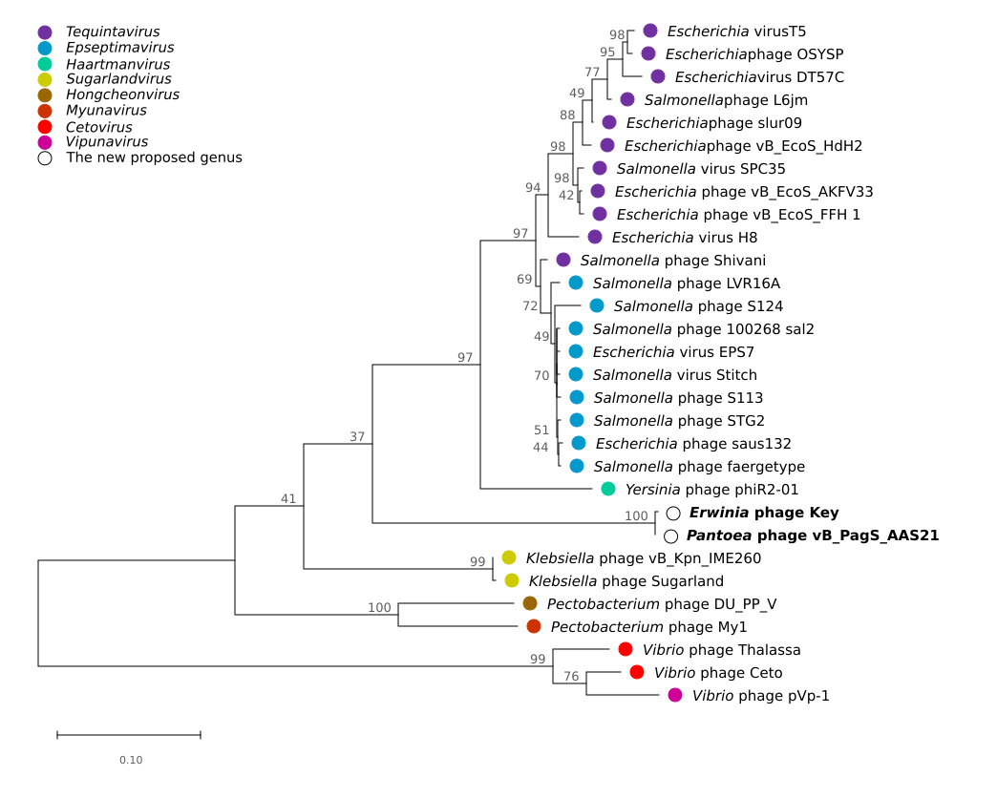
GenBank Summary:

Species name | Phage name | Accession | Size (KB) | GC% | Protein | tRNA
Keyvirus AAS21 | Pantoea phage vB_PagS_AAS21 | MK770119.1 | 116.649 | 39.01 | 213 | 29
Keyvirus Key | Erwinia phage Key | MZ616364 | 115.651 | 39.03 | 182 | 27

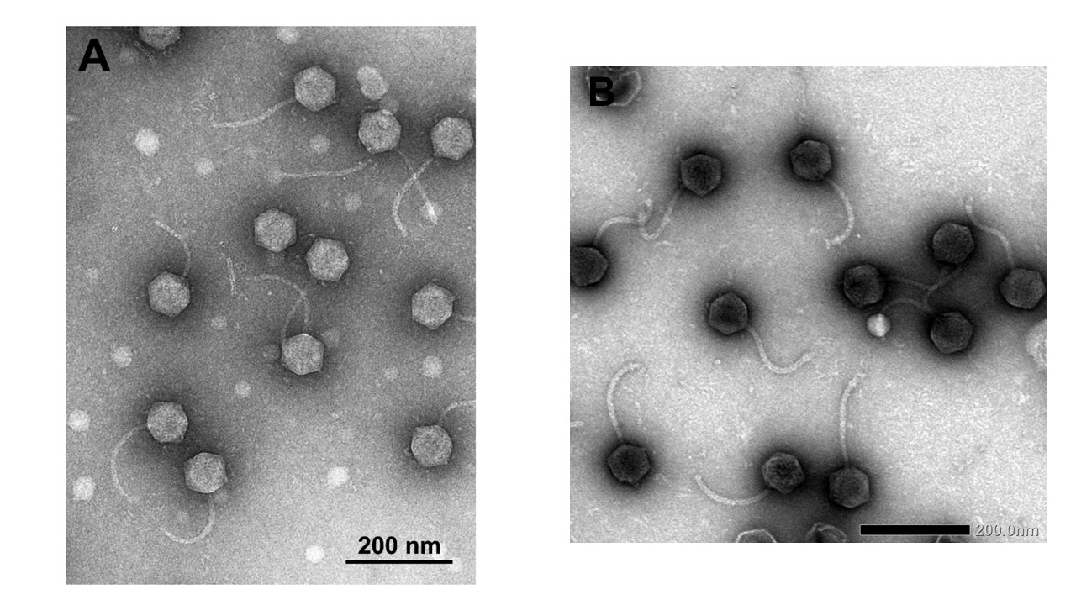
Electron micrograph: Electron micrographs of negatively stained Pantoea phage vB_PagS_AAS21 (A) and Erwinia phage Key (B). The TEM photo of the AAS21 virions was adopted from [3].

References
1. Tovkach F, Moroz S, Korol N, et al (2013) Polyvalence of bacteriophages isolated from fruit trees, affected by bacterial fire blight. Microbiol Zh 75:80–88. PMID: 23720968
2. Tovkach F, Faidiuk I, Korol N, et al (2013) Electron microscopy and restriction analysis of bacteriophages isolated from quince and pear with symptoms of fire blight. Microbiol Zh 75:67–75. PMID: 24479316
3. Šimoliūnienė M, Truncaitė L, Petrauskaitė E, et al (2020) Pantoea agglomerans-Infecting Bacteriophage vB_PagS_AAS21: A Cold-Adapted Virus Representing a Novel Genus within the Family Siphoviridae. Viruses 12:1–8. https://doi.org/10.3390/v12040479
4. Turner D, Kropinski AM, Adriaenssens EM (2021) A Roadmap for Genome-Based Phage Taxonomy. Viruses 13:506. https://doi.org/10.3390/v13030506
5. Moraru C, Varsani A, Kropinski AM (2020) VIRIDIC—A Novel Tool to Calculate the Intergenomic Similarities of Prokaryote-Infecting Viruses. Viruses 12:1268. https://doi.org/10.3390/v12111268
6. Meier-Kolthoff JP, Göker M (2017) VICTOR: genome-based phylogeny and classification of prokaryotic viruses. Bioinformatics 33:3396–3404. https://doi.org/10.1093/bioinformatics/btx440
7. Adriaenssens EM, Cowan DA (2014) Using signature genes as tools to assess environmental viral ecology and diversity. Appl Environ Microbiol 80:4470–4480. https://doi.org/10.1128/AEM.00878-14
8. Tamura K, Stecher G, Kumar S (2021) MEGA11: Molecular Evolutionary Genetics Analysis Version 11. Mol Biol Evol 38:3022–3027. https://doi.org/10.1093/molbev/msab120

