

Part 1: TITLE, AUTHORS, APPROVALS, etc

Code assigned: | 2023.021B
Short title: To create one genus, Efunavirus, containing two species in the class Caudoviricetes
Author(s) and email address(es)
Buttimer C, Murray E, Kropinski AM, Turner D, Draper L-A, Ross R-P, Hill C | colin.buttimer@ucc.ie; 114308696@umail.ucc.ie; phage.canada@gmail.com; Dann2.Turner@uwe.ac.uk; l.draper@ucc.ie; p.ross@ucc.ie; c.hill@ucc.ie
Author(s) institutional address(es) (optional)
Biosciences Building, University College Cork, Ireland [CB, EM, RPR, CH]
Departments of Pathobiology, University of Guelph, Guelph, Ontario, Canada [AMK]
Department of Applied Sciences, University of the West of England, Bristol, UK [DT]
Corresponding author
C Buttimer
List the ICTV Study Group(s) that have seen this proposal
ICTV Study Group comments and response of proposer
ICTV Study Group votes on proposal
Study Group | Number of members
Study Group | Votes support | Votes against | No vote
Authority to use the name of a living person
Is any taxon name used here derived from that of a living person (Y/N) | N

Taxon name | Person from whom the name is derived | Permission attached (Y/N)
Submission dates
Date first submitted to SC Chair | May 2023
Date of this revision (if different to above)
ICTV-EC comments and response of the proposer

Part 2: NON-TAXONOMIC PROPOSAL
Text of proposal

Part 3: TAXONOMIC PROPOSAL
Name of accompanying Excel module
2023.021B.N.v1.Efunavirus_ng.xlsx
Abstract

Here, we propose the creation of a new genus, Efunavirus, comprising two new species within the class Caudoviricetes. This proposal is based on genomic-based comparisons.

Text of proposal
Source of the names used for taxa:
Efunavirus: The name of the genus is derived from the name given to the first example of this phage isolated, namely Enterococcus phage EF1.

Species demarcation criteria:
In this proposal, we have chosen 95% DNA sequence identity as the criterion for the demarcation of a species. Each proposed species genome differs by more than 5% in nucleotide identity as determined by the BLASTN algorithm (Table 1). Based on the above criteria, we have classed Enterococcus phage EF5 (accession no. MF001361) as a strain of Enterococcus phage EF1.
Genus demarcation criteria:
Phylogenetic analysis indicates that phages Enterococcus phages EF1 and H1 represent species that form a cohesive and distinct genus within the class Caudoviricetes (Table 1, Figures 2-4). Analysis with VIPtree allowed the construction of a proteomic tree utilizing 517 genomes. This analysis shows that EF1-like phages are phylogenetically related to a clade of phages with genomes exceeding 100 kbp and possessing a siphovirus virion morphology, such as found with members of the genus Audreyjarvisvirus (figure 2). However, this relationship appears to be distant, as indicated by proteome analysis of these phages using Gegenees (TBLASTX) with low identity values (Figure 3). The position of phage EF1 and H1 within this clade was further confirmed with analysis with VICTOR (Figure 4). Gene synteny can be found between genomes of phage EF1 and H1, with limited gene synteny observed between these phages and those of Audreyjarvisvirus. In the latter case, gene synteny appears to be mostly limited to genes with gene products associated with the formation of the phage virion (Figure 5).
Examination of the virions of Enterococcus phage H1 by transmission electron microscopy (TEM) shows they possess a siphovirus morphology with the B1 morphotype [1]. The capsid of the virion is icosahedral (88.98 ± 0.79 nm in diameter) with distinguishable hexagonal outlines with a very long flexible, non-contractile tail (441.26 ± 5.54 nm in length) terminating with a knob-like base plate structure (Figure 1) [2].

Supporting evidence

History:

Isolation source of the phages forming the proposed genus Efunavirus:
- The isolation source of Enterococcus phage EF1 & EF5 is unknown. No details are provided in their GenBank files, and no publication currently exists that describes them.
- Enterococcus phage H1 was isolated from human faeces [2].

Electron micrograph:

Figure 1. Transmission electron micrographs of negatively stained Enterococcus phage H1 using uranyl acetate (0.5%) [2].

GenBank Summary:

Table 1. Properties of the two phages representing the species belonging to the genus Efunavirus

phage | INSDC Accession no | GC% | Genome length (bp) | Number of ORFs | Number of tRNA genes | Nucleotide Identity (%)* | % Common proteins**
Enterococcus phage EF1 | MF001358 | 32 | 141,996 | 172 | 14 | 100 | 100
Enterococcus phage H1 | OP534061 | 32 | 138,084 | 167 | 19 | 86 | 84

* Determined using BLASTN [3]; ** Determined using CoreGenes 5 [4]

Phylogeny:

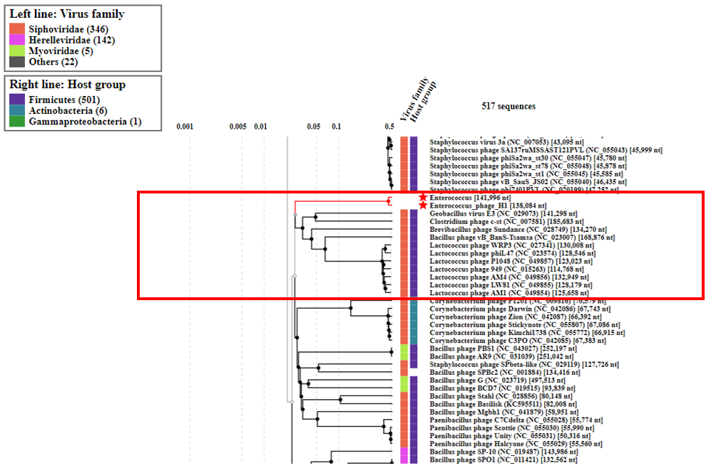
Figure 2. (A) A subsection of a ViPTree phylogram using phage genomes of 517 genome sequences of the tree showing the clade of phages phylogenetic related to phage H1 (highlighted in red) [5].

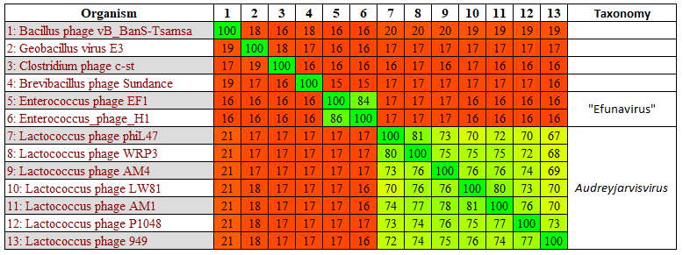
Figure 3. TBLASTX heat map generated using Gegenees with accurate parameters – fragment length: 200 bp; and step size: 100 kbp [6]. The map includes the genomes of Enterococcus phage H1 and siphovirus phages with genomes exceeding 100 kbp.

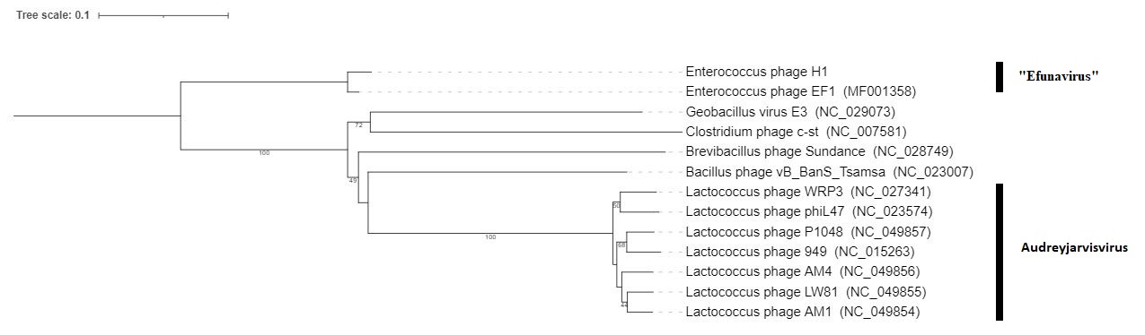

Figure 4. VICTOR-generated phylogenomic Genome-BLAST Distance Phylogeny (GBDP) trees of Enterococcus phage H1 and siphovirus phages with genomes exceeding 100 kbp using the formula D4 and yielding average support of 58% [7]. The numbers above branches are GBDP pseudo-bootstrap support values from 100 replications. Members of the genus Audreyjarvisvirus are illustrated.

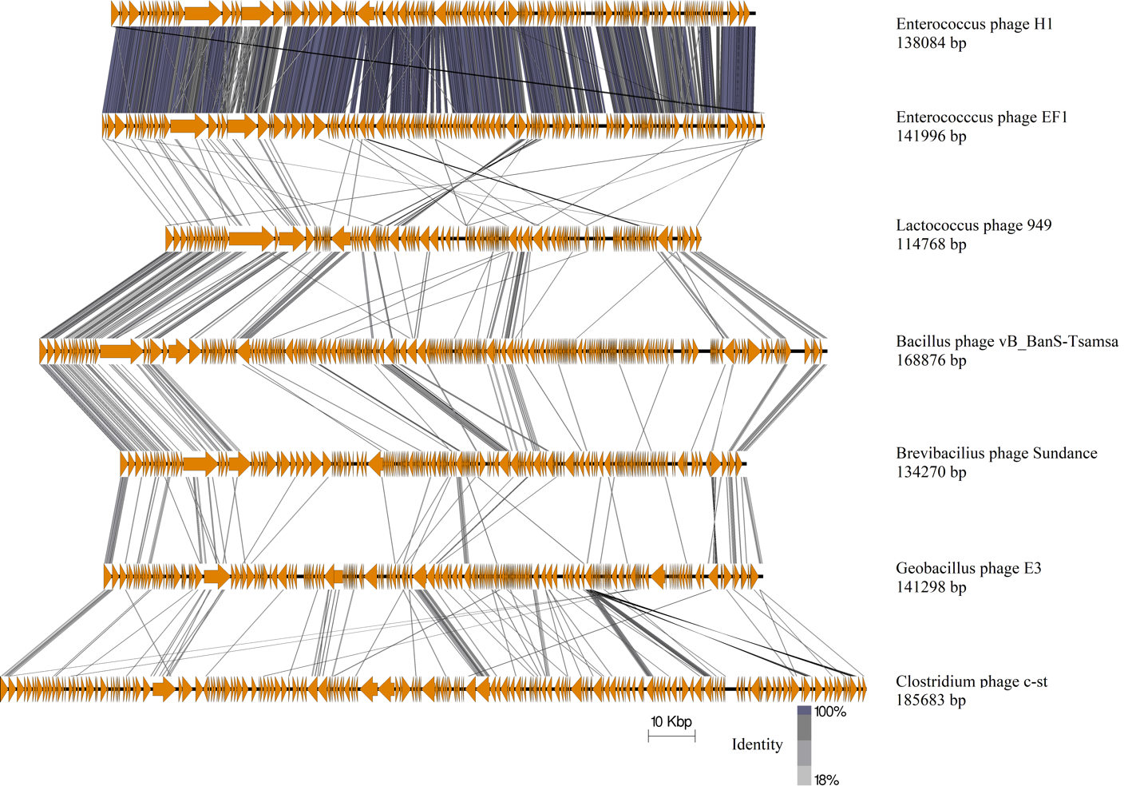
Figure 5. Pairwise comparison of the type phages representing six genera of Enterococcus phage H1 and EF1 with distantly related phages with virions with a siphovirus morphology and with genomes exceeding 100 kbp in size. Genomic maps were created using currently available annotation from Genbank with comparisons employing TBLASTX and visualization with Easyfig [8]. The genome maps display arrows indicating the locations and orientation of ORFs. Lines between genome maps indicate the level of identity. The large terminase was set as the first gene among all genomes. The genome size of all phages is illustrated.

References
1. Ackermann HW (2001) Frequency of morphological phage descriptions in the year 2000. Brief review. Arch Virol 146:843–57
2. Murray E, Buttimer C, Bolocan A, et al LysH1 of Enterococcus phage H1: a member of the newly proposed genus of “Efunavirus” In preparation.
3. Altschul SF, Gish W, Miller W, et al (1990) Basic local alignment search tool. J Mol Biol 215:. https://doi.org/10.1016/S0022-2836(05)80360-2
4. Turner D, Reynolds D, Seto D, Mahadevan P (2013) CoreGenes3.5: a webserver for the determination of core genes from sets of viral and small bacterial genomes. BMC Res Notes 6:140. https://doi.org/10.1186/1756-0500-6-140
5. Nishimura Y, Yoshida T, Kuronishi M, et al (2017) ViPTree: The viral proteomic tree server. Bioinformatics 33:2379–2380. https://doi.org/10.1093/bioinformatics/btx157
6. Ågren J, Sundström A, Håfström T, Segerman B (2012) Gegenees: fragmented alignment of multiple genomes for determining phylogenomic distances and genetic signatures unique for specified target groups. PLoS One 7:e39107. https://doi.org/10.1371/journal.pone.0039107
7. Meier-Kolthoff JP, Göker M (2017) VICTOR: genome-based phylogeny and classification of prokaryotic viruses. Bioinformatics 33:3396–3404. https://doi.org/10.1093/bioinformatics/btx440
8. Sullivan MJJ, Petty NKK, Beatson SAA (2011) Easyfig: a genome comparison visualizer. Bioinformatics 27:1009–1010. https://doi.org/10.1093/bioinformatics/btr039
9. O'Leary NA, Wright MW, Brister JR, Ciufo S, Haddad D, McVeigh R, et al. Reference sequence (RefSeq) database at NCBI: current status, taxonomic expansion, and functional annotation. Nucleic Acids Res. 2016;44(D1):D733-45. doi: 10.1093/nar/gkv1189. PMID: 26553804.
10. Sayers EW, Beck J, Bolton EE, Bourexis D, Brister JR, Canese K, Comeau DC, Funk K, Kim S, Klimke W, Marchler-Bauer A, Landrum M, Lathrop S, Lu Z, Madden TL, O'Leary N, Phan L, Rangwala SH, Schneider VA, Skripchenko Y, Wang J, Ye J, Trawick BW, Pruitt KD, Sherry ST. Database resources of the National Center for Biotechnology Information. Nucleic Acids Res. 2021 Jan 8;49(D1):D10-D17. doi: 10.1093/nar/gkaa892. PMID: 33095870

