

Part 1: TITLE, AUTHORS, APPROVALS, etc

Code assigned: | 2023.015B
Short title: Create one new family (Chimalliviridae) in the class Caudoviricetes

Author(s) and email address(es)
Prichard A, Lee J, Pogliano J | aprichar@ucsd.edu; jil143@ucsd.edu; jpogliano@ucsd.edu
Author(s) institutional address(es) (optional)
Univeristy of California, San Diego [AP, JL, JP]

Corresponding author
Joe Pogliano

List the ICTV Study Group(s) that have seen this proposal
ICTV Study Group comments and response of proposer
ICTV Study Group votes on proposal

Study Group | Number of members
Study Group | Votes support | Votes against | No vote
Authority to use the name of a living person
Is any taxon name used here derived from that of a living person (Y/N) | N

Taxon name | Person from whom the name is derived | Permission attached (Y/N)

Submission dates
Date first submitted to SC Chair | 4 June 2023
Date of this revision (if different to above)
ICTV-EC comments and response of the proposer
Part 2: NON-TAXONOMIC PROPOSAL
Text of proposal

Part 3: TAXONOMIC PROPOSAL
Name of accompanying Excel module
2023.015B.N.v1.Chimalliviridae_nf.xlsx
Abstract
The recent discovery of nucleus-forming phages has prompted many questions as to how widespread their unique replication strategy may be and whether these phages are phylogenetically related. The initial discovery of the phage nucleus was made in phages related to PhiKZ (binomial classification: Phikzvirus phiKZ) [1, 2], but more and more examples of diverse nucleus-forming phages are being characterized each year (PCH45 (no binomial classification) [3], Goslar (Goslarvirus goslar) [4], and RAY (Agricanvirus ray) [5]). To determine whether nucleus-forming phages share a common ancestry, we analyzed their phylogeny and compared their genomes. We found that they are indeed related and share a core genome. Based on this core genome and phylogenetic data, we propose that the nucleus-forming phages belong to a viral family which we call Chimalliviridae after the major phage nuclear shell protein (chimallin) that is part of the core genome these phages all share.
Text of proposal
The main defining characteristics of the proposed family Chimalliviridae are that the members of this group encode a shared core genome, and they cluster together in a monophyletic clade in trees made using whole genome data [5]. The core genome and phylogenetic clustering are described in more detail below.

The etymology of “Chimalliviridae” is from “chimallin” which is the major protein important for phage nucleus formation [6] and the unique phage replication mechanism currently characterized members of this group exhibit [1–5]. The name “chimallin” itself is derived from “chīmalli” (pronounced “chee-MAL-ey”), the ancient Aztec shield [6, 7], due to its role in protecting phage DNA from host defenses [3, 8, 9].

Supporting evidence
Rationale
With more and more work focusing on a group of phages known as the nucleus-forming “jumbo” phages in recent years, some researchers have proposed that these phages may belong to a distinct family. It has been difficult to differentiate work on nucleus-forming phages from work on canonically replicating large-genome phages as these groups of phages have all been colloquially referred to as “jumbo phages” due to the average sizes of their genomes being over 200kb. Since phages with genome sizes over 200kb are genetically diverse and clearly not one related group, we are seeking to provide some organization to this field by using what we know about nucleus-forming phages to propose the existence of a new viral family that we call Chimalliviridae.
Initial research revealed that nucleus-forming phages encode a major nuclear shell protein that makes up the phage nucleus [1–3] which was later characterized [6, 10] and found in diverse phages to assemble into similar lattice structures surrounding the phage genome during the replication cycle [4–6]. This protein is known as chimallin or ChmA [6]. At first, we suspected that chimallin would be widespread among unrelated phages, similar to phage-encoded tubulin PhuZ or multi-subunit RNA polymerases [11]. However, when we used PSI-BLAST to identify phages with homologs of chimallin, all phage encoding homologs of this protein were found to cluster together in whole-genome trees created with VICTOR [12] (Figure 1) and forms one monophyletic clade when compared with all phages available in the database used by ViPTree [13] (Figure 2).

Phylogenetic Analysis and Core Genome Determination
The phylogenetic clustering of all phages encoding chimallin homologs made us wonder if the diverse nucleus-forming phages that have been studied so far represent just a subset of a viral family that might use this same phage replication strategy. We used PSI-BLAST to identify homologs of every gene in the genomes of these phages and discovered that there are 72 genes from Agricanvirus ray (common name: RAY) conserved in 90% of these phages, from which we can start to identify a shared core genome [5]. We began our work with RAY because it is genetically divergent from the well-studied PhiKZ-like viruses, and we wanted to avoid any bias that may come from starting with a known group of related nucleus-forming phages. The core genome we identified consists of 68 non-homologous genes that are found in seven distinct blocks throughout the genomes of the phages we analyzed [5]. These blocks are encoded in the same order in these phages’ genomes, showing that members of this clade share conserved genome organization. Looking into these core genes further, we found that 21 of them are unique to the proposed family Chimalliviridae, and we speculate that these 21 genes are important for replicating via the phage nucleus pathway, although since these genes have unknown functions, it is impossible to predict with certainty whether all members of this clade indeed form a phage nucleus during their replication cycle [5]. Regardless of replication mechanism, due to their monophyletic clustering (Figures 1 & 2) and shared core genes [5, 14], we propose that they form a viral family.

Membership of the new family Chimalliviridae and taxonomic changes
All phages that we identified as members of the new family were already assigned to genera. In this proposal, we suggest that 19 existing genera and their members be moved from the unclassified Caudoviricetes into the new family. The genera Aphroditevirus and Tidunavirus are currently assigned to the subfamily Gorgonvirinae which we propose to move into the new family as well.
Genera to be moved: Agricanvirus, Goslarvirus, Moabitevirus, Iapetusvirus, Phikzvirus, Noxifervirus, Chiangmaivrius, Ripduovirus, Erskinevirus, Seoulvirus, Machinavirus, Wellingtonvirus, Derbicusvirus, Aphroditevirus, Tidunavirus, Risingsunvirus, Elvirus, Petsuvirus, Takahashivirus

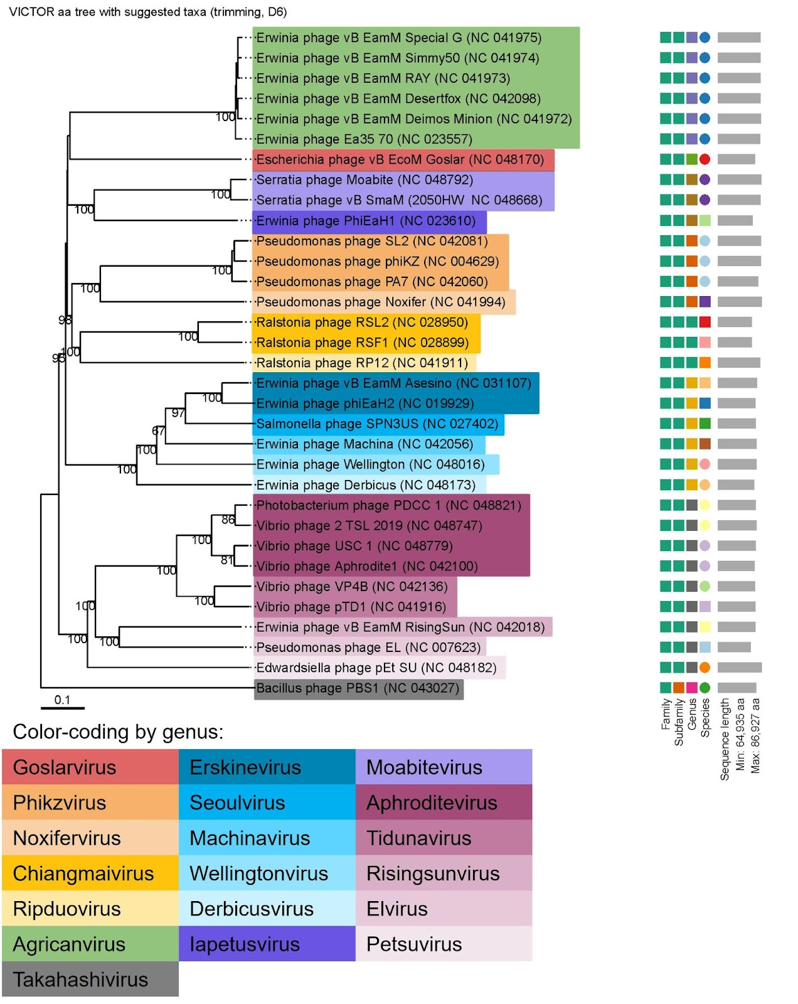
Figure 1. Phylogenetic tree made with VICTOR [12] of all phages currently recognized by the ICTV that encode chimallin homologs. Takahashivirus PBS1 (which does not encode a chimallin homolog) was used as an outgroup since it shares some genetic similarity with the chimalllin-encoding phages [15] such as the msRNAP subunits [11], but it does not share the conserved genome organization or the identified core genome of the chimalliviruses [5]. Bootstrap values are shown on the branches.

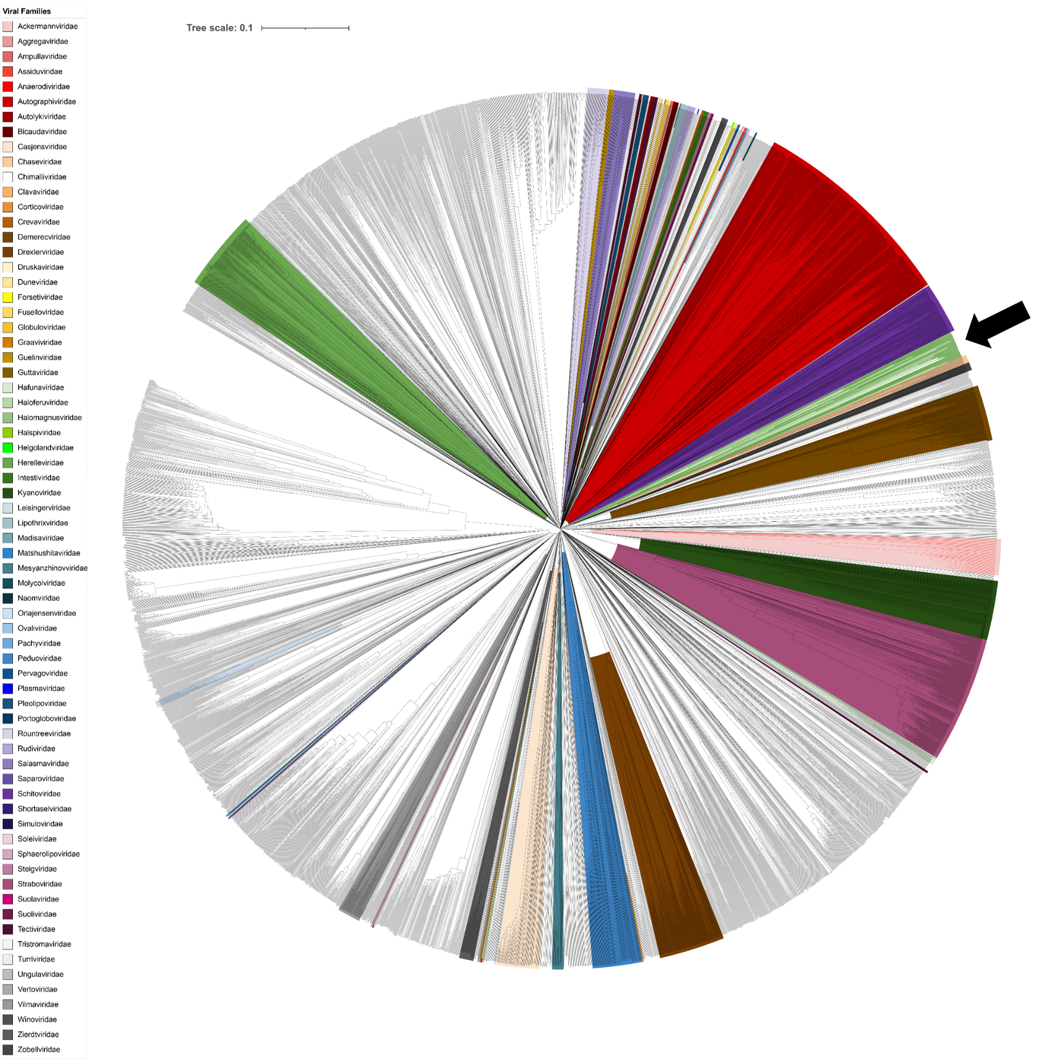
Figure 2. Tree of all phages from ViPTree annotated by family [13]. The proposed Chimalliviridae family is not highlighted, but the branches are colored in green and an arrow is pointing to the Chimalliviridae clade. The branching length of the Chimalliviridae is similar to nearby families such as the Autographiviridae and Schitoviridae. This tree was annotated in iTOL [16]. Branch labels are not shown as there are too many to be legible.

References
1. Chaikeeratisak V, Nguyen K, Khanna K, et al (2017) Assembly of a nucleus-like structure during viral replication in bacteria. Science 355:194–197. https://doi.org/10.1126/science.aal2130
2. Chaikeeratisak V, Nguyen K, Egan ME, et al (2017) The Phage Nucleus and Tubulin Spindle Are Conserved among Large Pseudomonas Phages. Cell Rep 20:1563–1571. https://doi.org/10.1016/j.celrep.2017.07.064
3. Malone LM, Warring SL, Jackson SA, et al (2020) A jumbo phage that forms a nucleus-like structure evades CRISPR-Cas DNA targeting but is vulnerable to type III RNA-based immunity. Nat Microbiol 5:48–55. https://doi.org/10.1038/s41564-019-0612-5
4. Birkholz EA, Laughlin TG, Armbruster E, et al (2022) A cytoskeletal vortex drives phage nucleus rotation during jumbo phage replication in E. coli. Cell Rep 40:111179. https://doi.org/10.1016/j.celrep.2022.111179
5. Prichard A, Lee J, Laughlin TG, et al (2023) Identifying the core genome of the nucleus-forming bacteriophage family and characterization of Erwinia phage RAY. Cell Rep 42:112432. https://doi.org/10.1016/j.celrep.2023.112432
6. Laughlin TG, Deep A, Prichard AM, et al (2022) Architecture and self-assembly of the jumbo bacteriophage nuclear shell. Nature 608:429–435. https://doi.org/10.1038/s41586-022-05013-4
7. Knipe DM, Prichard A, Sharma S, Pogliano J (2022) Replication Compartments of Eukaryotic and Bacterial DNA Viruses: Common Themes Between Different Domains of Host Cells. Annu Rev Virol 9:307–327. https://doi.org/10.1146/annurev-virology-012822-125828
8. Mendoza SD, Nieweglowska ES, Govindarajan S, et al (2020) A bacteriophage nucleus-like compartment shields DNA from CRISPR nucleases. Nature 577:244–248. https://doi.org/10.1038/s41586-019-1786-y
9. Nguyen KT, Sugie J, Khanna K, et al (2021) Selective transport of fluorescent proteins into the phage nucleus. PLoS One 16:e0251429. https://doi.org/10.1371/journal.pone.0251429
10. Nieweglowska ES, Brilot AF, Méndez-Moran M, et al (2022) The ϕPA3 Phage Nucleus is Enclosed by a Self-Assembling, 2D Crystalline Lattice. bioRxiv 2022.04.06.487387
11. Sokolova ML, Misovetc I, Severinov K V (2020) Multisubunit RNA Polymerases of Jumbo Bacteriophages. Viruses 12.: https://doi.org/10.3390/v12101064
12. Meier-Kolthoff JP, Göker M (2017) VICTOR: genome-based phylogeny and classification of prokaryotic viruses. Bioinformatics 33:3396–3404. https://doi.org/10.1093/bioinformatics/btx440
13. Nishimura Y, Yoshida T, Kuronishi M, et al (2017) ViPTree: the viral proteomic tree server. Bioinformatics 33:2379–2380. https://doi.org/10.1093/bioinformatics/btx157
14. Jang HB, Fagutao FF, Nho SW, et al (2013) Phylogenomic network and comparative genomics reveal a diverged member of the ΦKZ-related group, marine vibrio phage ΦJM-2012. J Virol 87:12866–12878. https://doi.org/10.1128/JVI.02656-13
15. Iyer LM, Anantharaman V, Krishnan A, et al (2021) Jumbo Phages: A Comparative Genomic Overview of Core Functions and Adaptions for Biological Conflicts. Viruses 13.: https://doi.org/10.3390/v13010063
16. Letunic I, Bork P (2021) Interactive Tree Of Life (iTOL) v5: an online tool for phylogenetic tree display and annotation. Nucleic Acids Res 49:W293–W296. https://doi.org/10.1093/nar/gkab301

