

Part 1: TITLE, AUTHORS, APPROVALS, etc

Code assigned: | 2023.003B
Short title: To create twenty-five (25) new Actinobacteriophage genera [Caudoviricetes]
Author(s) and email address(es)
Kurtböke I, Turner D, Moraru C, Tolstoy I, Kropinski AM | IKurtbok@usc.edu.au; Dann2.Turner@uwe.ac.uk; liliana.cristina.moraru@uol.de; tolstoy@ncbi.nlm.nih.gov; Phage.Canada@gmail.com
Author(s) institutional address(es) (optional)

University of the Sunshine Coast, Queensland, Australia [IK]
University of the West of England, Bristol, UK [DT]
Carl von Ossietzky Universität Oldenburg, Germany [CM]
National Center for Biotechnology Information, MD, USA [IT]
University of Guelph, Ontario, Canada [AMK]

Corresponding author
Andrew M. Kropinski
List the ICTV Study Group(s) that have seen this proposal

Actinophage Study Group

ICTV Study Group comments and response of proposer

ICTV Study Group votes on proposal

Study Group | Number of members
Study Group | Votes support | Votes against | No vote
Authority to use the name of a living person

Is any taxon name used here derived from that of a living person (Y/N) | N

Taxon name | Person from whom the name is derived | Permission attached (Y/N)

Submission dates
Date first submitted to SC Chair | May 2023
Date of this revision (if different to above)
ICTV-EC comments and response of the proposer
Part 2: NON-TAXONOMIC PROPOSAL
Text of proposal

Part 3: TAXONOMIC PROPOSAL
Name of accompanying Excel module
2023.003B.A.v1.Actinobacteriophage_singletons_25ng.xlsx

Abstract
In this proposal, we have classified singleton members of the Actinobacteriophage database, i.e. phages with no discernible genome similarity to other phages, into 25 new genera and species.
Text of proposal
The phages in this proposal were all identified as singletons in the Actinobacteriophage database, which means they have no show no nucleotide identity to other published phages and cannot be classified into known species and genera.

Species demarcation criteria: Two phages are assigned to the same species if their genomes are more than 95% identical over their genome length for isolates.
These values can be calculated by a number of tools, such as BLASTn [1,2] – usually calculated using intergenomic distance calculator VIRIDIC [3].

Genus demarcation criteria: In search for criteria that create cohesive and distinct genera that are reproducible and monophyletic, the Bacterial Viruses Subcommittee has established 70% nucleotide identity of the genome length as the cut-off for genera. Genus-level groupings should always be monophyletic in the signature genes, as tested with a phylogenetic tree [10].

Supporting evidence

- To create a new single-species genus, Chewyvirus

Origin of the name of this taxon: The name of this taxon derives directly from the name of the first virus of its type Rhodococcus phage ChewyVIII

Historical aspects: This lytic siphophage was isolated from soil against Rhodococcus erythropolis RIA 643 by Jordan Wagner (University of Louisiana at Monroe, LA USA) as part of the Science Education Alliance-Phage Hunters Advancing Genomics and Evolutionary Science program. The genome has 10 nt 3’-cohesive termini (CACCACGTGC). The Actinobacteriophage Database considers this phage to be a singleton.

Electron micrograph: N/A

Genome summary:

Phage name | INSDC | Size (Kb) | GC% | Protein | tRNA
Rhodococcus phage ChewyVIII | KX557288.1 | 69.17 | 61.8 | 95 | 0

- To create a new single-species genus, Chymeravirus

Origin of the name of this taxon: The name of this taxon derives directly from the name of the first virus of its type Streptomyces phage Chymera

Historical aspects: This lytic siphophage was isolated from a soil sample collected from Lake Ray Roberts against Streptomyces venezuelae ATCC 10712 by Conner Kennedy and Stetson Norried (University of North Texas, Sanger, TX USA) as part of the Science Education Alliance-Phage Hunters Advancing Genomics and Evolutionary Science program. The genome has 10 nt 3’-cohesive termini (CGCGGGGGGG). The Actinobacteriophage Database considers this phage to be a singleton.

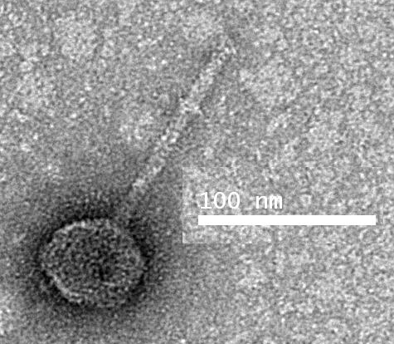

Electron micrograph: Electron micrographs of negatively stained Streptomyces phage Chymera (https://phagesdb.org/phages/Chymera/). Limited permission was granted by The Actinobacteriophages Database (https://phagesdb.org/), funded by the Howard Hughes Medical Institute, to use this electron micrograph for this taxonomy proposal; it cannot be reused without permission of The Actinobacteriophages Database.

Genome summary:

Phage name | INSDC | Size (Kb) | GC% | Protein | tRNA
Streptomyces phage Chymera | KU958700.1 | 34.74 | 71.4 | 55 | 0

- To create a new single-species genus, Emirosevirus

Origin of the name of this taxon: The name of this taxon derives directly from the name of the first virus of its type Corynebacterium phage EmiRose

Historical aspects: This lytic siphophage was isolated from soil against Corynebacterium flavescens ATCC 10340 by Emily Davis (Howard Hughes Medical Institute, Los Angeles, CA USA) as part of the Science Education Alliance-Phage Hunters Advancing Genomics and Evolutionary Science program. The genome has 9 nt 3’-cohesive termini (CCCTCCGGT). The Actinobacteriophage Database considers this phage to be a singleton.

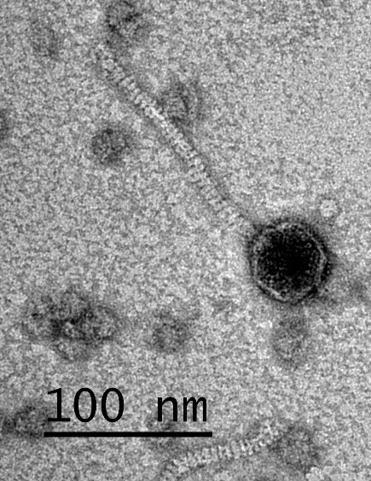

Electron micrograph: Electron micrographs of negatively stained Corynebacterium phage EmiRose (https://phagesdb.org/phages/EmiRose/). Limited permission was granted by The Actinobacteriophages Database (https://phagesdb.org/), funded by the Howard Hughes Medical Institute, to use this electron micrograph for this taxonomy proposal; it cannot be reused without permission of The Actinobacteriophages Database.

Genome summary:

Phage name | INSDC | Size (Kb) | GC% | Protein | tRNA
Corynebacterium phage EmiRose | MN586033.1 | 37.43 | 56.4 | 46 | 0

- To create a new single-species genus, Finkelvirus

Origin of the name of this taxon: The name of this taxon derives directly from the name of the first virus of its type Gordonia phage Finkle

Historical aspects: This lytic siphophage was isolated from soil against Gordonia terrae 3612 by Leslie Zabielski (University of Maine, Brewer, ME USA) as part of the Science Education Alliance-Phage Hunters Advancing Genomics and Evolutionary Science program. The genome has 14 nt 3’-cohesive termini (CTACCTGCGGGGGA). The Actinobacteriophage Database considers this phage to be a singleton.

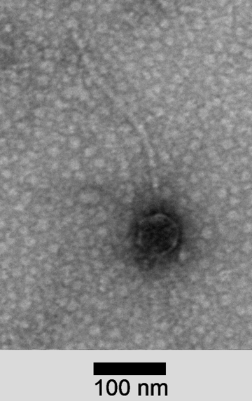

Electron micrograph: Electron micrographs of negatively stained Gordonia phage Finkle (https://phagesdb.org/phages/Finkle/). Limited permission was granted by The Actinobacteriophages Database (https://phagesdb.org/), funded by the Howard Hughes Medical Institute, to use this electron micrograph for this taxonomy proposal; it cannot be reused without permission of The Actinobacteriophages Database.

Genome summary:

Phage name | INSDC | Size (Kb) | GC% | Protein | tRNA
Gordonia phage Finkle | ON456347.1 | 47.9 | 66.6 | 84 | 0

- To create a new single-species genus, Footloosevirus

Origin of the name of this taxon: The name of this taxon derives directly from the name of the first virus of its type Microbacterium phage Footloose

Historical aspects: This temperate siphophage was isolated from soil against Microbacterium paraoxydans NRRL B-14843 by Keegan Piton and Trey Hovde (University of Wisconsin-River Falls, WI USA) as part of the Science Education Alliance-Phage Hunters Advancing Genomics and Evolutionary Science program. The genome has 10 nt 3’-cohesive termini (CGCCGGGGAT). The Actinobacteriophage Database considers this phage to be a singleton.

Electron micrograph: Electron micrographs of negatively stained Microbacterium phage Footloose (https://phagesdb.org/phages/Footloose/). Limited permission was granted by The Actinobacteriophages Database (https://phagesdb.org/), funded by the Howard Hughes Medical Institute, to use this electron micrograph for this taxonomy proposal; it cannot be reused without permission of The Actinobacteriophages Database.

Genome summary:

Phage name | INSDC | Size (Kb) | GC% | Protein | tRNA
Microbacterium phage Footloose | MZ150789.1 | 39.74 | 61.7 | 71 | 1

- To create a new single-species genus, Gilgameshvirus

Origin of the name of this taxon: The name of this taxon derives directly from the name of the first virus of its type Streptomyces phage Gilgamesh

Historical aspects: This temperate siphophage was isolated from soil against Streptomyces lividans JI 1326 by Michael Almisry, and Madeline Lee (Washington University, St Louis, MO USA) as part of the Science Education Alliance-Phage Hunters Advancing Genomics and Evolutionary Science program. The genome is circularly permuted. The Actinobacteriophage Database considers this phage to be a singleton.

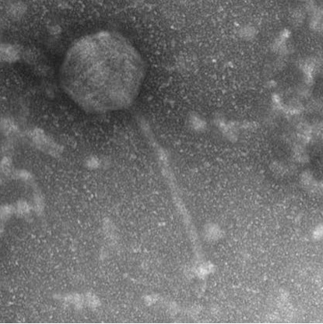

Electron micrograph: Electron micrographs of negatively stained Streptomyces phage Gilgamesh (https://phagesdb.org/phages/Gilgamesh/). Limited permission was granted by The Actinobacteriophages Database (https://phagesdb.org/), funded by the Howard Hughes Medical Institute, to use this electron micrograph for this taxonomy proposal; it cannot be reused without permission of The Actinobacteriophages Database.

Genome summary:

Phage name | INSDC | Size (Kb) | GC% | Protein | tRNA
Streptomyces phage Gilgamesh | MN234216.1 | 129.14 | 71.3 | 156 | 0

- To create a new single-species genus, Ibantikvirus

Origin of the name of this taxon: The name of this taxon derives directly from the name of the first virus of its type Streptomyces phage Ibantik

Historical aspects: This temperate siphophage was isolated from soil against Streptomyces lividans JI 1326 by Kaitlyn Brown (Wilkes University, Pringle, PA USA) as part of the Science Education Alliance-Phage Hunters Advancing Genomics and Evolutionary Science program. The genome has 11 nt 3’-cohesive termini (CGCCGGGGGCA). The Actinobacteriophage Database considers this phage to be a singleton.

Electron micrograph: N/A

Genome summary:

Phage name | INSDC | Size (Kb) | GC% | Protein | tRNA
Streptomyces phage Ibantik | MH155870.1 | 56.36 | 57.4 | 105 | 2

- To create a new single-species genus, Identitycrisisvirus

Origin of the name of this taxon: The name of this taxon derives directly from the name of the first virus of its type Mycobacterium phage IdentityCrisis

Historical aspects: This temperate siphophage was isolated from soil against Mycobacterium smegmatis mc²155 by Justice B. Widman (Indian River State College, Port Saint Lucie, FL USA) as part of the Science Education Alliance-Phage Hunters Advancing Genomics and Evolutionary Science program. The genome has 10 nt 3’-cohesive termini (CTCAGGGCAT). The Actinobacteriophage Database considers this phage to be a singleton.

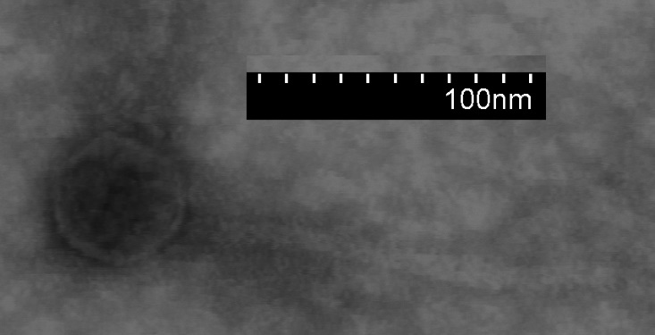

Electron micrograph: Electron micrographs of negatively stained Mycobacterium phage IdentityCrisis (https://phagesdb.org/phages/IdentityCrisis/). Limited permission was granted by The Actinobacteriophages Database (https://phagesdb.org/), funded by the Howard Hughes Medical Institute, to use this electron micrograph for this taxonomy proposal; it cannot be reused without permission of The Actinobacteriophages Database.

Genome summary:

Phage name | INSDC | Size (Kb) | GC% | Protein | tRNA
Mycobacterium phage IdentityCrisis | MN234184.1 | 38.34 | 65.0 | 60 | 0

- To create a new single-species genus, Krompvirus

Origin of the name of this taxon: The name of this taxon derives directly from the name of the first virus of its type Streptomyces phage Kromp

Historical aspects: This temperate siphophage was isolated from soil against Streptomyces lividans JI 1326 by Muhammad Mousa and Benjamin Kelsky (Washington University, St. Louis, MO USA) as part of the Science Education Alliance-Phage Hunters Advancing Genomics and Evolutionary Science program. The genome has 9 nt 3’-cohesive termini (TCTCCCGGCA). The Actinobacteriophage Database considers this phage to be a singleton.

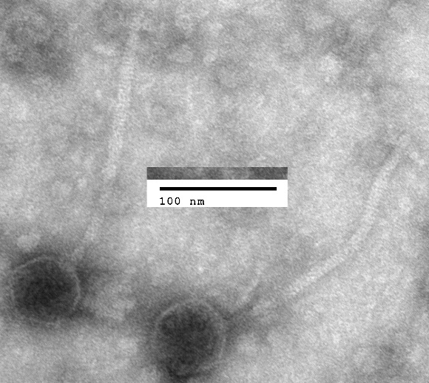

Electron micrograph: Electron micrographs of negatively stained Streptomyces phage Kromp (https://phagesdb.org/phages/Kromp/). Limited permission was granted by The Actinobacteriophages Database (https://phagesdb.org/), funded by the Howard Hughes Medical Institute, to use this electron micrograph for this taxonomy proposal; it cannot be reused without permission of The Actinobacteriophages Database.

Genome summary:

Phage name | INSDC | Size (Kb) | GC% | Protein | tRNA
Streptomyces phage Kromp | MH744420.1 | 58.27 | 71.4 | 95 | 0

- To create a new single-species genus, Lilspottyvirus

Origin of the name of this taxon: The name of this taxon derives directly from the name of the first virus of its type Mycobacterium phage LilSpotty

Historical aspects: This temperate siphophage was isolated from soil against Mycobacterium smegmatis mc²155 by Rinah Kim (University of California, Los Angeles, CA USA) as part of the Science Education Alliance-Phage Hunters Advancing Genomics and Evolutionary Science program. The genome has 10 nt 3’-cohesive termini (CGGCCGGCAT). The Actinobacteriophage Database considers this phage to be a singleton.

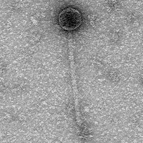

Electron micrograph: Electron micrographs of negatively stained Mycobacterium phage LilSpotty (https://phagesdb.org/phages/LilSpotty/). Limited permission was granted by The Actinobacteriophages Database (https://phagesdb.org/), funded by the Howard Hughes Medical Institute, to use this electron micrograph for this taxonomy proposal; it cannot be reused without permission of The Actinobacteriophages Database.

Genome summary:

Phage name | INSDC | Size (Kb) | GC% | Protein | tRNA
Mycobacterium phage LilSpotty | MK977707.1 | 49.8 | 64.7 | 85 | 0

- To create a new single-species genus, Malagasyrosevirus

Origin of the name of this taxon: The name of this taxon derives directly from the name of the first virus of its type Mycobacterium phage MalagasyRose

Historical aspects: This temperate siphophage was isolated from Antsirabe, Madagascar soil against Mycobacterium smegmatis mc²155 by Deborah Jacobs-Sera (University of Pittsburgh, PA USA) as part of the Phage Hunters Integrating Research and Education program. The genome possesses 3’-cohesive termini (sequence not known). The Actinobacteriophage Database considers this phage to be a Singleton.

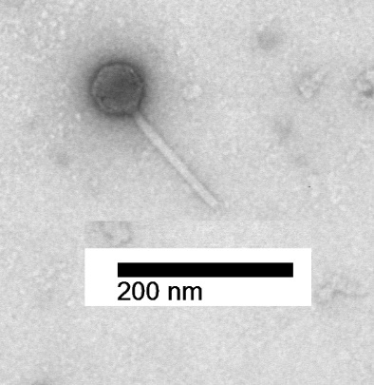

Electron micrograph: Electron micrographs of negatively stained Mycobacterium phage MalagasyRose (https://phagesdb.org/phages/MalagasyRose/). Limited permission was granted by The Actinobacteriophages Database (https://phagesdb.org/), funded by the Howard Hughes Medical Institute, to use this electron micrograph for this taxonomy proposal; it cannot be reused without permission of The Actinobacteriophages Database.
Genome summary:

Phage name | INSDC | Size (Kb) | GC% | Protein | tRNA
Mycobacterium phage MalagasyRose | MN234170.1 | 54.3 | 65.3 | 84 | 2

- To create a new single-species genus, Oscarsovirus

Origin of the name of this taxon: The name of this taxon derives directly from the name of the first virus of its type Microbacterium phage OscarSo,
Historical aspects: This lytic siphophage was isolated from soil against Microbacterium radiodurans NRRL B-24799 by Chelsi Arias and Jacqueline Washington (Nyack College, Nyack, NY USA) as part of the Science Education Alliance-Phage Hunters Advancing Genomics and Evolutionary Science program. The genome is circularly permuted. The Actinobacteriophage Database considers this phage to be a singleton.

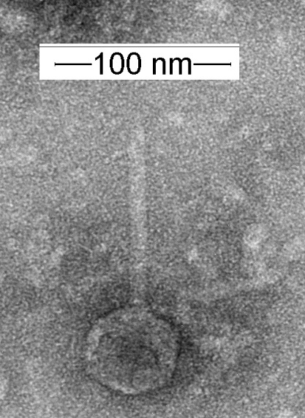

Electron micrograph: Electron micrographs of negatively stained Microbacterium phage OscarSo (https://phagesdb.org/phages/OscarSo/). Limited permission was granted by The Actinobacteriophages Database (https://phagesdb.org/), funded by the Howard Hughes Medical Institute, to use this electron micrograph for this taxonomy proposal; it cannot be reused without permission of The Actinobacteriophages Database.

Genome summary:

Phage name | INSDC | Size (Kb) | GC% | Protein | tRNA
Microbacterium phage OscarSo | OP434449.1 | 33.43 | 69.2 | 50 | 0

- To create a new single-species genus, Aspduovirus

Origin of the name of this taxon: The name of this taxon derives directly from the name of the first virus of its type Actinoplanes phage phiAsp2

Historical aspects: This lytic siphophage was isolated from soil in Germany against Actinoplanes sp. SN223/29 by M. Jarling et al. [2003; 2004]. This phage has an icosahedral head, 45 nm in diameter. The tail is non-contractile and is approximately 125×10 nm in length. It forms pseudolysogens. The Actinobacteriophage Database considers this phage to be a singleton.

Electron micrograph: N/A

Genome summary:

Phage name | INSDC | Size (Kb) | GC% | Protein | tRNA
Actinoplanes phage phiAsp2 | AY576796.1 | 58.64 | 70.4 | 76 | 0

Specific reference:
Jarling M, Bartkowiak K, Robenek H, Pape H, Meinhardt F. Isolation of phages infecting Actinoplanes SN223 and characterization of two of these viruses. Appl Microbiol Biotechnol. 2004 Apr;64(2):250-4. doi: 10.1007/s00253-003-1473-6. Epub 2003 Oct 29. PMID: 14586581.

Jarling M, Bartkowiak K, Pape H, Meinhardt F. The genome of phiAsp2, an actinoplanes infecting phage. Virus Genes. 2004 Aug;29(1):117-29. doi: 10.1023/B:VIRU.0000032795.17713.6c. PMID: 15215690.

- To create a new single-species genus, Amherstvirus

Origin of the name of this taxon: The name of this taxon derives from the location, Amherst, MA where the first virus of its type Microbacterium phage PineapplePizza was isolated

Historical aspects: This lytic podophage was isolated from soil against Microbacterium foliorum NRRL B-24224 by Juan Brito (University of Massachusetts Amherst, MA USA) as part of the Science Education Alliance-Phage Hunters Advancing Genomics and Evolutionary Science program. The genome has a covalent terminal protein. The Actinobacteriophage Database considers this phage to be a singleton. Morphologically this phage is related to bacillus phage phi29.

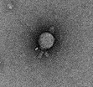

Electron micrograph: Electron micrographs of negatively stained Microbacterium phage PineapplePizza (https://phagesdb.org/phages/PineapplePizza/). Limited permission was granted by The Actinobacteriophages Database (https://phagesdb.org/), funded by the Howard Hughes Medical Institute, to use this electron micrograph for this taxonomy proposal; it cannot be reused without permission of The Actinobacteriophages Database.

Genome summary:

Phage name | INSDC | Size (Kb) | GC% | Protein | tRNA
Microbacterium phage PineapplePizza | ON724010.1 | 16.66 | 53.6 | 23 | 0

- To create a new single-species genus, Pumpernickelvirus

Origin of the name of this taxon: The name of this taxon derives directly from the name of the first virus of its type Microbacterium phage Pumpernickel

Historical aspects: This lytic siphophage was isolated from soil against Microbacterium paraoxydans NRRL B-14843 by Ethan Heelein (University of Wisconsin-River Falls, WI USA) as part of the Science Education Alliance-Phage Hunters Advancing Genomics and Evolutionary Science program. The genome has direct terminal repeats. The Actinobacteriophage Database considers this phage to be a singleton.

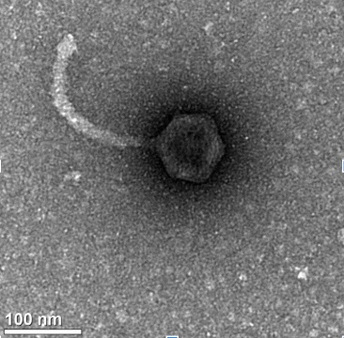

Electron micrograph: Electron micrographs of negatively stained Microbacterium phage Pumpernickel (https://phagesdb.org/phages/Pumpernickel/). Limited permission was granted by The Actinobacteriophages Database (https://phagesdb.org/), funded by the Howard Hughes Medical Institute, to use this electron micrograph for this taxonomy proposal; it cannot be reused without permission of The Actinobacteriophages Database.

Genome summary:

Phage name | INSDC | Size (Kb) | GC% | Protein | tRNA
Microbacterium phage Pumpernickel | OK040790.1 | 186.1 | 56.5 | 312 | 41

- To create a new single-species genus, Fuzanglongvirus

Origin of the name of this taxon: The name of this taxon derives from Chinese mythology, the Fuzanglong is the Chinese dragon of hidden treasures and an underworld dragon which guards buried treasure, both natural and man-made. (https://en.wikipedia.org/wiki/Fuzanglong)

Historical aspects: This temperate conjugal prophage was identified in China by Zhong L et al. 2010. The Actinobacteriophage Database considers this phage to be a Singleton.

Electron micrograph: N/A

Genome summary:

Phage name | INSDC | Size (Kb) | GC% | Protein | tRNA
Streptomyces phage ZL12 | GQ919031.1 | 90.44 | 69.5 | 112 | 0

Specific reference:
Zhong L, Cheng Q, Tian X, Zhao L, Qin Z. Characterization of the replication, transfer, and plasmid/lytic phage cycle of the Streptomyces plasmid-phage pZL12. J Bacteriol. 2010 Jul;192(14):3747-54. doi: 10.1128/JB.00123-10. Epub 2010 May 14. PMID: 20472796; PMCID: PMC2897331.

- To create a new single-species genus, Edwardsroadvirus

Origin of the name of this taxon: The name of this taxon derives directly from the address (Edwards Road) where in Pharmacy and Applied Science, La Trobe University the first virus of its type Rhodococcus phage RRH1 was studied.

Historical aspects: This lytic siphophage was isolated from soil against Microbacterium foliorum NRRL B-24224 by Katie Chalifoux, Jessica Mejia, Carina Gutierrez and Hari Kotturi (University of Central Oklahoma, Choctaw, OK USA) as part of the Science Education Alliance-Phage Hunters Advancing Genomics and Evolutionary Science program. The genome has 10 nt 3’-cohesive termini (TCTCCCGGCA). The Actinobacteriophage Database considers this phage to be a singleton.

Electron micrograph: N/A

Genome summary:

Phage name | INSDC | Size (Kb) | GC% | Protein | tRNA
Rhodococcus phage RRH1 | JN116822.1 | 14.27 | 68.4 | 20 | 0

- To create a new single-species genus, Bismarckvirus

Origin of the name of this taxon: The name of this taxon derives directly from the name of the city (Bismarck, ND, USA) where first virus of its type Arthrobacter phage Shambre1. We have chosen this rather than “Shambrevirus” since phage Shambre1 is named after its isolator.

Historical aspects: This lytic siphophage was isolated from soil against Arthrobacter globiformis B-2979 by Shambre Feiring (University of Mary, Bismarck, ND USA) as part of the Science Education Alliance-Phage Hunters Advancing Genomics and Evolutionary Science program. The genome has 10 nt 3’-cohesive termini (CGCCGGGGTA). The Actinobacteriophage Database considers this phage to be a singleton.

Electron micrograph: N/A

Genome summary:

Phage name | INSDC | Size (Kb) | GC% | Protein | tRNA
Arthrobacter phage Shambre1 | OP297545.1 | 42.21 | 65.4 | 67 | 0

- To create a new single-species genus, Shockervirus

Origin of the name of this taxon: The name of this taxon derives directly from the name of the first virus of its type Microbacterium phage Shocker

Historical aspects: This lytic podophage was isolated from Oakdale, MN soil against Microbacterium paraoxydans NRRL B-14843 by James Vang (University of Wisconsin-River Falls, WI USA) as part of the Science Education Alliance-Phage Hunters Advancing Genomics and Evolutionary Science program. The genome has direct terminal repeats. The Actinobacteriophage Database considers this phage to be a singleton.

Electron micrograph: Electron micrographs of negatively stained Microbacterium phage Shocker (https://phagesdb.org/phages/Shocker/). Limited permission was granted by The Actinobacteriophages Database (https://phagesdb.org/), funded by the Howard Hughes Medical Institute, to use this electron micrograph for this taxonomy proposal; it cannot be reused without permission of The Actinobacteriophages Database.

Genome summary:

Phage name | INSDC | Size (Kb) | GC% | Protein | tRNA
Microbacterium phage Shocker | MW507126.1 | 45.43 | 63.0 | 66 | 0

- To create a new single-species genus, Spartoivirus

Origin of the name of this taxon: The name of this taxon derives directly from the name of the first virus of its type Rothia phage Spartoi

Historical aspects: This temperate siphophage was isolated from human mouth washings against Rothia dentocariosa TC5 by Trevor Cross (St. Joseph's University, Philadelphia, PA USA) as part of the Science Education Alliance-Phage Hunters Advancing Genomics and Evolutionary Science program. The genome has 12 nt 3’-cohesive termini (CCCCCCGGCGAT). The Actinobacteriophage Database considers this phage to be a singleton.

Electron micrograph: Electron micrographs of negatively stained Rothia phage Spartoi (https://phagesdb.org/phages/Spartoi/). Limited permission was granted by The Actinobacteriophages Database (https://phagesdb.org/), funded by the Howard Hughes Medical Institute, to use this electron micrograph for this taxonomy proposal; it cannot be reused without permission of The Actinobacteriophages Database.

Genome summary:

Phage name | INSDC | Size (Kb) | GC% | Protein | tRNA
Rothia phage Spartoi | MK061416.1 | 35.19 | 52.4 | 56 | 0

- To create a new single-species genus, Successvirus

Origin of the name of this taxon: The name of this taxon derives directly from the name of the first virus of its type Streptomyces phage Success

Historical aspects: This lytic siphophage was isolated from soil against Streptomyces lividans JI 1326 by Jay Msuya and Mason Roth (Washington University, St. Louis, MO USA) as part of the Science Education Alliance-Phage Hunters Advancing Genomics and Evolutionary Science program. The genome has 11 nt 3’-cohesive termini (CGCAGGGGGCG). The Actinobacteriophage Database considers this phage to be a singleton.

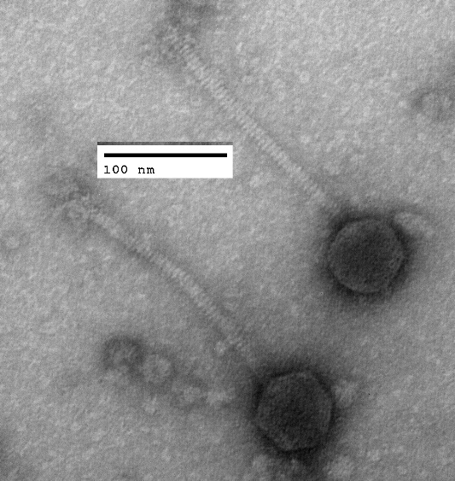

Electron micrograph: Electron micrographs of negatively stained Streptomyces phage Success (https://phagesdb.org/phages/Success/). Limited permission was granted by The Actinobacteriophages Database (https://phagesdb.org/), funded by the Howard Hughes Medical Institute, to use this electron micrograph for this taxonomy proposal; it cannot be reused without permission of The Actinobacteriophages Database.

Genome summary:

Phage name | INSDC | Size (Kb) | GC% | Protein | tRNA
Streptomyces phage Success | OP751148.1 | 57.16 | 61.6 | 84 | 8

- To create a new single-species genus, Dolmabahcevirus

Origin of the name of this taxon: The name of this taxon derives directly from the name of location (Dolmabahçe Palace gardens, İstanbul, Türkiye) where the first virus of its type Streptomyces phage TurkishDelight was found.

Historical aspects: This lytic siphophage was isolated from the Dolmabahçe Palace gardens soil in İstanbul (Türkiye) against Streptomyces scabiei RL-34 by Samar Behdin & Aniruddha Rao (University of Maryland, Baltimore County, MD USA) as part of the Science Education Alliance-Phage Hunters Advancing Genomics and Evolutionary Science program. The capsid is elongated. The genome is circularly permuted. The Actinobacteriophage Database considers this phage to be a singleton.

Electron micrograph: Electron micrographs of negatively stained Streptomyces phage TurkishDelight (https://phagesdb.org/phages/TurkishDelight/). Limited permission was granted by The Actinobacteriophages Database (https://phagesdb.org/), funded by the Howard Hughes Medical Institute, to use this electron micrograph for this taxonomy proposal; it cannot be reused without permission of The Actinobacteriophages Database.

Genome summary:

Phage name | INSDC | Size (Kb) | GC% | Protein | tRNA
Streptomyces phage TurkishDelight | MW291017.1 | 93.61 | 72.6 | 125 | 0

- To create a new single-species genus, Valentinivirus

Origin of the name of this taxon: The name of this taxon derives directly from the name of the first virus of its type Microbacterium phage ValentiniPuff

Historical aspects: This lytic siphophage was isolated from Fairchild, WI soil against Microbacterium paraoxydans NRRL B-14843 by Kylie Myers (University of Wisconsin-River Falls, WI USA) as part of the Science Education Alliance-Phage Hunters Advancing Genomics and Evolutionary Science program. The genome is circularly permuted. The Actinobacteriophage Database considers this phage to be a singleton.

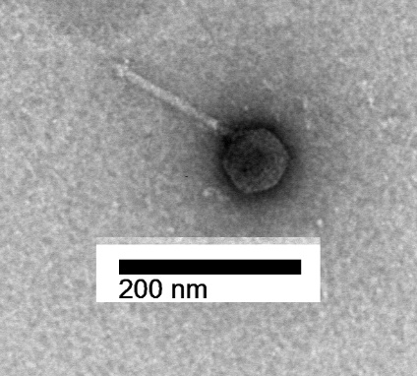

Electron micrograph: Electron micrographs of negatively stained Microbacterium phage ValentiniPuff (https://phagesdb.org/phages/ValentiniPuff/). Limited permission was granted by The Actinobacteriophages Database (https://phagesdb.org/), funded by the Howard Hughes Medical Institute, to use this electron micrograph for this taxonomy proposal; it cannot be reused without permission of The Actinobacteriophages Database.

Genome summary:

Phage name | INSDC | Size (Kb) | GC% | Protein | tRNA
Microbacterium phage ValentiniPuff | MH825712.1 | 62.52 | 67.1 | 112 | 0

- To create a new single-species genus, Vanleevirus

Origin of the name of this taxon: The name of this taxon derives directly from the name of the first virus of its type Gordonia phage VanLee.

Historical aspects: This temperate siphophage was isolated from soil against Gordonia rubripertincta NRRL B-16540 by Vanessa Franco and Kaylee Barnhill (University of South Florida, Tampa, FL USA) as part of the Science Education Alliance-Phage Hunters Advancing Genomics and Evolutionary Science program [Franco et al 2021]. The genome is circularly permuted. The Actinobacteriophage Database considers this phage to be a singleton.

Electron micrograph: Electron micrographs of negatively stained Gordonia phage VanLee (https://phagesdb.org/phages/VanLee/). Limited permission was granted by The Actinobacteriophages Database (https://phagesdb.org/), funded by the Howard Hughes Medical Institute, to use this electron micrograph for this taxonomy proposal; it cannot be reused without permission of The Actinobacteriophages Database.

Genome summary:

Phage name | INSDC | Size (Kb) | GC% | Protein | tRNA
Gordonia phage VanLee | MZ028627.1 | 84.56 | 67.8 | 164 | 1

Specific reference:
Franco V, Barnhill K, Biggs A, Bland J, Choudhary H, Crogan T, Finocchiaro A, Fuller T, Hanwacker C, Howard Z, Iqbal M, Mathew A, Miller S, Padhye S, Rainey E, Rodriguez A, Stewart E, Chase M, Otero L, Pollenz RS. Genome Sequence of VanLee, a Singleton Actinobacteriophage That Infects Multiple Gordonia Strains. Microbiol Resour Announc. 2021 Jul 29;10(30):e0051921. doi: 10.1128/MRA.00519-21. Epub 2021 Jul 29. PMID: 34323611; PMCID: PMC8320454.

- To create a new single-species genus, Mboquatrovirus

Origin of the name of this taxon: The name of this taxon derives directly from the name of the first virus of its type Rhodococcus phage Mbo4

Historical aspects: This temperate siphophage was isolated from wastewater against Rhodococcus opacus by Baixin Wang (Texas A&M University, College Station, TX USA).

Electron micrograph: N/A

Genome summary:

Phage name | INSDC | Size (Kb) | GC% | Protein | tRNA
Rhodococcus phage Mbo4 | ON191532.1 | 46.23 | 65.2 | 66 | 0

References
1. Sayers EW, Beck J, Bolton EE, Bourexis D, Brister JR, Canese K, Comeau DC, Funk K, Kim S, Klimke W, Marchler-Bauer A, Landrum M, Lathrop S, Lu Z, Madden TL, O'Leary N, Phan L, Rangwala SH, Schneider VA, Skripchenko Y, Wang J, Ye J, Trawick BW, Pruitt KD, Sherry ST. Database resources of the National Center for Biotechnology Information. Nucleic Acids Res. 2021 Jan 8;49(D1):D10-D17. doi: 10.1093/nar/gkaa892. PMID: 33095870
2. O'Leary NA, Wright MW, Brister JR, Ciufo S, Haddad D, McVeigh R, et al. Reference sequence (RefSeq) database at NCBI: current status, taxonomic expansion, and functional annotation. Nucleic Acids Res. 2016;44(D1):D733-45. doi: 10.1093/nar/gkv1189. PMID: 26553804.
3. Moraru C, Varsani A, Kropinski AM. VIRIDIC-A Novel Tool to Calculate the Intergenomic Similarities of Prokaryote-Infecting Viruses. Viruses. 2020 Nov 6;12(11):1268. doi: 10.3390/v12111268. PMID: 33172115; PMCID: PMC7694805. http://kronos.icbm.uni-oldenburg.de/viridic/
4. Nishimura Y, Yoshida T, Kuronishi M, Uehara H, Ogata H, Goto S. ViPTree: the viral proteomic tree server. Bioinformatics. 2017; 33(15):2379-2380. doi:10.1093/bioinformatics/btx157. PubMed PMID: 28379287. https://www.genome.jp/viptree/
5. Rohwer F, Edwards R. The Phage Proteomic Tree: a genome-based taxonomy for phage. J Bacteriol. 2002 Aug;184(16):4529-35. PubMed PMID: 12142423
6. Turner D, Reynolds D, Seto D, Mahadevan P. CoreGenes3.5: a webserver for the determination of core genes from sets of viral and small bacterial genomes. BMC Res Notes. 2013;6:140. doi: 10.1186/1756-0500-6-140. PMID: 23566564.
7. Davis P, Seto D, Mahadevan P. CoreGenes5.0: An Updated User-Friendly Webserver for the Determination of Core Genes from Sets of Viral and Bacterial Genomes. Viruses. 2022 Nov 16;14(11):2534. doi: 10.3390/v14112534. PMID: 36423143; PMCID: PMC9693508.
8. Dereeper A, Guignon V, Blanc G, Audic S, Buffet S, Chevenet F, Dufayard JF, Guindon S, Lefort V, Lescot M, Claverie JM, Gascuel O. Phylogeny.fr: robust phylogenetic analysis for the non-specialist. Nucleic Acids Res. 2008;36(Web Server issue):W465-9. doi: 10.1093/nar/gkn180. Epub 2008 Apr 19. PMID: 18424797.
9. Anisimova M, Gascuel O. Approximate likelihood-ratio test for branches: A fast, accurate, and powerful alternative. Syst Biol. 2006;55(4):539-52. PMID: 16785212. DOI: 10.1080/10635150600755453.
10. Turner D, Kropinski AM, Adriaenssens EM. A Roadmap for Genome-Based Phage Taxonomy. Viruses. 2021 Mar 18;13(3):506. doi: 10.3390/v13030506. PMID: 33803862; PMCID: PMC8003253.

