

Part 1: TITLE, AUTHORS, APPROVALS, etc

Code assigned: | 2022.095B
Short title: Create one new genus (Youngvirus) including one new species in the Autographiviridae (Caudoviricetes)
Author(s) and email address(es)
Jing Wang, Zekun Liu, Shixuan Huang | 1546750609@qq.com;  lzk_98@foxmail.com;  nhuhuganaxis@outlook.com;
Author(s) institutional address(es) (optional)
South China Agricultural University, China [WJ, LZK, HSX]
Guangdong Institute of Microbiology, China [WJ, LZK, HSX]
Corresponding author
Jing Wang, Zekun Liu
List the ICTV Study Group(s) that have seen this proposal
Bacterial Viruses Subcommittee,
Autographiviridae Study Group
ICTV Study Group comments and response of proposer
ICTV Study Group votes on proposal
Study Group | Number of members
Study Group | Votes support | Votes against | No vote
Authority to use the name of a living person
Is any taxon name used here derived from that of a living person (Y/N) | N

Taxon name | Person from whom the name is derived | Permission attached (Y/N)

Submission dates
Date first submitted to SC Chair | May 2022
Date of this revision (if different to above)
ICTV-EC comments and response of the proposer

Part 3: TAXONOMIC PROPOSAL
Name of accompanying Excel module
2022.095B.N.v1.Youngvirus_ng.xlsx
Abstract

We have created a new genus of Vibrio phages, Youngvirus.
Text of proposal
Species demarcation criteria: We have chosen 95% DNA sequence identity as the criterion for demarcation of species in this new genus. The proposed species differs from the others with more than 5% at the DNA level as confirmed with the BLASTN algorithm.

Supporting evidence
Source of the name of this taxon: This genus is named after the word ‘young' where, in 2021, Vibrio phage vB_VpP_G1 was isolated in the Huangsha aquatic products trading market, Guangzhou, China.

VIRIDIC heat map: VIRIDIC (Virus Intergenomic Distance Calculator; [1]) computes pairwise intergenomic distances/similarities amongst phage genomes. VIRDIC analysis of strains with high similarity after BLAST comparison showed that Vibrio phage vB_VpP_G1 had the highest similarity with Yersinia phage phiR8-01 and vB_YenP_ISAO8, but both were well below the generic level similarity threshold. (The black box)

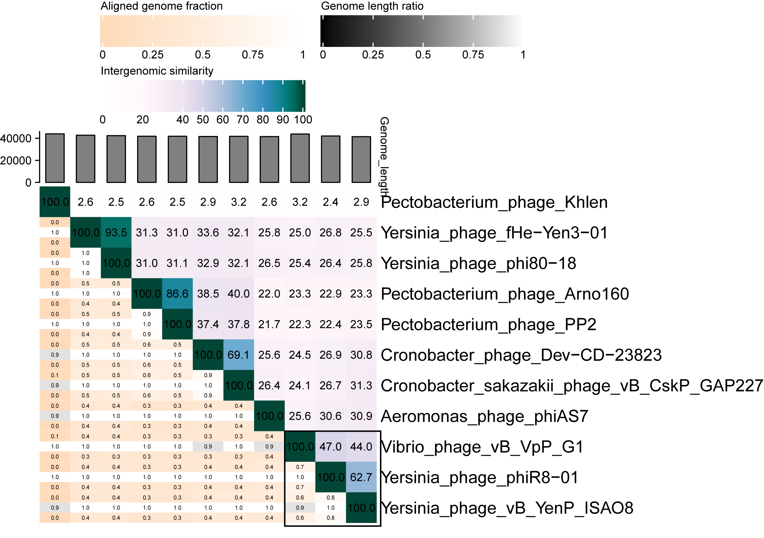

vConTACT2 analysis: vConTACT2 [2] is a uses genome-wide gene sharing mapping for virus classification. Red lines show strains associated with vB_VpP_G1, most of which are unclassified (gray), while vB_YenP_ISAO8 strains show the strongest association (red solid line). Associated groups include Teseptimavirus (green), Phikmvvirus (blue), Bifseptvirus (red), Aqualcavirus (orange), Napahaivirus (yellow) and Peadovirus (pink).
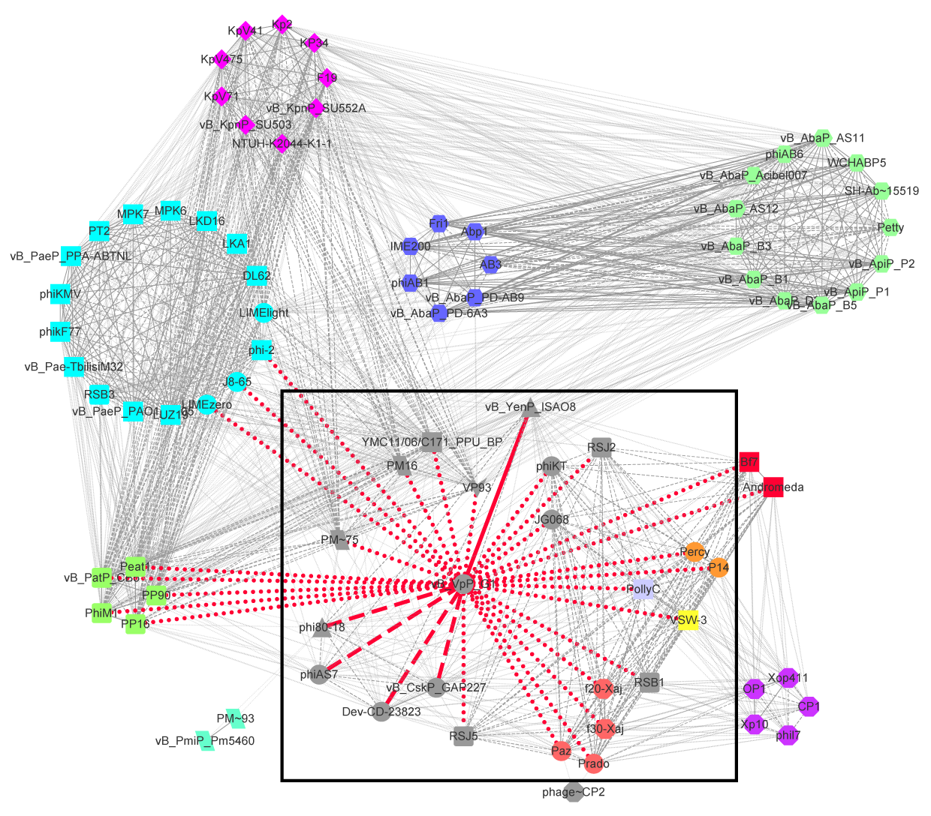

GenBank Summary:

Phage name | INSDC | Size (Kb) | GC% | Protein | tRNAs
Vibrio phage vB_VpP_G1 | MZ592920.1 | 43.8 | 47.22% | 51 | 0

Electron micrograph:

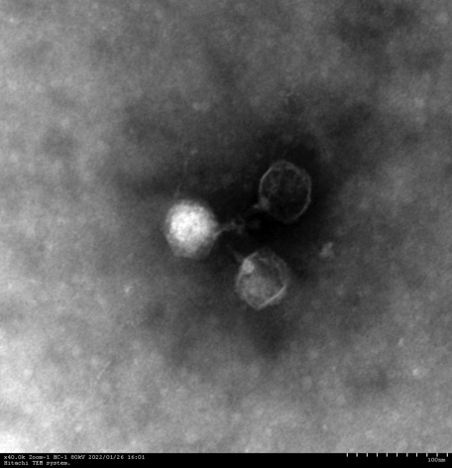
References
- Sayers EW, Agarwala R, Bolton EE, Brister JR, Canese K, Clark K, et al. Database resources of the National Center for Biotechnology Information. Nucleic Acids Res. 2019;47(D1):D23-D28. doi: 10.1093/nar/gkz899. PMID: 31602479.
- Bin Jang H, Bolduc B, Zablocki O, et al. Taxonomic assignment of uncultivated prokaryotic virus genomes is enabled by gene-sharing networks. Nat Biotechnol. 2019;37(6):632-639. doi:10.1038/s41587-019-0100-8 PMID: 31061483

