

Part 1: TITLE, AUTHORS, APPROVALS, etc

Code assigned: | 2022.068B
Short title: Create one new species in the genus Rosenblumvirus and two new species in the genus Andhravirus of Rakietenvirinae subfamily (Caudoviricetes: Rountreeviridae)
Author(s) and email address(es)
Łobocka M, Stefańczyk E, Adriaenssens EM, Kropinski AM, Turner D | lobocka@ibb.waw.pl;  e.stefanczyk@ibb.waw.pl;  evelien.adriaenssens@quadram.ac.uk;  Phage.Canada@gmail.com; dann2.turner@uwe.ac.uk
Author(s) institutional address(es) (optional)
Institute of Biochemistry and Biophysics of the Polish Academy of Sciences Poland [MŁ]
Institute of Biochemistry and Biophysics of the Polish Academy of Sciences Poland [ES]
Quadram Institute Bioscience, UK [EMA]
University of Guelph, Canada [AMK]
University of the West of England [DT]
Corresponding author
Malgorzata Łobocka
List the ICTV Study Group(s) that have seen this proposal

Salasmaviridae, Rountreeviridae, Guelinviridae Study Group, Bacterial Viruses Subcommittee
ICTV Study Group comments and response of proposer
ICTV Study Group votes on proposal

Study Group | Number of members
Study Group | Votes support | Votes against | No vote
Salasmaviridae, Rountreeviridae, Guelinviridae Study Group | 2 | 0 | 0

Authority to use the name of a living person

Is any taxon name used here derived from that of a living person (Y/N) | N

Taxon name | Person from whom the name is derived | Permission attached (Y/N)

Submission dates
Date first submitted to SC Chair | May 2022
Date of this revision (if different to above)
ICTV-EC comments and response of the proposer

Part 2: NON-TAXONOMIC PROPOSAL
Text of proposal

Part 3: TAXONOMIC PROPOSAL

Name of accompanying Excel module
2022.068B.N.v1.Rakietenvirinae_3nsp.xlsx
Abstract

In a complete review of the staphylococcal phages belonging to the Rakietenvirinae subfamily using VIRIDIC and ViPTree we have discovered one new species in the genus Rosenblumvirus and two new species in the genus Andhravirus. These phages share almost all properties with other phages of their genera, respectively, but differ significantly enough (less than 95% identity with phages of other Rakietenvirinae species) to classify them as separate species of this subfamily.

Text of proposal
Species demarcation criteria: We have chosen 95% DNA sequence identity as the criterion for demarcation of species in this new genus. Each of the proposed species differs from the others with more than 5% at the DNA level as confirmed with the BLASTN and Viridic algorithm

Supporting evidence

1) Create one new species, Rosenblumvirus JPL50, in the genus Rosenblumvirus of Rakietenvirinae subfamily

History: This subfamily was established via Taxonomy Proposal 2019.078B.A.Andhravirus.zip

Specific References: None. References concerning general description of Rakietenvirinae subfamily genera were included in Taxonomy Proposal 2019.078B.A.Andhravirus.zip

GenBank Summary:

Phage name | RefSeq No. | INSDC | Size (Kb) | GC% | Protein | tRNAs* | Overall % DNA sequence identity (**) | Overall % homologous proteins (***)
JPL-50 |  | MZ35909 | 16.93 | 29.3 | 29 | 0 | 86.7 | 88.0

N.B. Exemplar representative of Resenblumvirus genus is Staphylococcus phage 44AHJD (AF513032.1).
(*) determined using RNAscan-SE [1]
(**) determined using Viridic [2] and compared to Staphylococcus phage phi44AHJD (AF513032)
(***) determined using CoreGenes 5.0 [3,4] and compared to Staphylococcus phage phi44AHJD (AF513032)

BLASTN homologs: VIRIDIC analysis reveals that the closest relative besides other phages of Rosenblumvirus genus is Staphylococcus virus BESEP3 [MT596500] of Andhravirus andhra species of Andhravirus genus of Rekietenvirinae subfamily. It shares 45% DNA sequence with Staphylococcus phage JPL-50.

2) Create two new species, Andhravirus besep3 and Andhravirus sealphi with single representatives in the Andhravirus genus of Rakietenvirinae subfamily

History: This subfamily was established via Taxonomy Proposal 2019.078B.A.Andhravirus.zip

Specific References: None. References concerning general description of Rakietenvirinae subfamily genera were included in Taxonomy Proposal 2019.078B.A.Andhravirus.zip

GenBank Summary:

Phage name | RefSeq No. | INSDC | Size (Kb) | GC% | Protein | tRNAs* | Overall % DNA sequence identity (**) | Overall % homologous proteins (***)
BESEP3 |  | MT596500.1 | 18.27 | 30.0 | 20 | 0 | 88.7 | 95
SeAlphi |  | MZ152915.1 | 18.29 | 29.9 | 20 | 0 | 89.1 | 95

N.B. Exemplar representative of Andhravirus genus is Staphylococcus phage Andhra of Andhravirus andhra species [NC_047813.1].
(*) determined using RNAscan-SE [1]
(**) determined using Viridic [2] and compared to Staphylococcus phage Andhra of Andhravirus andhra species [NC_047813.1].
(***) determined using CoreGenes 5.0 [3,4] and compared to Staphylococcus phage Andhra of Andhravirus andhra species [NC_047813.1].

BLASTN homologs: VIRIDIC analysis reveals that the closest relative of BESEP3 besides other phages of Andhravirus genus is Staphylococcus virus SA46-CTH4 [MK922548] of Rosenblumvirus SA46CL1 species of Rosenblumvirus genus of Rekietenvirinae subfamily. It shares 45% DNA sequence with Staphylococcus phage BESEP3. The closest relative of SeAlphi besides other phages of Andhravirus genus is Staphylococcus virus SA46-CTH4 [MK922548] of Rosenblumvirus SA46CL1 species of Rosenblumvirus genus of Rekietenvirinae subfamily. It shares 45% DNA sequence with Staphylococcus phage BESEP3.

VIRIDIC heat map: VIRIDIC (Virus Intergenomic Distance Calculator; [2]) computes pairwise intergenomic distances/similarities amongst phage genomes. The comparison below provides the results of DNA sequence comparison of strains of known and proposed new species of staphylococcal Rakietenvirinae phages. The phage names correspond to phages of existing species or, when indicated by an arrow, to newly proposed species that will be added through this TaxoProp.
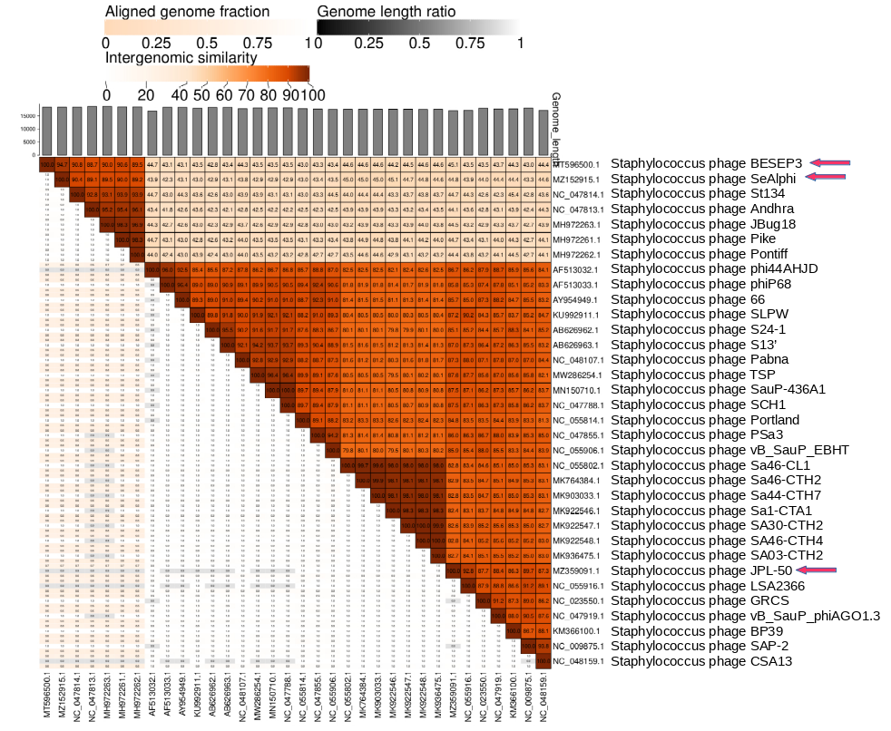

ViPTree analysis: ViPTree analysis (https://www.genome.jp/viptree/; [5]) is based upon Rohwer and Edwards (2002) famous Phage Proteomic Tree [6]. The red stars point to the new species of Rakietenvirinae subfamily. The blue arrowheads point to the genus Andhravirus and Rosenblumvirus of Rakietenvirinae subfamily.

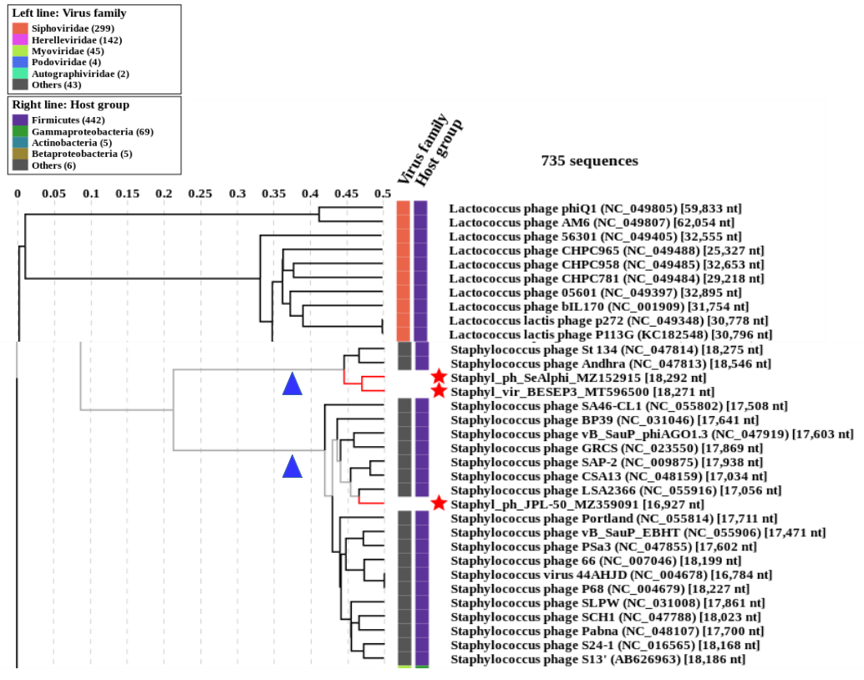

Phylogeny: The phylogenetic trees weres constructed using the major capsid protein and DNA polymerase homologs of Staphylococcus phage 44AHJD and related phages by employing the Tamura–Nei genetic distance model and a neighbour-joining tree-build method using the Geneious Tree Builder included in the Geneious Prime 2022 software. As an outgroup, a sequence of corresponding gene (DNA polymerase or major head/capsid protein) of closely related species was used, that was selected based on prior VipTree results. Proteins of phages of proposed new species are pointed with arrows.
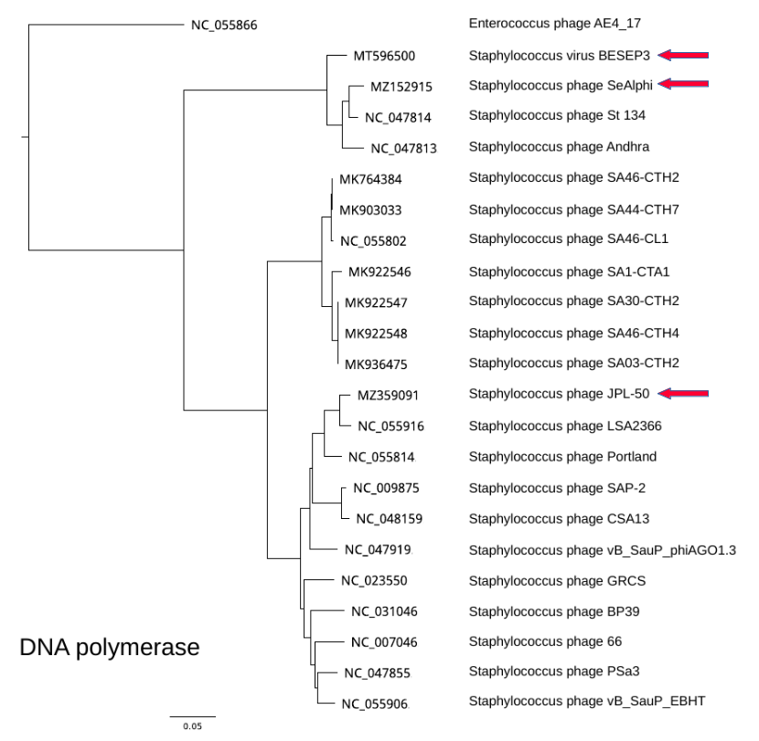

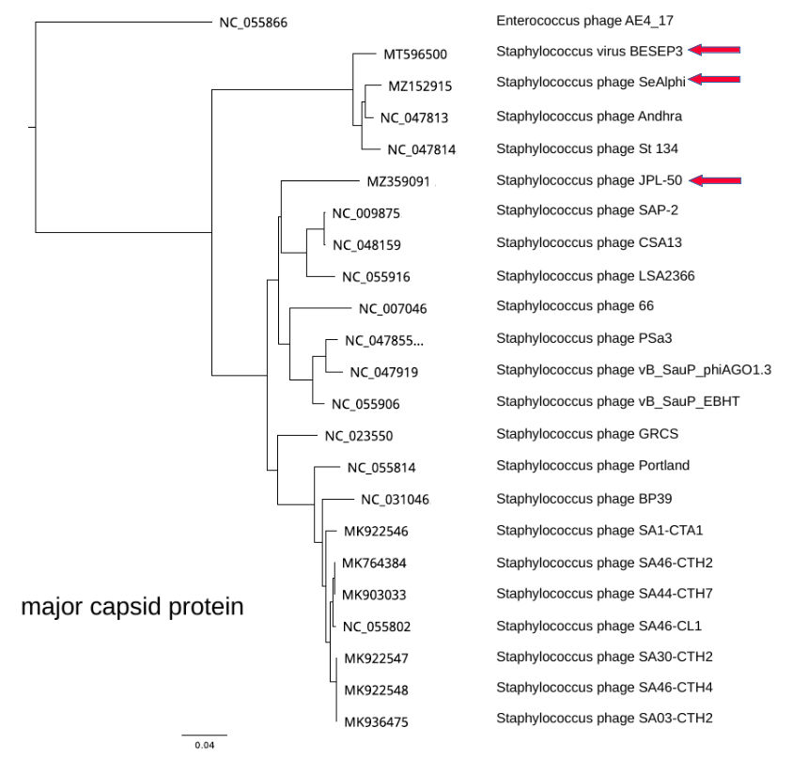

References

1. Chan PP, Lowe TM (2019) tRNAscan-SE: Searching for tRNA Genes in Genomic Sequences. Methods Mol Biol 1962:1-14. https://doi.org/10.1007/978-1-4939-9173-0_1. PMID: 31020551.
2. Moraru C (2020) VIRIDIC (Virus Intergenomic Distance Calculator) computes pairwise intergenomic distances/similarities amongst phage genomes. http://kronos.icbm.uni-oldenburg.de/viridic/
3: Turner D, Reynolds D, Seto D, Mahadevan P. (2013) CoreGenes3.5: a webserver for the determination of core genes from sets of viral and small bacterial genomes. BMC Res Notes 6:140. https://doi.org/10.1186/1756-0500-6-140. PMID: 23566564.
4. Contreras-Moreira, B., & Vinuesa, P. (2013). GET_HOMOLOGUES, a versatile software package for scalable and robust microbial pangenome analysis. Appl Environ Microbiol 79:7696-7701.
5. Nishimura Y, Yoshida T, Kuronishi M, Uehara H, Ogata H, Goto S. ViPTree: the viral proteomic tree server. (2017) Bioinformatics 33:2379-2380. https://doi.org/10.1093/bioinformatics/btx157. PubMed PMID: 28379287.
6. Rohwer F, Edwards R (2002) The Phage Proteomic Tree: a genome-based taxonomy for phage. J Bacteriol 184:4529-35. PubMed PMID: 12142423

