

Part 1: TITLE, AUTHORS, APPROVALS, etc

Code assigned: | 2022.064B
Short title: Create a new genus (Ponsvirus) with seven species (Caudoviricetes)

Author(s) and email address(es)
Turner D, Moraru C, Kropinski AM | Dann2.Turner@uwe.ac.uk; liliana.cristina.moraru@uol.de; Phage.Canada@gmail.com
Author(s) institutional address(es) (optional)
University of the West of England, Bristol, UK [DT]
Carl von Ossietzky Universität Oldenburg, Germany [CM]
Quadram Institute Bioscience, UK [EMA]
University of Guelph, Canada [AMK]
Corresponding author
Andrew M. Kropinski
List the ICTV Study Group(s) that have seen this proposal

Bacterial Viruses Subcommittee, Caudoviricetes Study Group

ICTV Study Group comments and response of proposer

ICTV Study Group votes on proposal

Study Group | Number of members
Study Group | Votes support | Votes against | No vote
Authority to use the name of a living person

Is any taxon name used here derived from that of a living person (Y/N) | N

Taxon name | Person from whom the name is derived | Permission attached (Y/N)

Submission dates
Date first submitted to SC Chair | May 2022
Date of this revision (if different to above)
ICTV-EC comments and response of the proposer

Part 2: NON-TAXONOMIC PROPOSAL

Text of proposal

Part 3: TAXONOMIC PROPOSAL
Name of accompanying Excel module
2022.064B.N.v1.Ponsvirus_ng.xlsx
Abstract
The genus Ponsvirus was created for siphoviruses which The Actinobacteriophage Database classifies this phage to Cluster A/Subcluster CT. These genomes are, on average, 48.04 kb (60.5 mol% G+C) and encode 72 proteins and no tRNA.
Text of proposal
Species demarcation criteria: Two phages are assigned to the same species if their genomes are more than 95% identical over their genome length for isolates.
These values can be calculated by a number of tools, such as BLASTn [1] – usually calculated using intergenomic distance calculator VIRIDIC [2].

Genus demarcation criteria: In search for criteria that create cohesive and distinct genera that are reproducible and monophyletic, the Bacterial Viruses Subcommittee has established 70% nucleotide identity of the genome length as the cut-off for genera. Genus-level groupings should always be monophyletic in the signature genes, as tested with a phylogenetic tree. [8]

Supporting evidence

Origin of the name of this taxon: This taxon is named after Gordonia phage Pons.

Historical aspects: Lytic siphophage Pons was isolated in 2017 by Sonia Zarate from Baltimore MD (USA) soil using Gordonia rubripertincta NRRL B-16540 as the host bacterium. This was part of the Science Education Alliance-Phage Hunters Advancing Genomics and Evolutionary Science program. Its genome contains 10 nt 3’-cohesive termini (CGGTAGGCTT). The Actinobacteriophage Database classifies this phage to Cluster A/Subcluster CT.

Electron micrograph: Electron micrographs of negatively stained Gordonia phage Pons (https://phagesdb.org/phages/Pons/). Limited permission was granted by The Actinobacteriophages Database (https://phagesdb.org/), funded by the Howard Hughes Medical Institute, to use this electron micrograph for this taxonomy proposal; it cannot be reused without permission of The Actinobacteriophages Database.

Genome summary:

Phage name | RefSeq No. | INSDC | Size (Kb) | GC% | Protein | Overall % DNA sequence identity (*) | Overall % homologous proteins (**)
Gordonia phage Pons |  | OK040785.1 | 47.98 | 60.6 | 74 | 100 | 100
Gordonia phage Mayweather |  | MN062716.1 | 48.38 | 60.6 | 74 | 94.2 | 94.6
Gordonia phage CherryonLim |  | MN284906.1 | 48.95 | 60.2 | 72 | 90.3 | 89.2
Gordonia phage Lauer |  | MN586015.1 | 48.12 | 60.1 | 66 | 85.1 | 83.8
Gordonia phage SheckWes |  | MK967385.1 | 47.62 | 60.8 | 75 | 88.1 | 89.2
Gordonia phage BigChungus |  | MT776810.1 | 47.17 | 60.7 | 69 | 84.9 | 86.5
Gordonia phage Vine |  | MZ622167.1 | 48.09 | 60.4 | 74 | 82.4 | 87.8
(*) determined using VIRIDIC [2]
(**) determined using CoreGenes 3.5 [5]

VIRIDIC heat map: VIRIDIC (Virus Intergenomic Distance Calculator; VIRIDIC (Virus Intergenomic Distance Calculator; [2]; http://rhea.icbm.uni-oldenburg.de/VIRIDIC/) computes pairwise intergenomic distances/similarities amongst phage genomes.

ViPTree analysis: ViPTree analysis (https://www.genome.jp/viptree/; [3]) is based upon Rohwer and Edwards (2002) famous Phage Proteomic Tree [4]. The phages of interest are indicated with red stars.

Phylogeny: The phylogenetic tree was constructed using the TerL protein homologs of Gordonia phage Pons and related phages with phylogeny.fr in “one click” mode [6]. It also includes the use of Gblocks to eliminate poorly aligned positions and divergent regions. "The usual bootstrapping procedure is replaced by a new confidence index that is much faster to compute. See: Anisimova M., Gascuel O. Approximate likelihood ratio test for branches: A fast, accurate and powerful alternative [7] for details." The members of the Ponsvirus are indicated with a blue rectangle.

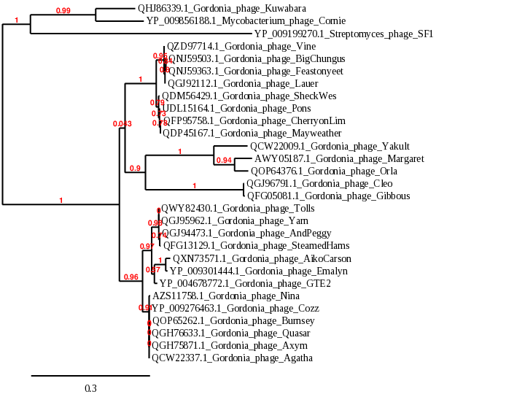

References
- Sayers EW, Beck J, Bolton EE, Bourexis D, Brister JR, Canese K, Comeau DC, Funk K, Kim S, Klimke W, Marchler-Bauer A, Landrum M, Lathrop S, Lu Z, Madden TL, O'Leary N, Phan L, Rangwala SH, Schneider VA, Skripchenko Y, Wang J, Ye J, Trawick BW, Pruitt KD, Sherry ST. Database resources of the National Center for Biotechnology Information. Nucleic Acids Res. 2021 Jan 8;49(D1):D10-D17. doi: 10.1093/nar/gkaa892. PMID: 33095870
- Moraru C, Varsani A, Kropinski AM. VIRIDIC-A Novel Tool to Calculate the Intergenomic Similarities of Prokaryote-Infecting Viruses. Viruses. 2020 Nov 6;12(11):1268. doi: 10.3390/v12111268. PMID: 33172115; PMCID: PMC7694805. http://kronos.icbm.uni-oldenburg.de/viridic/
- Nishimura Y, Yoshida T, Kuronishi M, Uehara H, Ogata H, Goto S. ViPTree: the viral proteomic tree server. Bioinformatics. 2017; 33(15):2379-2380. doi:10.1093/bioinformatics/btx157. PubMed PMID: 28379287. https://www.genome.jp/viptree/
- Rohwer F, Edwards R. The Phage Proteomic Tree: a genome-based taxonomy for phage. J Bacteriol. 2002 Aug;184(16):4529-35. PubMed PMID: 12142423
- Turner D, Reynolds D, Seto D, Mahadevan P. CoreGenes3.5: a webserver for the determination of core genes from sets of viral and small bacterial genomes. BMC Res Notes. 2013;6:140. doi: 10.1186/1756-0500-6-140. PMID: 23566564.
- Dereeper A, Guignon V, Blanc G, Audic S, Buffet S, Chevenet F, Dufayard JF, Guindon S, Lefort V, Lescot M, Claverie JM, Gascuel O. Phylogeny.fr: robust phylogenetic analysis for the non-specialist. Nucleic Acids Res. 2008;36(Web Server issue):W465-9. doi: 10.1093/nar/gkn180. Epub 2008 Apr 19. PMID: 18424797.
- Anisimova M, Gascuel O. Approximate likelihood-ratio test for branches: A fast, accurate, and powerful alternative. Syst Biol. 2006;55(4):539-52. PMID: 16785212. DOI: 10.1080/10635150600755453.
- Turner D, Kropinski AM, Adriaenssens EM. A Roadmap for Genome-Based Phage Taxonomy. Viruses. 2021 Mar 18;13(3):506. doi: 10.3390/v13030506. PMID: 33803862; PMCID: PMC8003253.
- O'Leary NA, Wright MW, Brister JR, Ciufo S, Haddad D, McVeigh R, et al. Reference sequence (RefSeq) database at NCBI: current status, taxonomic expansion, and functional annotation. Nucleic Acids Res. 2016;44(D1):D733-45. doi: 10.1093/nar/gkv1189. PMID: 26553804.
- Olsen NS, Hendriksen NB, Hansen LH and Kot W. A New High-Throughput Screening Method for Phages: Enabling Crude Isolation and Fast Identification of Diverse Phages with Therapeutic Potential. Phage (New Rochelle) 1 (3), 137-148 (2020) https://www.liebertpub.com/doi/10.1089/phage.2020.0016

