

Part 1: TITLE, AUTHORS, APPROVALS, etc

Code assigned: | 2022.062B
Short title: Create 6 new genera and 19 new species to the family Peduoviridae (Caudoviricetes)

Author(s) and email address(es)
Lueder MR, Van Zyl LJ, Adriaenssens EM | luederm@mail.gvsu.edu; vanzyllj@gmail.com;  Evelien.adriaenssens@quadram.ac.uk
Author(s) institutional address(es) (optional)
Department of Pathology and Laboratory Medicine, The Children’s Hospital of Philadelphia [MRL]

Institute for Microbial Biotechnology and Metagenomics, University of the Western Cape, ZAR

Quadram Institute Bioscience, UK [EMA]

Corresponding author
Leonardo Joaquim van Zyl – lvanzyl@uwc.ac.za
List the ICTV Study Group(s) that have seen this proposal
Peduoviridae Study Group

ICTV Study Group comments and response of proposer
ICTV Study Group votes on proposal
Study Group | Number of members
Study Group | Votes support | Votes against | No vote
Authority to use the name of a living person

Is any taxon name used here derived from that of a living person (Y/N) | N

Taxon name | Person from whom the name is derived | Permission attached (Y/N)

Submission dates
Date first submitted to SC Chair | May 2022
Date of this revision (if different to above)
ICTV-EC comments and response of the proposer

Part 2: NON-TAXONOMIC PROPOSAL
Text of proposal

Part 3: TAXONOMIC PROPOSAL
Name of accompanying Excel module
2022.062B.N.v1.Peduoviridae_6ng_19nsp.xlsx
Abstract
In this proposal we analyze phage genomes released on the Genbank database since April 2022 comparing them to the current ICTV virus classification to determine if they represent new phyla. Based on both nucleotide identity over the length of the genome as determined using VIRIDIC and protein similarity of the core genes (terminase large and small subunit -, portal -, capsid completion -, capsid scaffolding - and major capsid proteins) we find that there are 6 genera and 16 new species that belong to the family Peduoviridae.

Text of proposal
Species demarcation criteria: We have chosen 95% DNA sequence identity as the criterion for demarcation of species in each genus. Each of the proposed species differs from the others by more than 5% at the DNA level as confirmed with the BLASTn algorithm.

Genus demarcation criteria (updated): The defining criterion for membership in a genus is that the species display 70-95% DNA sequence identity to one another. This was previously set to 50-95%. Membership to existing genera is adjusted to meet this new criterion within this proposal. All genera are monophyletic in the marker gene trees.

Family demarcation criteria: All members of Peduoviridae encode a set of 6 orthologous core genes:
Orthogroup 1 | Terminase, large subunit
Orthogroup 2 | Portal protein
Orthogroup 3 | Capsid scaffolding protein
Orthogroup 4 | Major capsid protein
Orthogroup 5 | Terminase, small subunit
Orthogroup 6 | Capsid completion/stabilization protein
Members of Peduoviridae have genome sizes between 28 kb and 41kb.

Proposal 1: To create seven new species and assign them to the genus Peduovirus.

Background/History: Escherichia phage 11W was isolated from an E. coli lysogenic strain. The Escherichia phages, AC1, DC1, SIAC10 and SIDE7 were isolated from a E. coli strains in Eligo Bioscience’s strain collection (Rousset et al., 2022). Phage P37 was isolated from a rat cecum sample and infects Yersinia pestis EV76, while HQ103 infects Yersinia pestis EV76-CN. Both were isolated in China however the exact source material is currently unknown.

Source of name of this taxon: The species names are derived from the Genbank entry exemplar virus name.

Genome Summary Table:
Exemplar  Genbank Accession | Exemplar  RefSeq  Accession | Species Name | Genome Length | GC Content | Number of tRNAs* | Number of ORFs**
OM475429 | N/A | Peduovirus 11W | 31,564bp | 51.4% | 0 | 47
OV192280 | N/A | Peduuovirus AC1 | 33,349bp | 50.7% | 0 | 42
OU784549 | N/A | Peduovirus SIAC10 | 33,562bp | 51.5% | 0 | 43
OU784750 | N/A | Peduovirus DC1 | 32541bp | 51.6% | 0 | 42
OU784746 | N/A | Peduovirus SIDE7 | 31,490bp | 52.5% | 0 | 40
MT239398 | N/A | Peduovirus P37 | 33,007bp | 51.7% | 0 | 42
MZ420230 | N/A | Peduovirus HQ103 | 35,113bp | 51.5% | 0 | 53
* Determined using tRNAscan-SE
** Determined using PHANOTATE or GenBank entry

References:

Rousset F, Depardieu F, Miele S, Dowding J, Laval A-L, Lieberman E, Garry D, Rocha EPC, Bernheim A, Bikard D (2022) Phages and their satellites encode hotspots of antiviral systems. Cell Host & Microbe 30: 740–753 PMID: 35316646

Proposal 2: To create a new species in the genus Elveevirus.

Background/History: The exemplar for Elveevirus cartapus is a temperate phage from the Crohn’s disease associated E. coli LF82. The genome present on the Genbank database represents the encapsidated form of the virus.

Source of name of this taxon: The species name is derived from the Genbank entry exemplar virus name.

Genome Summary Table:
Exemplar  Genbank Accession | Exemplar  RefSeq  Accession | Species Name | Genome Length | GC Content | Number of tRNAs* | Number of ORFs**
OV696611 | N/A | Elveevirus cartapus | 33,368bp | 51.0% | 1 | 47
* Determined using tRNAscan-SE
** Determined using PHANOTATE or GenBank entry

Proposal 3: To create a new species in the genus Kisquattuordecimvirus.

Background/History: The exemplar for Kisquattuordecimvirus FLC10 is a virus that infects Burkholderia glumae and was isolated in Sendai Japan. The source material from which it was isolated is currently unknown.

Source of name of this taxon: The species name is derived from the Genbank entry exemplar virus name.

Genome Summary Table:
Exemplar  Genbank Accession | Exemplar  RefSeq  Accession | Species Name | Genome Length | GC Content | Number of tRNAs* | Number of ORFs**
LC667452 | N/A | Kisquattuordecimvirus FLC10 | 32,867bp | 61.3% | 0 | 43
* Determined using tRNAscan-SE
** Determined using PHANOTATE or GenBank entry

Proposal 4: To create a new species in the genus Eganvirus.

Background/History: The exemplar for Eganvirus BIS20 was isolated in Pakistan from retail poultry tissue samples suspected of Salmonella infection using Salmonella Typhimurium strain SE-BS17 (Sattar et al., 2022).

Source of name of this taxon: The species name is derived from the Genbank entry exemplar virus name.

Genome Summary Table:
Exemplar  Genbank Accession | Exemplar  RefSeq  Accession | Species Name | Genome Length | GC Content | Number of tRNAs* | Number of ORFs**
MZ520833 | N/A | Eganvirus BIS20 | 29,512bp | 53.2% | 1 | 39
* Determined using tRNAscan-SE
** Determined using PHANOTATE or GenBank entry

References:

Sattar S, Ullah I, Khanum S et al. (2022) Phenotypic characterization and genome analysis of a novel Salmonella typhimurium phage having unique tail fiber genes. Sci Rep 12: 5732 PMID: 35388062

Proposal 5: To create a new species in the genus Tigrvirus.and a new species, Tigrvirus BP822

Background/History: The exemplar for Tigrvirus BP822 is a prophage resident in Burkholderia pseudomallei BP8, a derivative of 1026b, which is an Select Agent exempt strain obtained from H. Schweizer Lab at UF.

Source of name of this taxon: The species name is derived from the Genbank entry exemplar virus name.

Genome Summary Table:
Exemplar  Genbank Accession | Exemplar  RefSeq  Accession | Species Name | Genome Length | GC Content | Number of tRNAs* | Number of ORFs**
OM304382 | N/A | Tigrvirus BP822 | 36,280bp | 64.8% | 0 | 54
* Determined using tRNAscan-SE
** Determined using PHANOTATE or GenBank entry

Proposal 6: To create a new genus, Firavirus, and a new species, Firavirus YenM4218.

Background/History: The exemplar for Firavirus YenM4218 was isolated in Germany from unknown source material and infects Yersinia enterocolitica.

Source of name of this taxon: The genus name is derived from the organisation that isolated the virus (Federal Institute for Risk Assessment - FIRA) and the species name from the Genbank entry exemplar virus name.

Genome Summary Table:
Exemplar  Genbank Accession | Exemplar  RefSeq  Accession | Species Name | Genome Length | GC Content | Number of tRNAs* | Number of ORFs**
OM046624 | N/A | Firavirus YenM4218 | 36,481bp | 46.4% | 0 | 54
* Determined using tRNAscan-SE
** Determined using PHANOTATE or GenBank entry

Proposal 7: To create a new genus, Duonihilunusvirus, and three new species in the genus namely Duonihilunusvirus YenM20116, Duonihilunusvirus YenM5617, Duonihilunusvirus YenM06162.

Background/History: All three exemplar viruses were isolated in Germany from unknown source material and infect Yersinia enterocolitica.

Source of name of this taxon: The genus name is derived from the name given to this virus (vB_YenM_201.16) by the discoverers, while the species name is derived from the Genbank entry exemplar virus name.
Genome Summary Table:
Exemplar  Genbank Accession | Exemplar  RefSeq  Accession | Species Name | Genome Length | GC Content | Number of tRNAs* | Number of ORFs**
OM046628 | N/A | Duonihilunusvirus YenM20116 | 30,280bp | 51.3% | 0 | 52
OM046627 | N/A | Duonihilunusvirus YenM5617 | 33,247bp | 49.7% | 0 | 55
OM046626 | N/A | Duonihilunusvirus YenM06162 | 29,546bp | 50.6% | 0 | 44
* Determined using tRNAscan-SE
** Determined using PHANOTATE or GenBank entry

Proposal 8: To create a new genus, Tresduoquattuorvirus, and a new species, Tresduoquattuorvirus YenM324.

Background/History: The exemplar for Tresduoquattuorvirus YenM324 was isolated in Germany from unknown source material and infects Yersinia enterocolitica 324.

Source of name of this taxon: The genus name is derived from the name given to this virus (vB_YenM_324) by the discoverers, while the species name is derived from the Genbank entry exemplar virus name.

Genome Summary Table:
Exemplar  Genbank Accession | Exemplar  RefSeq  Accession | Species Name | Genome Length | GC Content | Number of tRNAs* | Number of ORFs**
OM095401 | N/A | Tresduoquattuorvirus YenM324 | 29,180bp | 49.6% | 0 | 39
* Determined using tRNAscan-SE
** Determined using PHANOTATE or GenBank entry

Proposal 9: To create a new genus, Graikaemvirus, and a new species, Graikaemvirus YenM3117.

Background/History: The exemplar for Graikaemvirus YenM3117 was isolated in Germany from unknown source material and infects Yersinia enterocolitica.

Source of name of this taxon: The genus name is derived from the name given to this virus (vB_YenM_31.17) by the discoverers, while the species name is derived from the Genbank entry exemplar virus name.

Genome Summary Table:
Exemplar  Genbank Accession | Exemplar  RefSeq  Accession | Species Name | Genome Length | GC Content | Number of tRNAs* | Number of ORFs**
OM140653 | N/A | Graikaemvirus YenM324 | 32,949bp | 49.0% | 0 | 44
* Determined using tRNAscan-SE
** Determined using PHANOTATE or GenBank entry

Proposal 10: To create a new genus, Piscesmortuivirus, and a new species, Piscesmortuivirus LPM4.

Background/History: The exemplar for Piscesmortuivirus LPM4 was isolated from a deceased fish (Hosseini et al., 2021).

Source of name of this taxon: The genus name is derived from the isolation source material (deceased fish), while the species name for the virus is derived from the Genbank entry exemplar virus name.

Genome Summary Table:
Exemplar  Genbank Accession | Exemplar  RefSeq  Accession | Species Name | Genome Length | GC Content | Number of tRNAs* | Number of ORFs**
OL348188 | N/A | Piscesmortuivirus LPM4 | 37,312bp | 58.1% | 0 | 55
* Determined using tRNAscan-SE
** Determined using PHANOTATE or GenBank entry

References:

Hosseini N, Paquet VE, Chehreghani M, Moineau S, Charette SJ (2021) Phage cocktail development against Aeromonas salmonicida subsp. salmonicida strains is compromised by a prophage. Viruses 13: 2241 PMID: 34835047

Proposal 11: To create a new genus, Arsenicumvirus, and a new species, Arsenicumvirus M163.

Background/History: The exemplar for Arsenicumvirus M163 was isolated from arsenic-containing microbial mats and infects Shewanella sp. M16 (Bujak et al., 2021).

Source of name of this taxon: The genus name is derived from isolation source material (arsenic-containing microbial mats), while the species name for the virus is derived from the Genbank entry exemplar virus name.

Genome Summary Table:
Exemplar  Genbank Accession | Exemplar  RefSeq  Accession | Species Name | Genome Length | GC Content | Number of tRNAs* | Number of ORFs**
MZ568829 | N/A | Arsenicumvirus M163 | 40,166bp | 46.8% | 0 | 63
* Determined using tRNAscan-SE
** Determined using PHANOTATE or GenBank entry

References:

Bujak K, Decewicz P, Rosinska JM, Radlinska M (2021) Genome study of a novel virulent phage vB_SspS_KASIA and Mu-like prophages of Shewanella sp. M16 provides insights into the genetic diversity of the Shewanella virome. Int J Mol Sci. 22: 11070 PMID: 34681734

Supporting evidence

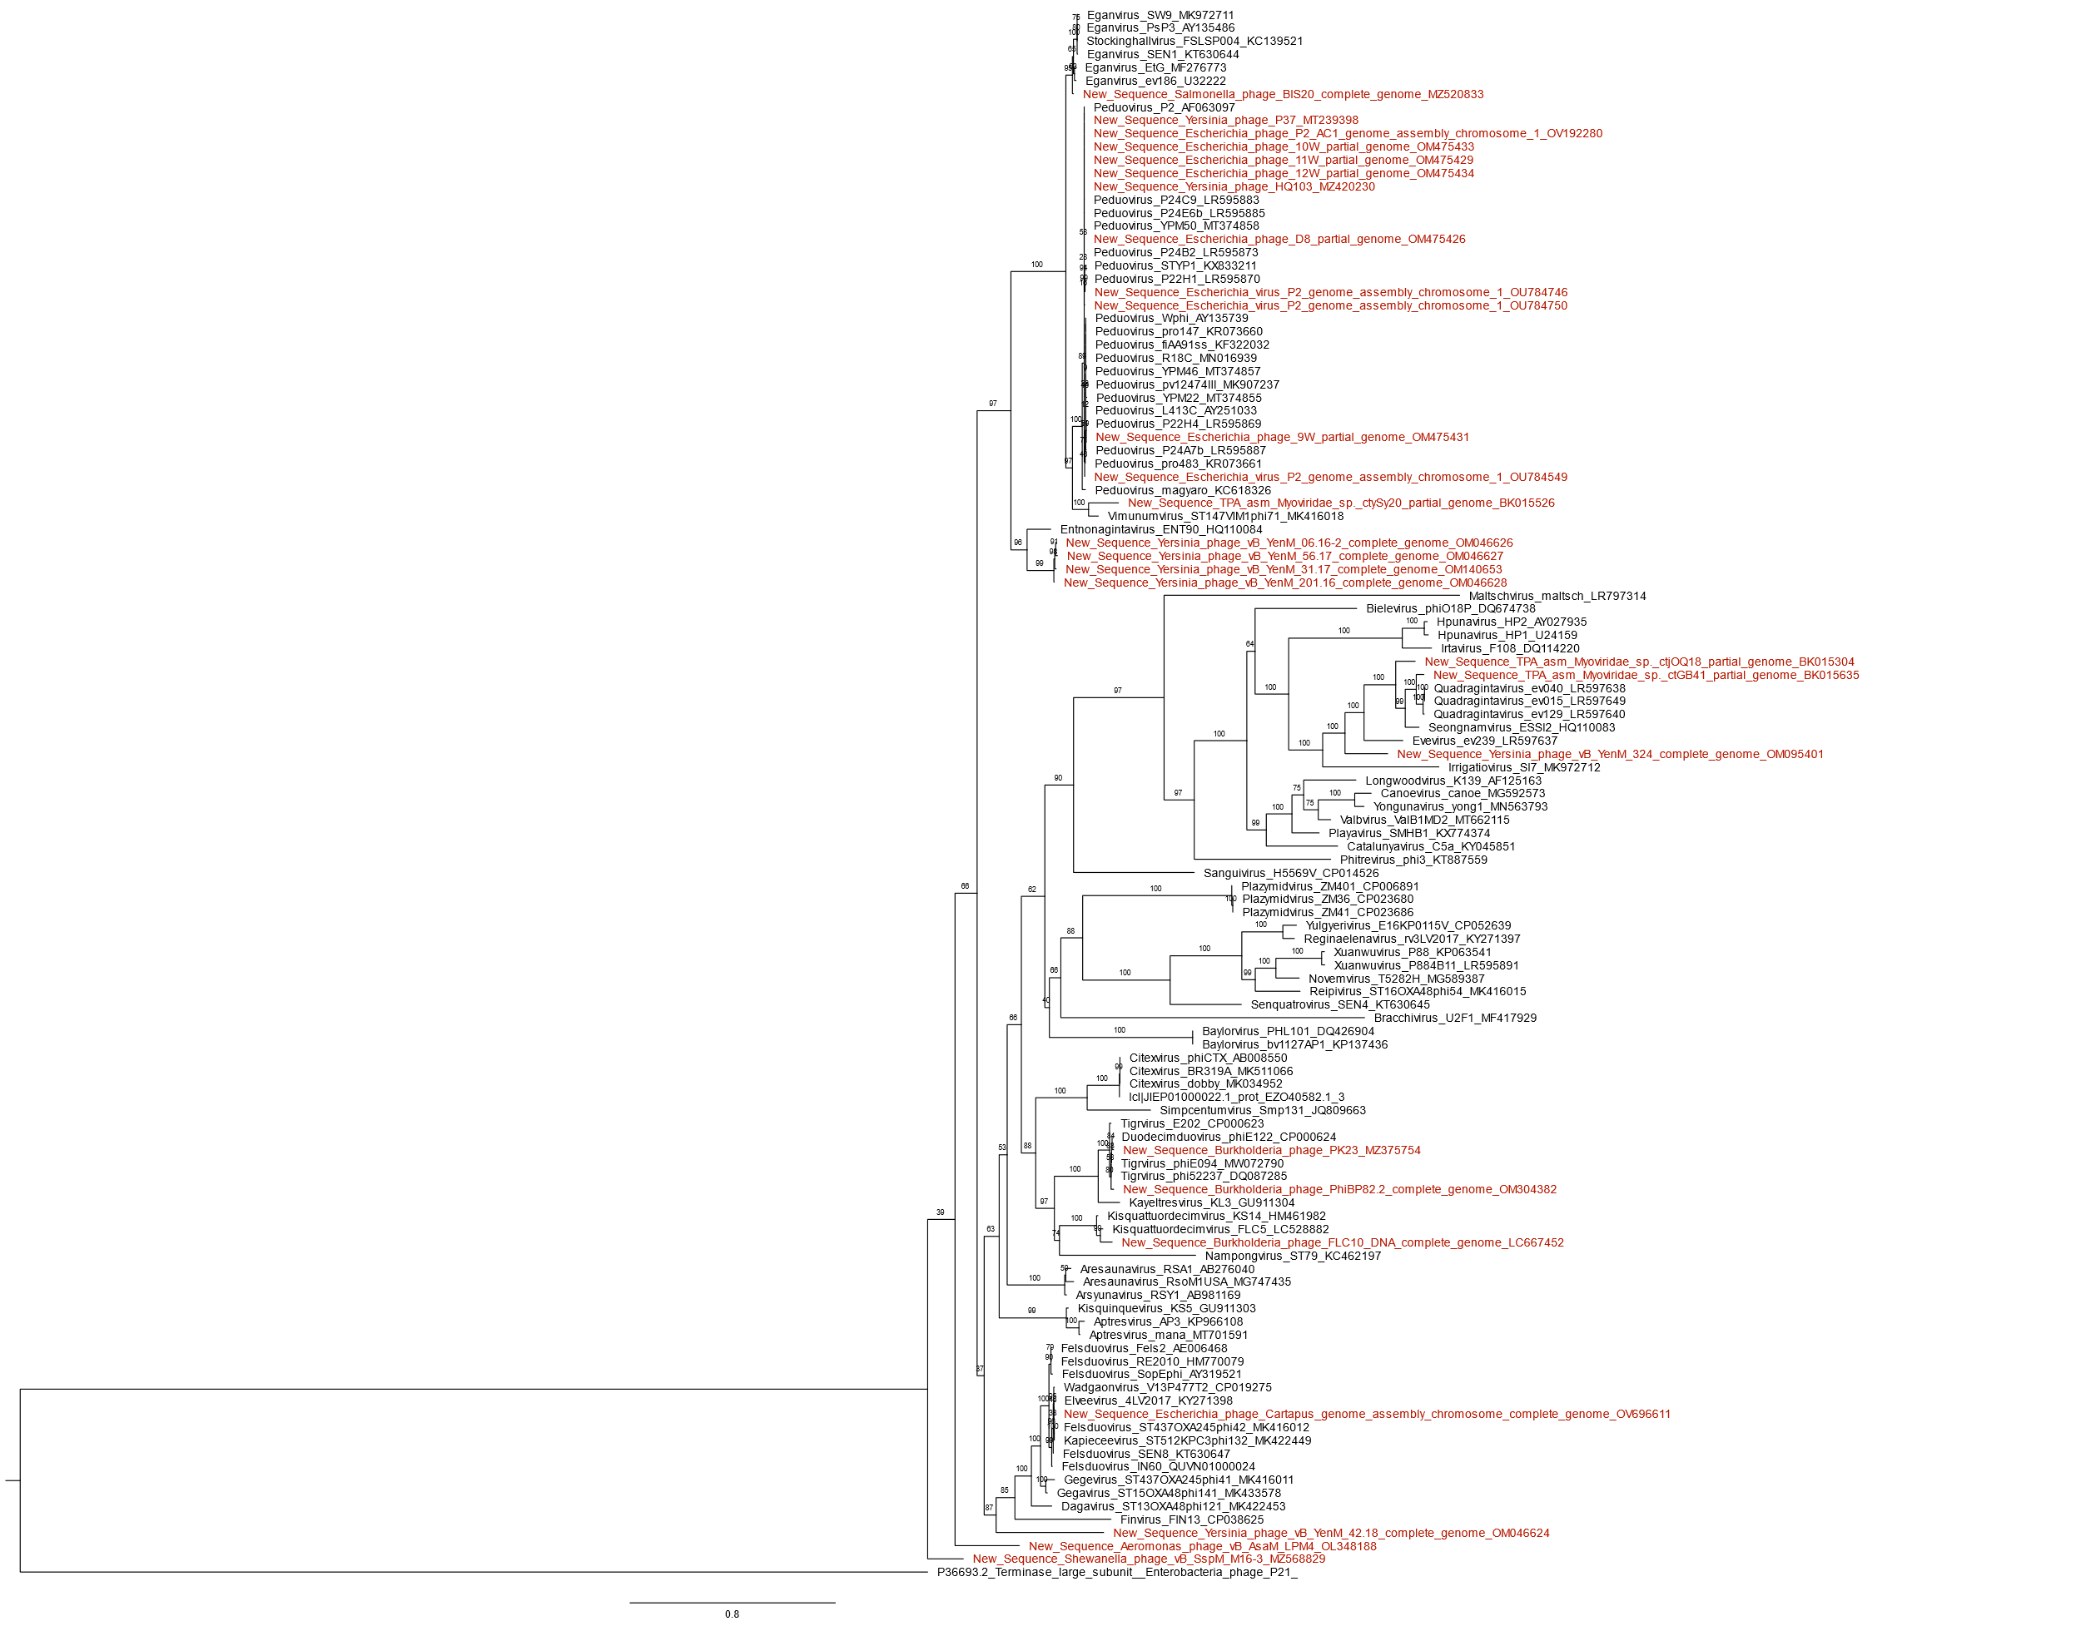

Figure 1. Peduoviridae large terminase subunit phylogeny created with Clustal Omega, BMGE, and IQ-Tree using the model LG+I+G4 and 2,500 bootstrap replicates. The large terminase of Enterobacteria phage P21 is used as an outgroup. Outgroup determined with HHpred. Tree visualized with FigTree.

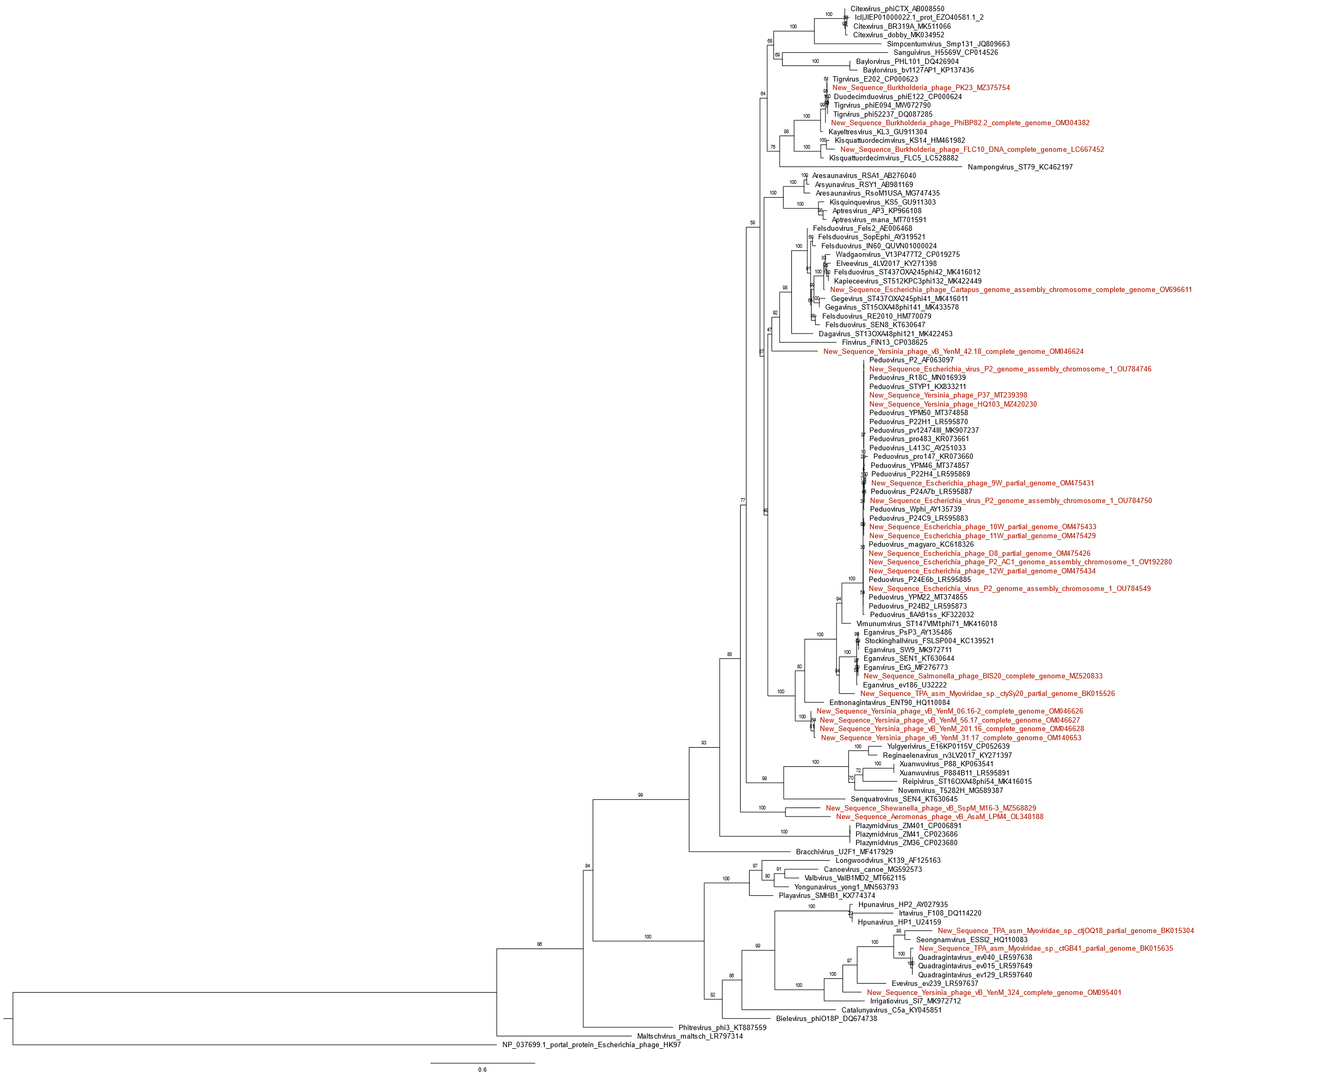

Figure 2. Peduoviridae portal protein phylogeny created with Clustal Omega, BMGE, and IQ-Tree using the model LG+I+G4 and 2,500 bootstrap replicates. Portal proteins from Enterobacteria phage HK97 are used as an outgroup. Outgroup determined with PSI-BLAST and HHpred. Tree visualized with FigTree.

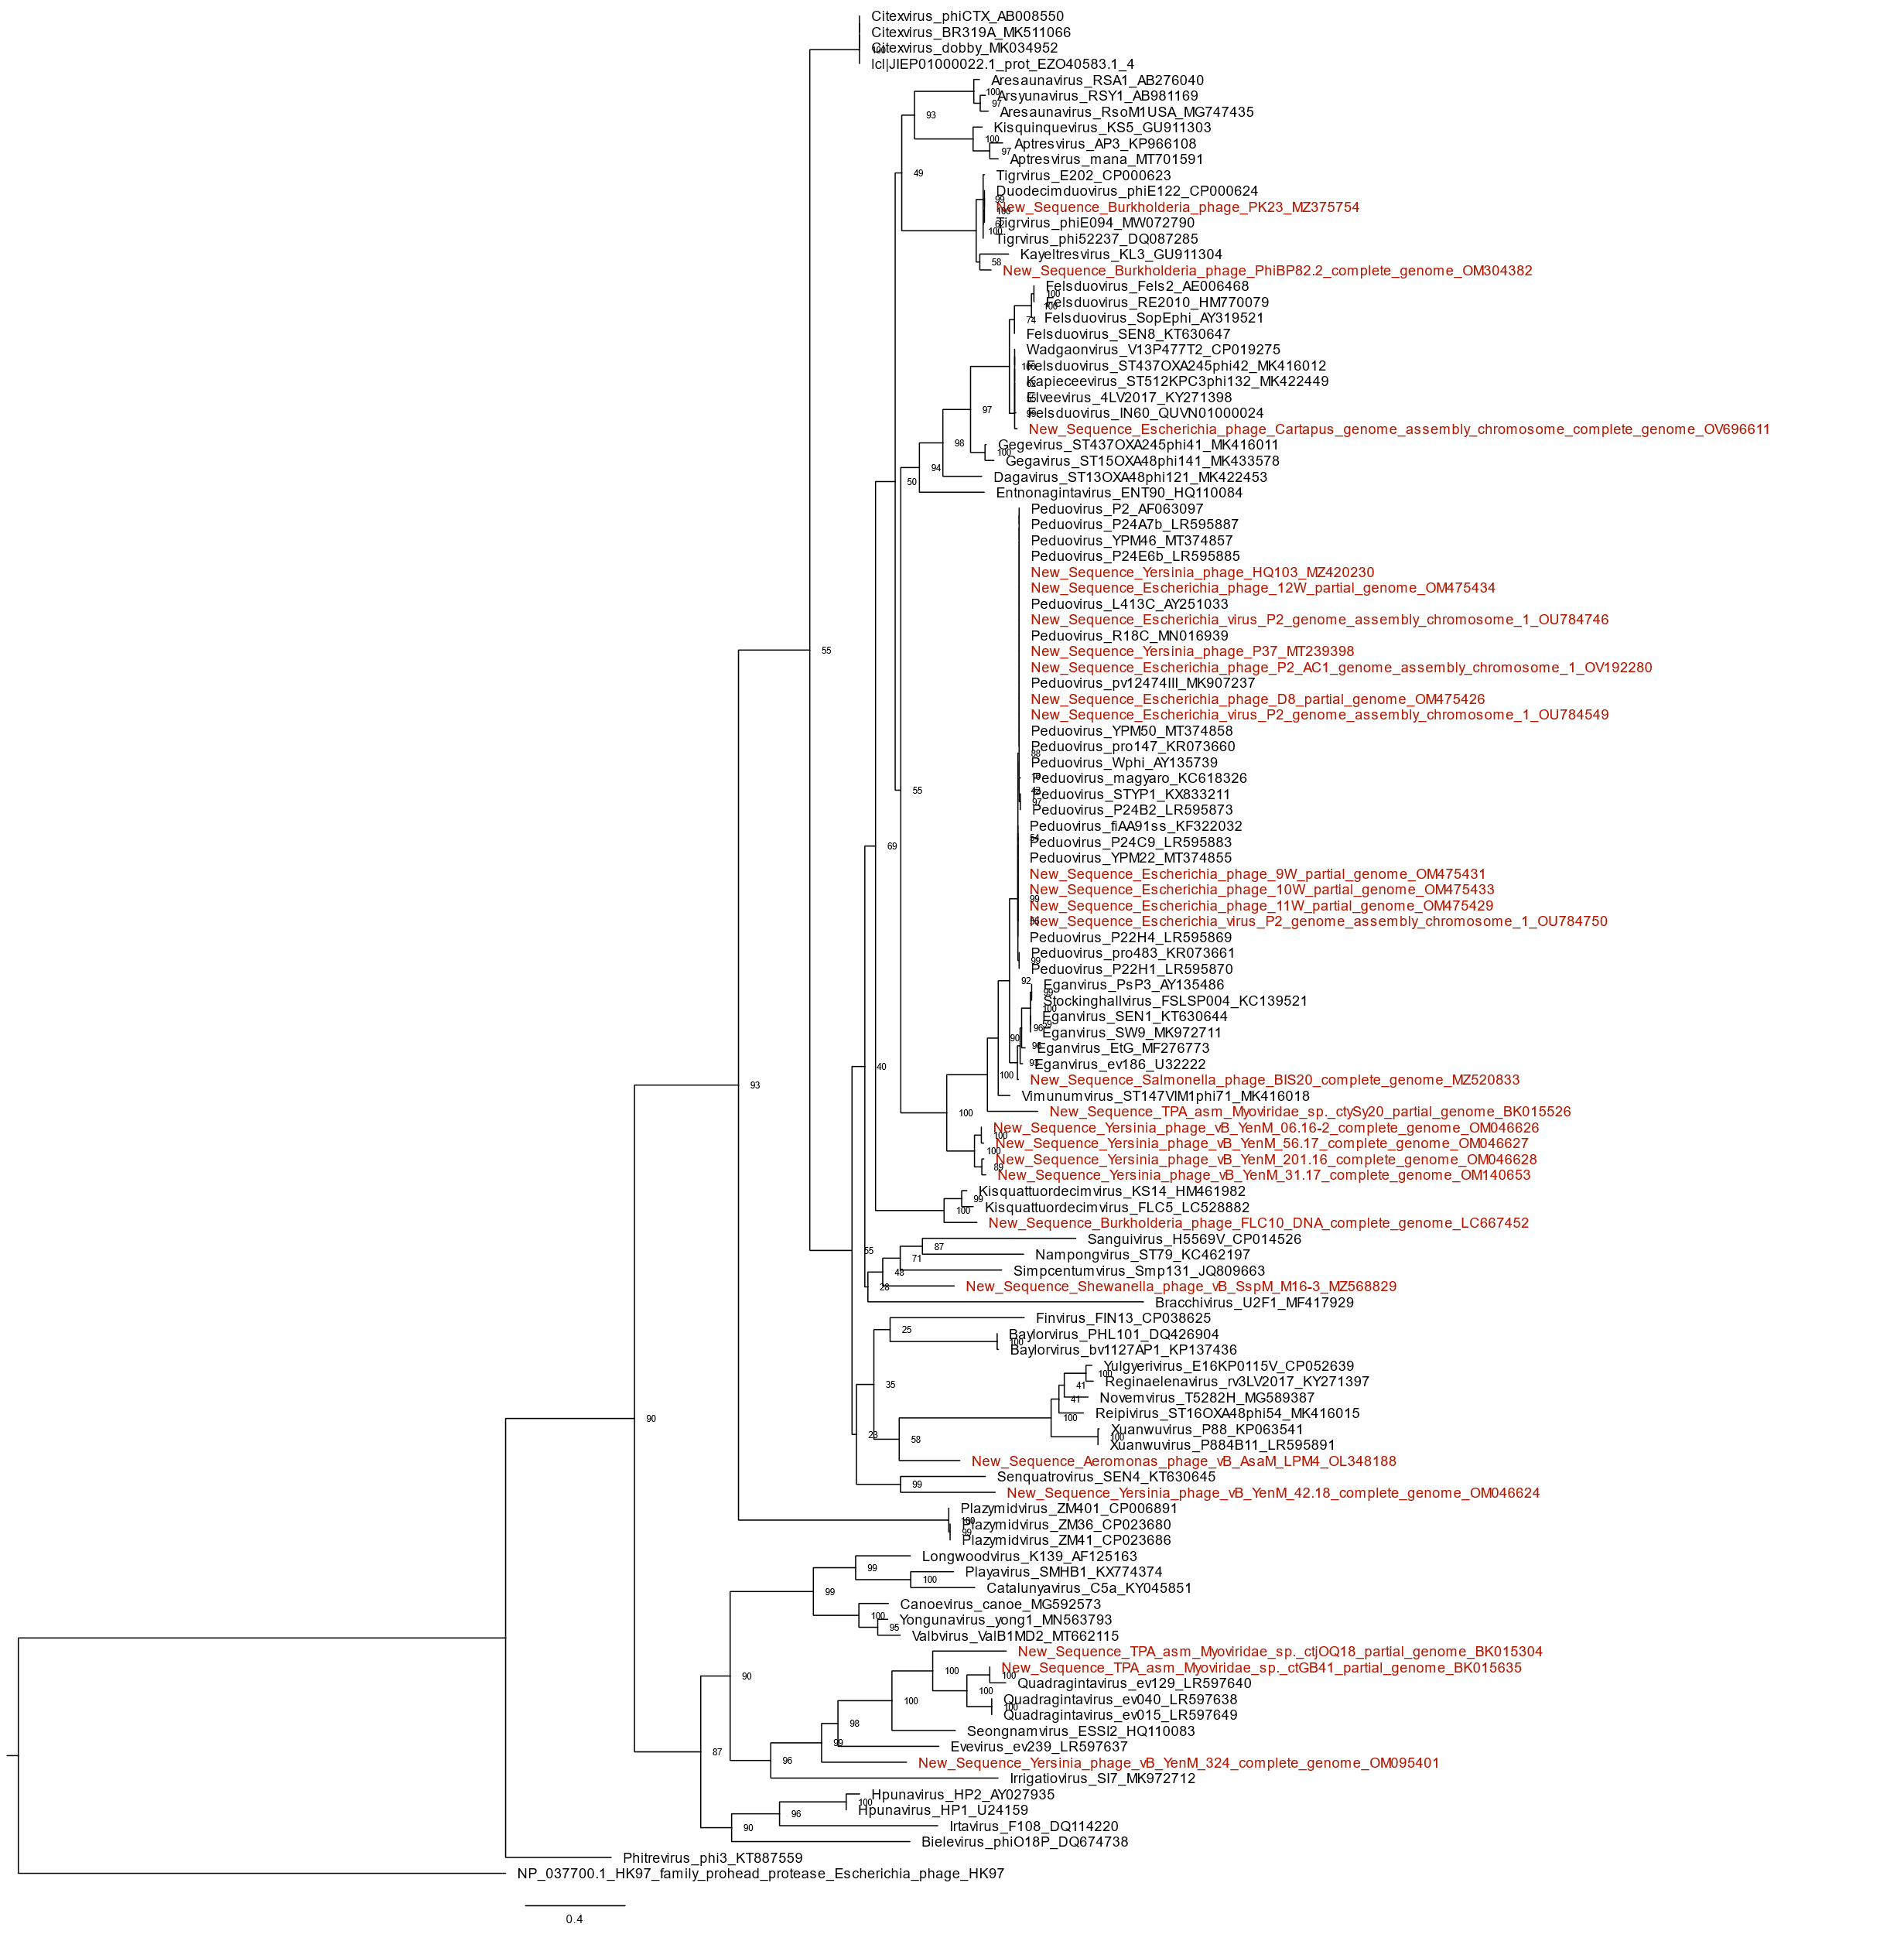

Figure 3. Peduoviridae capsid scaffolding protein phylogeny created with Clustal Omega, BMGE, and IQ-Tree using the model LG+I+G4 and 2,500 bootstrap replicates. Proteases from Enterobacteria phage HK97. Outgroup determined with HHpred. Tree visualized with ETE 3. Tree visualized with FigTree.

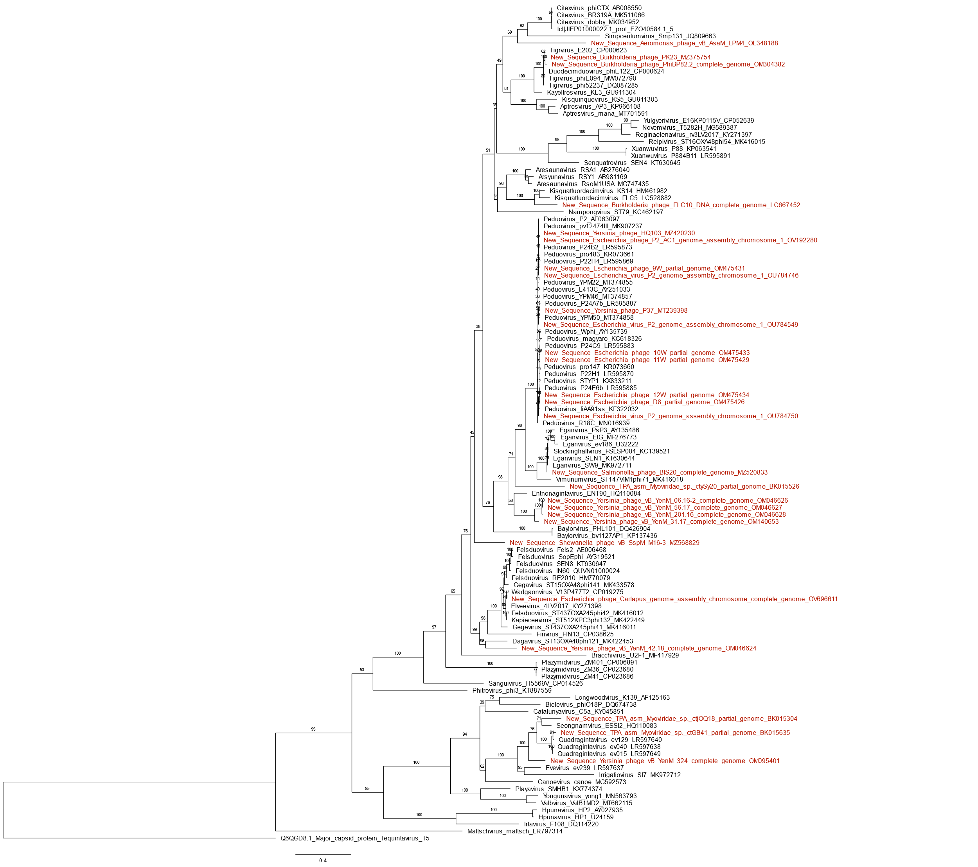

Figure 4. Peduoviridae major capsid protein phylogeny created with Clustal Omega, BMGE, and IQ-Tree using the model LG+I+G4 and 2,500 bootstrap replicates. The major capsid protein of Escherichia phage T5 is used as an outgroup. Outgroup determined with HHpred. Tree visualized with FigTree.

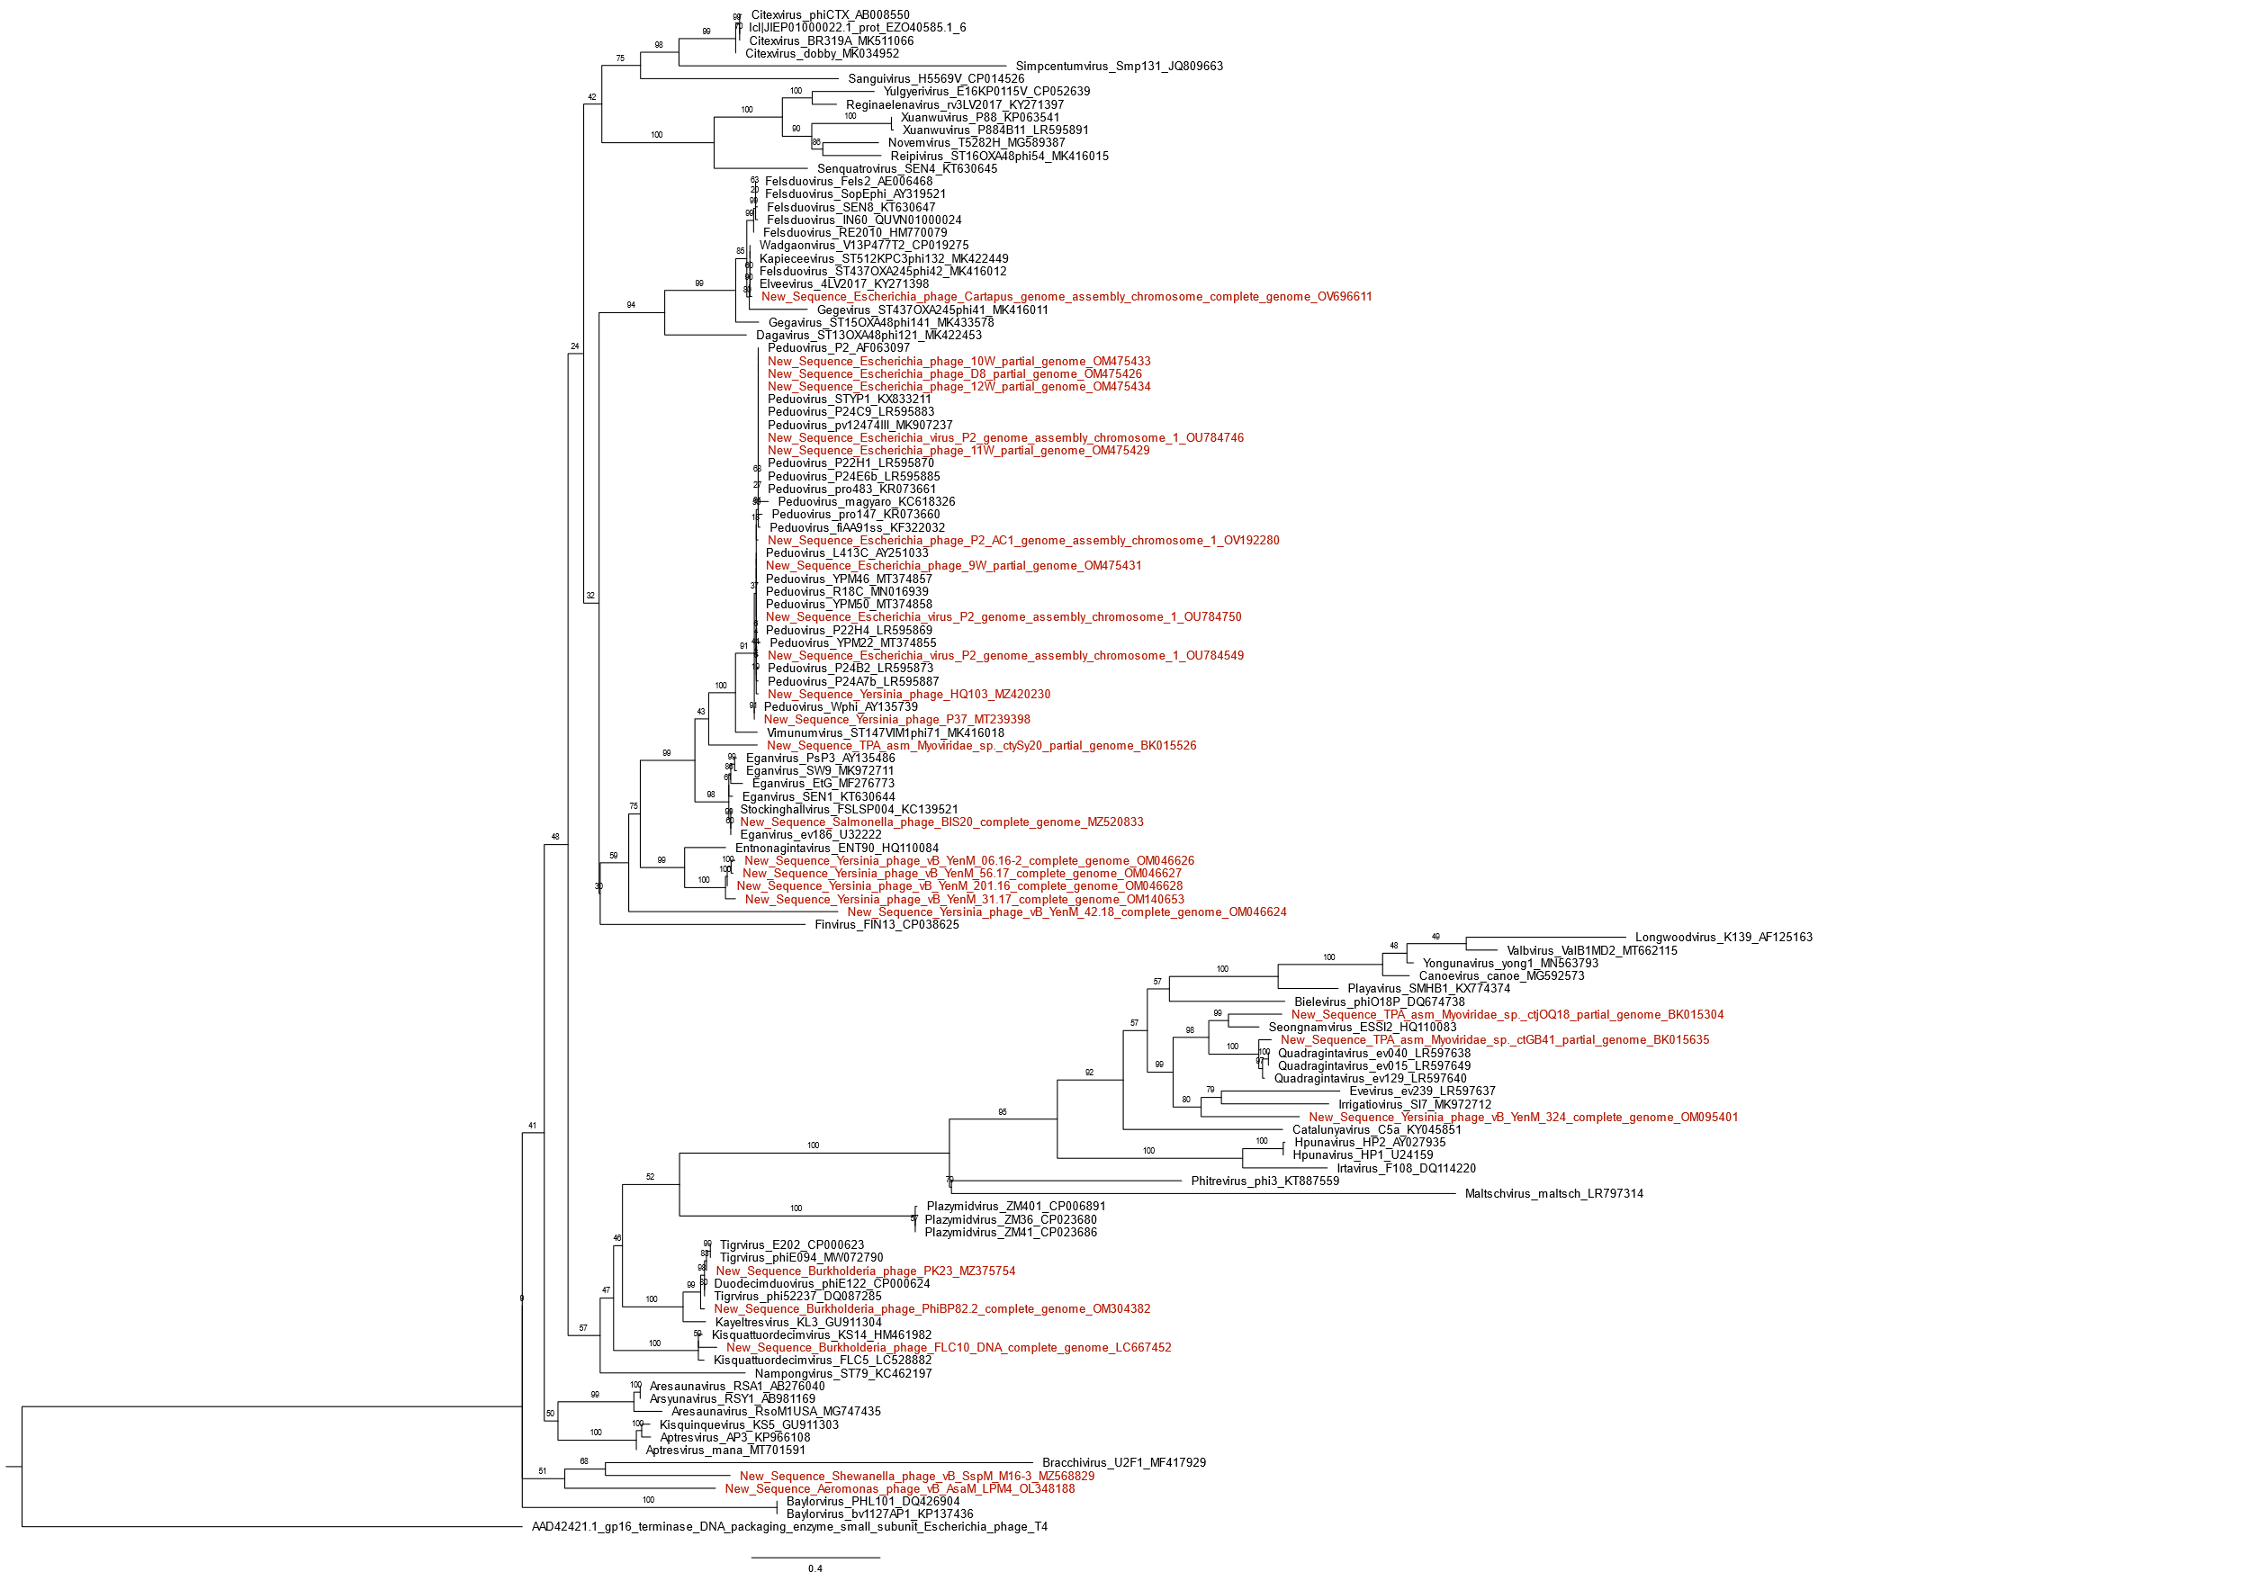

Figure 5. Peduoviridae small terminase subunit phylogeny created created with Clustal Omega, BMGE, and IQ-Tree using the model LG+I+G4 and 2,500 bootstrap replicates. The small terminase of Escherichia phage T4 is used as an outgroup. Tree visualized with FigTree.

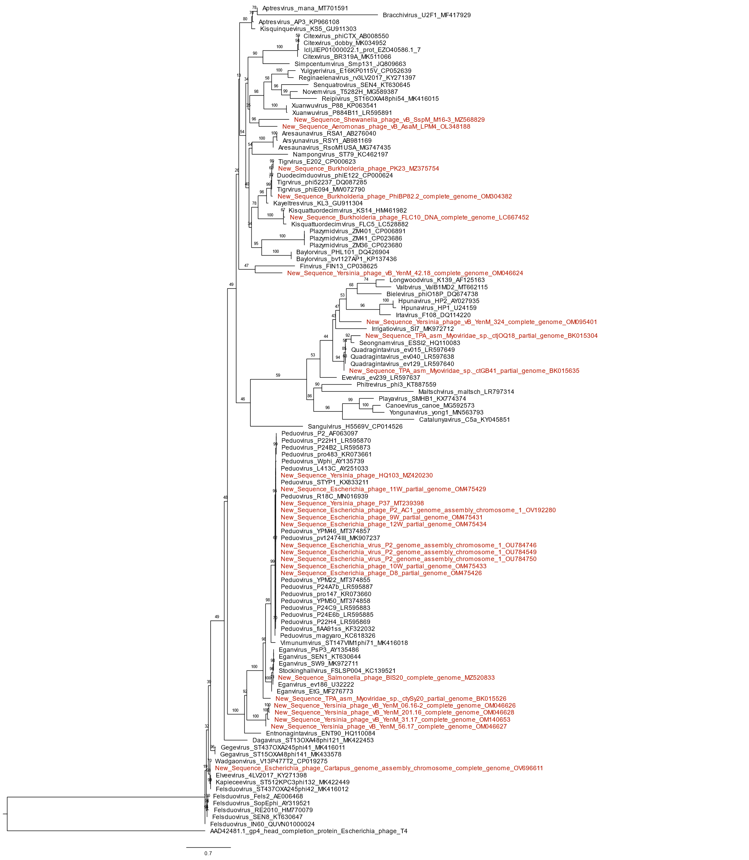

Figure 6. Peduoviridae capsid completion/stabilization protein phylogeny created with Clustal Omega, BMGE, and IQ-Tree using the model LG+I+G4 and 2,500 bootstrap replicates. The head completion protein of Escherichia phage T4 is used as an outgroup. Tree visualized with FigTree.

References

- Rousset F, Depardieu F, Miele S, Dowding J, Laval A-L, Lieberman E, Garry D, Rocha EPC, Bernheim A, Bikard D (2022) Phages and their satellites encode hotspots of antiviral systems. Cell Host & Microbe 30: 740–753 PMID: 35316646
- Sattar S, Ullah I, Khanum S et al. (2022) Phenotypic characterization and genome analysis of a novel Salmonella typhimurium phage having unique tail fiber genes. Sci Rep 12: 5732 PMID: 35388062
- Hosseini N, Paquet VE, Chehreghani M, Moineau S, Charette SJ (2021) Phage cocktail development against Aeromonas salmonicida subsp. salmonicida strains is compromised by a prophage. Viruses 13: 2241 PMID: 34835047
- Bujak K, Decewicz P, Rosinska JM, Radlinska M (2021) Genome study of a novel virulent phage vB_SspS_KASIA and Mu-like prophages of Shewanella sp. M16 provides insights into the genetic diversity of the Shewanella virome. Int J Mol Sci. 22: 11070 PMID: 34681734

