

Part 1: TITLE, AUTHORS, APPROVALS, etc

Code assigned: | 2022.049B
Short title: Create one new species in the genus Menderavirus (Caudoviricetes)
Author(s) and email address(es)
Vázquez-Campos X, Damnjanović D | xvazquezc@gmail.com; d.damnjanovic@unsw.edu.au
Author(s) institutional address(es) (optional)
School of Biotechnology and Biomolecular Sciences, University of New South Wales [XVC, DD]
Corresponding author
Vázquez-Campos X
List the ICTV Study Group(s) that have seen this proposal
Caudoviricetes Study Group, Bacterial and Archaeal Viruses Subcommittee
ICTV Study Group comments and response of proposer
ICTV Study Group votes on proposal
Study Group | Number of members
Study Group | Votes support | Votes against | No vote
Authority to use the name of a living person
Is any taxon name used here derived from that of a living person (Y/N) | N

Taxon name | Person from whom the name is derived | Permission attached (Y/N)

Submission dates
Date first submitted to SC Chair | April 2022
Date of this revision (if different to above)
ICTV-EC comments and response of the proposer

Part 2: NON-TAXONOMIC PROPOSAL
Text of proposal

Part 3: TAXONOMIC PROPOSAL
Name of accompanying Excel module
2022.049B.N.v1.Menderavirus_1nsp.xlsx
Abstract
There are currently three defined species in the genus Menderavirus. Here we propose a fourth species.

Text of proposal
A 95% DNA sequence identity was chosen as the criterion for demarcation of species in this genus Menderavirus. The proposed species differs from the others with more than 5% at the DNA level as confirmed with VIRIDIC.

Supporting evidence

Specific reference: Damnjanović D, Vázquez-Campos X, Elliot L, Willcox M, Bridge WJ (2022) Characterisation of bacteriophage vB_SmaM_Ps15 infective to Stenotrophomonas maltophilia clinical ocular isolates. Viruses 14:709. [1].

History: This phage was isolated from the Cleveland Bay Water Processing Plant in Townsville (Queensland, Australia), where the wastewater from public hospitals and most of Townsville city is processed. The phage was isolated and propagated on the Pseudomonas aeruginosa AP143 using standard phage isolation methods, a culture later known to be a mix of Pseudomonas aeruginosa and Stenotrophomonas maltophilia. Stenotrophomonas maltophilia is the only known host.

Genomic summary: Comparisons between genomes were performed based on gene callings performed for this analysis in order to avoid biases due to different annotation methods [1].

Phage strain | INSDC | Size (bp) | GC% | Proteins ª | Coding Density | Genome Similarity/Query Cover (%, BLASTn) ^{b} | Genomic similarity (VIRIDIC) | Shared Proteins (%)
vB_SmaM_Ps15 | OL702939.1 | 161,350 | 54.2 | 275 | 93.86 | 100.0/100 | 100 | 275 (100)
BUCT608 | MZ398248.1 | 160,122 | 54.2 | 270 (266) | 94.15 | 98.62/92 | 89.39 | 221 (81.85)
IME-SM1 | KR560069.1 | 159,514 | 54.1 | 267 (202) | 92.88 | 98.50/91 | 88.21 | 210 (78.65)
Marzo | MZ326868.1 | 159,384 | 54.0 | 262 (268) | 93.65 | 97.49/90.5 | 86.11 | 213 (81.30)
Mendera | MN098328.1 | 159,961 | 54.0 | 272 (286) | 94.05 | 98.07/89.5 | 86.09 | 207 (76.10)
Moby | MN095772.1 | 159,365 | 54.1 | 268 (271) | 94.02 | 94.73/91.5 | 87.23 | 215 (80.22)
YB07 | MK580972.1 | 159,862 | 54.1 | 269 (257) | 93.85 | 98.45/90.5 | 88.3 | 220 (81.78)
ª: values from NCBI’s public genome annotations in parenthesis. ^{b}: based on genome vs. genome with blastn on NCBI’s website. The values indicate the average of reciprocal hits. Note all strains are unique representatives of their species, except BUCT608, and YB07, which are strains of Stenotrophomonas virus IMESM1.

Pangenomics: Pangenomic analysis was performed with Roary v3.13.0 [2] with an identity threshold of 70% to account for the large variability in viral gene sequences. The genome of VB_SmaM_Ps15 showed the largest number of unique proteins (51) and some proteins found in all other Menderavirus were absent (28).

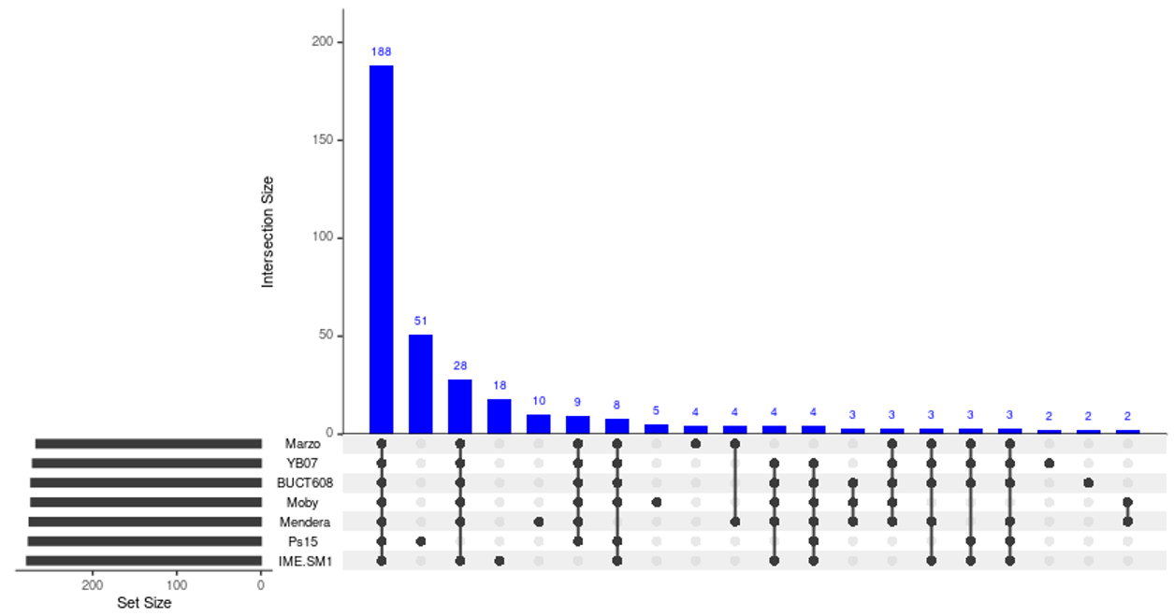

Phylogeny: Confirmation of the placement of VB_SmaM_Ps15 within the Menderavirus genus was performed with independent phylogenies of the major capsid protein and the large terminase subunit. The single protein trees were built using the top 100 UniProtKB matches against the respective VB_SmaM_Ps15 proteins (e-value 0.0001, low complexity regions filter). Matches were dereplicated using CD-Hit v4.8.1 [3] with the following parameters -s 0.95 -c 0.95. With the redundant sequences removed, all the corresponding Menderavirus sequences were added. Alignment was performed with MAFFT-L-INS-i v7.475 [4]. Trees were built with IQ-TREE v2.1.3 [5] under the recommended substitution model (-m MFP), with 1000 ultrafast bootstrap replicates and nearest neighbour interchange optimisation [6]. Rooting of the phylogenetic trees was evaluated using non-reversible substitution models [7] using IQ-TREE v2.1.3 [5] with 1000 ultrafast bootstrap replicates (referred to as rootstrapping) [7].

Placement within the Menderavirus genus was evaluated using a partitioned protein tree using all the protein coding genes present in all Menderavirus genomes (188). The proteins were aligned with MAFFT-L-INS-i v7.475 [4] and concatenated. A maximum likelihood tree was constructed with IQ-TREE v2.1.4-beta [5] with 1000 ultrafast bootstrap replicates [6] and automated substitution model selection for each partition. Due to the limited number of conserved genes with the closest non-Menderavirus genomes suitable to be used as root, i.e., Acidovorax phage ACP17 (GCF_002625205.1), the long evolutionary distance and the high sequence conservancy of the shared genes, the phylogenomic tree was rooted using non-reversible substitution models [7].

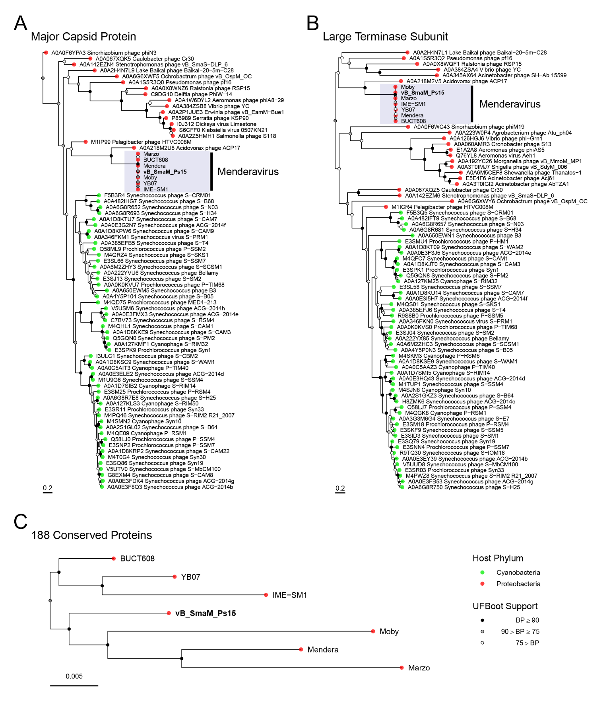
Phylogenetic trees showing the placement of VB_SmaM_Ps15 in relationship to other phages. Phylogenies are based on the major capsid protein (A), the large terminase subunit (B), and on the partitioned phylogenomic analysis with 188 core proteins (C). Tip colours indicate the phylum of the host. Trees were rooted using non-reversible substitution models [7].

Electron micrograph:

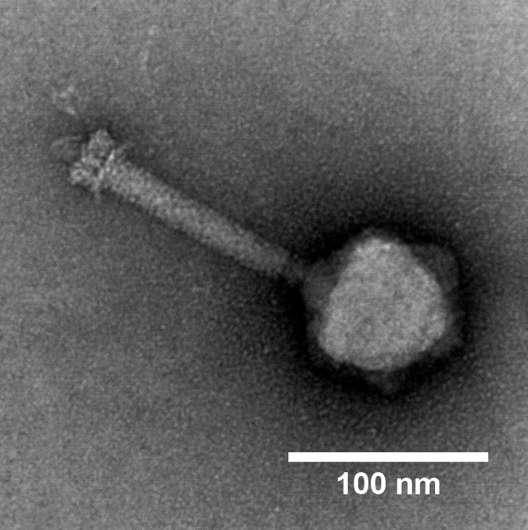 | 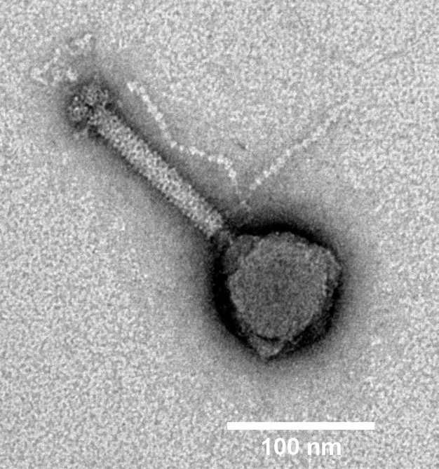
(a) | (b)
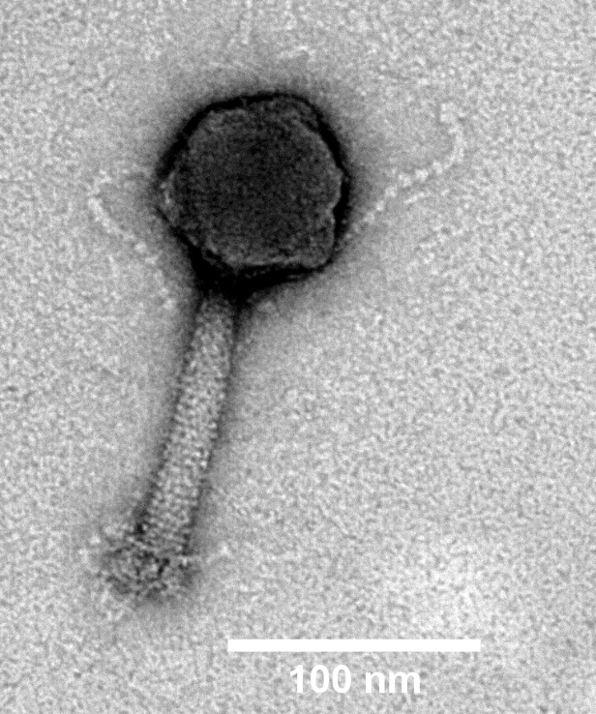
(c)

Transmission electron micrographs of the VB_SmaM_Ps15 phage particles stained with 2% (w/v) uranyl acetate displaying the myovirus morphotype. Magnification × 60 K. Scale bars are included for each image.

References
1. Damnjanović D, Vázquez-Campos X, Elliot L, et al (2022) Characterisation of bacteriophage vB_SmaM_Ps15 infective to Stenotrophomonas maltophilia clinical ocular isolates. Viruses 14:709. https://doi.org/10.3390/v14040709
2. Page AJ, Cummins CA, Hunt M, et al (2015) Roary: rapid large-scale prokaryote pan genome analysis. Bioinformatics 31:3691–3693. https://doi.org/10/ggbhmt
3. Li W, Godzik A (2006) Cd-hit: a fast program for clustering and comparing large sets of protein or nucleotide sequences. Bioinformatics 22:1658–1659. https://doi.org/10/ct8g72
4. Yamada KD, Tomii K, Katoh K (2016) Application of the MAFFT sequence alignment program to large data—reexamination of the usefulness of chained guide trees. Bioinformatics 32:3246–3251. https://doi.org/10/gbrb3f
5. Minh BQ, Schmidt HA, Chernomor O, et al (2020) IQ-TREE 2: New Models and Efficient Methods for Phylogenetic Inference in the Genomic Era. Mol Biol Evol 37:1530–1534. https://doi.org/10/ggkxzj
6. Hoang DT, Chernomor O, von Haeseler A, et al (2018) UFBoot2: Improving the Ultrafast Bootstrap Approximation. Mol Biol Evol 35:518–522. https://doi.org/10/gcxrqg
7. Naser-Khdour S, Quang Minh B, Lanfear R (2021) Assessing Confidence in Root Placement on Phylogenies: An Empirical Study Using Nonreversible Models for Mammals. Syst Biol. https://doi.org/10/gmkzg3

