

Part 1: TITLE, AUTHORS, APPROVALS, etc

Code assigned: | 2022.017B
Short title: Create a new genus (Carnodivirus) containing two new species (Caudoviricetes)
Author(s) and email address(es)
Britton AP, Visser KA, Zhang P, Wassink H, Doerksen TA, Ongenae V, Manocha C, Lynch KH, van Belkum MJ, Dennis JJ, Yang X, Claessen D, Briegel A, Martin-Visscher LA | abritton@ualberta.ca; kvisser@ualberta.ca; peipei.zhang@AGR.GC.CA; wassink.heather@icloud.com; tomdoerksen@gmail.com; v.m.a.ongenae@biology.leidenuniv.nl; catherine.Manocha@kingsu.ca; khlynch@ualberta.ca; mvanbelkum@ualberta.ca; jon.dennis@ualberta.ca; xianqin.yang@AGR.GC.CA; d.claessen@biology.leidenuniv.nl; a.briegel@biology.leidenuniv.nl; leah.martinvisscher@kingsu.ca
Author(s) institutional address(es) (optional)
The King’s University, Edmonton, Canada [APB, KAV, HW, TAD, CM, LAM]
Agriculture and Agri-Food Canada, Lacombe, Canada [PZ, XY]
University of Alberta, Edmonton, Canada [APB, KAV, KHL, MJvB, JJD]
Leiden University, Leiden, The Netherlands [VO, DC, AB]
Corresponding author
Leah A Martin-Visscher (leah.martinvisscher@kingsu.ca)
List the ICTV Study Group(s) that have seen this proposal
Bacterial Viruses Subcommittee
ICTV Study Group comments and response of proposer
ICTV Study Group votes on proposal
Study Group | Number of members
Study Group | Votes support | Votes against | No vote
Authority to use the name of a living person
Is any taxon name used here derived from that of a living person (Y/N) | N

Taxon name | Person from whom the name is derived | Permission attached (Y/N)

Submission dates
Date first submitted to SC Chair | April 2022
Date of this revision (if different to above)
ICTV-EC comments and response of the proposer

Part 2: NON-TAXONOMIC PROPOSAL
Text of proposal

Part 3: TAXONOMIC PROPOSAL
Name of accompanying Excel module
2022.017B.N.v1.Carnodivirus_ng.xlsx
Abstract
Carnobacterium phages cd2, cd3 and cd4 are lytic phages that infect various strains of Carnobacterium divergens. We have analyzed the genomes of these phages and propose that these phages constitute a new genus called Carnodivirus, within the class Caudoviricetes, where phages cd2 and cd3 belong to the same species and phage cd4 is a different species.

Text of proposal
Recently, we isolated and sequenced three lytic phages (Carnobacterium phages cd2, cd3 and cd4) that infect various strains of Carnobacterium divergens (1). Phages cd2, cd3 and cd4 have genome sizes of 56.7-57.2 kb, with G+C content of 38.7-39.0%, and are predicted to encode for 109-111 proteins (Table 1). A BlastN search of the genomes did not find closely related bacteriophages. Electron microscopy shows that phage cd2 has an elongated head (length: 111 nm; width: 45 nm) and a long, noncontractile tail (length: 157 nm). This morphology reveals that phage cd2 is a siphophage and displays the B3 morphotype (Fig 1). Based on the morphology and sequencing data, we propose the following taxonomic changes:
- Creating a new genus, called Carnodivirus, within the class Caudoviricetes
- Creating two new species, Carnodivirus cd2 and Carnodivirus cd4, within this new genus.

Rationale for change #1: Creating a new genus, Carnodivirus
We have chosen 70% sequence identity as the demarcation for a new genus (2). As described below, analyses by BlastN, CoreGenes, VipTree and Viridic all indicate that the proposed genus, Carnodivirus, is cohesive and distinct from other genera of viruses.
- BlastN reveals that phages cd2, cd3 and cd4 are related to each other (93-99% identity), but are unrelated to other reported phages as the top 10 matched nucleotide sequences displayed limited coverage (less than 5%) and identity (less than 75%).
- ViPTree shows that phages cd2, cd3 and cd4 have limited homology to a group of Enterococcus and Streptococcus phages (genus Saphexavirus) and Listeria phages (genus Homburgvirus) (Fig 2). A genomic alignment of phages cd2, cd3 and cd4 with these other phages illustrates that phages cd2, cd3 and cd4 are highly similar to each other, but distinct from phages in genera Saphexavirus and Homburgvirus (Fig 3).
- Using Viridic (2), a heatmap displaying the intergenomic similarity/dissimilarity between phages cd2, cd3 and cd4 with the phages in genera Saphexavirus and Homburgvirus was generated (Fig 4). The results show that phages cd2, cd3 and cd4 display < 70% similarity to the other phages and therefore, comprise a new genus of phage.
- Phylogenetic trees for the major capsid protein and primase enzymes show that phages cd2, cd3 and cd4 form a cohesive group, distinct from other known phages (Fig 5).

Rationale for change #2: Create two new species within the genus Carnodivirus
We have chosen 95% sequence identity as the demarcation for a new species (2). As illustrated in the Viridic heatmap (Fig 4), phages cd2 and cd3 belong to the same species (98.9% nucleotide similarity to each other) whereas phage cd4 is a different species (less than 95% nucleotide similarity to phages cd2 and cd3).

Supporting evidence
Table 1. Phage genomes belonging to the proposed genus Carnodivirus
Phage name | GenBank accession number | Genome size (bp) | GC content (%) | No. of ORFs | % nucleotide identity ª | % shared proteins^{b}
Phage cd2 | MZ398135 | 57,220 | 39.0 | 111 | 100 | 100
Phage cd3 | MZ398136 | 57,171 | 38.9 | 110 | 98.9 | 99
Phage cd4 | MZ399596 | 56,713 | 38.7 | 109 | 91.1 | 85

ª Calculated by multiplying the query coverage by the percent identity values, as reported by BlastN.
^{b} Relative to phage cd2, calculated using CoreGenes 3.5 (http://binf.gmu.edu:8080/CoreGenes3.5/) (3–5)

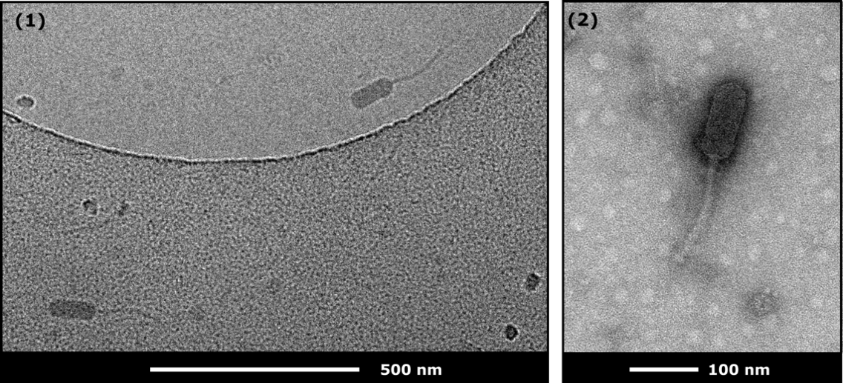

Figure 1. Electron micrographs of phage cd2 using cryo-EM (image 1) and TEM (image 2, staining with uranyl acetate), illustrating that it is a siphophage.

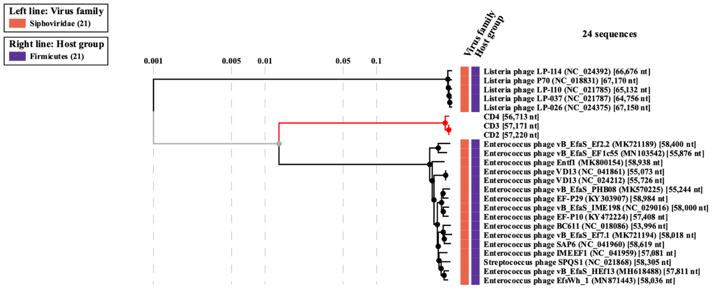
Figure 2. Proteomic tree for phages cd2, cd3 and cd4. Only viruses displaying a genomic similarity score greater than 0.05 (S_{G} > 0.05) are included. Figure generated using ViPTree (6).
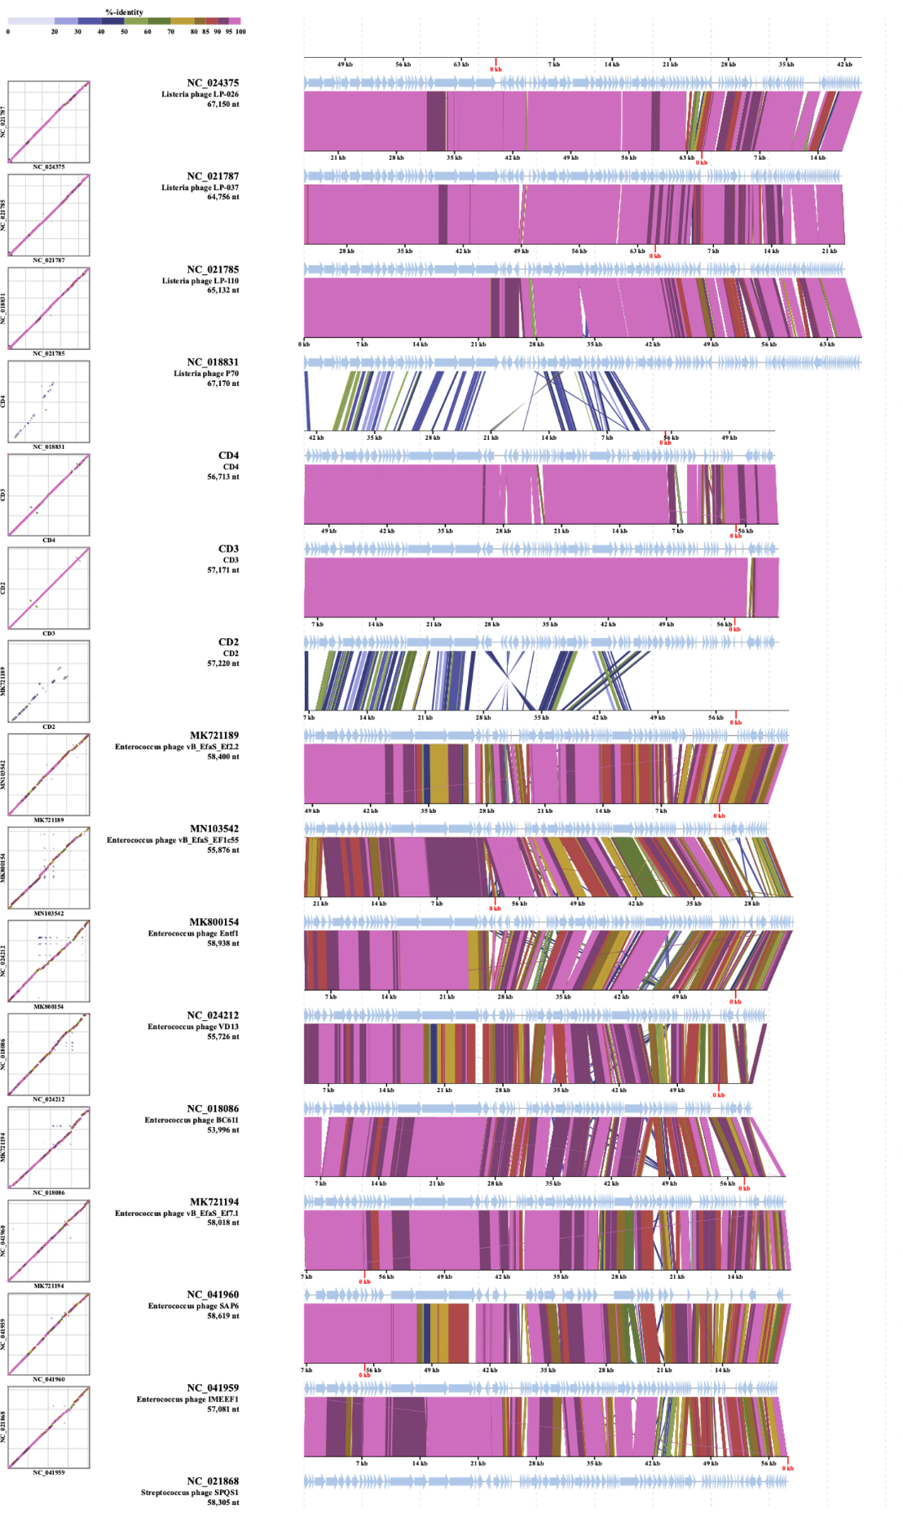
Figure 3. Genomic alignment of phages cd2, cd3 and cd4 with viruses belonging to genus Homburgvirus (Listeria viruses LP-026, LP-037, LP-110, P70) and viruses belonging to genus Saphexovirus (Enterococcus viruses vB_EfaS_Ef2.2, vB_EfaS_EF1c55, Entf1, VD13, BC611, vB_EfaS_Ef7.1, SAP6, IMEEF1 and Streptococcus phage SPQS1). The coloured vertical blocks indicate the level of nucleotide similarity between sequences. Sequences were adjusted and reordered to begin at the terminase small subunit. Figure generated using ViPTree (6).

Figure 4. Intergenomic similarities heatmap generated with Viridic, using default settings (2). The results suggest that phages cd2, cd3 and cd4 comprise a new genus since they display < 70% similarity to the Listeria phages (LP-037, LP-110, LP-114, P70), Enterococcus phages (vB_EfaS_EF1c55, IME-EF1, vB_EfaS_HEf13, Entf1, vB_EfaS_PHB08, EF-P29, vB_EfaS_IME198, VD13, BC611, SAP6, vB_EfaS_Ef7.1) and Streptococcus phage SPQS1. Within this new genus, phages cd2 and cd3 are the same species (>95% similarity), while phage cd4 is a different species (<95% similarity compared to phages cd2 and cd3).

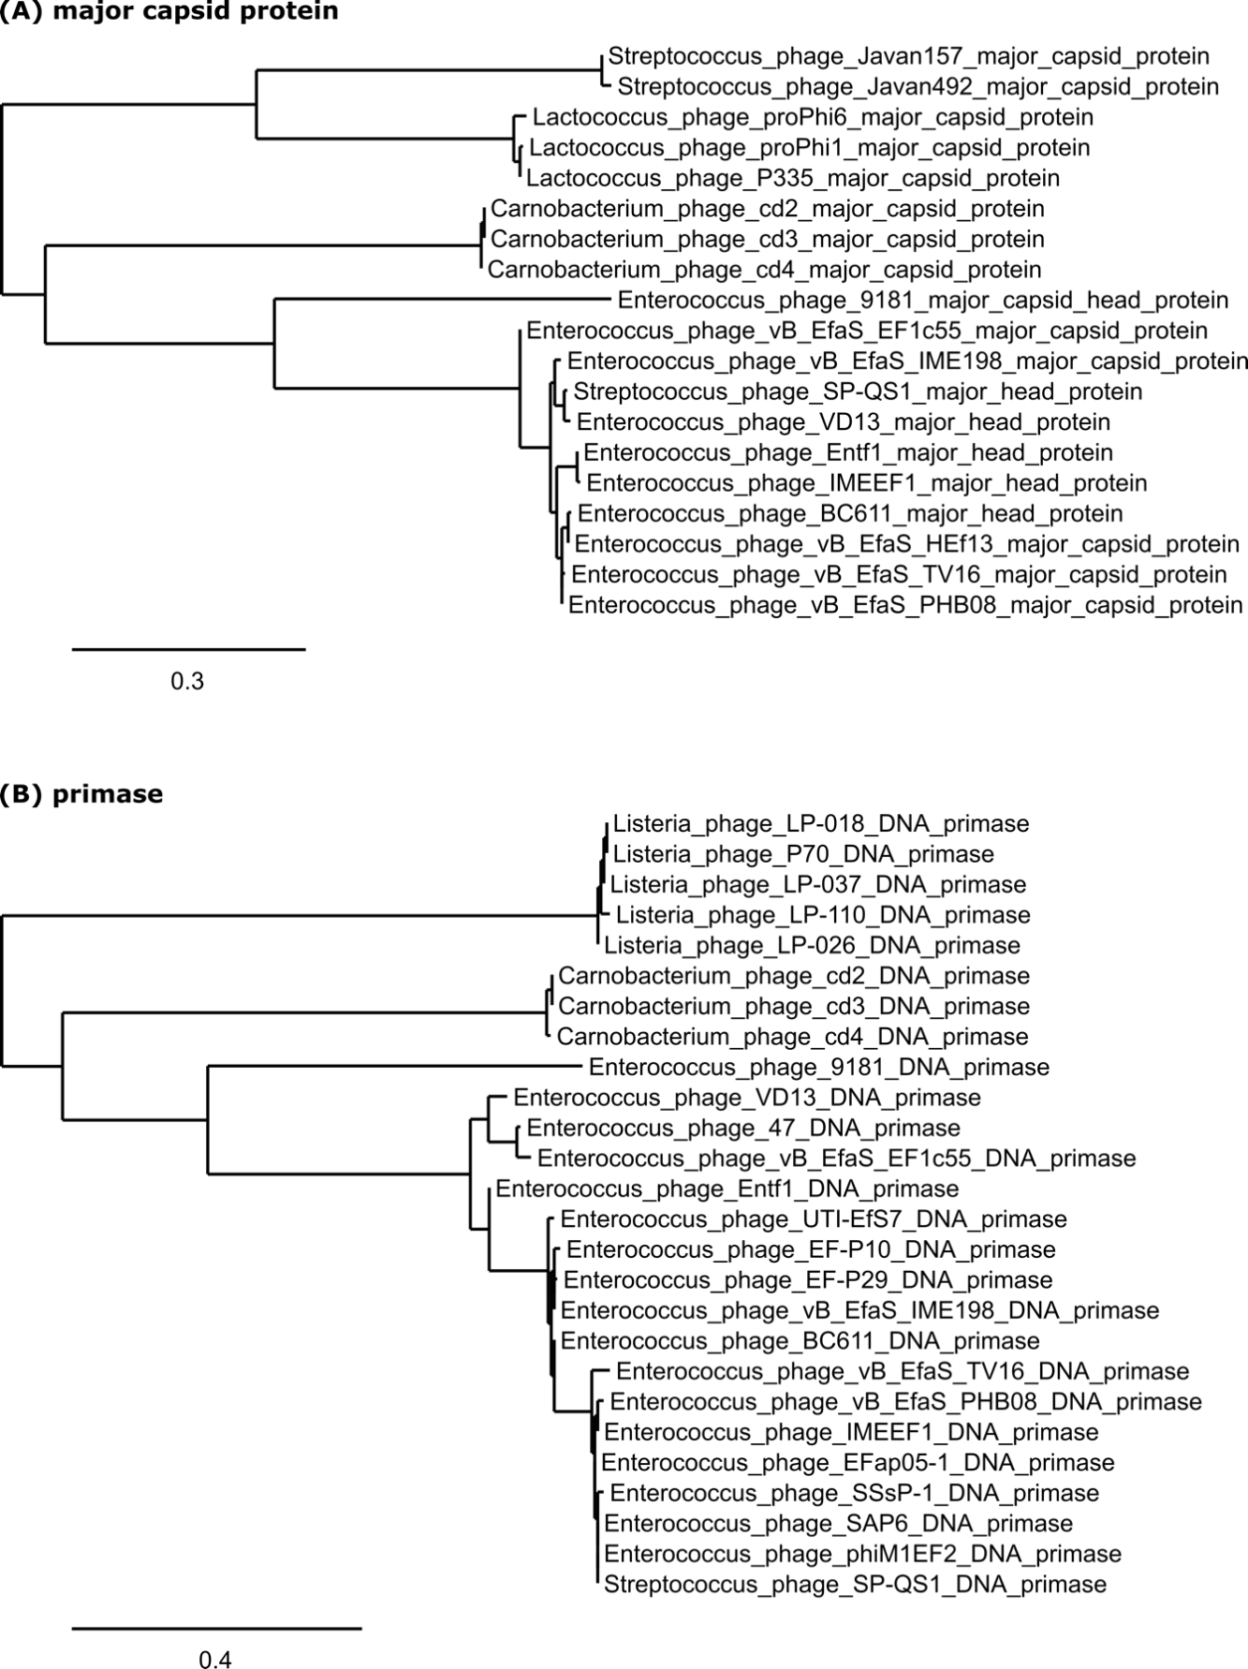

Figure 5: Phylogenetic trees for the major capsid proteins (A) and DNA primases (B) for phages cd2, cd3 and cd4 and other related phages, as identified by BLASTP. Figure generated using “one click” mode by Phylogeny.fr (http://www.phylogeny.fr/) (7). The positions of phages cd2, cd3 and cd4 are indicated with a yellow box.

References
- Zhang P, Britton AP, Visser KA, Welke CA, Wassink H, Prins E, Yang X, Martin-Visscher LA. 2021. Genome Sequences of Bacteriophages cd2, cd3, and cd4, which Specifically Target Carnobacterium divergens. Microbiol Resour Announc 10. https://doi.org/10.1128/MRA.00636-21
- Moraru C, Varsani A, Kropinski AM. 2020. VIRIDIC—A Novel Tool to Calculate the Intergenomic Similarities of Prokaryote-Infecting Viruses. Viruses 12:1268. https://doi.org/10.3390/v12111268
- Mahadevan P, King JF, Seto D. 2009. CGUG: in silico proteome and genome parsing tool for the determination of “core” and unique genes in the analysis of genomes up to ca. 1.9 Mb. BMC Res Notes 2:168. https://doi.org/10.1504/ijcbdd.2009.027586
- Mahadevan P, King J, Seto D. 2009. Data mining pathogen genomes using GeneOrder and CoreGenes and CGUG: gene order, synteny and in silico proteomes. Int J Comput Biol Drug Des 2:100–114. https://doi.org/10.1186/1756-0500-2-168
- Zafar N, Mazumder R, Seto D. 2002. CoreGenes: A computational tool for identifying and cataloging “core” genes in a set of small genomes. BMC Bioinformatics 3:12. https://doi.org/10.1186/1471-2105-3-12
- Nishimura Y, Yoshida T, Kuronishi M, Uehara H, Ogata H, Goto S. 2017. ViPTree: the viral proteomic tree server. Bioinformatics 33:2379–2380. https://doi.org/10.1093/bioinformatics/btx157
7. Dereeper A, Guignon V, Blanc G, Audic S, Buffet S, Chevenet F, Dufayard J-F, Guindon S, Lefort V, Lescot M, Claverie J-M, Gascuel O. 2008. Phylogeny.fr: robust phylogenetic analysis for the non-specialist. Nucleic Acids Res 36:W465–W469. https://doi.org/10.1093/nar/gkn180

